

Analysis of FreeRTOS Source Code: Implementation of the Ready List in the Scheduler

Team members:

|  |  |  |
| --- | --- | --- |
| S.NO | NAME | ROLL NUMBER |
| 1 | Aswin M | CB.EN.U4CSE21408 |
| 2 | Neeli Uday Kumar | CB.EN.U4CSE21441 |
| 3 | Nila Bhaskar | CB.EN.U4CSE21442 |
| 4 | Rithish Abinav | CB.EN.U4CSE21448 |
| 5 | Thota Abhignya | CB.EN.U4CSE21463 |

Introduction:

FreeRTOS is an open-source real-time operating system (RTOS) designed for embedded systems with real-time requirements. It provides a lightweight and portable platform for developing applications that need deterministic behaviour and efficient task scheduling. FreeRTOS is widely used in various industries, including automotive, aerospace, industrial automation, medical devices, and more.

The purpose of the report is to analyse the implementation of the Ready List in the FreeRTOS schedular. the ready list is a crucial data structure that stores the tasks which are ready to execute and by examining this we will get a deeper understanding of how FreeRTOS manages the task scheduling and proper utilization of resources.

The report is structured as follows:

Brief Introduction

Overview of FreeRTOS Scheduler

Understanding the Ready List

Analysing the Implementation of the Ready List

Detailed Examination of Ready List Operations

Integration of the Ready List with the Scheduler

Conclusion

Overview of FreeRTOS Scheduler:

The FreeRTOS scheduler plays a crucial role in task management and scheduling within an embedded system. Its primary responsibility is to determine which tasks should run and when based on predefined priorities and scheduling policies. By efficiently managing task execution, the scheduler ensures that the system meets the real-time requirements and effectively utilizes the available resources.

The scheduler maintains a list of tasks that are ready for execution, known as the Ready List. The Ready List is a fundamental component of the scheduler's functionality and is essential for efficient task management. It represents the pool of tasks that are eligible to run, based on their readiness and priority.

The importance of the Ready List lies in its ability to facilitate task prioritization and scheduling decisions. The Ready List allows the scheduler to quickly identify the highest-priority task that should be scheduled for execution. When a task becomes ready to run, such as when it completes a waiting state or is newly created, it is added to the Ready List. The scheduler then selects the task with the highest priority from the Ready List and switches the processor's execution context to that task.

Furthermore, the Ready List allows for efficient context switching between tasks. Context switching refers to the process of saving the state of one task and restoring the state of another task. When a task's execution is interrupted, its context is saved, and the processor switches to execute a different task. It is a key data structure that contributes to the real-time capabilities and resource utilization of the FreeRTOS operating system.

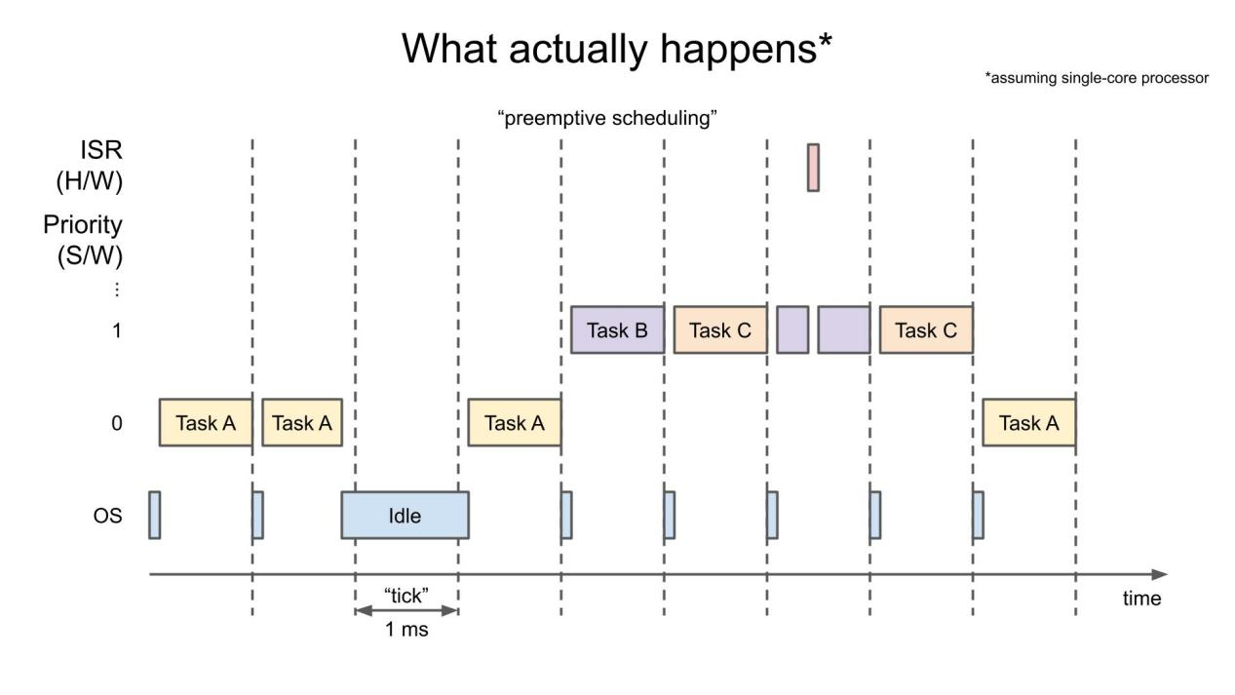

The Ready List and its Significance in Task Scheduling

The Ready List is a vital data structure in task scheduling within the FreeRTOS operating system. It represents a list of tasks that are ready to execute, based on their priority and readiness. The Ready List plays a crucial role in managing tasks' states efficiently, optimizing resource utilization, and ensuring the timely execution of critical tasks.

The Ready List and Task Scheduling:

The Ready List serves as a dynamic repository of tasks eligible for execution. It enables efficient and timely task scheduling by adding ready tasks to the list and selecting the highest-priority task for CPU allocation.

Managing Tasks' States Efficiently:

In a multitasking environment, tasks can be in different states: ready, blocked, and running. The Ready List focuses on managing tasks in the ready state. By maintaining the Ready List, FreeRTOS streamlines task management prioritizes tasks effectively, and ensures timely execution.

Significance of the Ready List:

a. Prioritization: The Ready List organizes tasks based on priority levels. This allows the scheduler to quickly identify and execute the highest-priority task, meeting real-time requirements and promptly ensuring critical tasks receive CPU time.

b. Resource Utilization: The Ready List facilitates efficient utilization of system resources. CPU time is allocated to tasks only when they are ready for execution, minimizing idle time, and maximizing resource utilization. The Ready List ensures a continuous supply of ready tasks, enhancing system performance and responsiveness.

In conclusion, the Ready List is a crucial component in task scheduling within FreeRTOS. It enables efficient task prioritization, ensures timely allocation of CPU resources, and facilitates the effective management of tasks' states. By maintaining the Ready List, FreeRTOS optimizes task scheduling, improves resource utilization, and enhances the efficiency of real-time embedded systems.

Analyzing the implementation of Ready List:

The data structure used for the ready list is an array of circular doubly Linked lists in which elements are arranged according to their priority and for each element in the circular linked list there is a pointer that points to TCB(Task Control Block) which contains the information about a specific task, including its state, priority, stack pointer, program counter, and other relevant context data. It serves as a control structure that allows the operating system to schedule, suspend, resume, and manage the execution of tasks.

By maintaining a circular linked list of TCBs, FreeRTOS can efficiently manage and switch between tasks, implement scheduling algorithms, handle task synchronization and communication, and provide real-time capabilities in embedded systems and other resource-constrained environments.

Some more advantages are,

Dynamic Task Insertion and Removal: The circular doubly linked list provides flexibility in dynamically inserting and removing tasks. New tasks can be inserted at a specific priority level, and existing tasks can be removed or relocated within the linked list. This dynamic nature allows for dynamic task creation and deletion, which is a common requirement in many real-time systems. And These operations have a constant time complexity, resulting in efficient task management and minimal impact on system performance.

Task Pre-emption: Pre-emption is the mechanism by which a higher-priority task interrupts the execution of a lower-priority task. The array of arrays structure facilitates efficient pre-emption by providing a clear organization of tasks based on priority levels. When a higher-priority task becomes ready, it can pre-empt the currently executing lower-priority task, ensuring that critical tasks are given priority in time-critical systems.

Memory Efficiency: The use of linked lists minimizes memory fragmentation and provides efficient memory utilization. Each task in the circular doubly linked list only requires the necessary control block and a few pointers, resulting in a small memory footprint per task. This allows for the efficient use of limited resources, particularly in embedded systems with constrained memory.

Detailed Examination of Ready List Operations:

There are mainly 5 operations performed in Ready List they are

1. TaskSwitchContext
2. AddTaskToReadyList
3. RemoveTaskFromReadyList
4. TopReadyPriority
5. CurrentTCB

TaskSwitchContext:

This function is used to switch the tasks, in such a way that when a task is running which has some priority among the elements in the array of circular doubly linked list and when another task which has higher priority arrives then this function checks whether the task is fully executed or not if not it will calculate the run time of this task and store it in it’s TCB and now this task is stored in the array of circular doubly linked list according to its priority. Now this function switches the task with which has the highest priority.

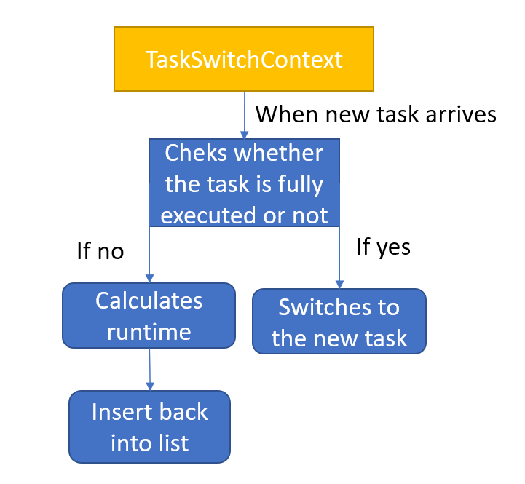

The time complexity and space complexity of this function are O(N) and O(1) and the impact on the scheduler's efficiency depends on factors such as the context switch overhead, frequency of context switches, scheduling algorithm, task execution time, and system load. Optimal scheduling algorithms and minimizing unnecessary context switches can improve the efficiency of the scheduler.

AddTaskToReadyList:

This function is used to add the task to the ready list. In this function first, the task is moved to the ready state and updated in its TCB and calculates its priority and according to the priority, the task is added to the ready list.

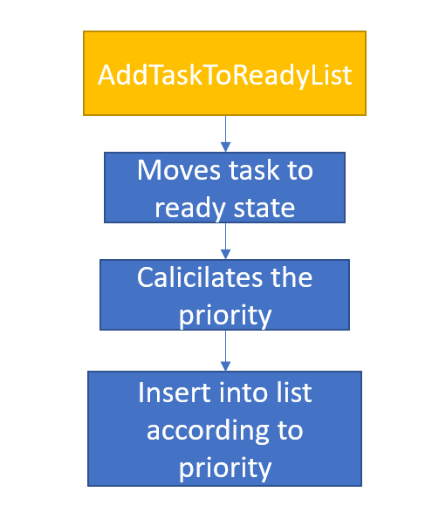

The time complexity and space for this are O(1) and O(1) and the AddTaskToReadyList function's impact on the scheduler's efficiency lies in efficient ready list management, effective task prioritization, minimizing overhead and execution time, proper concurrency and synchronization, and considering workload characteristics. Optimizing these factors can help improve the efficiency and overall performance of the scheduler.

RemoveTaskFromReadyList:

This function is used to remove the task from the ready list. This function follows the process where the previous node's reference of the removing note is referred to the next node of the removing node and the next node's previous reference of the removing node is a reference to the previous node to the removing node and the next node reference and previous node reference of the removing nodes are made none.

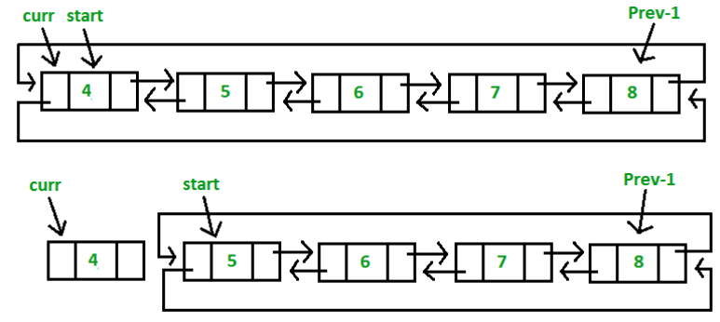

The time complexity and space for this are O(1) and O(1) and the AddTaskToReadyList function's impact on the scheduler's efficiency lies in efficient ready list management, effective task prioritization, minimizing overhead and execution time, proper concurrency and synchronization, and considering workload characteristics. Optimizing these factors can help improve the efficiency and overall performance of the scheduler.

TopReadyPriority:

This is a variable that Returns the priority of the highest-priority task in the Ready List, allowing the scheduler to quickly determine the task to execute.

CurrentTCB:

Provides a pointer to the currently executing task's Task Control Block (TCB), allowing efficient access and modification of the task's state.

Integration of the Ready List with the Scheduler :

The Ready List in FreeRTOS interacts with other parts of the scheduler, such as context switching and task pre-emption, to ensure effective task management and scheduling. Additionally, synchronization mechanisms and algorithms are used to maintain thread safety and prevent race conditions. These methods are discussed below in detail:

1. Interaction with Context Switching:

Context switching is the process of saving the current execution context of a task and restoring the execution context of another task. The ready List plays an important role in context switching by providing a collection of ready tasks for the scheduler to select from. When a task is interrupted, the scheduler consults the Ready List to determine the next task to execute. The current task's context is saved, and the context of the selected task is restored, allowing it to continue execution seamlessly.

1. Interaction with Task Pre-emption:

Task pre-emption refers to the mechanism by which a higher-priority task can interrupt the execution of a lower-priority task. The Ready List is responsible for determining whether a task should be pre-empted based on its priority. When a higher-priority task becomes ready and the current task has a lower priority, the Ready List facilitates task pre-emption. The scheduler interrupts the lower-priority task, saves its context, and switches to the higher-priority task by using the information provided by the Ready List.

1. Synchronization Mechanisms and Algorithms:

In multi-threaded environments, synchronization mechanisms are essential to maintain thread safety and prevent race conditions. Various synchronization mechanisms and algorithms are used in Free RTOS to ensure the integrity of the Ready List and its operations. The mechanisms are discussed below:

1. **Mutexes** are used to provide mutual exclusion, allowing only one task to access the Ready List at a time. When a task needs to operate on the Ready List, it must acquire the mutex, ensuring that no other task concurrently modifies the list. This prevents race conditions and ensures thread safety.
2. **Atomic operations** are used for low-level, indivisible operations on shared data structures. In Ready List, atomic operations may be used when updating task state or updating pointers to ensure that these operations are performed atomically without interruption.
3. **Interrupt Disable/Enable**: FreeRTOS may disable interrupts temporarily when performing critical operations on the Ready List. By disabling interrupts, the scheduler ensures that no interrupt handler or higher-priority task can pre-empt the operation, ensuring the consistency and correctness of the Ready List.

Conclusion:

The importance of the Ready List in attaining effective task scheduling and management is revealed by an investigation of the Ready List's implementation in FreeRTOS. A key data structure used by FreeRTOS to keep track of tasks that are prepared to run is called the Ready List. It acts as a central location where duties are arranged according to their importance.

FreeRTOS can immediately identify the highest-priority activity that is prepared to run by maintaining a Ready List, ensuring that the CPU is always assigned to the most crucial task. The real-time operating system can respond quickly to events and adhere to strict timing specifications because of the Ready List's rapid context switching between activities.

An array of task control blocks (TCBs) or a priority-based linked list are two common implementations of the Ready List in FreeRTOS. Each task's priority, status, and stack pointer are all contained in a TCB. As jobs transition from blocked to ready or from ready to block, the Ready List is dynamically updated.

Studying the FreeRTOS source code offers helpful insights into the guiding concepts and methods underlying task management and scheduling. In FreeRTOS' overall architecture, the Ready List is essential since it enables the operating system to effectively prioritize and carry out tasks cooperatively or preemptively.

The research reveals that FreeRTOS's ability to deliver deterministic and predictable task scheduling is a result of the Ready List's effective implementation. This is especially important for real-time systems when keeping up with deadlines and remaining responsive is critical.

Overall, FreeRTOS's Ready List implementation is a crucial part of good job scheduling and management. Understanding how it functions reveals the fundamentals of real-time operating systems and emphasizes the meticulousness needed to achieve effective multitasking in contexts with limited resources.

References:

<https://chat.openai.com>

[www.google.com](http://www.google.com)