AI Assisted Coding
Assignment 2.5
Name: S.Uday
Hall ticket no: 2303A51257
Batch no: 19
Task 1:
Prompt:
Generate the code to sum the even and odd numbers in a list
Code & Output:
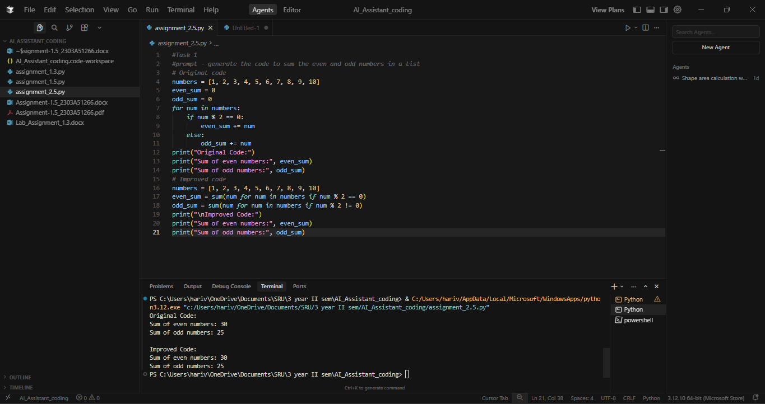
Explanation:
This code goes through each number in the list and checks whether it is even or odd. If the number is even, it gets added to even_sum, otherwise it gets added to odd_sum. At the end, the program prints the total of all even numbers and the total of all odd numbers separately. This helps us clearly see how much each group contributes to the list’s total.

Task 2:
Prompt:
Calculate the areas of all the shapes
Code & Output:
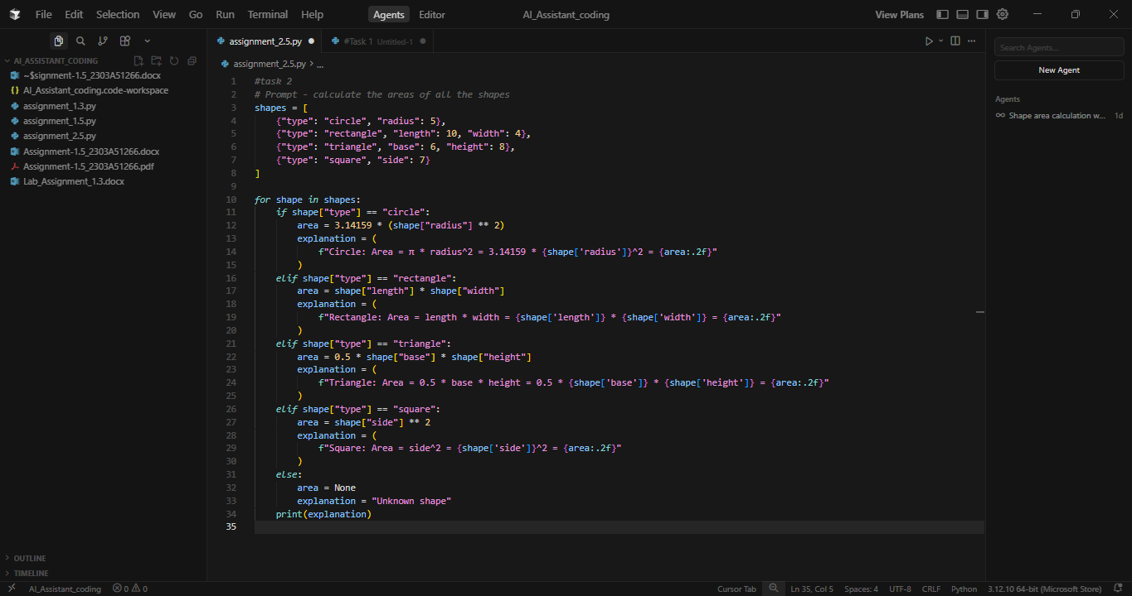
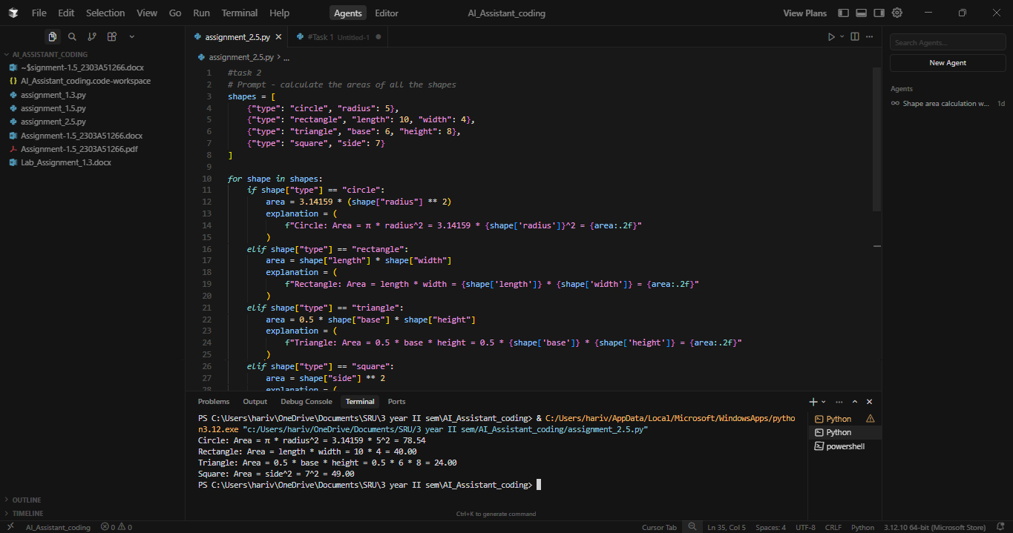
Explanation:
This code reads different shapes from a list and calculates their areas based on the type of shape. For each shape, it checks whether it is a circle, rectangle, triangle, or square and then applies the correct calculation for that shape. After calculating the area, it prepares a short explanation text describing what was done and finally prints it out. If the program encounters a shape that it doesn’t recognize, it prints that the shape is unknown. This makes the output easy to understand and useful for someone learning how area calculations work.
Task 3:
Use Cursor AI with different prompts for the same problem and observe code changes.
Prompt 3.1:
Calculate the factorial of a number
Code& Output:
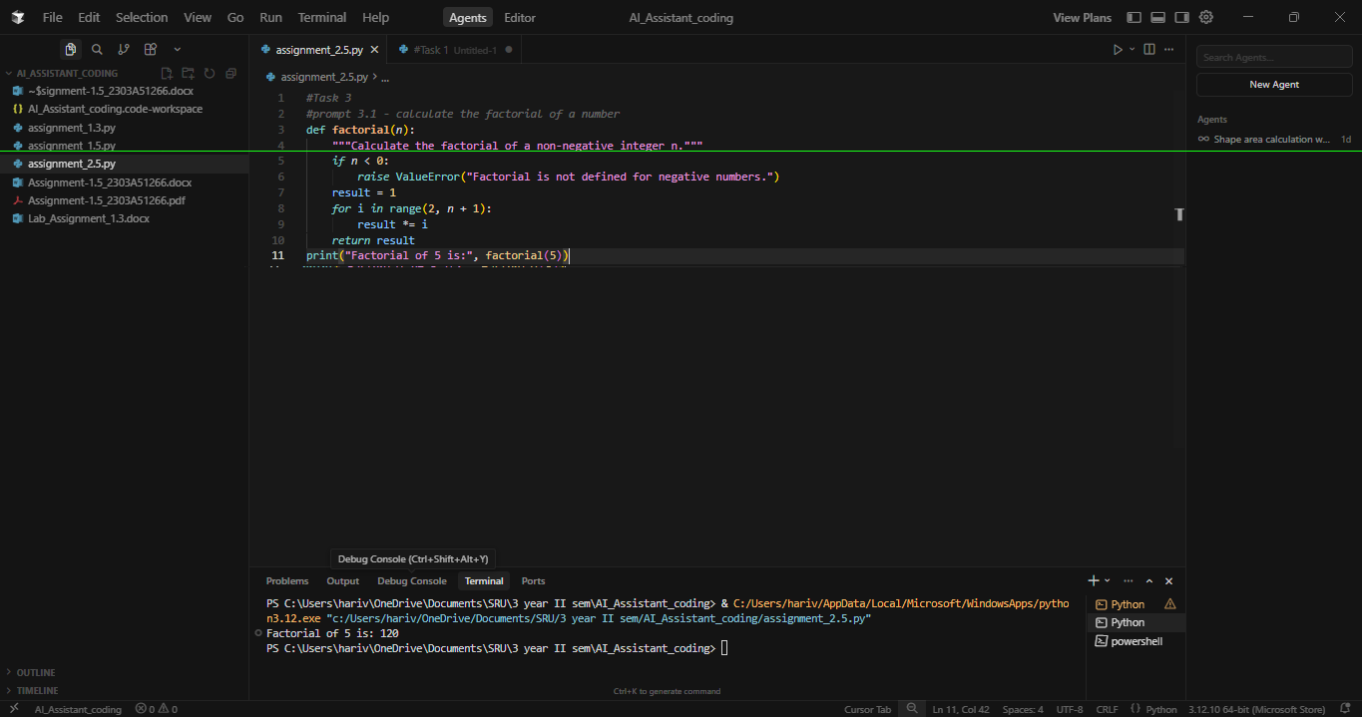
Prompt 3.2 :
Write factorial function in python using recursion
Code & Output:
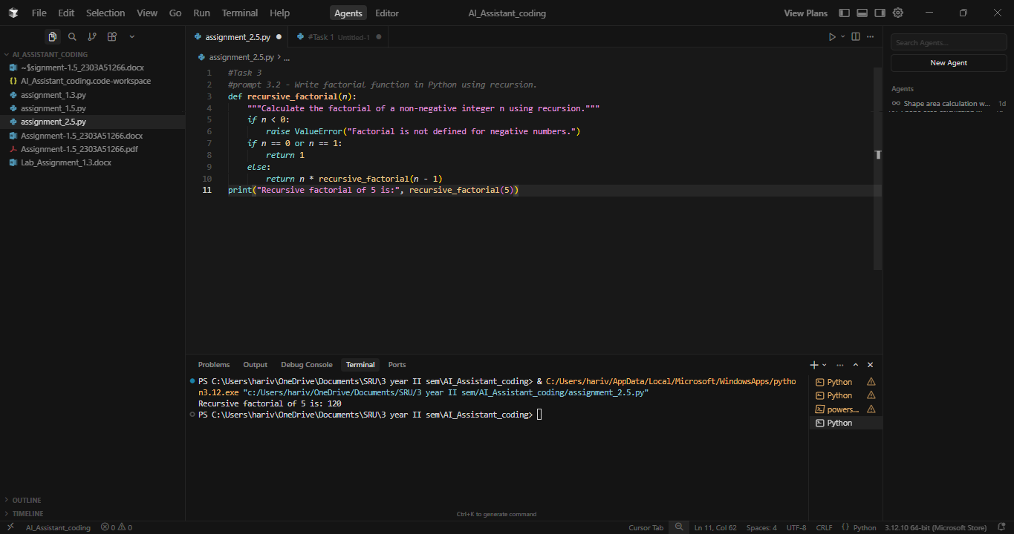
Prompt 3.3:
Write an optional factorial function with comments.
Code & Output:
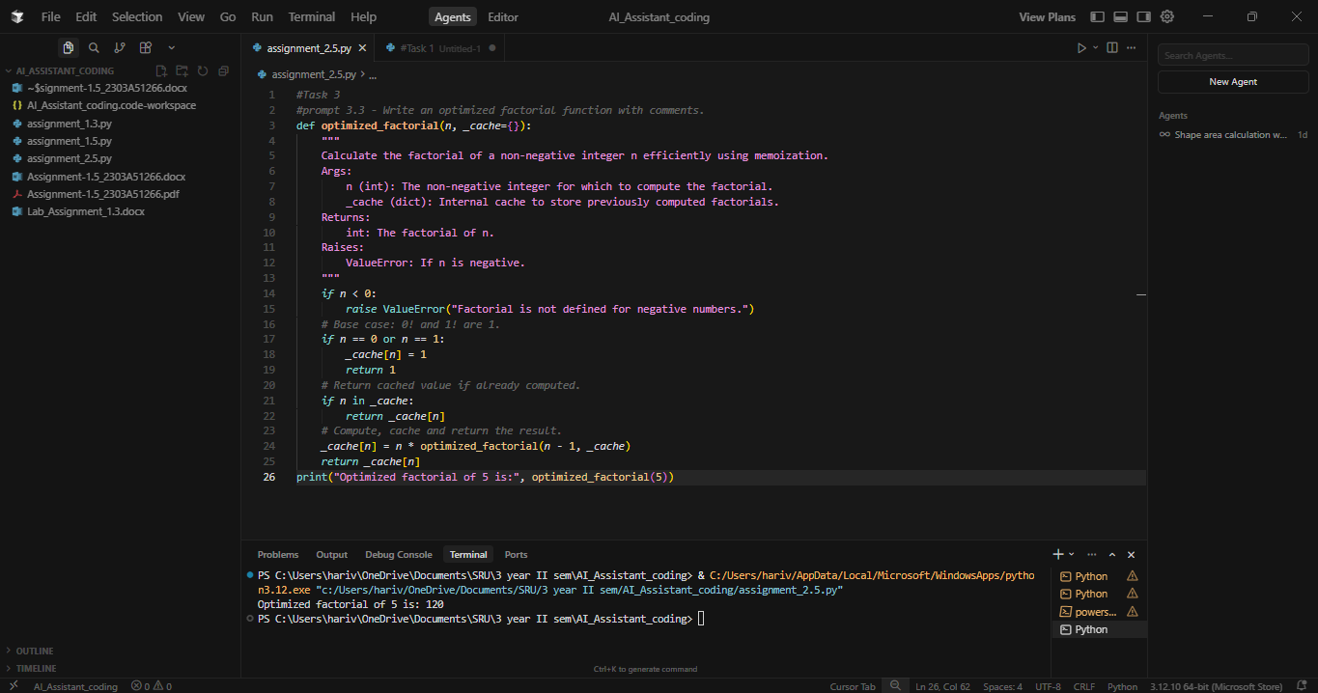
Prompt 3.4:
Write a factorial function in a single line.
Code & Output:
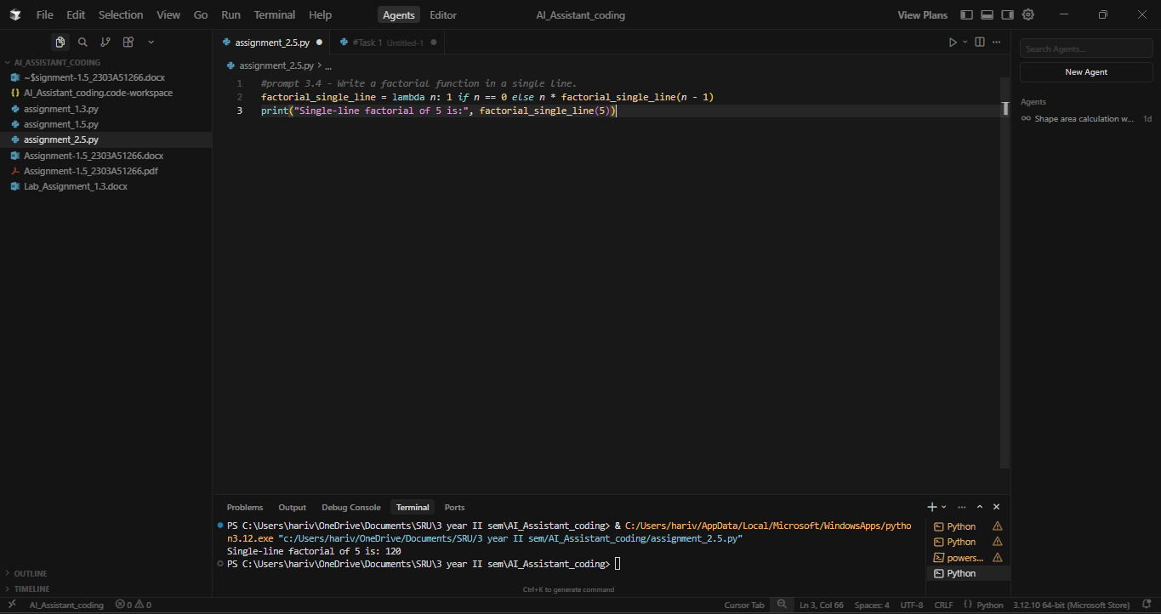
Prompt 3.5:
Write production grade factorial function with typing and docstring.
Code & Output:
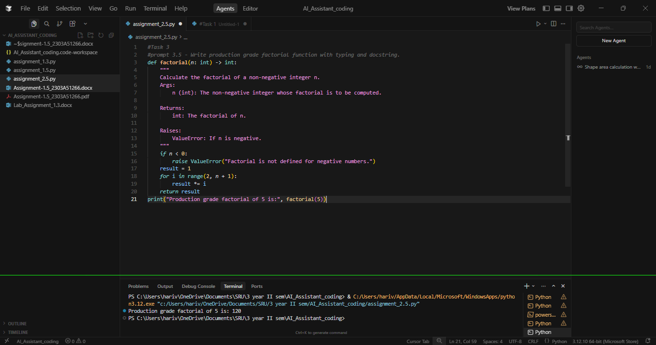
Explanation:
In this task, I asked Cursor to generate the factorial program using different prompts. Even though the problem was the same, the tool produced different versions of the code depending on how I asked. First, it gave a simple loop-based factorial, then a recursive version when I mentioned recursion, and later an optimized one when I asked for better performance. It also handled a single-line lambda version and finally a production-style version with typing and docstrings. This shows that the tool understands prompt details and adjusts the code style, structure, and features based on how clearly the prompt is written.
Task 4:
Prompt:
Code & Output:
Explanation:

