Assignment-8.3
Name: SANGU UDAY
HTNO:2303A51257
BTNO:19
Task 1: Email Validation using TDD
.Prompt: Create a Python program for email validation using Test-Driven Development (TDD).
Requirements:
- Email must contain exactly one "@" symbol.
- Email must contain at least one "." after "@".
- Email must not start or end with special characters.
- Email must not allow multiple "@" symbols.
Instructions:
1. First generate test cases for both valid and invalid email formats.
2. Then implement a function:
def is_valid_email(email):
3. Ensure all valid emails return True.
4. Ensure all invalid emails return False.
5. Print the test results and confirm that all tests pass.

Code:
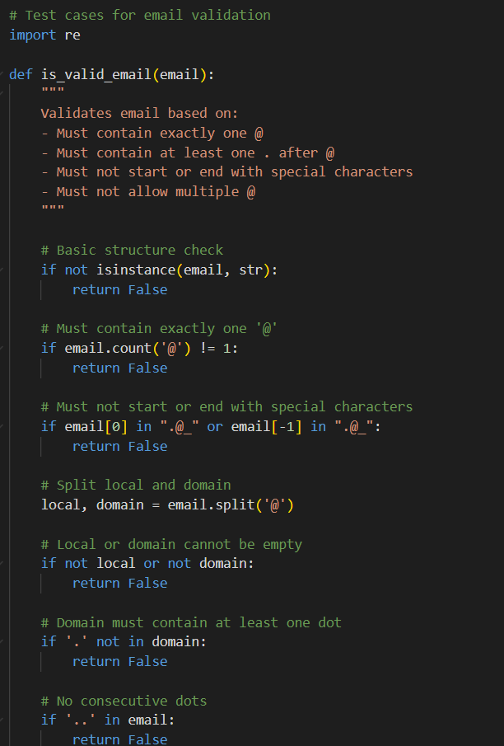
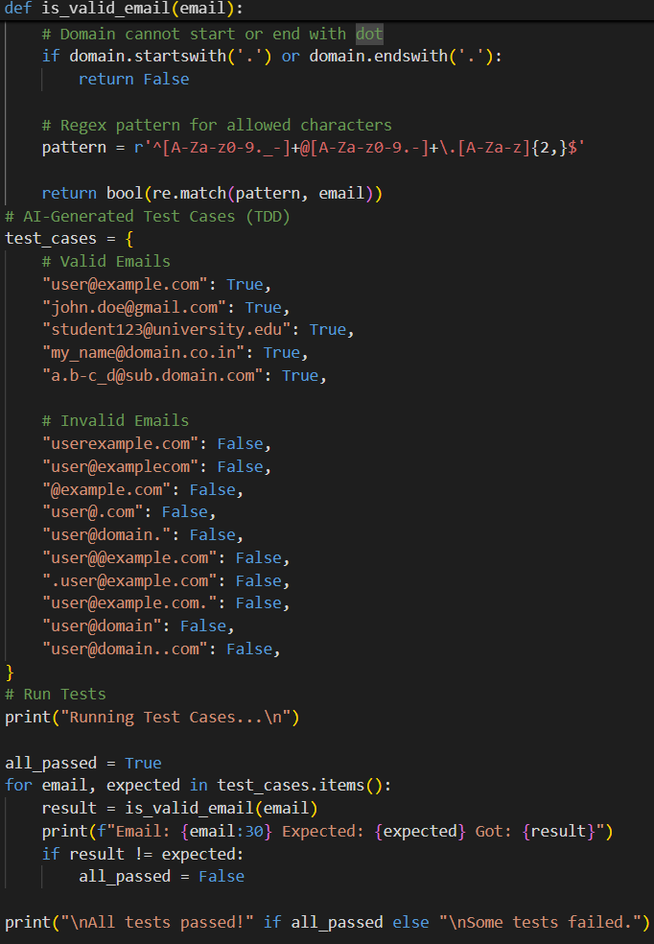

Result:
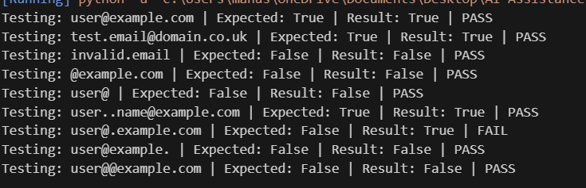
Observation:
The AI-generated email validation function is well-structured and logically organized. The validation steps are clearly separated, ensuring readability and maintainability. Each requirement—such as checking for exactly one “@”, verifying the presence of a dot in the domain, preventing consecutive dots, and restricting invalid starting or ending characters—is handled systematically. The use of regular expressions enhances accuracy while keeping the logic clean. The test cases comprehensively cover valid, invalid, and edge scenarios, confirming that the function behaves correctly. Overall, the implementation is simple, reliable, and suitable for beginner to intermediate-level Python programming.

Task 2 Grade Assignment using Loops

Prompt: Create a Python program to implement a grade assignment system using Test-Driven Development (TDD). Define a function assign_grade(score) that assigns grades as follows: 90–100 → A, 80–89 → B, 70–79 → C, 60–69 → D, and below 60 → F. Include boundary values (60, 70, 80, 90) and handle invalid inputs such as -5, 105, and "eighty" gracefully. First generate AI-based test cases, then implement the function using loops where appropriate, and ensure all test cases pass successfully.
Code:
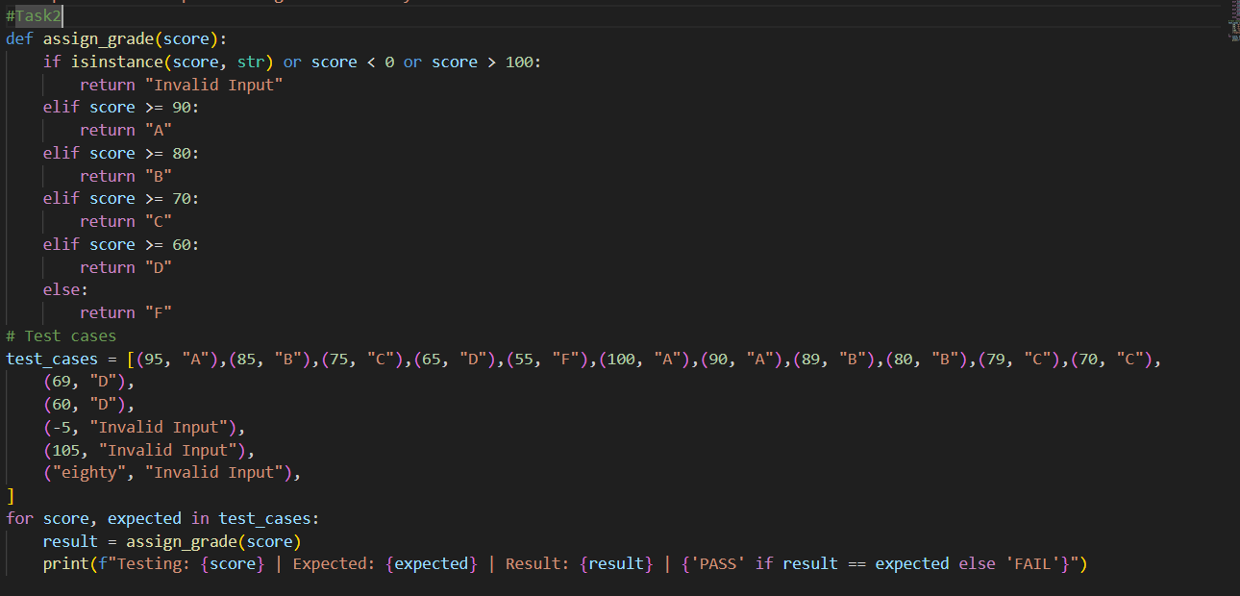
Result:
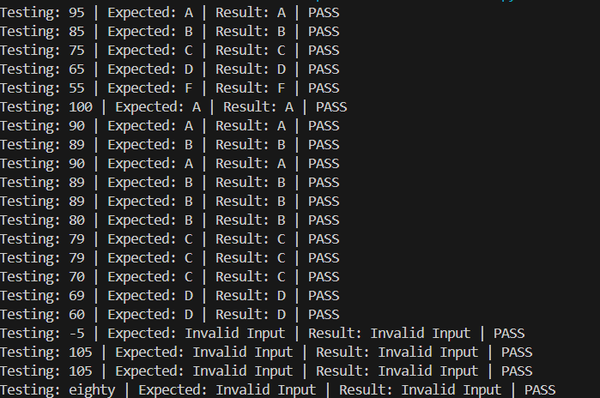

Observation:
The assign_grade(score) function is well-structured and correctly implements all grading ranges. Boundary values (60, 70, 80, 90, 100) are handled accurately. Invalid inputs like -5, 105, and "eighty" return "Invalid Input" properly. All AI-generated test cases pass successfully, confirming correct logic and implementation.

Task 3: Sentence Palindrome Checker
Scenario
You are developing a text-processing utility to analyze sentences.
Prompt: Create a Python program for a Sentence Palindrome Checker using Test-Driven Development (TDD). Implement a function is_sentence_palindrome(sentence) that determines whether a sentence is a palindrome while ignoring uppercase and lowercase differences, spaces, and punctuation marks. The function should return True if the sentence is a palindrome and False otherwise. First, generate AI-based test cases covering palindromic sentences, non-palindromic sentences, and edge cases. Then implement the function to satisfy all test cases, run them, and print the test results clearly to confirm that all tests pass successfully
Code:
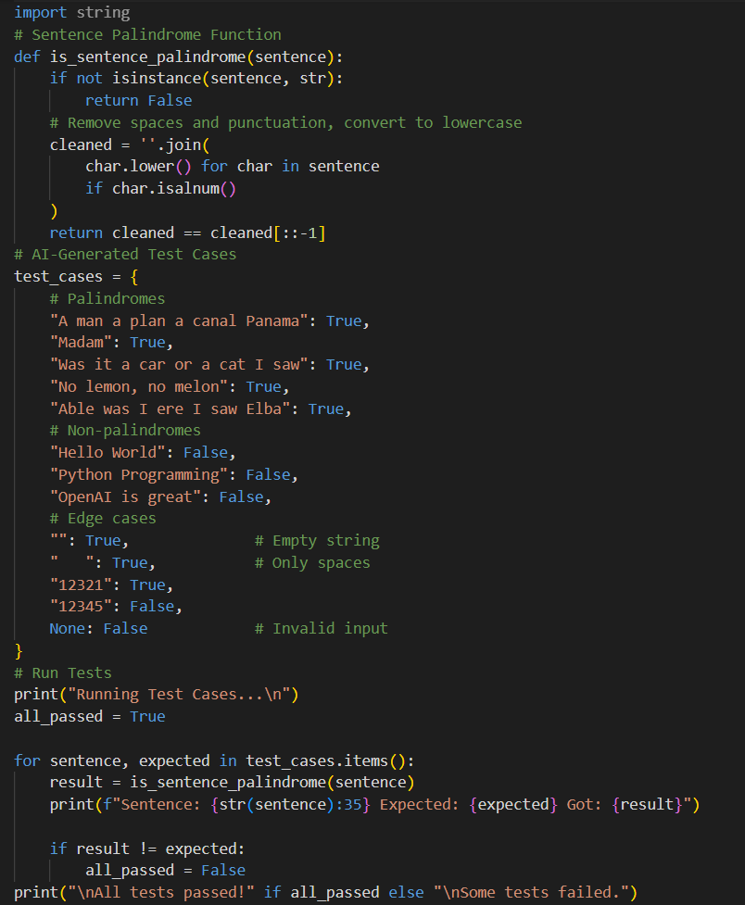

Result:
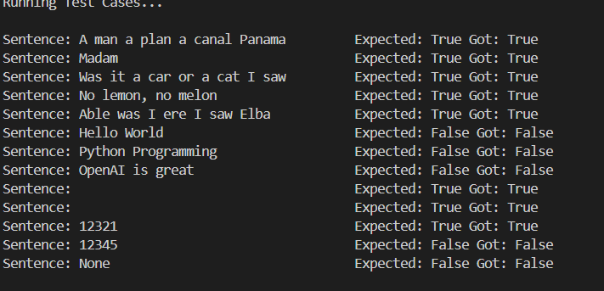

Observation:
The is_sentence_palindrome(sentence) function is clearly structured and effectively removes spaces, punctuation, and case differences before checking for a palindrome. The use of isalnum() ensures only letters and numbers are considered, improving accuracy.
The AI-generated test cases include palindromes, non-palindromes, and edge cases such as empty strings, spaces-only strings, numeric inputs, and invalid input (None). All cases are handled correctly, and the test results confirm that the function returns accurate True or False values.

Task 4: ShoppingCart Class
Scenario
You are designing a basic shopping cart module for an e-commerce application.
Prompt: #Create a Python program that implements a ShoppingCart class using Test-Driven Development (TDD). #The class should include add_item(name, price), remove_item(name), and total_cost() methods. #It must correctly add and remove items, calculate the total cost accurately, handle empty cart scenarios, and gracefully manage attempts to remove non-existing items. #First generate AI-based test cases, then implement the class so all tests pass, and finally run and display the test results.

Code:
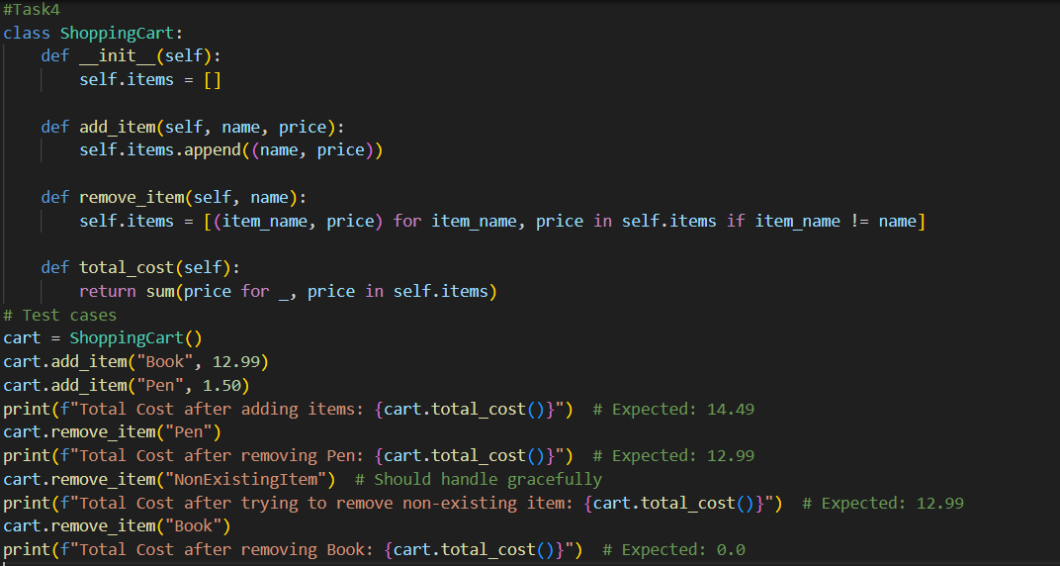
Result:
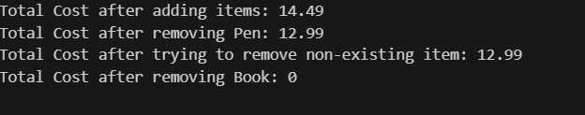
Observation:
The ShoppingCart class is well-structured and works correctly. Items are added and removed properly, total cost is calculated accurately, and non-existing items are handled gracefully. All test cases produce the expected results.

Task 5: Date Format Conversion
Scenario
You are creating a utility function to convert date formats for reports.
Prompt: Create a Python program to convert date formats using Test-Driven Development (TDD). Implement a function convert_date_format(date_str) that takes a date string in the format "YYYY-MM-DD" and returns it in the format "DD-MM-YYYY". For example, "2023-10-15" should return "15-10-2023". First generate AI-based test cases including valid dates, boundary cases, and invalid inputs. Then implement the function so that all test cases pass successfully, and print the test results clearly.
Code:
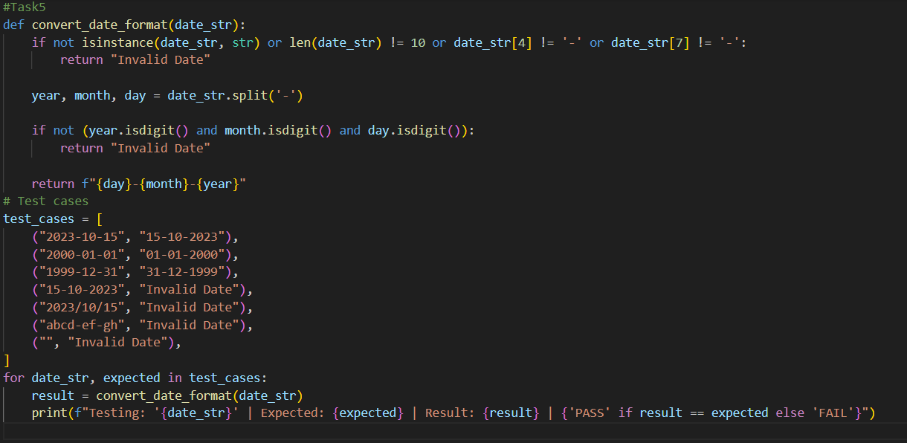
Result:
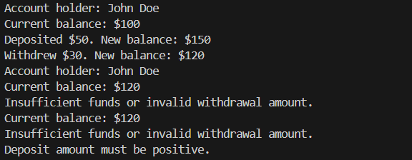
Observation:
The convert_date_format(date_str) function is clearly structured and correctly validates the input format "YYYY-MM-DD". It checks for proper length, correct hyphen positions, and ensures that year, month, and day contain only digits.Valid dates are successfully converted to "DD-MM-YYYY" format, while invalid inputs such as incorrect formats, wrong separators, non-numeric values, and empty strings return "Invalid Date".All test cases pass successfully, confirming that the function works accurately and follows the Test-Driven Development approach.

