Docker

1. What is diff btw VM vs Physical Server vs Container?
Here’s a clear comparison between Physical Server vs VM vs Container (very common DevOps interview question 👇)
🖥️ 1️⃣ Physical Server (Bare Metal)
✅ What it is:
A real hardware machine (CPU, RAM, Disk, Network) installed in a data center.
🏗️ Architecture:
Hardware → Operating System → Applications
👍 Advantages:
- Full hardware control
- High performance
- No virtualization overhead
👎 Disadvantages:
- Expensive
- Scaling is slow (need new hardware)
- Poor resource utilization

🖥️ 2️⃣ Virtual Machine (VM)
✅ What it is:
A virtual computer running on top of a hypervisor.
🏗️ Architecture:
Hardware → Hypervisor → Guest OS → Applications
🔹 Uses Hypervisors like:
- VMware vSphere
- Microsoft Hyper-V
- KVM
👍 Advantages:
- Multiple OS on same hardware
- Better resource utilization
- Easy scaling (cloud – like Amazon EC2)
👎 Disadvantages:
- Each VM needs full OS
- More memory usage
- Slower boot compared to containers

📦 3️⃣ Container
✅ What it is:
Lightweight virtualization that shares the host OS kernel.
🏗️ Architecture:
Hardware → OS → Container Engine → Containers (App + Dependencies)
🔹 Popular Technologies:
- Docker
- Kubernetes
👍 Advantages:
- Very lightweight
- Fast startup
- High scalability
- Best for microservices
👎 Disadvantages:
- Shares host OS kernel
- Less isolation than VM

🔥 Quick Comparison Table
Feature | Physical Server | VM | Container
Hardware Required | Yes (Dedicated) | Shared | Shared
OS Required | 1 OS | Full OS per VM | Share Host OS
Startup Time | Minutes | Minutes | Seconds
Resource Usage | High | Medium | Low
Isolation | High | High | Medium
Best For | Legacy apps | Traditional apps | Microservices / DevOps

🎯 Simple Interview Answer (2–3 Lines)
👉 Physical server is actual hardware.
👉 VM virtualizes hardware and runs multiple OS using hypervisor.
👉 Container virtualizes OS and runs lightweight isolated applications sharing host kernel.

2. What is a Hypervisor?
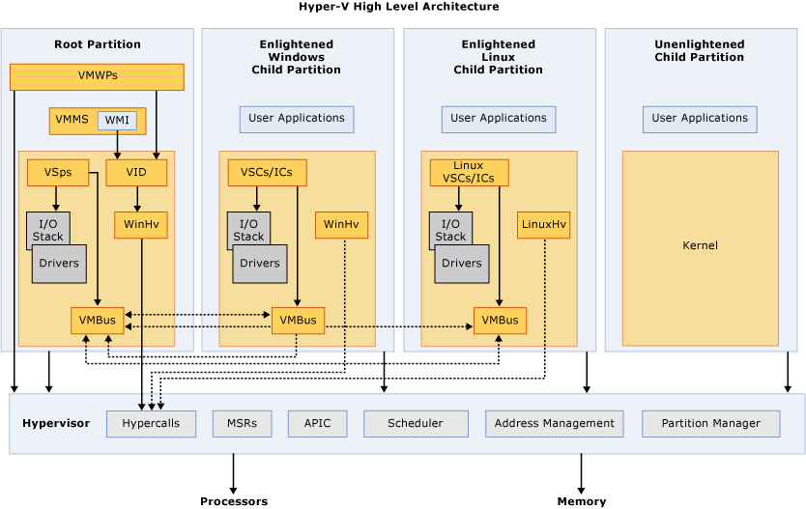
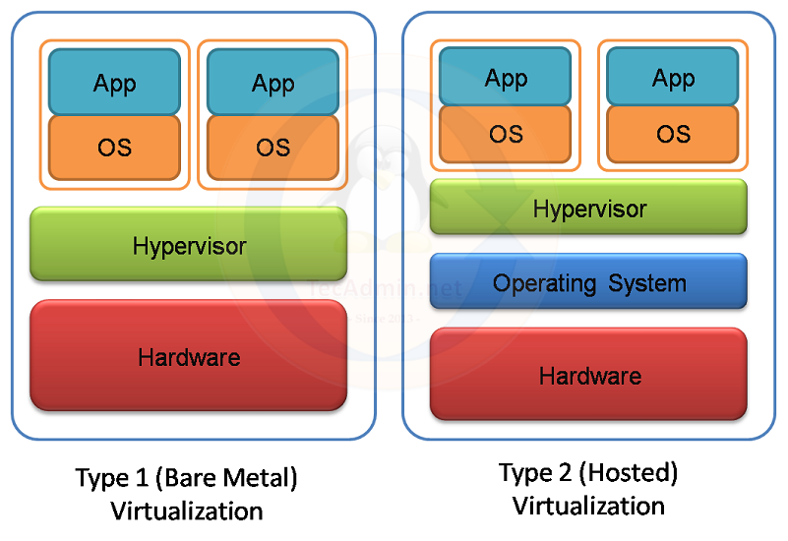
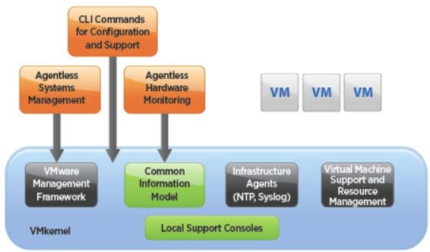

✅ Definition:
A hypervisor is software (or firmware) that creates and manages Virtual Machines (VMs) by allowing multiple operating systems to share a single physical server.
It sits between the hardware and the virtual machines.

🏗️ How It Works
Physical Hardware
⬇
Hypervisor
⬇
Multiple Virtual Machines (Each with its own OS & Applications)
The hypervisor:
- Allocates CPU, RAM, Storage, Network
- Ensures isolation between VMs
- Manages VM lifecycle (start/stop/snapshot)

🔹 Types of Hypervisors
1️⃣ Type 1 – Bare Metal Hypervisor
Runs directly on hardware.
Examples:
- VMware ESXi
- Microsoft Hyper-V
- KVM
✅ High performance
✅ Used in Data Centers & Cloud

2️⃣ Type 2 – Hosted Hypervisor
Runs on top of an existing OS.
Examples:
- Oracle VM VirtualBox
- VMware Workstation
✅ Used for development/testing
❌ Slightly slower (because it runs over host OS)

🔥 Real-Time Example (Cloud)
When you launch an EC2 instance in Amazon EC2, AWS uses a hypervisor in the backend to create your VM on physical hardware.

🎯 Interview Short Answer (2–3 Lines)
A hypervisor is software that allows multiple virtual machines to run on a single physical server by abstracting hardware resources.
It manages CPU, memory, storage allocation and ensures isolation between VMs.

3. What is docker container and why we needed it?
🐳 What is a Docker Container?
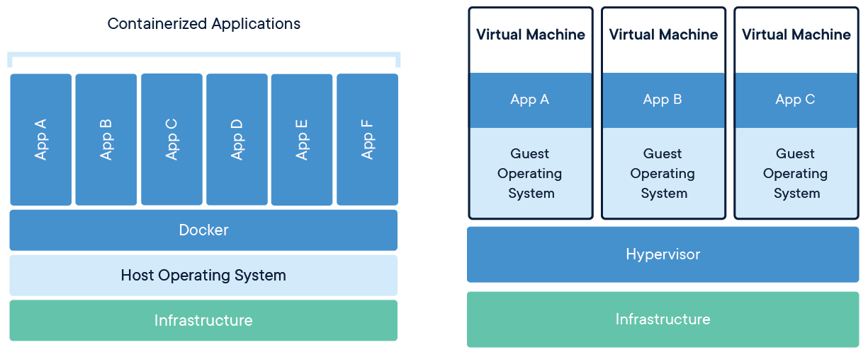
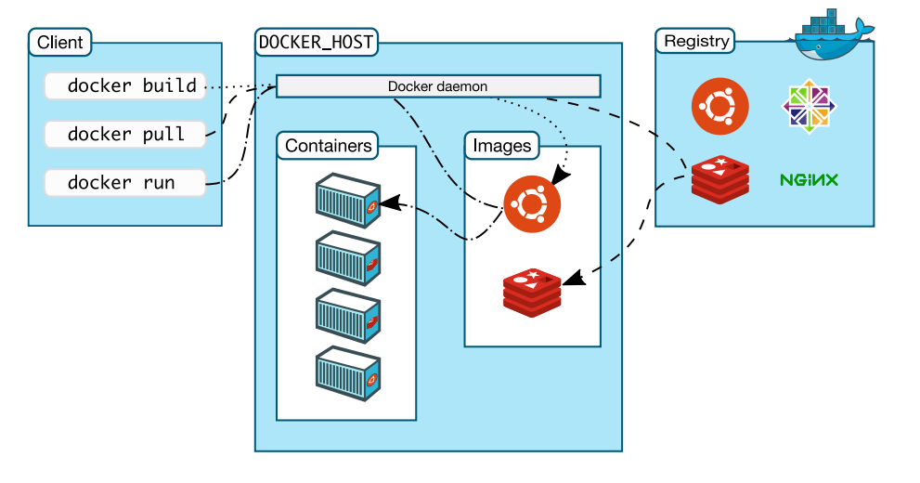
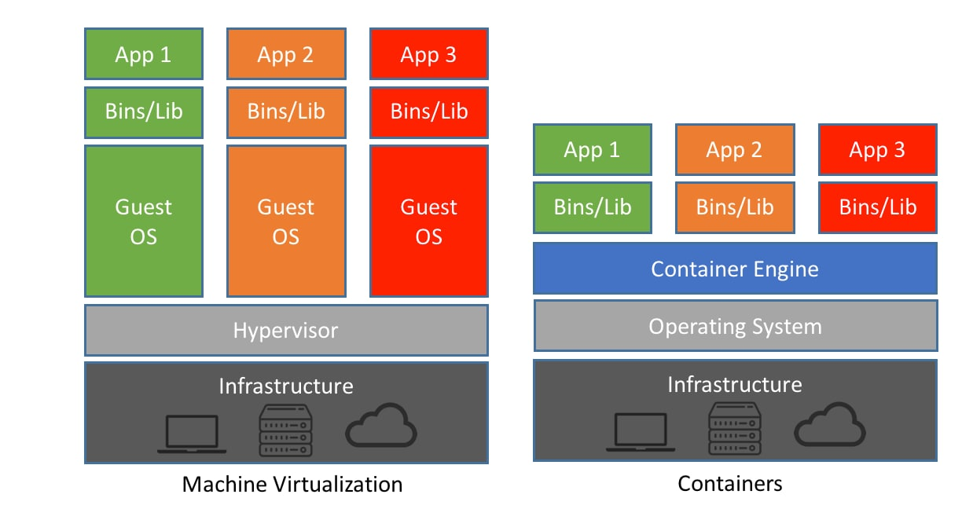

✅ Definition:
A Docker container is a lightweight, standalone, executable package that includes:
- Application code
- Runtime
- Libraries
- Dependencies
- System tools
It runs using OS-level virtualization and shares the host OS kernel.
Built using:
- Docker

🏗️ How Docker Works
Infrastructure
⬇
Host OS
⬇
Docker Engine
⬇
Containers (App + Dependencies)
👉 Unlike VMs, containers do NOT require a full OS per application.

🔥 Why Do We Need Docker?
1️⃣ Solve “Works on My Machine” Problem
Application behaves the same in:
- Dev
- Test
- Production
Because everything is packaged inside the container.

2️⃣ Lightweight & Fast
- Containers start in seconds
- Less memory usage than VMs
- Higher density (run more apps per server)

3️⃣ Better Resource Utilization
No need for:
- Separate OS for each app
- Heavy hypervisor overhead

4️⃣ Easy Scaling & Microservices
Works perfectly with:
- Kubernetes
- CI/CD pipelines
Used heavily in DevOps environments.

📊 Docker vs VM (Quick Difference)
Feature | VM | Docker Container
OS | Full OS per VM | Share Host OS
Boot Time | Minutes | Seconds
Size | GBs | MBs
Performance | Medium | Near Native

🎯 Interview Short Answer (2–3 Lines)
A Docker container is a lightweight, portable unit that packages an application and its dependencies to run consistently across environments.
We use Docker to improve portability, scalability, resource efficiency, and to support microservices architecture.

4. Advantage and Disadvantages of Container?
📦 Advantages and Disadvantages of Containers (Docker / Kubernetes)
Since you're working in DevOps, this is a common interview question. Here’s a clear and professional answer 👇

✅ Advantages of Containers
1️⃣ Lightweight & Fast


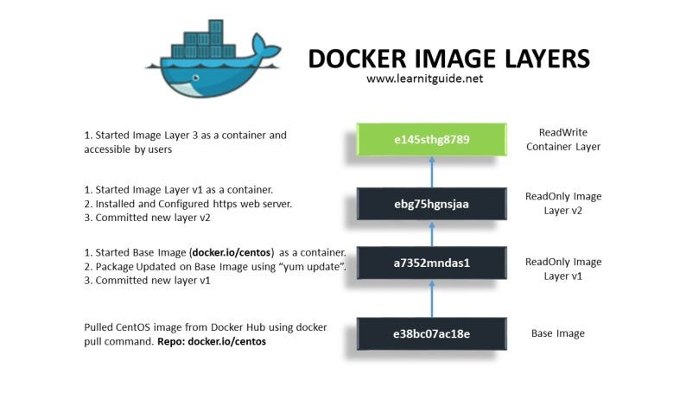
- Containers share the host OS kernel.
- No need to boot full OS like VMs.
- Start in seconds.
👉 Uses less CPU & RAM compared to Virtual Machines.

2️⃣ Portability (Build Once, Run Anywhere)
- Runs same in Dev, Test, Prod.
- Eliminates "Works on my machine" issue.
- Works across:
  - On-prem
  - Amazon Web Services
  - Microsoft Azure
  - Google Cloud Platform

3️⃣ Faster Deployment
- Containers can be deployed instantly.
- Perfect for CI/CD pipelines.
- Great for Microservices architecture.

4️⃣ Scalability
- Easy horizontal scaling.
- Managed using orchestrators like:
  - Kubernetes
  - Docker Swarm

5️⃣ Isolation
- Each container runs independently.
- No dependency conflicts.
- Application + dependencies bundled together.

6️⃣ Better Resource Utilization
- Multiple containers can run on one host efficiently.
- Higher density than VMs.

❌ Disadvantages of Containers
1️⃣ Security Concerns
- Share host OS kernel.
- If kernel is compromised → all containers affected.
- Less isolated than VMs.

2️⃣ Not Ideal for All Applications
- Heavy applications needing full OS may prefer VMs.
- GUI-based apps are harder to manage.

3️⃣ Complex Networking & Storage
- Container networking can be tricky.
- Persistent storage needs extra configuration.

4️⃣ Orchestration Complexity
- Managing thousands of containers requires tools like Kubernetes.
- Learning curve is high.

5️⃣ Monitoring & Logging Challenges
- Containers are ephemeral (temporary).
- Need external monitoring tools.

🎯 Simple Interview Summary (2–3 lines)
Containers are lightweight, portable, and enable faster deployment with better resource utilization.
However, they share the host OS kernel, which raises security concerns and adds complexity in networking, storage, and orchestration.

5. How Docker Works? Explain in Detail?
How Docker Works? (Detailed Explanation)
🔷 What is Docker?
Docker is a containerization platform that packages an application along with its dependencies into a container image and runs it as an isolated process on the host system.

🏗️ 1️⃣ Docker Architecture (High Level)

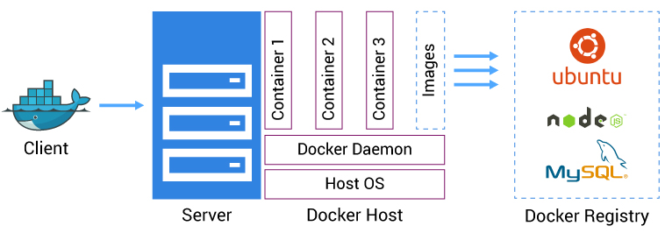
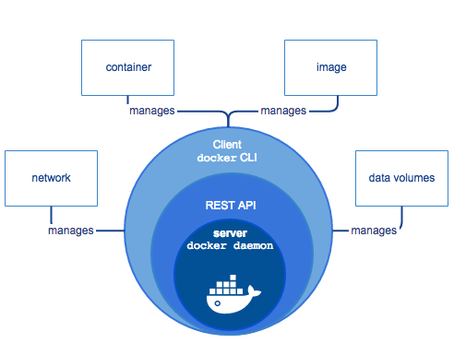
Docker works on a Client–Server Architecture:
🔹 Main Components:
- Docker Client
  - CLI (docker build, docker run)
  - Sends commands to Docker Daemon
- Docker Daemon (dockerd)
  - Runs in background
  - Builds images
  - Runs containers
  - Manages networks & volumes
- Docker Registry
  - Stores Docker images
  - Example: Docker Hub
  - Can also use private registries
- Docker Objects
  - Images
  - Containers
  - Volumes
  - Networks

⚙️ 2️⃣ How Docker Actually Works Internally
Docker uses Linux Kernel Features:
🔹 a) Namespaces (Isolation)
Namespaces isolate:
- Process IDs (PID)
- Network
- Mount
- Users
- IPC
👉 Each container thinks it has its own OS.

🔹 b) Control Groups (cgroups)
- Limit CPU
- Limit Memory
- Limit Disk I/O
👉 Prevents one container from consuming all resources.

🔹 c) Union File System (Layered FS)
Docker images are built in layers.
Example:
Ubuntu Base Layer
+ Java Layer
+ Application Layer
If you update the app → only top layer changes.
👉 Saves space & speeds up builds.

📦 3️⃣ Docker Workflow (Step-by-Step)
Step 1: Write Dockerfile
Example:
FROM ubuntu
RUN apt update
RUN apt install nginx -y
CMD ["nginx", "-g", "daemon off;"]

Step 2: Build Image
docker build -t myapp .
👉 Creates an Image

Step 3: Store Image in Registry (Optional)
docker push myapp
Push to:
- Docker Hub
- Private registry
- Cloud registry

Step 4: Run Container
docker run -d -p 80:80 myapp
👉 Docker:
- Checks image locally
- If not present → pulls from registry
- Creates container
- Applies namespaces & cgroups
- Starts application process

🔄 4️⃣ What Happens When You Run docker run?
Internally:
- Docker Client sends request to Daemon.
- Daemon checks image.
- Creates writable container layer.
- Allocates:
  - Network interface
  - IP address
  - CPU & Memory limits
- Executes the entrypoint process.
- Container runs as a process in host OS.
👉 Container = Just a Process with Isolation.

🌐 5️⃣ Docker Networking
Docker creates:
- Bridge Network (default)
- Host Network
- Overlay Network (for Swarm / multi-host)
Each container gets:
- Private IP
- Virtual network interface

💾 6️⃣ Docker Storage
Containers are temporary (ephemeral).
For persistent data:
- Use Volumes
- Bind Mounts
Example:
docker run -v myvolume:/data myapp

🧠 7️⃣ Docker vs VM (How It Differs Internally)

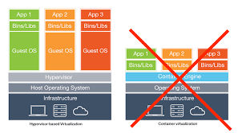
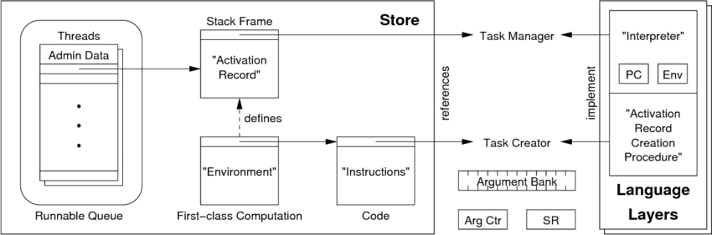
Virtual Machine | Docker Container
Has full OS | Shares host OS
Heavy | Lightweight
Boots in minutes | Starts in seconds
Uses Hypervisor | Uses Docker Engine

🎯 Simple Interview Explanation (3–4 Lines)
Docker works using a client-server architecture where the Docker client communicates with the Docker daemon to build and run containers. It uses Linux kernel features like namespaces for isolation and cgroups for resource management. Containers share the host OS kernel but run as isolated processes, making them lightweight and fast compared to virtual machines.
6. What Are the Problems with Docker?
Since you're preparing for DevOps interviews, here’s a structured and practical explanation 👇
❌ 1️⃣ Security Risks
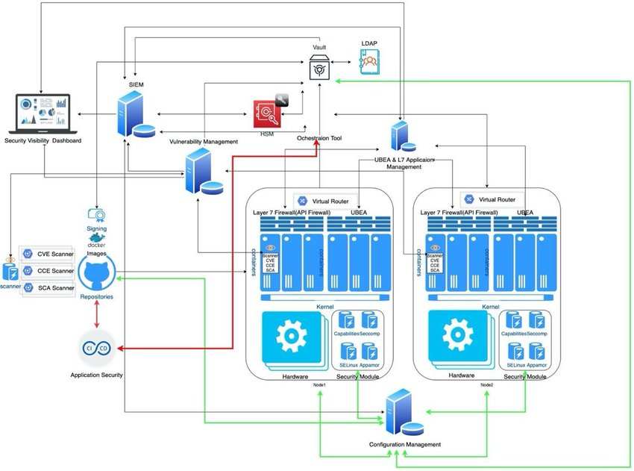
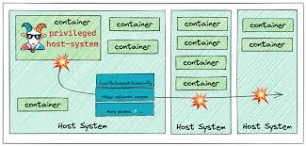
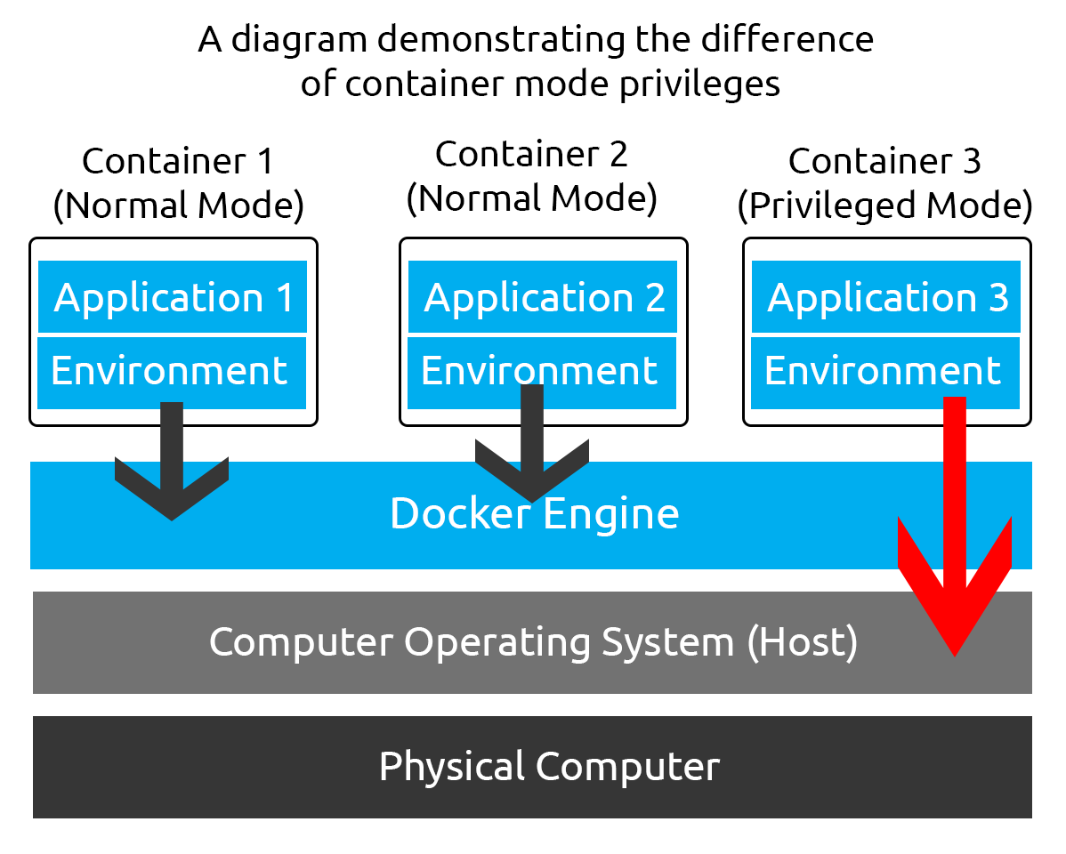
- Containers share the host OS kernel.
- If kernel is compromised → all containers are affected.
- Running containers in privileged mode is risky.
- Container escape vulnerabilities can occur.
👉 Less secure than Virtual Machines in strict isolation environments.

❌ 2️⃣ Not Full OS Virtualization
Docker containers:
- Do NOT have their own full OS.
- Cannot run different OS kernels (e.g., Windows container on Linux host easily).
👉 Unlike VMs, you can’t run completely different operating systems freely.

❌ 3️⃣ Persistent Storage Challenges
- Containers are ephemeral (temporary).
- Data is lost if container is deleted.
- Requires volumes, bind mounts, or external storage.
👉 Managing stateful apps (like databases) can be complex.

❌ 4️⃣ Complex Networking
- Container-to-container communication needs proper configuration.
- Port conflicts may occur.
- Multi-host networking is complex without orchestration.
Usually requires tools like:
- Kubernetes
- Docker Swarm

❌ 5️⃣ Learning Curve
Docker alone is simple, but real-world usage includes:
- Dockerfiles optimization
- Networking
- Volumes
- Security hardening
- Image scanning
👉 DevOps engineers must understand many concepts deeply.

❌ 6️⃣ Large Image Sizes
- Poorly written Dockerfiles create large images.
- Large images:
  - Slow CI/CD
  - Slow deployment
  - Higher storage cost

❌ 7️⃣ Monitoring & Logging Issues
- Containers are short-lived.
- Logs disappear if not centralized.
- Requires external tools (ELK, Prometheus, etc.)

❌ 8️⃣ Orchestration Dependency in Production
Running few containers → Easy
Running 1000+ containers → Complex
Requires orchestration platforms like:
- Kubernetes
👉 Adds operational complexity.

🎯 Short Interview Answer (2–3 Lines)
Docker’s main problems include security concerns due to shared kernel, difficulty in managing persistent storage, complex networking in large-scale environments, and the need for orchestration tools like Kubernetes for production deployments.

7. Explain Container lifecycle?
📦 Container Lifecycle (Docker)
Understanding the container lifecycle is very important for DevOps interviews and real-time troubleshooting.

🔄 1️⃣ Overview of Container Lifecycle
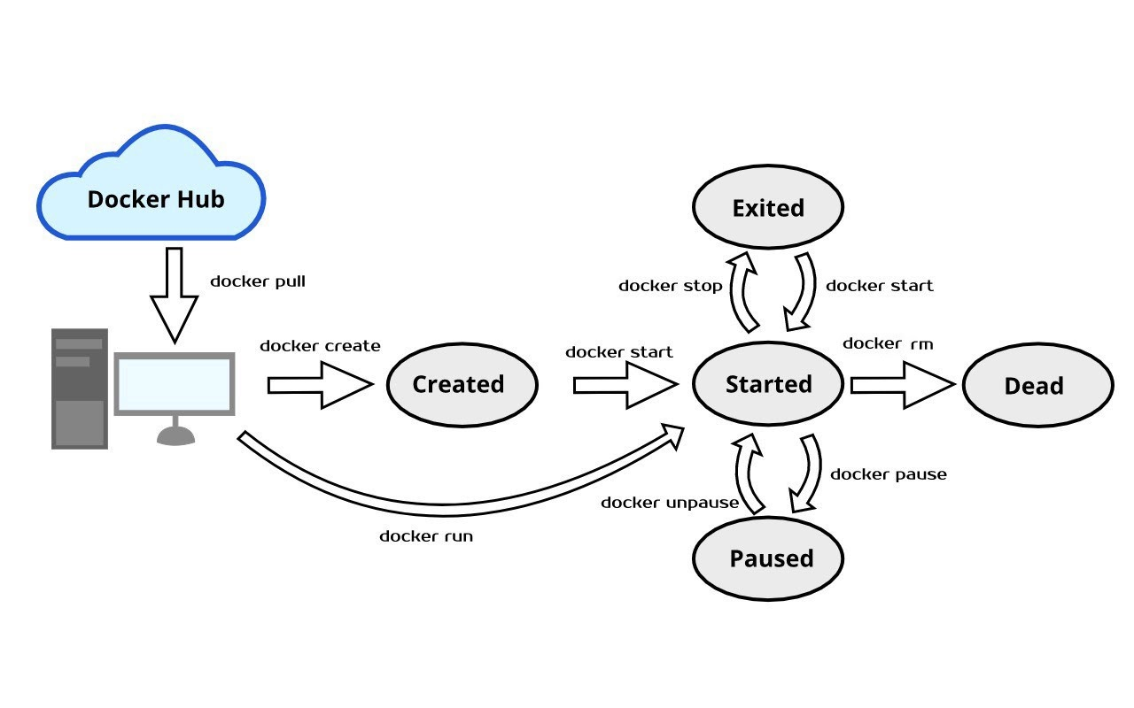
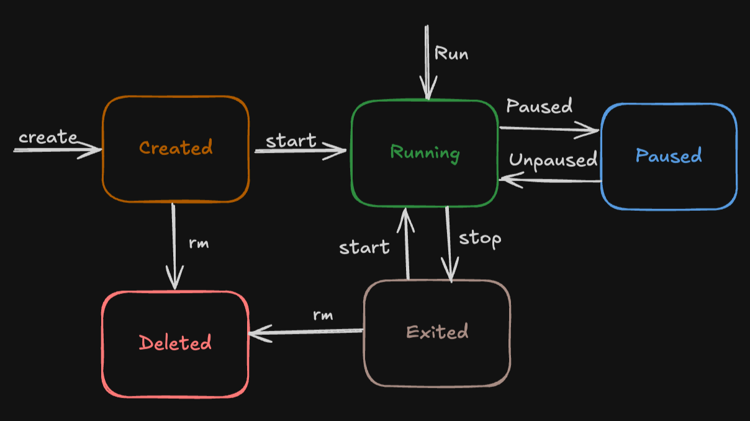

4
A container goes through these main states:
Created → Running → Paused → Stopped → Removed

🧱 2️⃣ Stage-by-Stage Explanation

1️⃣ Created State
Command:
docker create nginx
- Container is created from an image.
- Filesystem + metadata are prepared.
- Container is NOT started yet.
👉 Status: Created

2️⃣ Running State
Command:
docker start <container_id>
OR
docker run nginx
What happens internally:
- Namespaces are applied (process isolation)
- cgroups applied (resource limits)
- Network assigned (IP, bridge)
- Main process (PID 1) starts
👉 Status: Running
💡 Important:
If the main process stops → container stops.

3️⃣ Paused State
Command:
docker pause <container_id>
- Freezes all processes.
- Uses Linux freezer cgroup.
- CPU usage becomes zero.
To resume:
docker unpause <container_id>
👉 Status: Paused

4️⃣ Stopped (Exited) State
Command:
docker stop <container_id>
What happens:
- Sends SIGTERM signal
- Waits (default 10 seconds)
- Then sends SIGKILL if needed
👉 Status: Exited
💡 Data still exists unless container is removed.

5️⃣ Removed (Deleted) State
Command:
docker rm <container_id>
- Container metadata removed.
- Writable layer deleted.
- Volumes remain (if external).
👉 Status: Deleted

📊 Complete Lifecycle Flow
docker build → Image created
docker create → Container created
docker start → Running
docker pause → Paused
docker stop → Stopped
docker rm → Removed

🔁 Extra States (Production Level Knowledge)
🔹 Restarting
docker restart container
Stops and starts again.
🔹 Dead
If container fails unexpectedly and cannot recover.
🔹 Restart Policies
docker run --restart=always nginx
Options:
- no
- on-failure
- always
- unless-stopped

🧠 Important Concept
👉 Container lifecycle depends on main process (PID 1).
If PID 1 exits → container stops.
Example:
docker run ubuntu
It exits immediately because no foreground process is running.

🎯 Interview 3–4 Line Answer
A container lifecycle includes states like Created, Running, Paused, Stopped, and Removed. A container is created from an image, runs as an isolated process, and stops when its main process exits. It can be paused, restarted, or removed based on operational needs.

8.What is a Docker file?
🔷 Definition
A Dockerfile is a text file that contains a set of instructions used by Docker to automatically build a Docker image.
👉 It defines:
- Base image
- Application dependencies
- Configuration
- Startup command
Think of it as a blueprint to create a Docker image.

🏗️ How Dockerfile Works

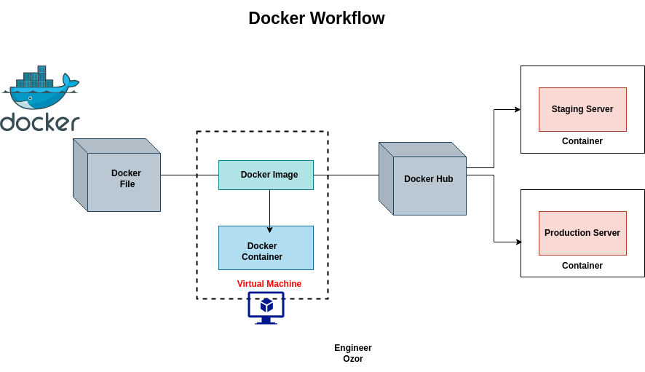

Workflow:
Dockerfile → docker build → Docker Image → docker run → Container
When you run:
docker build -t myapp .
Docker:
- Reads Dockerfile
- Executes instructions line-by-line
- Creates image layers
- Builds final image

📄 Basic Structure of a Dockerfile
Example:
# Base image
FROM ubuntu:22.04

# Install dependencies
RUN apt update && apt install -y nginx

# Copy application files
COPY . /app

# Set working directory
WORKDIR /app

# Expose port
EXPOSE 80

# Default command
CMD ["nginx", "-g", "daemon off;"]

🔑 Important Dockerfile Instructions
Instruction | Purpose
FROM | Base image (mandatory)
RUN | Execute command during build
COPY | Copy files into image
ADD | Copy + extra features (rarely used)
WORKDIR | Set working directory
ENV | Set environment variable
EXPOSE | Define port
CMD | Default command when container runs
ENTRYPOINT | Fixed executable command

🧱 Docker Image Layers Concept
Each Dockerfile instruction creates a layer.
Example:
Layer 1 → Ubuntu
Layer 2 → Install Java
Layer 3 → Copy App
Layer 4 → Start App
👉 If only app code changes → only top layer rebuilds.
This makes builds faster.

🎯 Real-Time DevOps Example
For a Java application:
FROM openjdk:17
COPY target/app.jar app.jar
CMD ["java", "-jar", "appa.jr"]
Used in:
- CI/CD pipeline
- Microservices deployment
- Kubernetes clusters

⚠️ Best Practices
- Use small base images (like alpine)
- Combine RUN commands to reduce layers
- Avoid storing secrets in Dockerfile
- Use .dockerignore

🎤 Interview 3–4 Line Answer
A Dockerfile is a text file containing instructions to build a Docker image. It defines the base image, dependencies, application code, and startup command. Docker reads the Dockerfile step-by-step to create layered images that can be run as containers.
9. List the most commonly used instructions in Dockerfile?
🐳 Most Commonly Used Dockerfile Instructions
A Dockerfile is used by Docker to build container images. Below are the most frequently used instructions you must know for interviews and real-time DevOps work.

🧱 Dockerfile Build Flow
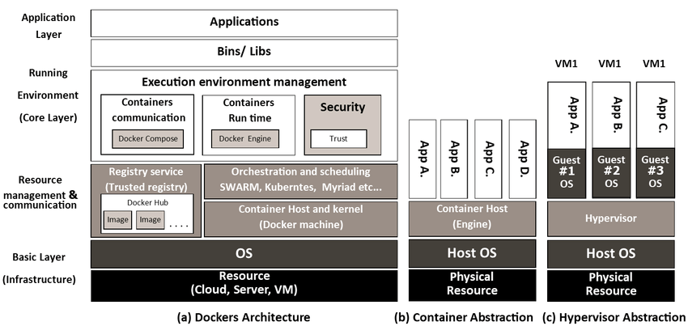
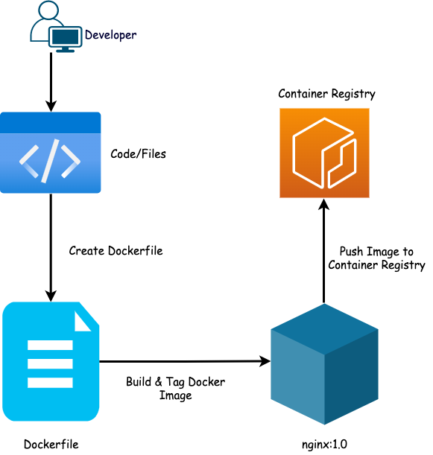
4
Each instruction creates a layer in the image (except a few like CMD, ENTRYPOINT).

📋 1️⃣ FROM
👉 Defines the base image (Mandatory instruction).
FROM ubuntu:22.04
- Must be the first instruction.
- Can use official images like nginx, node, openjdk.

📋 2️⃣ RUN
👉 Executes commands during image build.
RUN apt update && apt install -y nginx
- Used to install packages.
- Creates a new layer.

📋 3️⃣ COPY
👉 Copies files from local system to image.
COPY . /app
- Preferred over ADD for simple file copying.

📋 4️⃣ ADD
👉 Similar to COPY but with extra features.
ADD app.tar.gz /app
- Can extract tar files automatically.
- Can download from URL (not recommended).

📋 5️⃣ WORKDIR
👉 Sets working directory inside container.
WORKDIR /app
- All next commands run inside this directory.

📋 6️⃣ CMD
👉 Default command when container starts.
CMD ["nginx", "-g", "daemon off;"]
- Can be overridden at runtime.

📋 7️⃣ ENTRYPOINT
👉 Defines main executable.
ENTRYPOINT ["java", "-jar", "app.jar"]
- Harder to override than CMD.

📋 8️⃣ EXPOSE
👉 Documents which port container uses.
EXPOSE 8080
- Informational only (does not publish port).

📋 9️⃣ ENV
👉 Sets environment variables.
ENV APP_ENV=production

📋 🔟 VOLUME
👉 Creates mount point for persistent storage.
VOLUME /data

📋 1️⃣1️⃣ USER
👉 Specifies which user to run container as.
USER appuser
- Improves security.

📋 1️⃣2️⃣ ARG
👉 Defines build-time variable.
ARG VERSION=1.0
Used with:
docker build --build-arg VERSION=2.0 .

🎯 Most Important for Interviews
If interviewer asks “most commonly used”, say:
FROM, RUN, COPY, WORKDIR, CMD, ENTRYPOINT, ENV, EXPOSE

🎤 2–3 Line Interview Answer
The most commonly used Dockerfile instructions are FROM, RUN, COPY, WORKDIR, CMD, ENTRYPOINT, ENV, and EXPOSE. These instructions define the base image, install dependencies, copy application code, configure environment variables, and specify how the container should start.

11. How Will You Launch Multiple Applications at a Time in Docker?
In real-world DevOps, we usually run multiple services like:
- Frontend
- Backend
- Database
- Cache
There are 3 main ways to launch multiple applications in Docker 👇

✅ 1️⃣ Using Docker Compose (Recommended)
👉 Best and most common method.
Docker Compose allows you to define multiple containers in a single docker-compose.yml file.

📄 Example: docker-compose.yml
version: '3'
services:
web:
image: nginx
ports:
- "80:80"

app:
image: node:18
working_dir: /app
volumes:
- .:/app
command: node app.js

db:
image: mysql:8
environment:
MYSQL_ROOT_PASSWORD: root

▶️ Run All Services
docker-compose up -d
👉 This will:
- Create network
- Start all containers
- Connect them together

📊 How It Works
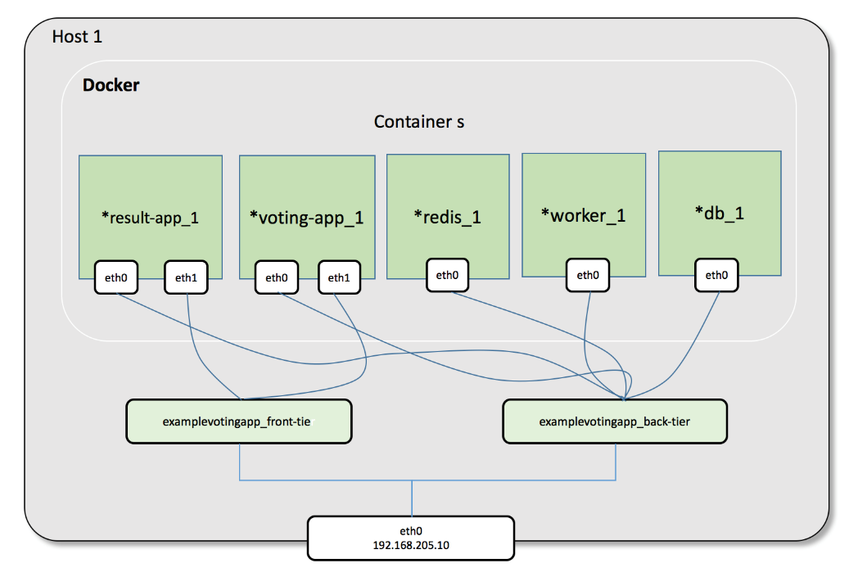
- All services run in same default network
- Containers communicate using service name
- Easy to scale (docker-compose up --scale web=3)

✅ 2️⃣ Using Multiple docker run Commands
You can manually start multiple containers:
docker run -d --name db mysql
docker run -d --name app node
docker run -d --name web nginx
👉 But:
- Hard to manage
- No automatic networking
- Not scalable
Used mostly for testing.

✅ 3️⃣ Using Orchestration (Production Level)
For large-scale production environments, use:
- Kubernetes
- Docker Swarm
These allow:
- Auto scaling
- Load balancing
- Self-healing
- Rolling updates

🧠 Best Practice Answer (Interview)
To launch multiple applications in Docker, I use Docker Compose, where multiple services are defined in a docker-compose.yml file and started together using docker-compose up. In production environments, we use orchestration tools like Kubernetes for better scalability and management.

🎯 Real-Time Example (DevOps)
For a microservices project:
- React frontend
- Spring Boot backend
- MySQL database
All managed in one compose file → easy local development.

12. What is Multi-Stage Docker Build?
A Multi-Stage Build is a feature in Docker that allows you to use multiple FROM statements in one Dockerfile to separate the build environment from the runtime environment.
👉 Goal: Reduce image size, improve security, and keep only required files in the final image.

🏗️ Why We Need Multi-Stage Builds?
Without multi-stage:
- Build tools (Maven, Node, GCC) remain inside the final image
- Image becomes large
- Security risk increases
With multi-stage:
- First stage → Build application
- Second stage → Copy only required artifact (e.g., JAR file)
- Final image is lightweight

🔄 How It Works
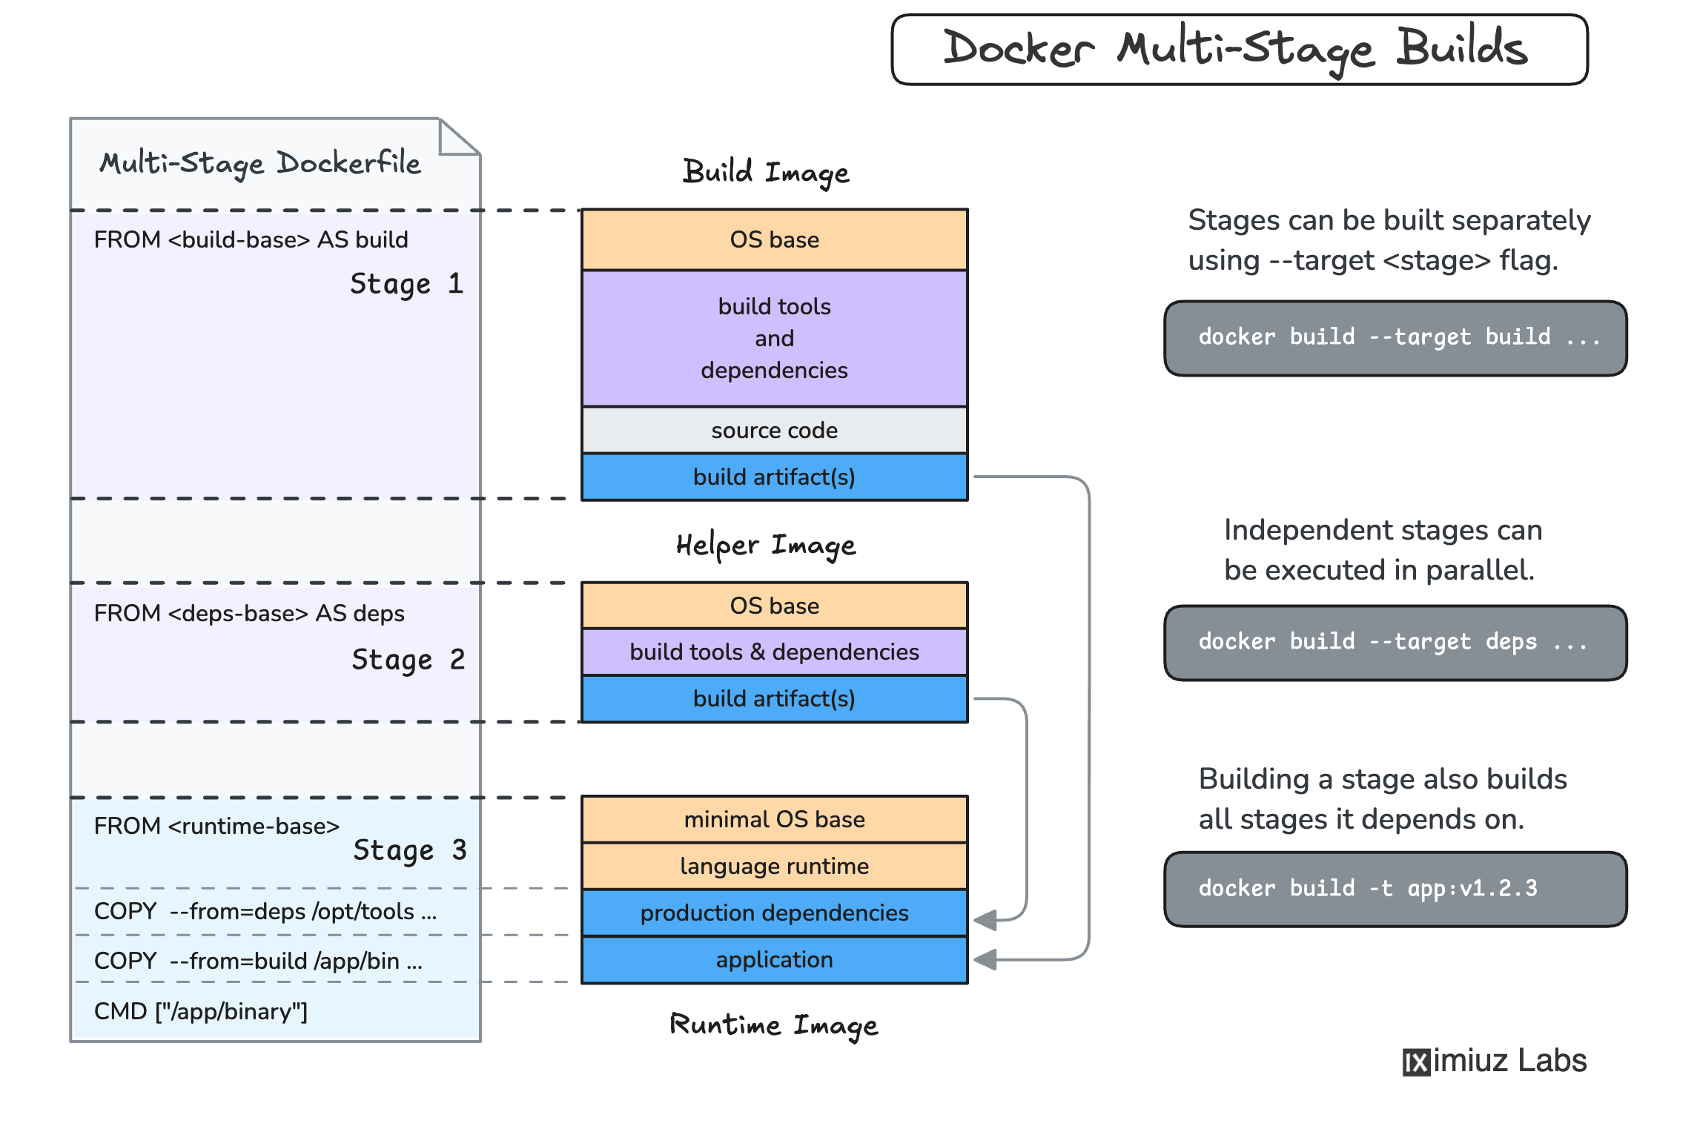
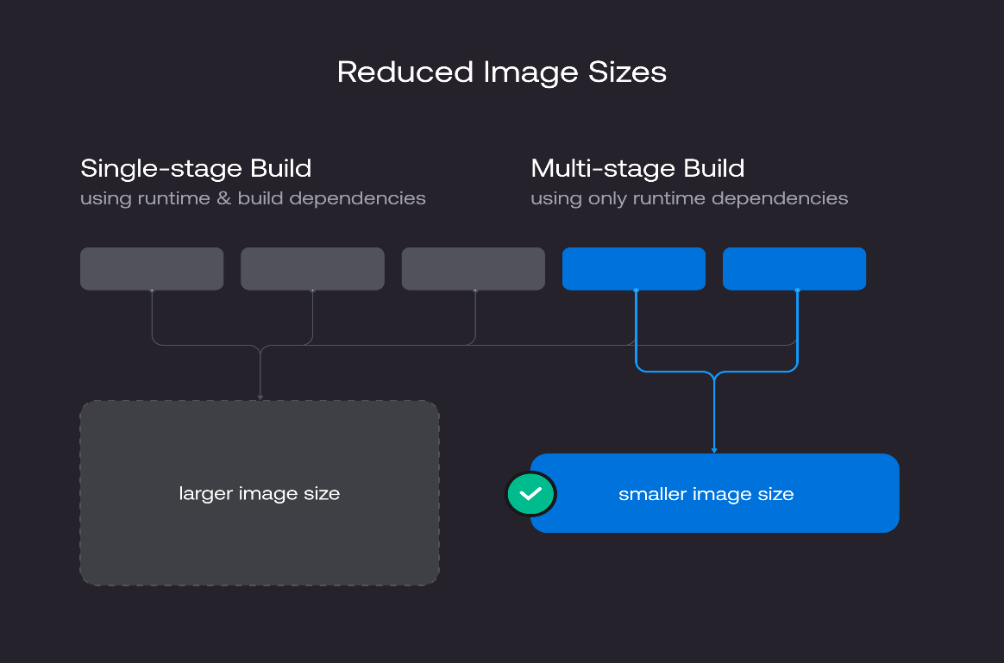
Flow:
Stage 1 → Build application
Stage 2 → Copy only build output
Final → Small & optimized image

📄 Example 1: Java Application (Maven)
# Stage 1: Build
FROM maven:3.9-jdk-17 AS builder
WORKDIR /app
COPY . .
RUN mvn clean package

# Stage 2: Runtime
FROM openjdk:17-jdk-slim
WORKDIR /app
COPY --from=builder /app/target/app.jar app.jar
CMD ["java", "-jar", "app.jar"]
👉 Result:
- Final image does NOT contain Maven.
- Only contains JAR file + JDK.

📄 Example 2: Node.js Application
# Build Stage
FROM node:18 AS build
WORKDIR /app
COPY package*.json ./
RUN npm install
COPY . .
RUN npm run build

# Production Stage
FROM nginx:alpine
COPY --from=build /app/dist /usr/share/nginx/html
👉 Final image contains only static files + Nginx.

🔑 Key Concept: AS Keyword
FROM maven:3.9-jdk-17 AS builder
- Names the stage
- Used with:
COPY --from=builder

🚀 Benefits of Multi-Stage Build
✅ Smaller image size
✅ Faster deployments
✅ Better security
✅ Cleaner production images
✅ No unnecessary dependencies

⚠️ Real-Time DevOps Impact
Before multi-stage:
- Image size = 1GB
After multi-stage:
- Image size = 150MB
👉 Huge improvement in CI/CD pipeline speed.

🎤 Interview 3–4 Line Answer
Multi-stage Docker build allows us to use multiple FROM statements in a single Dockerfile to separate build and runtime environments. The first stage builds the application, and the final stage copies only the required artifacts, resulting in smaller, secure, and optimized images.

13. What is a Docker Image?
A Docker Image is a read-only template used to create containers in Docker.
👉 It contains:
- Application code
- Runtime (Java, Node, Python, etc.)
- Libraries & dependencies
- Environment variables
- Configuration files
Think of it as a blueprint, and a container is the running instance of that blueprint.

🏗️ How Docker Image Works




Flow:
Dockerfile → docker build → Docker Image → docker run → Container
- Dockerfile defines instructions
- docker build creates an image
- docker run creates a container from the image

🧱 Key Characteristics of Docker Image
1️⃣ Read-Only
- Image cannot be modified once built.
- When container runs → a writable layer is added on top.

2️⃣ Layered Structure
Each Dockerfile instruction creates a layer.
Example:
Layer 1 → Ubuntu
Layer 2 → Install Java
Layer 3 → Copy App
Layer 4 → CMD instruction
👉 If only the app changes → only top layer rebuilds.

3️⃣ Stored in Registry
Images are stored in registries like:
- Docker Hub
- Private registry
- Cloud container registry
Example:
docker pull nginx
docker push myimage

📦 Example
Pull official Nginx image:
docker pull nginx
Run container:
docker run -d -p 80:80 nginx
Here:
- nginx = Image
- Running instance = Container

🔁 Image vs Container
Docker Image | Docker Container
Blueprint | Running instance
Read-only | Writable
Static | Dynamic
Stored in registry | Runs on host

🎯 Real-Time DevOps Usage
- Build image in CI pipeline
- Push to registry
- Deploy image to Kubernetes / production servers

🎤 Interview 3–4 Line Answer
A Docker image is a read-only template that contains application code, runtime, libraries, and dependencies required to run an application. It is built using a Dockerfile and used to create containers. Containers are running instances of Docker images.

14. Difference Between Docker Image & Docker Layers
Understanding this clearly is important for DevOps interviews 👇

🖼️ What is a Docker Image?
A Docker Image is a read-only template used to create containers in Docker.
It contains:
- Application code
- Runtime (Java/Node/Python etc.)
- Libraries
- Dependencies
- Configuration
👉 Image = Final packaged application.

🧱 What are Docker Layers?
Docker Layers are intermediate, read-only filesystem layers that make up a Docker image.
Each instruction in a Dockerfile creates a new layer.
Example Dockerfile:
FROM ubuntu
RUN apt update
RUN apt install nginx
COPY . /app
CMD ["nginx", "-g", "daemon off;"]
Here:
- FROM → Layer 1
- RUN apt update → Layer 2
- RUN apt install nginx → Layer 3
- COPY → Layer 4
- CMD → Metadata layer
All combined = Docker Image

🏗️ Visual Explanation

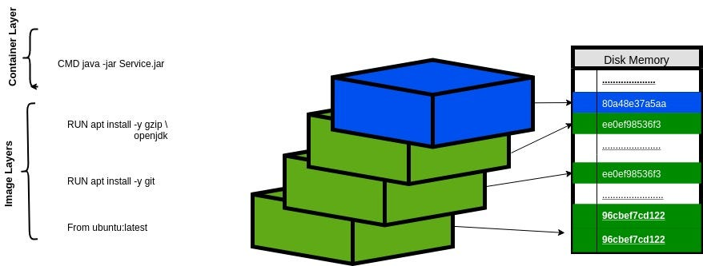
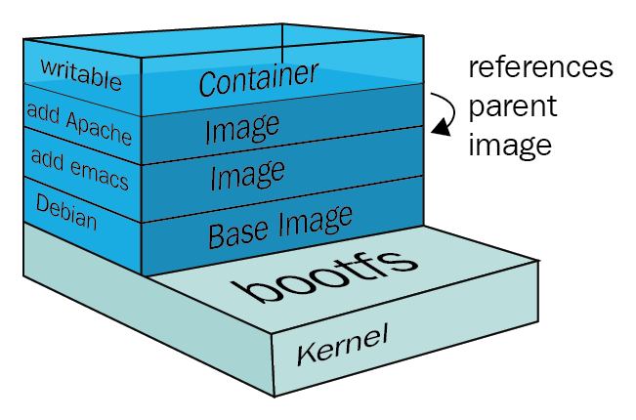
👉 Image is built as stacked layers using Union File System.

📊 Key Differences
Docker Image | Docker Layers
Complete packaged application | Individual building blocks of image
Used to create containers | Created from each Dockerfile instruction
Stored in registry | Stored internally as filesystem layers
Combination of multiple layers | Single read-only filesystem layer
Example: nginx:latest | Example: Base layer, Install layer, App layer

🧠 Important Concept
👉 Docker uses Union File System (OverlayFS)
👉 Layers are cached
👉 If only one instruction changes → only that layer rebuilds
Example:
If you change only application code → only COPY layer rebuilds.
This improves:
- Build speed
- Storage efficiency
- CI/CD performance

🎯 Simple Interview Answer (3–4 Lines)
A Docker image is a read-only template used to create containers, while Docker layers are the individual filesystem layers that make up that image. Each Dockerfile instruction creates a new layer, and all layers combined form the final Docker image.

15. Explain Docker volume and its types?
Docker Volume & Its Types
In Docker, a Volume is used to store data persistently outside the container’s writable layer.
👉 By default, containers are ephemeral (data is lost when container is removed).
👉 Volumes ensure data survives container restarts or deletion.

📦 Why Docker Volume is Needed?
Without volume:
Container deleted → Data lost ❌
With volume:
Container deleted → Data safe ✅
Common use cases:
- Databases (MySQL, PostgreSQL)
- Logs
- Upload files
- Shared data between containers

🏗️ How Docker Volume Works

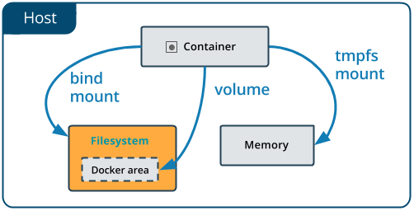
👉 Volume is mounted from host into container.
👉 Stored in /var/lib/docker/volumes/ (Linux default).
👉 Managed by Docker.

📌 Types of Docker Storage
There are 3 types:

1️⃣ Named Volume (Recommended)
Managed by Docker.
Create Volume:
docker volume create myvolume
Use Volume:
docker run -d -v myvolume:/data nginx
✔ Managed by Docker
✔ Easy backup
✔ Portable
✔ Best for production

2️⃣ Bind Mount
Mounts a specific host directory.
docker run -d -v /home/udaya/data:/app/data nginx
✔ Direct host access
✔ Useful for development
❌ Less portable
❌ Security risk if misconfigured

3️⃣ Anonymous Volume
Created automatically when path specified without name.
docker run -v /data nginx
✔ Quick temporary storage
❌ Hard to manage
❌ Not recommended for production

📊 Comparison Table
Feature | Named Volume | Bind Mount |  | Anonymous Volume
Managed by Docker | ✅ Yes |  | ❌ No | ✅ Yes
Production Ready | ✅ Yes |  | ⚠ Depends | ❌ No
Portable | ✅ Yes |  | ❌ No | ❌ No
Easy to Backup | ✅ Yes |  | ⚠ Manual | ❌ No

🔐 Volume vs Container Writable Layer
Writable Layer | Volume
Deleted with container | Persistent
Not shared easily | Can be shared
Slower performance | Better performance

🎯 Real-Time Example (Database)
docker run -d \
--name mysql-db \
-e MYSQL_ROOT_PASSWORD=root \
-v mysql-data:/var/lib/mysql \
mysql:8
Even if container is deleted → database data remains.

🎤 Interview 3–4 Line Answer
A Docker volume is a persistent storage mechanism used to store data outside a container’s writable layer. It ensures data remains even if the container is deleted. The three types are Named Volumes, Bind Mounts, and Anonymous Volumes, with named volumes being recommended for production use.

16. Docker Networks & Its Types
In Docker, Docker Networking allows containers to communicate:
- With other containers
- With the host machine
- With external networks (internet)
Every container gets:
- Its own IP address
- Virtual network interface
- DNS-based service discovery

🏗️ How Docker Networking Works
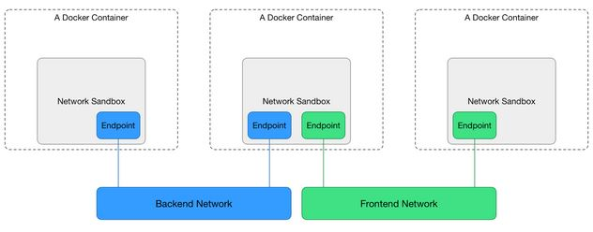
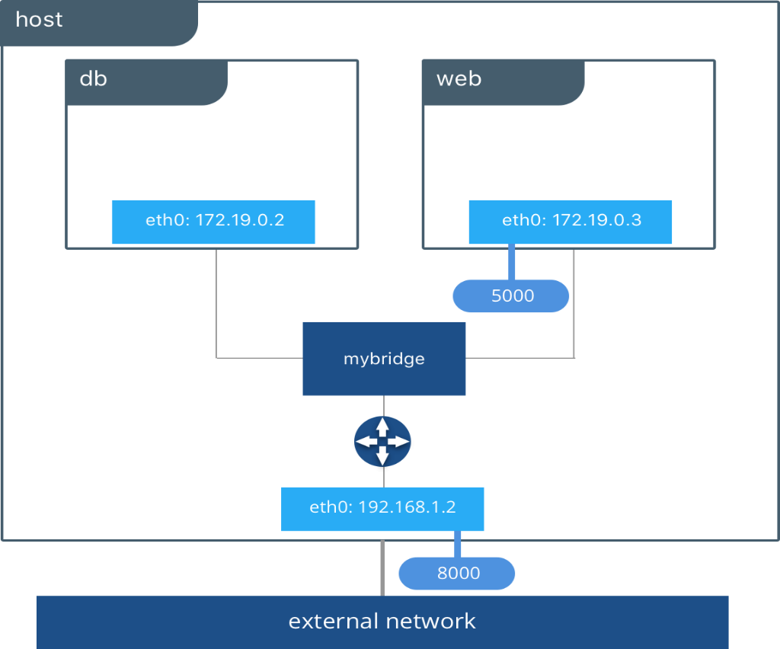
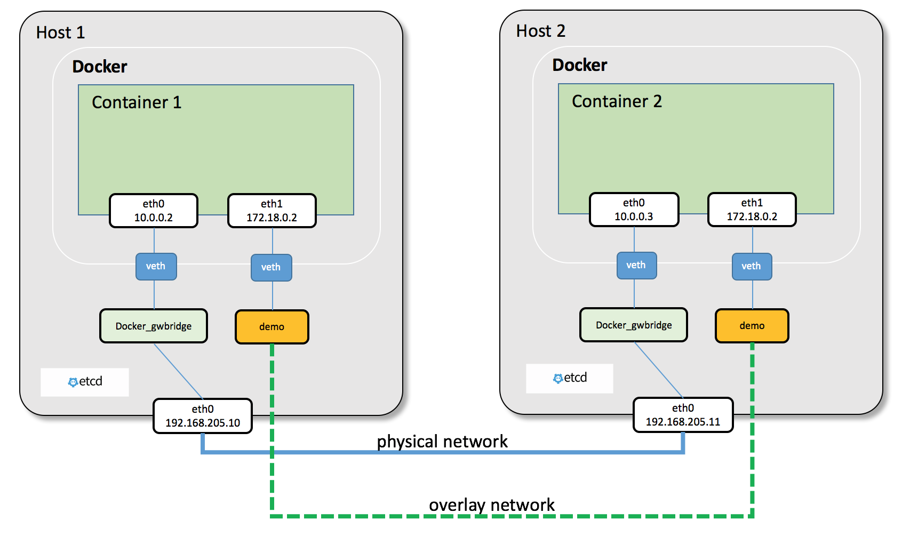
👉 Docker creates a virtual network layer on top of the host OS.
👉 By default, it creates a bridge network.
Check networks:
docker network ls

📌 Types of Docker Networks
There are 5 main types:

1️⃣ Bridge Network (Default)
- Default network for containers.
- Used when running containers on a single host.
- Containers can communicate using container name (if on same network).
Example:
docker run -d --name web nginx
docker run -d --name app busybox
Default bridge = bridge
✔ Most commonly used
✔ Good for single-host communication

2️⃣ Host Network
Container shares the host’s network stack.
docker run --network host nginx
- No separate container IP
- Uses host IP directly
- Better performance
- Less isolation
✔ Low latency
❌ Not secure for multi-tenant systems

3️⃣ None Network
Disables networking completely.
docker run --network none nginx
- No internet
- No communication
- Fully isolated
✔ High security
✔ Used for batch jobs

4️⃣ Overlay Network
Used for multi-host communication.
- Required for:
  - Docker Swarm
  - Kubernetes
✔ Containers across different hosts communicate
✔ Used in production clusters

5️⃣ Macvlan Network
Assigns a real MAC address to container.
- Container appears as a physical device on network.
- Used in legacy systems or special network setups.
✔ Direct communication with external network
❌ Advanced configuration

📊 Network Comparison Table
Network Type | Use Case | Isolation | Multi-Host
Bridge | Default single host | ✅ Yes | ❌ No
Host | High performance | ❌ No | ❌ No
None | No networking | ✅ Full | ❌ No
Overlay | Swarm / Cluster | ✅ Yes | ✅ Yes
Macvlan | Legacy integration | ⚠ Medium | ❌ Mostly No

🧠 Important Concepts
🔹 DNS-Based Service Discovery
In same network:
ping app
Docker resolves container name automatically.

🔹 Custom Network (Best Practice)
docker network create mynetwork
docker run -d --network mynetwork nginx
✔ Better isolation
✔ Clean microservices communication

🎯 Real-Time DevOps Example
For a 3-tier app:
- Frontend container
- Backend container
- Database container
All connected via custom bridge network.
Database not exposed to public internet.

🎤 Interview 3–4 Line Answer
Docker networking enables communication between containers, the host, and external networks. The main network types are Bridge (default), Host, None, Overlay (for multi-host), and Macvlan. Bridge is commonly used for single-host setups, while Overlay is used in clustered environments.

17. What is the Default Docker Container IP?
In Docker, when you run a container using the default bridge network, Docker automatically assigns a private IP address.

✅ Default Docker Bridge Network IP Range
By default, Docker creates a bridge network called:
bridge
This bridge usually has the subnet:
172.17.0.0/16
So containers typically get IPs like:
172.17.0.2
172.17.0.3
172.17.0.4
👉 The first container often gets:
172.17.0.2
(The host bridge interface itself is usually 172.17.0.1)

🏗️ How It Looks Internally
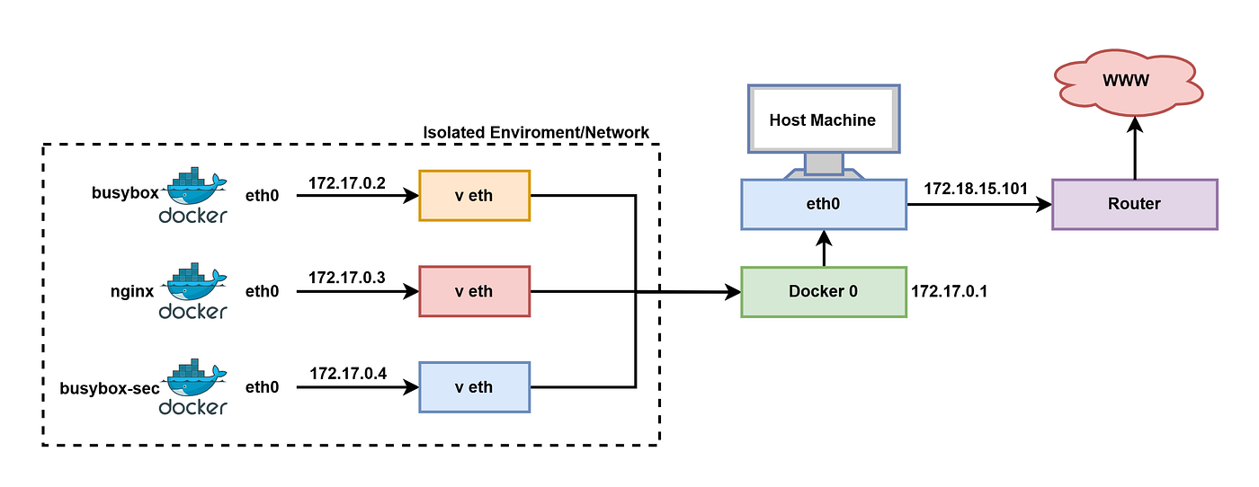
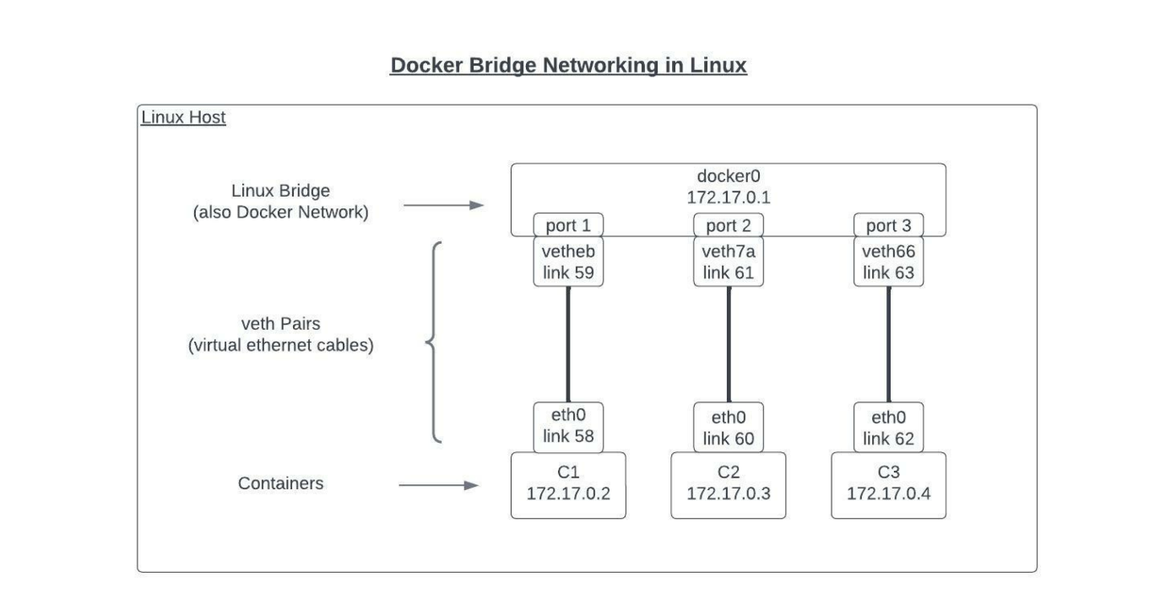
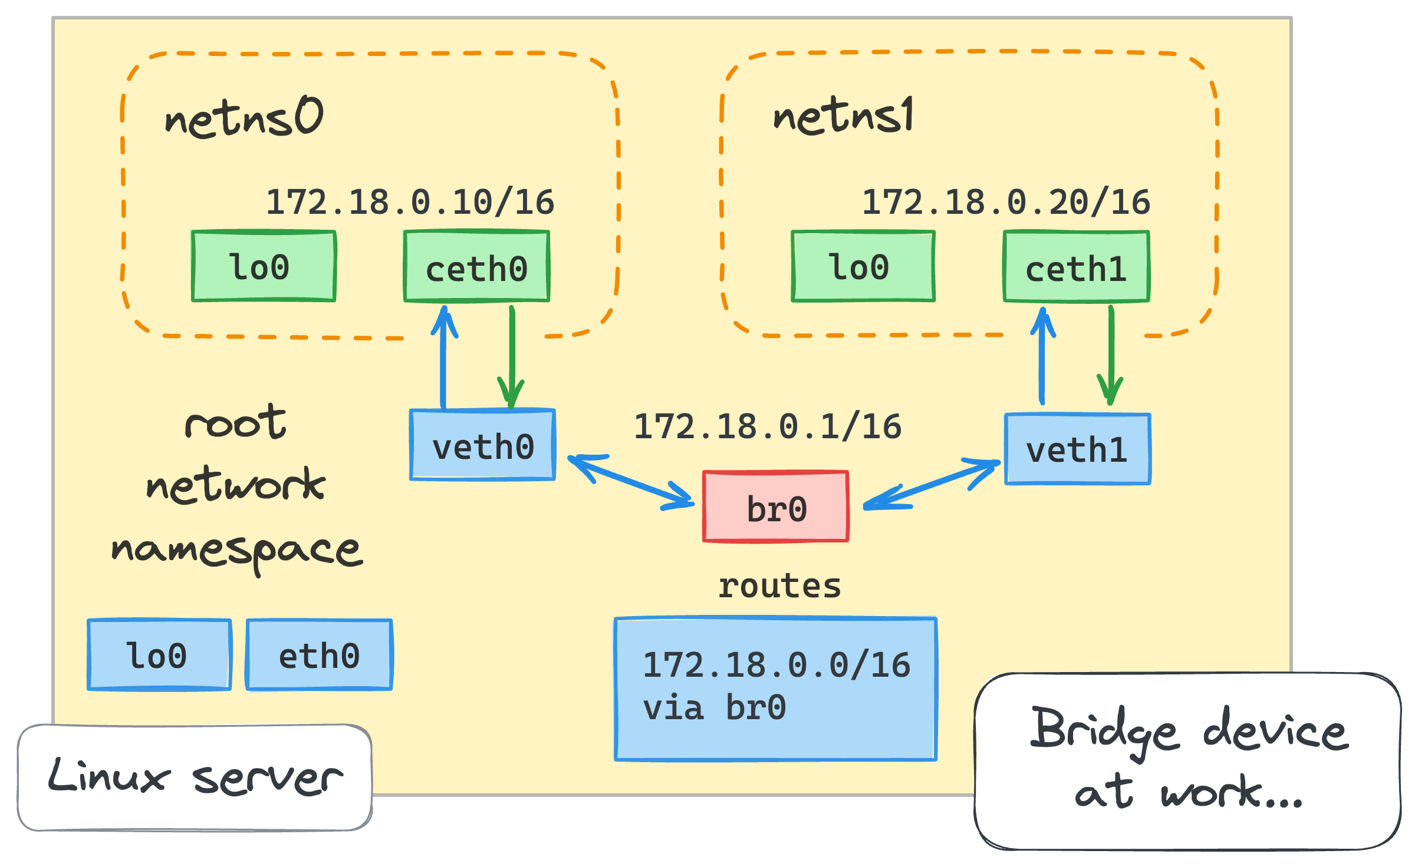
- Docker creates a virtual bridge: docker0
- Host IP: 172.17.0.1
- Containers connect via virtual ethernet (veth pairs)
- Each container gets a unique IP from the subnet

🔎 How to Check Container IP
1️⃣ List Networks
docker network ls
2️⃣ Inspect Bridge Network
docker network inspect bridge
3️⃣ Check Specific Container IP
docker inspect <container_id>
Look for:
"IPAddress": "172.17.0.2"

⚠️ Important Points
- This IP is internal only
- Not accessible from outside unless port is exposed:
docker run -p 80:80 nginx
- In production, we usually use:
  - Custom bridge networks
  - Or orchestration platforms like Kubernetes

🎯 Interview 2–3 Line Answer
By default, Docker containers running on the bridge network get an IP from the 172.17.0.0/16 subnet. The host bridge interface is usually 172.17.0.1, and containers are assigned IPs like 172.17.0.2 internally.

18. How to Assign a Static IP to a Docker Container?
In Docker, you cannot assign a static IP on the default bridge network directly.
To assign a static IP, you must create a custom bridge network.

✅ Method: Using Custom Bridge Network (Recommended)

🏗️ Step 1: Create Custom Network with Subnet
docker network create \
--subnet 192.168.1.0/24 \
mynetwork
Here:
- Network name → mynetwork
- Subnet → 192.168.1.0/24

🚀 Step 2: Run Container with Static IP
docker run -d \
--name mycontainer \
--net mynetwork \
--ip 192.168.1.10 \
nginx
👉 Now container IP will be:
192.168.1.10

🔍 Step 3: Verify IP
docker inspect mycontainer
Look for:
"IPAddress": "192.168.1.10"

🏗️ How It Works Internally
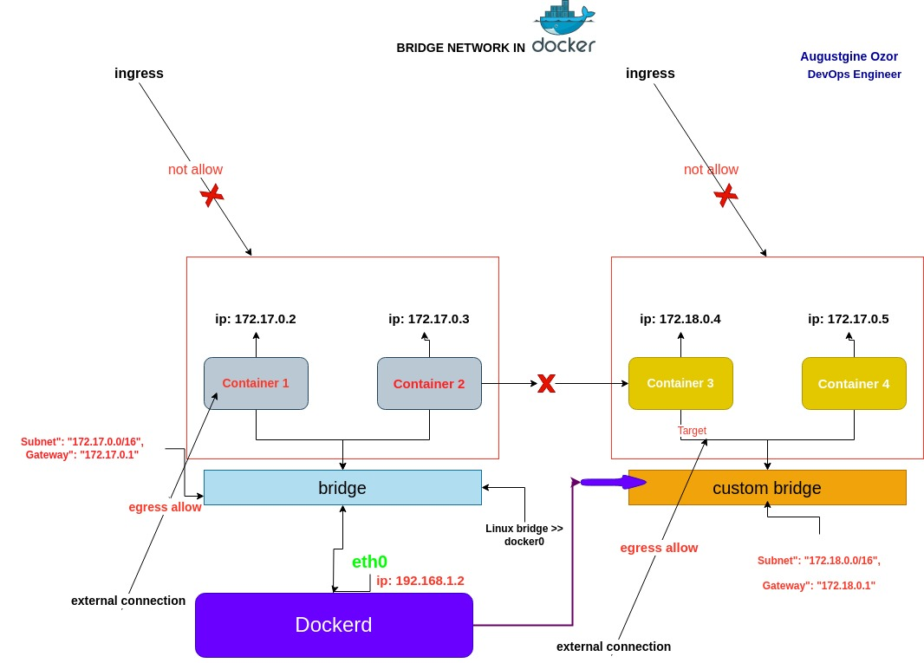
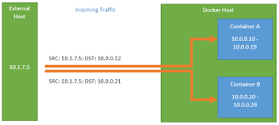
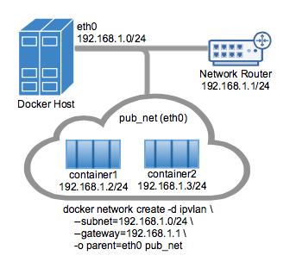
4
- Docker creates isolated bridge
- Containers get IP from defined subnet
- You manually specify IP using --ip

📌 Important Notes
❗ Static IP works only with:
- Custom bridge network
❌ Not supported in:
- Default bridge network
- Host network mode

📦 Using Docker Compose (Static IP)
version: "3"
services:
web:
image: nginx
networks:
mynetwork:
ipv4_address: 192.168.1.20

networks:
mynetwork:
driver: bridge
ipam:
config:
- subnet: 192.168.1.0/24
Run:
docker-compose up -d

⚠️ Best Practice Warning
In production:
- Avoid static IP
- Use container name (DNS resolution)
- Or use service discovery (like in Kubernetes)
Static IP is mainly used for:
- Testing
- Legacy applications
- Special networking needs

🎯 Interview 3–4 Line Answer
To assign a static IP in Docker, I create a custom bridge network with a defined subnet and then use the --ip option while running the container. Static IP assignment is not supported on the default bridge network and is mainly used in special scenarios.

19. How to Change the Default Docker Subnet IP Range?
By default, Docker uses the bridge network with subnet:
172.17.0.0/16
If this conflicts with your corporate network or VPN, you can change it by modifying the Docker daemon configuration.

✅ Method 1: Change Default docker0 Bridge Subnet (Linux)

🛑 Step 1: Stop Docker Service
sudo systemctl stop docker

📝 Step 2: Edit Docker Daemon Configuration
Open or create:
sudo vi /etc/docker/daemon.json
Add:
{
"bip": "192.168.100.1/24"
}
👉 bip = Bridge IP
👉 This sets:
- Bridge IP → 192.168.100.1
- Subnet → 192.168.100.0/24

▶️ Step 3: Restart Docker
sudo systemctl start docker

🔍 Step 4: Verify
docker network inspect bridge
You should now see:
192.168.100.0/24

🏗️ How It Works Internally
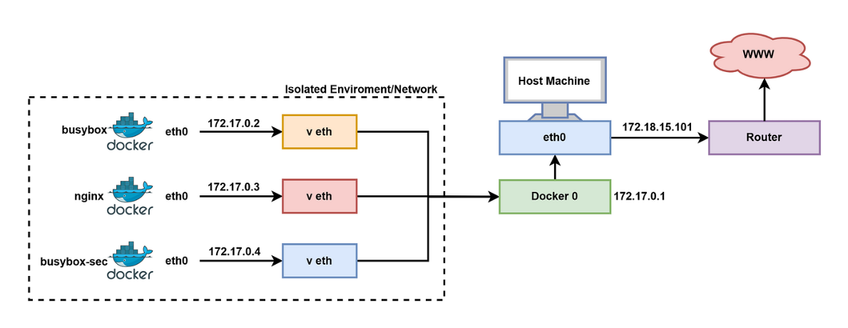
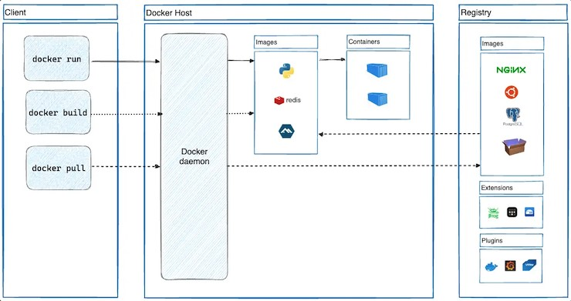
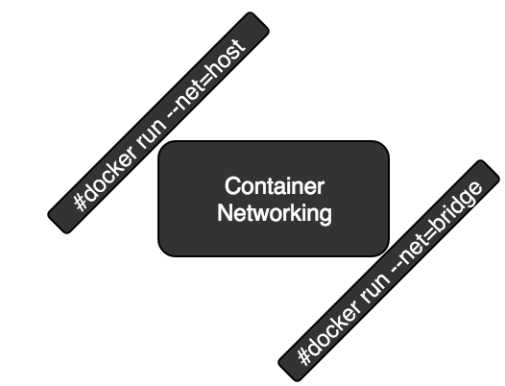
- Docker creates virtual bridge docker0
- bip defines the bridge IP & subnet
- Containers receive IPs from this new subnet

✅ Method 2: Configure Default Address Pools (Recommended for Production)
Instead of changing only bridge, configure address pools:
{
"default-address-pools": [
{
"base": "10.10.0.0/16",
"size": 24
}
]
}
👉 This:
- Allocates new custom networks from 10.10.0.0/16
- Each network gets /24 subnet
Better for:
- Large environments
- Multiple custom networks

⚠️ Important Notes
- Changing subnet requires Docker restart.
- Existing containers must be removed.
- Be careful not to conflict with:
  - Corporate LAN
  - VPN ranges
  - Cloud VPC ranges

🎯 Interview 3–4 Line Answer
To change the default Docker subnet, I modify the /etc/docker/daemon.json file and set the bip parameter or configure default-address-pools, then restart the Docker service. This updates the docker0 bridge network with a new IP range.

20. Will you write one simple dockerfile for java application or python app or nodeJs app?
Sure 👍 I’ll give you 3 simple production-style Dockerfiles (Java, Python, Node.js).
You can use any one in interview depending on the question.

☕ 1️⃣ Simple Dockerfile for Java Application
(Assume you already have app.jar built using Maven/Gradle)
# Use lightweight JDK image
FROM openjdk:17-jdk-slim

# Set working directory
WORKDIR /app

# Copy jar file
COPY app.jar app.jar

# Expose application port
EXPOSE 8080

# Run application
CMD ["java", "-jar", "app.jar"]
🔹 Build & Run
docker build -t java-app .
docker run -d -p 8080:8080 java-app

🐍 2️⃣ Simple Dockerfile for Python Application
(Assume app.py and requirements.txt exist)
FROM python:3.11-slim

WORKDIR /app

COPY requirements.txt .
RUN pip install --no-cache-dir -r requirements.txt

COPY . .

EXPOSE 5000

CMD ["python", "app.py"]
🔹 Build & Run
docker build -t python-app .
docker run -d -p 5000:5000 python-app

🟢 3️⃣ Simple Dockerfile for Node.js Application
(Assume package.json exists)
FROM node:18-alpine

WORKDIR /app

COPY package*.json ./
RUN npm install

COPY . .

EXPOSE 3000

CMD ["node", "app.js"]
🔹 Build & Run
docker build -t node-app .
docker run -d -p 3000:3000 node-app

🏗️ How It Works


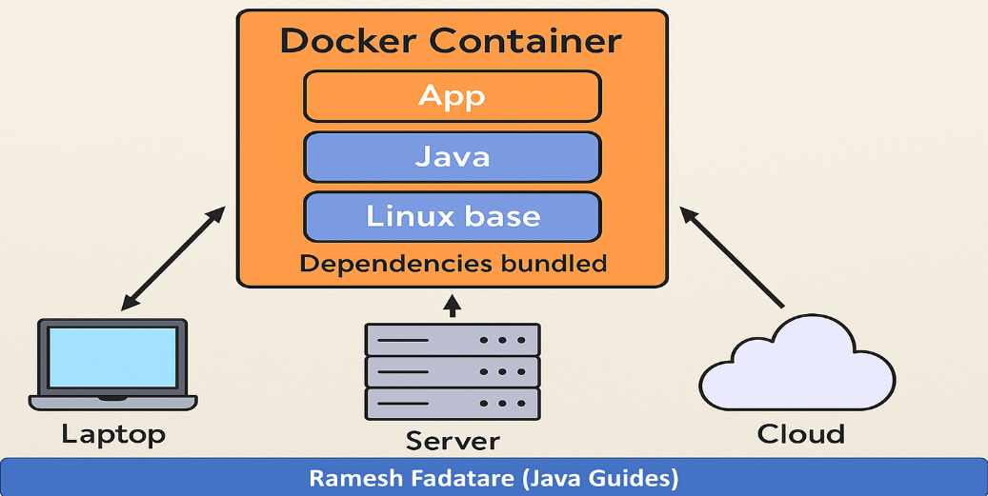
4
Dockerfile → docker build → Image → docker run → Container

🎯 Interview Tip (Very Important)
If interviewer asks:
“Write a simple Dockerfile for Java app”
Say this confidently:
I will use a lightweight base image, set WORKDIR, copy the application artifact, expose the port, and define the CMD instruction to start the application.
That’s enough 👍

21. Will you write one docker compose file and explain in detail?
🐳 Docker Compose File – Example & Detailed Explanation
We use Docker Compose to run multiple containers together using a single YAML file.

✅ Real-Time Example: 3-Tier Application
- 🌐 Frontend (Nginx)
- ⚙ Backend (Node.js)
- 🗄 Database (MySQL)

📄 docker-compose.yml
version: "3.9"

services:
frontend:
image: nginx:latest
container_name: frontend
ports:
- "80:80"
depends_on:
- backend
networks:
- app-network

backend:
image: node:18-alpine
container_name: backend
working_dir: /app
volumes:
- ./backend:/app
command: node app.js
ports:
- "3000:3000"
environment:
DB_HOST: database
DB_USER: root
DB_PASSWORD: root
depends_on:
- database
networks:
- app-network

database:
image: mysql:8
container_name: database
environment:
MYSQL_ROOT_PASSWORD: root
MYSQL_DATABASE: mydb
volumes:
- db-data:/var/lib/mysql
ports:
- "3306:3306"
networks:
- app-network

volumes:
db-data:

networks:
app-network:
driver: bridge

▶️ How to Run
docker-compose up -d
Stop:
docker-compose down

🏗️ Architecture Overview

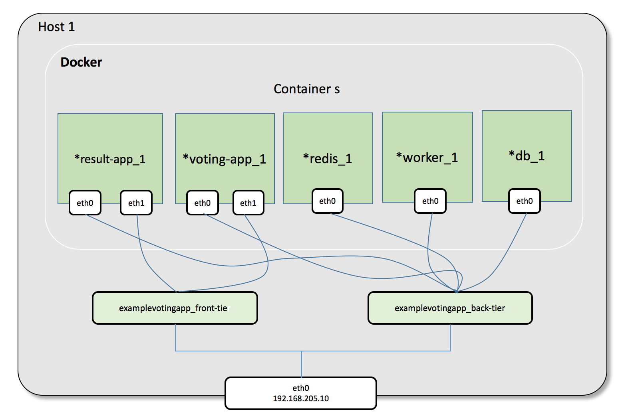

📘 Detailed Explanation

🔹 1️⃣ version
version: "3.9"
Specifies Compose file format version.

🔹 2️⃣ services
Defines containers to run.
We have:
- frontend
- backend
- database
Each service becomes a container.

🔹 3️⃣ image
image: nginx:latest
Specifies which Docker image to use.

🔹 4️⃣ container_name
container_name: frontend
Custom name for container.

🔹 5️⃣ ports
ports:
- "80:80"
Format:
HOST_PORT : CONTAINER_PORT

🔹 6️⃣ depends_on
depends_on:
- backend
Ensures container starts after dependency.
⚠ Note: It does NOT wait for service readiness (only container start order).

🔹 7️⃣ environment
Used to pass environment variables.
environment:
DB_HOST: database
Notice:
- Backend connects to DB using service name database
- Docker automatically provides DNS resolution.

🔹 8️⃣ volumes
volumes:
- db-data:/var/lib/mysql
- Persistent storage for MySQL
- Data remains even if container is removed

🔹 9️⃣ networks
networks:
app-network:
driver: bridge
- Creates custom bridge network
- All services communicate securely
- Database not exposed publicly unless needed

🔁 How Containers Communicate
Backend connects to DB using:
database:3306
Because Docker Compose:
- Creates default internal DNS
- Uses service names as hostnames

📦 What Happens Internally?
When you run:
docker-compose up -d
Docker Compose:
- Creates network
- Creates volume
- Pulls images (if not available)
- Creates containers
- Starts services in dependency order

🎯 Interview 4–5 Line Answer
Docker Compose is used to define and manage multi-container applications using a YAML file. In the compose file, we define services, images, ports, volumes, networks, and environment variables. When we run docker-compose up, it creates the network, volumes, and containers automatically and connects them together.

22. Will you write one multistage docker file?
🐳 Multi-Stage Dockerfile (Production Example)
A multi-stage Dockerfile allows us to use multiple FROM statements to separate build stage and runtime stage, resulting in a smaller and secure image.
This feature is supported in Docker.

✅ Example: Java (Maven) Multi-Stage Dockerfile
Assume:
- Spring Boot project
- pom.xml
- Source code in src/
- Final output → target/app.jar

📄 Dockerfile
# -------- Stage 1: Build Stage --------
FROM maven:3.9-eclipse-temurin-17 AS builder

WORKDIR /app

# Copy pom.xml first (for caching dependencies)
COPY pom.xml .

# Download dependencies
RUN mvn dependency:go-offline

# Copy source code
COPY src ./src

# Build application
RUN mvn clean package -DskipTests

# -------- Stage 2: Runtime Stage --------
FROM eclipse-temurin:17-jre-alpine

WORKDIR /app

# Copy only jar file from builder stage
COPY --from=builder /app/target/*.jar app.jar

EXPOSE 8080

ENTRYPOINT ["java", "-jar", "app.jar"]

🏗️ How It Works


🔍 Explanation
🔹 Stage 1 (Builder)
- Uses full Maven + JDK image
- Downloads dependencies
- Compiles code
- Generates .jar file
⚠ This stage contains heavy tools like Maven.

🔹 Stage 2 (Runtime)
- Uses lightweight JRE image
- Copies only .jar file
- No Maven, no source code
- Much smaller image

📊 Why Multi-Stage is Important?
Without multi-stage:
- Image size ≈ 900MB+
With multi-stage:
- Image size ≈ 150–250MB
Benefits:
- Faster CI/CD
- Lower storage cost
- Better security
- Cleaner production image

🚀 Build & Run
docker build -t springboot-app .
docker run -d -p 8080:8080 springboot-app

🎯 Interview 3–4 Line Answer
A multi-stage Dockerfile uses multiple FROM statements to separate the build and runtime environments. The first stage builds the application, and the final stage copies only the required artifacts, resulting in a smaller, optimized, and secure production image.

