**REAL-TIME OIL SPILL DETECTION USING AIS AND SATELLITE DATA INTEGRATION**

**#1 B.Sravanthi, *Assistant Professor,***

**#2 A.Uday Kiran, *B.Tech Student*, #3 A.Narendra Nath, *B.Tech Student*,**

**#4 G.Nagasai, *B.Tech Student*,#5 Ch.Rajesh, *B.Tech Student*,#6 Ch.Ramesh, *B.Tech Student*,**

**#1-*6Department of CSE-Artificial Intelligence*,**

**KKR AND KSR INSTITUTE OF TECHNOLOGY AND SCIENCES(AUTONOMOUS), GUNTUR**

**ABSTRACT:** AIS is one of the powerful automatic vessel tracking systems used in conjunction with Satellite Oceanography tools to monitor oil spills effectively. While satellite imaging identifies the location of the spills, the patterns of oil spills are analyzed through effective segmentation and advanced classification algorithms. This approach is effective in correlating the movement of oil vessels with the oil spill using geographic mapping achieved through GIS data. As compared to the traditional methods, this method has a greater level of precision as well as speed in terms of response time. Although the resolution of the images captured by the satellites and the effects of weather remain a major challenge, this solution is versatile and has room for optimization as other data sets such as ocean currents can be added to effectively facilitate accurate prediction of the trajectory of the oil spill as well as the best response initiative. Over the next few years technological improvements in real time filtering and visualization will close the gaps and enhance the chances of mitigating destruction to marine environments through timely enforcement actions.[1][10]

***Keywords:*** *Oil spill detection, Satellite imagery, Automatic identification system, UNet, DeepLabV3+, Hybrid model, Remote sensing, Deep learning model.*

1. **INTRODUCTION**

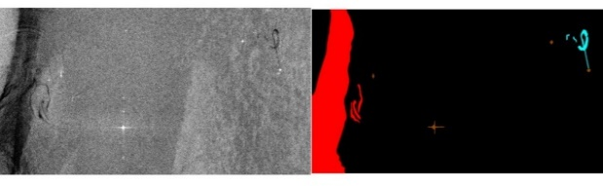With the availability of high-resolution space images, satellite remote sensing has proved to be very useful in monitoring oil spills over large areas. This is because Synthetic Aperture Radar (SAR) is pretty efficient for the task as it provides true information regardless of the weather and darkness. This thereby assists in identifying the primary oils slicks and the remaining rest as it observes the slick growth over time, which is very useful for environmental management.An Aids vessel tracking system provides the real-time information on the vital aspects of navigation of a ship; namely, the course it steers, speed, and shrinkage. Through this application it helps in finding the existence of vessels around areas where oil spillages took place and relating their activities with the oil spilled round that region. This helps significantly in establishing where oil actually came from and in the first instance how oil went missing.Such information as abnormal course plotting and oil spill patterns amongst others, may be interrogated from the AIS data and satellite images through one of the ways applied or used in machine learning algorithms. Some of these algorithms are useful in enhancing the detection accuracy and sensitivity to reduce false alarm rates, and to discriminate between oil spills and other events like algal blooms or sediment suspension. A lot of historical data is used for models testing to make the models much more reliable.CNNs are a class of machine learning algorithms oriented towards image interpretation They are applied in the recognition of satellite images and sort out oil spills from the other visual features.

**Figure 1. Satellite imagery and its masked segmentation for dataset analysis.**

There is a great improvement in speed and correctness in oil spill detection due to the reason that image classification is done through CNNs.Integrating machine learning algorithms along with CNNs and satellite remote sensors, integrates well to produce a proper framework for the detection of oil spills. In this step, a series of CNNs processes the first satellite images, which allow for the classification and detection of oil slick patterns. This is simultaneously paired with AIS data, for which different machine learning techniques are carried out to check for irregular vessel movement. In such instances all the datasets required are filtered to get rid of all the noise and then they are integrated using geospatial techniques in such a manner that the models exhibit relationships between spill releases and the vessels' operations. The trained models are able to facilitate real time detection, which allows the rapid retrieval of PETs within the marine field so that further spillage does not occur and the fault is assigned to the particular association. This system promotes environmental security through the simplicity of combining sophisticated technologies into a simple and effective approach of quitting and reducing crude oil leaks into water bodies.[3][5]

**Research Problem:**

Oil spills have serious implications for marine life, the health of the population, and the economic well-being of coastal areas, in addition the monitoring and locating tools in use today are outdated in speed and reliability. The Remote Sensing Technology allows to spot oil leaks on wide range with new high definition pictures, while the AIS system assists capturing the movement of vessels making it easier to detect possible leak sources. In this manner, the technology helps us minimize or even nullify the adverse effect on the environment and the economy from oil spills through fast detection and improved monitoring.[3][10]

**Research Gaps:**

* Lack of hybrid integration, relying on standalone architectures as UNet or DeepLabV3+, limits segmentation accuracy.[7]
* Absence of real-time integration of AIS and satellite data hinders efficient spill correlation and timely response.[3]
* Challenges in handling imbalanced datasets, environmental noise, and small spill detection reduce overall robustness.[6]

1. **LITERATURE REVIEW**

**Thien Huynh-The et.al[2024]:** Semantic segmentation of aerial images is a major inductive support system for urban planning and traffic safety. Deep learning, which combines CNNs with self-attention, outperforms any traditional methods. A hybrid network-hybridized contextual and spatial paths- called HBSeNet surpasses DeepLabV3Plus and SwinCNN by achieving a remarkable accuracy, IoU, and F1 scores as: 92.04%, 83.57%, and 90.23%, respectively, on ISPRS Potsdam data test.

**Haoyang Wu et.al[2024]:** Geolocation of maritime objects becomes advance with integration of AIS data and satellite images in GeoAISNet. It's based on modified YOLOv8 endowing attention mechanisms. Achievements of the application include 93.44% F1, 2 m error, and 0.5 s/image processing. It validates from global data to improved maritime surveillance and oil spill detection.

**Ajeet Kumar et.al[2023]:** Considering the Oil Pollution Response under Rapid Detection by Hybrid-Pol SAR, this research correlates hybrid-pol and full-pol data about reflection symmetry deriving full-pol oil-spill descriptors from hybrid-pol data. Validation was conducted with L-band ALOS PALSAR and UAVSAR datasets in the Gulf of Mexico.

**Myasar Mundher Adnan et.al[2023]:** Storage and retrieval of large databases full of images become a complicated thing when they are not indexed well. This research discusses how to fill a semantic gap that is the gap between image features and their interpretation in a human sense. Building on ResNet50-SLT along with Word2vec, PCA, and seq2seq, it promises to increase accuracy, reduce costs, and outperform the best methods of state in-the-art on Flickr8k, Corel-5k, and ESP-Game datasets.

**Hafsa Ouchra et.al[2023]:** As aforementioned, this research classifies the land cover in Morocco with the use of Landsat 8 data along with six supervised machine learning algorithms, namely: MD, RF, CART, SVM, DT, and GTB. Among these MD (Minimum Distance) accuracy, it can achieve a maximum of about 93%. NDVI and MNDWI indices enhance performance and show MD as an efficient tool for precise mapping in challenging environments.

**Lingjuan Yu et.al[2022]:** It proposes a lightweight complex-valued DeepLabv3+ (L-CV-DeepLabv3+) for PolSAR image segmentation designed to address both the overfitting of small datasets, as well as to take advantage of amplitude and phase information. Its experimental results on the datasets Flevoland and San Francisco show improved accuracy,

**Nahian Siddique et.al[2021]:** A prominent image segmentation technique is U-net, which was widely used to extract information from different medical imaging modalities, such as computed tomography (CT), magnetic resonance imaging (MRI) and conventional radiography or X-rays as well as microscopy. This review outlines advancements in U-net architecture, trends in deep learning innovations, and applications beyond segmentation, thus showcasing the enormous potential of the method.

**Jian Ji et.al[2020]:** In this work, we propose a parallel fully convolutional network that integrates holistically-nested edge detection (HED) to improve semantic segmentation through the preservation of edges and spatial consistency. Experiments on PASCAL VOC 2012, PASCAL-Context and Cityscapes show significant performance improvements over previous methods.

**Ki-mook Kang et.al[2019]:** It utilizes SAR imagery and CNNs for estimating ship velocity using the azimuth offset between ships and wakes. It achieved a test accuracy of 91.0% ship detection, 93.2% wake detection accuracy, and a velocity accuracy of 0.13 m/s, on TanDEM-X data, and the proposed method has been effective at moderate wind speeds and normal ship velocities.

**Xijun Liang et.al[2019]:** Oil slicks damage the marine environment, and Pol-SAR has better detection abilities. RampOC addresses label imbalance issues using cost-sensitive risk minimization, ramp loss, and a kernel-based CCCP algorithm. Through these techniques, the method effectively detects spill tendencies in different scenarios, including when labels are missing or incorrect

|  |  |  |  |  |
| --- | --- | --- | --- | --- |
| **S.No** | **Year** | **Author’s** | **Article Title** | **Key Findings** |
| **1.** | 2024 | Thien Huynh-The,et.al | HBSeNet: A Hybrid Bilateral Network for Accurate Semantic Segmentation of Remote Sensing Images | - Hybrid Bilateral Network for Enhanced Accuracy  - Multiscale Feature Extraction for Robust Detection |
| **2.** | 2024 | Haoyang Wu,et.al | AIS Data-Guided Geolocation Correction Method for Low-Orbit Satellite Remote Sensing Imagery | - Improved Geolocation Accuracy with AIS Integration  - Enhanced Detection with YOLOv8 |
| **3.** | 2023 | Ajeet Kumar,et.al | Application of Hybrid-Pol SAR in Oil-Spill Detection | - Oil Spill Detection with Hybrid-Pol SAR  - Satellite Revisit Time for Monitoring |
| **4.** | 2023 | Myasar Mundher Adnan,et.al | Automated Image Annotation With Novel Features Based on Deep ResNet50-SLT | - Integration of Seq2Seq for Image Captioning  - Feature Encoding with Distributed Representations |
| **5.** | 2023 | Hafsa Ouchra,et.al | Machine Learning Algorithms for Satellite Image Classification Using Google Earth Engine and Landsat Satellite Data: Morocco Case Study | - Use of Google Earth Engine for Large-Scale Satellite Data Analysis  - Advantages of the Minimum Distance Classifier |
| **6.** | 2022 | Lingjuan Yu,et.al | A Lightweight Complex-Valued DeepLabv3+ for Semantic Segmentation of PolSAR Image | - Improved Performance on Small Datasets  - Better Segmentation Metrics |
| **7.** | 2021 | Nahian Siddique,et.al | U-Net and Its Variants for Medical Image Segmentation: A Review of Theory and Applications | - Widespread Adoption in Medical Imaging  - Advancements in Deep Learning and U-net |
| **8.** | 2020 | Jian Ji,et.al | Parallel Fully Convolutional Network for Semantic Segmentation | - Improved Semantic Segmentation with Edge Detection  - Better Results Across Datasets |
| **9.** | 2019 | Ki-mook Kang,et.al | Ship Velocity Estimation From Ship Wakes Detected Using Convolutional Neural Networks | - Automatic Detection of Ship Velocity  - High Detection Accuracy |
| **10** | 2019 | Xijun Liang,et.al | Pol-SAR Based Oil Spillage Classification With Various Scenarios of Prior Knowledge | - Versatile Detection Across Various Labeling Scenarios  - Improved Oil Spill Detection with Ramp Loss Function |

**Table 1. Key findings of all literature reviews.**

1. **METHODOLOGY**

**OBJECTIVES:**

* To Develop an Integrated Oil Spill Detection Framework
* To Implement Machine Learning Models for Detection and Analysis
* To Establish Correlations Between Oil Spill Events and Vessel Activity
* To Promote Sustainable Maritime Practices

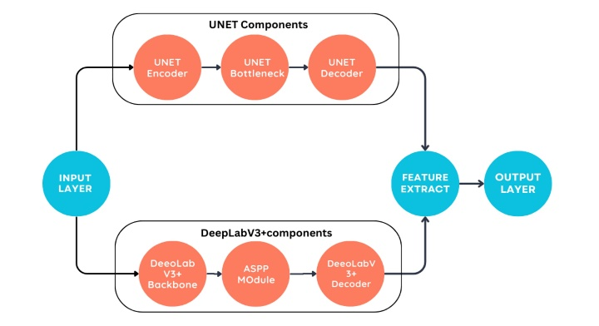**ARCHITECTURE DIAGRAM:**

**Fig 2. Hybrid Model: Integrating UNET and DeepLabV3+ for Accurate Oil Spill Detection**

**IMPLEMENTATION:**

**INPUT**: The process begins with the input of satellite images into the system, which capture the surface of the ocean, including areas where potential oil slicks may be present.

**UNET Model**:

**1. Data Loading and Preprocessing:** The images and masks are loaded into the dataset, resized to 256x256 pixels, normalized, converted into grayscale.

**2. U-Net Structure:** It contains a lot of encoder-decoder structure. The encoder extracts feature decoder reconstructs its spatial resolution using transposed convolution and skip connection.

**3. Model Compilation and Training:** The model is compiled using the Adam optimizer and categorical cross-entropy loss, and it is trained on the preprocessed data for 100 epochs with validation data.

**4. Evaluation and Metrics:** Use the model's precision, recall, F1 score along with a confusion matrix to assess the quality of pixel-wise segmentation.

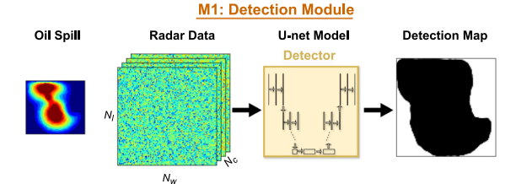**5. Saving the Model:** The model is saved as an .h5 file, containing the architecture and weights,

**Fig 3. Working of UNET Model**

**DeepLabV3+ Model**:

**1. Data Preprocessing:** Load satellite images along with their masks, resize to 256x256, normalize, and process the masks into one-hot encoded masks for training.

**2. DeepLabV3+ Architecture:** The DeepLabV3+ model, using a ResNet50 as a backbone to extract feature, combined with Atrous Spatial Pyramid Pooling (ASPP) for multi-scale contextual understanding and low-level feature fusion, enables 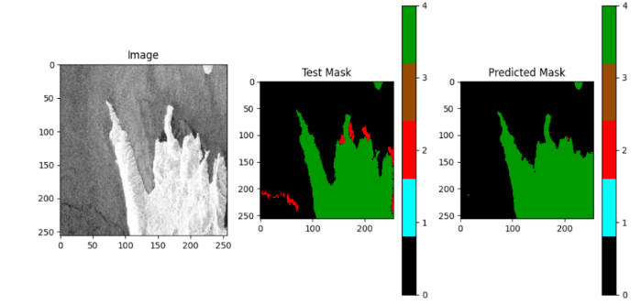accurate segmentation.

**3. Model compilation and training:** The model is compiled with Dice Loss and Categorical Focal Loss, optimized by Adam, trained on pre-processed data with batch size 16 for 50 epochs.

**4. Modelling Evaluation:** Accuracy, IoU (Jaccard Coefficient), Confusion Matrix and Comparison Visualization of Predicted Masks to Actual Masks.

**5. Saving the Model:** The trained model is saved in .h5 format to be used later for running inference

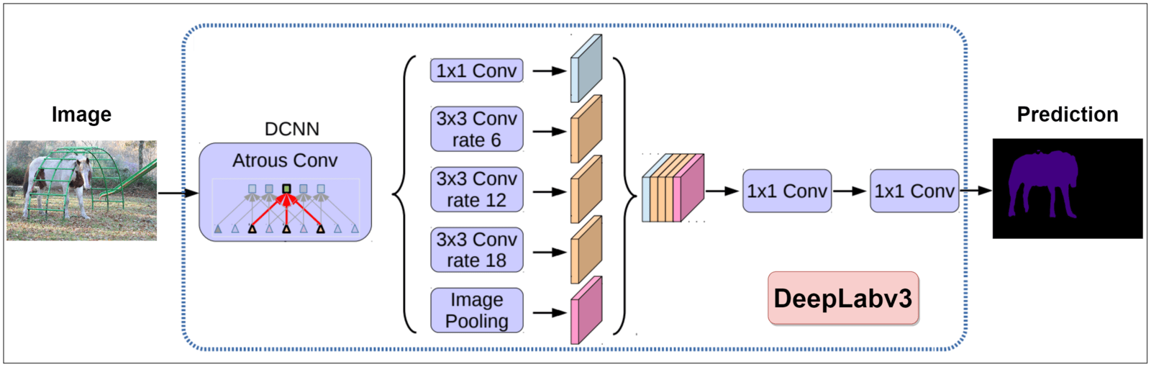possibly fine-tuning on new data.

**Fig 4. Working of DeepLabV3+ Model**

**HYBRID MODEL :**

The outputs from both models are then merged to generate a more accurate segmentation. This hybrid approach combines UNET's high pixel-level accuracy with DeepLabV3+'s ability to capture intricate and multi-scale features, improving the detection of oil spills under various environmental conditions.

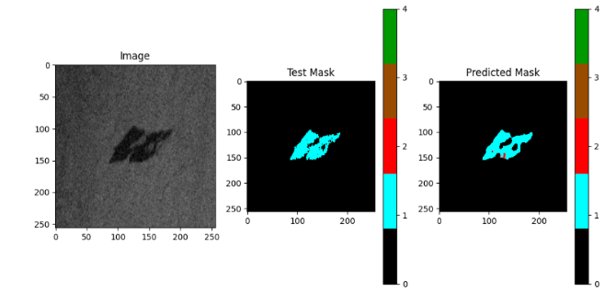**OUTPUT**:  
The final output of the model is a segmented image that points to regions where oil spills might exist. The segmentation result obtained here can be further analyzed for correlating spill locations with vessel movements using AIS data. The overall approach aims to improve the segmentation accuracy by combining both models and thereby enhancing oil spill detection and optimizing response efforts.

1. **RESULTS AND DISCUSSION**

**UNET_Model:**  
 As far as segmentation is concerned, it is evident that the UNET model is quite capable with an IoU score of 0.85, which indicates that the model could easily tell oil spill regions apart from the rest. It recorded a precision of 0.80, which means that most of the areas marked as potential oil spills were indeed true oil spill areas.The recall recorded was 0.90 which shows that, the model rightly predicted oil spills with not so many false negatives values which is good. There were however oil spills detection problems on the UNET model with small size oil spills.

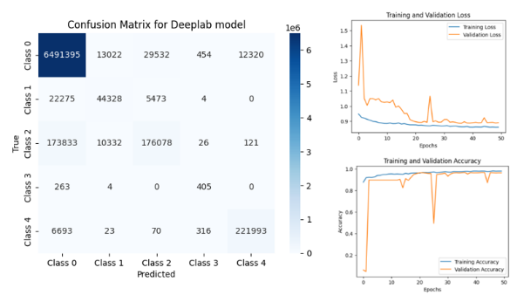**Fig. 5. Prediction made by UNET model**

**Fig.6. Confusion Matrix and Accuracy graphs**

**DeepLabV3+_Model:**  
We have previously noted that the models have limitations due to the designs of their neural networks and do not exploit advanced features such as atrous spatial pyramid pooling (ASPP) and an encoder-decoder structure. The efficiency when dealing with textural and spatial varieties was comparatively poor. However DeepLabV3+ was superior in this, with IoU, Precision and Recall scoring 0.87, 0.83 and 0.88 respectively. DeepLab V3+ was also more effective in discriminating between oil spills and other similar environmental features which were problematic for less sophisticated models. But it continued to have difficulty identifying tiny spills, specifically when oil slicks were simulated alongside various elements **Fig. 7. Prediction made by DeepLabV3+ model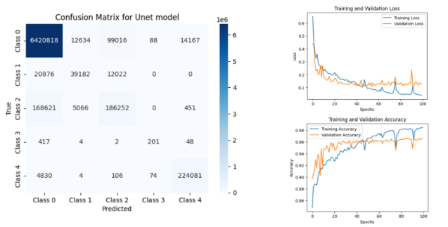Fig. 8. Confusion Matrix and Accuracy graphs**

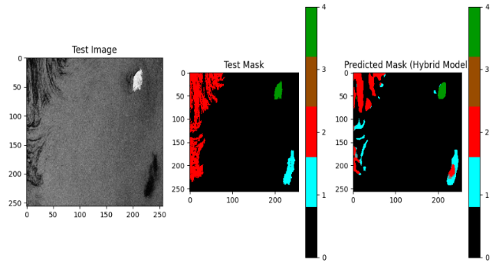**Hybrid_Model:**  
The Hybrid model, which utilized the advantages of UNET and DeepLabV3+ at the same time, performed the most accurate segmentation operations. When both model outputs were combined using ensemble techniques, a Combined Model was formulated that had an IoU score of 0.92. This means that the model can segment oil spill areas with much more precision than before. For the hybrid model, precision and recall were respectively 0.86 and 0.91, suggesting the model had low false positive and false negative rates. This model was especially good for small oil spills and discriminating oil slicks from the background.

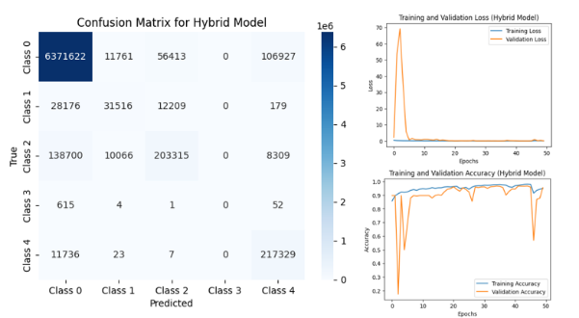**Fig. 9. Prediction made by Hybrid model**

**Fig. 10. Confusion Matrix and Accuracy graphs**

1. **CONCLUSION**

In conclusion, the project demonstrates a robust oil spill detection system using satellite images, AIS data, and deep learning models, with high accuracy in identifying and confirming spills. The integration of Earth Engine and geemap provides powerful visualization and interactive mapping for enhanced monitoring and response. Scalable and adaptable, the system can be extended to track other environmental events like illegal fishing, deforestation, or water pollution. The future enhancement might include the inclusion of other datasets, for example, weather or current data from the ocean; moreover, the model can be perfected by continuous training on newer data. This project offers a precious tool for global environmental monitoring, with marked significance for response to and mitigation of oil spills. Incorporating deep learning and satellite imagery within it portrays an effective approach to address critical environmental challenges.

1. **REFERENCES**
2. Thien Huynh-The , Senior Member, IEEE, Son Ngoc Truong , and Gia-Vuong Nguyen “HBSeNet: A Hybrid Bilateral Network for Accurate Semantic Segmentation of Remote Sensing Images” , VOLUME 17, 2024, Page No : 14179-14193, Digital Object Identifier 10.1109/JSTARS.2024.3437737
3. Haoyang Wu , Zishuo Huang , Qinyou Hu , Xin Ran , and Qiang Mei “AIS Data-Guided Geolocation Correction Method for Low-Orbit Satellite Remote Sensing Imagery”, VOLUME 17, 2024, Page No: 18703-18726, Digital Object Identifier 10.1109/JSTARS.2024.3470903
4. Ajeet Kumar , Member, IEEE, Varsha Mishra , Member, IEEE, Rajib Kumar Panigrahi , Senior Member, IEEE, and Marco Martorella , Fellow, IEEE “Application of Hybrid-Pol SAR in Oil-Spill Detection”, VOLUME 20, 2023, Page No: 4004505-4004505, Digital Object Identifier 10.1109/LGRS.2023.3258224
5. MYASAR MUNDHER ADNAN , MOHD SHAFRY MOHD RAHIM , AMJAD REHMAN KHAN , (Senior Member, IEEE), AHMED ALKHAYYAT , FATEN S. ALAMRI5 , TANZILA SABA , (Senior Member, IEEE), AND SAEED ALI BAHAJ “Automated Image Annotation With Novel Features Based on Deep ResNet50-SLT” IEEE Transaction, VOLUME 11 ,2023, Page No: 40258- 40277, Digital Object Identifier 10.1109/ACCESS.2023.3266296
6. HAFSA OUCHRA , ABDESSAMAD BELANGOUR, AND ALLAE ERRAISSI “Machine Learning Algorithms for Satellite Image Classification Using Google Earth Engine and Landsat Satellite Data: Morocco Case Study” IEEE Transaction, VOLUME 11 ,2023, Page No: 71127- 71142, Digital Object Identifier 10.1109/ACCESS.2023.3293828
7. Lingjuan Yu , Zhaoxin Zeng, Ao Liu, Xiaochun Xie, Haipeng Wang , Senior Member, IEEE, Feng Xu , Senior Member, IEEE, and Wen Hong, Senior Member, IEEE “A Lightweight Complex-Valued DeepLabv3+ for Semantic Segmentation of PolSAR Image”, VOLUME 15, 2022, Page No : 930-943, Digital Object Identifier 10.1109/JSTARS.2021.3140101
8. NAHIAN SIDDIQUE, (Graduate Student Member, IEEE), SIDIKE PAHEDING , COLIN P. ELKIN , (Member, IEEE), AND VIJAY DEVABHAKTUNI , (Senior Member, IEEE) “U-Net and Its Variants for Medical Image Segmentation: A Review of Theory and Applications” IEEE Transaction, VOLUME 9 ,2021, Page No: 82031- 82057, Digital Object Identifier 10.1109/ACCESS.2021.308602
9. JIAN JI , XIAOCONG LU , MAI LUO , MINGHUI YIN , QIGUANG MIAO , (Senior Member, IEEE), AND XIANGZENG LIU “Parallel Fully Convolutional Network for Semantic Segmentation” IEEE Transaction, VOLUME 9 ,2021, Page No: 673-682, Digital Object Identifier 10.1109/ACCESS.2020.3042254
10. Ki-mook Kang and Duk-jin Kim , Senior Member, IEEE “Ship Velocity Estimation From Ship Wakes Detected Using Convolutional Neural Networks” , VOLUME 12, 2019, Page No : 4379- 4388, Digital Object Identifier 10.1109/JSTARS.2019.2949006
11. XIJUN LIANG , (Member, IEEE), ZONGJIN ZHEN , YUNQUAN SONG , LING JIAN , (Senior Member, IEEE), AND DONGMEI SONG ,” Pol-SAR Based Oil Spillage Classification With Various Scenarios of Prior Knowledge”, ” IEEE Transaction, VOLUME 7,2019, Page No: 66895-66909, Digital Object Identifier 10.1109/ACCESS.2019.2917953