Environment setup:

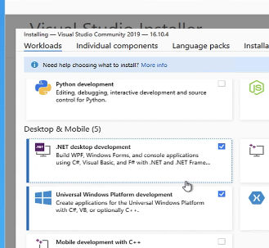

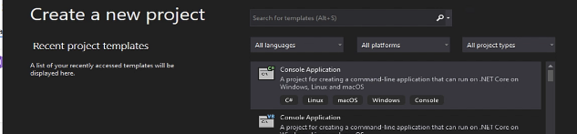

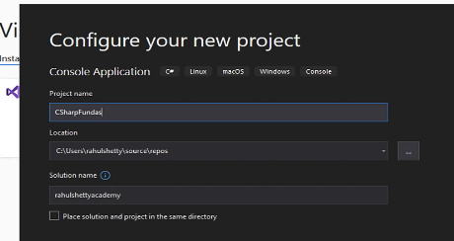

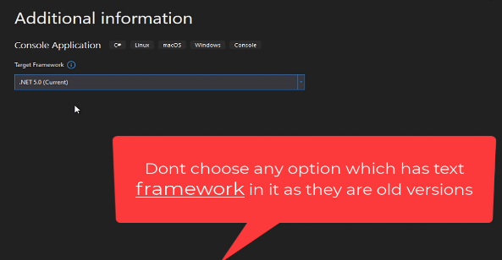

In the project structure, bin stores the executable files (.dll), obj stores the complied files, .sln stores the solution meta data details, .proj stores meta data about the project and .cs stores actual code.

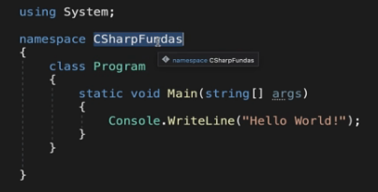

Or can write without using keyword.

System.Console.WriteLine(“Hello World!”);

Debugging class.(Debug.WriteLine), to print on debug window.

Package manager for dotnet: <https://www.nuget.org>

Like maven in java, npm in javascript

Right click on project and select manage nuget packages.

Or in project folder, run below command.

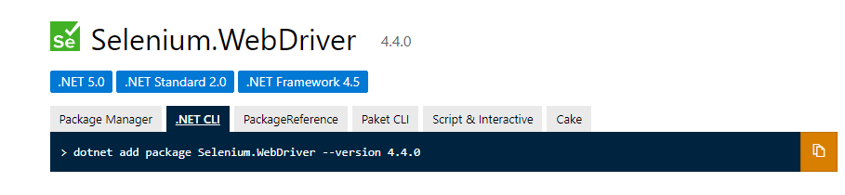

Received from link: <https://www.nuget.org/packages/Selenium.WebDriver>

Right click – edit project file – see the PackageReference added.

Obj folder – compiled code for all files.

Bin folder – executable file(.dll/.exe) combined with all the compiled files above in obj folder.

**Concatenation and evaluation string.**

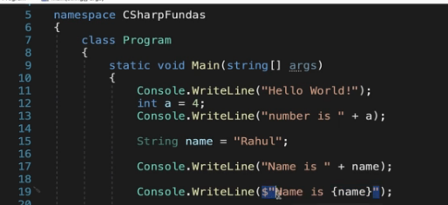

**Static and dynamic datatypes.**

int,float are static datatypes.

var is dynamic data type, which will set a type of data using run time assignment.

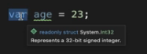

Can’t reassign a different type later, only done at first time.

dynamic. Same as var, but supports reassign also.



**Method.**

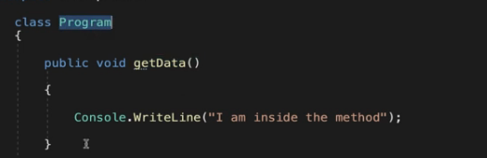

To use this, create object and use from that.

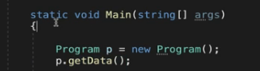

Using from another class.

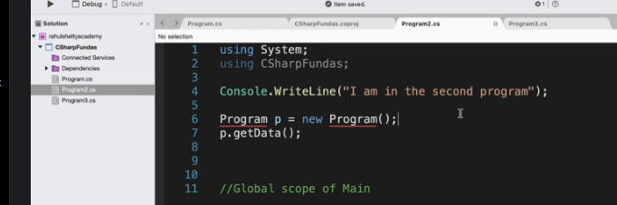

We can write a new class file code without main block also, c# generates it at runtime.

Below code will come under Global scope of Main.

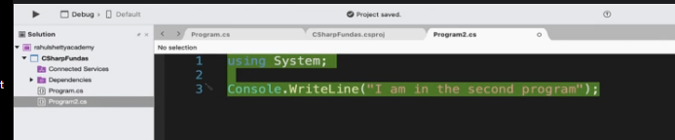

**Run selective file in the project with compiler setting.:**

There can be only one Main entry in a project.

When multiple main are there in different cs files, global scope one will be taken.

If no global scope, then it will give error asking which to pick.

Right click on cs file – build action – compile

Right click on cs file – build action – None … will skip the class from compiling when the project is build.

Or from properties of cs file.

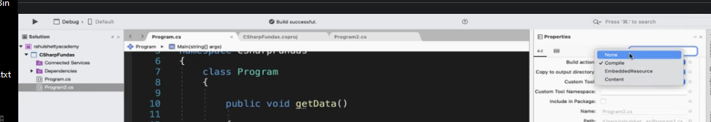

Inheritance:

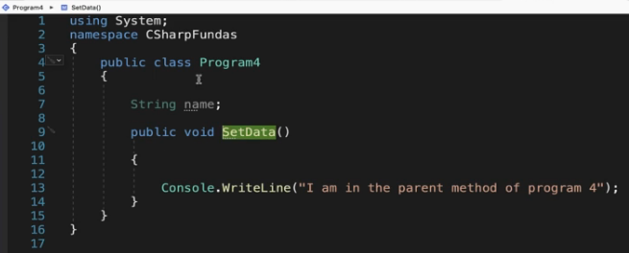

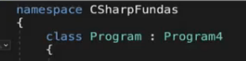

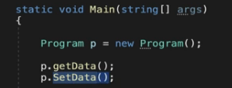

Constructor:

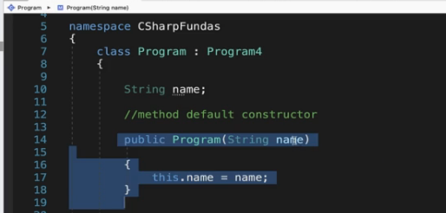

Inside the Main method of class.

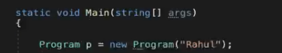

Can have multiple constructors with different arguments.

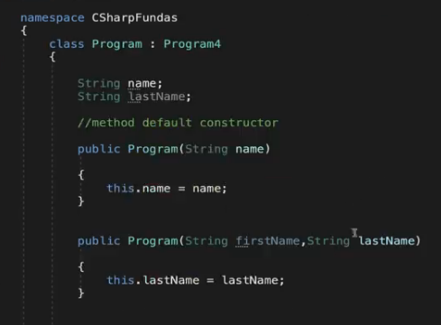

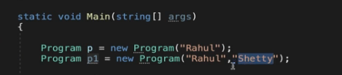

**Arrays:**

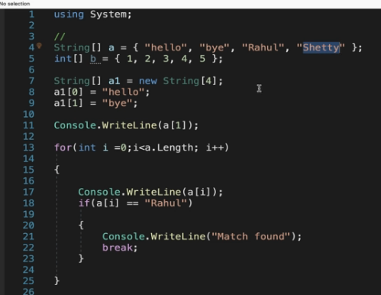

**ArrayList** and enhanced for loops.

Size can be set at runtime.

