Project type: NUnit test project

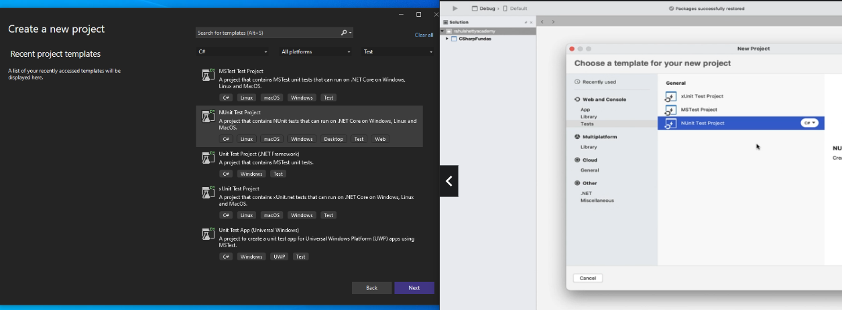

Right click on project and click edit project file and can see the dependencies of NUnit.

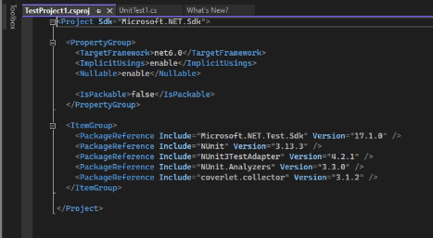

Test frameworks:

Junit/TestEngine -- java

Pytest -- python

Moca/Jasmine –Javascript

NUnit --- C#

Right click on project – manage nunit packages – selenium.webdriver, selenium.support

When using Selenium.WebDriver package, the Selenium.Support package aids/needed in creating automation test code

In the test code below, Setup is for prereq environment setup like webpage loading, Test is core logic what we need to do after page loaded. Teardown is for cleanup tasks.

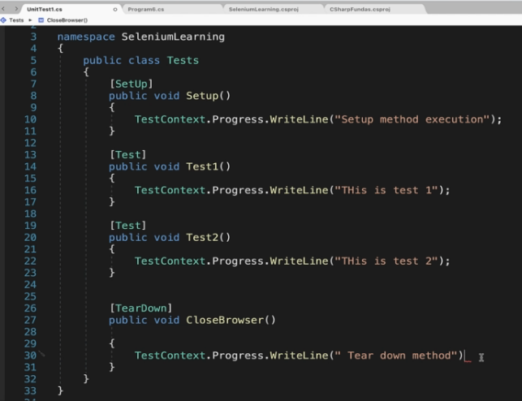

After building.

View –tests---test explorer

Right click on Tests 🡪 run tests

Outputs 🡪 Tests

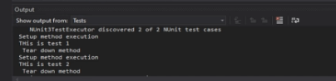

In mac:

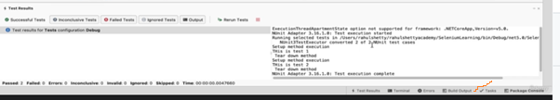

To invoke chome browser.:

Using WebDriverManager, you don’t need to handle downloading of specific webdriver for browser with specific version, it handles internally. Selenium.WebDriver nuget package doesn’t contain that.Need to install one more.

Then use that below.



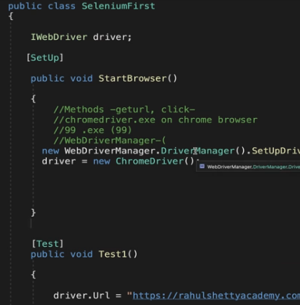

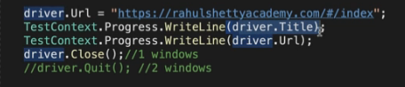

To maximize window:

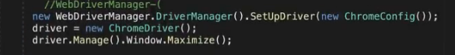

// To see code of page.



Firefox uses geckodriver.Like Chrome uses chromedriver, but FirefoxConfig manages it internally.

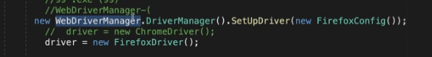

For Microsoft edge:

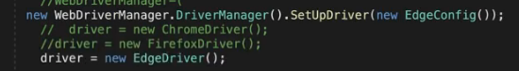

<https://github.com/uday1kiran/MyBlog/blob/master/RunningNotes/Selenium/c%23/samples/sample1.cs>