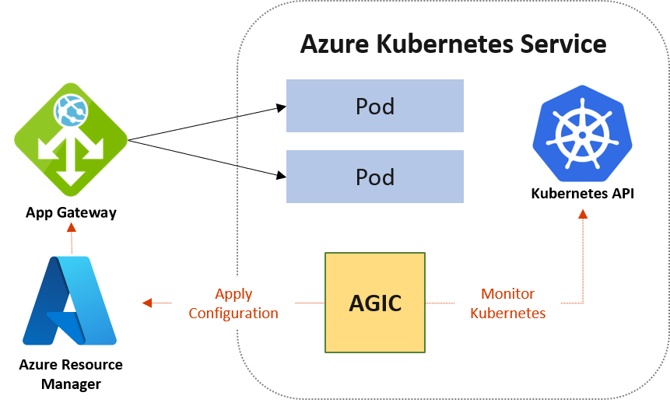

Create Deployments and Services Using The Following:

#Creating Deployments

apiVersion: apps/v1

kind: Deployment

metadata:

name: nginx-deployment-1

labels:

app: nginx1

spec:

replicas: 2

selector:

matchLabels:

app: nginx1

template:

metadata:

labels:

app: nginx1

spec:

containers:

- name: nginx1

image: sreeharshav/testcontainer:v1

ports:

- containerPort: 80

---

apiVersion: apps/v1

kind: Deployment

metadata:

name: nginx-deployment-2

labels:

app: nginx2

spec:

replicas: 2

selector:

matchLabels:

app: nginx2

template:

metadata:

labels:

app: nginx2

spec:

containers:

- name: nginx2

image: sreeharshav/testcontainer:v1

ports:

- containerPort: 80

---

apiVersion: apps/v1

kind: Deployment

metadata:

name: nginx-deployment-3

labels:

app: nginx3

spec:

replicas: 2

selector:

matchLabels:

app: nginx3

template:

metadata:

labels:

app: nginx3

spec:

containers:

- name: nginx3

image: sreeharshav/testcontainer:v1

ports:

- containerPort: 80

#Creating Service

---

apiVersion: v1

kind: Service

metadata:

labels:

app: nginx1

name: nginx-deployment-1

spec:

ports:

- port: 80

protocol: TCP

targetPort: 80

selector:

app: nginx1

---

apiVersion: v1

kind: Service

metadata:

labels:

app: nginx

name: nginx-deployment-2

spec:

ports:

- port: 80

protocol: TCP

targetPort: 80

selector:

app: nginx2

---

apiVersion: v1

kind: Service

metadata:

labels:

app: nginx

name: nginx-deployment-3

spec:

ports:

- port: 80

protocol: TCP

targetPort: 80

selector:

app: nginx3

IF you manually try to add the appgw as ingress controller following errors is expected.

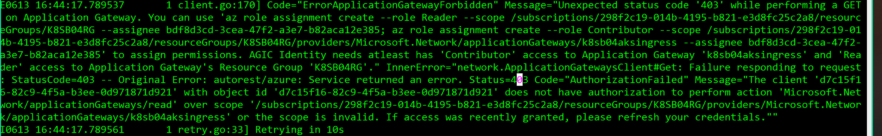

Better deploy the app gateway in the node resource group instead of cluster resource group.

Creating Ingress:

az aks get-credentials --resource-group K8SB06-AKS --name k8sb06-cluster

az aks get-credentials --resource-group K8SB06-AKS --name k8sb06-cluster

az network public-ip create -n appGwIp -g MC_K8SB06-AKS_k8sb06-cluster_eastus --allocation-method Static --sku Standard

az network application-gateway create -n k8sb04aksingress -l eastus -g MC_K8SB06-AKS_k8sb06-cluster_eastus \

--sku Standard_v2 --public-ip-address appGwIp --vnet-name K8SB06-AKS-vnet --subnet appgwsubnet

appgwId=$(az network application-gateway show -n k8sb04aksingress -g MC_K8SB06-AKS_k8sb06-cluster_eastus -o tsv --query "id")

az aks enable-addons -n k8sb06-cluster -g K8SB06-AKS -a ingress-appgw --appgw-id $appgwId

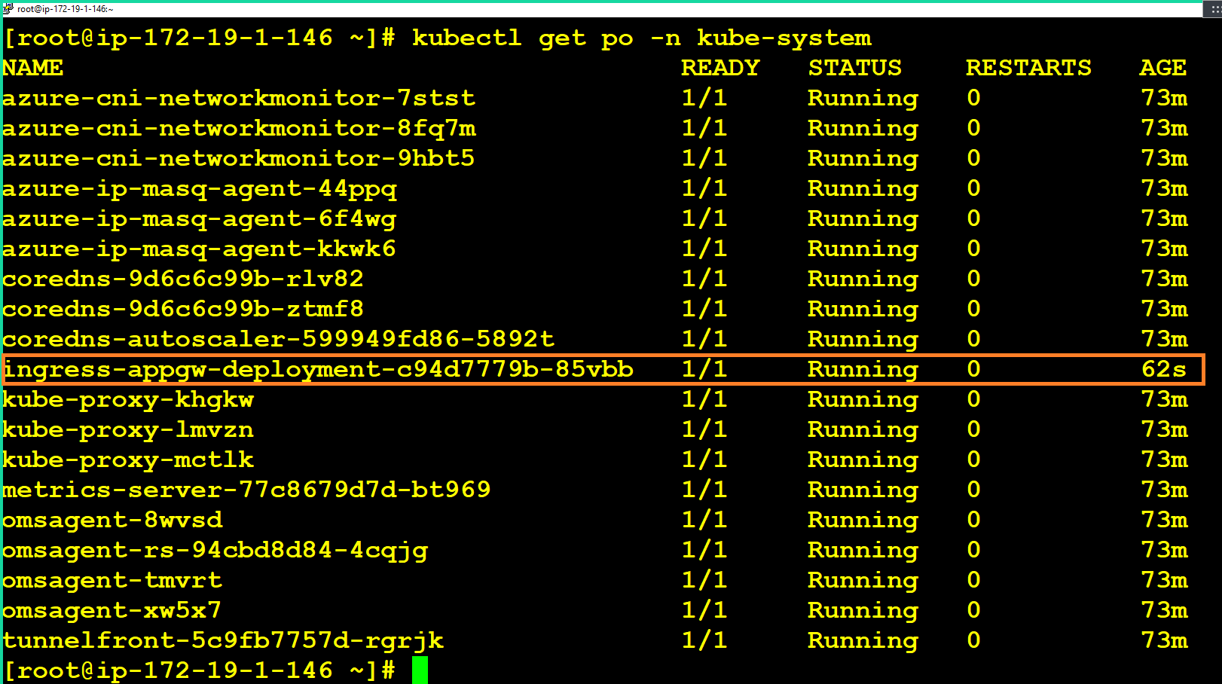

Make sure you have a working DNS created using Azure DNS or Route53:

apiVersion: networking.k8s.io/v1

kind: Ingress

metadata:

name: votingapp

annotations:

kubernetes.io/ingress.class: azure/application-gateway

spec:

rules:

- host: vote.engazure.xyz

http:

paths:

- path: /

backend:

serviceName: vote

servicePort: 80

- host: result.engazure.xyz

http:

paths:

- path: /

backend:

serviceName: result

servicePort: 80

#---------------------------------------------------------------------

apiVersion: networking.k8s.io/v1

kind: Ingress

metadata:

name: votinapp

annotations:

kubernetes.io/ingress.class: azure/application-gateway

spec:

rules:

- host: vote.engazure.xyz

http:

paths:

- path: /

pathType: Prefix

backend:

service:

name: vote

port:

number: 80

- host: result.engazure.xyz

http:

paths:

- path: /

pathType: Prefix

backend:

service:

name: result

port:

number: 80