We need to create a new GitHub Pages website.

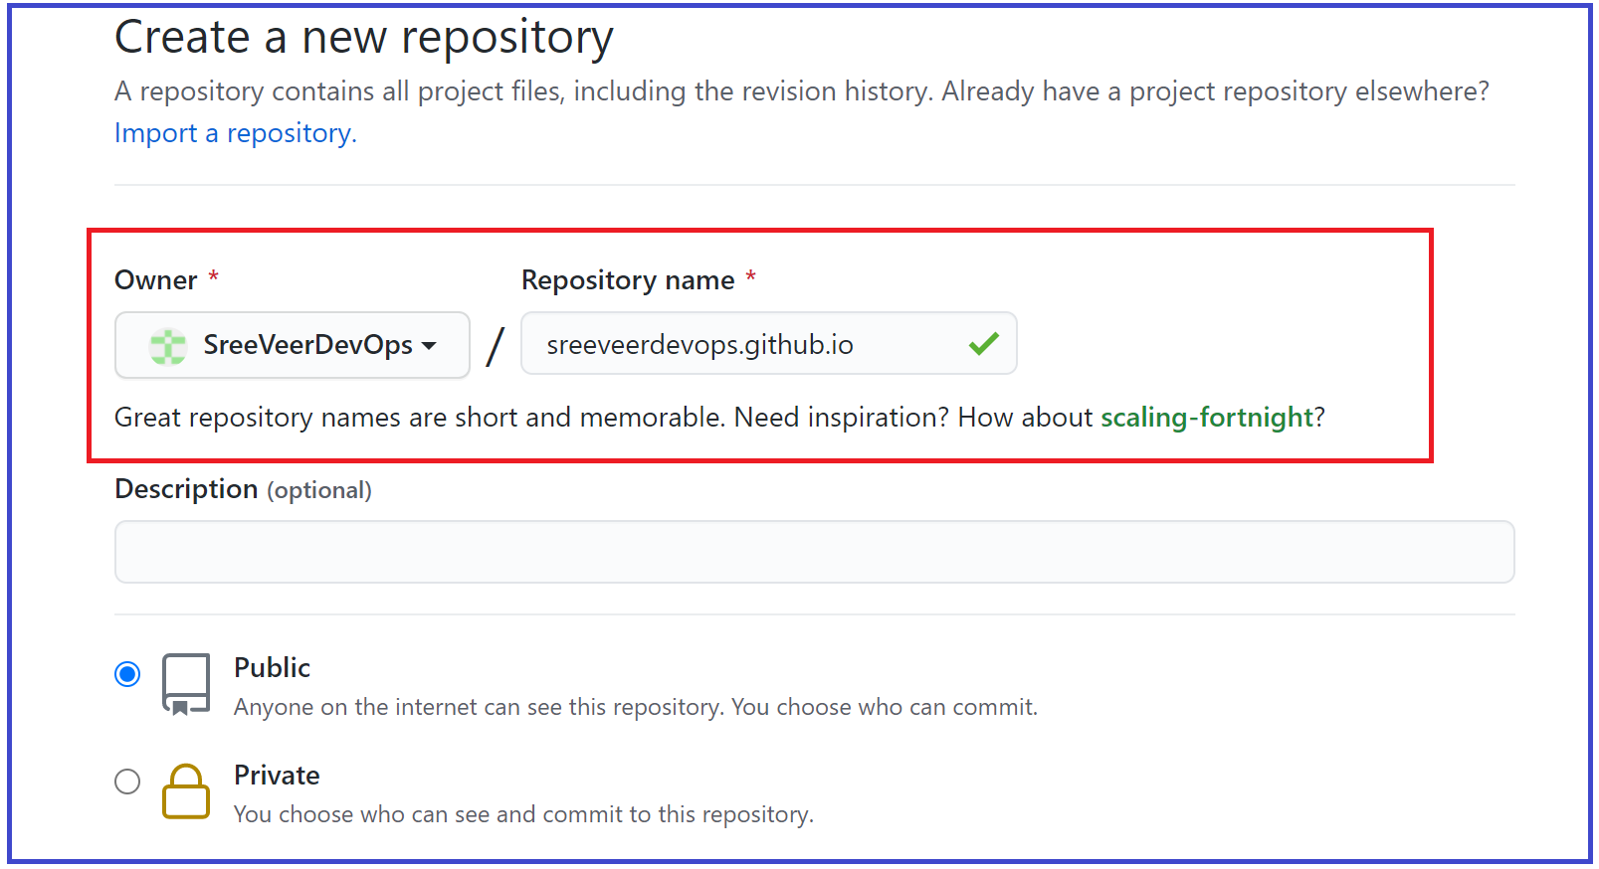

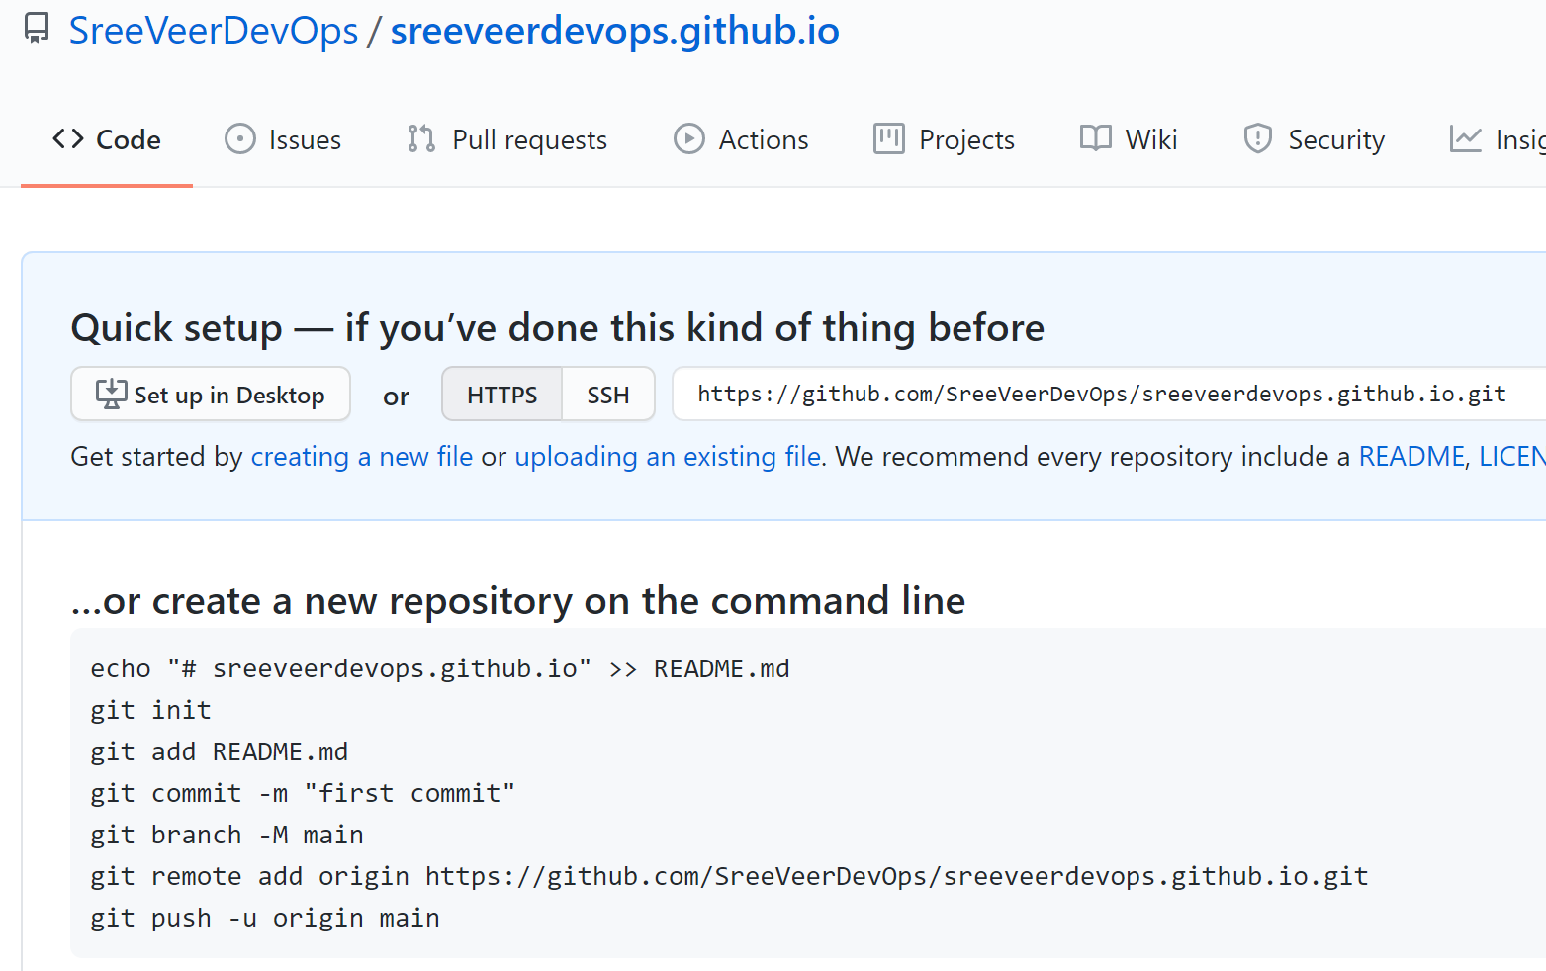

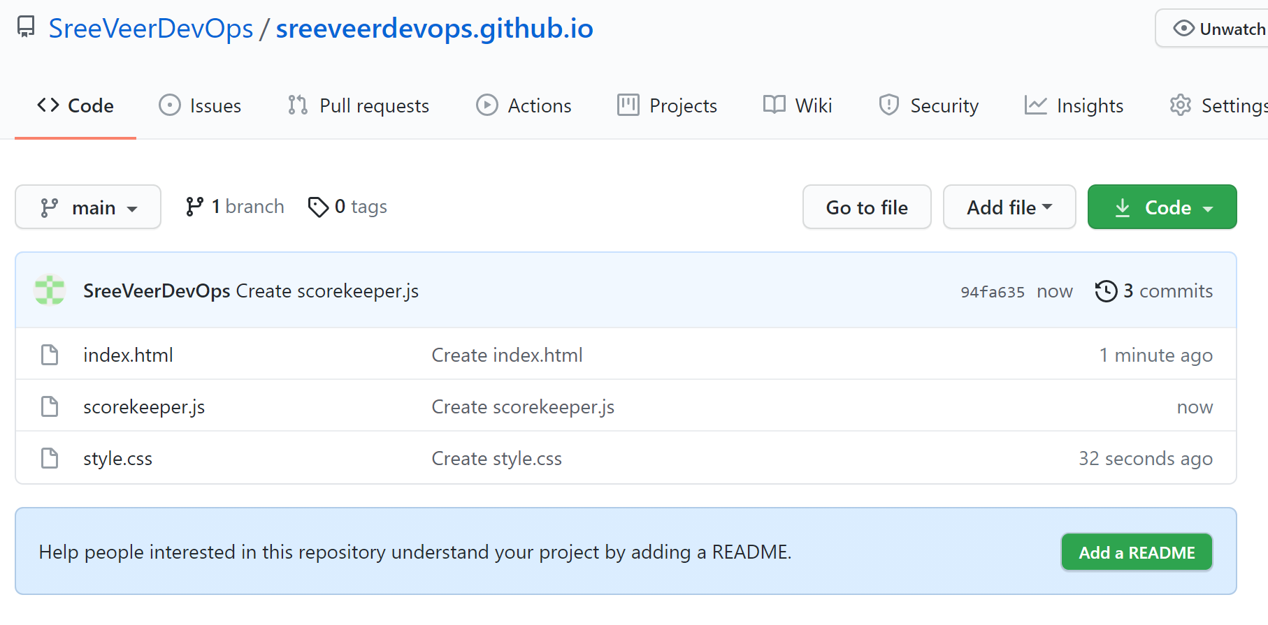

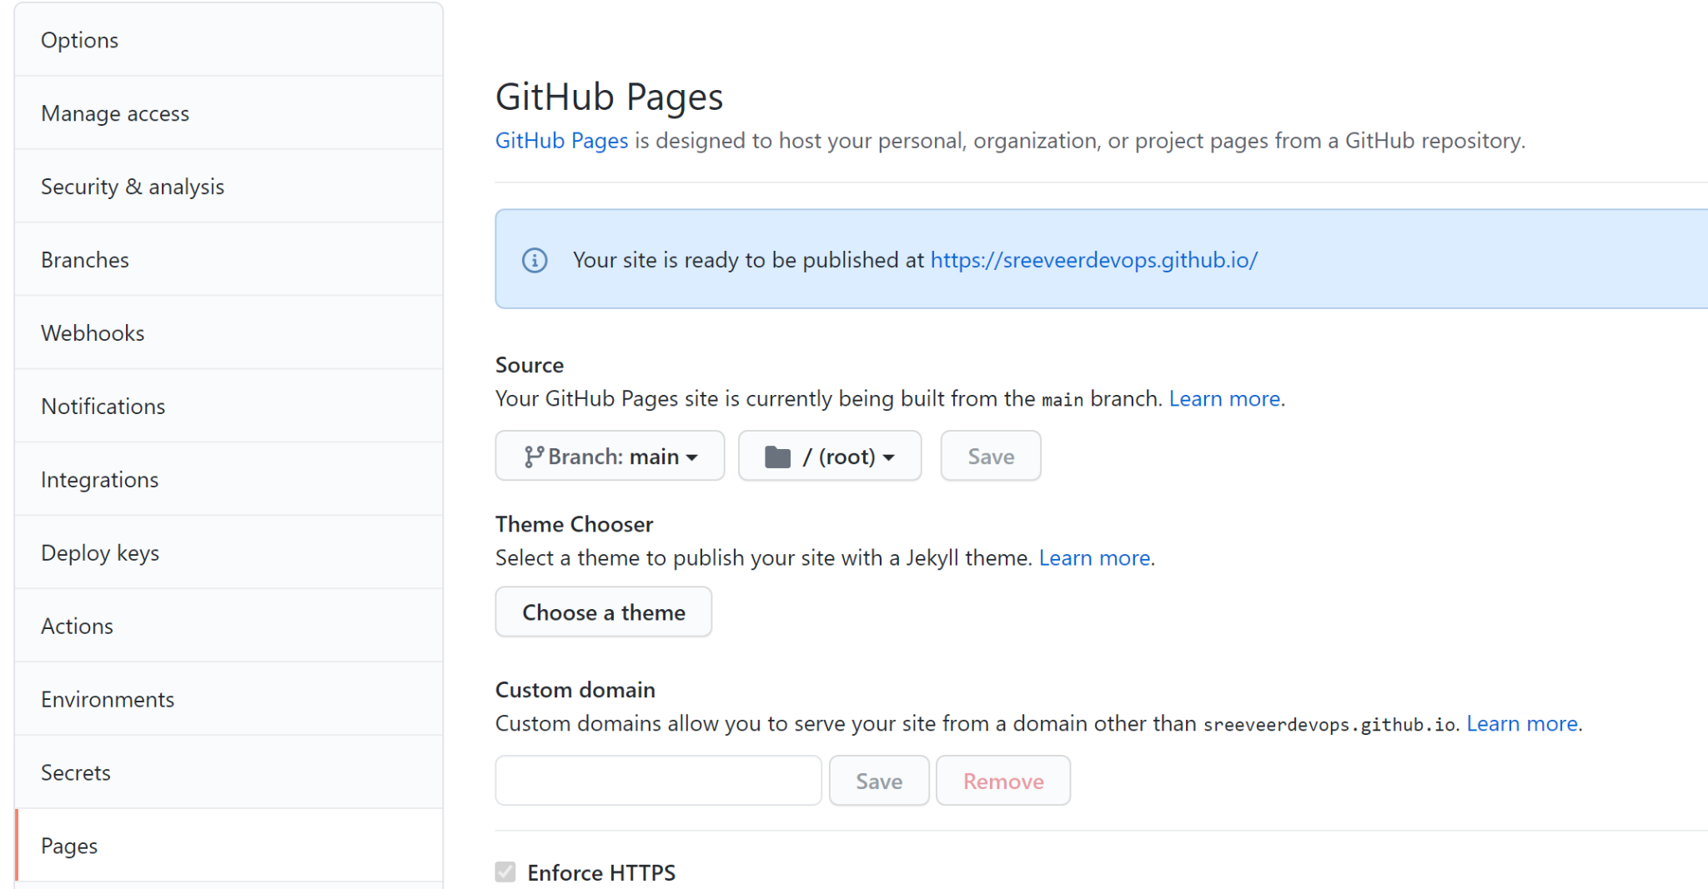



Create a new-repo as k8sb06-helm-charts

Clone the repo to local

Fecth the solr and tomcat repo from bitnami and move the tgz files to the k8sb06-helm-charts repo.

Run the following command to create index.yaml file.

CD in to k8sb06-helm-charts

helm repo index --url https://sreeveerdevops.github.io/k8sb06-helm-charts/ .

Perform git push to the repo.

Enable the github pages on the repo in github.

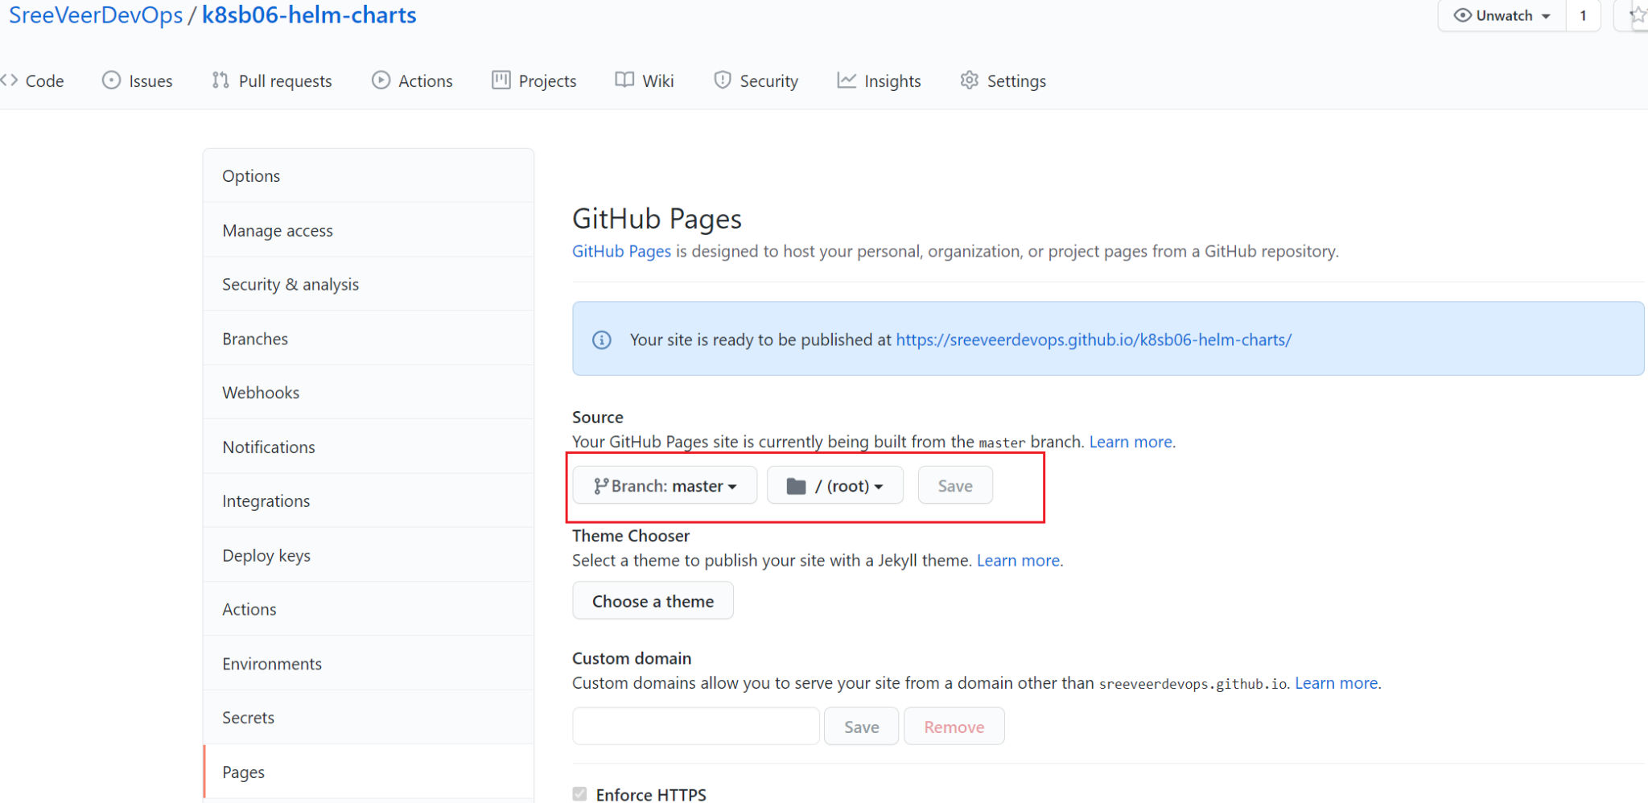

helm repo add test123 <https://sreeveerdevops.github.io/k8sb06-helm-charts/>

helm repo update

helm search repo tomcat

helm install tomtom test123/tomcat

