Deploying Highly Available Kubernetes Cluster With Rancher RKE:

1. Deploy 6 EC2 Ubuntu t2.medium instances and install docker using user data.

#!/bin/bash

sudo curl <https://get.docker.com/> | bash

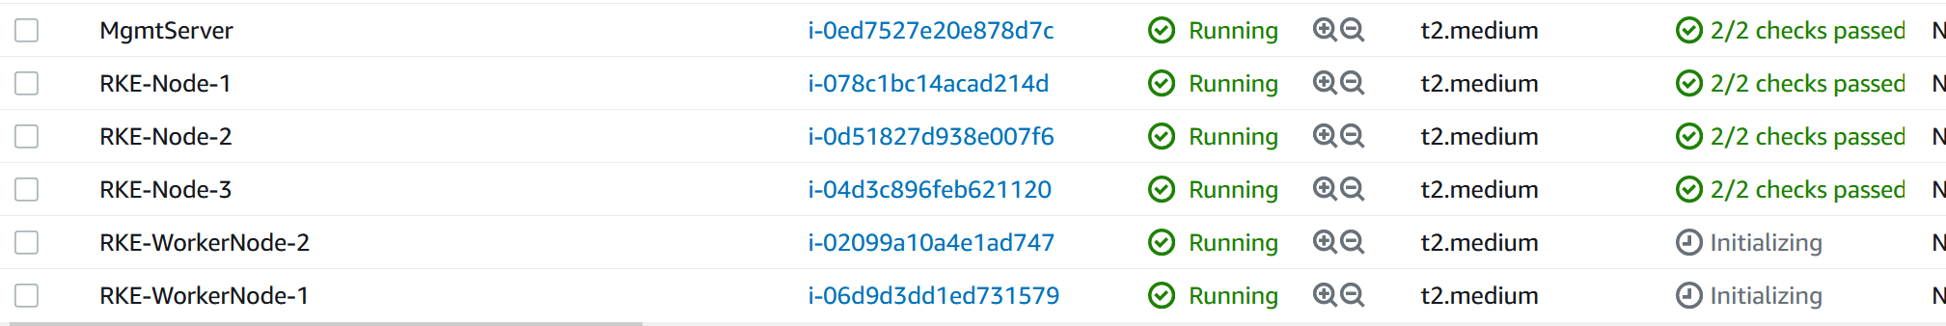

We are going to use one machine as Mgmt Server for running RKE, 3 for Master Nodes and 2 for worker nodes.

In the Mgmt Node, download the RKE binary to /usr/local/bin

<https://github.com/rancher/rke/releases>

1. On all the Master and Worker nodes, enabled password authentication for root user and also add your public key in the .ssh/authorized_keys
2. Check the SSH from Mgmt server to all Master and Worker nodes.
3. Create a directory naed as /myrkecluster and create a file called rke-cluster.yml. Paste the following in the YAML File.

nodes:

- address: 54.211.52.195

internal_address: 172.16.1.5

user: root

role: [controlplane,etcd,worker]

hostname_override: rke-node-1

- address: 3.94.82.218

internal_address: 172.16.1.99

user: root

role: [controlplane,worker,etcd]

hostname_override: rke-node-2

- address: 54.211.83.26

internal_address: 172.16.1.128

user: root

role: [controlplane,worker,etcd]

hostname_override: rke-node-3

- address: 3.86.243.77

internal_address: 172.16.1.153

user: root

role: [worker]

hostname_override: rke-workernode-1

- address: 3.84.51.83

internal_address: 172.16.1.171

user: root

role: [worker]

hostname_override: rke-workernode-2

1. Run the following commands to create the Kubernetes cluster.

rke up --config rancher-cluster.yaml

1. The RKE will create two new files as shown below.

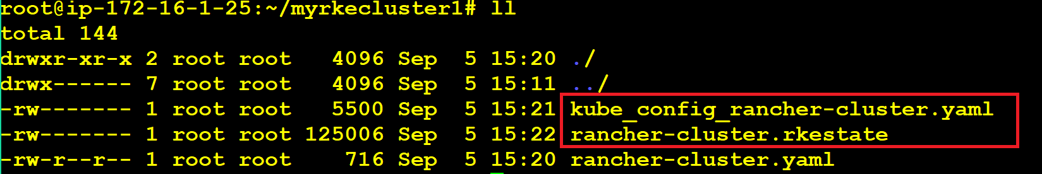

One is a kubeconfig file and other is rke-state file which contain all the details of the cluster deployed.

kubectl create deploy mytestdeploy01 --image=sreeharshav/testcontainer:v1 --replicas 10

kubectl expose deploy mytestdeploy01 --port=8000 --target-port=80 --type=NodePort

kubectl get svc

while true; do curl -sL http://ec2-54-211-52-195.compute-1.amazonaws.com:30542/ | grep -i 'IP A'; sleep 1; done