Cluster Creation Time : 15 Min

Node Group Creation Time: 5 Min

<https://www.eksworkshop.com/beginner/110_irsa/>

Using a AWS Role and Deploying EKS Cluster will give following error when you try to access the Cluster Workloads from Console.

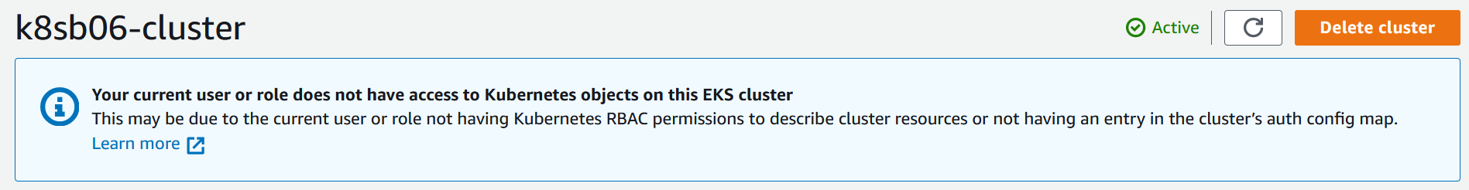

To avoid the above error, create a user with administrator policy and allow CLI and Console access. Deploying the cluster using the user credentials from CLI and once deployed, login to the console using user and check workloads.

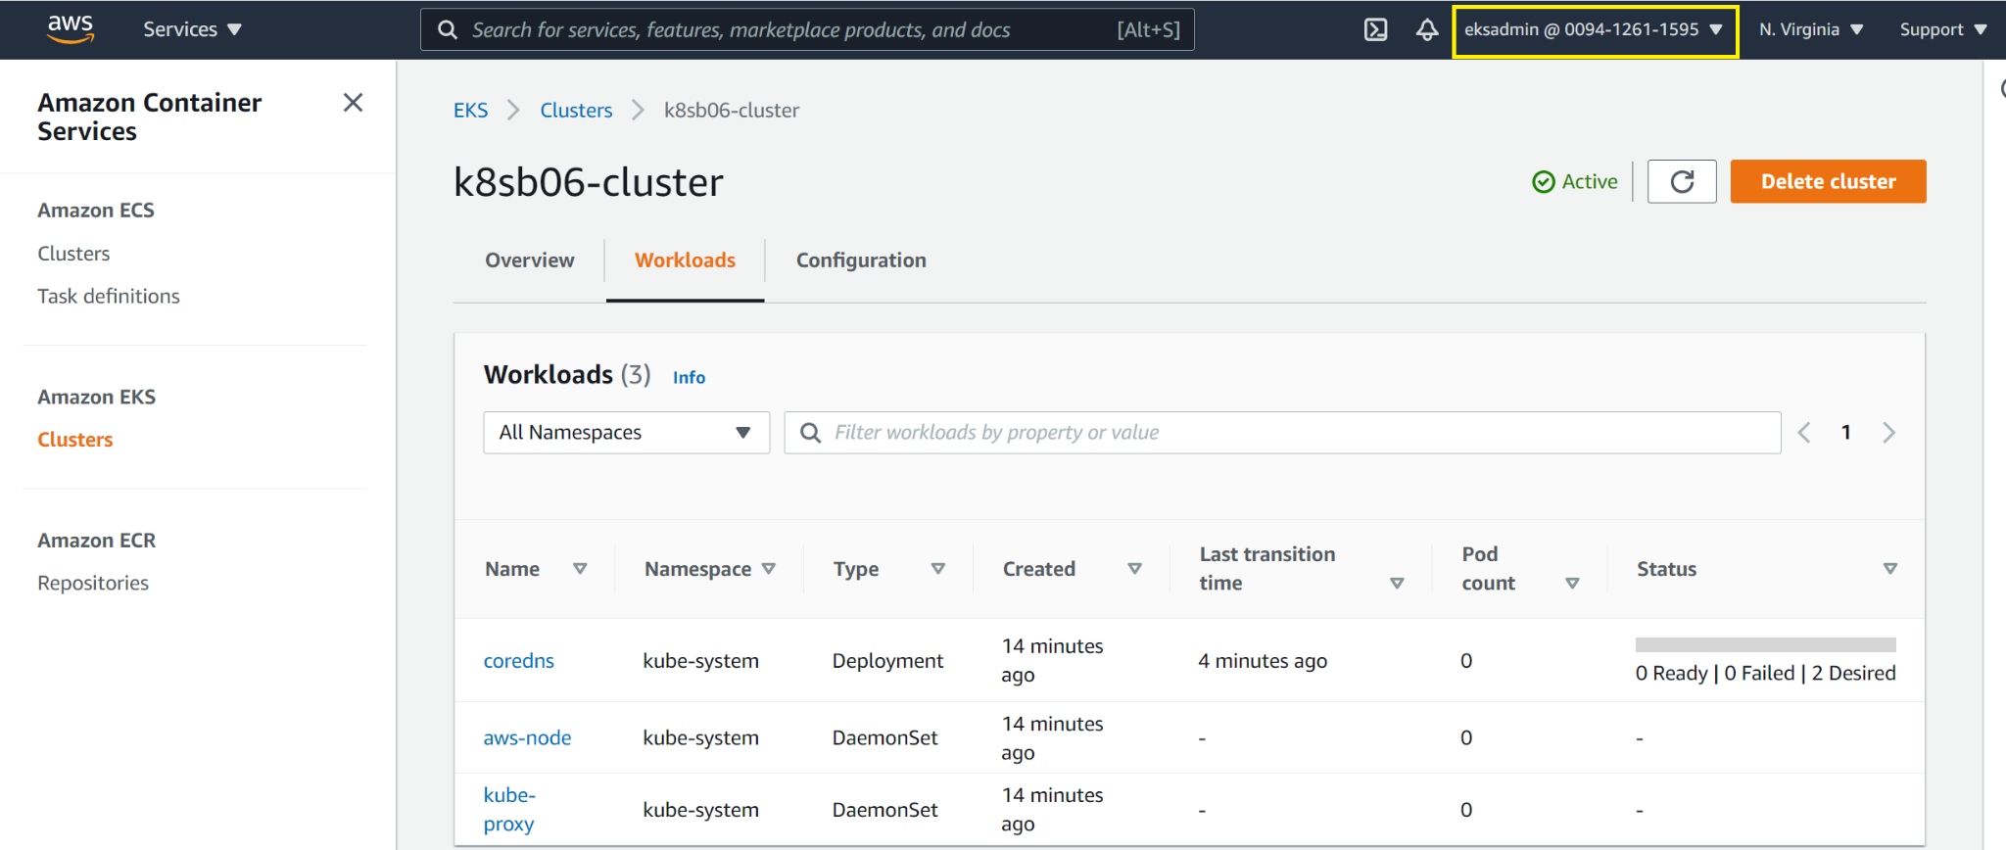

##Install AWS CLI or Choose AWS EC2 Amazon Linux 2

Run aws configure and provide access and secret key.

##Kubectl

curl -LO "https://storage.googleapis.com/kubernetes-release/release/$(curl -s https://storage.googleapis.com/kubernetes-release/release/stable.txt)/bin/linux/amd64/kubectl"

sudo mv ./kubectl /usr/local/bin/kubectl

chmod 777 /usr/local/bin/kubectl

kubectl version --short

##Download eksctl

curl --silent --location "https://github.com/weaveworks/eksctl/releases/latest/download/eksctl_$(uname -s)_amd64.tar.gz" | tar xz -C /tmp

sudo mv /tmp/eksctl /usr/local/bin

sudo chmod 700 /usr/local/bin/eksctl

eksctl version

https://documentation.sisense.com/latest/linux/prepeks.htm#gsc.tab=0

## aws configure

aws configure

AWS_REGION=$(aws configure get region)

AWS_REGION=us-east-1

eksctl create cluster \

--name "k8sb09-cluster" \

--version 1.21 \

--zones=us-east-1a,us-east-1b,us-east-1c \

--without-nodegroup

eksctl utils associate-iam-oidc-provider \

--region us-east-1 \

--cluster k8sb09-cluster \

--approve

aws eks describe-cluster --name k8sb09-cluster --query cluster.identity.oidc.issuer --output text

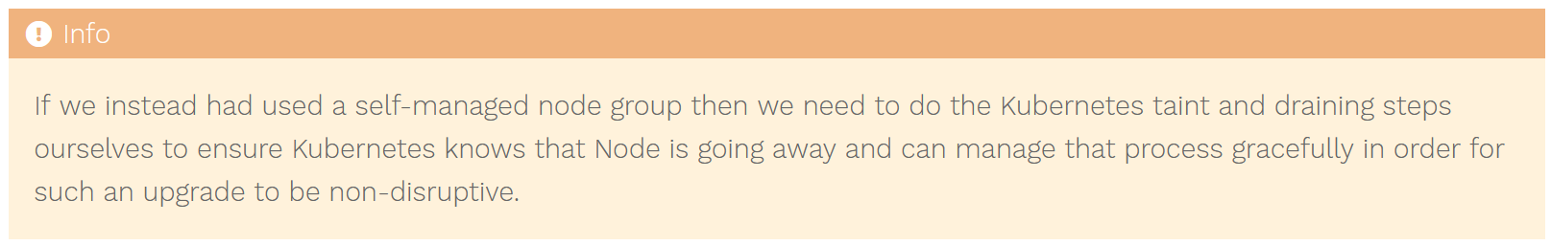

<https://eksctl.io/usage/nodegroup-upgrade/>

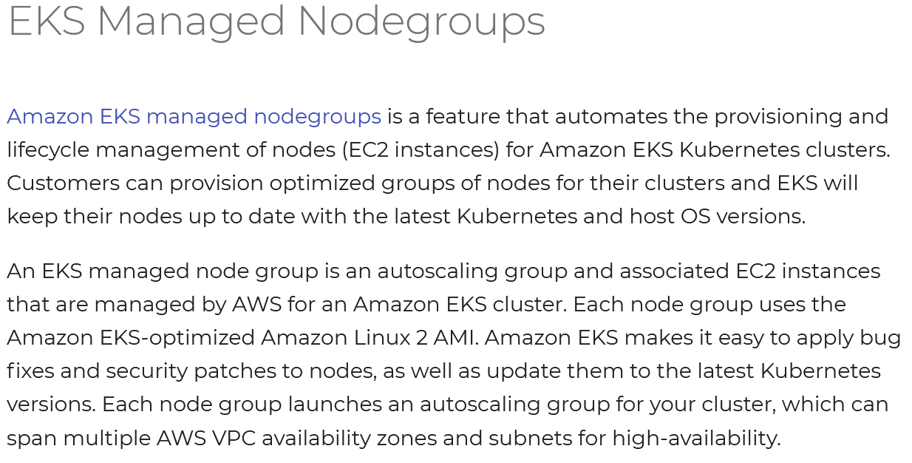

#For Node Group In Public Subnet

---Node Group 1---

eksctl create nodegroup --cluster=k8sb09-cluster \

--region=us-east-1 \

--name=high-perf-ng \

--node-type=t3.medium \

--nodes=1 \

--nodes-min=1 \

--nodes-max=2 \

--node-volume-size=20 \

--ssh-access \

--ssh-public-key=LaptopKey \

--managed \

--asg-access \

--external-dns-access \

--full-ecr-access \

--appmesh-access \

--alb-ingress-access

#For Node Group In Private

---Node Group 2---

eksctl create nodegroup --cluster=k8sb09-cluster \

--region=us-east-1 \

--name=low-perf-ng \

--node-type=t3.medium \

--nodes=1 \

--nodes-min=1 \

--nodes-max=2 \

--node-volume-size=20 \

--ssh-access \

--ssh-public-key=LaptopKey \

--managed \

--asg-access \

--external-dns-access \

--full-ecr-access \

--appmesh-access \

--alb-ingress-access

# List EKS Clusters

eksctl get clusters

# Capture Node Group name

eksctl get nodegroup --cluster=<clusterName>

# Delete Node Group

eksctl delete nodegroup --cluster=<clusterName> --name=<nodegroupName>

# Delete Cluster

eksctl delete cluster --name=<clusterName>

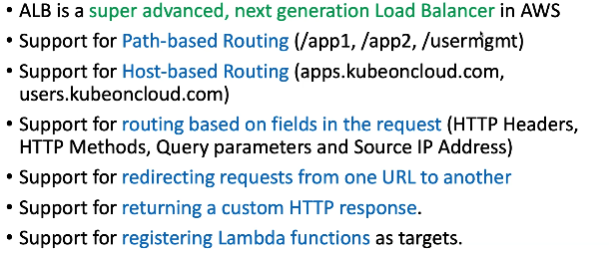

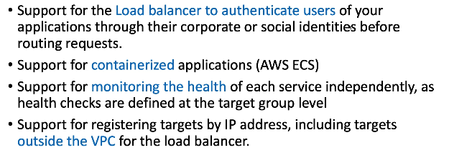

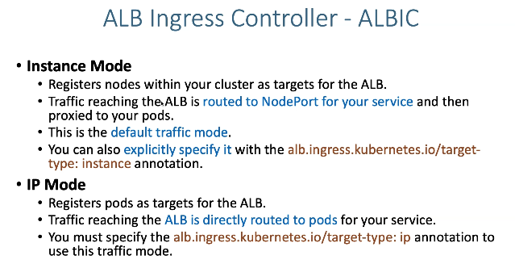

FARGATE dont support nodeport as it is serverless.

