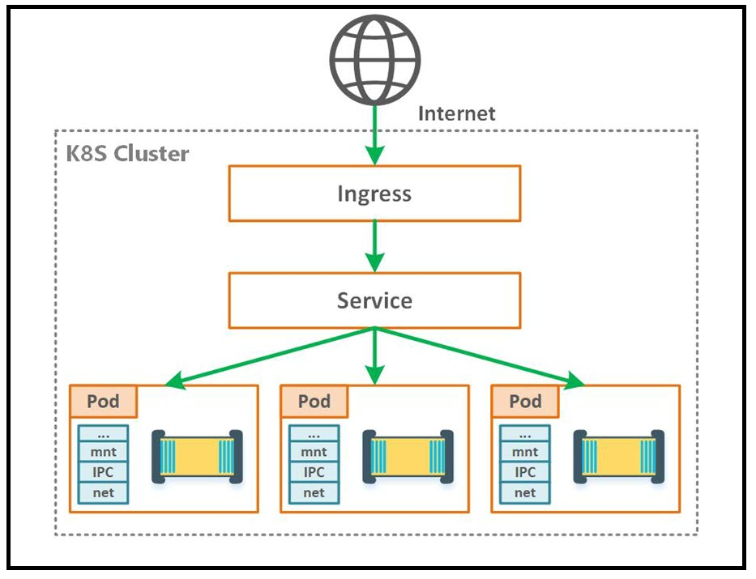

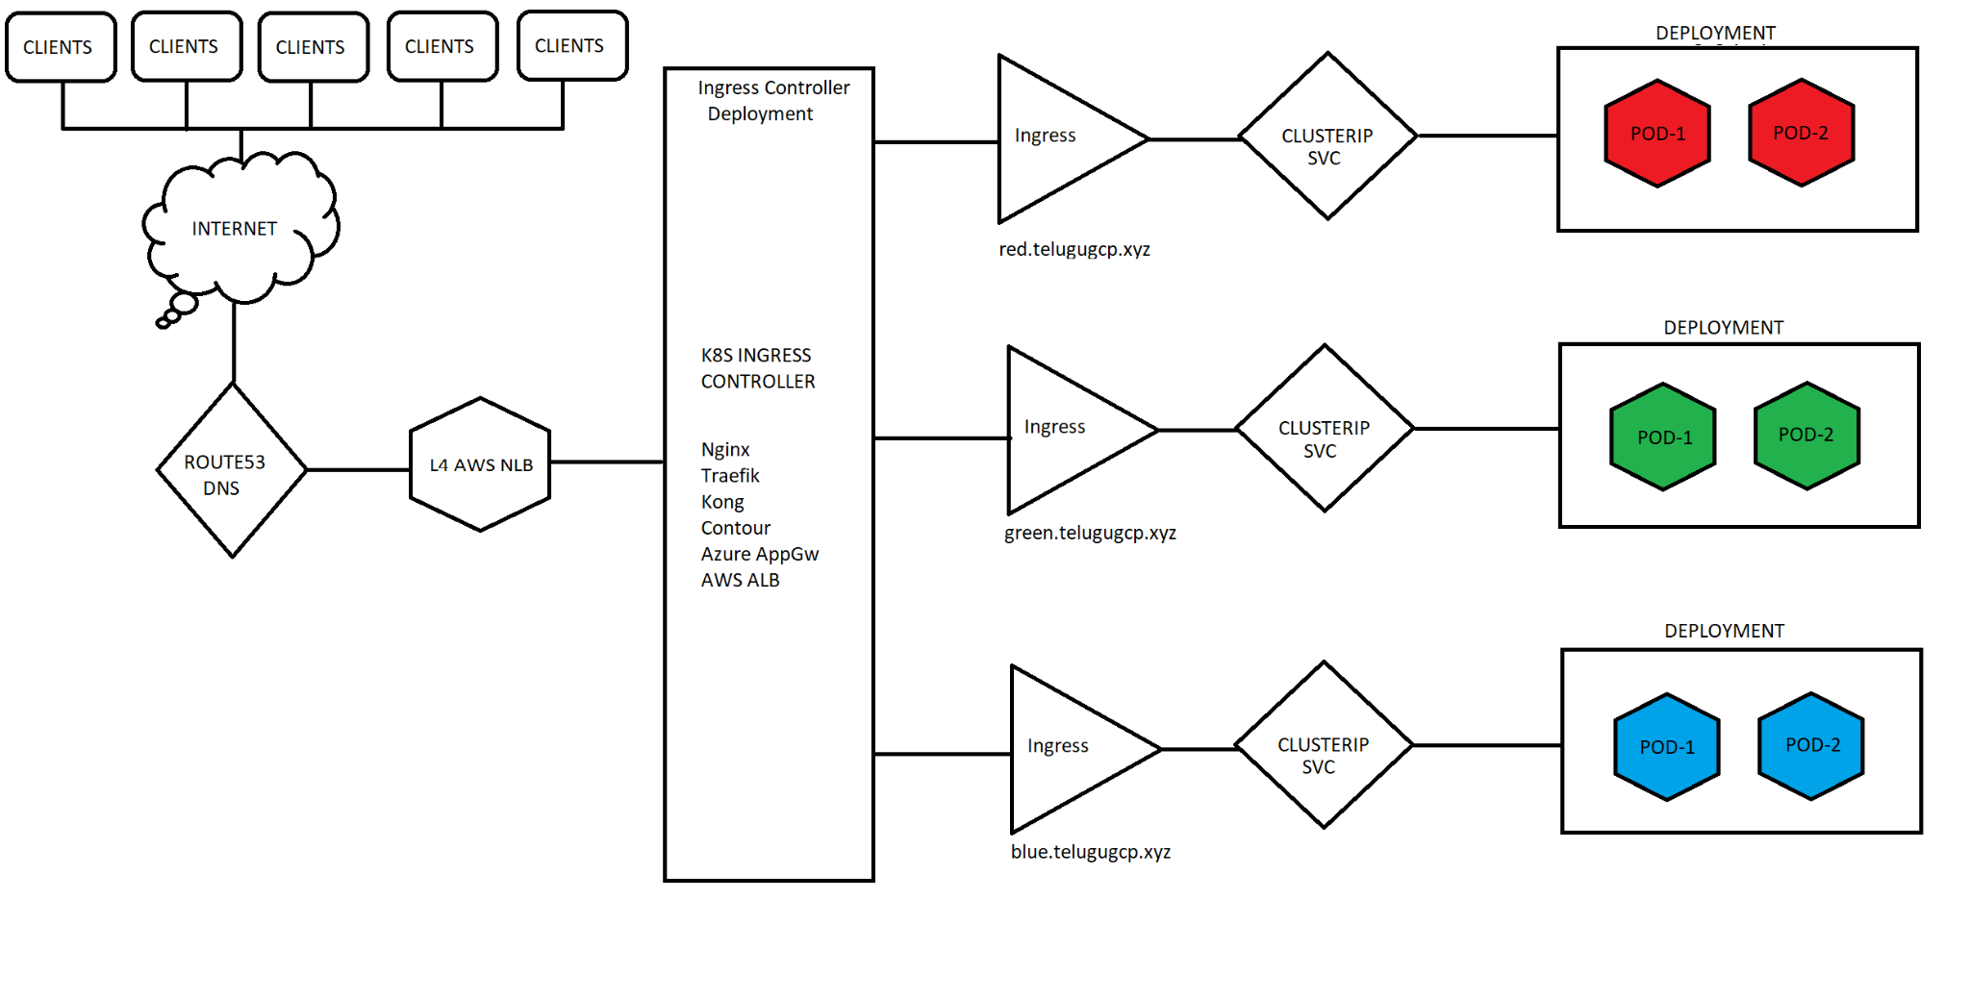

For Batch 08 I have used ingress v1.0.5

Kubectl apply -f https://raw.githubusercontent.com/kubernetes/ingress-nginx/controller-v1.0.5/deploy/static/provider/aws/deploy.yaml

Use the ingress file red-blue-green-ingress.yml

kubectl apply -f <https://raw.githubusercontent.com/kubernetes/ingress-nginx/controller-0.32.0/deploy/static/provider/aws/deploy.yaml>

https://github.com/kubernetes/ingress-nginx

Kubectl apply -f <https://raw.githubusercontent.com/kubernetes/ingress-nginx/controller-v0.44.0/deploy/static/provider/aws/deploy.yaml>

NGinx Ingress Controller 1.0.0, got issue as no address when we run kubectl get ing. This issue is solved by using the annotation for ingress as kubernetes.io/ingress.class: "nginx"

Need to check the notes. Deploy 0.44.0 using above URL.

kubectl apply -f https://raw.githubusercontent.com/kubernetes/ingress-nginx/controller-v1.0.0/deploy/static/provider/aws/deploy.yaml

https://github.com/kubernetes/ingress-nginx

https://medium.com/@madeeshafernando/deploying-multiple-ingress-controllers-in-a-kubernetes-cluster-dc6c7700a795

ku create deploy deploy1 --image=index.docker.io/sreeharshav/rollingupdate:v1

ku create deploy deploy2 --image=index.docker.io/sreeharshav/rollingupdate:v5

ku create deploy deploy3 --image=index.docker.io/sreeharshav/testcontainer:v1

ku create deploy devopsk8s --image=index.docker.io/sreeharshav/testcontainer:v1

ku create deploy apple1 --image=index.docker.io/sreeharshav/testcontainer:v1 -n apple

ku expose deploy deploy1 --port=5000 --target-port=80 --type=NodePort

ku expose deploy deploy2 --port=8000 --target-port=80

ku expose deploy deploy3 --port=9000 --target-port=80

ku expose deploy devopsk8s --port=8200 --target-port=80

ku expose deploy apple1 --port=5000 --target-port=80 -n apple

#Multiple services in the namespace can use the same port type but when we expose using NodePort

#they will have a random node port.

—- - NEW PI FOR INGRESS—-

apiVersion: networking.k8s.io/v1

kind: Ingress

metadata:

name: sreek8s-deploy-ingress

spec:

ingressClassName: nginx

tls:

- hosts:

- www.sreeharshak8s.xyz

secretName: sreeharshak8s

rules:

- host: www.sreeharshak8s.xyz

http:

paths:

- path: /

pathType: Prefix

backend:

service:

name: sreek8s-deploy

port:

number: 8000

—---BELOW IS OLD API—-

apiVersion: extensions/v1beta1

kind: Ingress

metadata:

name: example-ingress

annotations:

ingress.kubernetes.io/rewrite-target: /

spec:

rules:

- host: www.sreek8s.xyz

http:

paths:

- path: /

backend:

serviceName: deploy01

servicePort: 8000

apiVersion: extensions/v1beta1

kind: Ingress

metadata:

name: example-ingress-2

annotations:

ingress.kubernetes.io/rewrite-target: /

spec:

rules:

- host: app1.sreek8s.xyz

http:

paths:

- path: /

backend:

serviceName: deploy2

servicePort: 8000

apiVersion: extensions/v1beta1

kind: Ingress

metadata:

name: example-ingress-3

annotations:

ingress.kubernetes.io/rewrite-target: /

spec:

rules:

- host: app2.sreek8s.xyz

http:

paths:

- path: /

backend:

serviceName: deploy3

servicePort: 9000

apiVersion: extensions/v1beta1

kind: Ingress

metadata:

name: example-ingress4

annotations:

ingress.kubernetes.io/rewrite-target: /

spec:

rules:

- host: sreek8s.xyz

http:

paths:

- path: /

backend:

serviceName: deploy1

servicePort: 5000

apiVersion: extensions/v1beta1

kind: Ingress

metadata:

name: devopsk8s-ingress4

annotations:

ingress.kubernetes.io/rewrite-target: /

spec:

rules:

- host: www.devopsk8s.xyz

http:

paths:

- path: /

backend:

serviceName: devopsk8s

servicePort: 8200

apiVersion: extensions/v1beta1

kind: Ingress

metadata:

name: apple-ingress

annotations:

ingress.kubernetes.io/rewrite-target: /

spec:

rules:

- host: app.devopsk8s.xyz

http:

paths:

- path: /

backend:

serviceName: apple1

servicePort: 8300

apiVersion: extensions/v1beta1

kind: Ingress

metadata:

namespace: apple

name: apple-ingress-2

annotations:

ingress.kubernetes.io/rewrite-target: /

spec:

rules:

- host: japp.devopsk8s.xyz

http:

paths:

- path: /

backend:

serviceName: apple1

servicePort: 5000

apiVersion: extensions/v1beta1

kind: Ingress

metadata:

name: apple-ingress-2

annotations:

ingress.kubernetes.io/rewrite-target: /

spec:

rules:

- host: japp.devopsk8s.xyz

http:

paths:

- path: /

backend:

serviceName: deploy1

servicePort: 5000