Challenges of a Microservice Application

<https://www.youtube.com/watch?v=16fgzklcF7Y>

<https://www.youtube.com/watch?v=voAyroDb6xk>

Good article on ServiceMesh:

<https://www.altoros.com/blog/using-istio-to-unify-microservices-with-a-service-mesh-on-kubernetes/>

Service Mesh manages communication between the microservices. Why do we need it?

Imagine application which has multiple microservices which is deployed in the K8S Cluster. Some of the services includes webservice, paymentservice, shoppingcart etc

Each microservice (pod & service) have its own business logic. Apart from it, following are needed as well. Microservices must talk to each other.

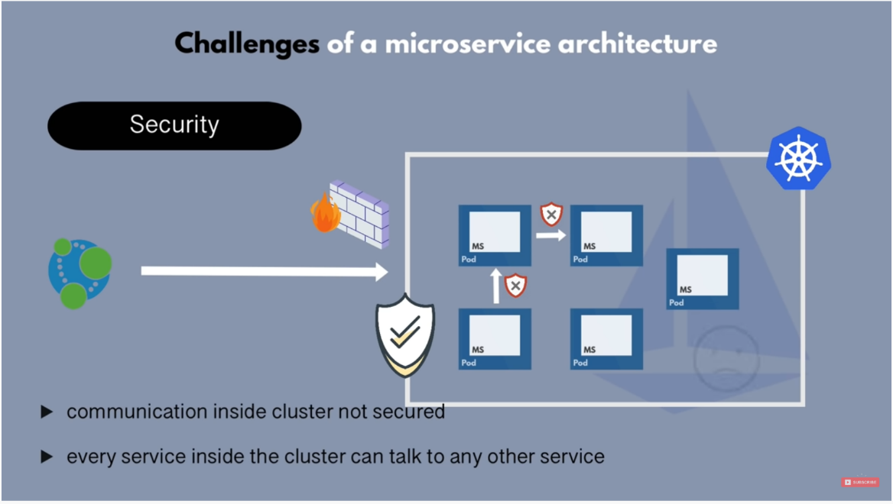

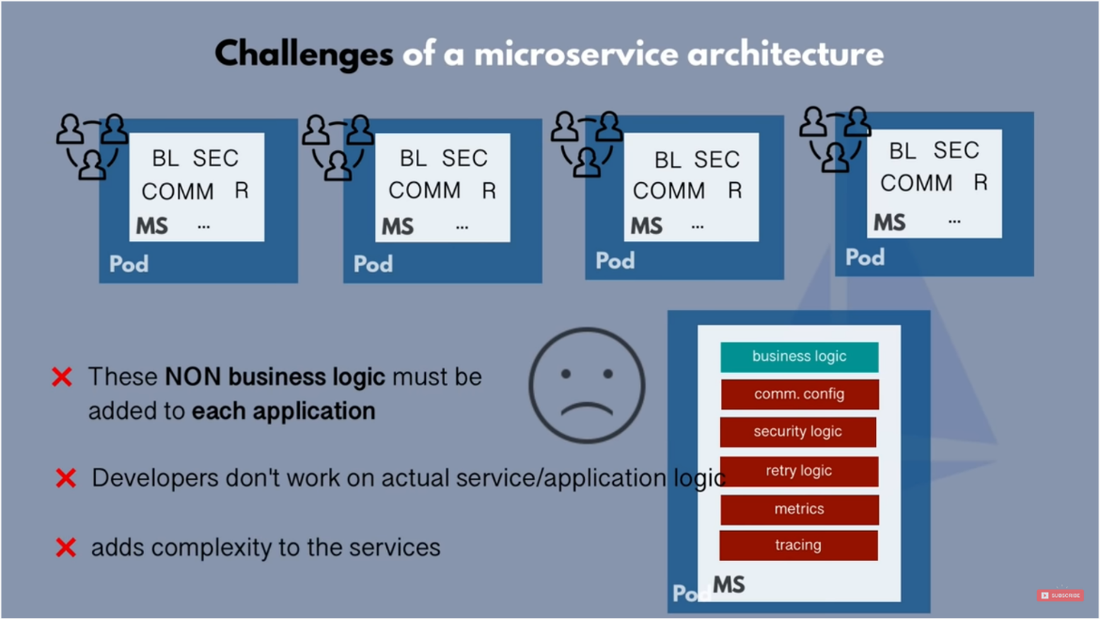

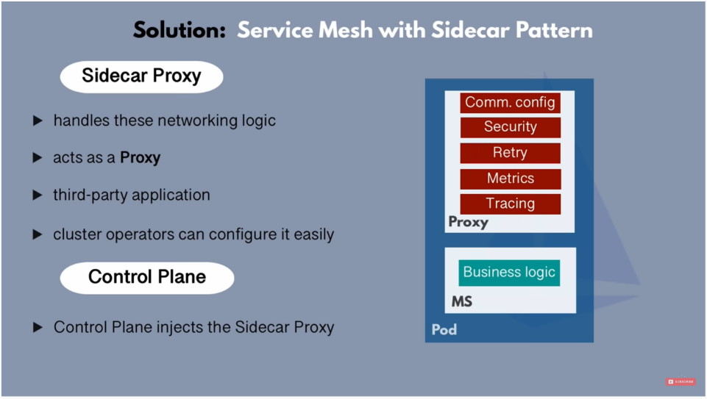

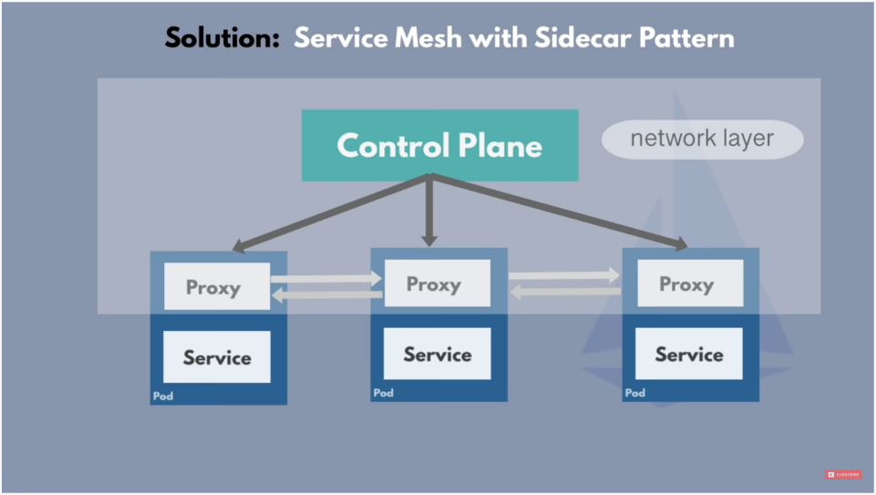

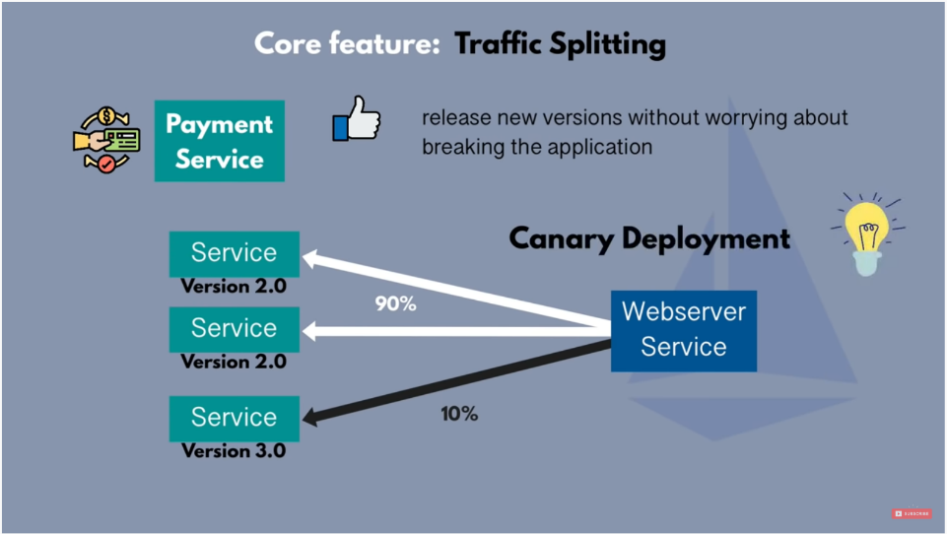

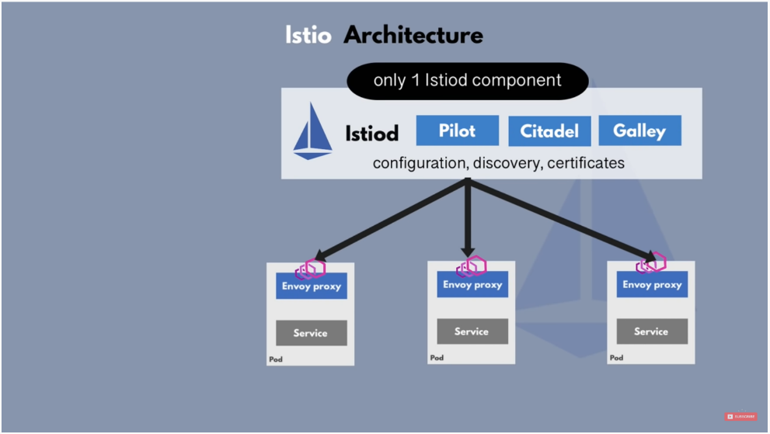

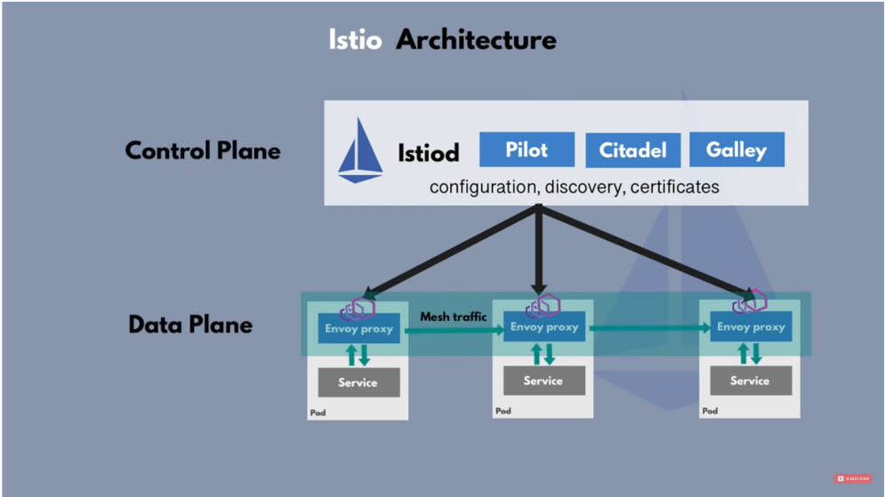

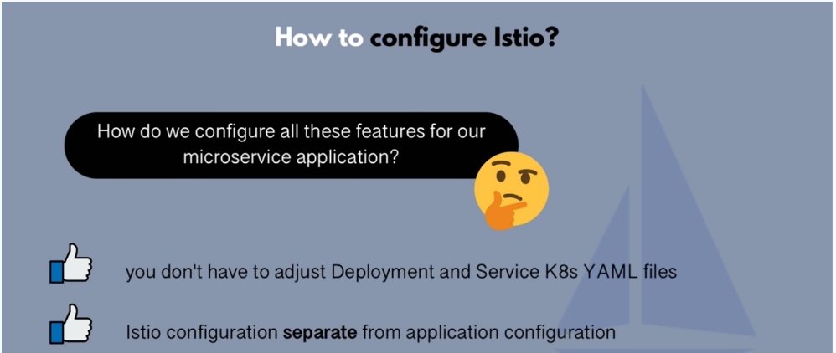

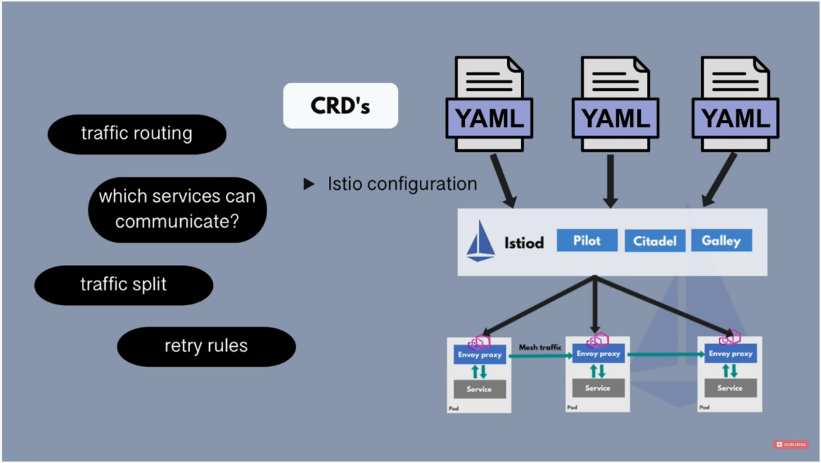

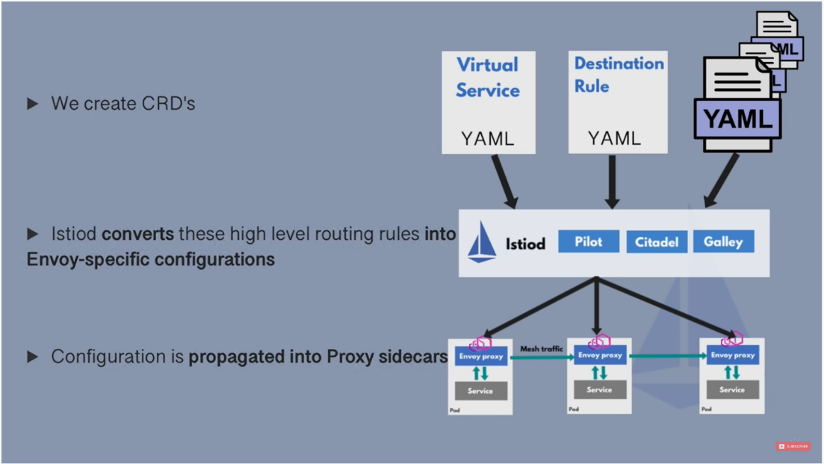

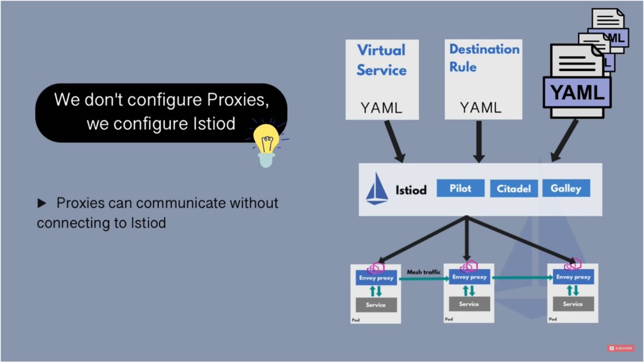

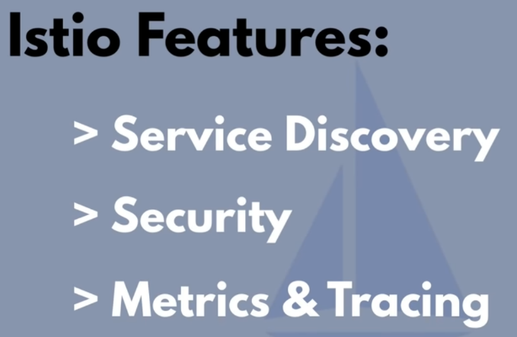

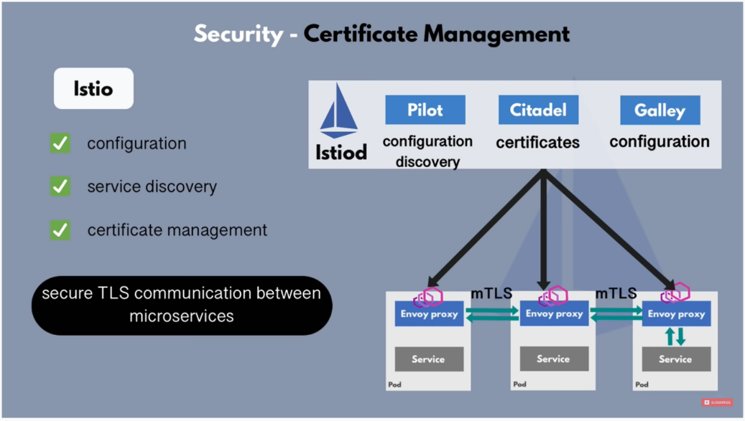

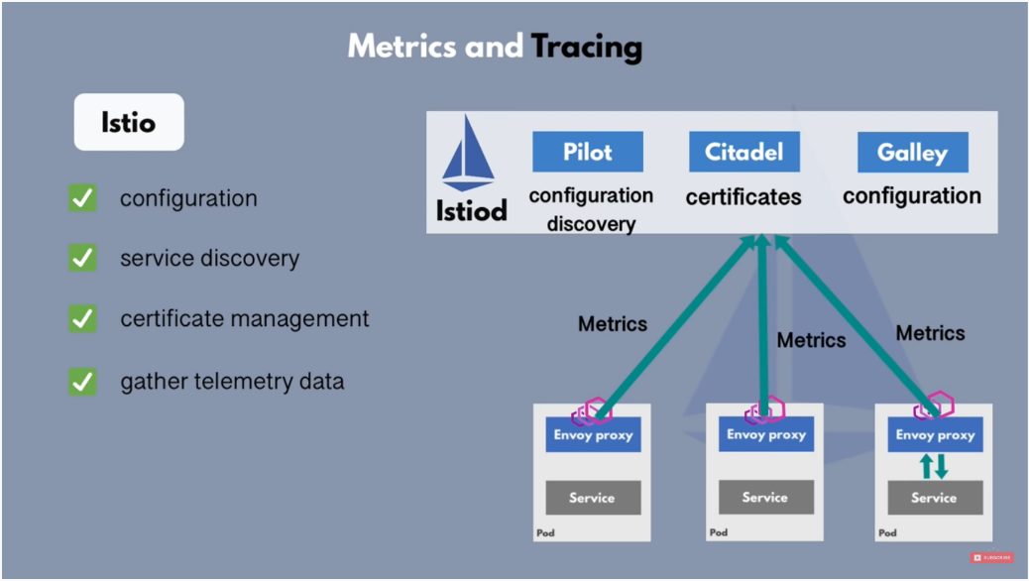

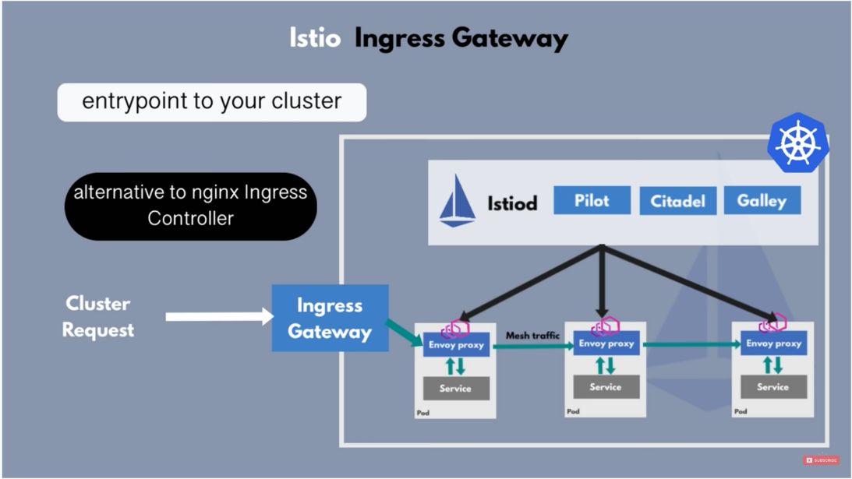

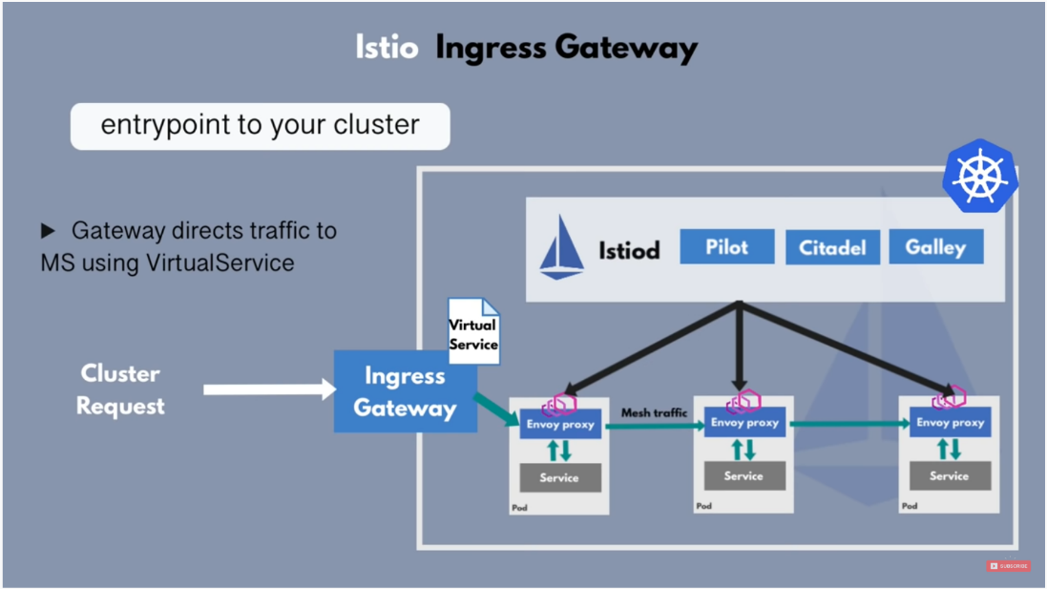

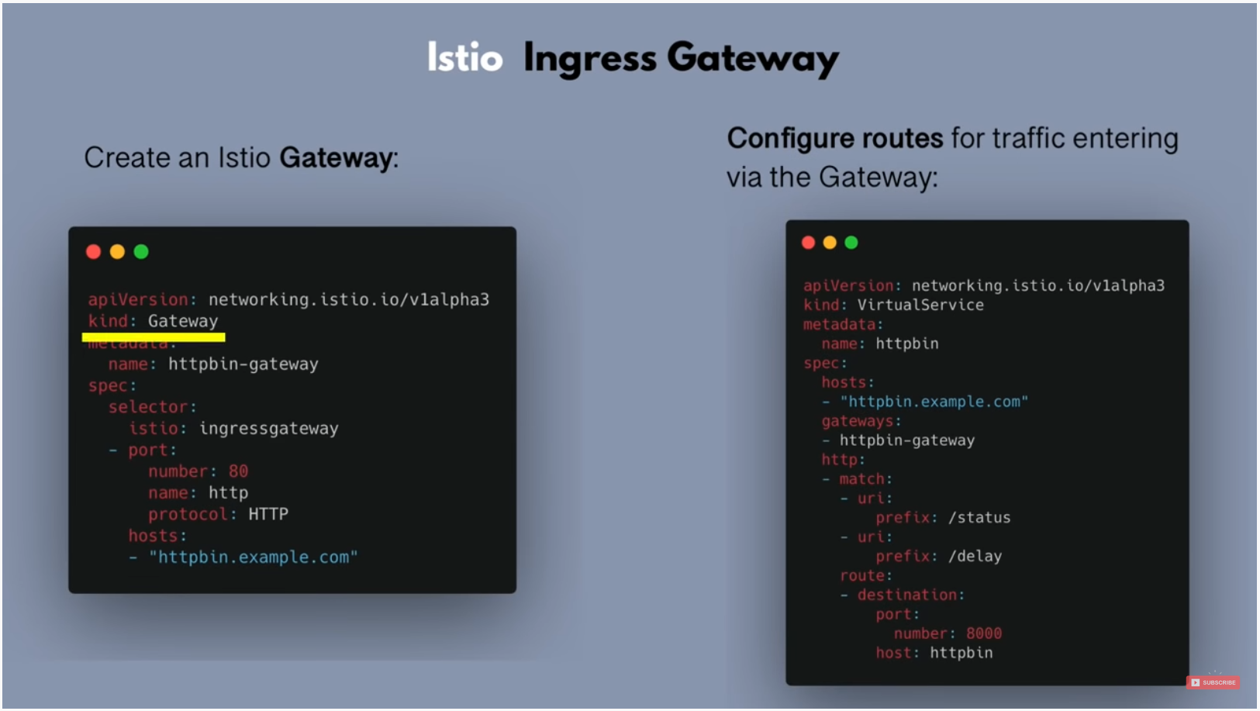

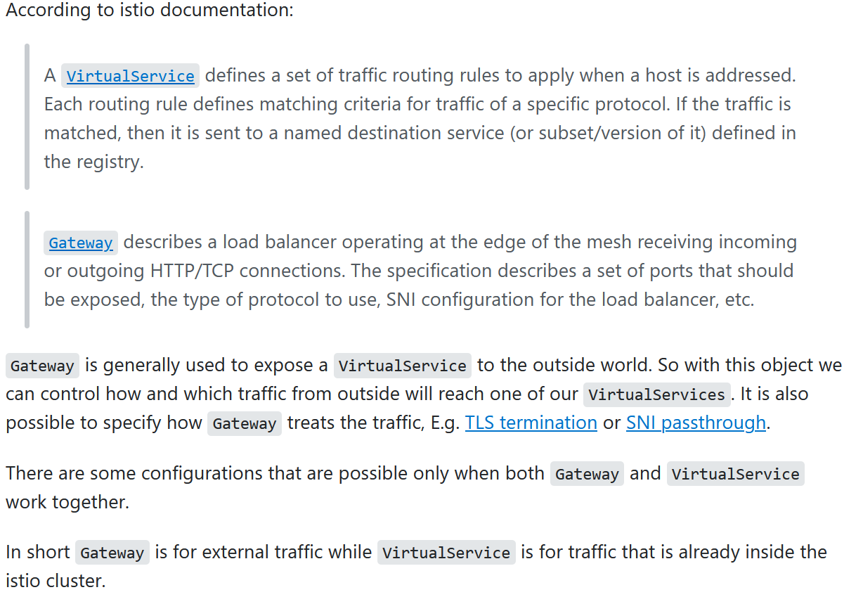

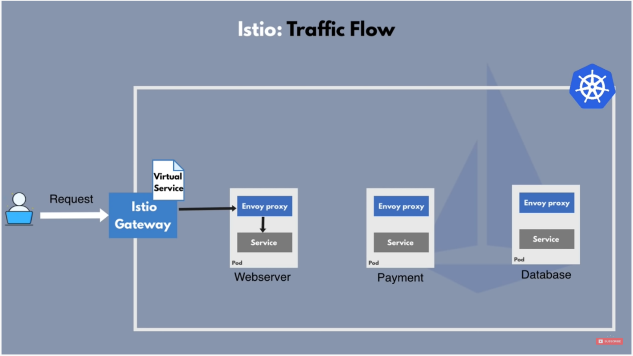

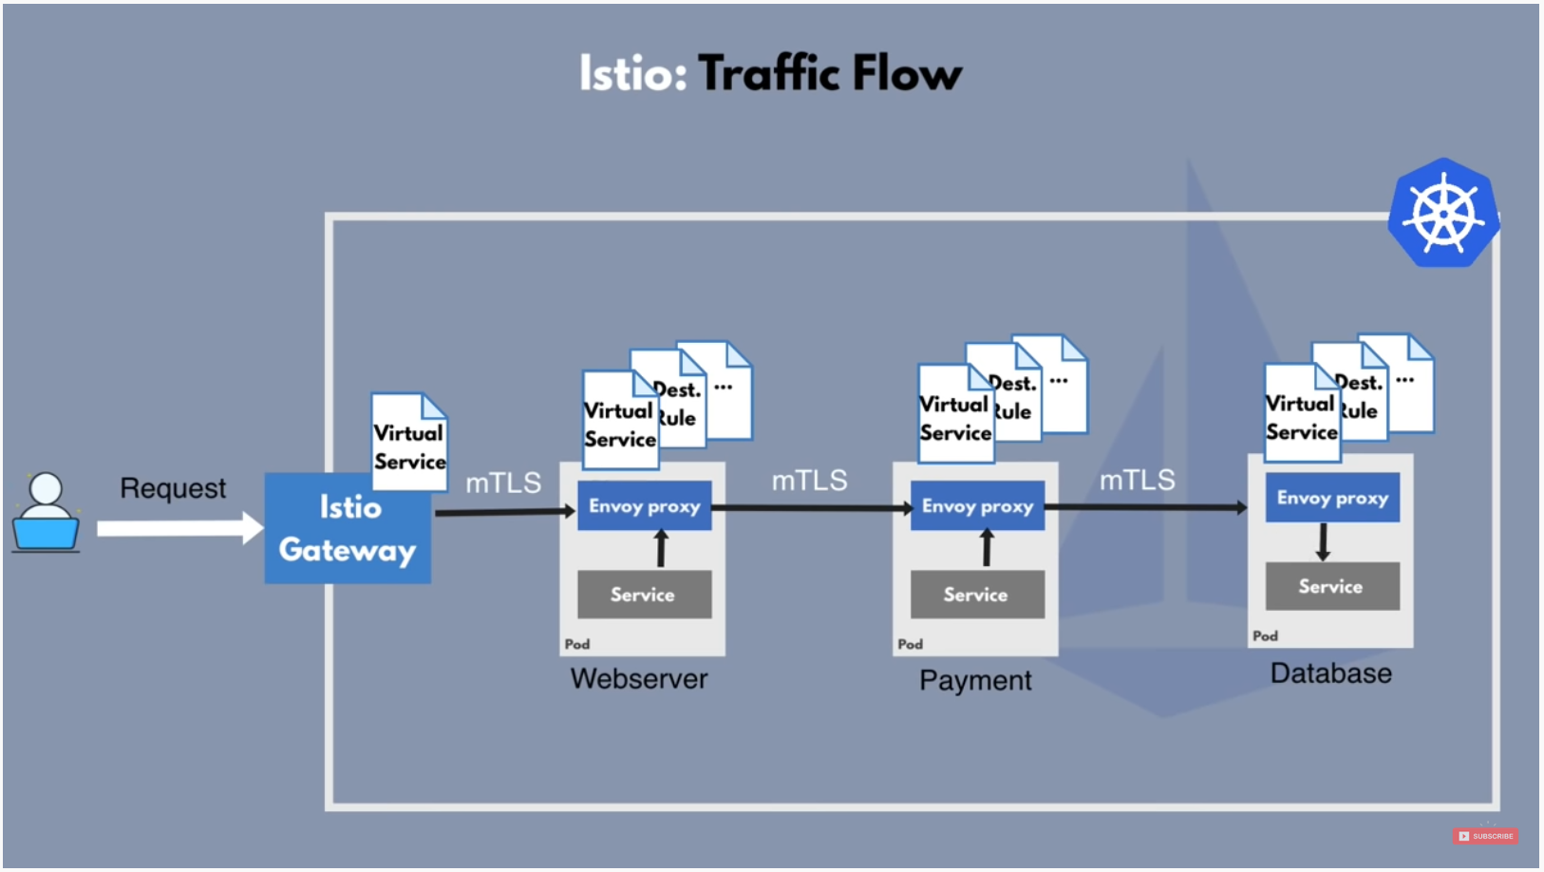

curl -sfL https://get.k3s.io | sh - #Installs Traefik Ingress Controller

Below command for K3S for using ISTIO:

curl -sfL https://get.k3s.io | INSTALL_K3S_EXEC="--no-deploy traefik" sh -s –

cat /var/lib/rancher/k3s/server/node-token

curl -sfL https://get.k3s.io | K3S_URL=https://192.168.1.248:6443 K3S_TOKEN=<token> sh -

/usr/local/bin/k3s-uninstall.sh

export KUBECONFIG=/etc/rancher/k3s/k3s.yaml

kubectl label namespace default istio-injection=enabled

ku port-forward svc/grafana -n istio-system 20001

ku port-forward svc/grafana -n istio-system 3000

ISTIO Profiles:

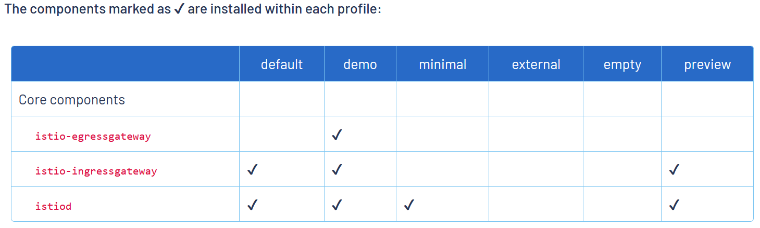

istioctl profile list

istioctl install --set profile=minimal

istioctl profile list

Uninstall istio:

istioctl x uninstall --purge