<https://medium.com/better-programming/k8s-tips-using-a-serviceaccount-801c433d0023>

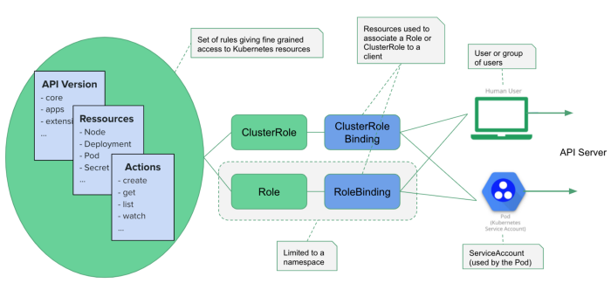

Service Account Creation - ClusterRole Creation - ClusterRoleBinding Creation

apiVersion: v1

kind: ServiceAccount

metadata:

name: api-access

namespace: default

---

apiVersion: rbac.authorization.k8s.io/v1

kind: ClusterRole

metadata:

name: pods-sa-cluster-admin-role

rules:

- apiGroups: ["*"]

resources: ["*"]

verbs: ["*"]

---

kind: ClusterRoleBinding

apiVersion: rbac.authorization.k8s.io/v1

metadata:

name: pods-sa-cluster-admin-role-binding

subjects:

- kind: ServiceAccount

name: api-access

namespace: default

roleRef:

kind: ClusterRole

name: pods-sa-cluster-admin-role

apiGroup: rbac.authorization.k8s.io

---

apiVersion: v1

kind: Pod

metadata:

labels:

run: kubectlpod2

name: kubectlpod2

namespace: default

spec:

serviceAccountName: api-access

containers:

- image: sreeharshav/kubectlpod:v2

name: kubectlpod2

POD SPEC for ServiceAccount Testing:

Image used for this testing is **sreeharshav/kubectlpod:v2**

---

apiVersion: v1

kind: Pod

metadata:

labels:

run: kubectlpod2

name: kubectlpod2

namespace: default

spec:

serviceAccountName: api-access

containers:

- image: sreeharshav/kubectlpod:v2

name: kubectlpod2