https://awesomeopensource.com/projects/kubectl-plugins

<https://krew.sigs.k8s.io/docs/user-guide/setup/install/>

<https://krew.sigs.k8s.io/plugins/>

Kubectx -> helps to change between different contexts and clusters.

Kubens -> helps to change between name namespaces

<https://github.com/ahmetb/kubectx/releases>

KREW Installation:

<https://github.com/kubernetes-sigs/krew>

wget <https://github.com/kubernetes-sigs/krew/releases/download/v0.4.2/krew-linux_amd64.tar.gz>

tar xzvf krew-linux_amd64.tar.gz

mv krew-linux_amd64 /usr/local/bin/krew

export PATH="${PATH}:${HOME}/.krew/bin"

alias kk='kubectl krew'

krew install view-utilization

ku view-utilization -n default

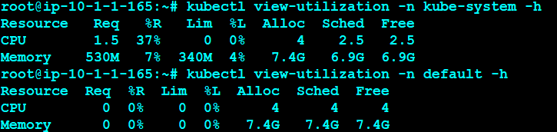

ku krew install tree

ku run hello --image=sreeharshav/rollingupdate:v5 --replicas 3

ku tree deployment hello

ku krew install example

ku example deployment

kk install iexec

ku krew install topology

ku topology pod node

krew install rbac-view

kubectl rbac-view

http://ec2-18-206-64-91.compute-1.amazonaws.com:8800/index.html

ku krew install tail

ku krew install service-tree

ku expose deployment hello --port=8300 --target-port=80 --type=NodePort --name hello3

kubectl service-tree

kk install popeye

kubectl popeye

kk install pod-logs

kubectl pod-logs

kk install iexec

ku iexec hello-d4d6db749-bmzht bash

alias exec='kubectl iexec'

exec hello-d4d6db749-fzdff bash

kk install deprecations

kubectl deprecations

krew install popeye

krew install view-utilization

krew install ktop

krew install node-admin

krew install node-shell #same as node-admin

krew install rbac-view

kubectl popeye -n default

kubectl view-utilization -n default

kubectl ktop --namespace kube-system

kubectl node-admin #Deploys a POD with all tools

kubectl node-shell ip-172-20-42-159.ec2.internal

Installing k9s:

curl -sS https://webinstall.dev/k9s | bash