<https://thenewstack.io/logging-for-kubernetes-what-to-log-and-how-to-log-it/>

USING AWSLOGS for Management Cluster will impact the fluentD logging. Make sure you have tested the fluentD first enable the AWS Logs for the Cluster Management Logs. We have experienced problem with AWSLOgs agent along with FluentD.

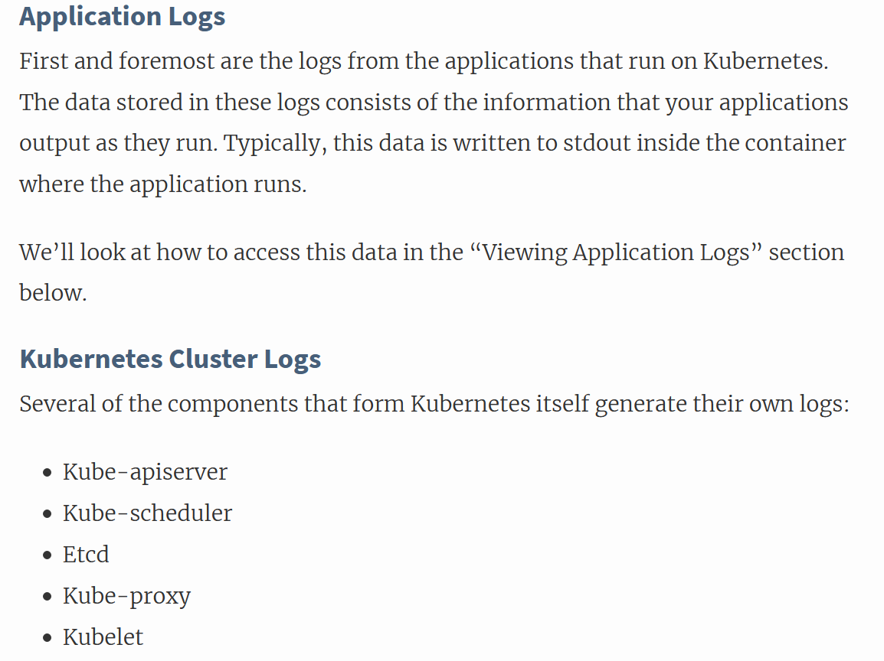

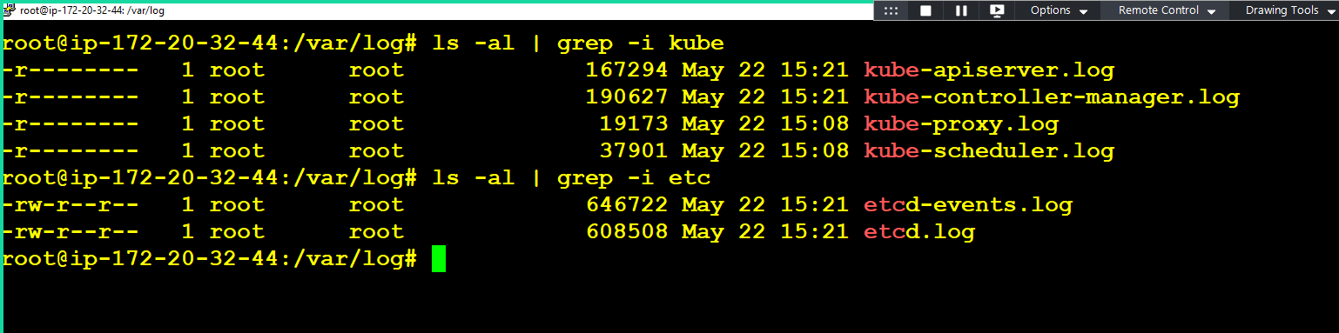

1. Management Logs with KOPS

/var/log/kube-apiserver.log

/var/log/kube-controller-manager.log

/var/log/kube-proxy.log

/var/log/kube-scheduler.log

/var/log/etcd-events.log

/var/log/etcd.log

We will use AWS Cloudwatch Log & Log Groups to send the management logs. Assign “CloudWatchLogsFullAccess” Policy to Master Server Role.

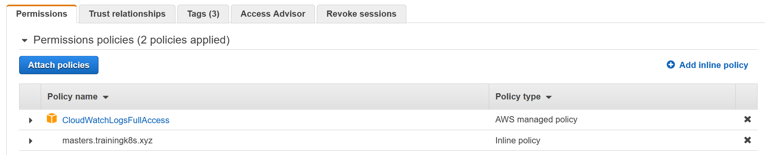

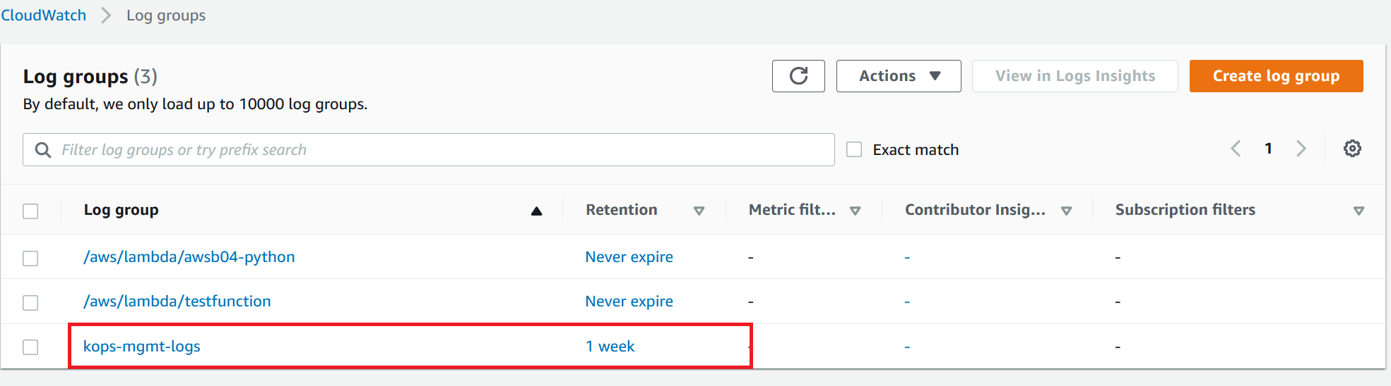

Install awslogs application in the Master Server running UBunt 18.04

<https://docs.aws.amazon.com/AmazonCloudWatch/latest/logs/QuickStartEC2Instance.html>

Ubuntu 18.04 comes with python3 and we need to python2 .

apt install python -y

curl https://s3.amazonaws.com/aws-cloudwatch/downloads/latest/awslogs-agent-setup.py -O

sudo python ./awslogs-agent-setup.py --region us-east-1