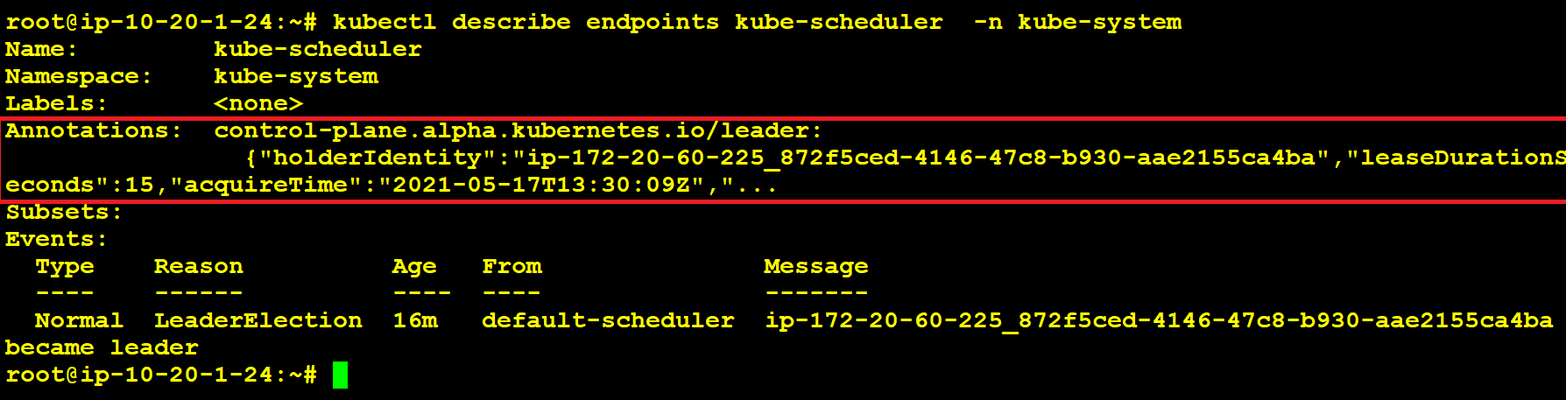

#!/bin/bash

#This Deployes 3 Masters and 2 Worker Nodes.

kops create cluster --name=sreek8s.xyz --state=s3://sreek8s --zones=us-east-1a,us-east-1b,us-east-1c,us-east-1d --node-count=2 --node-size=t2.micro --master-size=t2.micro --master-zones=us-east-1a,us-east-1b,us-east-1c --master-volume-size 10 --node-volume-size 10 --dns-zone=sreek8s.xyz --yes

kubectl describe ep -n kube-system kube-controller-manager

https://aws.amazon.com/blogs/compute/kubernetes-clusters-aws-kops/

http://thesecretlivesofdata.com/raft/

https://www.digitalocean.com/community/tutorials/how-to-back-up-and-restore-a-kubernetes-cluster-on-digitalocean-using-velerohttps://www.digitalocean.com/community/tutorials/how-to-back-up-and-restore-a-kubernetes-cluster-on-digitalocean-using-velero