kops create cluster --name=telugugcp.xyz \

--state=s3://telugugcp.xyz --zones=us-east-1a,us-east-1b,us-east-1c \

--node-count=2 --node-size=t3.medium --master-size=t3.medium \

--master-volume-size 10 --node-volume-size 10 \

--dns-zone=telugugcp.xyz --kubernetes-version 1.19.9 --yes

ku create deploy nginx01 --image=sreeharshav/rollingupdate:v5 --replicas 3

ku expose deployment nginx01 --port=80 --target-port=80 --type=LoadBalancer

ubuntu@ip-192-168-1-100:/tmp$ kops upgrade cluster --state=s3://sreek8s

Using cluster from kubectl context: k8sb04.k8s.local

ITEM PROPERTY OLD NEW

Cluster KubernetesVersion 1.19.9 1.20.6

----------------------------------------------------------------

kops update cluster k8sb04.k8s.local --state=s3://sreek8s

kops update cluster k8sb04.k8s.local --state=s3://sreek8s --yes

kops rolling-update cluster --state=s3://sreek8s --yes

# Upgrading Kubernetes Cluster with Kops:

<https://gist.github.com/stevenc81/e8d86d68a2aff69b7268938fa1f711fe>

<https://ahmet.im/blog/mastering-kubeconfig/>

**KOPS ROLLBACK to 1.19.9:**

kops edit cluster

Change the value of kubernetesVersion as below. Save and Exit.

kubernetesVersion: 1.19.9

kops update cluster k8sb04.k8s.local --state=s3://sreek8s --yes

kops rolling-update cluster --state=s3://sreek8s --yes

KUBECONFIG=config:config2

KUBECONFIG=config:config2 kubectl config view --merge --flatten > out.txt

Export KUBECONFIG=out.txt

root@ip-192-168-1-100:~/.kube# KUBECONFIG=out.txt kubectx

k8sb04.k8s.local

Trainingk8s.xyz

root@ip-192-168-1-100:~/.kube# kubectl config view | grep -i cluster

clusters:

- cluster:

- cluster:

- cluster:

cluster: k8sb04.k8s.local

cluster: trainingk8s.xyz

cluster: twok8sb04.k8s.local

kubectl config use-context <cluster-name>

Or add lias as below

alias trainctx='kubectl config use-context trainingk8s.xyz'

alias trainctx='kubectl config use-context k8sb04.k8s.local'

alias trainctx='kubectl config use-context twok8sb04.k8s.local

Deploying multiple K8S Clusters using AWS Cloudshell:

1. Login to AWS Cloudshell
2. Create a folder called KOPS
3. Download kops & kubectl & kubectx to it and give execution permissions.
4. Execute the following command to create prod.k8s.local cluster.

./kops create cluster --name=prod.k8s.local \

--state=s3://sreek8s --zones=us-east-1a,us-east-1b,us-east-1c \

--node-count=1 --node-size=t3.medium --master-size=t3.medium \

--master-volume-size 10 --node-volume-size 10 --yes

1. Kubeconfig will be found in below location.

KUBECONFIG=/home/cloudshell-user/.kube/prod_config ./kubectl get no

1. Rename the config to prod_config
2. Execute the following command to create dev.k8s.local cluster.

./kops create cluster --name=dev.k8s.local \

--state=s3://sreek8s --zones=us-east-1a,us-east-1b,us-east-1c \

--node-count=1 --node-size=t3.medium --master-size=t3.medium \

--master-volume-size 10 --node-volume-size 10 --yes

KUBECONFIG=/home/cloudshell-user/.kube/dev_config ./kubectl get no

1. Rename the config to dev_config
2. Download kubectx and extract it.
3. But kubectx wont work and give below error when used multiple files.



1. Now we need to merge both the kubeconfig files in to one.

KUBECONFIG=/home/cloudshell-user/.kube/prod_config:/home/cloudshell-user/.kube/dev_config ./kubectl config view --merge --flatten > out.txt

export KUBECONFIG=/home/cloudshell-user/kops/out.txt

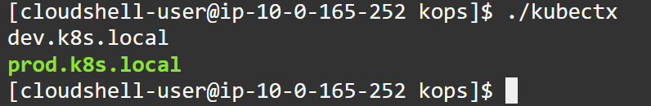

alias ku=./kubectl

alias kx=./kubectx

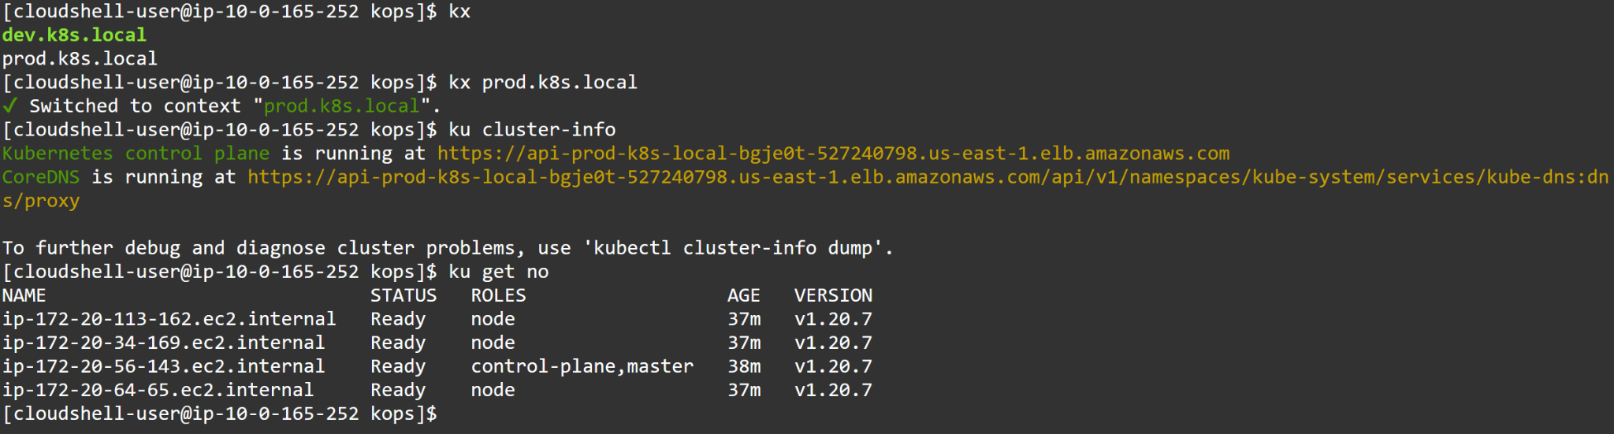

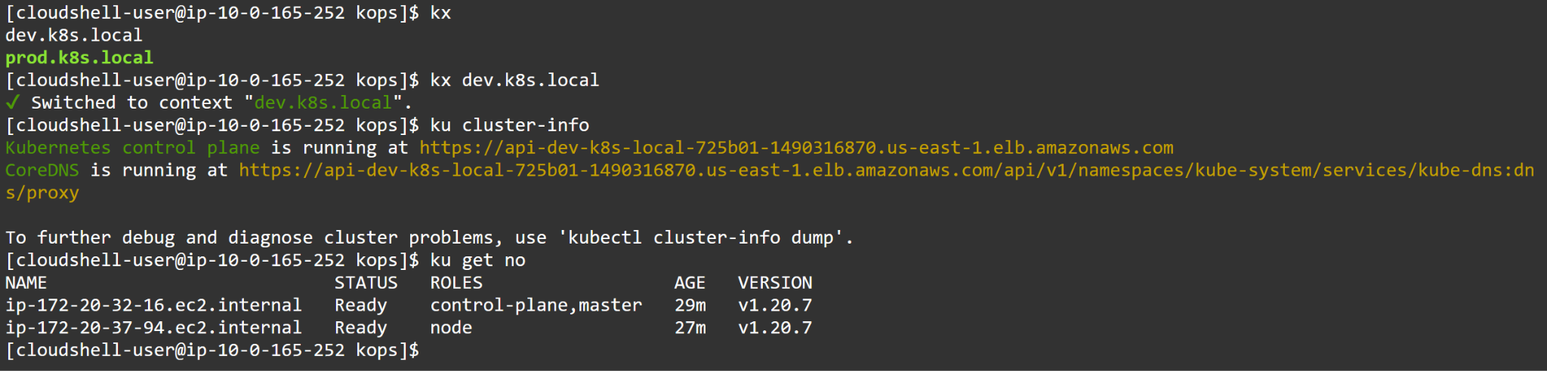

kops update cluster --name telugugcp.xyz --yes *[sync state to Kops state bucket]*

kops update cluster --name telugugcp.xyz --yes --admin=87600h

kops rolling-update cluster --name telugugcp.xyz --yes *[start updating the nodes]*

kops rolling-update cluster --master-interval=10m --node interval=10m --yes -v 10

You might experience errors as shown below.



The above error can be resolved by following command:

kops export kubecfg --admin

