When the cluster is deployed with KUBEADM , the kubeadm dont have knowledge about the cloud where the cluster is installed. In orde to make aware of the cloud platform, we need to deploy Cloud Control Manager. In this case we need to deploy AWS Cloud Provider.

<https://github.com/kubernetes/cloud-provider-aws>

First we need to create to files in the folder /etc/kubernetes

First file will be aws.conf and add the following in the file.

apiVersion: kubeadm.k8s.io/v1alpha1

kind: MasterConfiguration

cloudProvider: aws

kubernetesVersion: 1.21.1 #Plz change the version if you using other than 1.21.1

Second file will be cloud-config.conf and add following in the file.

[Global]

KubernetesClusterTag=k8s

KubernetesClusterID=k8s

The next step be tagging the instances with the tag as below:

KubernetesCluster: k8s

Assign a IAM Role with admin access to the master.

Deploy the two manifests from the following folder.

<https://github.com/kubernetes/cloud-provider-aws/tree/master/manifests>

First deploy [rbac.yaml](https://github.com/kubernetes/cloud-provider-aws/blob/master/manifests/rbac.yaml)

Next [aws-cloud-controller-manager-daemonset.yaml](https://github.com/kubernetes/cloud-provider-aws/blob/master/manifests/aws-cloud-controller-manager-daemonset.yaml)

Perform kubectl get po -n kube-system:

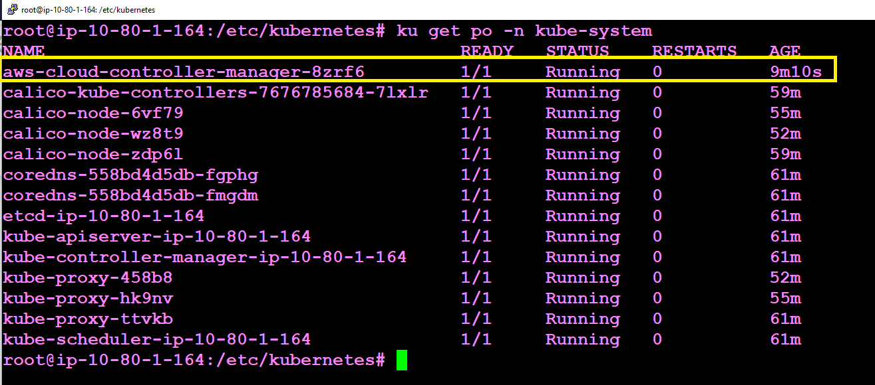

Deploy following manifest and check classic LB is deployed:

#With Classic Load Balancer Will Work

apiVersion: v1

kind: Service

metadata:

labels:

app: nginx

name: nginx

spec:

ports:

- port: 80

protocol: TCP

targetPort: 80

selector:

app: nginx

type: LoadBalancer

With AWS NLB the load balancer will fail with the errors below.

#With Network Load Balancer Will Fail

kind: Service

metadata:

annotations:

service.beta.kubernetes.io/aws-load-balancer-type: "nlb"

labels:

app: nginx

name: nginx

spec:

ports:

- port: 80

protocol: TCP

targetPort: 80

selector:

app: nginx

type: LoadBalancer

