For CPU and Memory utilization of the nodes, we can use kubectl top command. But when deployed using the KOPS, the metrics server is not default installed. For this we need to edit he KOPS Configuration file. **This metrics server is also useful for Pod Autoscalter(HPA)**

Please use the file in kops-metrics.yaml in HPA Folder.

**Below is not more valid. Dont use it.**

Ref: <https://github.com/kubernetes/kops/blob/master/addons/metrics-server/README.md>

For enabling the metrics server we need to change KOPS config file which will lead to update the nodes one by one and result in recreation of nodes. This can be avoided.

When you are creating a cluster, create it with out giving “--yes” at the last of the command which will result in creating the cluster config but not applied. Perform the following steps:

kops create cluster --name=telugugcp.xyz \

--state=s3://telugugcp.xyz --zones=us-east-1a,us-east-1b,us-east-1c \

--node-count=2 --node-size=t3.medium --master-size=t3.medium \

--master-volume-size 10 --node-volume-size 10 \

--dns-zone=telugugcp.xyz #Dont give –yes which will create the cluster config file which we can edit.

kops edit cluster --name telugugcp.xyz

Append below under kubelet:

kubelet:

anonymousAuth: false

authorizationMode: Webhook

authenticationTokenWebhook: true

kops update cluster --name telugugcp.xyz --yes *[sync state to Kops state bucket]*

kops update cluster --name telugugcp.xyz --yes --admin=87600h

kops rolling-update cluster --name telugugcp.xyz --yes *[start updating the nodes]*

kops rolling-update cluster --master-interval=10m --node interval=10m --yes -v 10

You might experience errors as shown below.



The above error can be resolved by following command:

kops export kubecfg --admin

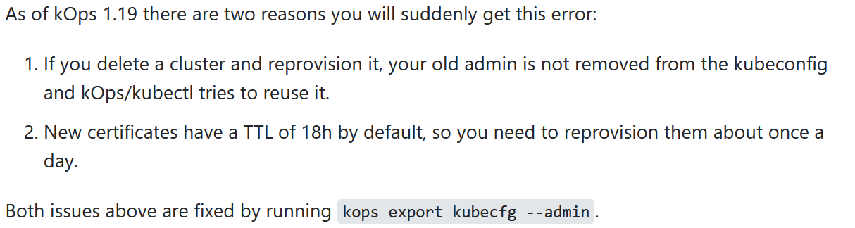

wget https://raw.githubusercontent.com/kubernetes/kops/master/addons/metrics-server/v1.8.x.yaml

Replace apiVersion: extensions/v1beta1 to apiVersion: apps/v1

kubectl apply -f metrics-server-v1.8.yml

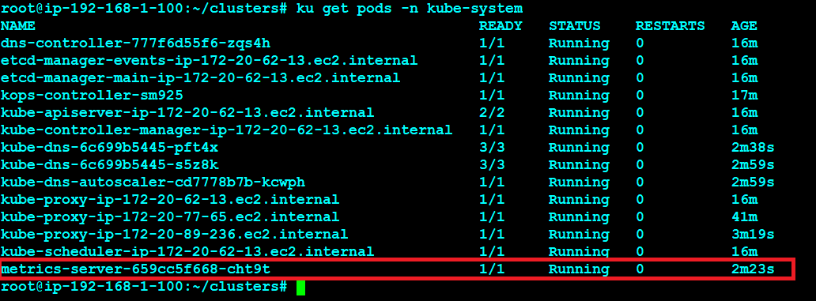

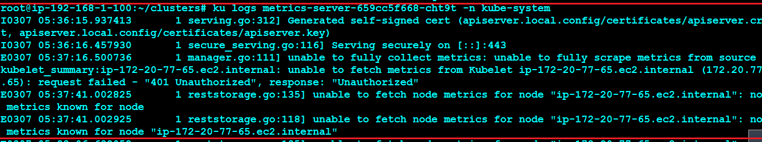

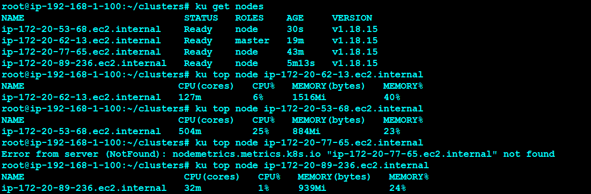

kube-state-metrics:

<https://ralph.blog.imixs.com/2020/11/04/monitoring-your-kubernetes-cluster-the-right-way/>

<https://devopscube.com/setup-prometheus-monitoring-on-kubernetes/>

<https://devopscube.com/alert-manager-kubernetes-guide/>

<https://devopscube.com/setup-grafana-kubernetes/>

<https://devopscube.com/node-exporter-kubernetes/>

git clone <https://github.com/kubernetes/kube-state-metrics.git>

cd [kube-state-metrics](https://github.com/kubernetes/kube-state-metrics.git)

kubectl apply -f examples/standard/

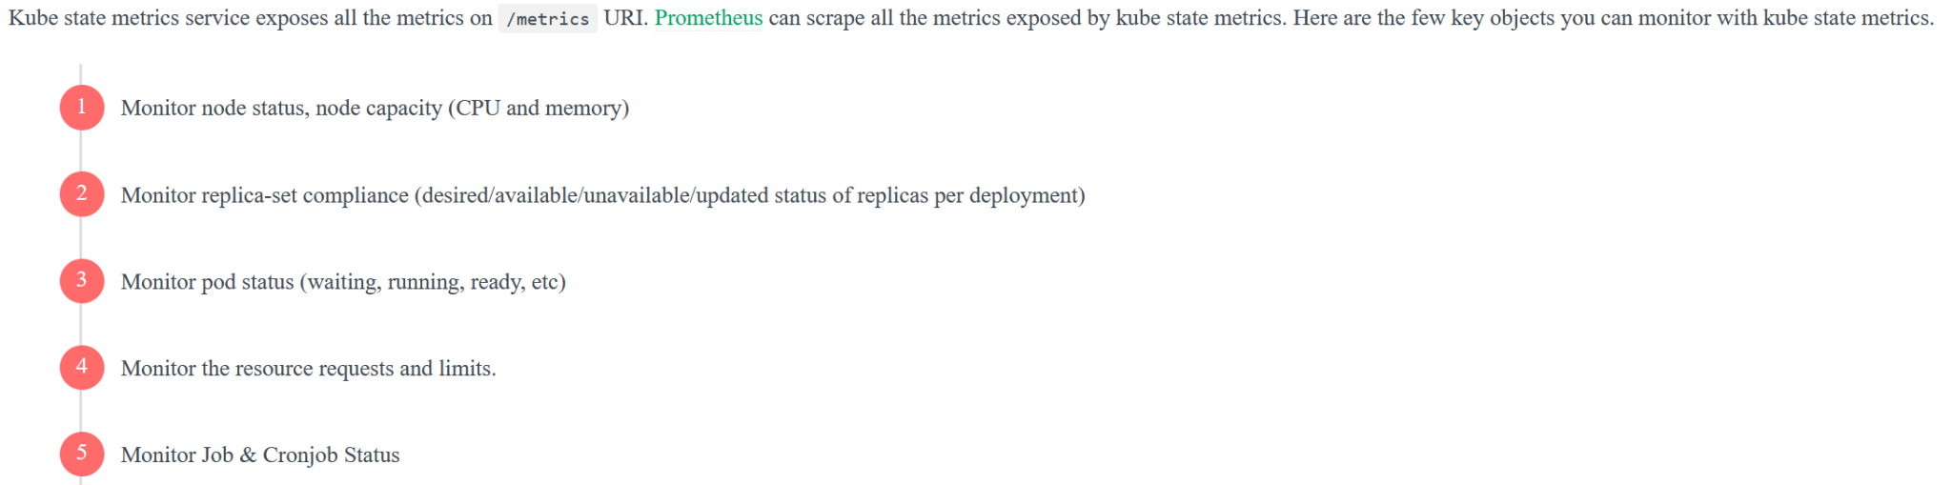

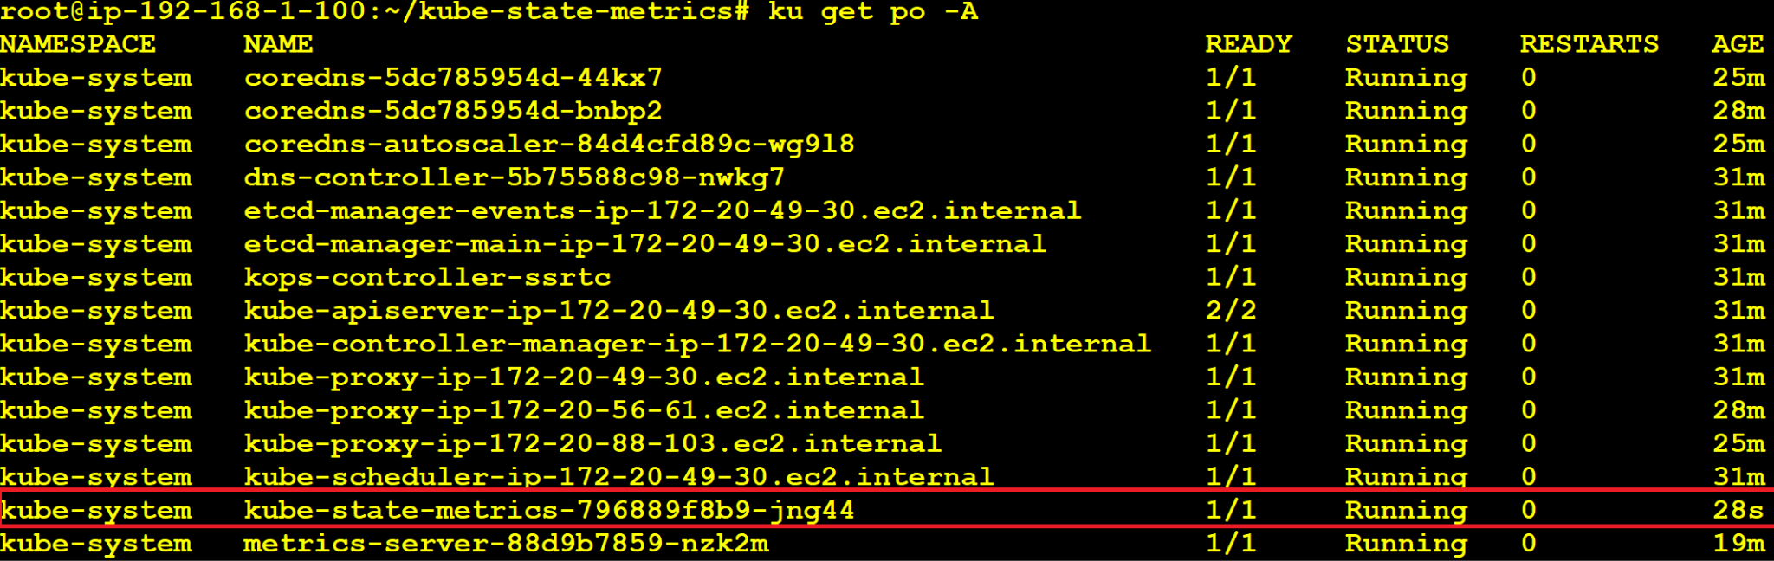

Deploy prometheus as mentioned in the file <https://github.com/mavrick202/gooddocs/blob/master/Prometheus/Installation>

## prometheus.yml

global:

scrape_interval: 15s

scrape_configs:

- job_name: 'prometheus'

scrape_interval: 5s

static_configs:

- targets: ['localhost:9090']

- job_name: 'kube-state-metrics'

scrape_interval: 5s

static_configs:

- targets: ['ec2-34-205-33-53.compute-1.amazonaws.com:32712'] #Exposed kube-state-metrics deployment on the node port.

<https://grafana.com/grafana/dashboards/6417>