Check-In #2

Project Check-In #3 - Group 6

Team Information [Group 6]:
Student 1: Joao Lucas Veras - SJSU ID: 015555345
Student 2: Shloak Aggarwal - SJSU ID: 018189938
Student 3: Pramod Yadav - SJSU ID: 019142370
Student 4: Uday Arora - SJSU ID: 019098404

Github Repository:
https://github.com/shloakk/iql-robustness-analysis
Work Split / Progress:
Joao — Baseline on Remaining Environments + Shift Runs
- Run baseline IQL on halfcheetah-medium-v2 and walker2d-medium-v2 and log scores
- Once Shloak commits the wrappers, run baseline IQL through gravity shift on those two environments as well
- Commit all results
Shloak — Shift Wrappers + Hopper Shift Runs
- Commit gravity and observation noise wrappers to GitHub
- Run baseline IQL through gravity (0.5x, 1.0x, 2.0x) and observation noise (0.01, 0.1, 0.3) on hopper-medium-v2
- Log normalized scores at each level
Pramod — Robustness Metrics + Results Table
- Use Shloak and Joao's shift results to compute the robustness drop metric for each shift level and environment
- Build a results table showing normalized score and delta across all shift types, levels, and environments
- Add to report and update evaluation section
Uday — Q-Ensemble Under Shift
- Once Shloak commits the wrappers, run TripleCritic through gravity and observation noise on hopper-medium-v2
- Log scores and compute robustness drop
- Build comparison table showing DoubleCritic vs TripleCritic robustness drop side by side
- Update report with findings

Paper Outline

Robustness of Implicit Q-Learning Under Controlled Distribution Shift
Joao Lucas Veras, Shloak Aggarwal, Uday Arora, Pramod Yadav

Abstract
Offline Reinforcement Learning (Offline RL) focuses on learning decision-making policies from previously collected datasets, without any additional interaction with the environment. A key challenge in this setting is distribution shift, where the policy learned from static data must operate in environments that differ from those represented in the training dataset. Such shifts can arise from changes in system dynamics, observations, or reward structures, and often lead to performance degradation.

In this project, we study the robustness of Implicit Q-Learning (IQL), a recent Offline RL algorithm that addresses overestimation of unseen actions through expectile regression and advantage-weighted policy updates. We first reproduce IQL on standard D4RL benchmark tasks to establish baseline performance. We then evaluate the trained policies under controlled environment modifications, including variations in gravity, friction, observation noise, and reward perturbations. By systematically increasing the level of distribution shift, we measure how performance degrades and identify patterns of sensitivity.

As an extension, we explore a modification aimed at improving robustness, such as incorporating Q-function ensembles to capture uncertainty or adding regularization to the advantage estimates. We compare the modified approach against the baseline IQL implementation under the same shifted conditions. Overall, this work combines reproduction, systematic evaluation, and algorithmic enhancement to better understand and potentially improve the robustness of Offline RL methods in the presence of distribution shift.

Introduction

Overview
Offline RL has gained traction due to its applicability in safety-critical domains where interaction is expensive or infeasible. However, the absence of exploration introduces a fundamental limitation: policies are trained only on the support of the dataset, yet must generalize beyond it.

Context and Baseline
Recent methods attempt to mitigate distribution shift using different strategies. Conservative Q-Learning (CQL) enforces pessimism in value estimates. TD3+BC constrains the policy to remain close to the behavior distribution. Implicit Q-Learning (IQL) avoids querying unseen actions during value updates.

Research Goal
How robust is IQL under controlled distribution shift, and can simple modifications improve its stability?

Literature Survey
Offline Reinforcement Learning (Offline RL) algorithms differ primarily in how they address distribution shift between the behavior policy that generated the dataset and the learned policy. Standard evaluation protocols, such as D4RL, assume identical training and testing environments, but in practice policies must generalize beyond dataset support. This section reviews three representative methods: Implicit Q-Learning (IQL), Conservative Q-Learning (CQL), and TD3+BC; each of which introduces a different mechanism for controlling extrapolation error under such shifts.

Implicit Q-Learning (IQL)
Implicit Q-Learning (IQL) avoids explicit maximization over actions in the Bellman backup, which is a major source of overestimation in offline settings ^{[2]}. Instead, it estimates a state value function using expectile regression over actions sampled from the dataset, ensuring that value learning remains within the support of the data.

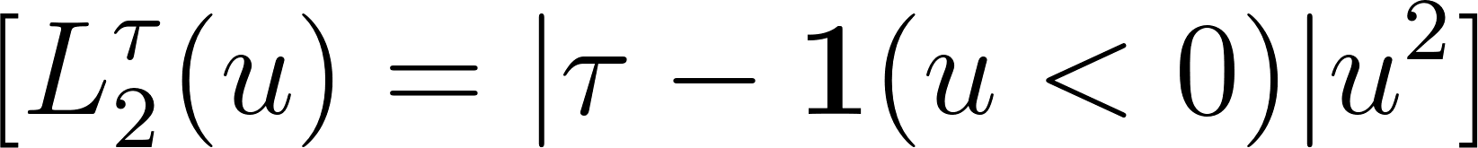

The Q-function is updated using in-sample temporal difference learning:

Policy extraction is performed via advantage-weighted behavioral cloning:

Key idea: IQL reduces extrapolation error by avoiding evaluation of out-of-distribution (OOD) actions during training. This makes it well-suited as a baseline under standard D4RL evaluation, and a natural candidate for studying robustness when deployment conditions differ from training.

Conservative Q-Learning (CQL)
Conservative Q-Learning (CQL) addresses distribution shift by learning a pessimistic Q-function that underestimates the value of OOD actions ^{[1]}. This is achieved by adding a regularization term that penalizes high Q-values outside the dataset distribution.

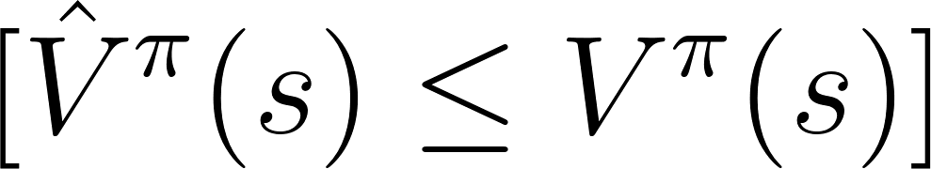

Key idea: CQL enforces pessimism to guarantee safe policy improvement under distribution shift. Unlike IQL, which avoids OOD actions implicitly, CQL explicitly regularizes against them, making it more robust but often more conservative in practice.

TD3+BC
TD3+BC takes a simpler approach by modifying the policy objective to include a behavior cloning term ^{[3]}. Rather than changing the critic, it constrains the learned policy to remain close to actions observed in the dataset.

Key idea: TD3+BC achieves robustness through policy regularization, ensuring that the learned policy does not deviate significantly from the behavior policy. While simple, this approach is effective under standard offline benchmarks but may be sensitive under larger distribution shifts.

Mathematical Definition of Robustness
We define robustness as the stability of policy performance when evaluated under a shifted environment relative to the training environment.

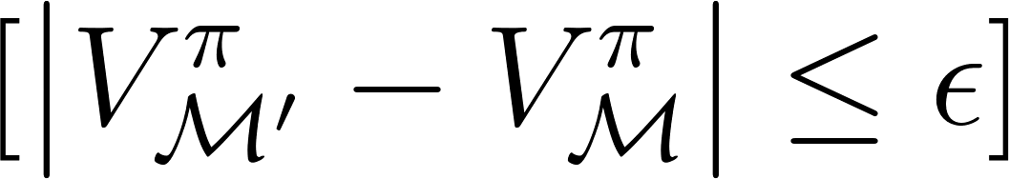

This definition aligns with our evaluation protocol, where policies trained under standard D4RL conditions are tested under controlled perturbations.

A stronger notion, aligned with CQL, is pessimistic robustness:



We also consider robustness under distributional shift:

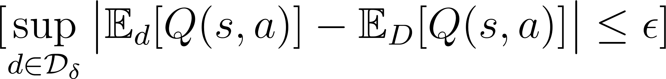

Discussion
These methods represent three complementary strategies for handling distribution shift:

- CQL: robustness via pessimistic value estimation
- IQL: robustness via in-support Bellman updates
- TD3+BC: robustness via policy constraint

In this work, we follow standard D4RL evaluation used in prior literature and then extend it by introducing controlled environment perturbations. This allows us to study how these design choices impact robustness when the deployment environment deviates from the training distribution.

These differences highlight a trade-off between conservatism and flexibility: CQL provides stronger safety guarantees, IQL offers a balance between stability and performance, and TD3+BC prioritizes simplicity at the cost of reduced robustness under larger shifts.

Summary and Gap. While prior work provides multiple strategies for handling distribution shift, these methods are primarily evaluated under the assumption that training and testing environments are identical. CQL enforces pessimistic value estimates, IQL restricts value learning to in-distribution actions, and TD3+BC constrains policy deviation from the dataset. However, none of these approaches explicitly evaluate robustness under environment-level perturbations. This gap motivates our study, where we retain standard offline training but evaluate policies under controlled distribution shift at deployment time.

Dataset: D4RL Benchmark
We use the D4RL (Datasets for Deep Data-Driven Reinforcement Learning) benchmark ^{[4]}, which provides standardized offline RL datasets collected from fixed behavior policies. These datasets are widely used for evaluating offline RL algorithms under controlled conditions.

D4RL includes a range of environments with varying levels of dataset quality and coverage:

- Locomotion tasks: HalfCheetah, Hopper, and Walker2d, which involve continuous control in MuJoCo environments.
- AntMaze tasks: Navigation tasks requiring long-horizon planning and trajectory stitching.

Each environment is provided with multiple dataset variants:

- Random: Data collected from a random policy
- Medium: Data from a partially trained policy
- Expert: Data from a near-optimal policy

In this work, we follow the standard D4RL evaluation protocol used in prior offline RL literature, where policies are trained on a fixed dataset and evaluated in the same environment using normalized scores.

Importantly, D4RL assumes that the training and evaluation environments are identical. To study robustness, we extend this setup by evaluating trained policies under controlled distribution shift, where environment dynamics (e.g., friction, gravity, or observations) are modified at test time.

Methodology
Our methodology follows a two-stage design: reproducing IQL on D4RL datasets, and evaluating robustness under controlled distribution shift. This work builds upon the Implicit Q-Learning framework introduced by Kostrikov et al. (2021) and its official implementation ^{[5]}.

We train IQL using expectile regression for value learning, TD updates for Q-learning, and advantage-weighted behavioral cloning for policy extraction. We then evaluate the trained policy under perturbations such as gravity, friction, observation noise, and reward scaling, without retraining.

Training Details. We use a standard IQL implementation with two-layer MLP networks (256 hidden units) for both Q and value functions. The expectile parameter  is set to a value greater than 0.5 to bias value estimation toward higher-return actions, and the policy is trained using advantage-weighted behavioral cloning. Optimization is performed using Adam with minibatch updates from the fixed dataset.

Evaluation

Metrics
We evaluate performance using relative degradation in return under distribution shift. Let  denote the average return of the policy in the original environment, and 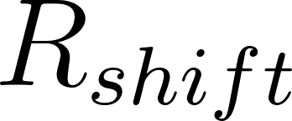 denote the return under a perturbed environment.

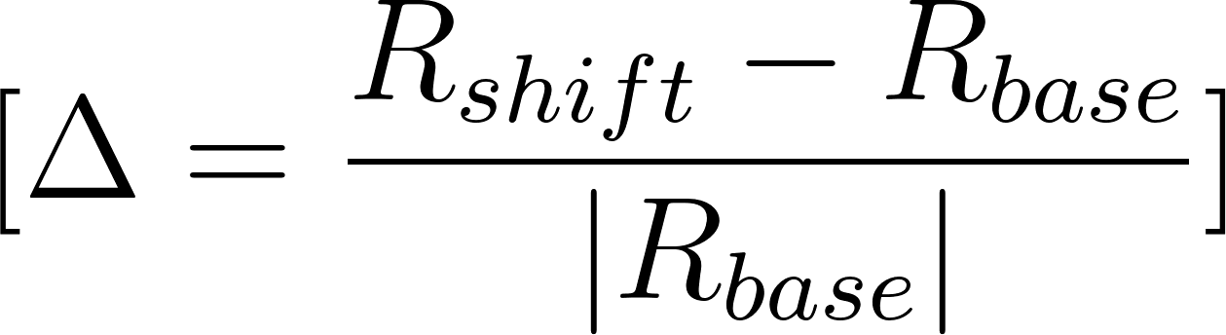

This metric captures the sensitivity of the learned policy to changes in environment dynamics. A value of  close to zero indicates robustness, while larger negative values indicate performance degradation under distribution shift.

In addition to relative degradation, we follow standard D4RL evaluation protocols and will report normalized scores to ensure comparability with prior work.

Experimental Results
We follow the standard D4RL evaluation protocol as a baseline, where policies are trained and evaluated in the same environment using normalized scores. As full experiments are ongoing, we focus on establishing the evaluation framework and expected behavior under controlled distribution shift.

We then extend this setup by introducing controlled distribution shift at test time, without retraining the policy. While full experimental results are pending, this setup enables systematic measurement of performance degradation as a function of perturbation magnitude. This evaluation isolates the sensitivity of offline policies to changes in environment dynamics ^{[6]}.

Environment | IQL Score
HalfCheetah-medium-v2 | Pending
Hopper-medium-v2 (Baseline IQL) | 52.79
Hopper-medium-v2 (Q-Ensemble IQL) | 50.88
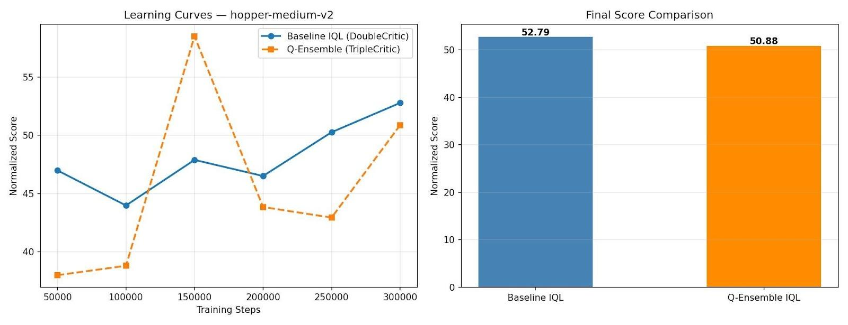

Figure 1: Normalized score comparison between baseline IQL (DoubleCritic) and Q-ensemble IQL (TripleCritic) on hopper-medium-v2 over 300k training steps.

Q-Ensemble Extension: Initial Results

We ran an initial comparison between the baseline IQL using a DoubleCritic (2 Q-networks) and our Q-ensemble extension using a TripleCritic (3 Q-networks) on hopper-medium-v2 for 300k training steps. Both models were trained under identical conditions and evaluated every 50k steps using normalized score. The baseline IQL achieved a final normalized score of 52.79, while the Q-ensemble achieved 50.88, a difference of 1.91 points. While the Q-ensemble shows more variance during training, particularly peaking around 150k steps before stabilizing, both models converge to comparable final performance. This is expected behavior at this stage since the benefit of the ensemble is not in baseline performance but in robustness under distribution shift, which will be evaluated in the next phase using the gravity and observation noise wrappers. The close final scores confirm that the TripleCritic implementation is correct and training is stable, providing a valid starting point for the robustness experiments in Check-In 3.

Limitations
Limited to simulated environments and controlled perturbations.

Conclusion
IQL balances performance and simplicity, but robustness under shift remains an open problem.

References
- A. Kumar, A. Zhou, G. Tucker, and S. Levine, “Conservative Q-Learning for Offline Reinforcement Learning,” in Advances in Neural Information Processing Systems (NeurIPS), 2020.
- I. Kostrikov, A. Nair, and S. Levine, “Offline Reinforcement Learning with Implicit Q-Learning,” in International Conference on Learning Representations (ICLR), 2022.
- S. Fujimoto and S. Gu, “A Minimalist Approach to Offline Reinforcement Learning,” in Advances in Neural Information Processing Systems (NeurIPS), 2021.
- J. Fu, A. Kumar, O. Nachum, G. Tucker, and S. Levine, “D4RL: Datasets for Deep Data-Driven Reinforcement Learning,” arXiv:2004.07219, 2020.
- I. Kostrikov, A. Nair, and S. Levine, "Implicit Q-Learning (Official Implementation)," GitHub repository. Available: https://github.com/ikostrikov/implicit_q_learning
- S. Aggarwal, J. L. Veras, U. Arora, and P. Yadav, "IQL Robustness Analysis: Controlled Distribution Shift Experiments," GitHub repository, 2026.
Available: https://github.com/shloakk/iql-robustness-analysis/tree/baseline

