ISTE Escape Challenge: Innovate and Code

Type of Activity: ISTE Escape Challenge: Innovate and Code

Date of Activity: 03rd October 2025
Duration of activity (in Hours): 4Hrs
Mode of Session Delivery (Online/Offline): Offline
Objective: To provide students with an engaging platform that integrates coding with puzzle-solving, thereby strengthening their technical knowledge, teamwork, and critical thinking skills in a fun and competitive environment.
Link of the Pre conduct of Activity:

Link of the Post conduct of Activity:

Name/s of Organizing Department/Agency: ISTE
No. of Participants:
Facilitators:
Dr Nisha Rana (Assitant Professor), SOET, Chitkara University, Himachal Pradesh
Sustainable development goals covered in the activity (Provide with Serial No.): 4,8,9
Description:
The ISTE Student Chapter at Chitkara University, Himachal Pradesh, successfully organized the ISTE Escape Challenge: Innovate and Code on October 3, 2025, at the Beta Zone. The event was designed to provide students with an escape-style coding experience that tested their logical reasoning, analytical ability, and programming skills.

Participants competed across multiple engaging rounds that included debugging faulty code, solving equations, memory match puzzles, word hunts, Sudoku solving, code runner debugging tasks, and a blindfold balloon tech hunt. These activities encouraged students to think creatively and collaboratively, making the competition both challenging and enjoyable.

A total of 31 teams, with around 80 participants, took part in the event, showcasing their enthusiasm, problem-solving skills, and teamwork. After a highly competitive series of rounds, four teams emerged as winners. The Hunter secured the first position, ADK stood second, Maksad achieved third place, and RCB received the consolation prize.

The event concluded on a successful note, with participants appreciating the unique format and vibrant execution. The Escape Challenge not only reflected ISTE’s vision of fostering innovation and skill development but also motivated students to actively engage in future activities and continue exploring new avenues of growth and learning.

Photographs of the event:

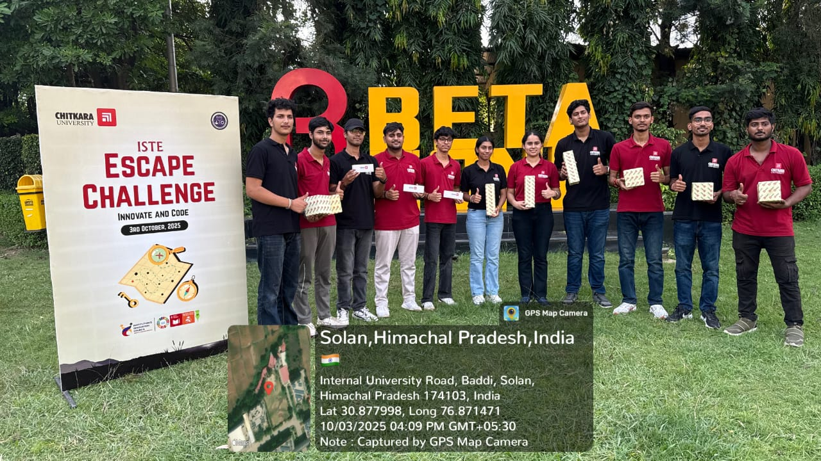

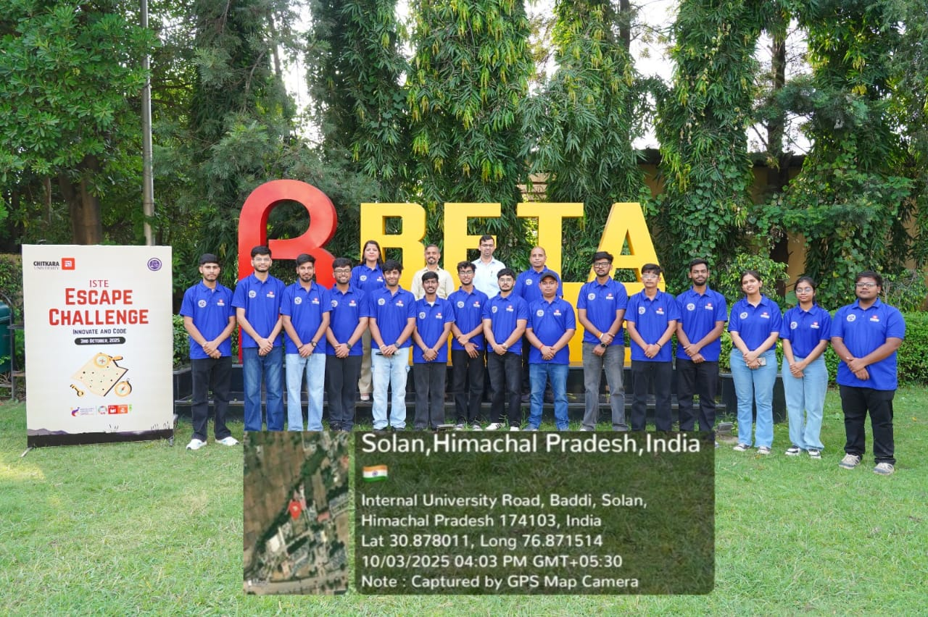

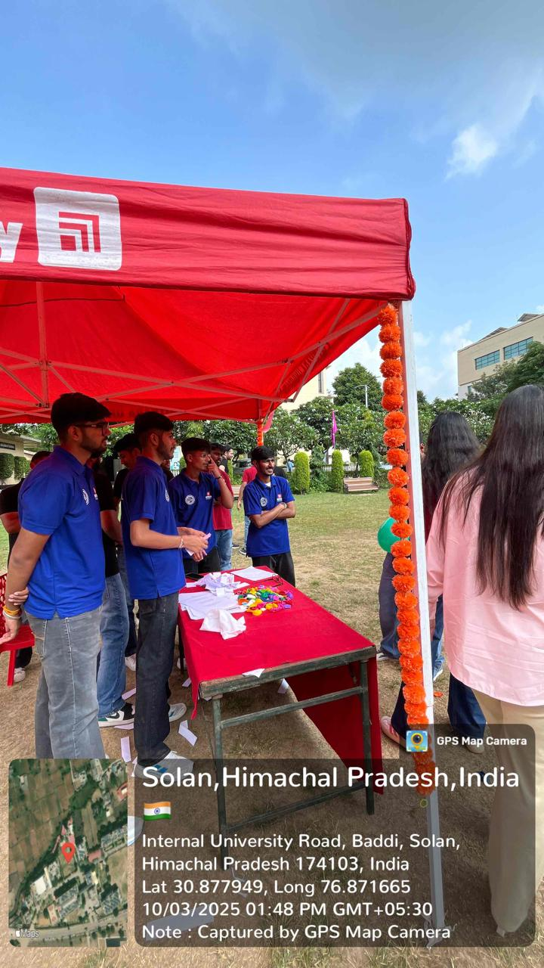
Attendance Sheet

