Developer Guide — AI-Assisted Bank Reconciliation

1. Purpose
How the code is organized, the rules every change must keep, and the steps for the changes most likely to be needed. The reasons behind each design choice are in the System Design (DOC-05, ADR-01..31); requirement, rule and test IDs are defined in DOC-02 and DOC-06. Read section 4 before changing anything.

2. Development Setup
Follow the Installation Guide (GDE-01) sections 3 and 4, then:
Task | Command
Run every test | python3 -m pytest -q
Run one file | python3 -m pytest -q tests/test_review.py
Run tests by name | python3 -m pytest -q -k manual_match
Start the interface | python3 -m app.cli serve (restart after code changes)
Fresh database | python3 -m app.cli reset --force then python3 -m app.cli init
Inspect a run | python3 -m app.cli status and python3 -m app.cli verify
Tests never touch reconciliation.db: each builds its own database in a temporary folder.

3. Codebase Map
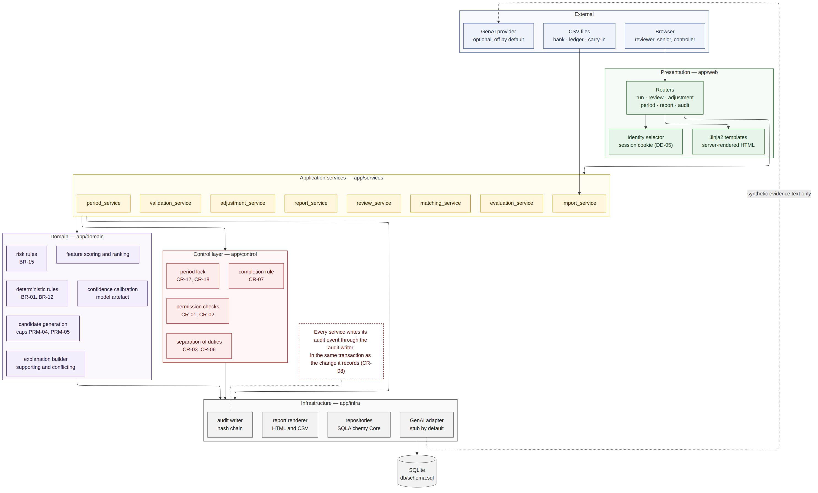
Layered architecture
Layer | Package | Holds | May import
Presentation | app/web | Routes (routes/), view functions (views.py), templates, wording (labels.py, plain.py) | services, control, labels
Services | app/services | One service per workflow; owns every transaction; container.py wires them | control, domain, infra
Control | app/control | Permissions, separation of duties, state models, period lock, the six-condition reconciliation rule, error codes | domain
Domain | app/domain | Rules, candidates, features, scoring, calibration, risk, exceptions, explanations, statement arithmetic. No input or output | nothing outside domain
Infrastructure | app/infra | Database, repositories (all SQL), audit chain, report rendering, AI summary adapters | domain
Storage | db/schema.sql | Tables, constraints, append-only and period-lock triggers, indexes | —
Key files:
File | What it does
app/cli.py | Command line entry point
app/config.py | Loads config/default.toml and config/local.toml; the per-run parameter snapshot
app/infra/db.py | Connections and transaction() (BEGIN IMMEDIATE, rollback on any error)
app/infra/audit.py | AuditLog.write appends one hash-chained event; verify recomputes the chain
app/infra/repositories.py | Every SQL statement, grouped by table
app/services/matching_service.py | Rules, then candidates and scoring, then risk and routing
app/services/review_service.py | Every reviewer decision, batches and hand pairing
app/services/period_service.py | Readiness, sign-off, lock, reopening
app/services/report_builders.py | One builder per report
app/services/evaluation_service.py | The only code that reads ground truth
app/web/views.py | What each screen shows, built without a server

4. Rules Every Change Must Keep
Rule | Why | Where it is enforced
Every state change writes an audit event in the same transaction | An action without evidence must be impossible (CR-08) | AuditLog.write takes the caller’s connection
Checks that guard a write run on the caller’s connection, inside the transaction | The check must see exactly the state the write changes | Services pass connection to control functions and repository reads
Audit and decision tables are append-only; a correction is a new row | Evidence is never edited (CR-09) | Database triggers, and no UPDATE/DELETE in repositories
A refused action raises ControlViolation(rule, message) and records a BLOCKED_ATTEMPT | Refusals leave evidence (ADR-12) | services/blocked.record_blocked
Nothing is approved because of confidence | Every item needs a human decision (CR-01) | No code path approves without a decision row
Money is integer cents; dates are ISO 8601; timestamps UTC | No rounding drift; stable sorting | Schema CHECK constraints, domain types
Rules use business dates, never processing time | Same data, same results on every run | Domain functions take dates as input
Parameters come from the run’s snapshot, not the config file | A closed month never changes (ADR-10) | parameter_snapshot on reconciliation_run
Ground truth is read only by the evaluator, tests and benchmarks | The system cannot learn the answers | Only evaluation_service.py and scripts/ open ground_truth.csv
Originals are kept beside normalized values | Reviewers and auditors see what arrived | *_original and *_normalized columns
No journal entry is ever posted | The system proposes; accounting posts | Adjustments end at approved
Screens show plain words; codes go behind Show details | Reviewers act on meaning, auditors still see codes | labels.py, plain.py, class="tech"; tests TC-I-080, TC-I-082
db/schema.sql is the source of truth | One definition of the data | Repositories write explicit SQL against it

5. How a Decision Flows
An approval from the item screen, end to end:
Step | Code | What happens
1 | web/routes/review.py | Reads the form and the person acting; calls the service
2 | ReviewService.decide | Opens database.transaction()
3 | control/permissions.py, duties.py, period_lock.py | Role, separation of duties, offered actions, comment rule and period lock, all on the transaction’s connection
4 | repositories.py | Writes the review_decision row and the status changes
5 | AuditLog.write | Appends the DECISION event with the new chain hash
6 | db.transaction | Commits; on any exception rolls back steps 4 and 5 together
7 | On ControlViolation | record_blocked writes a BLOCKED_ATTEMPT event in its own transaction; the route shows the plain reason

6. Common Changes
Change | Steps
Change a threshold | Edit config/default.toml and its dataclass in app/config.py; update the PRM entry in DOC-02. Existing runs keep their snapshot
Add a matching rule | Pure function in domain/rules.py, called from apply_rules; a new exception kind goes in domain/exceptions.py, with its plain name in web/labels.py (EXCEPTION_NAMES, EXCEPTION_HELP) and infra/genai/base.py (EXCEPTION_WORDS); TC-U-173 checks the two lists agree. Add unit and scenario tests
Add a control | Function in control/ raising ControlViolation; register the rule in control/errors.py (ERROR_CODES) and its plain sentence in labels.RULE_TEXT; call it inside the service transaction; test the refusal and its BLOCKED_ATTEMPT event
Add a report | Builder in services/report_builders.py, registered in BUILDERS; title in views.REPORT_TITLES, description in labels.REPORT_DESCRIPTIONS
Add a screen | View function in web/views.py, template in web/templates/, route in web/routes/; a render test in test_web_views.py and an HTTP test in test_web_routes.py
Change wording | web/labels.py (fixed words) or web/plain.py (sentences built from data); keep codes in class="tech" elements
Add an AI summary provider | Subclass GenAIAdapter and implement _generate only; register it in build_adapter. The base class applies the decision-language guard, word limit and fallback
Regenerate data | python3 scripts/generate_dataset.py (add --profile calibration for July); refit with python3 scripts/fit_calibration.py
Change the schema | Edit db/schema.sql, update repositories and DOC-04; reset local databases. There is no migration tool by design (see requirements.txt)

7. Tests
Family | ID | Covers | Main files
Unit | TC-U-nnn | Domain and control functions on fixed inputs | test_domain.py, test_scoring.py, test_control.py
Integration | TC-I-nnn | Services on a real database, screens, routes, evaluator | test_review.py, test_web_views.py, test_web_routes.py
Control | TC-C-nnn | Each control rule: the refusal, the rule named, the evidence | test_controls.py, test_period.py
Hybrid | TC-H-nnn | What scoring adds, and must never do | test_pipeline.py
Scenario | TC-S-nnn | SCN-01..08 and the complete August month | test_pipeline.py, test_reports.py, test_manual_match.py
Reproducibility | TC-R-nnn | Same seed, same results; frozen parameters | test_pipeline.py, test_evaluation.py
Name each test test_<family>_<number>_<what it proves>, using the next free number in that family; IDs are never reused. Shared fixtures are in tests/conftest.py and tests/web_support.py (build_services gives a matched August run on a fresh database). Every rule in DOC-02 maps to at least one test in DOC-06 section 5; keep that table current when adding a rule.

8. Working Conventions
Topic | Convention
Branches | One branch per piece of work, from main; squash-merge by pull request
Commits | Conventional Commits: feat(web): ..., fix(review): ..., docs: ..., test: ...
Never commit | .env, config/local.toml, reconciliation.db*, reports/run_* (all in .gitignore)
Documents | Every document in Markdown (docs/markdown, guides/markdown) and Word (docs/word-files, guides/word-files); diagrams as Mermaid source plus PNG in docs/diagrams
IDs | Requirement, rule, scenario and test IDs are stable across code, tests and documents
Not built on purpose | Anything deliberately left out is listed with its reason (DOC-05, DOC-06 section 10)
Questions about behaviour are answered in the FAQ and Troubleshooting guide (GDE-04).

