🍱
ANNASETU AI
An Intelligent AI-Powered Food Rescue & Redistribution Platform
Project Documentation

Project Type | AI-enabled web platform
Primary Goal | Reduce food wastage by connecting surplus-food providers with nearby receivers
Technology | FastAPI, Jinja2/HTML/CSS/JavaScript, SQLite, Python, Gemini AI

This document describes the implemented platform, user workflows, AI agents, security controls, project structure, and current user interface.

Table of Contents
- 1. Executive Summary
- 2. Problem Statement
- 3. Objectives
- 4. Solution Overview
- 5. User Roles
- 6. System Architecture
- 7. Project Structure
- 8. Core Functional Modules
- 9. AI and Agentic AI Architecture
- 10. End-to-End Workflows
- 11. Security and Validation
- 12. Database and Data Flow
- 13. API Overview
- 14. User Interface Documentation
- 15. Testing and Verification
- 16. Installation and Deployment
- 17. Future Enhancements
- 18. Conclusion

1. Executive Summary
ANNASETU AI is an AI-enabled food rescue and redistribution platform designed to reduce the amount of usable food that is discarded by hostels, restaurants, institutions, households, and other food providers. The platform creates a digital connection between people or organizations that have surplus food and nearby receivers such as NGOs, ashrams, old-age homes, community organizations, and other eligible recipients.
The system supports food posting, location-aware discovery, AI-based food matching, receiver selection, notifications, food requests, provider approval, collection tracking, expiry/rescue analysis, and an agent dashboard. Security controls are applied to authentication, authorization, input validation, request status transitions, CSRF/origin protection, rate limiting, and notification ownership.

2. Problem Statement
Large quantities of prepared food can become waste because providers may not have a fast and reliable way to identify nearby organizations that can use the food. At the same time, potential receivers may not know when surplus food becomes available, where it is located, or whether it is still suitable for collection.
ANNASETU AI addresses this coordination problem by combining:
- A centralized surplus-food listing system
- Location-based discovery and receiver matching
- AI-assisted ranking and recommendations
- Targeted notifications
- Controlled request and collection workflows
- Expiry and rescue prioritization

3. Objectives
- Reduce avoidable food wastage by improving the speed of food redistribution.
- Connect providers with nearby and suitable receivers.
- Use location and availability information to prioritize practical pickups.
- Use AI to rank food-to-receiver and receiver-to-food matches without allowing AI to bypass application security.
- Notify suitable receivers while preventing duplicate or unauthorized notifications.
- Maintain a traceable lifecycle from food posting to request, acceptance, and collection.
- Provide dashboards that make the operational status of the food-rescue network easy to understand.

4. Solution Overview
The platform follows this high-level flow:
Step | Actor | Action
1 | Provider | Posts surplus food with quantity, type, pickup/location and availability information.
2 | Platform | Validates the listing and stores it in the database.
3 | AI Matching | Ranks suitable food or receivers using location, quantity, type, urgency and practicality.
4 | Notification Agent | Targets eligible receivers and creates controlled notifications.
5 | Receiver | Views available food or a notification and submits a request.
6 | Provider | Reviews the request and accepts or rejects it.
7 | Collection | An accepted request can be marked collected through the authorized workflow.

5. User Roles
Role | Responsibilities
Provider | Posts surplus food, provides pickup information, views requests, manages request status, and can run AI receiver-selection/rescue workflows for their own food.
Receiver | Shares location, searches available food, receives targeted notifications, uses AI food matching, requests food, and tracks request/collection status.
Administrator | Provides administrative/monitoring capabilities in the project structure and can be used for platform oversight and impact analytics.
AI Agents | Analyze and rank data, generate explanations, identify urgent/rescue opportunities, and coordinate controlled workflows. Agents do not replace authorization rules.

6. System Architecture
The implementation uses a Python FastAPI backend, server-rendered HTML templates, client-side JavaScript for interactive dashboard actions, and SQLite for application data. AI functionality is integrated through Python agent modules and Gemini-based reasoning/explanation where appropriate.
Layer | Implementation
Presentation Layer | Jinja2 HTML templates, CSS, JavaScript dashboards and forms.
Application Layer | FastAPI routes, authentication/session handling, validation, authorization, business workflows and API endpoints.
AI Layer | Food matching agent, receiver selection agent, notification agent, expiry/rescue agent and multi-agent workflow components.
Data Layer | SQLite database containing users, food listings, requests, notifications, receiver locations and related operational records.
Security Layer | Password hashing, sessions, role checks, ownership checks, validation, CSRF/origin protection, rate limiting and security headers.

7. Project Structure
The supplied project screenshot shows a structure containing application modules, agent modules, templates, static assets, database files, and project documentation. The important components are:
- main.py — FastAPI application and route/controller layer.
- database.py — SQLite/database access and persistence functions.
- ai_agent.py / foodloop_agent.py — AI matching and agent logic.
- notification_agent.py — notification-agent functionality.
- expiry_rescue_agent.py — expiry/rescue analysis.
- workflow_agent.py — coordinated multi-agent workflow.
- agent_dashboard.py — AI agent dashboard/backend support.
- admin_dashboard.py / make_admin.py — administrative functionality.
- templates/ — HTML pages such as receiver.html, provider.html, login.html, available_foods.html and request pages.
- static/ — shared JavaScript and CSS assets.
- foodloop.db — SQLite database.
- .env — environment configuration such as API keys; secrets should not be committed to source control.
- venv/ — Python virtual environment.
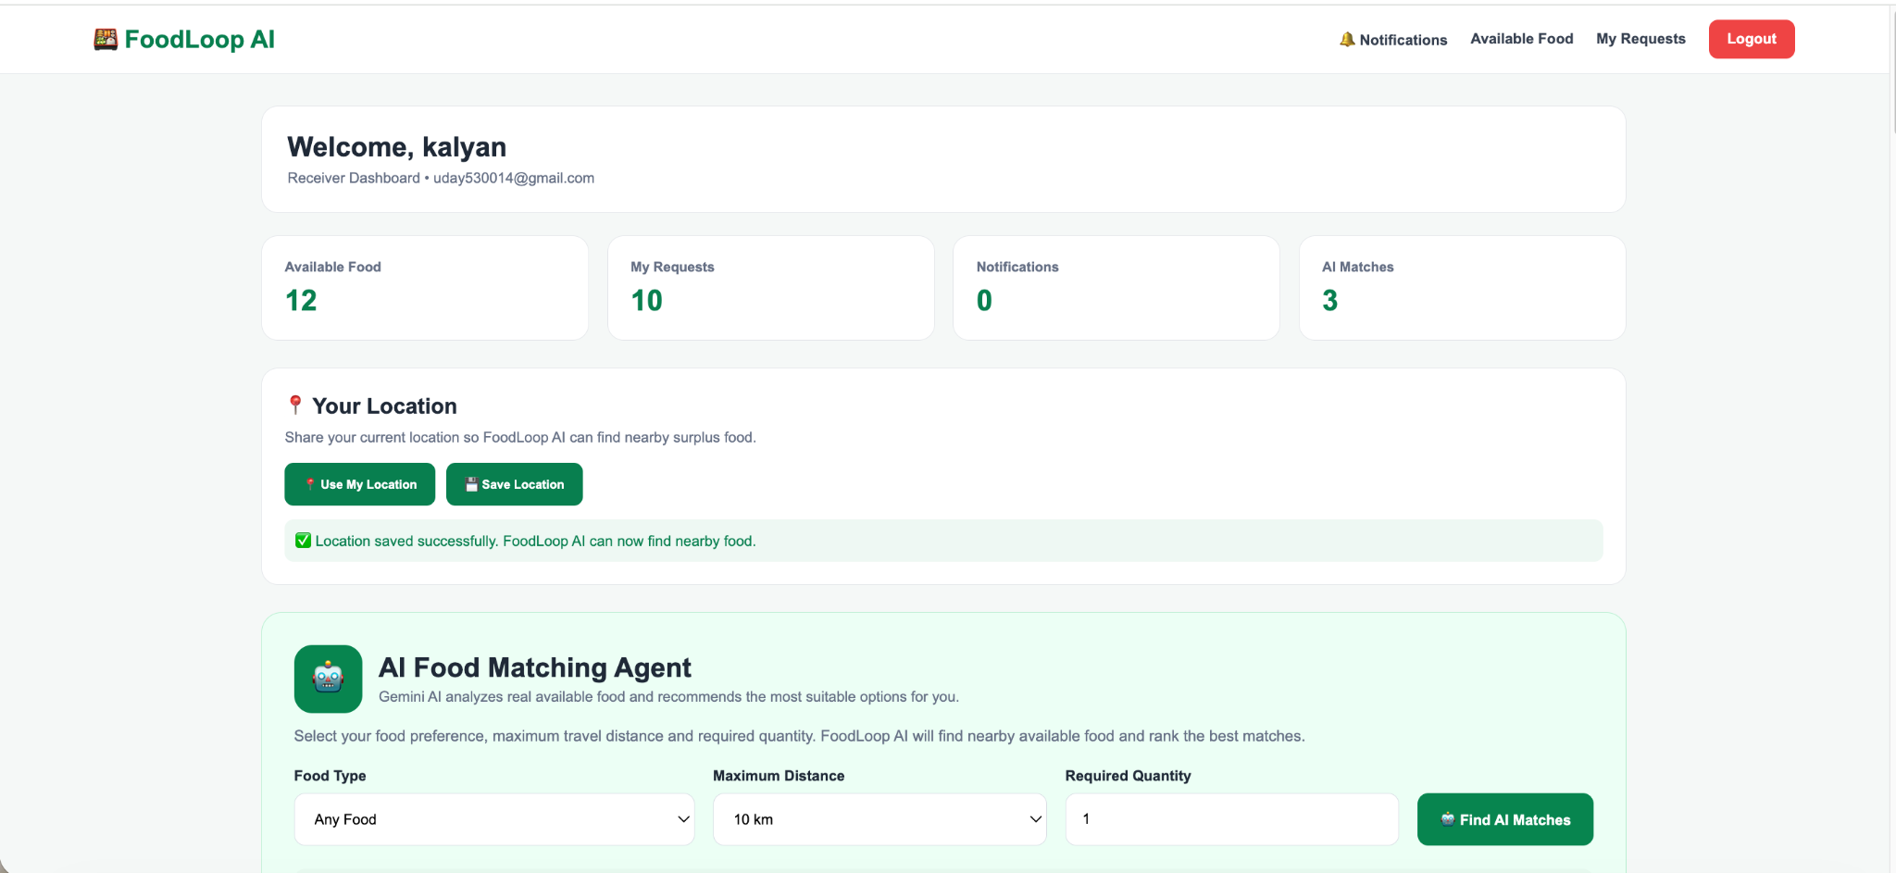
Figure 1. Project workspace and project structure shown in the supplied screenshot.

8. Core Functional Modules
Module | Purpose
Authentication | Registration, login, session management, logout and role-aware dashboards.
Provider Food Management | Create surplus-food listings, provide quantity/type/location/availability information, and manage food lifecycle.
Receiver Discovery | Available-food view, location saving, distance-based matching and search/filter functionality.
Requests | Receivers request food; providers accept/reject; accepted requests can proceed to collection.
Notifications | In-app notifications, unread badge/count, read state and receiver-specific targeting.
Maps & Location | Receiver location storage, provider/food coordinates, distance calculation and location-aware matching.
AI Food Matching | Ranks available food for a receiver using deterministic scoring plus AI-generated explanation.
AI Receiver Selection | Ranks nearby receivers for a provider's food using distance, freshness, eligibility and pickup practicality.
Expiry/Rescue | Identifies food approaching expiry and prioritizes rescue actions.
Multi-Agent Workflow | Coordinates matching, receiver selection, rescue analysis and notification-related actions.
Agent Dashboard | Displays food, request, rescue/urgency and receiver-network information for operational monitoring.

9. AI and Agentic AI Architecture

9.1 AI Food Matching Agent
The receiver-side matching agent evaluates real available food and ranks it for a receiver. The implemented scoring model gives weight to food type, distance, quantity suitability, expiry/urgency and pickup practicality. The backend calculates the score, while Gemini can provide a natural-language explanation based on the real candidate data.
Criterion | Weight
Food Type | 25%
Distance | 25%
Quantity Suitability | 20%
Expiry / Urgency | 20%
Pickup Practicality | 10%

9.2 Receiver Selection Agent
For provider-side rescue, the receiver selection agent identifies and ranks eligible nearby receivers for a specific food listing. The scoring model shown in the project is based on distance, location freshness, receiver eligibility and pickup practicality.
- Distance — 50%
- Location Freshness — 20%
- Receiver Eligibility — 20%
- Pickup Practicality — 10%
Ownership is enforced: a provider can analyze only food listings belonging to that provider. The agent recommends receivers but does not create an unauthorized food request.

9.3 Notification Agent
The notification agent is intended to connect the receiver-selection result with the existing notification system. It targets eligible receivers, avoids duplicate notification creation, respects food availability/expiry, and does not automatically create a food request on behalf of a receiver.

9.4 Expiry / Rescue Agent
The rescue component scans available food for urgency based on the availability window and presents a rescue/urgency queue. The supplied provider dashboard screenshot shows a dedicated 'Scan Expiry & Rescue' action and an AI Rescue / Urgency Queue.

9.5 Multi-Agent Workflow
The workflow layer coordinates the different agents so that matching, receiver selection, urgency analysis and notifications can be used together while retaining the application's security and authorization controls.

10. End-to-End Workflows

10.1 Provider-to-Receiver Workflow
- Provider logs in.
- Provider posts surplus food with quantity, food type, location/pickup information and availability time.
- Platform validates the listing and stores it.
- Provider can run AI Receiver Selection to rank eligible nearby receivers.
- Notification workflow can target suitable receivers.
- Receiver sees the notification or discovers the food through Available Food / AI Matching.
- Receiver requests the food.
- Provider reviews the request.
- Provider accepts or rejects it.
- After an accepted request is fulfilled, the authorized collection workflow marks it as collected.

10.2 Receiver AI Matching Workflow
- Receiver saves/shares a location.
- Receiver selects food preference, maximum distance and required quantity.
- ANNASETU AI retrieves eligible available listings.
- Backend applies matching/scoring rules.
- AI explanation is generated from real candidate data.
- Receiver sees ranked recommendations, score percentage and reason.
- Receiver may request a selected listing.

11. Security and Validation
- Authentication and session security for logged-in users.
- Role protection so provider and receiver operations are separated.
- Ownership checks so users cannot modify another user's food/request records.
- Valid request status transitions: Pending → Accepted/Rejected; Accepted → Collected (and other explicitly allowed transitions).
- Quantity validation requiring a positive quantity.
- Availability/expiry checks to prevent requests for unavailable or expired food.
- Input sanitization and length/type/range validation.
- Password hashing and session protection.
- Same-origin checks for unsafe HTTP methods.
- Rate limiting for sensitive endpoints.
- Security headers including content-type sniffing and framing protections.
- Notification ownership checks so users can access only their own notifications.
- AI agents are constrained to recommendation/analysis tasks and do not bypass authorization.

12. Database and Data Flow
The application uses SQLite as the persistent data store. The project includes food, user, request, notification and receiver-location data. Food records contain availability information and location coordinates when supplied. Receiver locations are stored separately so nearby-receiver calculations can be performed.
Data Area | Purpose
Users | Identity, role and authentication-related information.
Food | Food name, quantity, food type, provider, location, coordinates and availability.
Food Requests | Receiver requests and request lifecycle/status.
Notifications | Receiver-targeted messages, read/unread state and notification timestamps.
Receiver Locations | Receiver coordinates and location update time.
Agent/Operational Data | Information used by dashboard/agent workflows where applicable.

13. API Overview
Endpoint | Purpose
/register | User registration
/login | User authentication
/logout | Logout/session termination
/provider | Provider dashboard
/receiver | Receiver dashboard
/post-food | Create a food listing
/available-foods-data | Available-food data for discovery/mapping
/api/food | Food API
/api/request-food | Submit a food request
/api/food-requests | Food-request information
/notifications | Notification page
/notifications/count | Unread notification count
/receiver-location | Save receiver location
/nearby-receivers | Find nearby receivers
/api/ai-matches | Receiver-side AI food matching
/api/ai-agent-matches | Agent-based food matching
/api/ai-receiver-matches | Provider-side AI receiver selection
/health | Application/AI health status

14. User Interface Documentation
The following figures are taken directly from the screenshots supplied for this documentation.
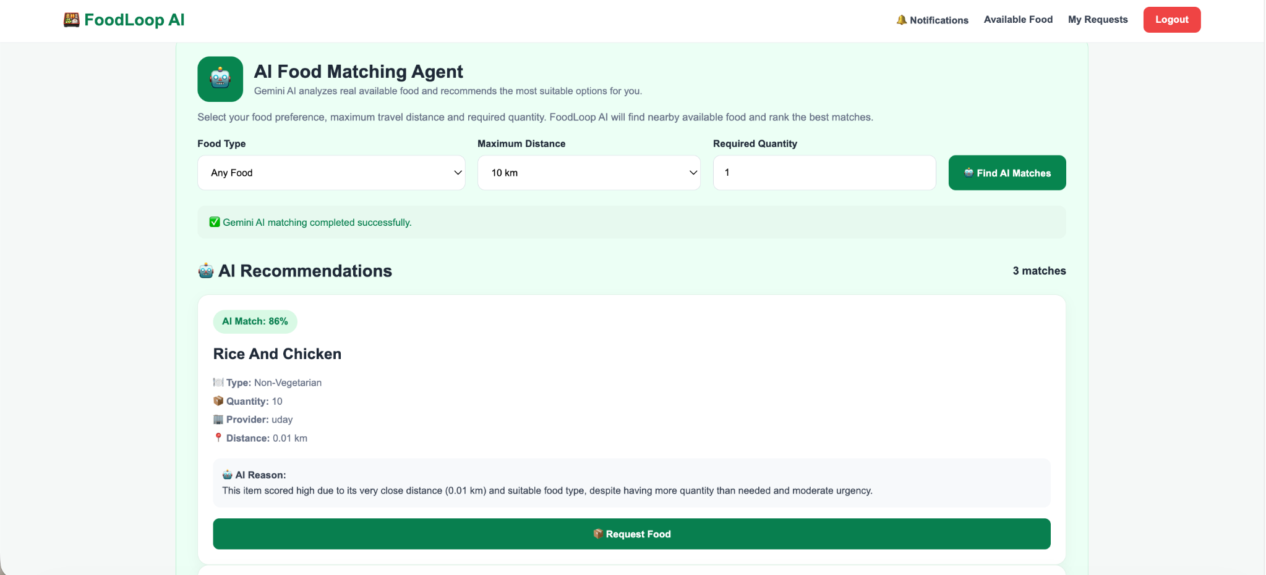
Figure 2. Receiver dashboard — account summary, location sharing and AI Food Matching Agent.
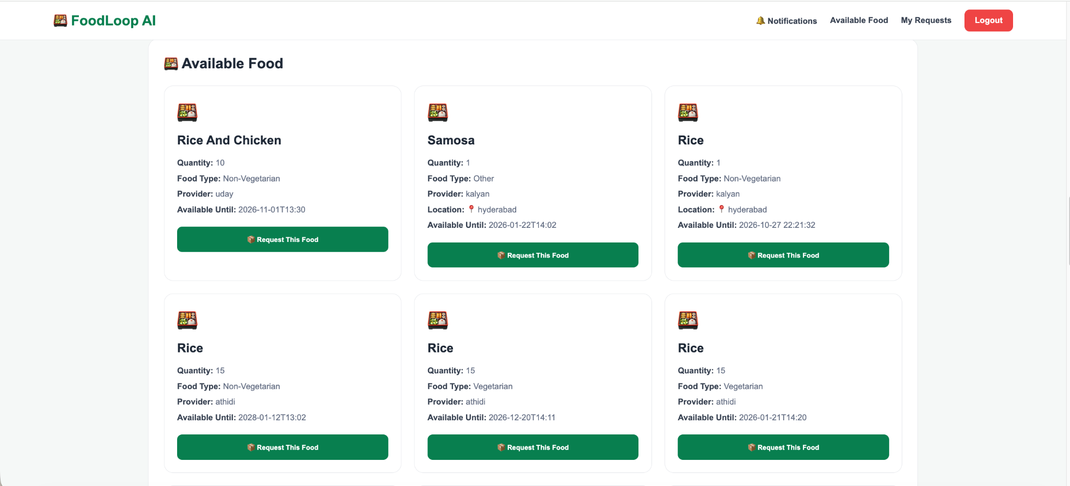
Figure 3. Receiver AI recommendations — ranked food, match percentage, AI reason and Request Food action.
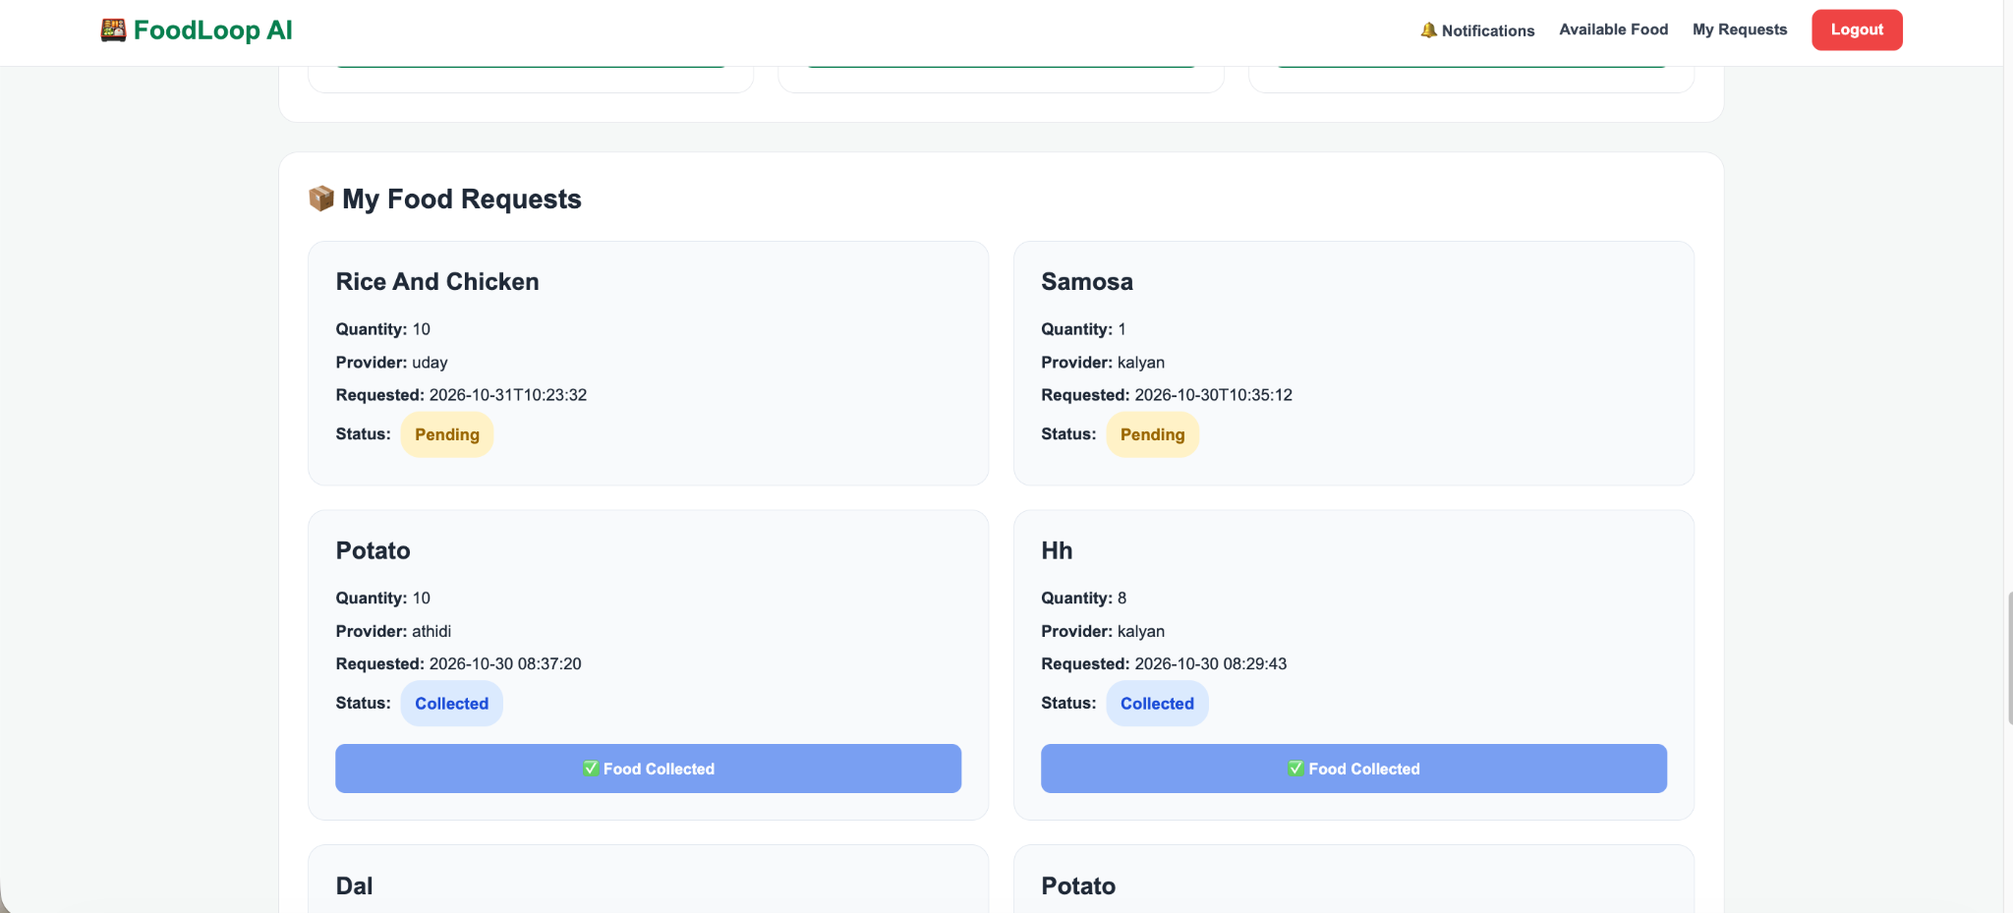
Figure 4. Available Food — food listings with quantity, food type, provider, availability and request action.
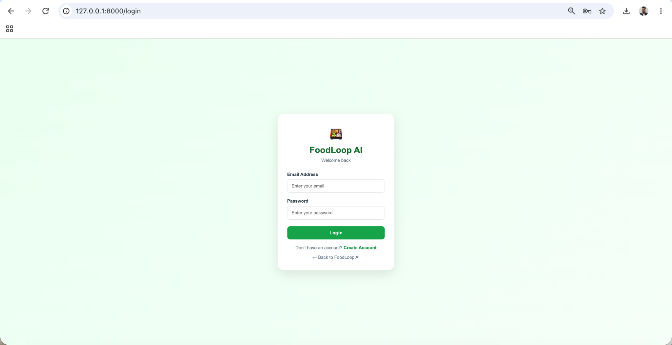
Figure 5. My Food Requests — request history and lifecycle status such as Pending and Collected.
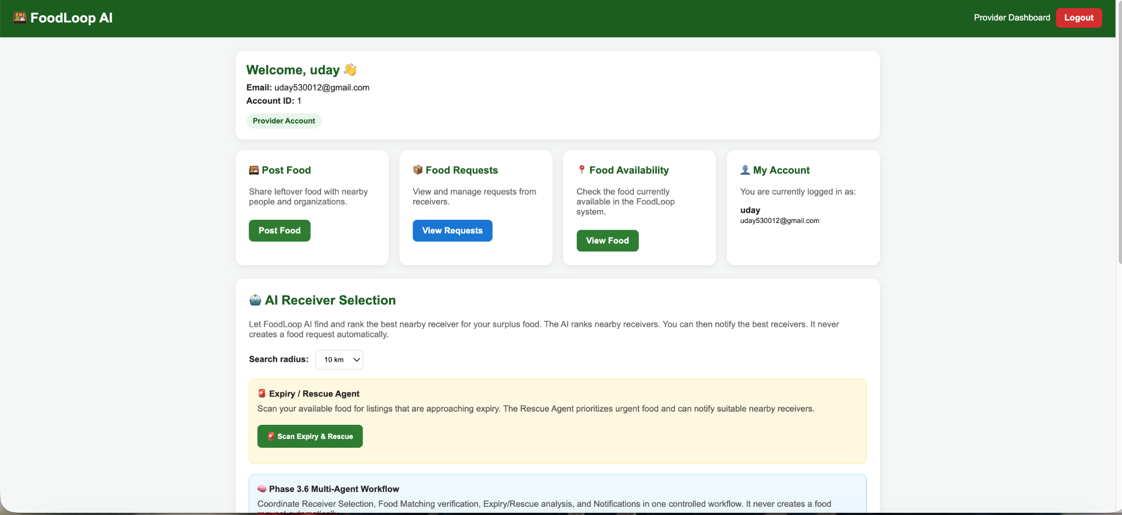
Figure 6. Login page — ANNASETU AI authentication interface.
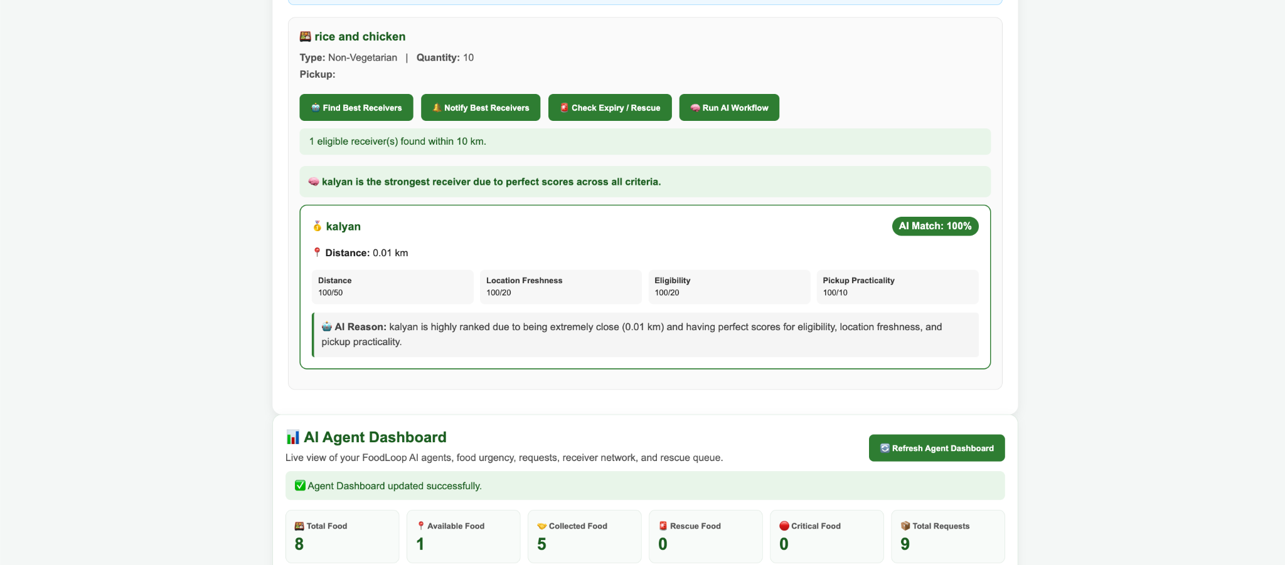
Figure 7. Provider dashboard — provider account, food management and AI Receiver Selection.
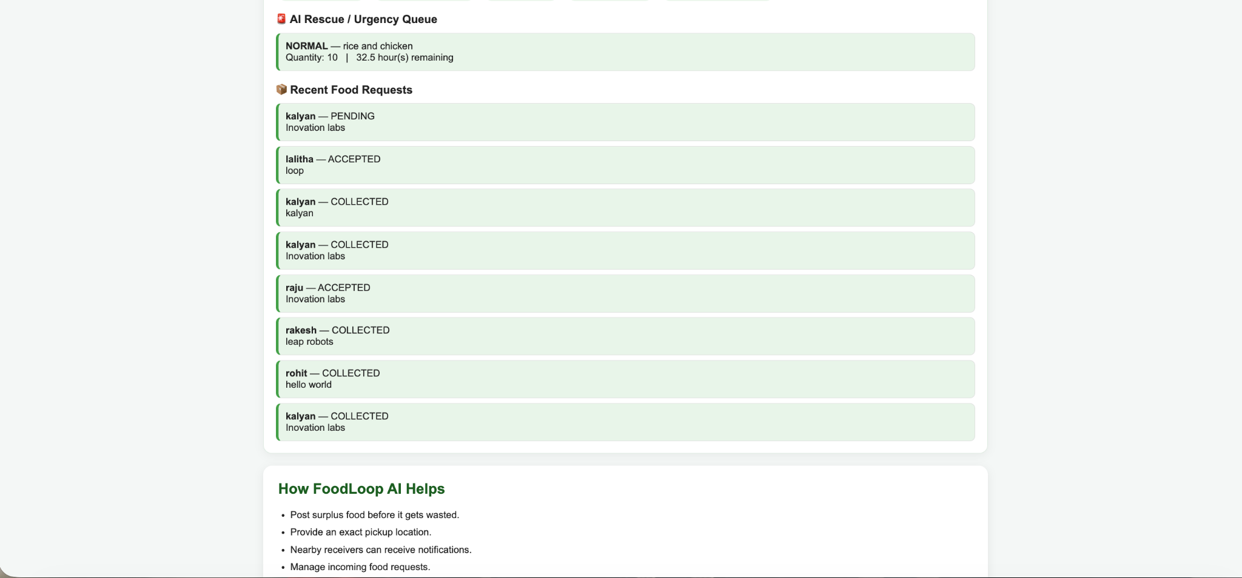
Figure 8. Provider AI Receiver Selection and Agent Dashboard — receiver ranking, score breakdown, rescue/workflow actions and operational metrics.

15. Testing and Verification
The project development and verification process covered the following categories:
Test Area | Verification Focus
Authentication | Registration, login, logout and role-aware dashboard access.
Authorization | Provider ownership and receiver-specific access controls.
Food Validation | Positive quantity, valid IDs, valid location coordinates and acceptable input lengths/types.
Request Lifecycle | Pending, accepted, rejected and collected flows with invalid transitions blocked.
Availability | Requests for unavailable/reserved/expired food are prevented.
AI Matching | Real food records are ranked and displayed with match percentages and explanations.
Receiver Selection | Nearby eligible receivers are ranked for provider-owned food.
Notifications | Receiver-specific notifications and unread counts are available; duplicate notification protection is part of the notification workflow.
Security | Same-origin checks, rate limiting and security headers were added and tested.
UI | Provider and receiver dashboards, AI sections, requests, available food and agent dashboard were verified through the supplied screenshots.

16. Installation and Deployment
Typical local setup:
- Create/activate the Python virtual environment.
- Install the project's Python dependencies.
- Configure required environment variables in .env, including the Gemini API key where AI functionality is enabled.
- Ensure the SQLite database is available and initialized.
- Place HTML templates under templates/ and static assets under static/.
- Start the FastAPI application using Uvicorn.
- Open the local application in a browser and test login, provider and receiver flows.
Production considerations:
- Use a production ASGI deployment rather than the development reload server.
- Store secrets only in secure environment/secret-management systems.
- For multiple application workers, replace in-memory rate limiting with a shared store such as Redis or an equivalent mechanism.
- Configure trusted origins/proxy headers explicitly for the deployment environment.
- Back up the database and implement appropriate operational logging and monitoring.
- Review the authentication/session configuration and enforce HTTPS.

17. Future Enhancements
- Push notifications and optional email/SMS notifications.
- Receiver organization profiles with capacity, food preferences and operating hours.
- Real-time map visualization of active rescue opportunities.
- Donation impact metrics such as meals rescued, kilograms of food saved and receiver organizations served.
- Admin analytics and reporting dashboards.
- Improved multi-agent orchestration with event-driven processing.
- Shared rate-limiting and background job infrastructure for production scale.
- Audit logs for sensitive actions.
- Mobile/PWA experience for field receivers and pickup teams.
- More advanced expiry prediction using historical food-safety and availability data.

18. Conclusion
ANNASETU AI combines a practical food-sharing workflow with location intelligence, AI-assisted matching and an agentic architecture. The platform provides a complete operational path from surplus-food posting to discovery, notification, request, approval and collection, while maintaining security and user ownership controls.
The supplied screenshots demonstrate that the project has evolved beyond a basic food-listing application into a coordinated AI-enabled platform with receiver matching, provider-side receiver selection, expiry/rescue analysis, multi-agent workflow support and an operational agent dashboard.

ANNASETU AI — Project Documentation

