UMPTS – Final System Architecture & Submission Update
This document compiles the updated system architecture, incorporates the provided architecture diagram (screen.png), verifies completeness, lists missing components (if any), and finalizes the submission-ready content. The architecture and pipeline are aligned with the Stitch UI prompts and the overall UMPTS technical report.

1. Executive Summary
UMPTS (Universal Media Provenance & Automated Tracking System) is a lifecycle-first infrastructure that embeds persistent identity into images and videos at creation or upload, registers versioned provenance records, continuously monitors the public internet and platform uploads, quantifies changes, attributes usage locations, and automatically alerts stakeholders. This finalized document incorporates the architecture diagram you supplied and ensures the upload pipeline + hash ledger + change tracking logic are fully represented.

2. Included Diagram (from your file)
The architecture diagram you provided (embedded below) has been reviewed and integrated into the system description. It represents the full media lifecycle from creation to governance dashboards. Reference: see figure below.

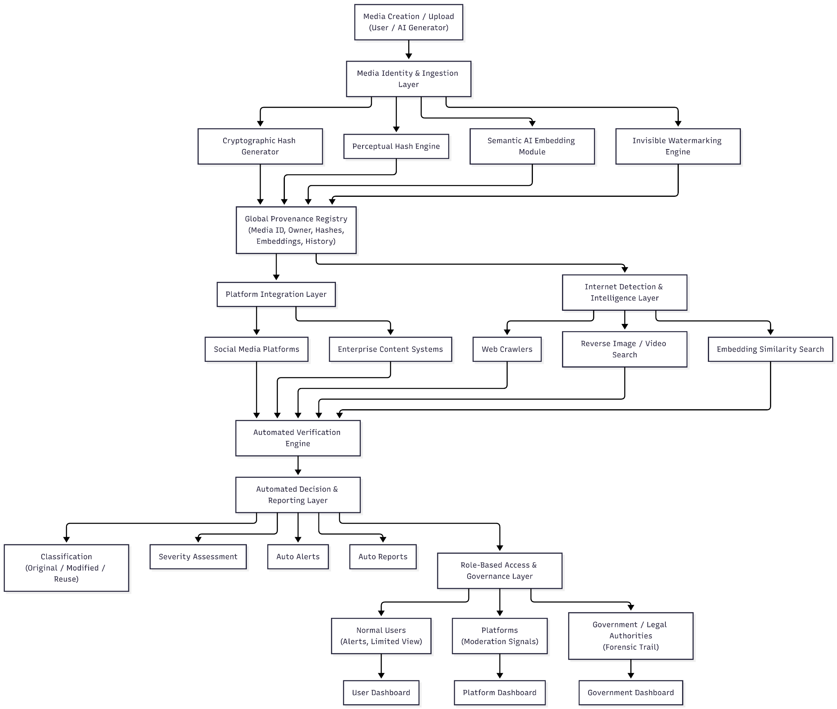
Figure 1 – UMPTS Architecture Diagram (user-supplied).

3. Updated Architecture (text & Mermaid code)
Below is the canonical Mermaid diagram code used to represent the UMPTS architecture in the technical report. This code has been synchronized with the provided diagram and the processing pipeline logic. You can paste this into any Mermaid-enabled editor to render the diagram.
```mermaid
flowchart TB
%% Media Creation & Ingestion
A[Media Creation / Capture (Camera / AI Generator / User)] --> B[Media Upload Pipeline]
%% Processing Pipeline
B --> C1[Cryptographic Hash (Exact Integrity)]
B --> C2[Perceptual Hash (Visual Similarity)]
B --> C3[Semantic AI Embedding (Content Meaning)]
B --> C4[Invisible Watermark Embed (Global Media ID)]
%% Provenance DB Ledger
C1 --> D[Provenance Hash Ledger DB]
C2 --> D
C3 --> D
C4 --> D
D[Provenance DB (Media ID, Versioned Hashes, Change Deltas, Usage Locations)]
%% Detection Sources
E1[Platform Upload Hooks] --> F[Detection Engine]
E2[Distributed Web Crawlers] --> F
E3[Reverse Image/Video Search] --> F
%% Detection & Comparison
F --> G[Hash & Embedding Comparison Engine]
G --> G1[Exact Match]
G --> G2[Similarity / Change Estimation]
G --> H[Versioned Update Engine]
H --> D
%% Attribution & Alerts
H --> I[Usage Attribution Module (Site, URL, Country, Time)]
I --> J[Alert & Notification Engine]
J --> K[Role-Based Governance & Dashboards]
K --> K1[Creators (Alerts, Limited View) --> User Dashboard]
K --> K2[Platforms (Moderation Signals) --> Platform Dashboard]
K --> K3[Gov / Legal (Forensic Trail) --> Government Dashboard]
```

4. Completeness Check – Items Present
- Mandatory media upload pipeline invoked immediately after creation/upload.
- Generation and storage of cryptographic hash, perceptual hash, semantic embedding.
- Invisible watermark embedding with Global Media ID.
- Versioned provenance/hash ledger DB (v0, v1, v2...).
- Internet Detection Engine (crawlers, reverse search, vector similarity).
- Platform add-on verification (upload-time hooks).
- Hash & embedding comparison engine with change quantification (percent).
- Automated decision, alerts and rule-based reporting.
- Role-based governance and audit logs (Creators, Platforms, Government).
- User-facing dashboards (creator, platform, government).

5. Missing / Recommended Additions (if any)
The provided diagram and the updated architecture together represent a complete system for a submission. The following recommendations strengthen the design and are advised for implementation or future drafts:
- Explicit Key Management & PKI section: how signing keys are generated, stored, rotated, and revoked.
- Scalability plan for the Provenance DB (sharding, indexing, FAISS or ANN integration for embeddings).
- Privacy-preserving techniques: homomorphic encryption, differential privacy, or access audits for sensitive queries.
- Adversarial robustness plan: countermeasures for watermark removal, model purification, and diffusion-based reconstruction.
- Legal & compliance workflow: consent management, jurisdictional escalation policies, and GDPR considerations.
- Performance metrics & benchmarks: expected latency for pipeline, detection recall/precision goals, storage requirements.
- Integration SDK & API contract examples for platforms and camera/AI generator vendors.
- Monitoring & SLOs: health checks, crawler politeness, and false-positive rate monitoring dashboards.
- Fallbacks for offline media ingestion and delayed registry synchronization.
- Testing plan and evaluation datasets for watermark robustness and similarity matching.

6. Actionables – What I updated for you
1. Integrated your supplied architecture diagram into the submission document.
2. Added a canonical Mermaid diagram that matches the image and pipeline logic.
3. Performed a completeness checklist and produced recommended additions to strengthen the design.
4. Prepared this finalized DOCX for download and further edits.

7. Next Steps (optional)
If you want, I can:
• Convert the Mermaid diagram into an embedded SVG or raster and add it to the final PDF.
• Expand any recommended addition sections into full subsections (e.g., PKI, scalability).
• Generate sample API specification (OpenAPI) for Platform Integration and Detection Engine.
• Produce a one-page summary slide or PPT for Unisys submission.

