BIKEWALE VEHICLE MARKET ANALYSIS
Final Project Report
Web Scraping, Data Cleaning, EDA, Visualization & Business Insights
Author
K. Uday Kiran Reddy
Website: BikeWale – https://www.bikewale.com/

Executive Summary
This project follows a complete data analytics pipeline for a BikeWale-oriented vehicle dataset: Website Selection → Data Collection → Data Understanding → Data Cleaning → Exploratory Data Analysis → Data Visualization → Business Insights & Recommendations → Presentation. The supplied dataset contains 500 vehicle records and 17 fields. The analysis covers vehicle brands, models, vehicle categories, fuel types, pricing, mileage/range, engine capacity, power, transmission, variants, colors, cities, customer ratings, reviews and model years.
In the supplied dataset, the average ex-showroom price is ₹243,059, the average on-road price is ₹282,119, and the average customer rating is 4.10/5. Petrol vehicles account for 413 records, while electric vehicles account for 87. Suzuki is the most represented brand with 67 records, and Jaipur is the most represented city with 59 records. The findings provide a strong foundation for market segmentation, pricing comparisons and dashboard reporting.

1. Project Objective
- Collect or structure two-wheeler data associated with an automobile website.
- Understand and clean the collected records before analysis.
- Perform EDA to identify patterns in price, brands, fuel type, ratings and vehicle specifications.
- Create business-focused visualizations and a dashboard-ready summary.
- Convert the analytical results into practical recommendations for customers, manufacturers and marketers.

2. Project Workflow
Website Selection → Data Collection → Data Understanding → Data Cleaning → Exploratory Data Analysis → Data Visualization → Business Insights & Recommendations → Presentation

3. Website Selection and Data Collection
Selected website: BikeWale (https://www.bikewale.com/). BikeWale is the domain selected for the project because vehicle listings provide attributes that are useful for comparing products, prices, specifications and customer feedback.
Web scraping can be implemented in Python using Requests and BeautifulSoup on permitted, publicly accessible pages. Because page structures and access rules can change, the scraper should use current, verified selectors and respect the website’s terms and robots.txt.

Sample Python Framework
import requests
from bs4 import BeautifulSoup
import pandas as pd
url = "YOUR_PERMITTED_BIKEWALE_LISTING_URL"
headers = {"User-Agent": "Mozilla/5.0"}
response = requests.get(url, headers=headers, timeout=20)
soup = BeautifulSoup(response.text, "html.parser")
records = []
for item in soup.select("YOUR_VEHICLE_SELECTOR"):
records.append({
"brand": item.select_one("YOUR_BRAND_SELECTOR").get_text(strip=True),
"model": item.select_one("YOUR_MODEL_SELECTOR").get_text(strip=True)
})
df = pd.DataFrame(records)
df.to_csv("bikewale_raw_data.csv", index=False)

4. Data Understanding
Metric | Value
Records | 500
Columns | 17
Brands | 10
Cities | 10
Petrol records | 413
Electric records | 87
Average ex-showroom price | ₹243,059
Average on-road price | ₹282,119
Average rating | 4.10/5
Average mileage/range | 75.21

5. Data Dictionary
Field | Description | Type
vehicle_id | Unique vehicle identifier | Integer
brand | Vehicle manufacturer | Text
model | Vehicle model name | Text
vehicle_type | Vehicle category | Text
fuel_type | Petrol or Electric | Text
ex_showroom_price | Ex-showroom price | Numeric
on_road_price | Estimated on-road price | Numeric
mileage_kmpl_or_range_km | Mileage or electric range | Numeric
engine_cc | Engine capacity; 0 represents electric in this dataset | Integer
power_bhp | Power output | Numeric
transmission | Manual or Automatic | Text
number_of_variants | Available variants | Integer
number_of_colors | Available colors | Integer
city | City/market represented | Text
rating | Customer rating | Numeric
review_count | Number of reviews | Integer
model_year | Vehicle model year | Integer

6. Data Cleaning
The raw supplied dataset contained 500 records with no exact duplicate rows. Five missing values were present in each of the rating, number_of_colors and power_bhp fields. These numeric gaps were filled using the median of the corresponding non-missing values. Numeric fields were converted to appropriate numeric types and the cleaned dataset was saved for analysis.
Cleaning Check | Result / Action
Duplicate records | 0 exact duplicate rows found
Missing rating | 5 values; median imputation
Missing number_of_colors | 5 values; median imputation
Missing power_bhp | 5 values; median imputation
Invalid price/rating checks | Validated during preparation
Final cleaned records | 500

7. Exploratory Data Analysis

7.1 Brand Analysis
Suzuki has the highest representation in the dataset with 67 records. The brand distribution shows that the dataset is not evenly distributed across manufacturers, so comparisons should be interpreted as sample-level findings.
Brand | Vehicle Count | Avg. Ex-showroom Price
Suzuki | 67 | ₹268,179
Hero | 63 | ₹261,580
Royal Enfield | 54 | ₹263,632
Honda | 53 | ₹277,520
Yamaha | 52 | ₹265,616
KTM | 51 | ₹235,210
Ather | 50 | ₹149,217
Bajaj | 42 | ₹270,292
Ola | 37 | ₹158,862
TVS | 31 | ₹246,401

7.2 Fuel Type Analysis
There are 413 petrol records (82.6%) and 87 electric records (17.4%). Petrol vehicles therefore form the majority of the supplied sample.

7.3 Price Analysis
The average ex-showroom price is ₹243,059, while the average on-road price is ₹282,119. The highest average ex-showroom price among brands in this dataset is recorded for Honda, at about ₹277,520.

7.4 Customer Rating Analysis
The average customer rating is 4.10/5. The brand with the highest average rating in this sample is KTM at approximately 4.28/5.

7.5 City Analysis
Jaipur has the highest number of records with 59. City-level analysis can be used to compare product presence across markets.

8. Data Visualization

8.1 Brand Distribution
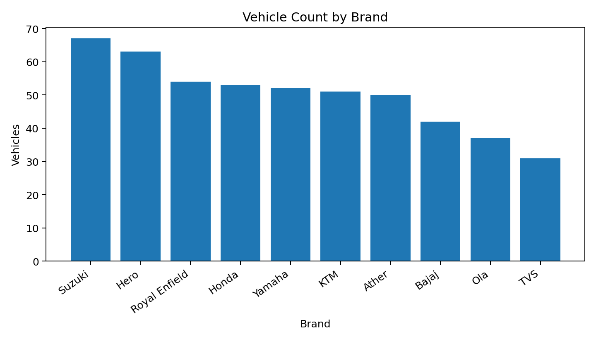
Figure 1. Number of vehicle records by brand.

8.2 Fuel Type Distribution
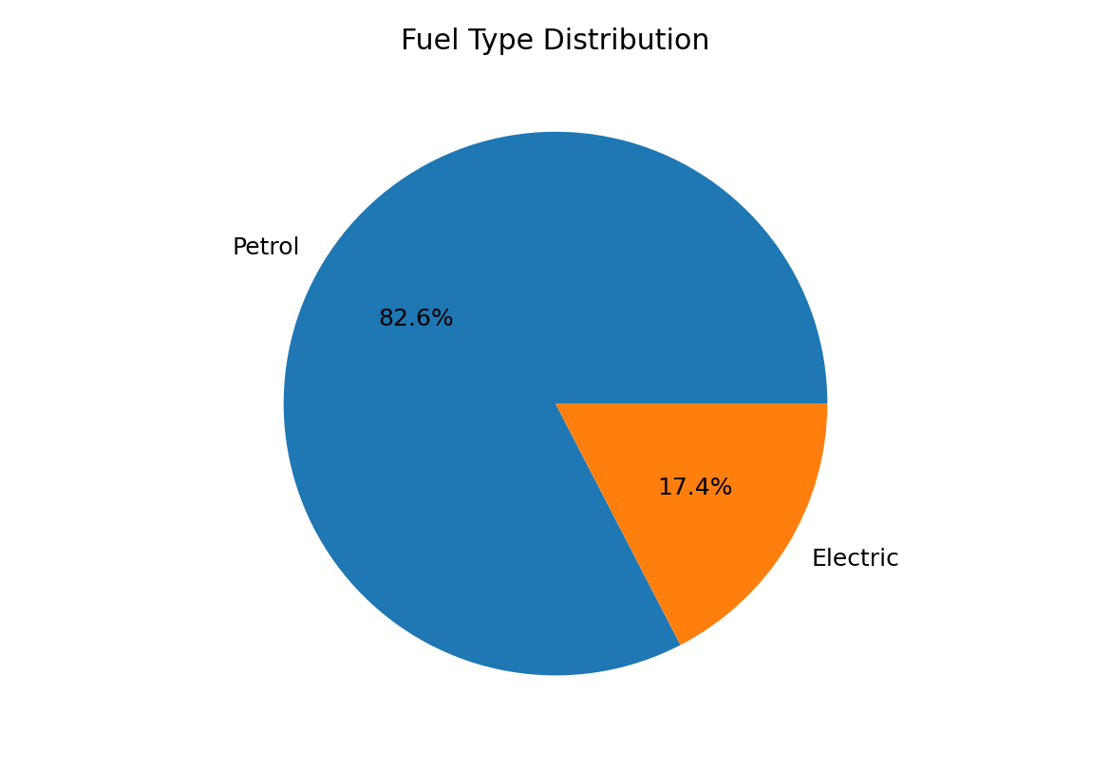
Figure 2. Petrol versus electric vehicle distribution.

8.3 Average Price by Brand
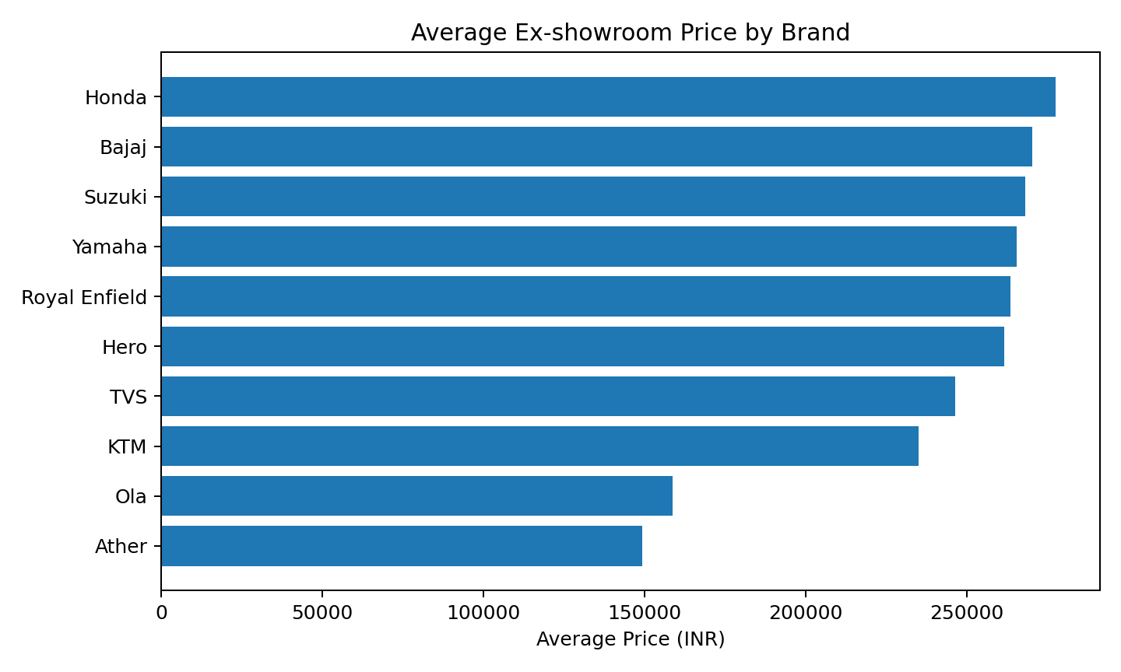
Figure 3. Average ex-showroom price by brand.

8.4 Price versus Rating
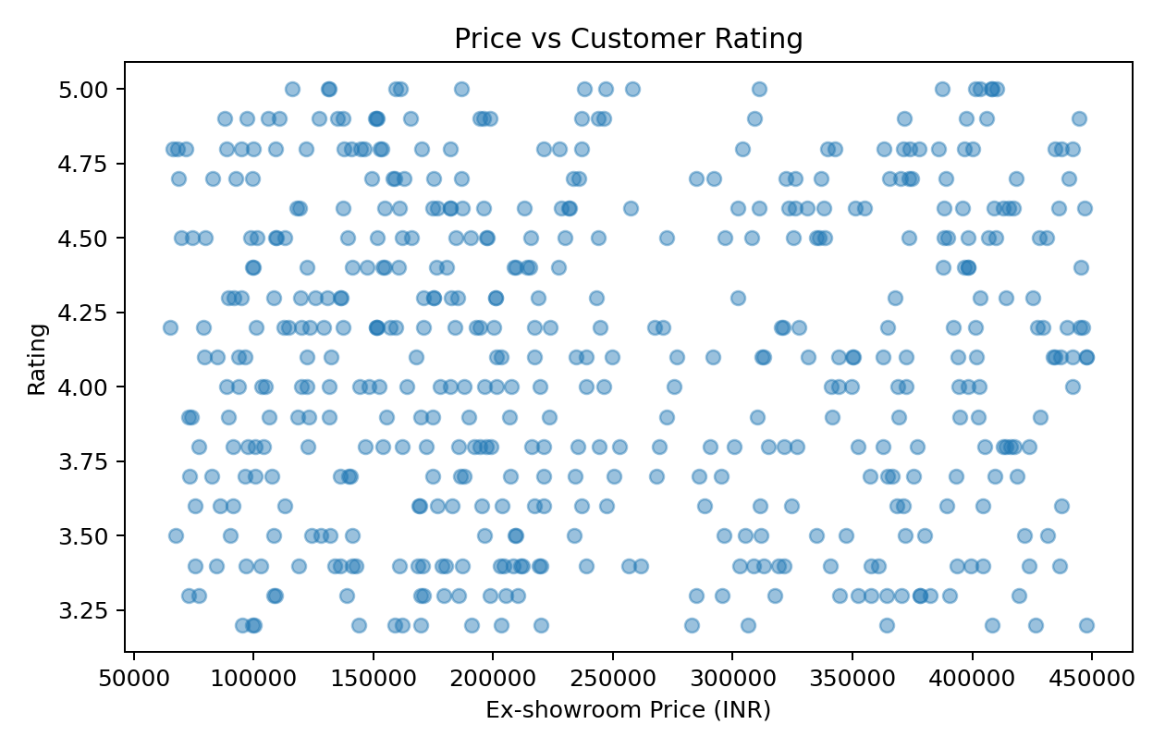
Figure 4. Relationship between ex-showroom price and customer rating.

9. Dashboard Design
The cleaned dataset is suitable for a Power BI, Excel or Streamlit dashboard. Recommended KPI cards are Total Vehicles, Average Ex-showroom Price, Average On-road Price, Average Rating and Electric Vehicle Count. Recommended filters are Brand, Vehicle Type, Fuel Type, City and Model Year.
Dashboard Component | Recommended Measure
KPI Card | Total vehicles = 500
KPI Card | Average ex-showroom price = ₹243,059
KPI Card | Average rating = 4.10/5
KPI Card | Electric vehicles = 87
Bar chart | Vehicle count by brand
Donut/Pie chart | Petrol versus electric
Bar chart | Average price by brand
Scatter plot | Price versus rating
Filter | Brand / Fuel / City / Vehicle type / Model year

10. Business Insights
- Suzuki has the highest number of records in the supplied sample.
- Petrol vehicles dominate the sample, while electric vehicles represent a smaller but meaningful segment.
- The overall average ex-showroom price is around ₹243,059, providing a useful benchmark for segmentation.
- Honda has the highest average price among represented brands in this dataset.
- Customer ratings average 4.10/5 and can be combined with review counts to assess customer engagement.
- City-level distribution indicates that market presence varies by location, supporting city-specific marketing analysis.

11. Business Recommendations
- Segment vehicles into budget, mid-range and premium price bands for clearer competitive analysis.
- Use customer ratings together with review counts so that a high score with very few reviews is not treated as stronger evidence than a well-reviewed model.
- Evaluate electric vehicles separately on price and range because their performance metric differs from petrol mileage.
- Use city-wise patterns to plan localized campaigns, inventory and dealership priorities.
- Track competitor prices over time to detect pricing opportunities and changes in market positioning.
- Build an interactive dashboard so decision-makers can filter the analysis by brand, fuel type, city and model year.

12. Final Project Deliverables
✓ Python Web Scraping Script
✓ Raw Dataset
✓ Cleaned & Structured Dataset
✓ Data Dictionary
✓ Data Cleaning Documentation
✓ EDA Notebook
✓ Visualizations
✓ Dashboard
✓ Business Insights & Recommendations
✓ Final Report / Presentation

13. Limitations
The supplied dataset is used as the project dataset and should not be described as a verified live snapshot of BikeWale. The current web page structure, available fields and access rules may change. Therefore, the scraping code in this report is a framework with placeholders rather than a claim that the exact current BikeWale selectors were executed.

14. Conclusion
The BikeWale Vehicle Market Analysis project demonstrates a complete end-to-end analytics workflow using a 500-record, 17-field vehicle dataset. Data preparation identified and resolved missing numeric values, after which EDA highlighted differences in brand representation, fuel type, pricing, ratings and city distribution. Visualizations make these patterns easier to communicate, while the dashboard design converts them into a decision-support tool. The project can be extended through additional permitted data collection, historical snapshots and predictive analytics.

Appendix A – Key Python Libraries
Requests, BeautifulSoup, Pandas and NumPy for collection/preparation; Matplotlib for visualization; and Power BI, Excel or Streamlit for dashboarding.

