

Bus Tracking System

**For IIT TIRUPATI**

**SDG GOALS 11:**

**SUSTAINABLE CITIES AND COMMUNITIES**

PROJECT

REQUIREMENTS

TEAM 12

# **Introductio**n

Creating a Bus Tracking Web application for Students of IIT Tirupati using 3D google Map and tracking bus location using drivers location using drivers smartphone GPS.

## 

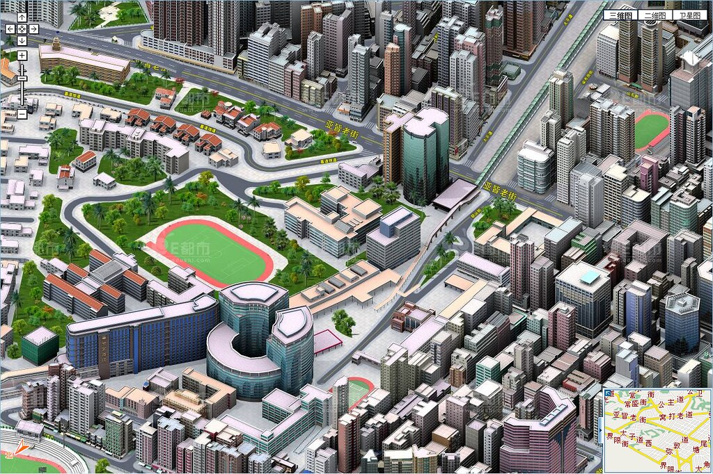

## **Technical Requirements :**

**Front-end Requirements (React):**

1**. User Authentication:** Implement user registration and login functionality for both students and drivers.

2. **Dashboard for Students:**  Create a user-friendly dashboard where students can view real-time bus locations, bus routes, and estimated arrival times.

3. **3D Map Integration:** Integrate a 3D map library (e.g., Three.js) to display the institution's map and visualize bus locations in a 3D environment.

4. **Real-Time Tracking:** Develop real-time tracking features using WebSocket or a similar technology to provide live updates of bus locations on the 3D map.

5. **User Profile Management:**  Allow students to manage their profiles and preferences, such as setting home locations or favorite bus routes.

6. **Responsive Design:** Ensure that the web application is responsive and works well on various screen sizes and devices.

**Back-end Requirements (Node.js with Express.js):**

1. **API Development:**  Build a RESTful API to handle communication between the front-end and back-end.

2. **GPS Data Integration:** Develop functionality to collect GPS data from drivers' smartphones and store it securely in the database.

3. **User Authentication:** Implement user authentication and authorization to secure access to the application and APIs.

4**. Database (MongoDB):** MongoDB database to store bus routes, driver information, student profiles, and GPS coordinates.

5. **Real-Time Data Processing:** Implement real-time data processing to update bus locations and send notifications to students in real-time.

6. **Security:** Apply encryption and secure communication protocols to protect sensitive data, including GPS coordinates and user information.

7. **Error Handling:**  Implement robust error handling and logging to identify and address issues quickly.

**Mapping and 3D Visualization Requirements:**

1. **3D Map Library:** Choose and integrate a 3D mapping library (e.g., Three.js) to render the institution's map and bus locations.

2. **Geolocation Integration:** Connect the 3D map with real-time GPS data from drivers to display accurate bus positions.

3. **Custom Map Design:** Design and develop a custom 3D representation of your institution's campus.

**Driver Smartphone Integration:**

1. **Mobile App for Drivers:** Develop a mobile app for drivers to share their GPS locations. The app should be capable of running in the background.

2. **GPS Data Transmission:** Create APIs on the server to receive GPS data from the mobile app and associate it with the respective buses.

**Deployment and Scaling Requirements:**

1. **Hosting:** Set up hosting for the application on a reliable server, such as AWS, Heroku, or a dedicated server.

2. **Load Balancing:**  Implement load balancing to handle increased traffic during peak times.

3. **Scalability:** Design the architecture to scale horizontally to accommodate a growing number of users and buses.

**Testing and Quality Assurance:**

1. **Comprehensive Testing:** Conduct thorough testing, including unit testing, integration testing, and user acceptance testing.

2. **Performance Testing:**  Ensure that the application performs well under different conditions, including peak loads.

**Documentation:**

1**. Technical Documentation:** Document the code, APIs, and system architecture for future reference and maintenance.

**Maintenance and Support:**

1**. Monitoring:**  Implement monitoring tools to track application performance and identify issues proactively.

2. **Regular Maintenance:** Plan for ongoing maintenance and updates to keep the system running smoothly and securely.

**Compliance and Privacy:**

1. **Regulatory Compliance:** Ensure compliance with data protection regulations, especially if you're handling user and location data.

2. **Privacy Considerations:** Address privacy concerns related to tracking and storing user and driver data.

**User Training and Support:**

1. **User Training:** Provide training and support for users, including students, drivers, and administrators.

**Scalability and Future Enhancements:**

1. **Scalability:** Design the system to scale as the number of buses and students increases.

2. It is also possible to extent this idea on larger scale as there will be electric vehicles which will have inbuilt GPS location tracking.