**Summary of the Design Thinking Processes:**

**Empathy:**

Empathy forms the core of all the design thinking processes. When we design a project, the first thing we need to think about is the people we are designing it for. We need to understand their feelings, needs, thoughts and ideas. When we started working on this project, the first thing we did was put ourselves in the user’s shoes. We shared our own experiences as a user ourselves, and it provided us with a lot of valuable inputs. The primary method we used during this stage of Empathy was interviewing people. Before we started interviewing people we did some interesting groundwork to analyze people’s behavior. We used photographs from our own collections and tried to observe the reactions of the people in those photographs. It was a fun part to get the team together on an easy platform.

We started with doing some preliminary research on some of the topics concerned to our project. We brainstormed through a series of meetings and created a list of questions to interview people. During the interviews, we tried to observe the user’s feelings when they were narrating their own personal experiences, especially when they faced some problems. We observed their basic behavioral patterns during this process like analyzing their feelings and emotions when they were narrating some unpleasant experiences. After the interviews, we did research on some of the topics the user’s mentioned in their interviews. We combined all our information together and tried to analyze the basic behavior patterns of the user that we observed during this stage. And by concentrating on some of the events that produced negative emotions from the user, we had the idea for our basic project plan. There were several user inputs we analyzed like the traffic problems they faced, overcrowded trains, lack of availability of trains after midnight etc., But the one user input that garnered our group’s attention was regarding the lack of proper parking spaces. And that was the insight we used to design our product.

**Define:**

To define the problems faced by the people we interviewed, we analyzed the stories and the experiences they shared with us. We created post-its to highlight some of the interesting things the interviewees said to us, especially some of the experiences that created a negative emotion in them. And then we listed all the possible reasons for the user’s dissatisfaction. We combined all our information together from the interviews and from our own observations, and created an Empathy map. Based on the Empathy map, we tried to understand the user’s needs.

During one of the interviews, the user said she faces the same problem multiple number of times in her day to day life. And that problem is her time management. And one of reasons she believes that is constantly affecting her time schedule was the lack of availability of parking spaces. Whenever she goes to an office or a family outing, it has been a persistent problem for her. We identified it as a problem that can be addressed to the user’s satisfaction by making parking spaces easily accessible to her.

We created a composite character profile for the user as given below.

**Composite Character Profile**

Name – Theresa

Age – 27 years

Married with 2 kids

Web Designer/Busy time schedule

Wants to allocate time for the family outing on the weekends.

Because of the weekend rush, wants an accessible way to easily book parking spaces without time delays.

**POV want AD**

“Working mother seeks an easy and accessible way to book parking spaces. Does not want the family outing to be ruined because of a time delay (How can there not be any more parking lots nearby!)”

We created a series of “How might we” questions to address the problem faced by the user. In this case, ”How might we allow the user to have easy access to parking spaces to save her time?”

We discussed through a series of possible answers to create an easy way to make parking spaces available for the user.

**Ideation:**

During this stage, we wanted to find a solution to the problem that we defined in the previous stage. We conducted a series of brainstorm sessions among us. We tried to generate as many ideas as possible. We listed out all the possible options and started eliminating them one by one. We tried to discuss the pros and cons of every available option. And in the end, we decided that creating a mobile app for checking the availability of parking spaces will be most efficient way to solve the user’s problem.

Once we have decided on creating an app, we used various methods to generate ideas. We tried to look at the usability from the user’s perspective by putting ourselves in the user’s shoes. We looked at various other apps to learn the basic design of making an app and how to make it more accessible to the user.

We started out with a basic sketch that is given below,

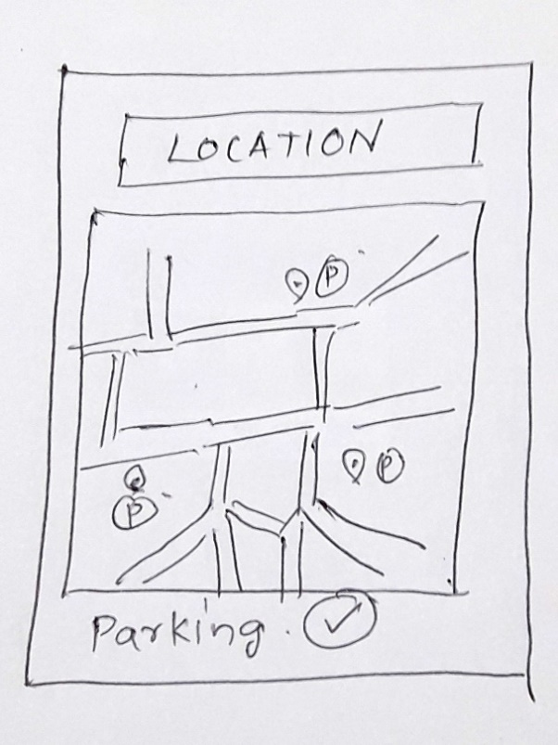

We conducted another brainstorm session to discuss the various aspects of our basic design. We discussed the various advantages and disadvantages of including more features in our app. After a series of brainstorm sessions we came to the conclusion to include multiple features in our app, that includes the user to “Rent out” their own parking space if available.

To summarize briefly, our workings on the project was a learning experience that went through a series of trial and error decisions before we finally arrived at the first Prototype.