**From Dhillip’s**

Github link :

<https://github.com/DhilipBinny/ad_mvc>

**Steps :**

1. Create a ‘notification’ column in the ‘Request’ table. (the notification status is up to you).

**Department :**

Notification & Emails :

1. Request done, sent to head, notify and email him.
2. Request Approved - sent to particular staff and email him
3. Appoint staff - that staff will receive notification and email (both rep & authorize)
4. Collection Point changes - sent to store side.

**Store :**

1. Once PO is created by store clerk, the PO will be sent to supervisor to approve or reject
2. Once adjustment voucher is created :
   1. the voucher will be sent to **store supervisor**(if voucher is less than zero) ,then he approve or reject.
   2. The voucher will be sent to **store manager**(if voucher is more than zero), then he approve or reject.

The Example steps :

1. First I create a ‘notification’ column in one of the table.

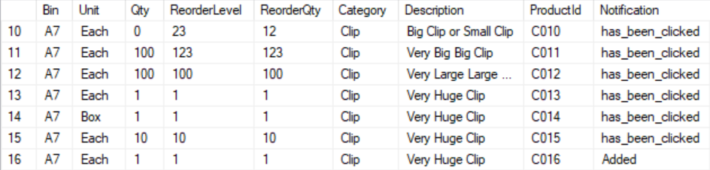

2. When a product is created, I set the notification status to be “Added”. So later we can list out the rows of product that has notification status “Added”.

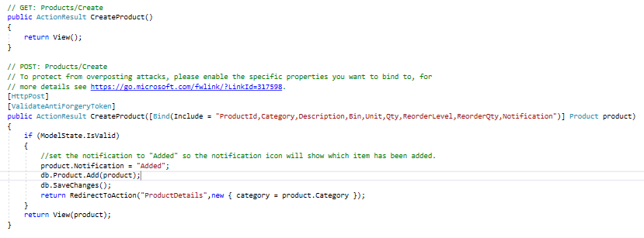

3. I list out the row where notification status is “Added” and count the number of rows that have this status.

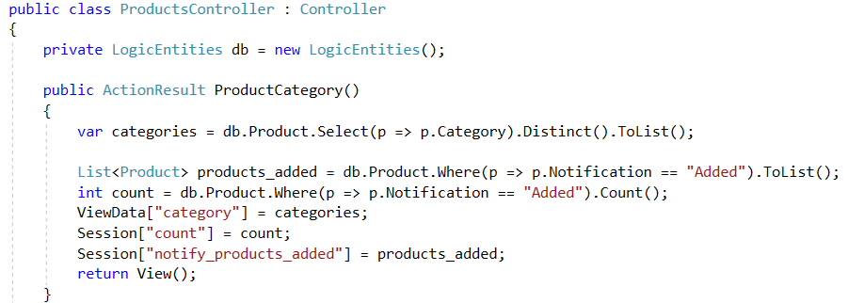

4. In the _layout.cshtml view, we pass the data

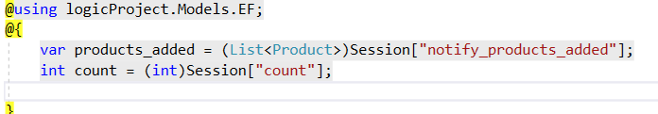

And the notification icon, where we pass the total count of rows that have the notification status : “Added”

</div>

<div class="collapse navbar-collapse">

<ul class="nav navbar-nav navbar-right">

<li id="bell">

<a id="bell_count" href="" class="p1 fa-2x has-badge" data-count=@count data-toggle="modal" data-target="#notifpopup">

<i class="fas fa-bell "></i>

</a>

</li>

<li><a href='@Url.Action("index", "login")'>Logout</a></li>

</ul>

</div>

</div>

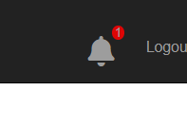

5. When I clicked on the notification bell icon, it will lead to <div> container where it has the id of “notifpopup”, because the data-target in the above is #notifpopup. The <div> is as below :

<!-- Modal -->

<div id="notifpopup" class="modal fade" role="dialog">

<div class="modal-dialog">

<!-- Modal content-->

<div class="modal-content">

<div class="modal-header">

<button type="button" class="close" data-dismiss="modal">&times;</button>

<h4 class="modal-title">Welcome</h4>

</div>

<div class="modal-body">

@foreach (var item in products_added)

{

<ul>

<li>

<a href="@Url.Action("ProductNotifyDetails","Products",new { id = item.ProductId, notification="clicked"})">@item.ProductId</a>

</li>

</ul>

}

</div>

<div class="modal-footer">

<button type="button" class="btn btn-default" data-dismiss="modal">Close</button>

</div>

</div>

</div>

</div>

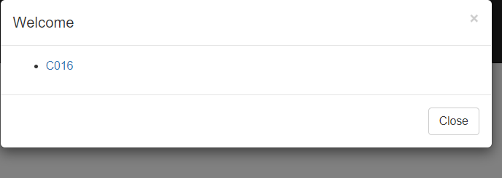

6. When I clicked on the link button above ‘C016’, it will lead me to the view (which I have not put any details ) and it will go to the action method “ProductNotifyDetails” under “ProductsController” . Code as below :

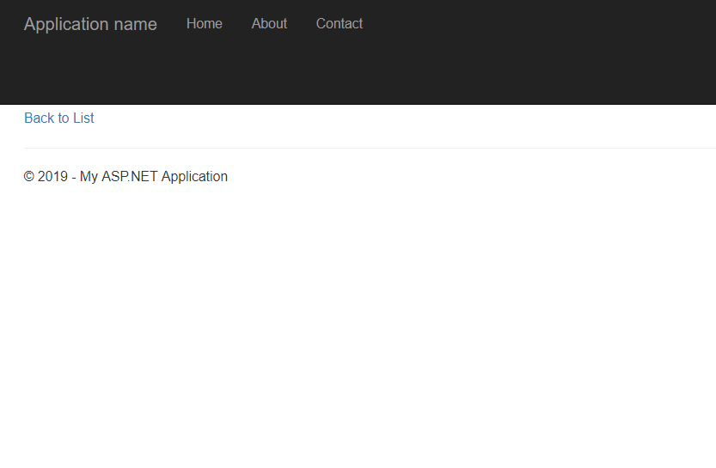

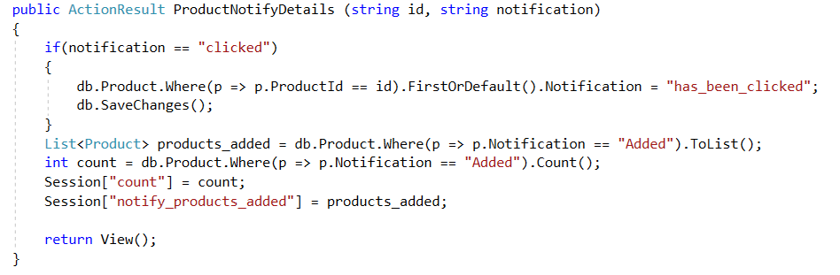

When the link is clicked, the notification status will change to “has_been_clicked”, then we list out again row that has data of notification status: “added”. Since there isn’t any row with “added” status, the notification bell will be zero.

