Name:Udaya Byreddy

Lab id: 6_2

Student id: 3

Patner name: Madhuri Sarda

Student id: 21

Assignment No: 5 Ionic application using Cordova plugin

1. Below are the screen shots of login, create user and get current location using Cordova plugin.

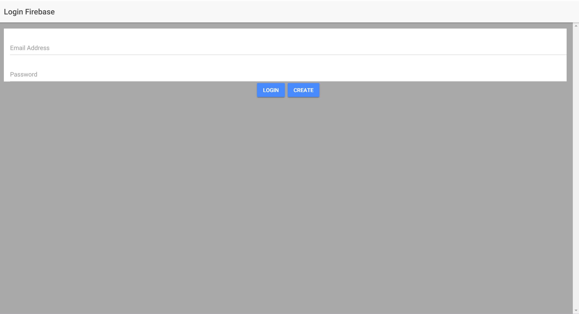

2. Create user page

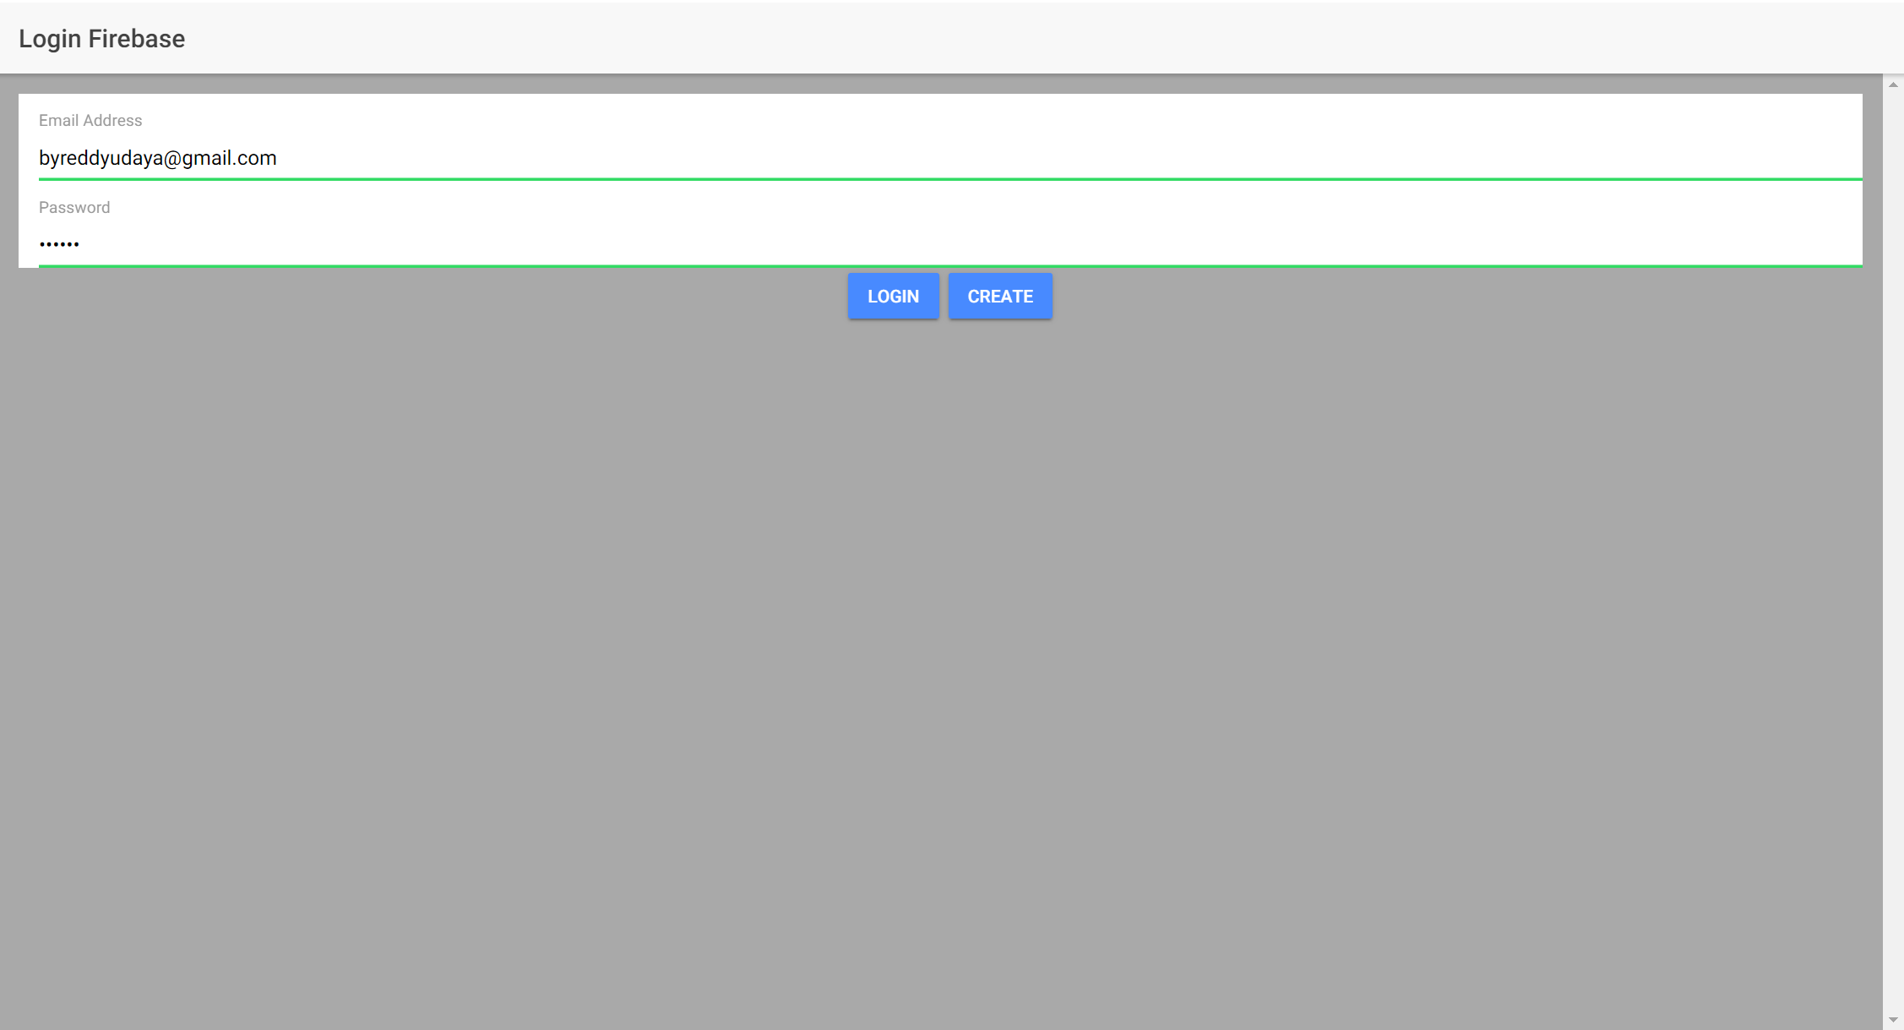

1. Creating user successfully

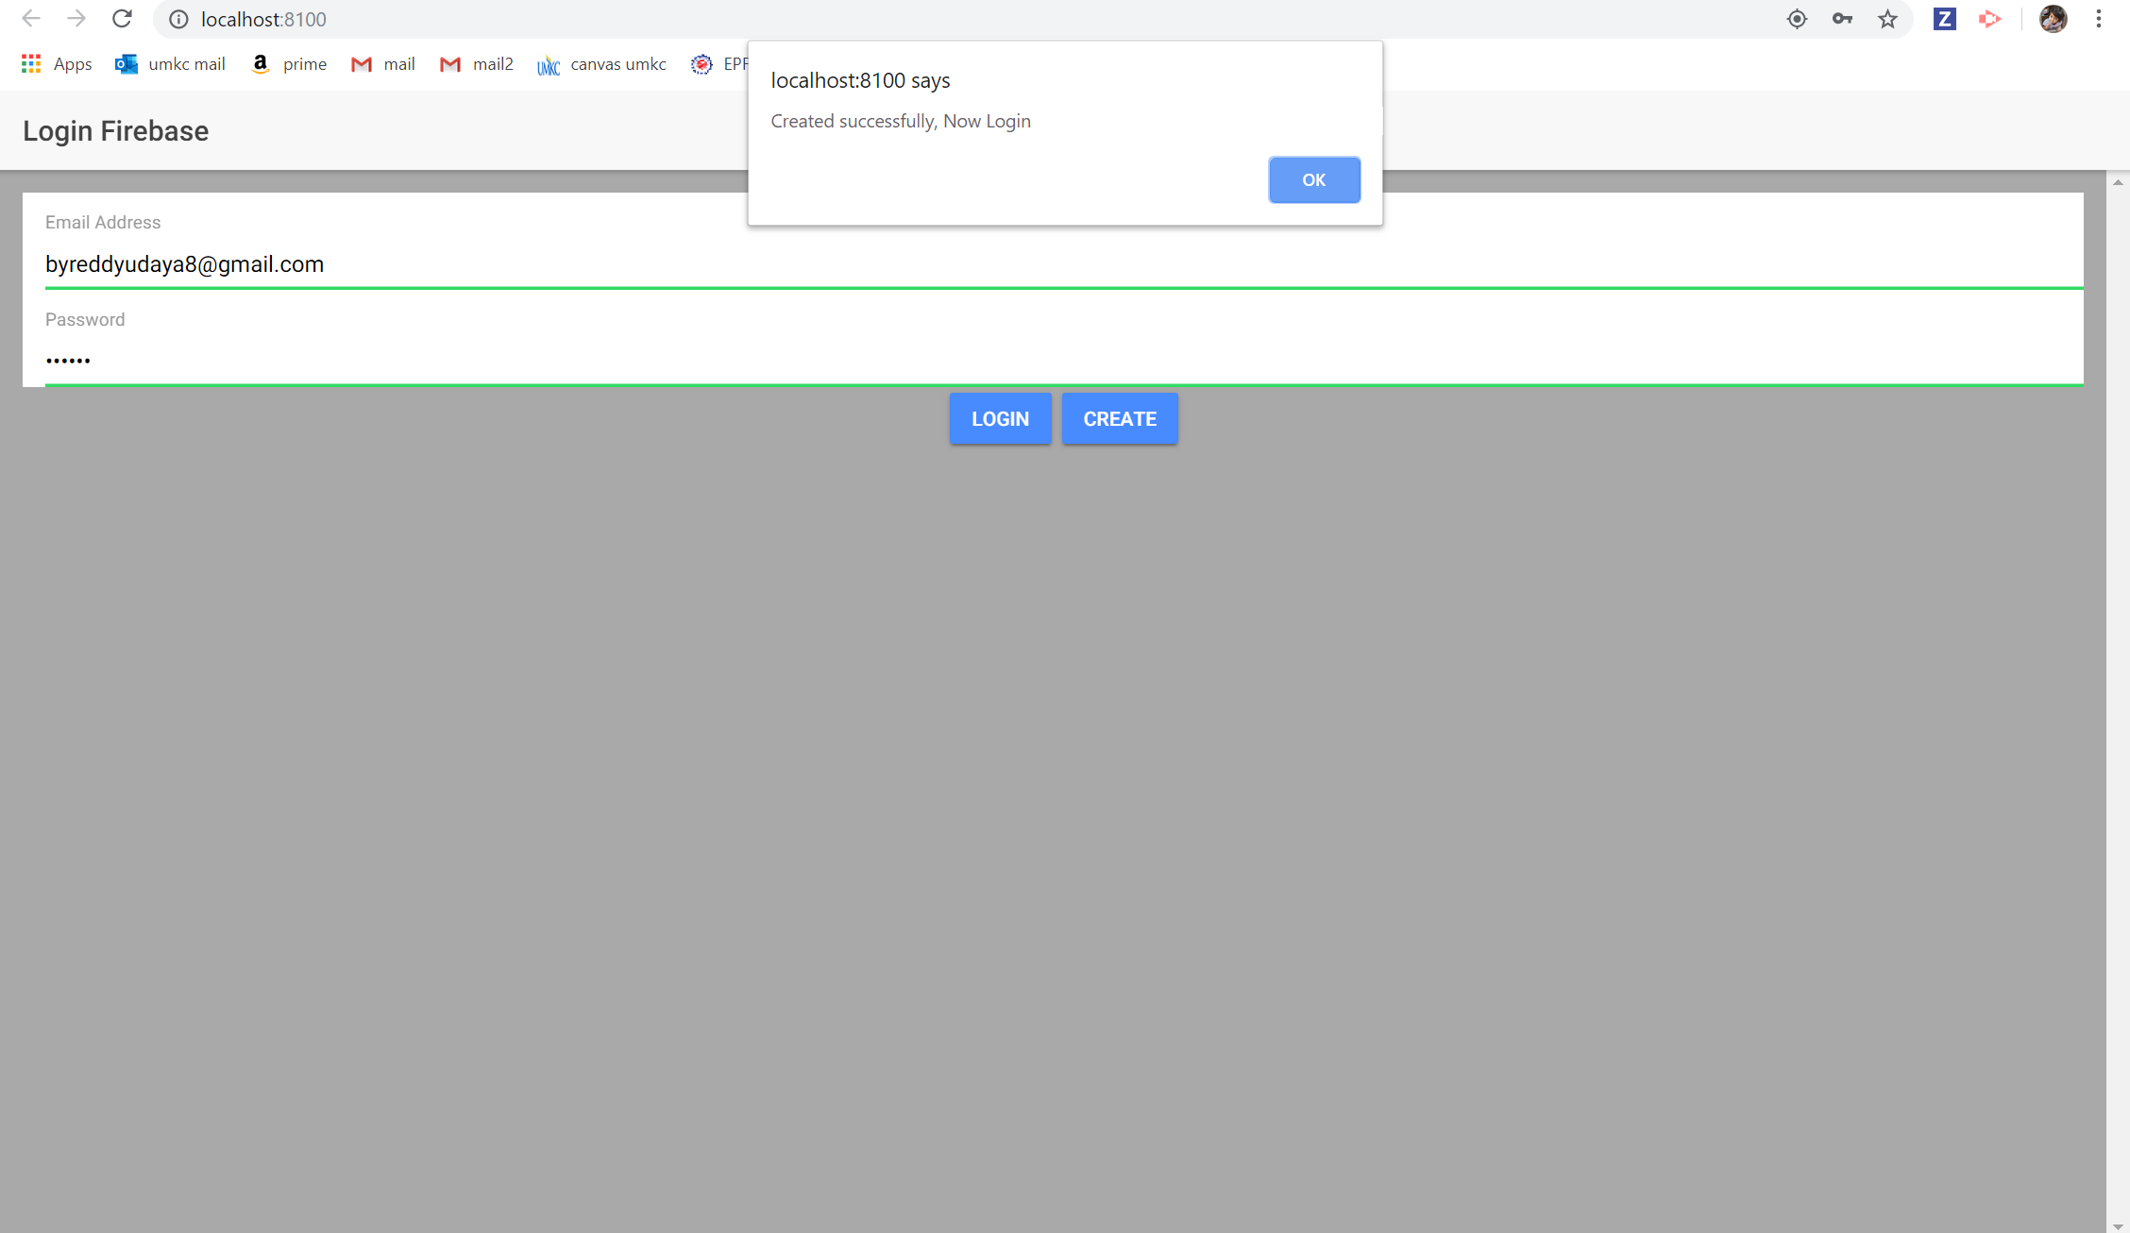

1. After login page when user clicks on current location button, we ask for permission and store the users current location in firebase real time database.

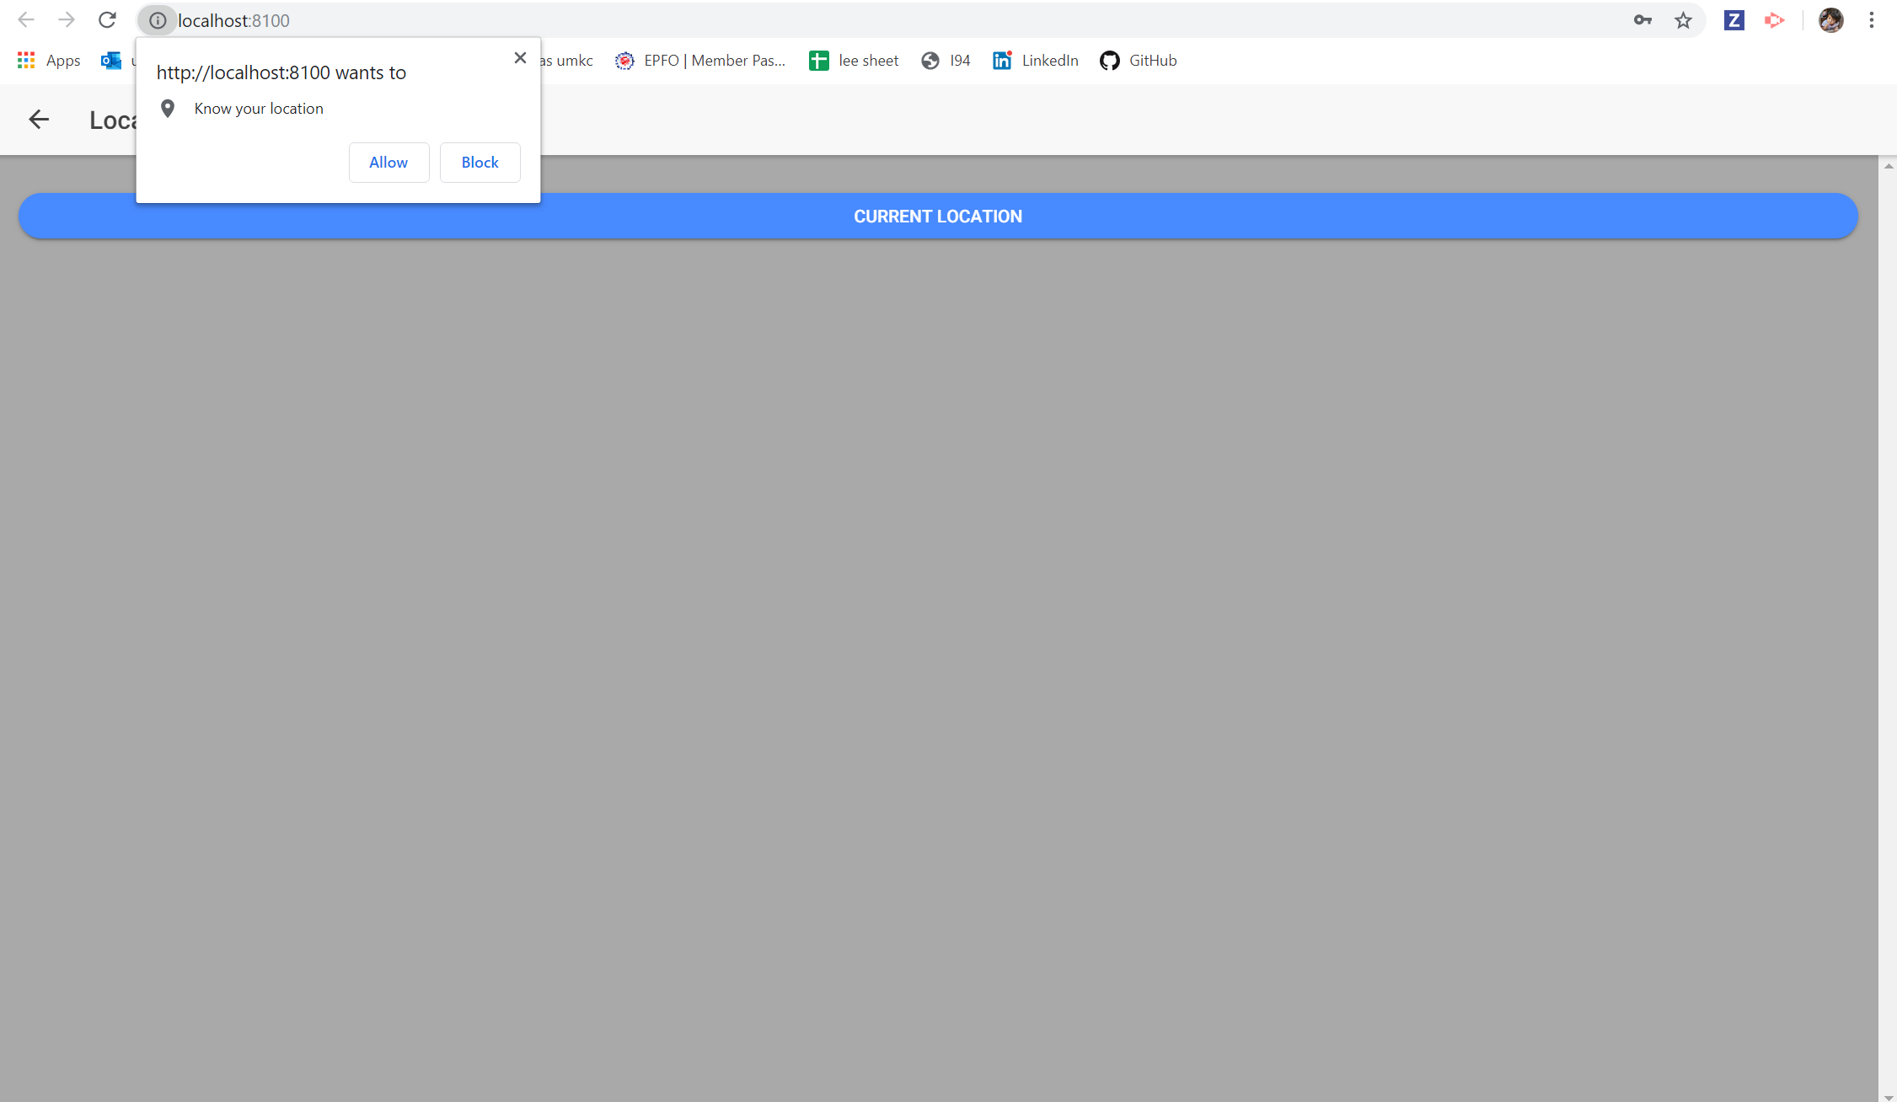

1. when the user logs in for second time, the current location which is stored previously is retrieved from firebase real time database.

