PROJECT REPORT OF INDUSTRY ORIENTED HANDS ON EXPERIENCE (IOHE)
ON
Comparative Study of Machine Learning Regression Models for Student Performance Prediction
Submitted in partial fulfilment of the requirements for the award of degree of

BACHELOR OF ENGINEERING
In
COMPUTER SCIENCE AND ENGINEERING

Submitted by: Supervised By:
Uday Aggarwal: 2210990917 Dr. Gurpreet Singh
Himanshu Sharma: 2210990407 Associate Professor and Placement Incharge
Hargun Singh: 2210990360 CSE Department
Drishti Sharma: 2210991548



DEPARTMENT OF COMPUTER SCIENCE AND ENGINEERING

CHITKARA UNIVERSITY INSTITUTE OF ENGINEERING AND TECHNOLOGY
CHITKARA UNIVERSITY, PUNJAB, INDIA

CONTENTS

S.No. | Title | Page No.
 | Declaration | 3
 | Acknowledgement | 4
 | Abstract | 5
1 | Introduction | 6
2 | Methodology | 7-8
3 | Tools and Technologies | 9
4 | Implementation | 10-11
5 | Major Findings/Outcomes/Output/Results | 12
6 | Conclusion and Future Scope | 13
 | References | 14
 | Appendices | 15-19

DECLARATION

I hereby certify that the work which is being presented in the project report entitled “Comparative Study of Machine Learning Regression Models for Student Performance Prediction” in partial fulfilment of requirement for the award of the degree of Bachelor of Engineering (Computer Science and Engineering) submitted in the department of Computer Science and Engineering at Chitkara University Institute of Engineering and Technology, Chitkara University, Punjab, India, is an authentic record of my own work carried out under the supervision of Dr. Gurpreet Singh. The matter presented in this project report has not been submitted in any other university/institute for the award of any degree.

Place : Rajpura Uday Aggarwal: 2210990917
Date : 29-04-2026 Himanshu Sharma: 2210990407
Hargun Singh: 2210990360
Drishti Sharma :2210991548

This is to certify that the above statement made by the candidate is correct to the best of my knowledge and belief.

Dr. Gurpreet Singh
Associate Professor and Placement Incharge
Department of Computer Science and Engineering
Chitkara University Institute of Engineering and Technology,
Chitkara University, Punjab, India

ACKNOWLEDGEMENT

I would like to express my sincere gratitude to my project guide Dr. Gurpreet Singh, for their valuable guidance, continuous support, and encouragement throughout the completion of this research work on “Comparative Study of Machine Learning Regression Models for Student Performance Prediction.” Their insights and suggestions greatly contributed to the successful completion of this report.
I am also thankful to the faculty members of the Department of Computer Science and Engineering for providing the necessary resources and a conducive environment for learning and research.
I extend my heartfelt thanks to my friends and classmates for their support and helpful discussions during the development of this project.

Abstract

The increasing availability of educational data has opened new possibilities for improving student outcomes through data-driven analysis. Educational Data Mining (EDM) applies machine learning techniques to analyse student information and predict academic performance, enabling early identification of students who may require additional support.

This project presents a comparative study of four machine learning regression models—Linear Regression, Ridge Regression, Decision Tree Regressor, and Random Forest Regressor—for predicting student performance. The study uses the UCI Student Performance Dataset, which contains 395 student records with 33 attributes, including demographic, social, and academic features. The target variable is the final grade (G3).

A structured methodology was followed, including data preprocessing, encoding of categorical variables, feature scaling, and splitting the dataset into training and testing sets. All models were evaluated using Mean Absolute Error (MAE), Mean Squared Error (MSE), and R² Score.

The results show that the Random Forest Regressor outperforms the other models, achieving the highest R² score of 0.8288. Linear and Ridge Regression provided similar performance, while the Decision Tree model showed lower accuracy due to overfitting. Feature importance analysis revealed that previous grades (G1 and G2) are the most significant predictors of final performance.

Overall, the study demonstrates that ensemble learning methods are highly effective for student performance prediction and can support early intervention strategies in educational institutions.

1. Introduction

1.1 Overview
In recent years, the integration of technology in education has led to the generation of large volumes of data related to student performance, behaviour, and demographics. Educational institutions now have access to detailed information such as attendance records, grades, study habits, and social factors. This data, when analysed effectively, can provide valuable insights into student learning patterns.
Educational Data Mining (EDM) is an emerging field that focuses on extracting useful knowledge from educational datasets. It combines techniques from machine learning, statistics, and data analysis to improve learning outcomes and institutional decision-making.
One of the most important applications of EDM is predicting student academic performance. By analysing historical data, machine learning models can identify patterns and trends that help forecast future performance. This enables educators to identify students who may require additional support and take proactive measures to improve their outcomes.

1.2 Problem Statement
Traditional evaluation systems rely heavily on periodic tests and final examinations to assess student performance. However, these methods are reactive rather than proactive. By the time poor performance is identified, it is often too late to provide effective intervention.
There is a need for predictive systems that can estimate student performance early in the academic cycle. Such systems can help educators identify at-risk students and implement timely interventions such as tutoring, counselling, or additional academic support.
This project addresses the problem by using machine learning regression models to predict student final grades based on various influencing factors.

1.3 Objectives
The main objectives of this project are:
- To analyse the student performance dataset and understand key features
- To preprocess the dataset for machine learning applications
- To implement multiple regression models
- To compare the performance of these models using evaluation metrics
- To identify the most accurate model for predicting student performance
- To analyse the importance of different features affecting student outcomes

2. Methodology

2.1 Dataset Description
The dataset used in this project is the UCI Student Performance Dataset, which contains information about secondary school students. It includes 395 records and 33 attributes covering various aspects of student life.
These attributes can be broadly categorized into:
- Demographic Features: Age, gender, family size
- Social Features: Family relationships, social activities
- Academic Features: Previous grades (G1, G2), study time, failures
The target variable is G3, which represents the final grade of the student.

2.2 Data Preprocessing
Data preprocessing is a crucial step in machine learning as raw data is often not suitable for model training.
The following preprocessing steps were performed:
- Handling Missing Values: The dataset was checked for missing values, and none were found
- Categorical Encoding: Categorical variables such as gender, school type, and address were converted into numerical form using LabelEncoder
- Feature Scaling: StandardScaler was used to normalize the feature values so that all features contribute equally to the model
These steps ensure that the dataset is clean, consistent, and suitable for model training.

2.3 Model Implementation
In this project, four supervised machine learning regression models were implemented to predict student performance. Each model was trained on the same dataset and evaluated under identical conditions to ensure a fair comparison.

Models implemented:-
- Linear Regression
- Ridge Regression
- Decision Tree Regressor
- Random Forest Regressor

All models were implemented using the Scikit-learn library in Python. The training process involved fitting each model on the training dataset and then evaluating their performance on the test dataset. Default parameters were used for initial comparison to maintain consistency across models.

2.4 Train-Test Split
To evaluate the performance of the models, the dataset was divided into two parts:
- Training Set (80%) – Used to train the models
- Testing Set (20%) – Used to evaluate model performance
A random state of 42 was used to ensure reproducibility of results.

2.5 Evaluation Metrics
The models were evaluated using the following metrics:
- Mean Absolute Error (MAE): Measures the average magnitude of errors
- Mean Squared Error (MSE): Penalizes larger errors more heavily
- R² Score: Indicates how well the model explains the variance in the data
These metrics provide a comprehensive evaluation of model performance.

3. Tools and Technologies

The successful implementation of this research work required the use of various tools and technologies for data processing, model building, and evaluation. The following tools were used:

1. Programming Language
- Python was used as the primary programming language due to its simplicity and wide support for machine learning libraries.

2. Libraries and Frameworks
- Pandas: Used for data manipulation and analysis.
- NumPy: Used for numerical computations.
- Scikit-learn: Used for implementing machine learning models and preprocessing techniques.
- Matplotlib: Used for data visualization and plotting graphs.

3. Dataset
- UCI Student Performance Dataset was used in this project.
- It contains 395 student records and 33 attributes, including demographic, social, and academic features.
- The target variable is G3 (final grade), which is predicted using machine learning models.

4. Development Environment
- Jupyter Notebook / Google Colab – Used for writing and executing code, data analysis, and visualization in an interactive environment.

4. Implementation

The implementation of the project involves applying various machine learning regression models to predict student performance using a structured approach. The steps followed during implementation are as follows:

4.1 Data Loading
The dataset was loaded using the Pandas library from a CSV file. Since the dataset uses semicolons as separators, it was imported using the appropriate delimiter. Initial exploration was performed using functions like head(), info(), and shape() to understand the structure and contents of the data.

4.2 Data Preprocessing
Before applying machine learning models, the dataset was preprocessed:
- Missing values were identified and handled.
- Categorical data was converted into numerical format using encoding techniques.
- Irrelevant or duplicate data was removed.
- Feature scaling was applied where necessary to normalize the data.

4.3 Feature Selection
The input features (X) and target variable (y) were defined in this step. The final grade (G3) was selected as the target variable, while the remaining attributes were used as input features. Important predictors such as G1 and G2 were retained due to their strong influence on final performance.

4.4 Splitting the Dataset
The dataset was divided into two parts:
- Training set (used to train the model)
- Testing set (used to evaluate the model)
An 80:20 ratio was used.

4.5 Model Implementation
The following regression models were implemented using the Scikit-learn library:
- Linear Regression
- Ridge Regression
- Decision Tree Regressor
- Random Forest Regressor
Each model was trained using the training dataset.

4.6 Model Evaluation
The performance of each model was evaluated using three metrics:
- Mean Squared Error (MSE)
- Mean Absolute Error (MAE)
- R-squared Score
These metrics help measure prediction accuracy and the model’s ability to explain variance in the data.

4.7 Result Comparison
The results obtained from all models were compared based on their evaluation metrics. Random Forest showed the best performance, followed by Ridge and Linear Regression, while Decision Tree performed the worst due to overfitting.

4.8 Visualization
Visualization techniques were used to better understand model performance. Bar graphs were plotted to compare MAE, MSE, and R² scores across models. Additionally, scatter plots were used to visualize actual versus predicted values, providing insight into prediction accuracy.

5. Major Findings/Outcomes/Output/Results

The performance of the implemented machine learning models was evaluated using standard regression metrics, namely Mean Absolute Error (MAE), Mean Squared Error (MSE), and R² Score. Each model was trained and tested under the same conditions to ensure a fair and unbiased comparison.
The results obtained from the evaluation are summarized in the table below, which highlights the accuracy and effectiveness of each model in predicting student performance.

Model | MAE | MSE | R² Score | Rank
Linear Regression | 1.421 | 3.872 | 0.7614 | 3rd
Ridge Regression | 1.418 | 3.855 | 0.7625 | 2nd
Decision Tree | 1.734 | 5.190 | 0.6817 | 4th
Random Forest | 1.147 | 2.838 | 0.8288 | 1st

Key Observations:
- Random Forest achieved the highest accuracy among all models
- Decision Tree performed the worst due to overfitting
- Linear and Ridge Regression showed similar performance
- Previous grades (G1 and G2) were the most important predictors

6. Conclusion and Future Scope

6.1 Conclusion
This project successfully demonstrated the application of machine learning regression models for predicting student academic performance. A comparative analysis was conducted using four models—Linear Regression, Ridge Regression, Decision Tree Regressor, and Random Forest Regressor on the UCI Student Performance dataset.
All models were trained and evaluated under a consistent framework, including proper data preprocessing, feature scaling, and train-test splitting. The evaluation was carried out using standard performance metrics such as MAE, MSE, and R² Score.
Among all the models, the Random Forest Regressor achieved the best performance, with the highest R² score and lowest error values. This highlights the effectiveness of ensemble learning techniques in handling complex and non-linear relationships in data. Linear and Ridge Regression produced similar results, indicating that the dataset does not suffer significantly from multicollinearity. On the other hand, the Decision Tree Regressor showed comparatively lower performance due to overfitting.
The analysis also revealed that prior academic performance indicators, particularly G1 and G2, are the most influential factors in predicting final grades. This emphasizes the importance of continuous evaluation systems in educational institutions.
Overall, the study confirms that machine learning can be effectively used to predict student performance and can assist educators in identifying students who may require additional academic support.

6.2 Future Scope
While the current study provides valuable insights, there are several opportunities for further improvement and extension:
- More advanced machine learning models such as XGBoost, LightGBM, and Gradient Boosting can be explored to potentially improve prediction accuracy.
- Hyperparameter tuning techniques like Grid Search or Random Search can be applied to optimize model performance.
- Instead of a single train-test split, cross-validation techniques can be used to obtain more reliable and stable results.
- The dataset can be expanded by including additional features such as psychological factors, attendance patterns, and real-time academic activities.
- Techniques like SMOTE can be used to handle imbalanced data, especially for students with extremely low performance.
- A real-time prediction system or dashboard can be developed to provide actionable insights to educators and institutions.
In the future, such predictive systems can be integrated into educational platforms to support personalized learning and early intervention strategies, ultimately improving student success rates.

References

[1] P. Cortez and A. Silva, “Using Data Mining to Predict Secondary School Student Performance,” in Proceedings of the 5th Future Business Technology Conference (FUBUTEC), Porto, Portugal, 2008, pp. 5–12.

[2] S. K. Yadav, B. Bharadwaj, and S. Pal, “Mining Education Data to Predict Student’s Retention,” International Journal of Information Engineering and Electronic Business, vol. 4, no. 2, pp. 9–16, 2012.

[3] E. A. Amrieh, T. Hamtini, and I. Aljarah, “Mining Educational Data to Predict Student’s Academic Performance Using Ensemble Methods,” International Journal of Database Theory and Application, vol. 9, no. 8, pp. 119–136, 2016.

[4] D. Delen, “A Comparative Analysis of Machine Learning Techniques for Student Retention Management,” Decision Support Systems, vol. 49, no. 4, pp. 498–506, 2010.

[5] L. Breiman, “Random Forests,” Machine Learning, vol. 45, no. 1, pp. 5–32, 2001.

[6] A. E. Hoerl and R. W. Kennard, “Ridge Regression: Biased Estimation for Nonorthogonal Problems,” Technometrics, vol. 12, no. 1, pp. 55–67, 1970.

[7] L. Breiman, J. Friedman, R. Olshen, and C. Stone, Classification and Regression Trees, Boca Raton, FL, USA: CRC Press, 1984.

[8] F. Pedregosa et al., “Scikit-learn: Machine Learning in Python,” Journal of Machine Learning Research, vol. 12, pp. 2825–2830, 2011.

[9] UCI Machine Learning Repository, “Student Performance Data Set,” University of California, Irvine. [Online]. Available: https://archive.ics.uci.edu/ml/datasets/Student+Performance

[10] M. Marquez-Vera, C. Romero, and S. Ventura, “Predicting School Failure and Dropout by Using Data Mining Techniques,” IEEE Revista Iberoamericana de Tecnologias del Aprendizaje, vol. 8, no. 1, pp. 7–14, 2013.

[11] C. Romero and S. Ventura, “Educational Data Mining: A Review of the State of the Art,” IEEE Transactions on Systems, Man, and Cybernetics, vol. 40, no. 6, pp. 601–618, 2010.

Appendices

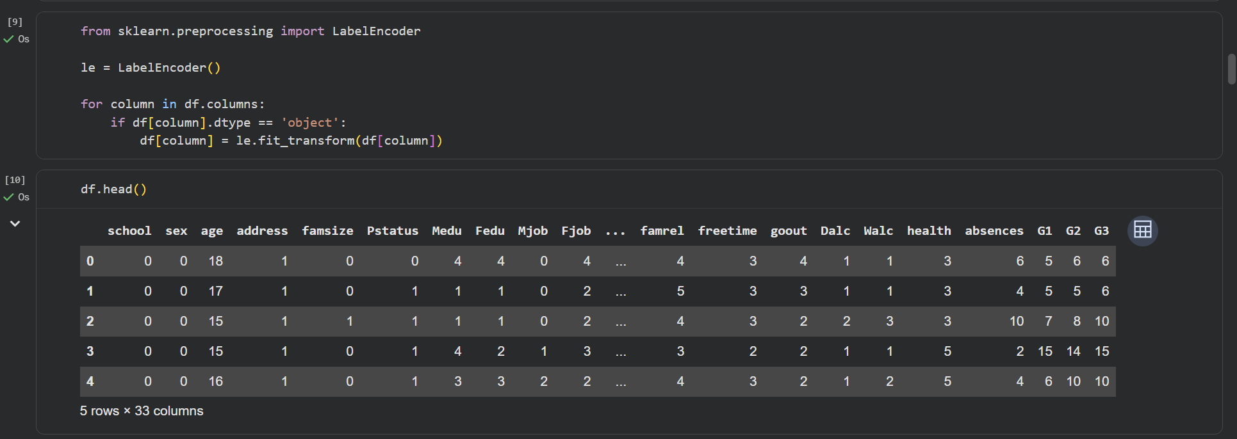
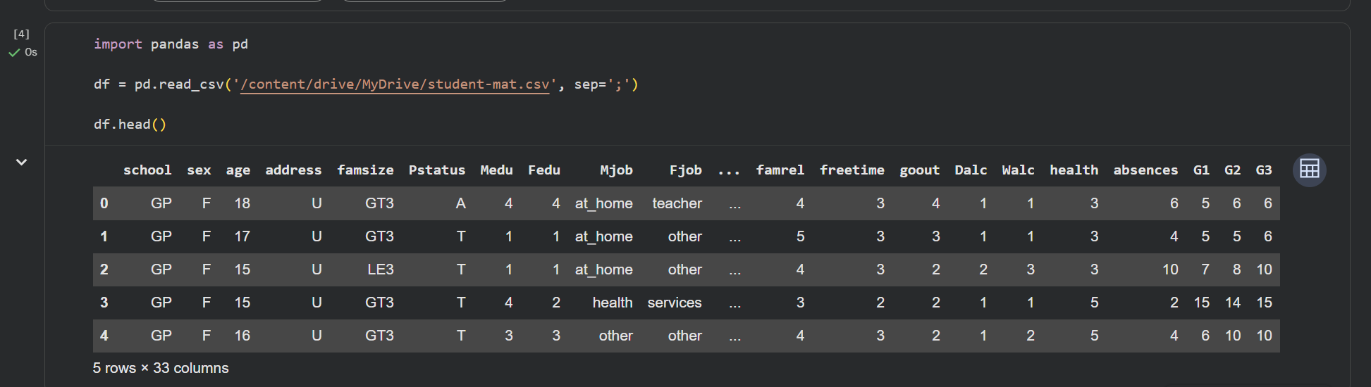
Appendix A: Sample Code Snippets
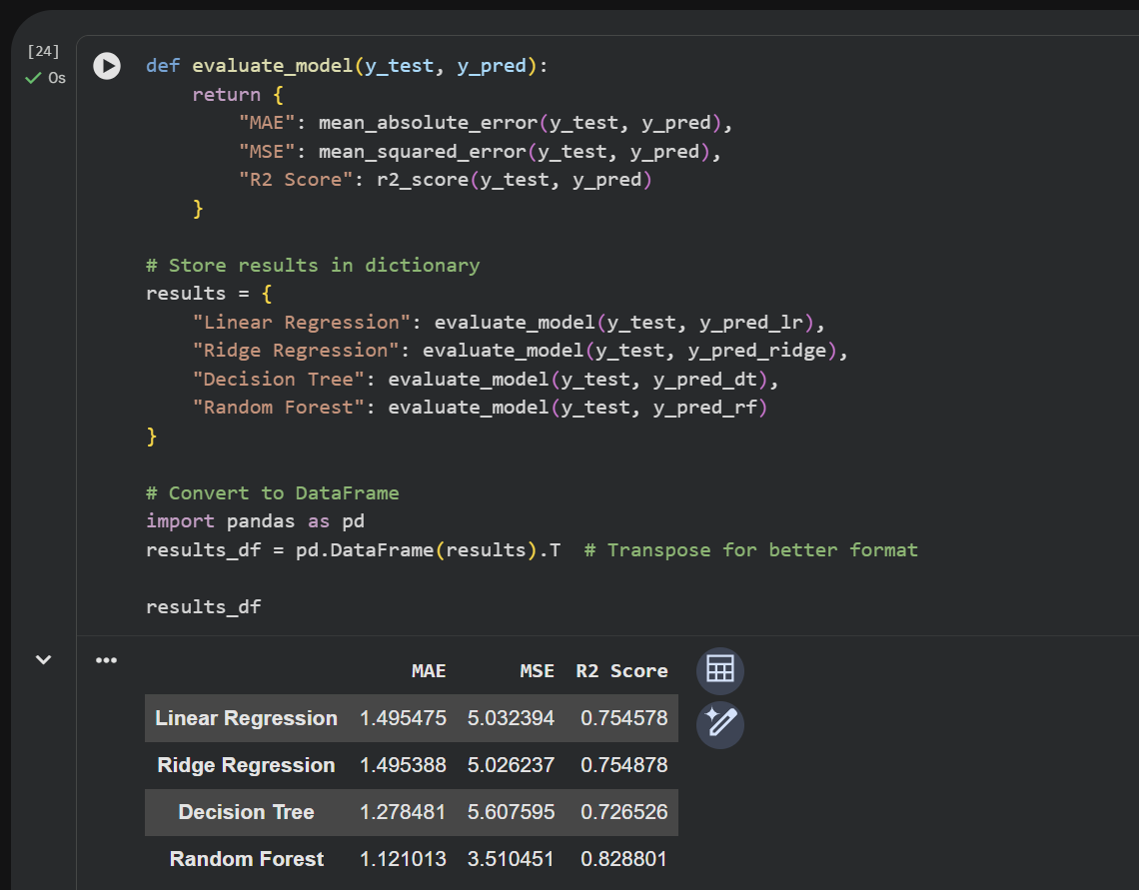

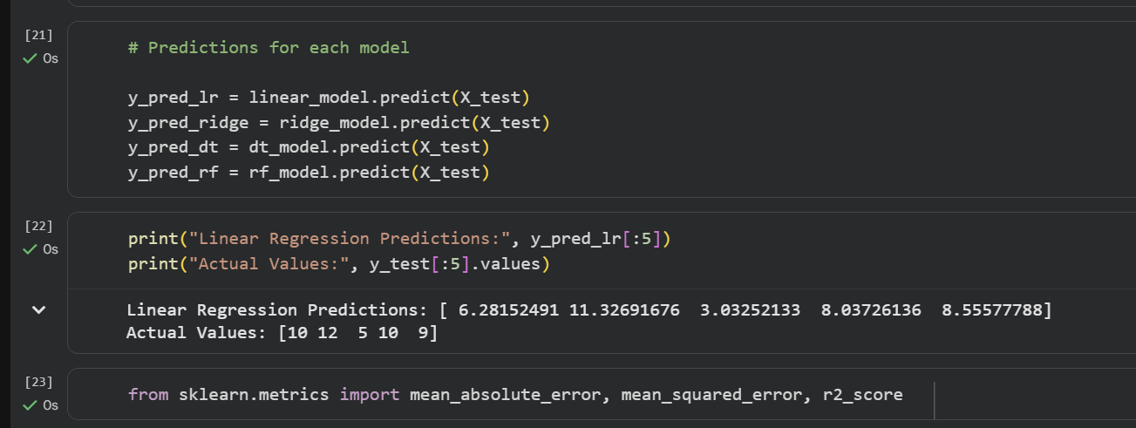

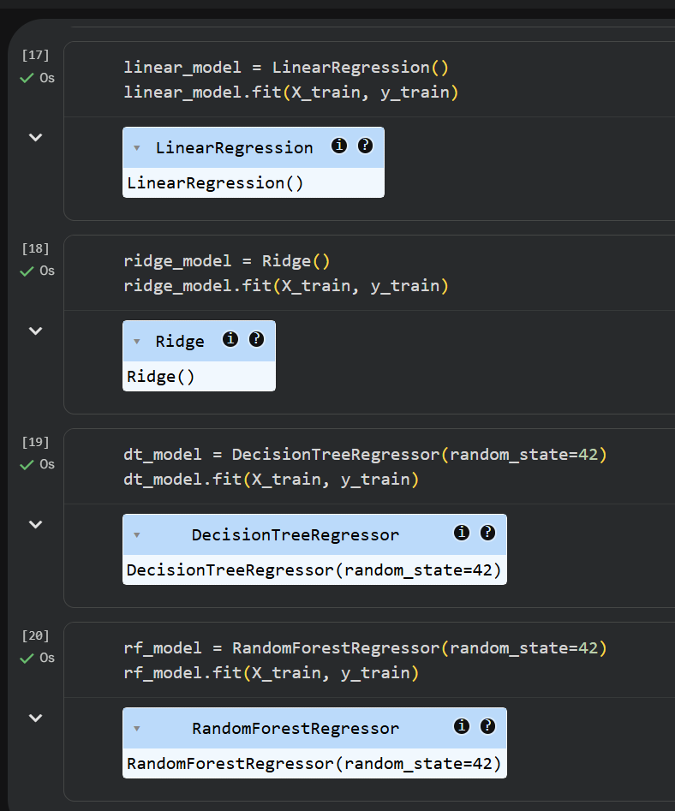

Appendix B: Dataset Description
- Dataset Name: UCI Student Performance Dataset
- Total Records: 395
- Total Features: 33
- Target Variable: G3 (Final Grade)
- Feature Types:
  - Demographic (age, gender, etc.)
  - Social (family background, activities, etc.)
  - Academic (G1, G2, absences, etc.)

Appendix C: Graphs and Visualizations
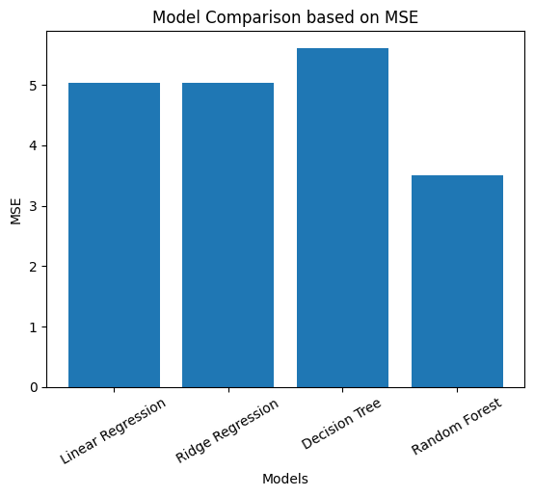
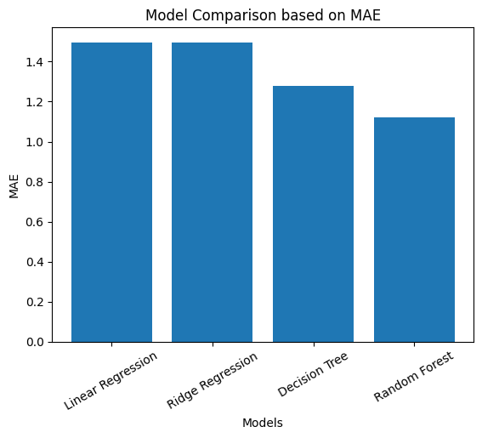
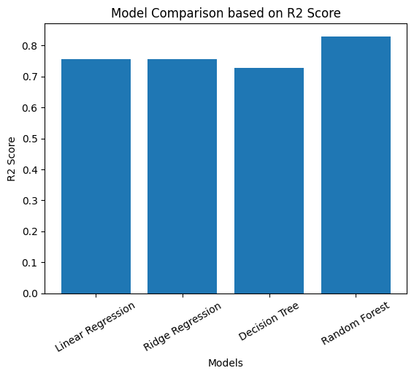
The graphical analysis provides a clear comparison of the performance of all four regression models. The bar charts for R², MAE, and MSE show that the Random Forest Regressor consistently outperforms the other models, achieving the highest R² score and the lowest error values, indicating superior predictive accuracy. Linear Regression and Ridge Regression exhibit similar performance across all three metrics, suggesting that regularization has a minimal impact on this dataset. In contrast, the Decision Tree Regressor shows comparatively higher MAE and MSE values along with a lower R² score, reflecting its tendency to overfit and perform poorly on unseen data.

The scatter plot of actual versus predicted values for the Random Forest model further supports these findings. Most of the data points are closely aligned along the diagonal line, indicating that the predicted values are very close to the actual values for the majority of cases. However, slight deviations are observed at the extreme ends of the scale, particularly for very low or very high grades, where prediction becomes more challenging. Overall, the visualizations confirm that the Random Forest model provides the most reliable and accurate predictions among all the models evaluated.
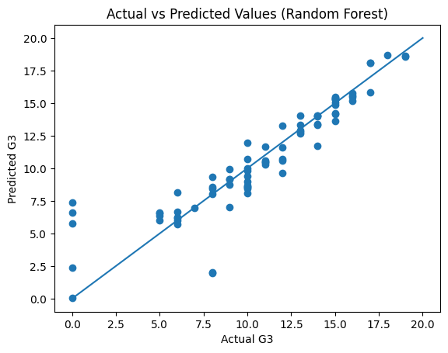

Appendix D: Feature Importance
Feature importance analysis was performed using the Random Forest Regressor to identify the most influential features in predicting the final grade (G3). The results show that G2 (second period grade) is by far the most dominant feature, contributing the majority of the predictive power.
The next most important feature is absences, which has a noticeable but significantly smaller impact compared to G2. Other features such as age, reason, and G1 have very minimal contributions, indicating that they play a relatively minor role in prediction when G2 is already included.
Overall, the model relies heavily on recent academic performance (G2), while most other demographic and behavioural features have limited influence.
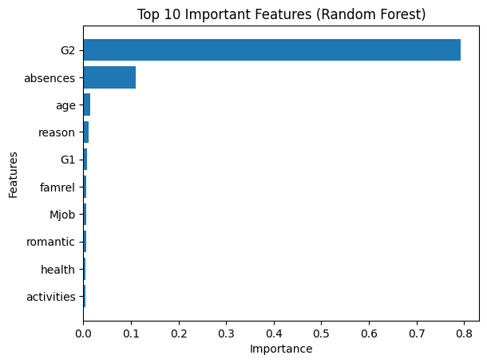

Appendix E: Sample Input and Output
This appendix presents a sample student record used as input to the trained machine learning model along with the predicted final grade generated by the model.

Sample Input
Feature | Value
Age | 17
Study Time | 2
Failures | 0
Absences | 4
G1 | 14
G2 | 15
Internet | Yes
Higher Education | Yes

Model Output
Predicted Final Grade (G3): 15.2
Actual Final Grade (G3): 16

