QuickDocMate



Submitted As

COMPUTER SCIENCE PROJECT

CLASS XII, 2022 - 23

Created By

1. Uday Ambaliya, Science, Roll No. 23
2. Hardik Gojiya, Science, Roll No. 21
3. Kaushik Nandaniya, Science, Roll No. 20

JNV AHMEDABAD

**Acknowledgement**

We would like to express our special thanks of gratitude to our teacher Tarun Sir as well as our principal Ravindra Kumar Dixit Sir who gave us the golden opportunity to do this wonderful project titled ***QuickDocMate***, which also helped us in doing a lot of Research and we came to know about so many new things. We are really thankful to them.

Secondly we would also like to thank our parents and friends who helped me a lot in finalizing this project within the limited time frame.

Certificate

This is to certify that **Uday Ambaliya, Hardik Gojiya** and **Punchok Namgail** of class XII from JNV Ahmedabad who were allowed to do work on this project titled **QuickDocMate** have faithfully carried out this project under my guidance and supervision and the accompanying report is completely their genuine work. They have completed the necessary preliminaries and have submitted the Project in allotted time.

Teacher Sign Principal Sign

INTRODUCTION

Welcome to the PDF Toolkit, a versatile program designed to perform various tasks related to PDF documents. This toolkit provides functionality to get metadata from PDFs, extract text, split PDFs into individual pages, and merge multiple PDFs into a single document.

## **Table of Contents**

* 1. Source Code
* 2. Usage
  + - Get Metadata
    - Extract Text
    - Split PDF
    - Merge PDF

SOURCE CODE

from PyPDF2 import PdfReader, PdfWriter, PdfMerger

import os

#function to get metadata

def metadata(file_path):

reader = PdfReader(file_path)

info = reader.metadata

print("Author: ",info.author)

print("Creator: ",info.creator)

print("Producer: ",info.producer)

print("Title: ",info.title)

print("Total no of pages: ",len(reader.pages))

print(reader.pages[0].extract_text())

def Showinf():

ask = input("Enter PDf name Case sensitive:")

file = open(ask+".pdf","rb")

metadata(file)

#function to extract text from pdf

def extract_text_from_pdf(pdf_path):

with open(pdf_path,"rb") as f:

reader = PdfReader(f)

results = []

for i in range(0,len(reader.pages)): # prev read.getNumPages()

selected_page = reader.pages[i]

text = selected_page.extract_text()

results.append(text)

return ' '.join(results) # convert list to a single doc

#function to split the pdf Into multiple Pdf pages

def get_pdf_upto(pdf_path,start_page:int=0,stop_page: int = 0):

with open(pdf_path,"rb") as f:

reader = PdfReader(f)

writer = PdfWriter()

for page_num in range(start_page,stop_page):

selected_page = reader.pages[page_num]

writer.add_page(selected_page) # prev :: addPage()

filename = os.path.splitext(pdf_path)[0]

output_filename = f"{filename}_from_{start_page+1}_to_{stop_page}.pdf"

with open(output_filename, "wb") as out:

writer.write(out)

def Pdf_merger():

nme1 = input("Enter name of first PDf: ")

nme2 = input("Enter name of the second pdf: ")

filem1 = open(nme1+".pdf","rb")

filem2 = open(nme2+".pdf","rb")

merger = PdfMerger()

pdfs = [filem1, filem2]

for pdf in pdfs:

merger.append(pdf)

merger.write('merge result.pdf')

print('print pdf file merged successfully')

merger.close()

def main():

flag = 0

while True:

print("_____________________________________________________________________")

print("Press 1 to get details of PDF:")

print("Press 2 to extract text from PDF:")

print("Press 3 to split the PDF:")

print("Press 4 to merge the PDF:")

print("Press 5 to quit")

print("_____________________________________________________________________")

flag = int(input("Enter your choice:"))

if flag == 1:

Showinf()

elif flag == 2:

ext = input("Enter PDf name Case sensitive: ")

a = extract_text_from_pdf(ext+".pdf")

print(a)

elif flag == 3:

name_pdf = input("Enter PDF Name: ")

initial_page = int(input("Starting page: "))

final_page = int(input("Final page: "))

get_pdf_upto(name_pdf+".pdf",initial_page-1,final_page)

elif flag == 4:

Pdf_merger()

elif flag == 5:

print("Thanks for Testing.")

break

def ask():

while True:

ask2 = input("Are you have pdf in this directory y/n:")

if ask2 in "yY":

main()

break

elif ask2 in "nN":

print("Please move all those pdf you want to handle and run again")

print("I am waiting for you...")

break

else:

print("Enter valid input: ")

continue

print("Welcome to PDF Manager.")

print("-->Please Move the all pdf in working directory that you want to handle")

print("-->Please install module named PyPDF2")

ask()

* Check this for latest update of code

OUTPUT

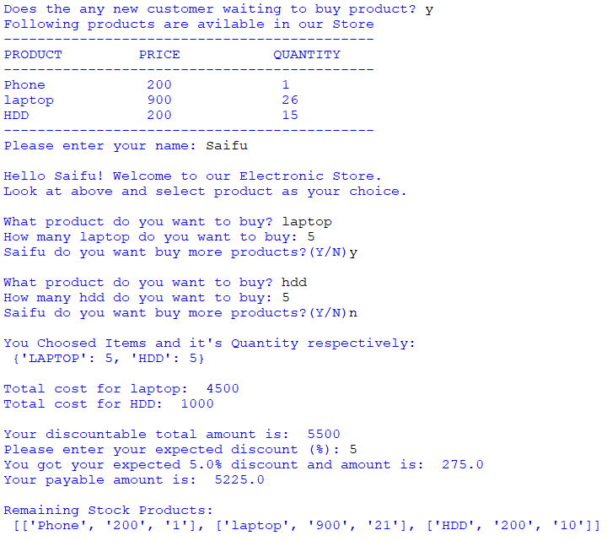

Invoice Generated in txt format:

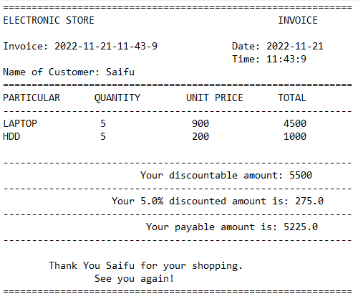

THANK YOU