mytaxi

**Security**

My taxi application is enabled with Authentication Provider. Whenever you are trying with to search data through browser GET request, system will prompt space to enter driver user name and password.

If the authentication is validated, system will allow you to search data from the repository.

Please find the below screenshot for more details.

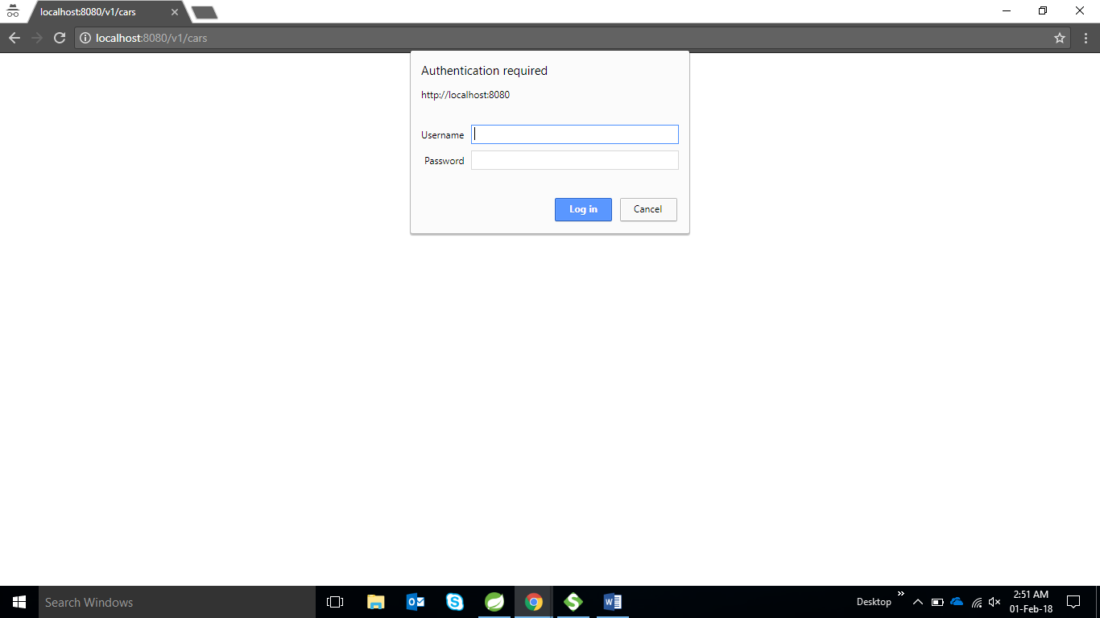

If the entered user name and password is validated successfully, then system will redirect to corresponding URI to fetch the data.

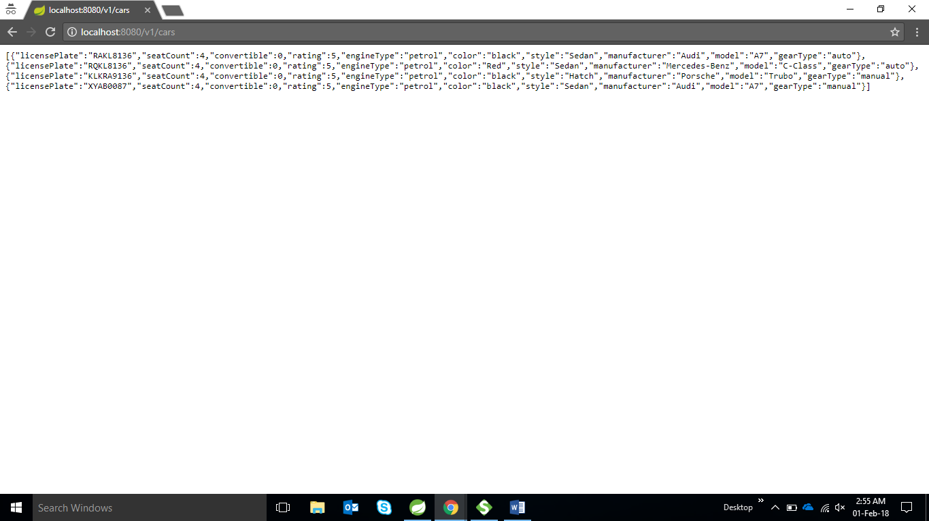

**How to add Security in Webservice Tool**

If the user trying to search the data through SOAP UI or any other Webservice tool, he has to pass creational details on Auth Header like below.

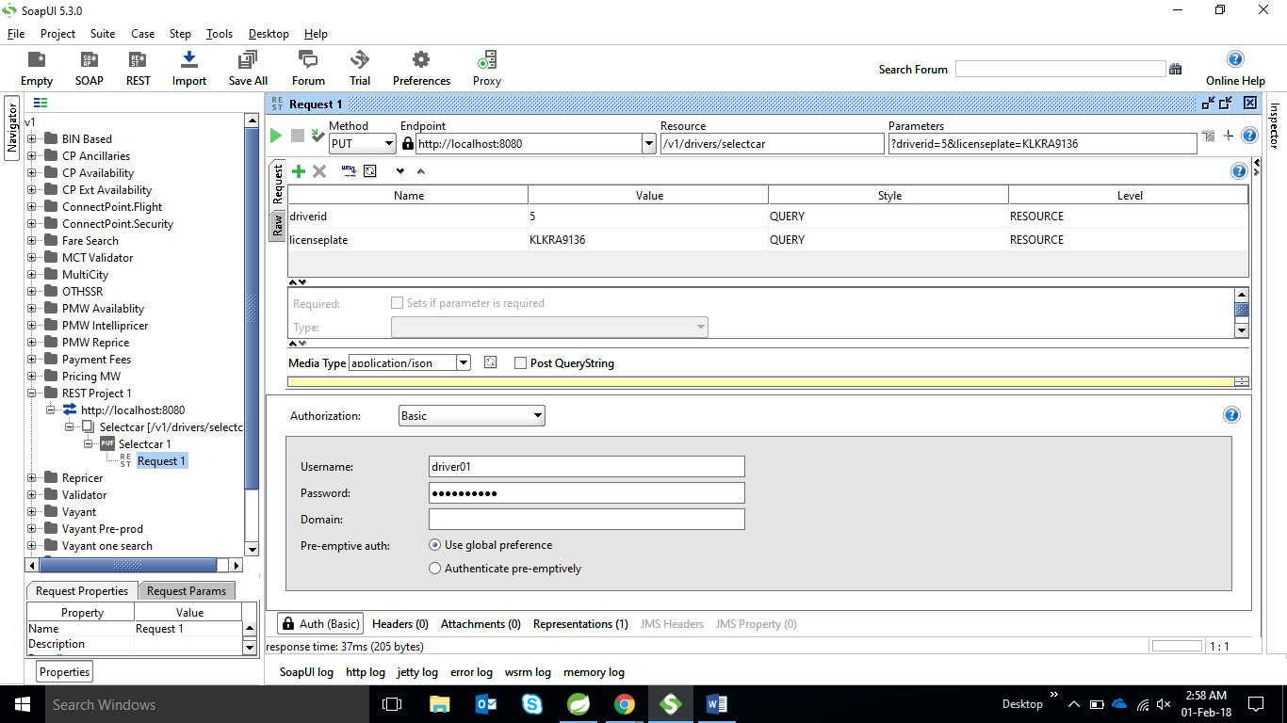

**API Integration**

**CARS**

* <http://localhost:8080/v1/cars> **- GET Method**
  + To list down all the cars details from the repository
* <http://localhost:8080/v1/cars> **- POST Method**
  + To add car details into the repository
* [http://localhost:8080/v1/cars/{carId}](http://localhost:8080/v1/cars/%7bcarId%7d) **– DELETE Method**
* To delete Car details from repository
* [http://localhost:8080/v1/cars/"/licenseplate/{licensePlate}](http://localhost:8080/v1/cars/%7bcarId%7d)  **– GET Method**
  + Search Car based on the license Plate.

**To select Car by driver**

This API is provided space to select / hired car from the repository by using this below API

<http://localhost:8080/v1/drivers/selectcar?driverid=5&licenseplate=KLKRA9136>

if the car is hired by another driver, system will throw car Already in Use Exception

**To De-Select car by driver**

<http://localhost:8080/v1/drivers/deselectcar?driverid=5&licenseplate=KLKRA9136>

This service will deselect the car.

**Filter Drivers by his characteristics**

Mytaxi application is using **Factory and Filter Design pattern** to filter the Driver information by his characteristics. Currently system is represents the only **gear type** as driver characteristics. We are search the driver characteristics by using following URI.

<http://localhost:8080/v1/drivers/filter?driverType=manual>

**Driver Type** : Manual or Auto Gear Type.