**Assessment Test Document:**

API Automation Framework built using Rest Assured, Java, Maven, TestNG, Extent Reports.

**Step 1 :** clone the project from below git repo.

https://github.com/udayasreeD/Mobiquity.git

**Step 2 :** import the project to any IDE like IntelliJ or Eclipse

**Step 3:** Run the project(right click on testing.xml and click run)

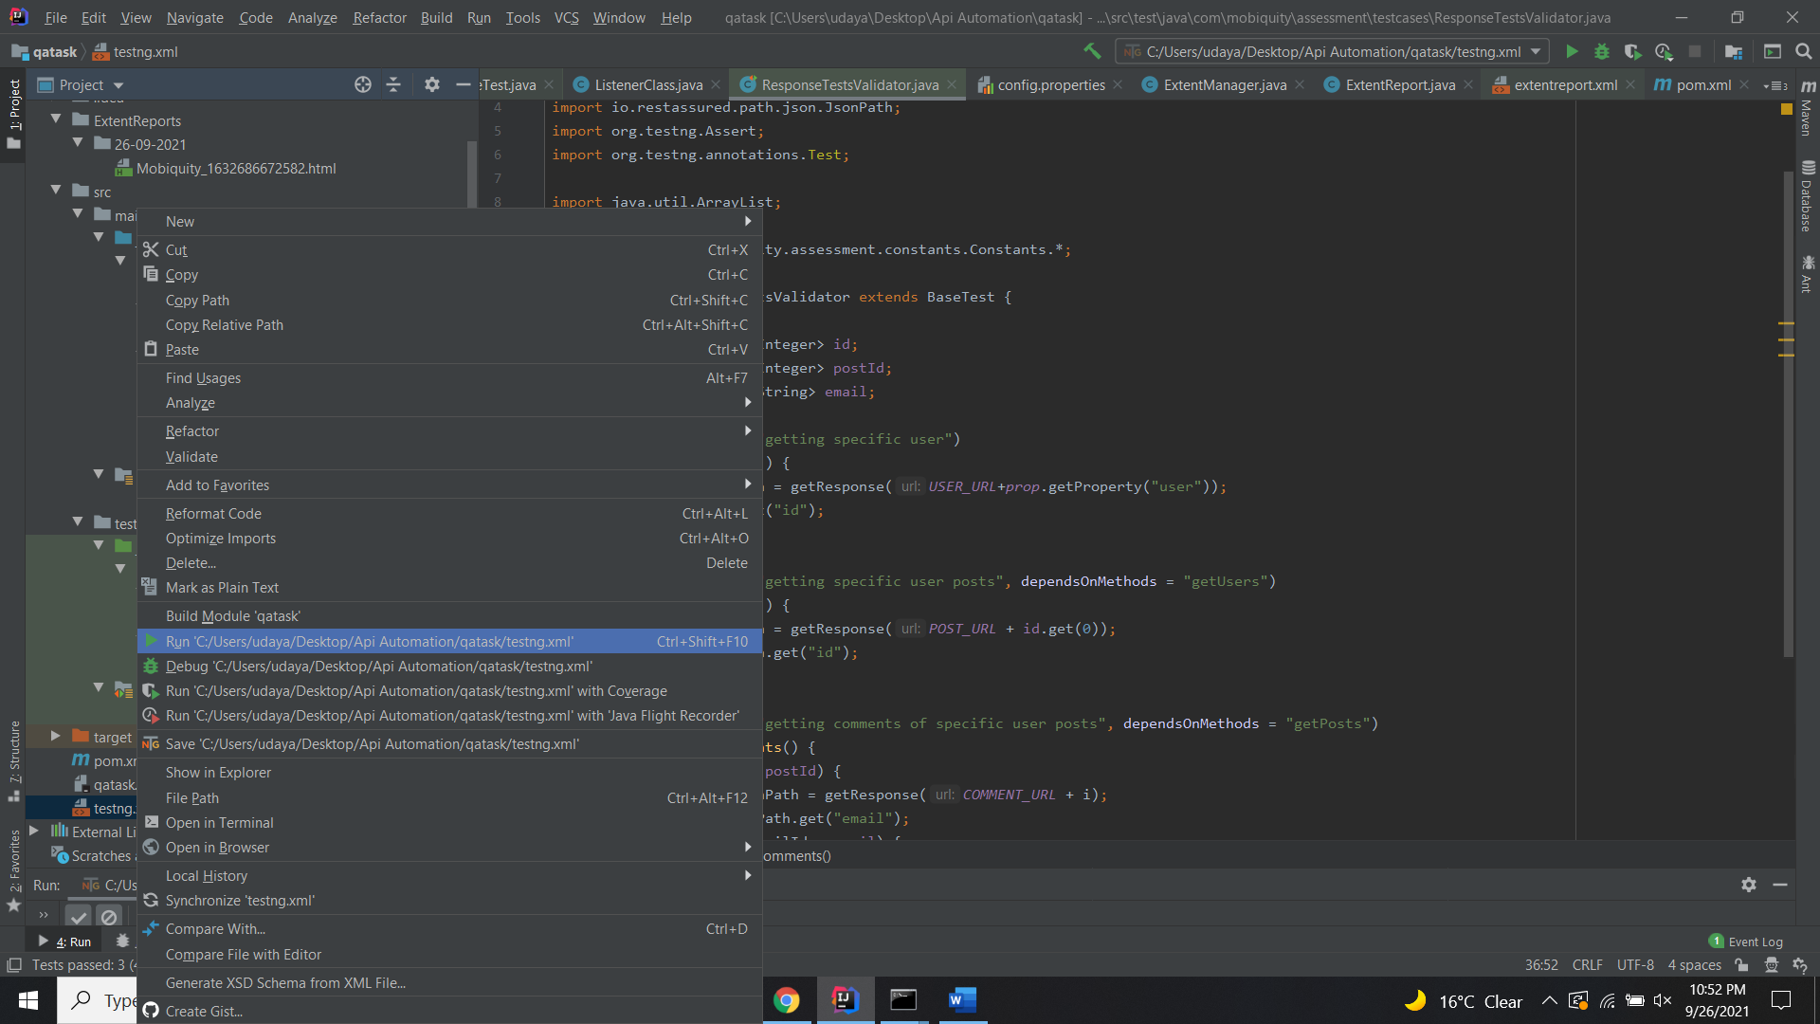

**Step 4:** Report get generated once ran.

Report folders will get creates based on date.

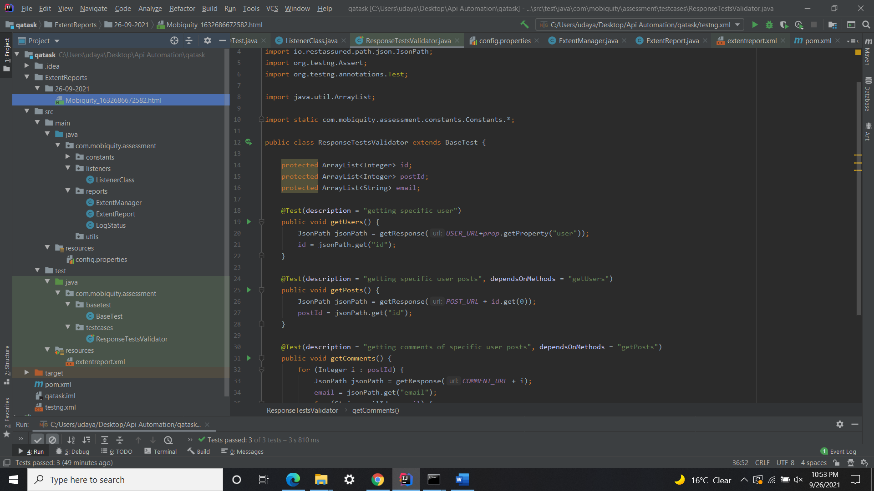



**ResponseTestsValidator class :**

Created 3 test cases in ResponseTestsValidator class

Test case 1: getting specific user

Test Case 2: getting specific user posts

Test Case 3: getting comments of specific user posts

**BaseTest Class :**

This is a main class which takes care of reusable methods setup, getResponse etc.

**Listeners Class :**

[TestNG](https://www.edureka.co/blog/selenium-webdriver-tutorial)can be made to listen to what we say with the help of Listeners. Listeners give us the flexibility to alter the default TestNG behavior.

* TestNG listener is formally called as ITestListener, which is an interface in TestNG.
* **ITestListener**: This function first makes a call to onStart() method and runs the scripts. In a similar way, it again makes a call to onFinish() method after a suite finishes execution and it makes the call before and after the Test. It has seven methods in it.

**Extent Reports :**

Extent reports produce HTML-based documents.

**Config.properties:**

Properties are used to externalize the data which is configurable and if you put that data in your code (test script) you have to build the code each time you want to change the value of the property.

**Constants Class :**

If your values are not going to change you can make them static final variable.