**Objectives :** This document provides a high level view of the type of test that is scheduled to be carried out and the features to be tested.

**Technologies Required :**

* + **Building Platform :** Eclipse, MS-Excel
  + **Frameworks :** POM**(**Page object model),TestNG
  + **Tools** : Selenium,Log4j
  + **Language** : Java
  + **Jar Files** : jxl,log4j
  + **Browser** : GoogleChrome
  + **Build Tool** : Maven
  + **Drivers** : Chrome Driver
  + **Operating System** : Windows

**Framework :**

1. Using Page Object model framework with functional/structural implementation.
2. Maintained a page class for every page in our application and a page test class to maintain test for that pages
3. Maintained separate package for page and page test e.g.  
   com.absa.usermanagement.pages and com.absa.usermanagement.tests

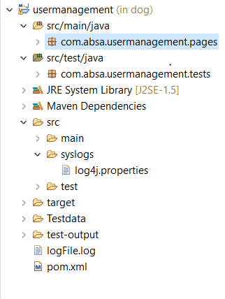

**TestNG :**

TestNG is a automation testing framework which provides annotation based testing and generate basic report for the testcases.

Report will be stored in the test-output folder.

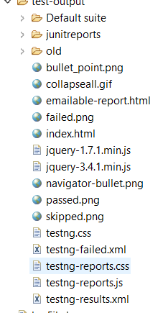

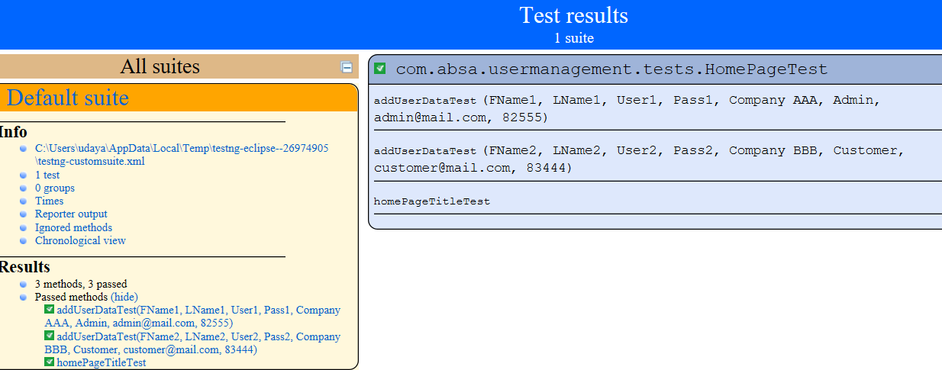

**BasePage.java :**

In the framework module, created a class called BasePage.java. All page object classes will extend the BasePage and inheriting all the base methods.

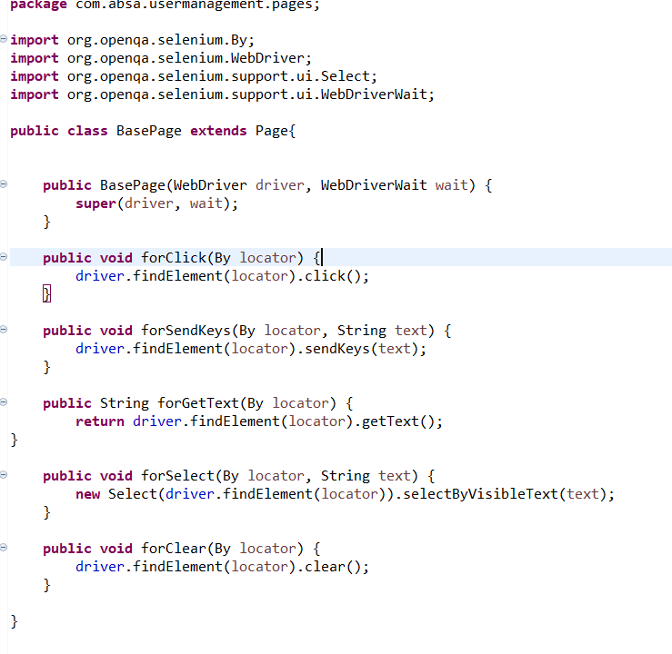

**Page.java :**

This is class is super class of basepage class and used getInstance() for returning the page class object

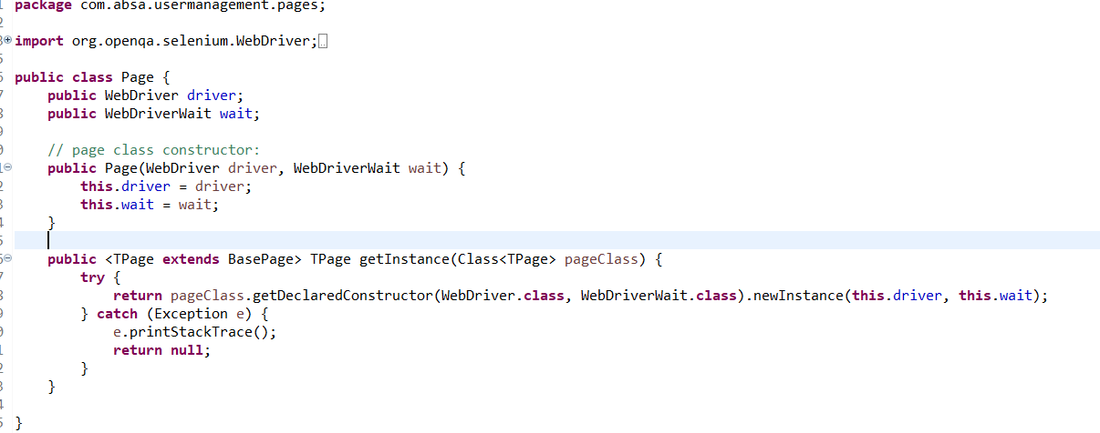

**BaseTest.java :**

BaseTest class holds the methods to initialize and terminate the WebDriver object. Since all the Test classes will extend the BaseTest class, then the initialization is done implicitly.

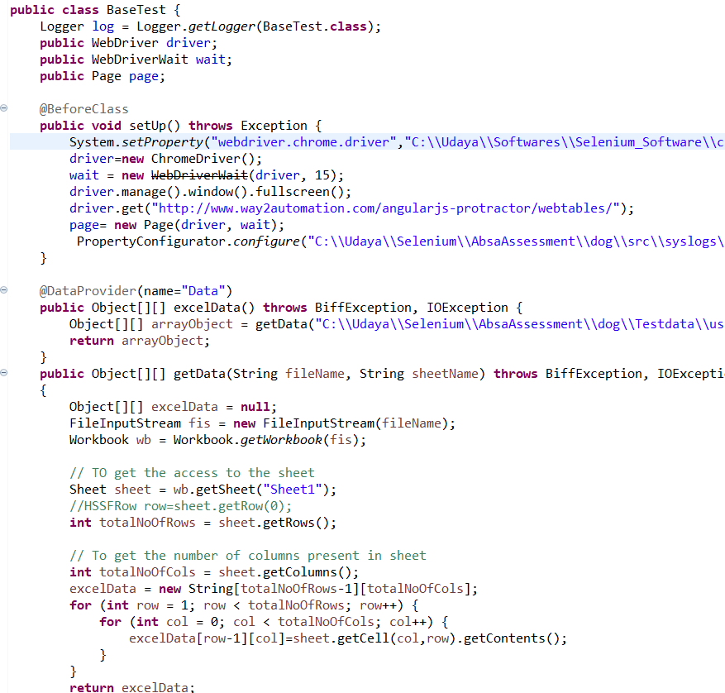

**HomePage.java:**

This class is used to locate the web elements of the web page and perform operation.

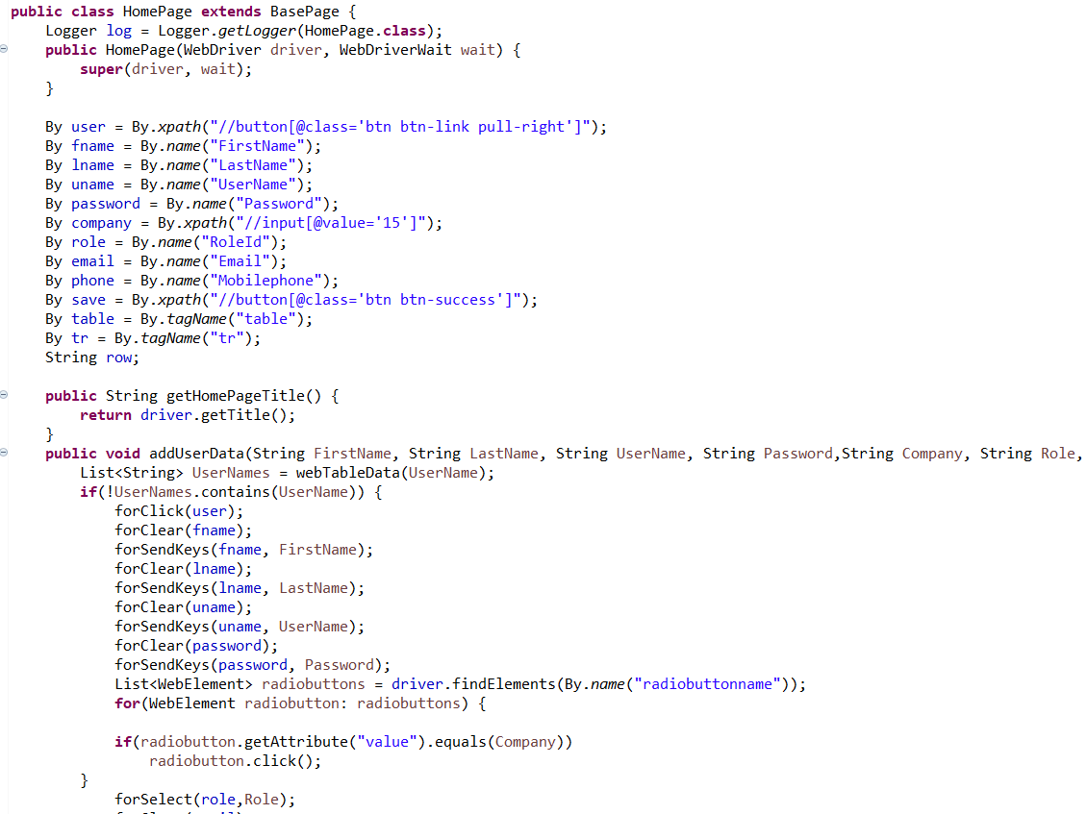

**HomePageTest.java:**

Used to perform the assertions and verify testdata.

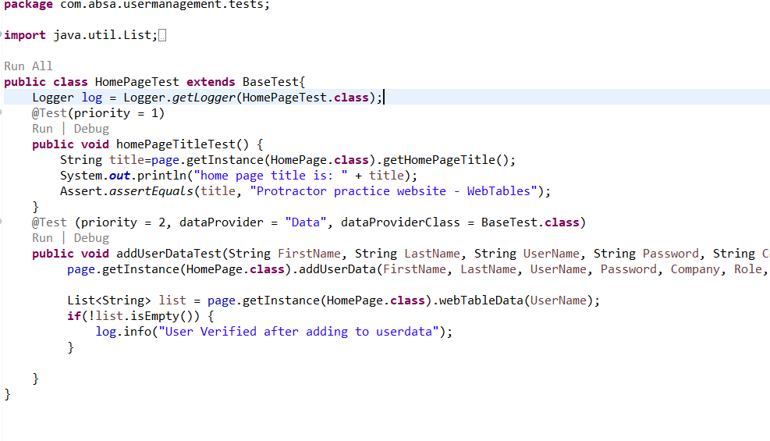

**Log4j property file :**

Log4j is used to print the log like info, debug and error

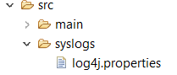

logfile.log is stored in main folder of the project.

**Performed the below operations :**

1) Navigate to - <http://www.way2automation.com/angularjs-protractor/webtables/>

2) Validate that you are on the User List Table

3) Click Add user

4) Add users with the following details:

5) Ensure that User Name (*) is unique on each run

6) Ensure that your users are added to the list