

Campus Lost & Found Digital Registry

Advanced Technology Lab

Mini Project Report

By

Uday Baheti – 230911580

Under the guidance of

Dr. Ashwath Rao B Dr. Subhrajit Barick
Assistant Professor - Selection Grade Assistant Professor
School of Computer Engineering School of Computer Engineering
Manipal Institute of Technology Manipal Institute of Technology
Manipal, Karnataka, India Manipal, Karnataka, India

Name | Registration number | Roll Number | Semester & Branch | Section
Uday Baheti | 230911580 | 62 | VI - IT | D

Title
Campus Lost & Found Digital Registry

I. Introduction to the App
The Campus Lost & Found Digital Registry is a mobile application designed to digitize the process of reporting, searching, and recovering misplaced belongings inside a campus environment. In many institutions, lost-and-found communication still depends on informal methods such as notice boards, messaging groups, and word-of-mouth communication. These methods are difficult to track and often delay communication between the owner of the item and the person who may have found it.
The application provides a centralized digital platform where authenticated users can log in using their campus registration ID, post lost or found items with descriptions and images, and search records using filters such as title, location, category, and status. This improves organization, preserves item history, and makes the overall recovery process more transparent.
A notable improvement in the present version is the corrected interaction logic. Found items can be claimed by users who believe the item belongs to them, while lost items allow another user to notify the owner that the item has been found. This makes the workflow more realistic for campus use.

II. Literature Review
Digital lost-and-found systems developed for campuses and public communities generally follow a similar pattern: user authentication, centralized item posting, classification of items, search facilities, and a recovery workflow. Studies on university and educational lost-and-found systems show that a structured digital registry is more efficient than manual reporting methods because it increases visibility, improves retrieval speed, and preserves data in a searchable form [1], [2].
Recent work has also explored stronger communication and intelligent matching mechanisms. Peer-to-peer based systems improve direct coordination between finders and owners [3], while AI-based image matching approaches such as LostNet show how future systems can identify visually similar lost and recovered objects with high accuracy [4]. These studies indicate that lost-and-found applications can evolve beyond basic record keeping into more adaptive and intelligent support systems.
This project adapts these design principles to a campus environment by using MAHE registration-based login, image-supported item posts, filter-based browsing, and separate workflows for found-item claiming and lost-item notification. In addition, the chosen Flutter and Firebase stack is well supported in the literature for building cross-platform applications with responsive interfaces and integrated backend services [5], [6].

III. Methodology
The application was developed using Flutter and Dart for the frontend. Firebase Authentication was used for user login and registration, Cloud Firestore was used to store user, item, and workflow data, and Firebase Storage was used for item images. This architecture supports cross-platform deployment and persistent cloud-backed records. Prior studies on Flutter and Firebase also support this stack as a practical choice for mobile application development because of its fast UI rendering, shared codebase, and integrated backend capabilities [5], [6].
The implementation follows a modular structure. The application contains separate model classes for items and claim or notification records, service classes for authentication and item operations, and individual screens for login, registration, home listing, reporting an item, and viewing item details. This separation improves maintainability and makes the code easier to test and extend.
The main use case begins when a registered user logs in and views the home screen. From there, the user can search for items by title or location, filter by category and status, report a new lost or found item, or open the details of an existing item. The app then applies different interactions depending on the item type. Found items allow a claim request, while lost items allow a finder to notify the owner.

System Workflow and Use Cases

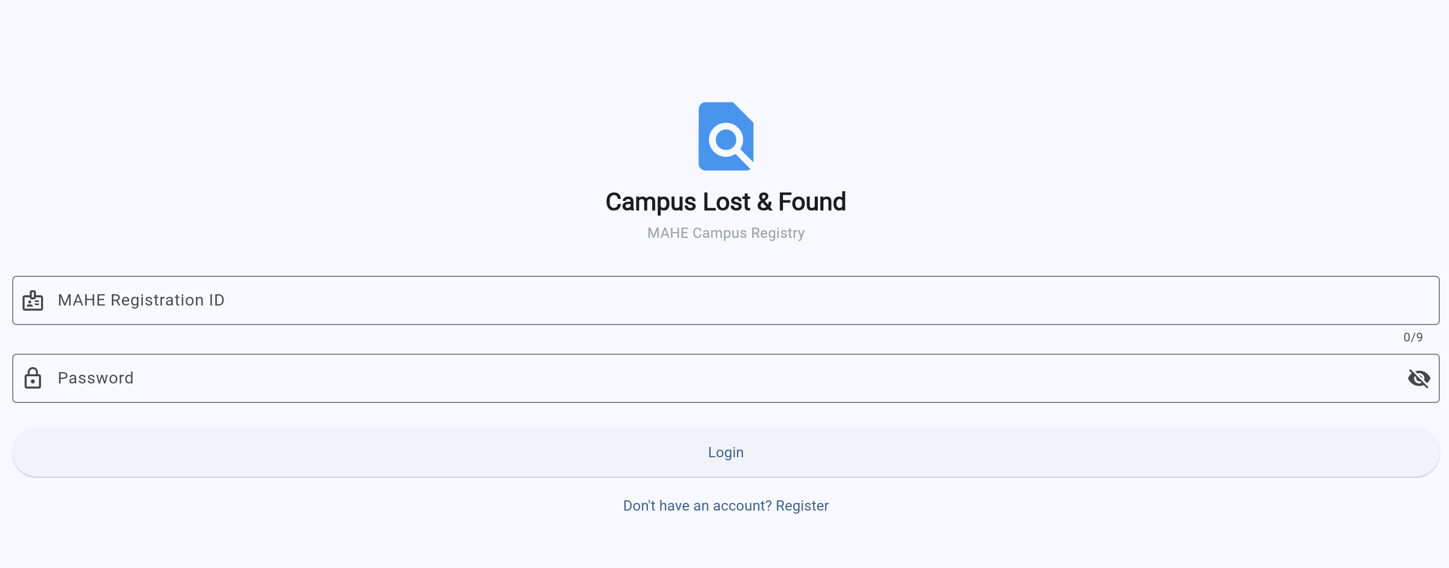
Figure 1. Login screen used for registration ID based authentication.

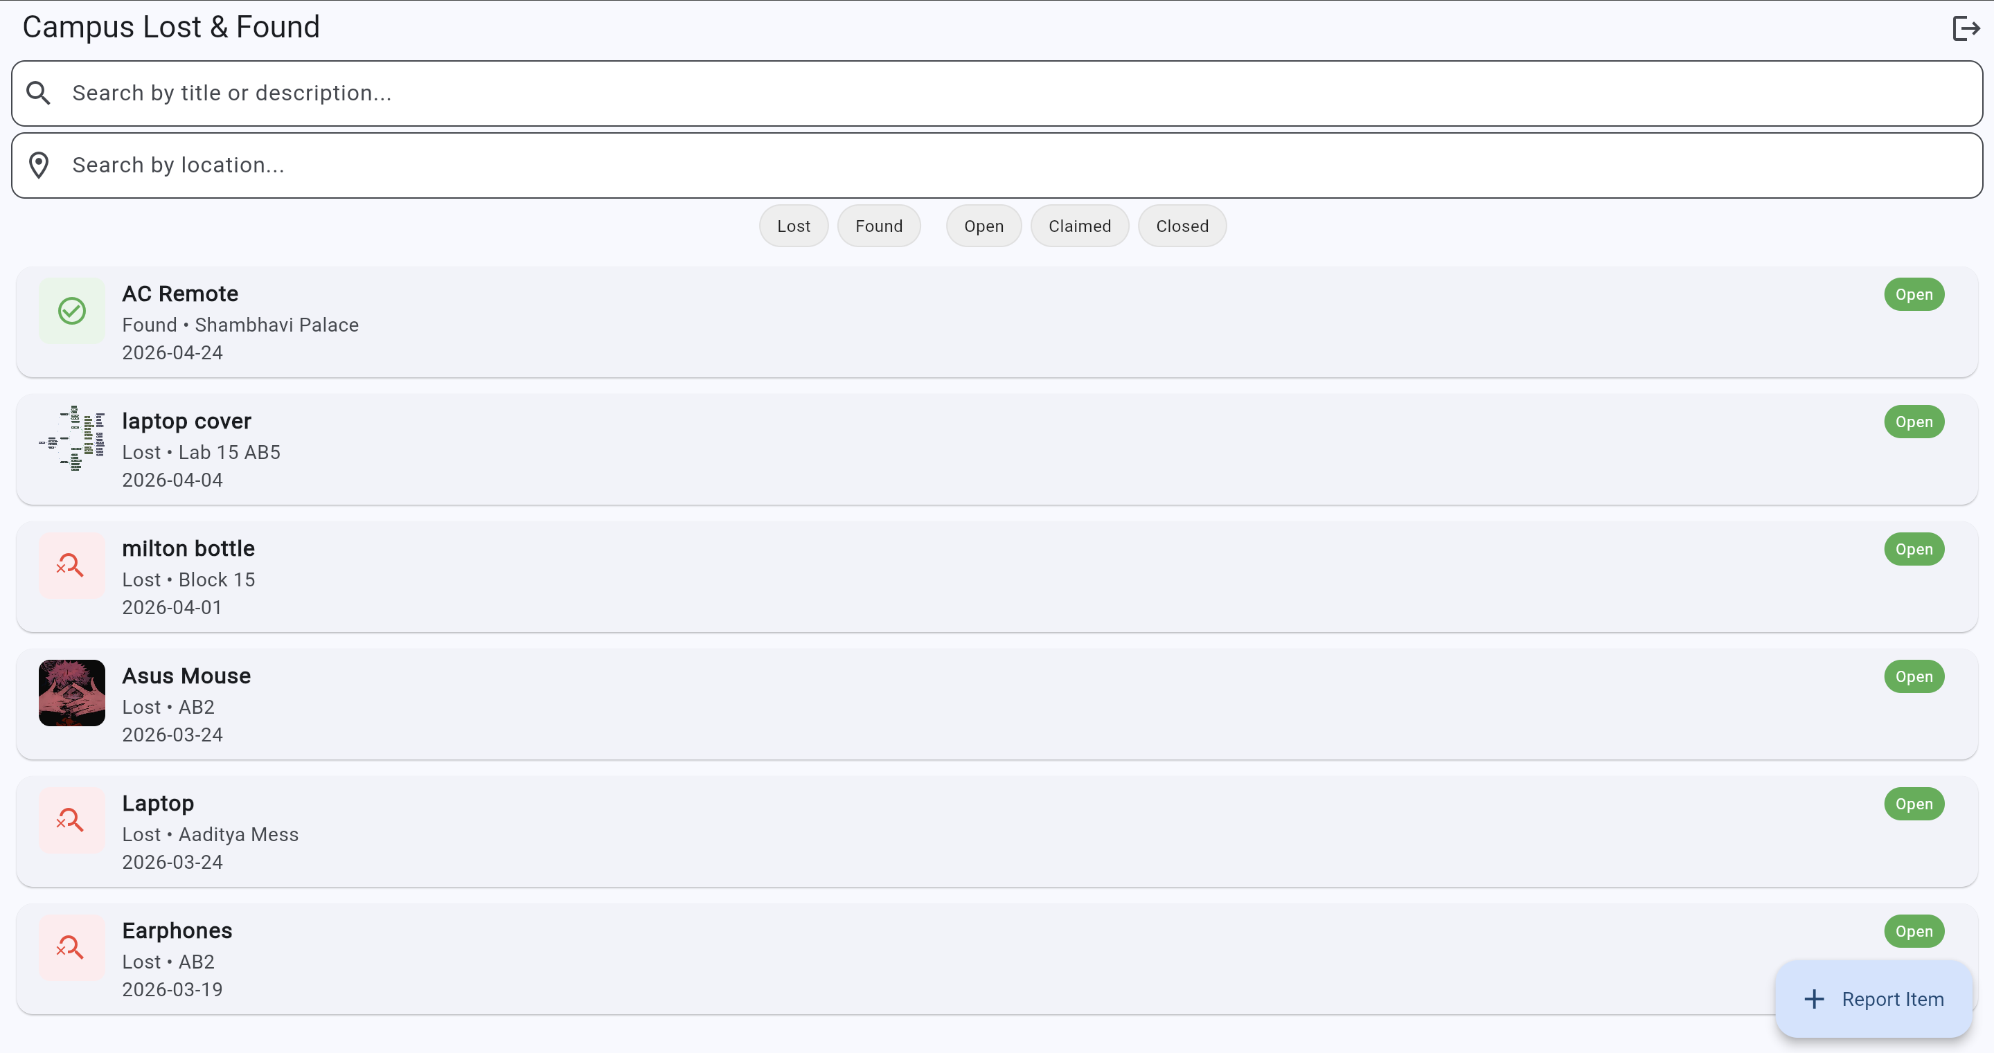
Figure 2. Main listing screen with search, location filter, and category/status filters.
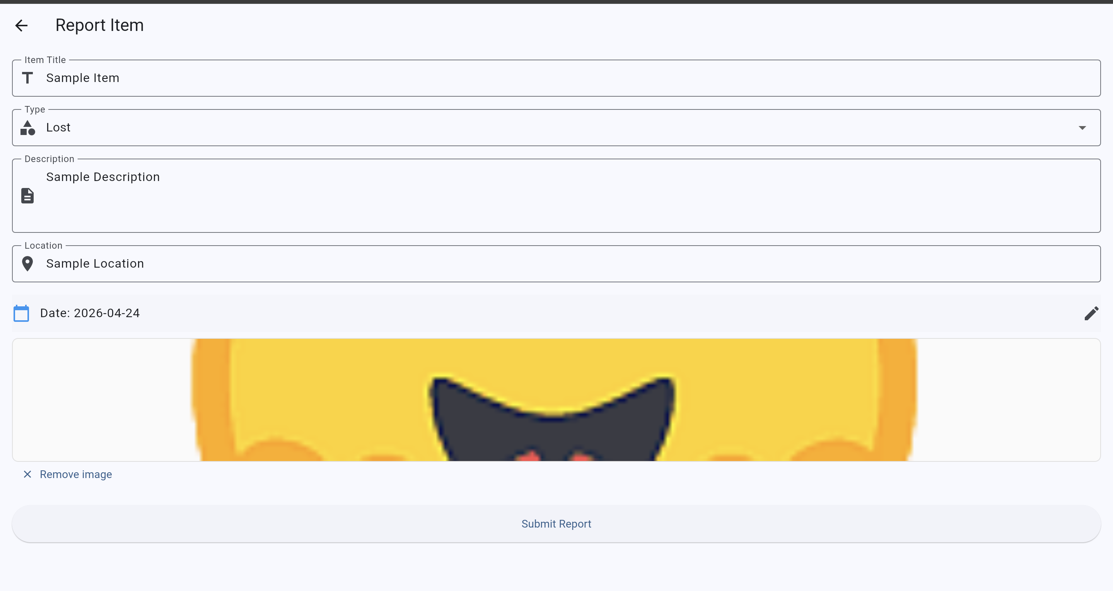
Figure 3. Report item screen for creating a lost or found post.

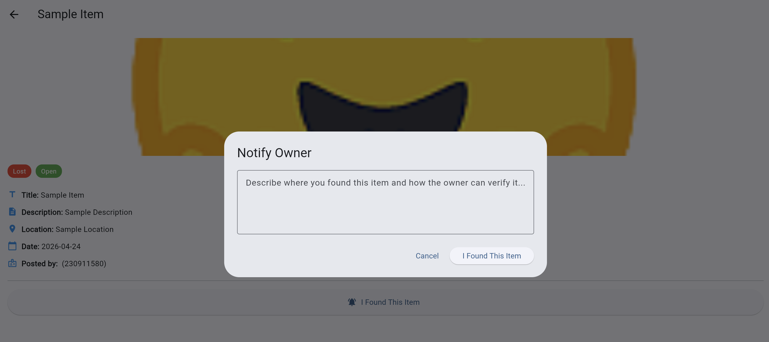
Figure 4. Lost-item notification dialog used when another user finds an item.

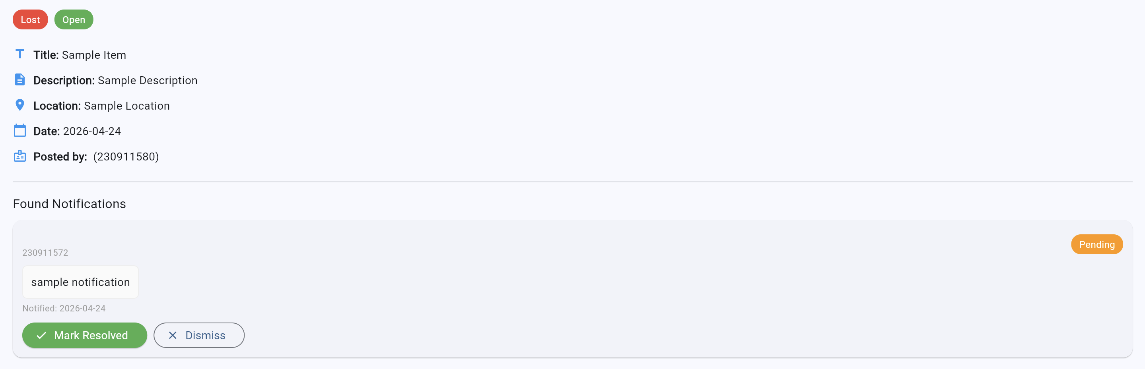
Figure 5. Owner-side view of found notifications with resolve and dismiss actions.

Database Design (Cloud Firestore)
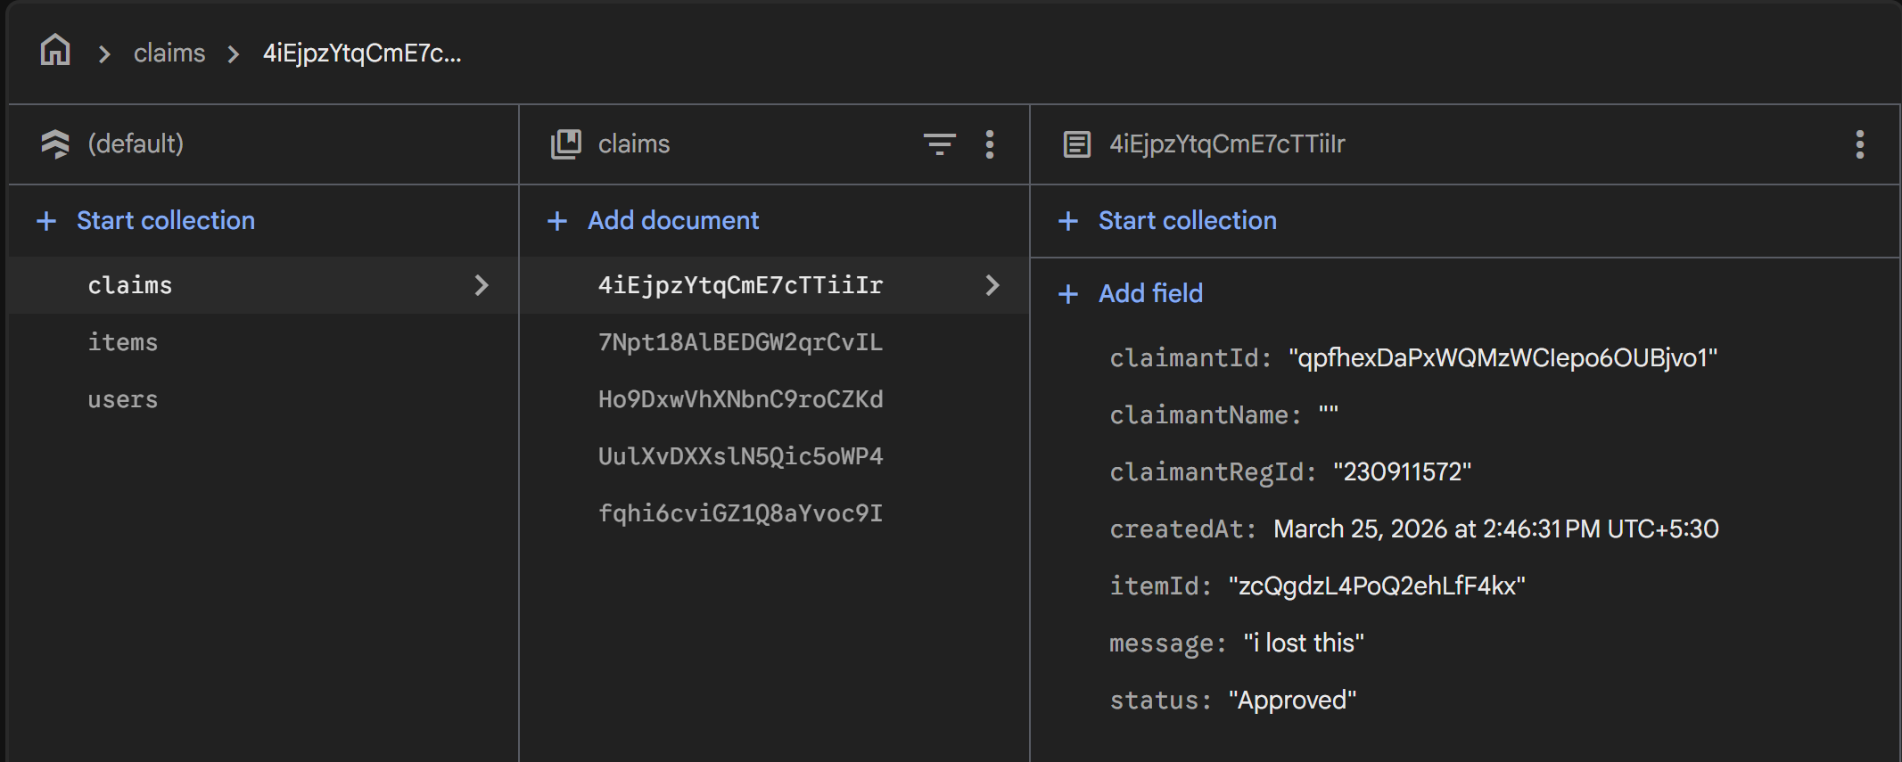
Figure 6: Claims collection document structure

The backend database is implemented using Cloud Firestore and is organized into three main collections: users, items, and claims. This structure provides a clear separation between user identity data, item records, and interaction records, thereby supporting maintainable storage and efficient retrieval of application data.
Users collection: The users collection stores the registered user profiles required for authentication and identification within the application. It maintains basic user information such as the user name, registration ID, and account creation details, which are referenced when items are posted and claims are submitted.
Items collection: The items collection stores the primary lost-and-found records posted by users. Each document contains item-specific attributes such as title, category, description, location, date, image URL, posting user details, and the current status of the item.
Claims collection: The claims collection stores user-generated claim or notification records associated with reported items. Each document includes claimant identity fields, itemId, message text, creation timestamp, and claim status so that item recovery actions can be tracked in a structured manner.

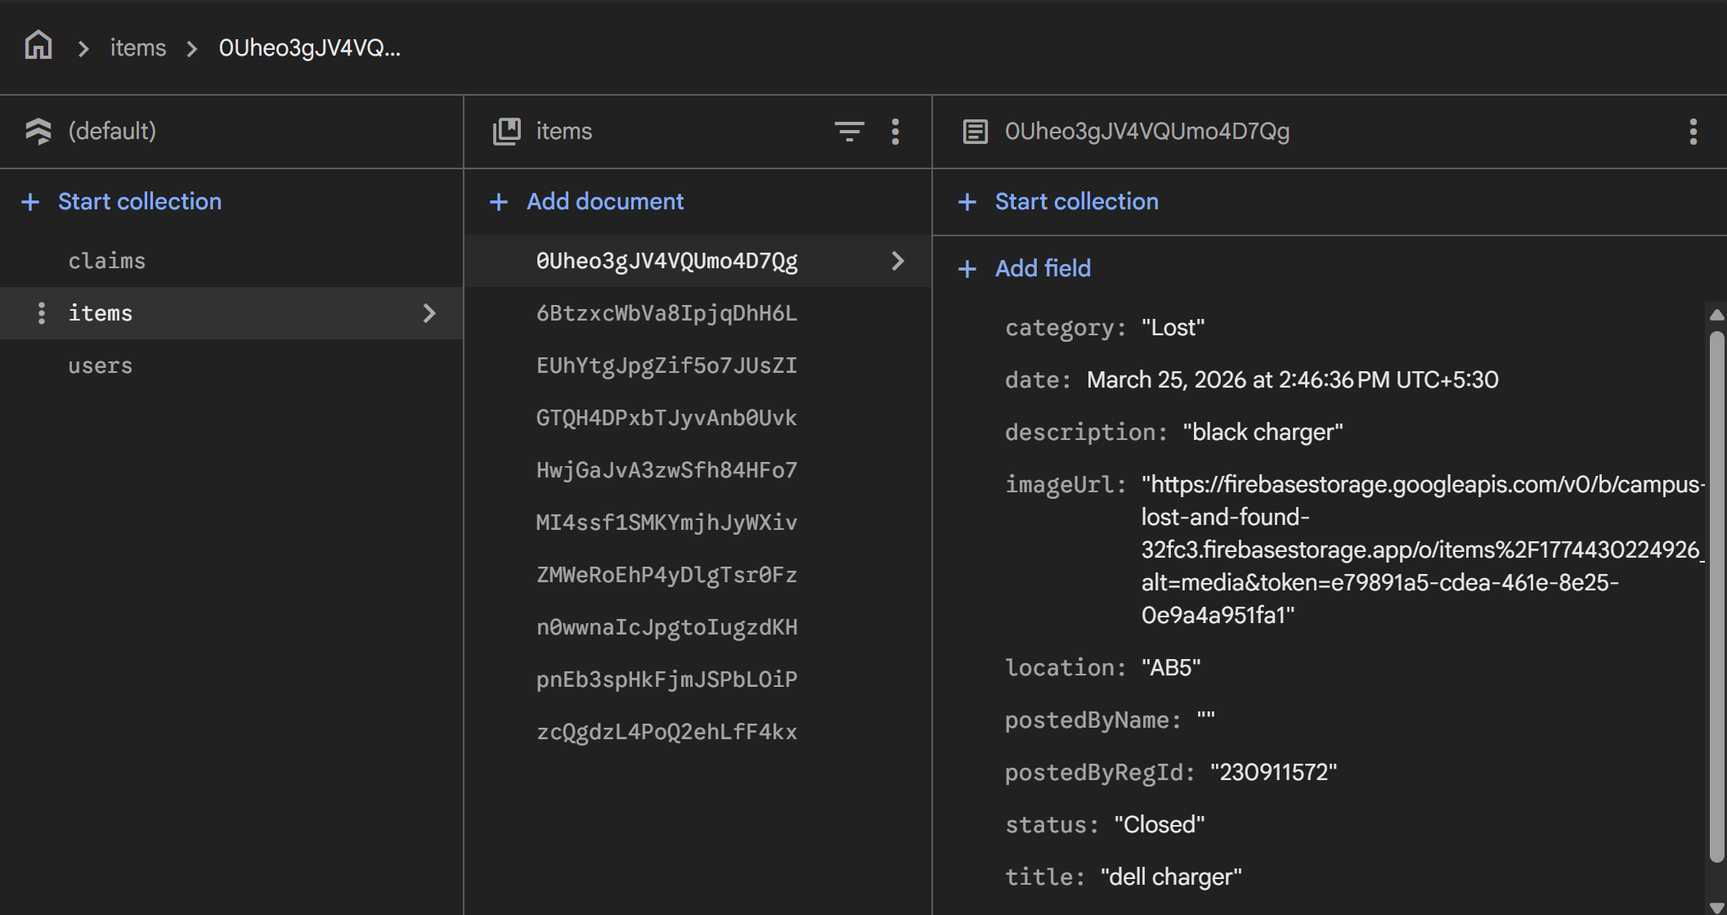
Figure 7: Items collection document structure
The claims collection maintains the relationship between users and item records through identifier fields. The itemId field links a claim to a specific item document, while claimantId links the request to the corresponding user account. These identifiers support traceability and allow the application to retrieve related records efficiently during approval, rejection, and status updates.

Testing Strategy
Testing was carried out primarily through functional testing and interface validation. The login, item listing, report submission, image upload, search, filter, and detail workflows were checked manually. Particular attention was given to verifying the corrected lost-versus-found behavior so that the action text, dialogs, and owner-side handling matched the intended domain logic. Basic smoke testing was also used to verify screen loading and navigation stability.

IV. Results
The developed application successfully demonstrates the main requirements of a campus lost-and-found system. Users can authenticate, view active records, add new items with structured details, and interact with posts according to the selected category. The list interface supports quick browsing and helps users narrow results using both text search and status/category filters.
The reporting workflow supports item title, type, description, location, date selection, and optional image upload. Once submitted, the item becomes visible in the main list. The updated logic also improves application correctness by allowing lost-item notifications and found-item claiming through separate user interactions.

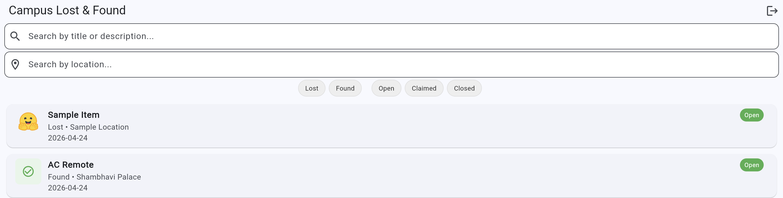
Figure 8. Completed report form with item details and image attachment.


Figure 9. Main list after adding a new lost item successfully.

The screenshots show that the application is not only visually complete but also functionally connected to backend services. The system demonstrates a working combination of user authentication, cloud data persistence, structured item reporting, and type-aware recovery actions.

V. Conclusion
The Campus Lost & Found Digital Registry provides a practical solution for managing misplaced items in a campus environment. By replacing informal communication methods with a centralized mobile platform, the project improves visibility, accountability, and ease of use.
The project also shows the effectiveness of combining Flutter with Firebase to create a real-world mobile application with authentication, database storage, and media upload support. The corrected item logic makes the system more meaningful and better aligned with actual lost-and-found behavior.
At the same time, the application has scope for future improvement. Possible extensions include push notifications, admin moderation, richer testing, analytics, direct messaging, and more advanced matching mechanisms. These additions can further strengthen the system for larger deployments.

VI. References
[1] An Effective Lost and Found System in University Campus, Journal of Information Technology Management (JISTM), 2023. https://gaexcellence.com/jistm/article/view/2714
[2] Design, Development and Usability Evaluation of an Online Web-based Lost and Found System, IJARCSSE, 2015. https://www.researchgate.net/publication/316087385
[3] A. Dutta, Y. Tolani, N. Singhal, "Automated Lost and Found System with Peer-to-Peer Communication," JETIR, vol. 11, no. 5, May 2024. https://www.jetir.org/papers/JETIRGG06022.pdf
[4] LostNet: A Smart Way for Lost and Find, arXiv, 2023. https://arxiv.org/pdf/2301.02277
[5] Review on Mobile Application Development Based on Flutter Platform, IJRASET, 2022. https://doi.org/10.22214/ijraset.2022.39920
[6] Improving the Tourists Experiences: Application of Firebase and Flutter Technologies in Mobile Applications Development Process, IEEE, 2021. https://ieeexplore.ieee.org/document/9623025
[7] Flutter Documentation. https://docs.flutter.dev/
[8] Firebase Documentation. https://firebase.google.com/docs

