ENGINEERING CALL-FLOW SPECIFICATION
Ghar Sajag P0 Requirement Sequence Diagrams
End-to-end participants, messages, durability points, branches and outcomes for F01-F14 and E01-E10
Design inventory | Coverage
Requirement coverage | 24 of 24 P0 requirements
Functional flows | F01-F14 (14 diagrams)
Engineering flows | E01-E10 (10 diagrams)
Participant rule | Every module mapped in Requirements v1.2 appears in its requirement sequence
Boundary: host logic and design are documented; ESP32, RF, flash, cloud-provider and installed-home evidence remain separate P0 gates.

Edition 2 reading guide
This edition is written for an engineer joining the project now or returning after a year. It expands the uploaded baseline with reasons, concrete household examples, execution order, failure cases and implementation boundaries. The original detailed chapters, tables and figures are retained. Their target designs are interpreted using the current status notes in this edition.
The immediate product is Ghar Sajag Parivar Saathi with Base P0. P1 is a future development stage or optional add-on decision, not a promised third product. Sarthi AI is a future interaction offering using the shared monitoring core. Base monitoring does not depend on a model, microphone or cloud inference.
Documentation edition 2.0 accompanies reference source 1.4.2. Source 1.4.2 adds requirement comments and version metadata to the 1.4.1 code; it does not implement new monitoring or AI algorithms. The 1.4 AI session controller is retained and explained in the AI design volume.
Term | How to interpret it
Required | An acceptance obligation from the SRD. It can remain unimplemented.
Implemented reference | A host-language component exists; it may use volatile stores or fake adapters.
Verified host checkpoint | The specific assertion ran on the development host. It is not full requirement coverage.
Target integration pending | GPIO, FreeRTOS, radio, flash, server/provider or full UI work still needs implementation and evidence.
Future AI | An extension excluded from the immediate Base P0 build scope.
Read START_HERE.md for the full document order. Use Requirement_Traceability.csv and Code_Traceability.csv to move from a requirement to module, source file and existing test. A comment such as @requirements F05, E02 is a responsibility link, not a claim that those requirements are fully complete.
Source baseline: Ghar_Sajag_P0_Requirement_Sequence_Diagrams_v1.0(1).docx. The original upload is also included under reference_baselines. The preservation report records original and revised word/table/figure counts and heading retention. Market prices and supplier availability are historical inputs unless explicitly dated as rechecked; this edition does not refresh market research.

Current decisions that resolve earlier ambiguity
Routine evidence. The current reducer accepts one qualifying activity event or OK in its window. Two-zone/session-duration examples are retained as future hypotheses. They are not implemented P0 qualification rules.
Coverage. Current lease status exists. Full-window coverage history and local prompt/grace orchestration are pending. Missing activity must not be presented as a wellbeing or medical conclusion.
Timing. The reference NodeConfig uses a 60-second heartbeat and HubRuntime a 190-second lease. Older 15-minute heartbeat and 35-minute timeout examples are trial alternatives and must not be mixed with these defaults.
Persistence. DURABLE is the target application-ACK meaning. In-memory test stores model ordering; they do not survive power loss. Production flash/database adapters and compaction remain open.
Modules. Canonical modules are N01–N05, H01–H08, B01–B08, A01–A05, S01–S03 and T01–T03, with S04 product profile, H09 interaction and S05 diagnostics. H10/H11/B09/A06 are planned. Legacy log aliases are not extra deployed modules.
Logs. ERROR hooks remain available in the commercial build profile, but absent/failed sinks can lose records. Current host logging is synchronous; it does not catch arbitrary memory corruption or guarantee crash persistence.

Retained detailed baseline with edition 2 explanations
The chapters below retain the uploaded detail. New explanatory paragraphs are placed at the relevant requirement/module headings. Historical implementation counts and future-state diagrams must be read with the current boundaries and open-work register above.

Sequence notation and interpretation
Each diagram is a normative logical call flow. Participant order is chosen for readability; deployment/process boundaries are identified by the architecture volume and interface catalog.
Green arrows represent host behavior already expressed by the reference implementation. Dashed blue arrows identify target hardware, network, identity, push, phone or OTA interactions that remain integration gates. Amber notes encode suppression rules, privacy boundaries or non-negotiable invariants.
Notation | Meaning
Call arrow | Request/event/command crossing a module or actor boundary
Dashed return | Explicit response, acknowledgement or applied-state report
Self call | Atomic validation/state transition owned by that participant
Amber note | Alternate/suppressed path or invariant that prevents false reassurance
Outcome | Required postcondition; not a claim that target testing has passed

F01 - Household profile and caregiver roles
Meaning. A household is the access boundary for every device, event and caregiver action. A resident is the person being observed; a caregiver is a person allowed to view or act on that household. These are different roles even when the same family member performs setup.
Worked example. For example, Rahul creates home H1 for two consenting residents and assigns two different caregiver accounts. An account belonging only to H2 must not read H1, even if it knows an H1 event identifier.
Reference implementation boundary. Python services and JavaScript form models exist. Production login, database transactions and complete resident-profile/consent evidence are not established by those tests. The local HTTP demo uses a development identity mechanism and must not be exposed as production authentication.
Acceptance experiment. Create a valid household, repeat the same creation request, try a missing-consent draft, assign the same primary and backup, and attempt cross-house access. Check both returned errors and stored membership records.
Participants and traceability. B01, B02, A01, S01. Source paths and test references are in the traceability register. See diagrams/sequences/png and diagrams/sequences/uml for the corresponding F01 flow.
SEQUENCE DESIGN COMPLETE | TARGET EXECUTION/INTEGRATION EVIDENCE PENDING
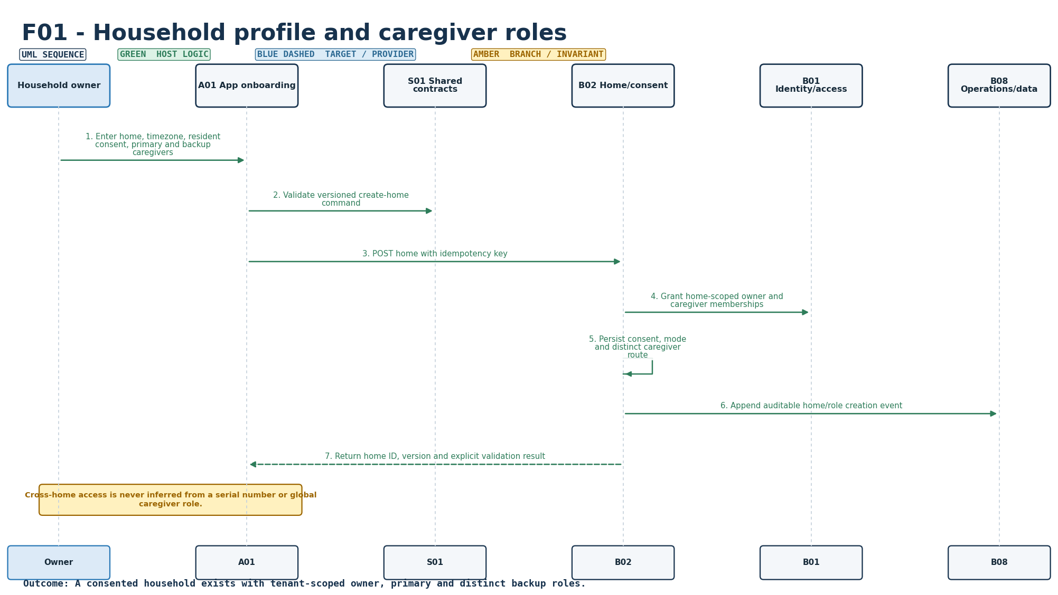
Figure S-01. Requirement-level call flow for F01.
Mapped modules: B01, B02, A01, S01. Participants: Owner, A01, S01, B02, B01, B08. Outcome: A consented household exists with tenant-scoped owner, primary and distinct backup roles.
Editable source: diagrams/sequences/uml/F01.puml

F02 - Resident consent and privacy controls
Meaning. Consent explains what is collected, why, who receives it and how to stop it. Privacy mode must affect collection and processing, not merely hide a dashboard card. AI consent is separate from permission to observe motion.
Worked example. A resident turns privacy on during a family visit. The caregiver should see observation paused. A later PIR event must not be interpreted as an ordinary monitored event. Turning privacy off does not reconstruct activity that was deliberately unobserved.
Reference implementation boundary. The backend mode mutation and a hub passive-event policy are present in the host model. End-to-end node stop, deletion/retention enforcement, physical privacy control and live AI cancellation propagation remain integration work.
Acceptance experiment. During an active routine, withdraw consent and send passive events before and after application acknowledgement. Confirm visible privacy state, no false absence incident and no resumption without a deliberate new state transition.
Participants and traceability. B02, H06, H07, A01, B08. Source paths and test references are in the traceability register. See diagrams/sequences/png and diagrams/sequences/uml for the corresponding F02 flow.
SEQUENCE DESIGN COMPLETE | TARGET EXECUTION/INTEGRATION EVIDENCE PENDING
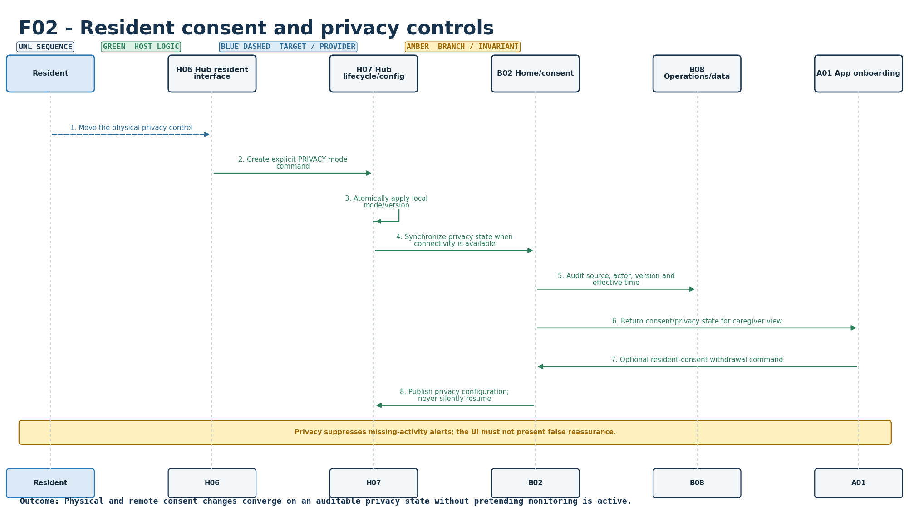
Figure S-02. Requirement-level call flow for F02.
Mapped modules: B02, H06, H07, A01, B08. Participants: Resident, H06, H07, B02, B08, A01. Outcome: Physical and remote consent changes converge on an auditable privacy state without pretending monitoring is active.
Editable source: diagrams/sequences/uml/F02.puml

F03 - Kit provisioning and installation verification
Meaning. Provisioning binds the physical kit to the correct home and names the place each node observes. Installation verification proves that a connected device also detects the intended movement. A heartbeat alone cannot prove correct placement.
Worked example. NODE-KT is paired to H1 but its PIR faces a hot window. Radio tests may pass while the sensor produces misleading evidence. The installation checklist must therefore include both communications and a real walk test.
Reference implementation boundary. Configuration validators and checklist scaffolds exist. A secure claim service, ESP-NOW pairing, factory keys, serial provisioning and verified physical evidence do not yet exist as an integrated system.
Acceptance experiment. Reject duplicate node IDs and wrong-board configuration. Walk each intended path, disconnect one sensor, test every resident button and perform a real notification drill before enabling unattended alerts.
Participants and traceability. N04, H07, B06, A01, S03, T02. Source paths and test references are in the traceability register. See diagrams/sequences/png and diagrams/sequences/uml for the corresponding F03 flow.
SEQUENCE DESIGN COMPLETE | TARGET EXECUTION/INTEGRATION EVIDENCE PENDING
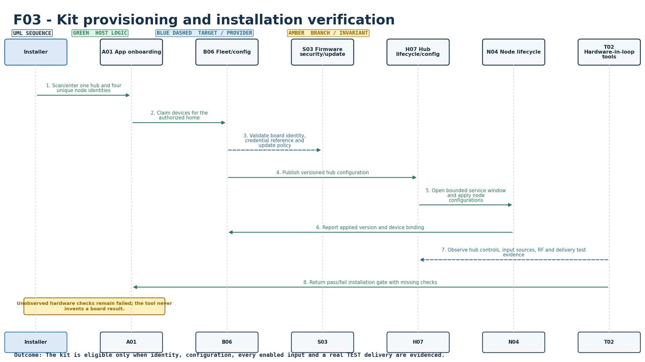
Figure S-03. Requirement-level call flow for F03.
Mapped modules: N04, H07, B06, A01, S03, T02. Participants: Installer, A01, B06, S03, H07, N04, T02. Outcome: The kit is eligible only when identity, configuration, every enabled input and a real TEST delivery are evidenced.
Editable source: diagrams/sequences/uml/F03.puml

F04 - Configurable morning routine
Meaning. A morning routine is a configured interval and a rule for interpreting household evidence. It is not a prediction of when a particular parent must wake. The same daily schedule can be adjusted after a shadow trial.
Worked example. For illustration, watch from 05:30 to 10:00 and finish the grace period at 10:10. These are editable trial values. A configuration saved on the phone at 09:00 is still pending until the hub reports the applied version.
Reference implementation boundary. Reference validators and a window reducer exist. The current C++ routine receives absolute epoch boundaries; a production scheduler must convert local dates and time zones and persist window transitions. Legacy capability flags do not all enforce behaviour.
Acceptance experiment. Apply an increasing version, reject an older one, simulate a time-zone boundary and a mid-window update, and inspect desired versus applied state. Do not mark the schedule active just because the API accepted it.
Participants and traceability. A03, B06, H07, H03, H05, S02. Source paths and test references are in the traceability register. See diagrams/sequences/png and diagrams/sequences/uml for the corresponding F04 flow.
SEQUENCE DESIGN COMPLETE | TARGET EXECUTION/INTEGRATION EVIDENCE PENDING
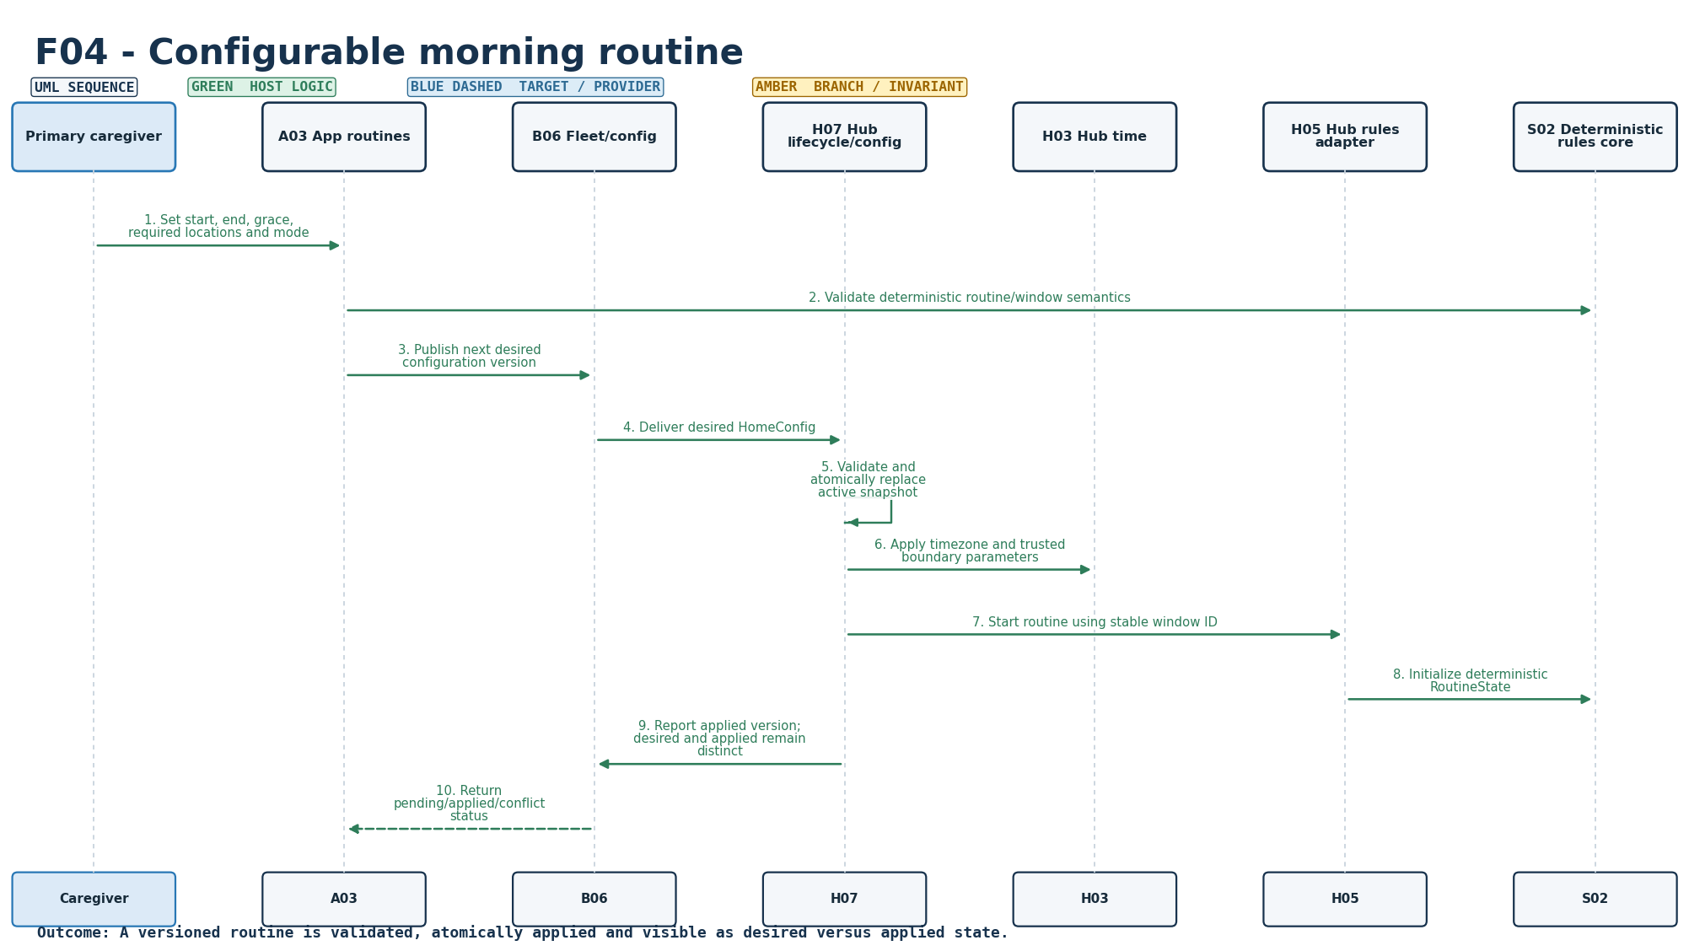
Figure S-04. Requirement-level call flow for F04.
Mapped modules: A03, B06, H07, H03, H05, S02. Participants: Caregiver, A03, B06, H07, H03, H05, S02. Outcome: A versioned routine is validated, atomically applied and visible as desired versus applied state.
Editable source: diagrams/sequences/uml/F04.puml

F05 - Morning activity evidence
Meaning. Activity evidence is a qualified motion or permitted door event within the configured window. It shows that movement was observed somewhere eligible. It does not identify mother or father and does not establish that either person is well.
Worked example. Mother enters the pooja area while father stays in Room 2. The household has activity evidence, but the system cannot conclude that father moved. Sitting still for fifteen minutes can produce no additional PIR edges.
Reference implementation boundary. Two-zone, kitchen-session and pooja-duration examples in the earlier deployment guide are historical hypotheses, not implemented algorithms. The host reducer also retains evidence IDs in a vector; bounded deduplication and historical coverage intervals remain open work.
Acceptance experiment. Replay allowed/disallowed locations, test events, out-of-window events and duplicate event IDs. Check household wording and separate coverage. A new replay test must expose duplicate evidence IDs rather than assuming journal deduplication protects the reducer.
Participants and traceability. N01, H01, H02, H05, S02, B07, A02. Source paths and test references are in the traceability register. See diagrams/sequences/png and diagrams/sequences/uml for the corresponding F05 flow.
SEQUENCE DESIGN COMPLETE | TARGET EXECUTION/INTEGRATION EVIDENCE PENDING
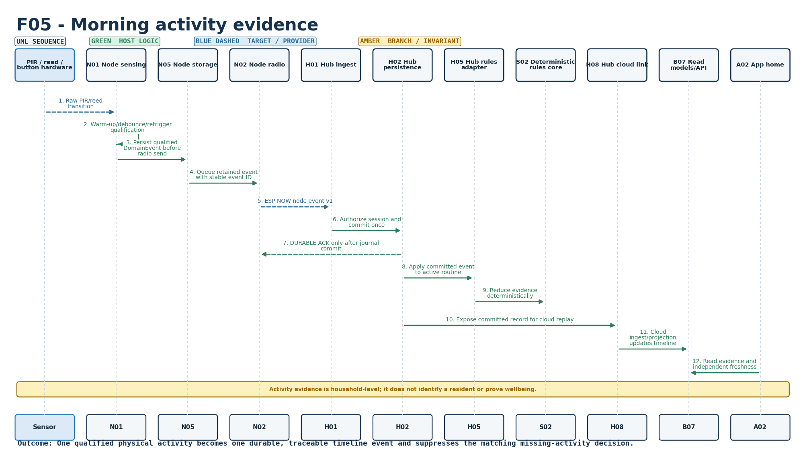
Figure S-05. Requirement-level call flow for F05.
Mapped modules: N01, H01, H02, H05, S02, B07, A02. Participants: Sensor, N01, N05, N02, H01, H02, H05, S02, H08, B07, A02. Outcome: One qualified physical activity becomes one durable, traceable timeline event and suppresses the matching missing-activity decision.
Editable source: diagrams/sequences/uml/F05.puml

F06 - Explicit I'm OK check-in
Meaning. An explicit I am OK action is a resident statement recorded separately from passive motion. It should be possible without a phone and should give immediate, understandable local feedback.
Worked example. A parent wakes late and presses OK. The display may say that the check-in was saved locally; if the internet is down it must not say the family has already received it.
Reference implementation boundary. Event construction and rule handling exist. The current reducer ignores OK while in suppressed modes and outside its configured activity interval. The product-level requirement to retain manual actions independently still requires complete runtime wiring and a reviewed grace-period policy.
Acceptance experiment. Test press, bounce, held button, WAN outage and reboot between save and send. Measure the 500 ms local confirmation target on hardware. Verify that a caregiver acknowledgement cannot masquerade as resident OK.
Participants and traceability. H06, H02, H05, S02, B07, A02. Source paths and test references are in the traceability register. See diagrams/sequences/png and diagrams/sequences/uml for the corresponding F06 flow.
SEQUENCE DESIGN COMPLETE | TARGET EXECUTION/INTEGRATION EVIDENCE PENDING
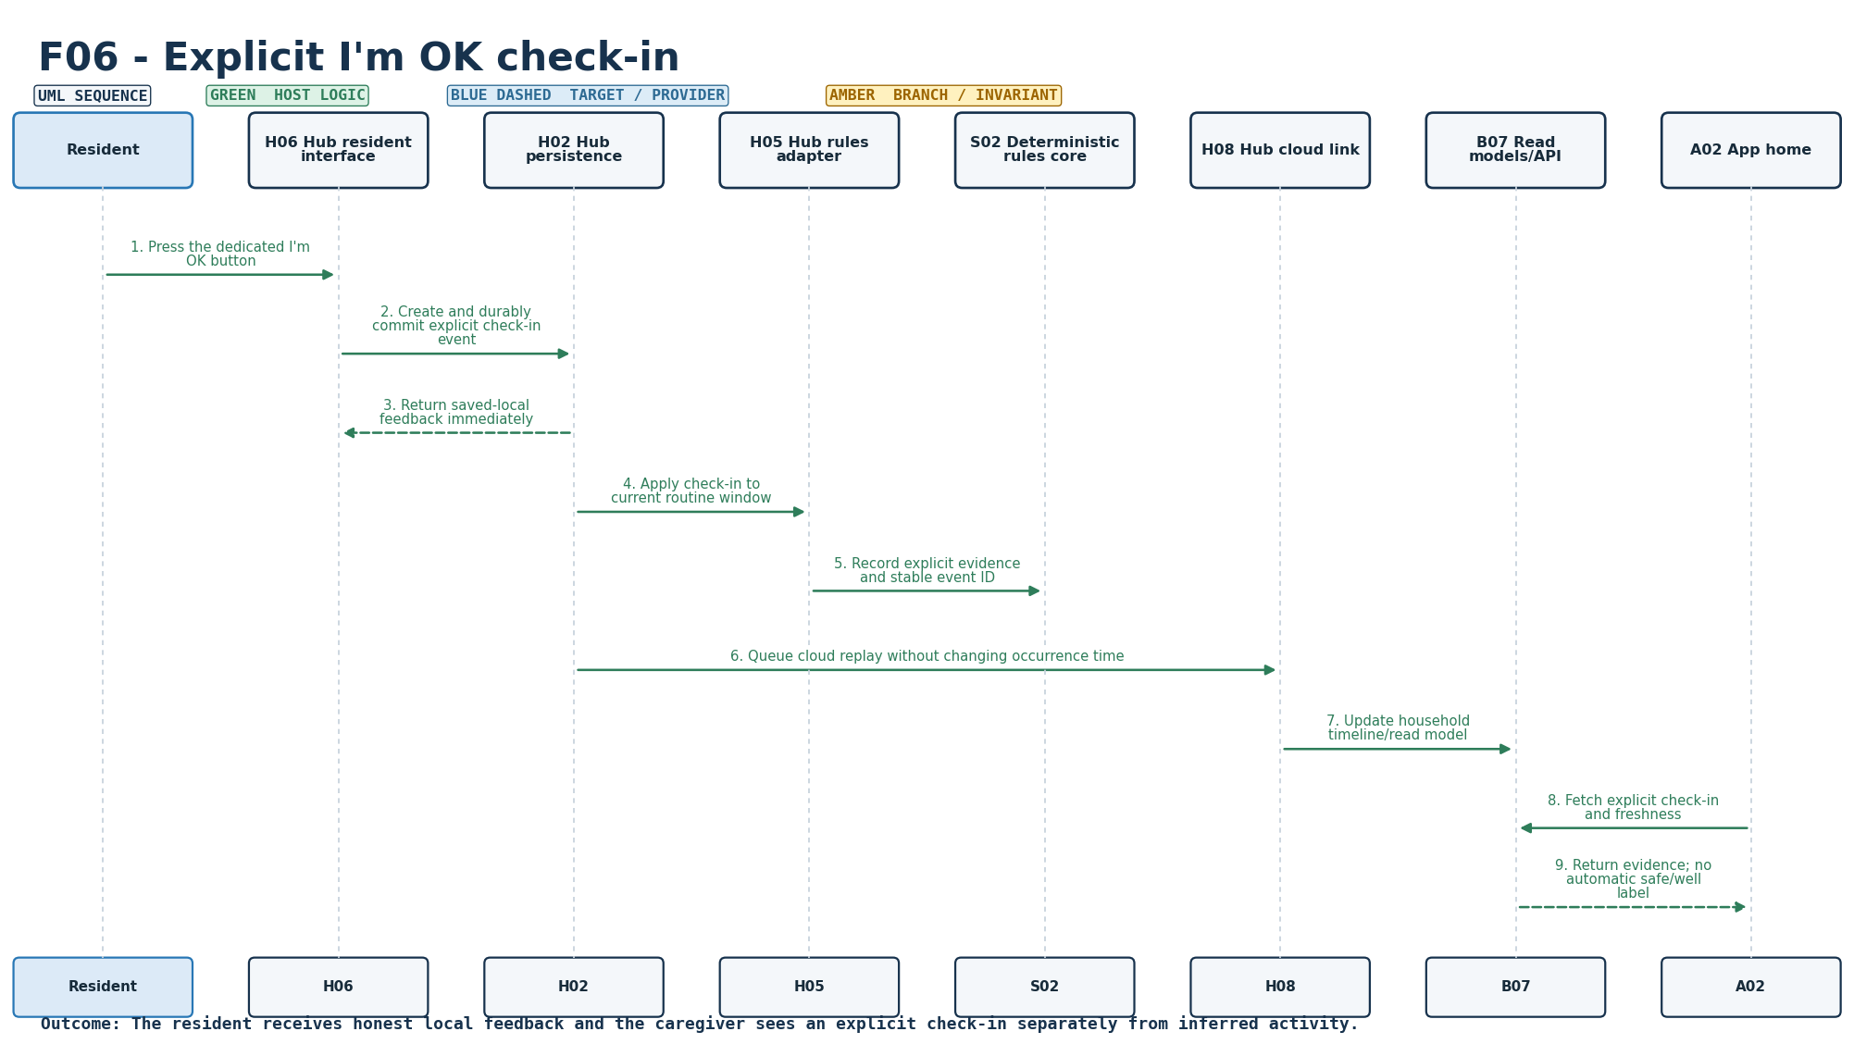
Figure S-06. Requirement-level call flow for F06.
Mapped modules: H06, H02, H05, S02, B07, A02. Participants: Resident, H06, H02, H05, S02, H08, B07, A02. Outcome: The resident receives honest local feedback and the caregiver sees an explicit check-in separately from inferred activity.
Editable source: diagrams/sequences/uml/F06.puml

F07 - Call family request
Meaning. Call family means the resident is requesting human contact. It is separate from missing routine evidence, carries higher routing importance and must not wait for the next morning deadline.
Worked example. At 15:00, father presses Call family while the internet is unavailable. The local response should explain that the request is saved and remote contact is unavailable, rather than implying someone is on the way.
Reference implementation boundary. The backend composition handles CALL_FAMILY and schedules jobs. End-to-end button-to-backend mapping and real provider delivery are pending. This is not automatic emergency dispatch or a guaranteed emergency response service.
Acceptance experiment. Send the same request twice and verify one incident and one job per recipient/stage. Exercise WAN loss, reboot, provider rejection and a caregiver acknowledgement that cancels pending backup routing.
Participants and traceability. H06, H02, H05, B04, B05, A04. Source paths and test references are in the traceability register. See diagrams/sequences/png and diagrams/sequences/uml for the corresponding F07 flow.
SEQUENCE DESIGN COMPLETE | TARGET EXECUTION/INTEGRATION EVIDENCE PENDING
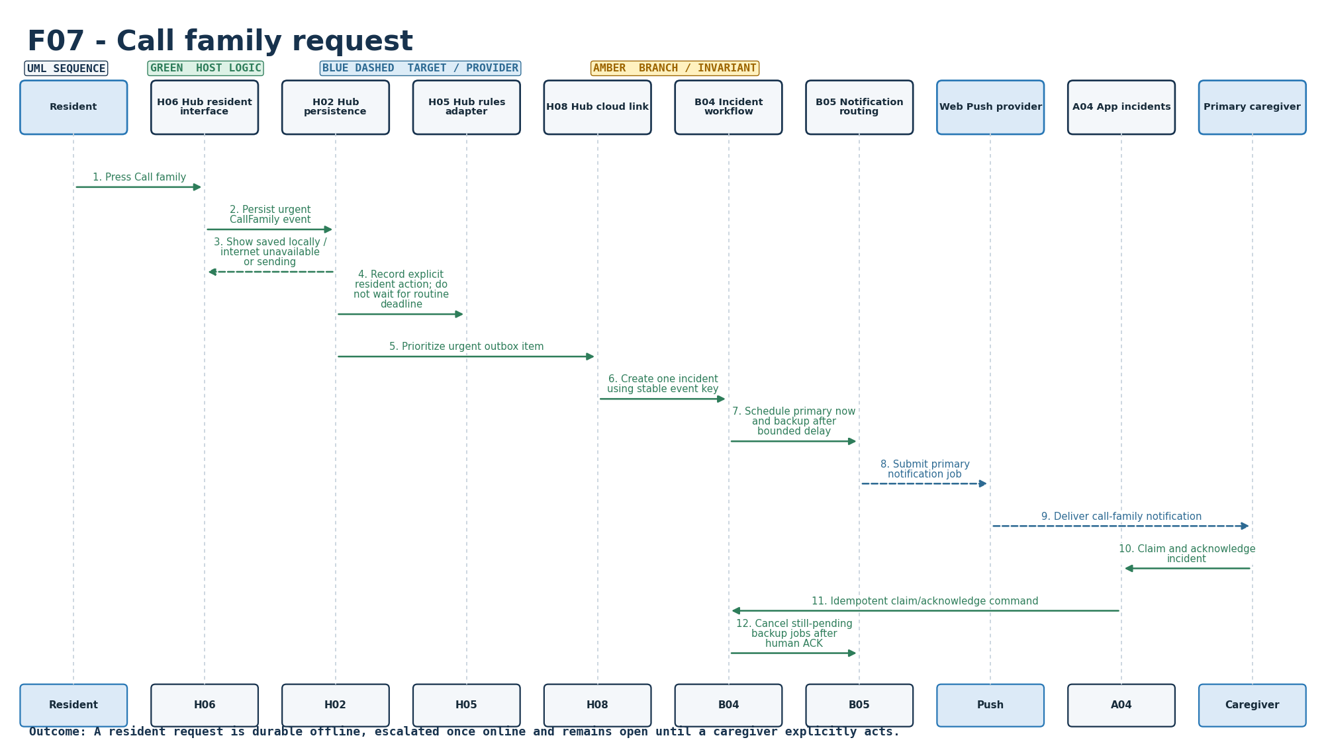
Figure S-07. Requirement-level call flow for F07.
Mapped modules: H06, H02, H05, B04, B05, A04. Participants: Resident, H06, H02, H05, H08, B04, B05, Push, A04, Caregiver. Outcome: A resident request is durable offline, escalated once online and remains open until a caregiver explicitly acts.
Editable source: diagrams/sequences/uml/F07.puml

F08 - Missing morning activity workflow
Meaning. Missing activity is meaningful only when the system had a usable opportunity to observe it. An unknown sensor, an untrusted clock or an intentional pause must not become a resident-risk assertion.
Worked example. At 10:10 there is no qualifying event. If required nodes are healthy and time is trusted, create one missing-morning intent. If NODE-KT is offline, show coverage unavailable instead. Neither outcome proves a medical emergency.
Reference implementation boundary. The host reducer returns an intent/reason. It does not implement the full local prompt then wait then notify orchestration, nor automatically publish a technical service incident. Current-state coverage cannot establish full-window coverage; that gap must close before reliable live absence alerts.
Acceptance experiment. Run covered quiet, evidence present, node missing, clock invalid, privacy, away, visitor and repeated-deadline cases. Restart mid-window and confirm persisted eligibility and duplicate suppression before accepting the hardware implementation.
Participants and traceability. H03, H04, H05, S02, B04, B05. Source paths and test references are in the traceability register. See diagrams/sequences/png and diagrams/sequences/uml for the corresponding F08 flow.
SEQUENCE DESIGN COMPLETE | TARGET EXECUTION/INTEGRATION EVIDENCE PENDING
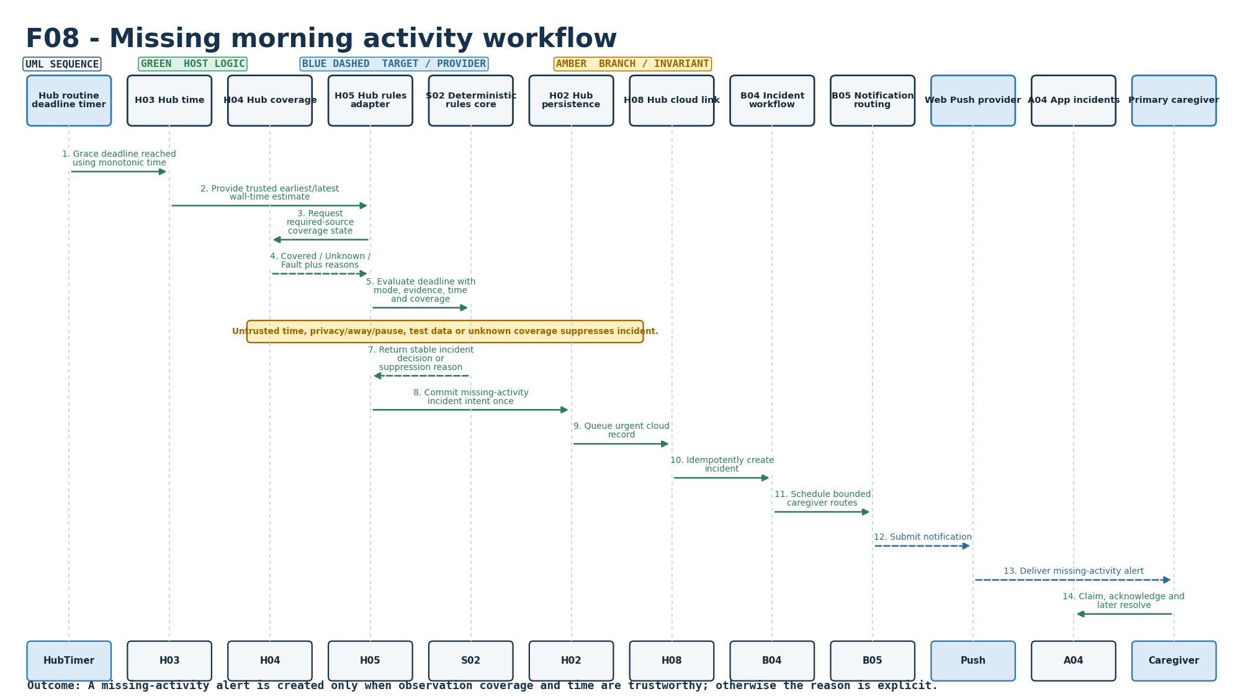
Figure S-08. Requirement-level call flow for F08.
Mapped modules: H03, H04, H05, S02, B04, B05. Participants: HubTimer, H03, H04, H05, S02, H02, H08, B04, B05, Push, A04, Caregiver. Outcome: A missing-activity alert is created only when observation coverage and time are trustworthy; otherwise the reason is explicit.
Editable source: diagrams/sequences/uml/F08.puml

F09 - Main-door history and quiet notice
Meaning. A reed contact reports that a door opened or closed. One contact or one PIR cannot determine who crossed the door or in which direction. A quiet-hour notice is an optional explanatory advisory, not an intrusion conclusion.
Worked example. The main door opens at 22:00. A caregiver may see a door event if permitted, but the product must not say that a parent left home or that a stranger entered.
Reference implementation boundary. The notice helper accepts a caller-supplied within_quiet_hours boolean. Computing local-time policy, enforcing user opt-in and routing the complete door flow are not established by that helper.
Acceptance experiment. Test bounce, initial open state, repeat delivery, quiet policy off, policy boundary and test-tagged data. Inspect the notice label for direction or identity claims.
Participants and traceability. N01, H05, S02, B07, B05, A02. Source paths and test references are in the traceability register. See diagrams/sequences/png and diagrams/sequences/uml for the corresponding F09 flow.
SEQUENCE DESIGN COMPLETE | TARGET EXECUTION/INTEGRATION EVIDENCE PENDING
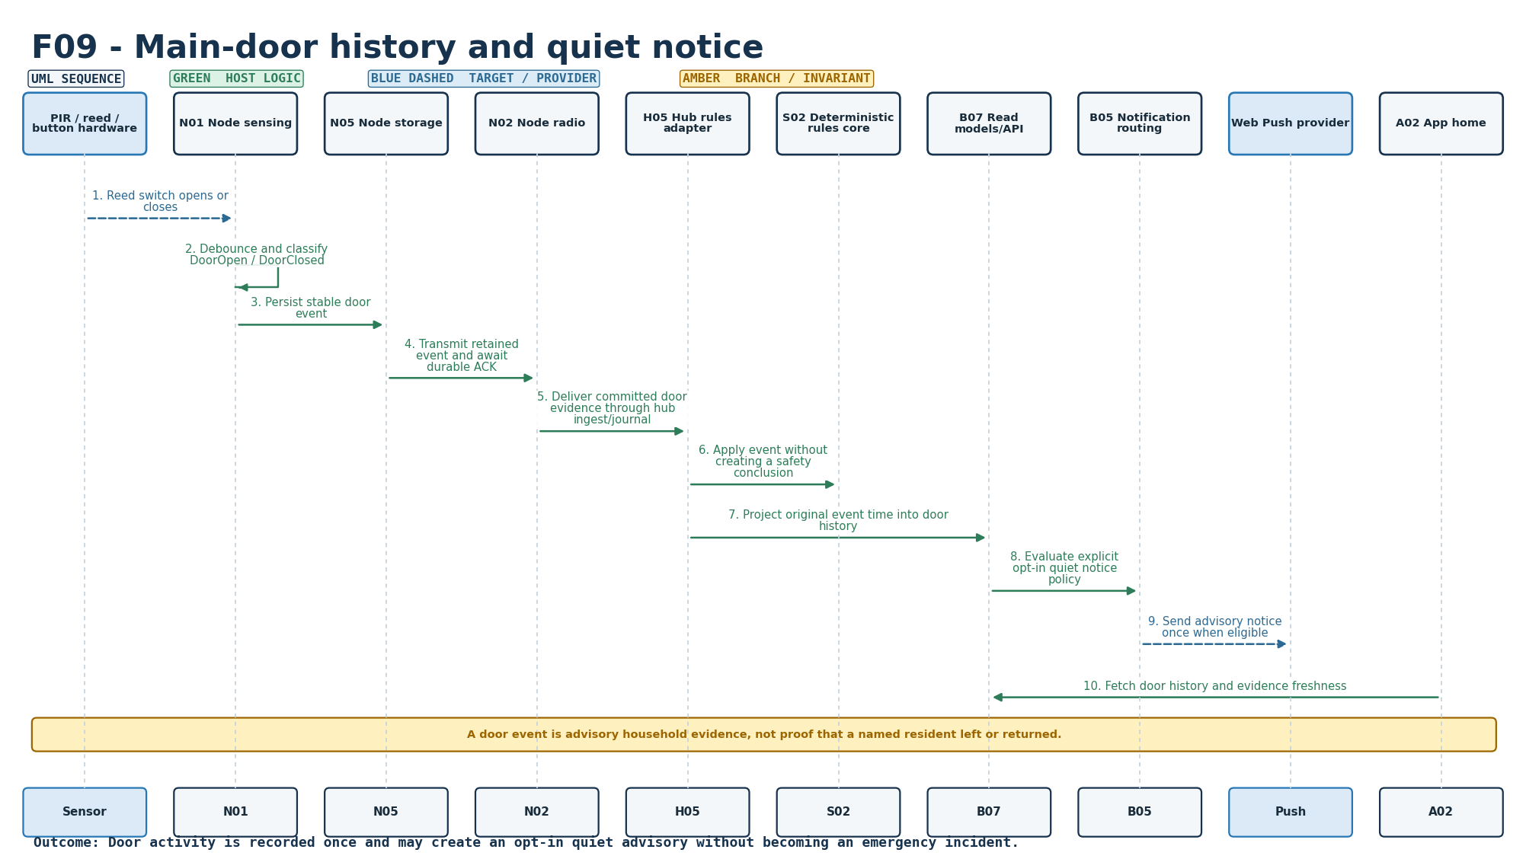
Figure S-09. Requirement-level call flow for F09.
Mapped modules: N01, H05, S02, B07, B05, A02. Participants: Sensor, N01, N05, N02, H05, S02, B07, B05, Push, A02. Outcome: Door activity is recorded once and may create an opt-in quiet advisory without becoming an emergency incident.
Editable source: diagrams/sequences/uml/F09.puml

F10 - Away, pause and visitor modes
Meaning. Modes explain why routine interpretation changes. AWAY means absence is expected; PAUSED means temporarily suspend routine handling; PRIVACY controls passive observation. VISITOR warns that observed movement may belong to someone else.
Worked example. Both parents go out and set AWAY. The deadline should not generate a missing-morning incident. A visitor moving in the kitchen must not be presented as proof of either parent moving.
Reference implementation boundary. The reducer suppresses absence unless mode is Home. Visitor can collect evidence but still suppresses deadline creation. Device propagation, audit detail and recovery of effective mode need integrated validation.
Acceptance experiment. Change each mode before, during and after a window; repeat an old command and reboot. Confirm that collection policy, absence eligibility and displayed mode agree.
Participants and traceability. A03, B02, H07, H06, H05, S02. Source paths and test references are in the traceability register. See diagrams/sequences/png and diagrams/sequences/uml for the corresponding F10 flow.
SEQUENCE DESIGN COMPLETE | TARGET EXECUTION/INTEGRATION EVIDENCE PENDING
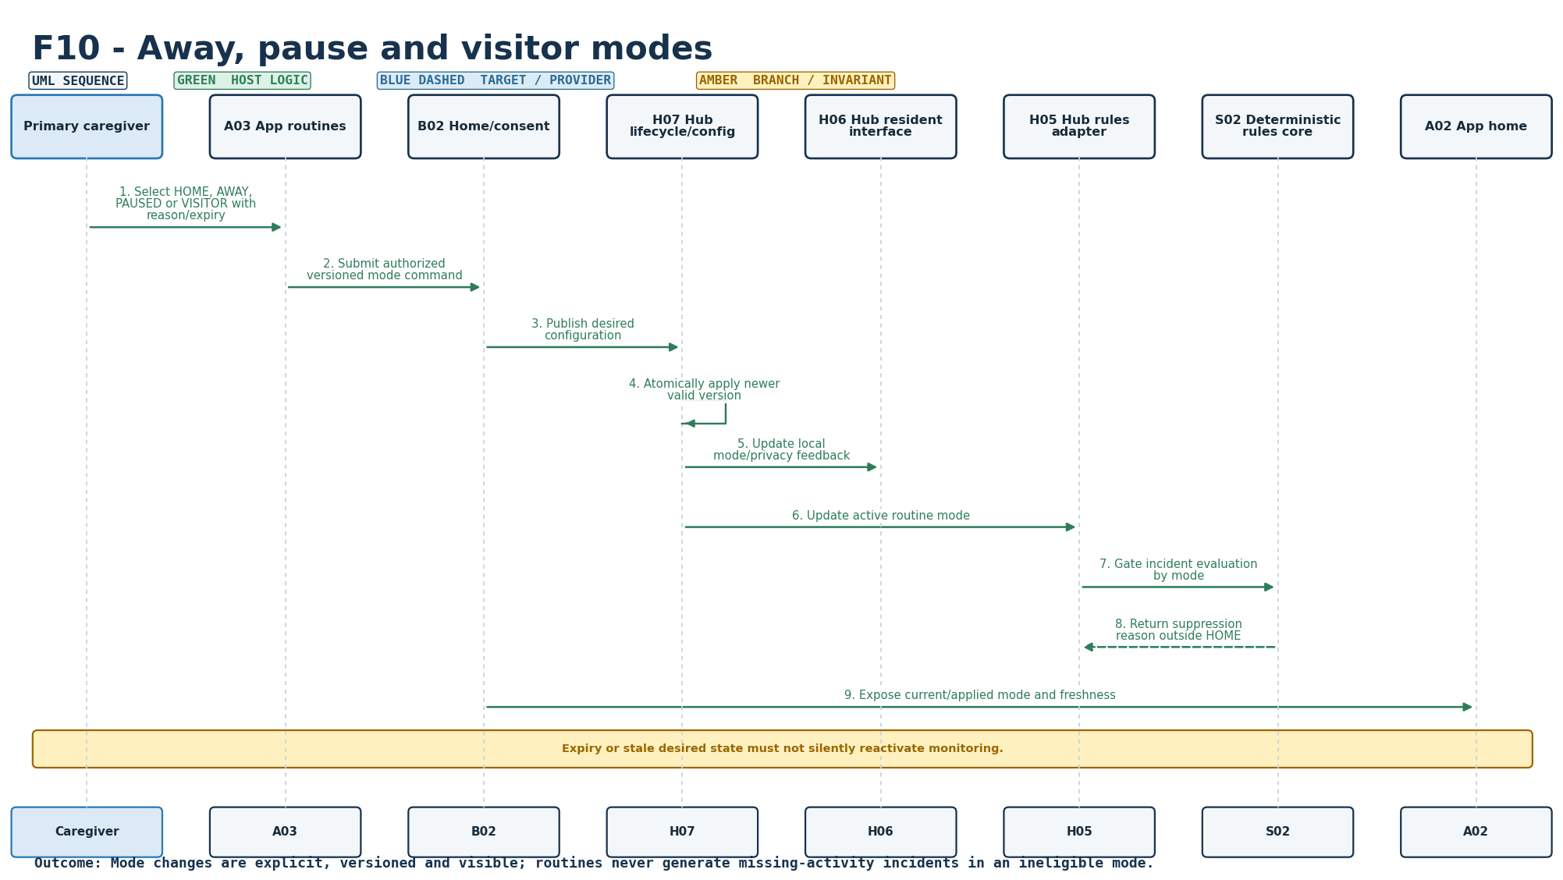
Figure S-10. Requirement-level call flow for F10.
Mapped modules: A03, B02, H07, H06, H05, S02. Participants: Caregiver, A03, B02, H07, H06, H05, S02, A02. Outcome: Mode changes are explicit, versioned and visible; routines never generate missing-activity incidents in an ineligible mode.
Editable source: diagrams/sequences/uml/F10.puml

F11 - Caregiver dashboard and timeline
Meaning. The dashboard is an explanation of observations and service condition. Last movement, resident OK, sensor availability, hub connectivity and an open family request are separate facts.
Worked example. A screen may legitimately show activity at 08:10 and hub offline since 08:30. Hiding either fact would mislead the caregiver. Never turn an old cached card into a green live-status indicator.
Reference implementation boundary. View-model helpers and a browser demonstration exist. The complete secured caregiver application, accessible screens, live refresh and supported-phone testing remain pending.
Acceptance experiment. Load fresh, stale, never-seen and disconnected snapshots; change phone time; try H2 credentials for H1; verify that labels remain understandable on a small mobile screen.
Participants and traceability. B07, B08, A02, A05. Source paths and test references are in the traceability register. See diagrams/sequences/png and diagrams/sequences/uml for the corresponding F11 flow.
SEQUENCE DESIGN COMPLETE | TARGET EXECUTION/INTEGRATION EVIDENCE PENDING
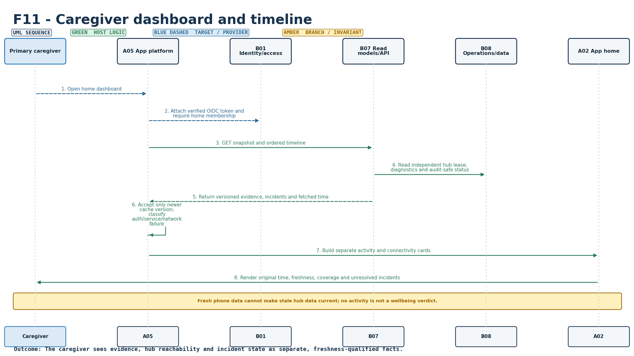
Figure S-11. Requirement-level call flow for F11.
Mapped modules: B07, B08, A02, A05. Participants: Caregiver, A05, B01, B07, B08, A02. Outcome: The caregiver sees evidence, hub reachability and incident state as separate, freshness-qualified facts.
Editable source: diagrams/sequences/uml/F11.puml

F12 - Acknowledgement and resolution
Meaning. Claim means one caregiver is taking responsibility for following up. Acknowledge means a human has seen and accepted the request. Resolve means the follow-up is deliberately closed. None is the same as provider delivery.
Worked example. Rahul claims an incident for five minutes. A second caregiver tries to claim during that lease and sees a conflict. After the lease expires, the backup may take over. A resident OK remains a separate recorded action.
Reference implementation boundary. Claim/acknowledge/resolve methods exist. The present permission check uses read access for mutation and needs a stricter production action policy. Unable-to-reach/handoff and atomic database concurrency are not complete.
Acceptance experiment. Race two claims, expire a lease, try cross-house access, repeat acknowledgement and resolve a closed incident. Verify authorised action permissions and notification cancellation in a transaction-level test.
Participants and traceability. B04, B07, B05, A04, H08. Source paths and test references are in the traceability register. See diagrams/sequences/png and diagrams/sequences/uml for the corresponding F12 flow.
SEQUENCE DESIGN COMPLETE | TARGET EXECUTION/INTEGRATION EVIDENCE PENDING
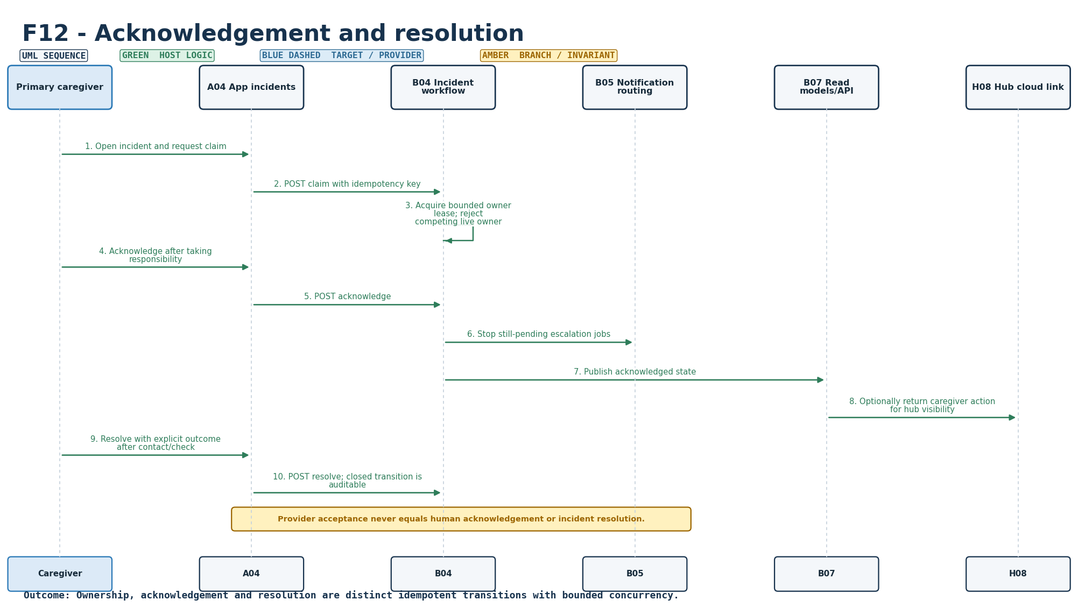
Figure S-12. Requirement-level call flow for F12.
Mapped modules: B04, B07, B05, A04, H08. Participants: Caregiver, A04, B04, B05, B07, H08. Outcome: Ownership, acknowledgement and resolution are distinct idempotent transitions with bounded concurrency.
Editable source: diagrams/sequences/uml/F12.puml

F13 - Backup routing and delivery visibility
Meaning. Routing is the plan for contacting primary and backup caregivers and reporting what actually happened. A push or SMS provider accepting a request is not evidence that a human read it.
Worked example. The primary receives a job at 10:10. With no human acknowledgement, a backup job becomes due at 10:15 using the reference five-minute delay. If the primary acknowledges at 10:13, an unsent backup job should be cancelled.
Reference implementation boundary. Scheduling and delivery-state helpers exist in memory. Real providers, durable worker claims, retry after FAILED, receipt callbacks, rate limits and route-exhaustion handling need implementation.
Acceptance experiment. Use a fake provider that accepts, rejects and times out. Crash a worker after sending but before saving the result. Verify idempotency and clear uncertain-delivery status instead of claiming guaranteed exactly-once notification.
Participants and traceability. B05, B04, B08, A04, A05. Source paths and test references are in the traceability register. See diagrams/sequences/png and diagrams/sequences/uml for the corresponding F13 flow.
SEQUENCE DESIGN COMPLETE | TARGET EXECUTION/INTEGRATION EVIDENCE PENDING
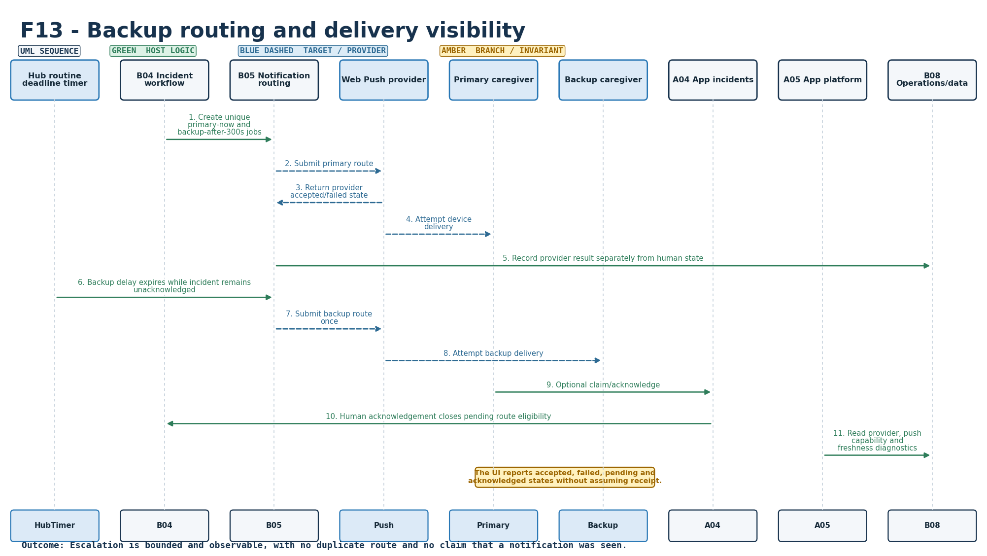
Figure S-13. Requirement-level call flow for F13.
Mapped modules: B05, B04, B08, A04, A05. Participants: HubTimer, B04, B05, Push, Primary, Backup, A04, A05, B08. Outcome: Escalation is bounded and observable, with no duplicate route and no claim that a notification was seen.
Editable source: diagrams/sequences/uml/F13.puml

F14 - Opt-in daily morning summary
Meaning. A daily summary is an optional recap after the window, not another urgent alert. It should include the evidence and its limits, the active mode and unresolved requests.
Worked example. A caregiver opts in to one morning summary. A day with an offline kitchen node should say observation incomplete. An older event from yesterday must not cause today to be reported as active.
Reference implementation boundary. The current helper scans all retained home events instead of filtering the requested local date/window. It also relies on caller-supplied flags and does not itself enforce consent. It is a host scaffold, not a ready scheduled report.
Acceptance experiment. Test no opt-in, no consent, events only from yesterday, partial coverage, repeated scheduling and policy change on the same date. Decide whether a policy revision should update or resend before implementing production routing.
Participants and traceability. B05, B07, A03, A02. Source paths and test references are in the traceability register. See diagrams/sequences/png and diagrams/sequences/uml for the corresponding F14 flow.
SEQUENCE DESIGN COMPLETE | TARGET EXECUTION/INTEGRATION EVIDENCE PENDING
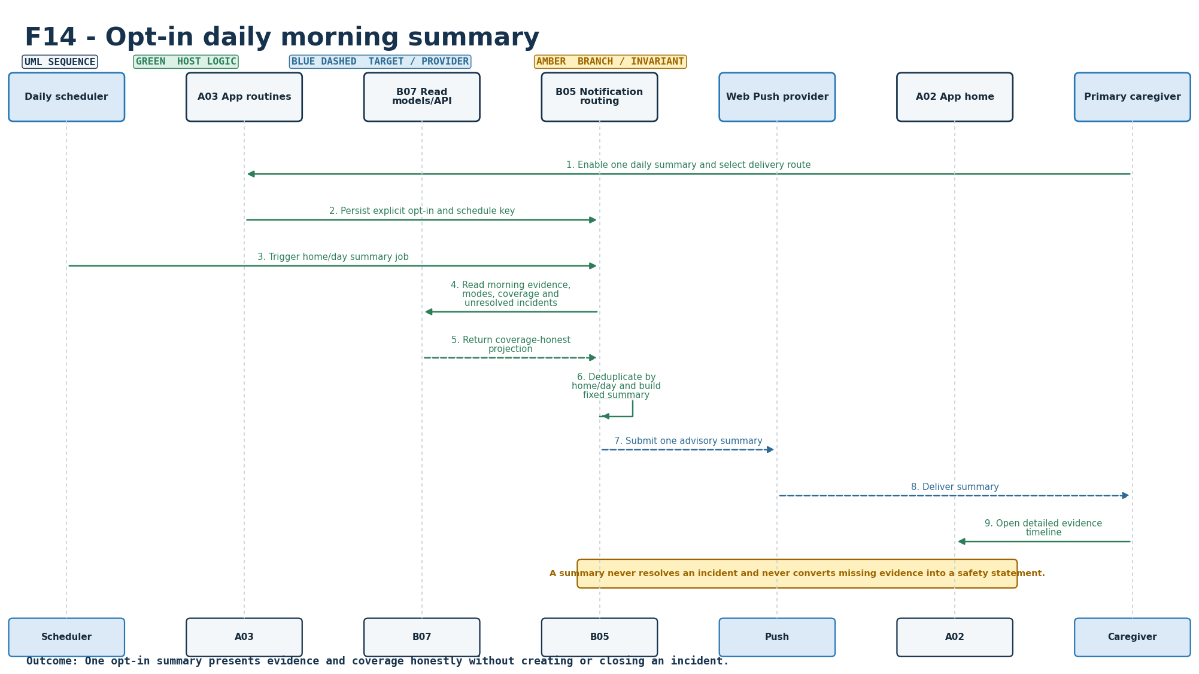
Figure S-14. Requirement-level call flow for F14.
Mapped modules: B05, B07, A03, A02. Participants: Scheduler, A03, B07, B05, Push, A02, Caregiver. Outcome: One opt-in summary presents evidence and coverage honestly without creating or closing an incident.
Editable source: diagrams/sequences/uml/F14.puml

E01 - Node health, battery and coverage
Meaning. Health telemetry tells whether the device and observation path can be trusted. It must not be mixed with resident activity. A responsive MCU can still have a disconnected or poorly aimed sensor.
Worked example. NODE-B1 sends heartbeats but its PIR wire is disconnected. The future fault/status model must be able to show sensor unavailable while radio connectivity remains good.
Reference implementation boundary. The host default is a 60-second heartbeat configuration and a 190-second hub lease. Earlier 15/35-minute deployment values were different trial proposals. Do not mix them. Coverage currently checks contact/fault, not a complete battery and historical-interval policy.
Acceptance experiment. Test never-seen, fresh, expired, explicit sensor fault and uncalibrated voltage. Measure battery impact and packet loss before freezing heartbeat intervals.
Participants and traceability. N03, N02, H04, B08, A02. Source paths and test references are in the traceability register. See diagrams/sequences/png and diagrams/sequences/uml for the corresponding E01 flow.
SEQUENCE DESIGN COMPLETE | TARGET EXECUTION/INTEGRATION EVIDENCE PENDING
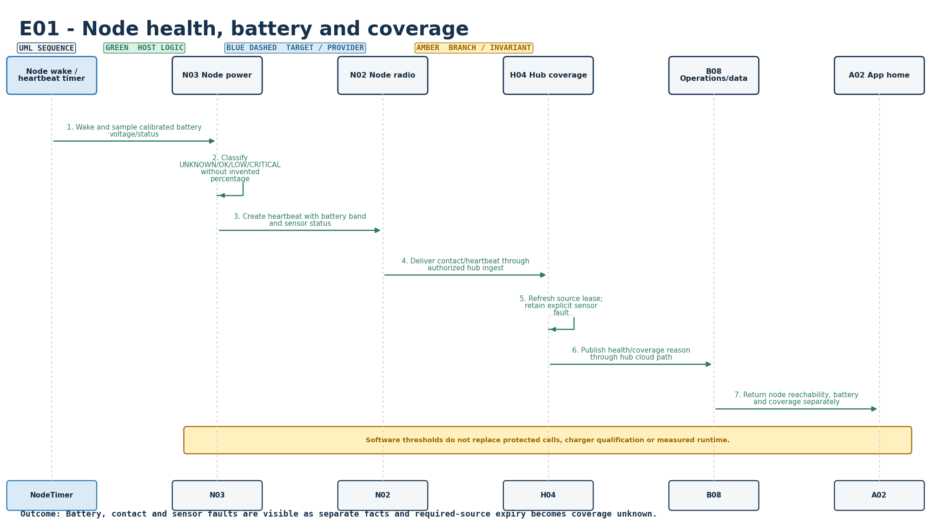
Figure S-15. Requirement-level call flow for E01.
Mapped modules: N03, N02, H04, B08, A02. Participants: NodeTimer, N03, N02, H04, B08, A02. Outcome: Battery, contact and sensor faults are visible as separate facts and required-source expiry becomes coverage unknown.
Editable source: diagrams/sequences/uml/E01.puml

E02 - Reliable transport and duplicate handling
Meaning. Reliable transport means retries do not create new business events and a sender does not delete evidence merely because a radio packet was received. Application acknowledgement and transport success are different layers.
Worked example. The hub stores an event but its ACK is lost. The node retries the same source/session/sequence. The hub recognises the event and returns the appropriate acknowledgement without creating a second backend incident.
Reference implementation boundary. In-memory retention and ACK semantics exist; encrypted radio, authenticated sessions across reboot and real durable flash do not. HubRuntime currently reapplies duplicates to the reducer, so effect-level deduplication is an explicit gap.
Acceptance experiment. Inject lost packet, lost ACK, duplicate packet, reordered packet, peer mismatch and receiver-full conditions. Examine both event counts and side effects such as evidence IDs and notification jobs.
Participants and traceability. N02, N05, H01, H02, H08, B03, S01. Source paths and test references are in the traceability register. See diagrams/sequences/png and diagrams/sequences/uml for the corresponding E02 flow.
SEQUENCE DESIGN COMPLETE | TARGET EXECUTION/INTEGRATION EVIDENCE PENDING
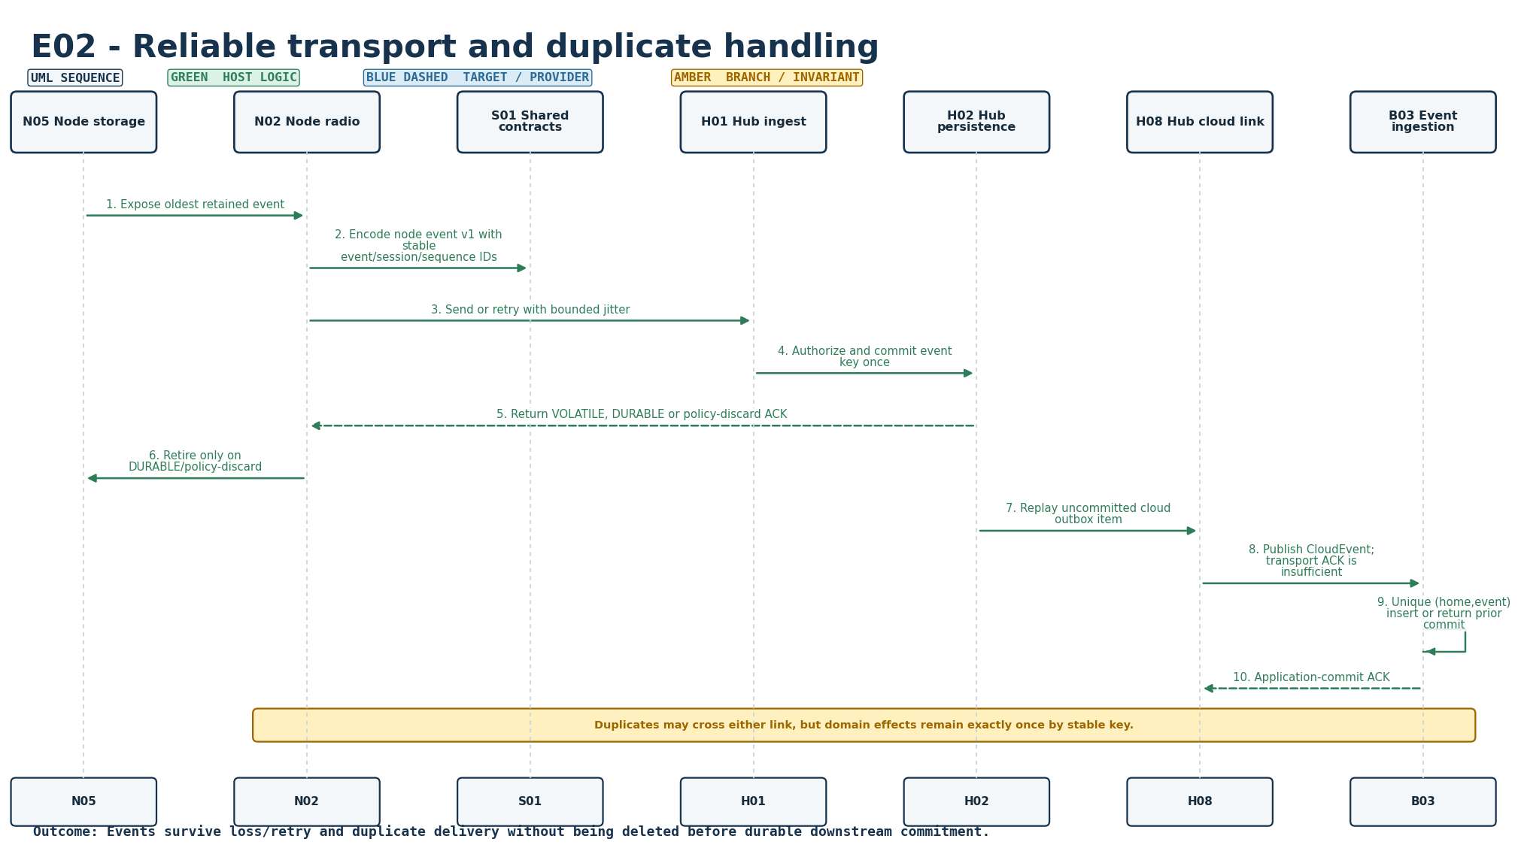
Figure S-16. Requirement-level call flow for E02.
Mapped modules: N02, N05, H01, H02, H08, B03, S01. Participants: N05, N02, S01, H01, H02, H08, B03. Outcome: Events survive loss/retry and duplicate delivery without being deleted before durable downstream commitment.
Editable source: diagrams/sequences/uml/E02.puml

E03 - Local operation during internet failure
Meaning. Offline operation means the home can continue supported local work when the wide-area internet is unavailable. It does not mean a remote caregiver can receive a new alert without any working outbound connection.
Worked example. The internet cable fails while the router and hub still have power. Local sensor events can continue in the target design; remote notifications are queued. If the router itself loses power, radio/channel recovery needs separate testing.
Reference implementation boundary. Host components can simulate disconnection and replay. Real flash, ESP-NOW/Wi-Fi coexistence, channel changes and local UI integration remain open. The home router needs its own power backup for remote access during mains loss.
Acceptance experiment. Separate WAN cut, router off, hub reboot and node off. Check the correct status for each, and verify replay without erasing the observation gap.
Participants and traceability. H03, H04, H05, H06, H02, H08. Source paths and test references are in the traceability register. See diagrams/sequences/png and diagrams/sequences/uml for the corresponding E03 flow.
SEQUENCE DESIGN COMPLETE | TARGET EXECUTION/INTEGRATION EVIDENCE PENDING
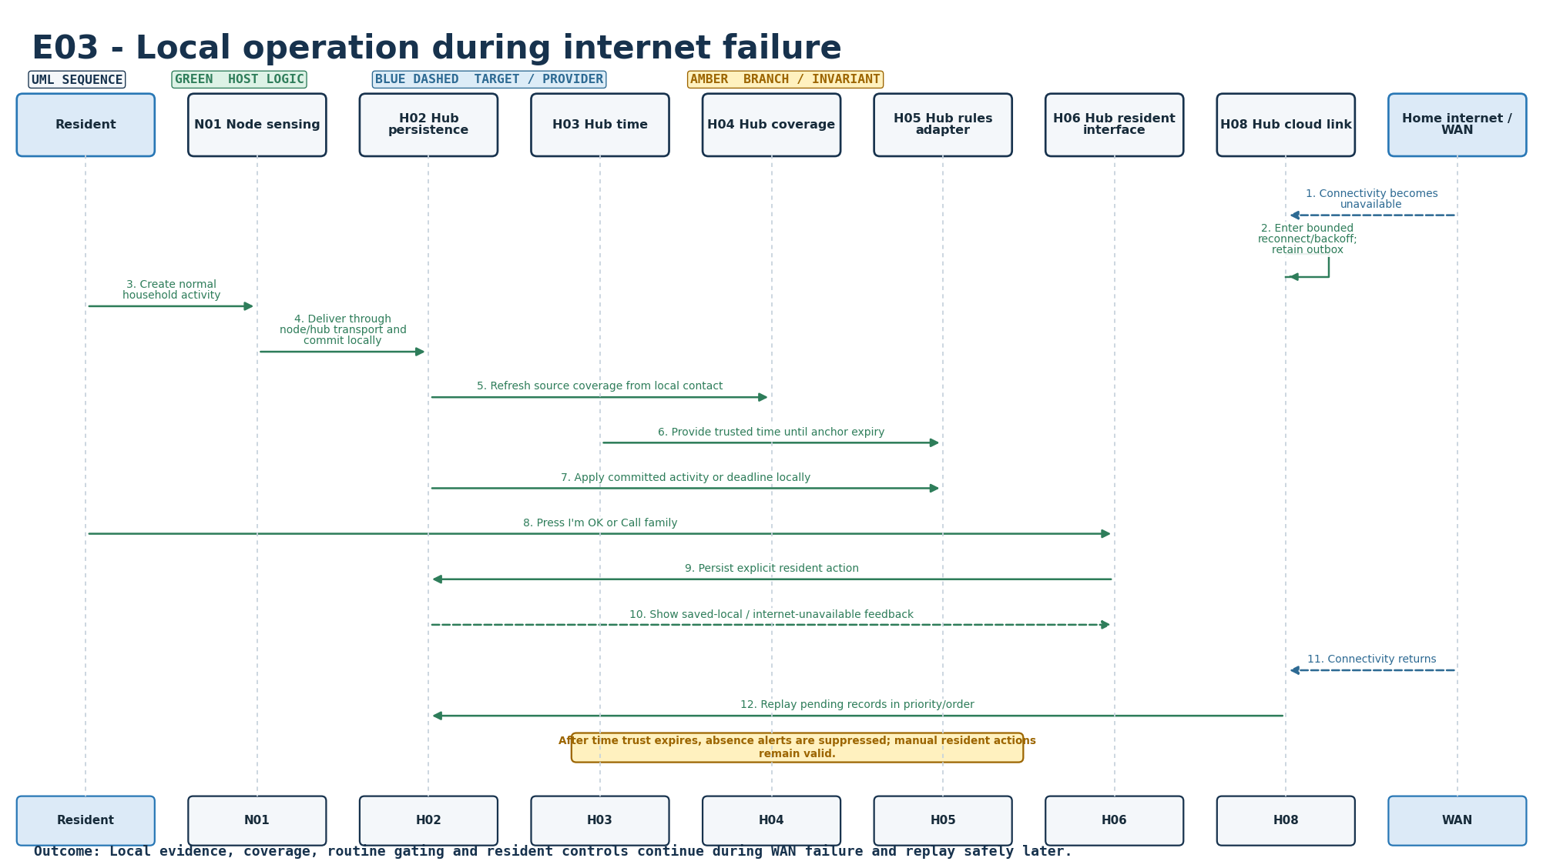
Figure S-17. Requirement-level call flow for E03.
Mapped modules: H03, H04, H05, H06, H02, H08. Participants: Resident, N01, H02, H03, H04, H05, H06, H08, WAN. Outcome: Local evidence, coverage, routine gating and resident controls continue during WAN failure and replay safely later.
Editable source: diagrams/sequences/uml/E03.puml

E04 - Hub/cloud/app connectivity and freshness
Meaning. Freshness is about when a fact was last observed at a specific boundary. Node-to-hub, hub-to-server, server-to-provider and phone-to-server each need their own status.
Worked example. The phone is offline but the hub and server are communicating. A cached dashboard should say its view is stale, rather than label the household sensor network offline.
Reference implementation boundary. Independent host representations exist. Production heartbeats, authenticated timestamps, streaming refresh and durable stale-state recovery require integration.
Acceptance experiment. Break one boundary at a time and verify that the other statuses remain correct. Confirm that broker retained online state is not used as the sole liveness proof.
Participants and traceability. H08, B08, B07, A05, A02. Source paths and test references are in the traceability register. See diagrams/sequences/png and diagrams/sequences/uml for the corresponding E04 flow.
SEQUENCE DESIGN COMPLETE | TARGET EXECUTION/INTEGRATION EVIDENCE PENDING
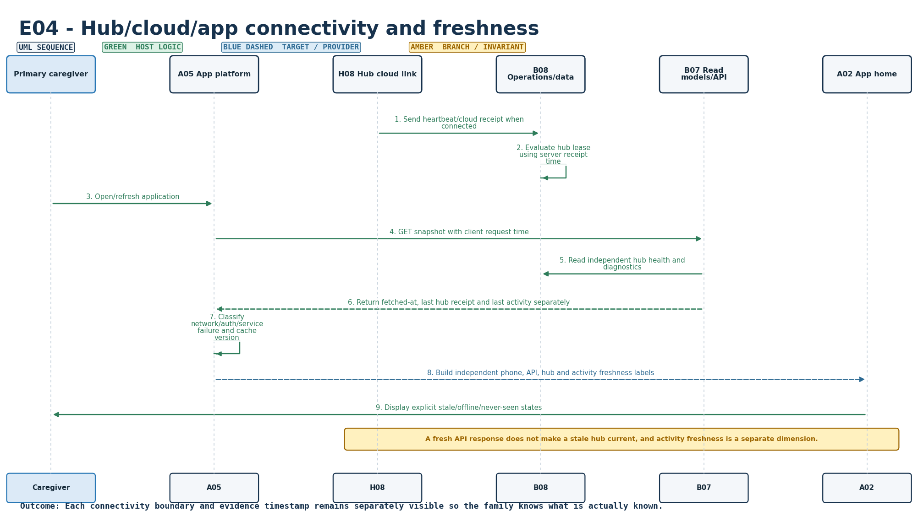
Figure S-18. Requirement-level call flow for E04.
Mapped modules: H08, B08, B07, A05, A02. Participants: Caregiver, A05, H08, B08, B07, A02. Outcome: Each connectivity boundary and evidence timestamp remains separately visible so the family knows what is actually known.
Editable source: diagrams/sequences/uml/E04.puml

E05 - Persistence, recovery and bounded storage
Meaning. Persistence must survive the failure it claims to tolerate. A C++ deque or Python dictionary is useful for testing order and identity, but loses all content when the process stops.
Worked example. Power fails after flash data bytes are written but before a commit marker. Recovery must ignore the incomplete tail, preserve earlier records and avoid acknowledging an event that was never durably committed.
Reference implementation boundary. Reference stores are in memory. HubJournal marks cloud acknowledgements but does not reclaim records; NodeRuntime can leave a stored item stranded if radio enqueue fails. A refill/recovery pump, flash adapter and bounded evidence collection are pending.
Acceptance experiment. Test full capacity, interruption at each commit step, reboot before ACK, compaction and offline retention exhaustion. Require an explicit gap/fault outcome when evidence cannot be retained.
Participants and traceability. N05, H02, B03, B04, B05, B08. Source paths and test references are in the traceability register. See diagrams/sequences/png and diagrams/sequences/uml for the corresponding E05 flow.
SEQUENCE DESIGN COMPLETE | TARGET EXECUTION/INTEGRATION EVIDENCE PENDING
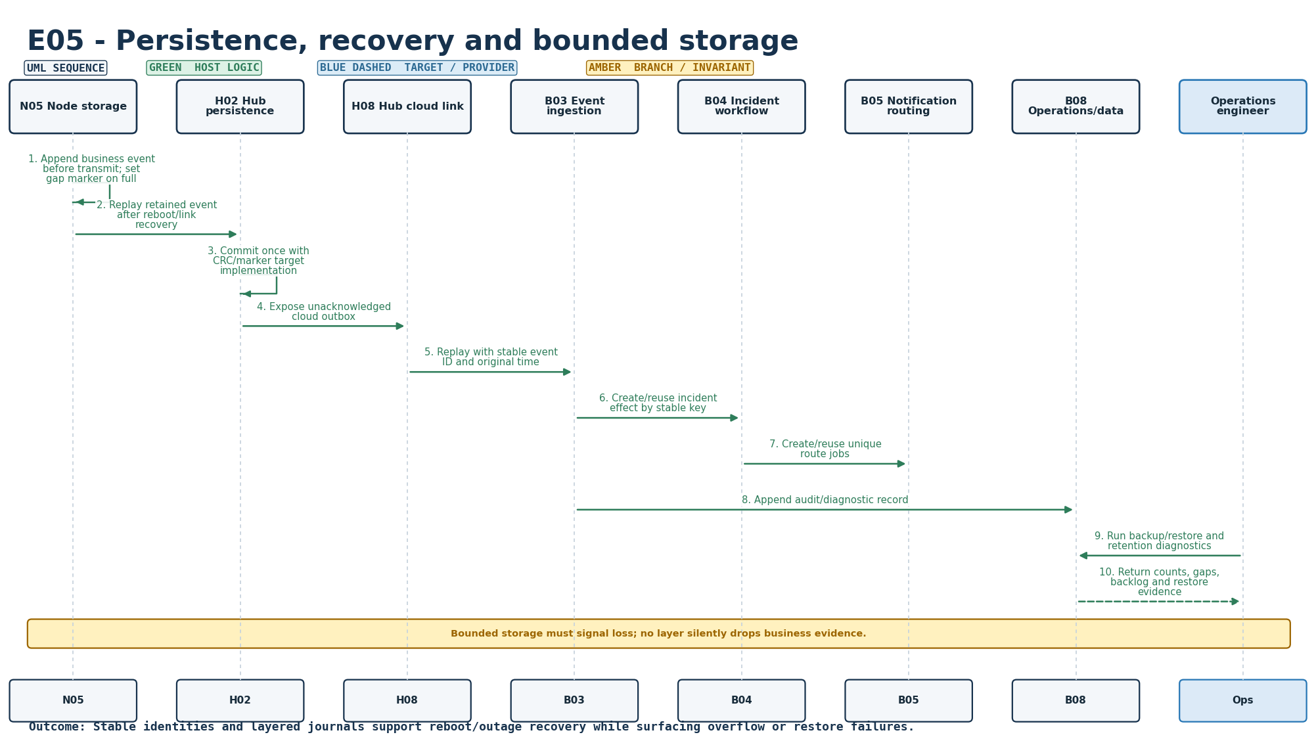
Figure S-19. Requirement-level call flow for E05.
Mapped modules: N05, H02, B03, B04, B05, B08. Participants: N05, H02, H08, B03, B04, B05, B08, Ops. Outcome: Stable identities and layered journals support reboot/outage recovery while surfacing overflow or restore failures.
Editable source: diagrams/sequences/uml/E05.puml

E06 - Trusted time and boundary handling
Meaning. Monotonic time measures elapsed duration; wall time identifies a local morning. Clock uncertainty expresses how much the timestamp could be wrong. Use the appropriate clock for each decision.
Worked example. A restarted hub has no trusted wall-clock anchor. It can respond to a button but must not infer that the 10:10 absence deadline has safely passed. A model timeout still uses monotonic elapsed milliseconds.
Reference implementation boundary. Host estimates exist, including a 72-hour anchor expiry. Production authenticated time acquisition, reboot checkpoints, timezone conversion and overflow/range validation are pending.
Acceptance experiment. Test missing anchor, stale anchor, clock rollback, uncertainty straddling a boundary and daylight-saving dates for non-India homes. Keep absolute timestamps and elapsed timer tests separate.
Participants and traceability. H03, H07, H05, S01, S02. Source paths and test references are in the traceability register. See diagrams/sequences/png and diagrams/sequences/uml for the corresponding E06 flow.
SEQUENCE DESIGN COMPLETE | TARGET EXECUTION/INTEGRATION EVIDENCE PENDING
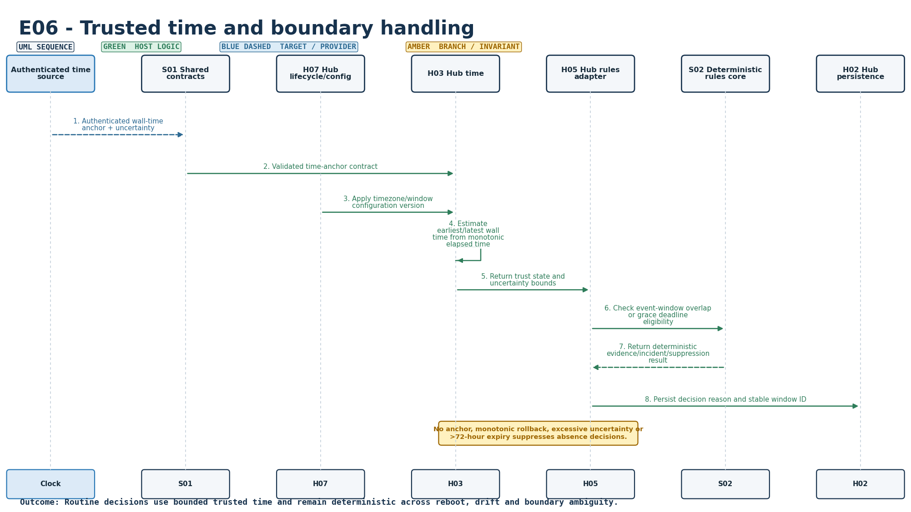
Figure S-20. Requirement-level call flow for E06.
Mapped modules: H03, H07, H05, S01, S02. Participants: Clock, S01, H07, H03, H05, S02, H02. Outcome: Routine decisions use bounded trusted time and remain deterministic across reboot, drift and boundary ambiguity.
Editable source: diagrams/sequences/uml/E06.puml

E07 - Versioned configuration and atomic application
Meaning. Desired configuration is what the caregiver requested; applied configuration is what the device accepted. Keeping both prevents a phone from showing a change that never reached the home.
Worked example. The server publishes version 8 while the hub is offline on version 7. The dashboard shows pending 8 and applied 7. A later delayed version 6 is rejected without replacing version 7.
Reference implementation boundary. Reference version validation exists. Persisted atomic updates, authenticated command envelopes, expiry and complete wrong-target validation need target integration and expanded tests.
Acceptance experiment. Reorder versions, duplicate the newest, corrupt one field and power-cycle during application. Verify that the active snapshot is entirely old or entirely new.
Participants and traceability. B06, A03, H07, N04, H08, S01. Source paths and test references are in the traceability register. See diagrams/sequences/png and diagrams/sequences/uml for the corresponding E07 flow.
SEQUENCE DESIGN COMPLETE | TARGET EXECUTION/INTEGRATION EVIDENCE PENDING
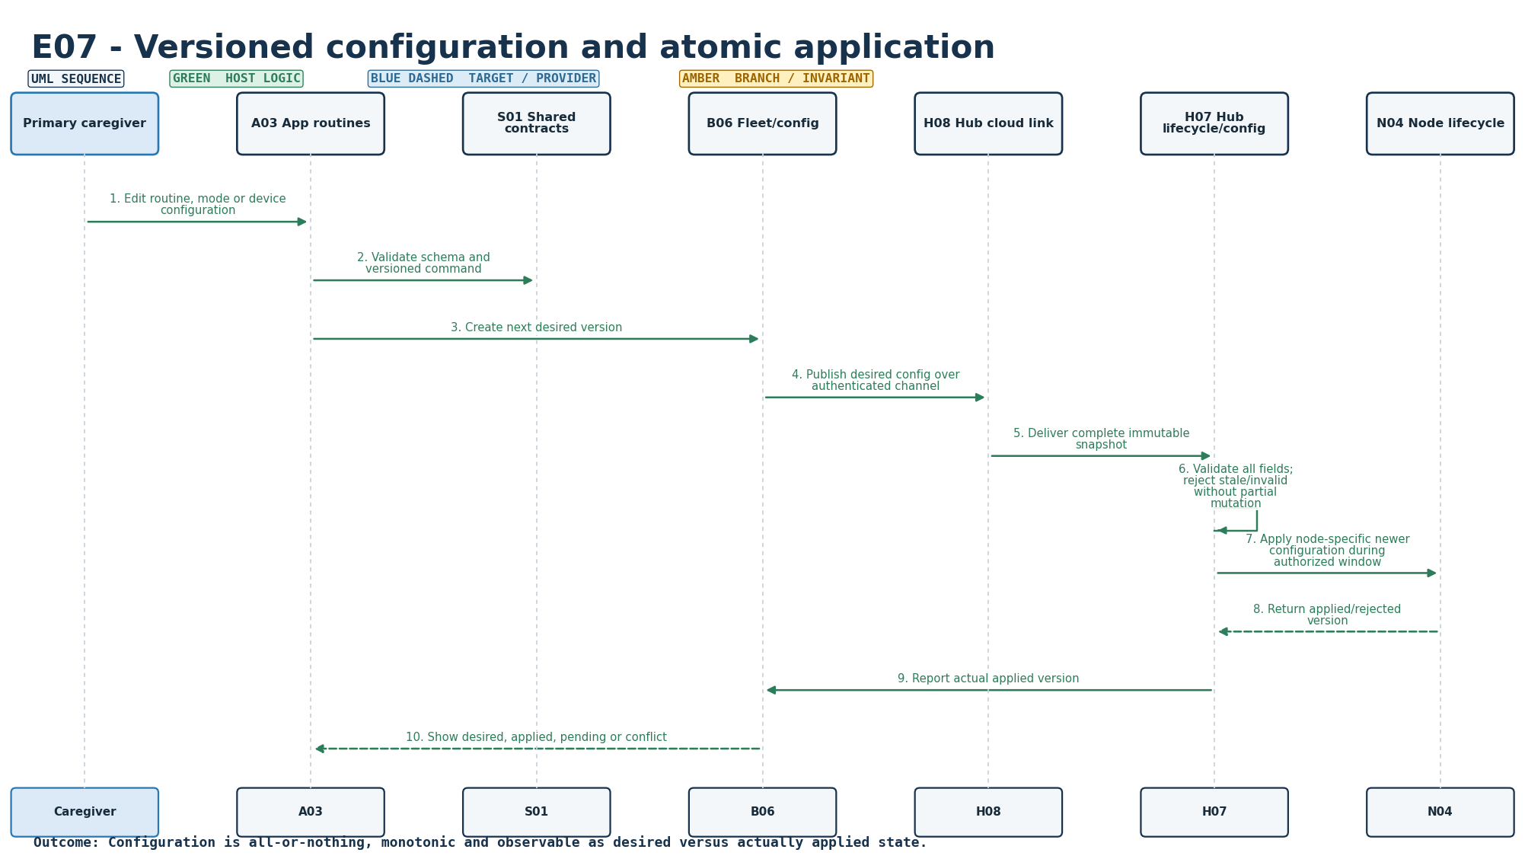
Figure S-21. Requirement-level call flow for E07.
Mapped modules: B06, A03, H07, N04, H08, S01. Participants: Caregiver, A03, S01, B06, H08, H07, N04. Outcome: Configuration is all-or-nothing, monotonic and observable as desired versus actually applied state.
Editable source: diagrams/sequences/uml/E07.puml

E08 - Security, privacy and tenant isolation
Meaning. Security is enforced at the boundary that owns the data or action. A hidden button, a MAC allow-list or a capability flag cannot replace authentication and authorisation.
Worked example. A person changes a home_id in an HTTP request. B01 must deny access before returning data. A node replaying another session must be rejected before changing the hub state.
Reference implementation boundary. Policies and negative host tests exist. TLS, OIDC, ESP-NOW key handling, secure boot, production token validation and strict mutation roles are not complete. Development HTTP headers are not authentication.
Acceptance experiment. Run cross-tenant read/write, revoked credential, wrong session and invalid signature cases. Inspect the deployed endpoints and logs; do not infer security from class names or a mock signature verifier.
Participants and traceability. S03, B01, B02, B06, B08, A05, T01. Source paths and test references are in the traceability register. See diagrams/sequences/png and diagrams/sequences/uml for the corresponding E08 flow.
SEQUENCE DESIGN COMPLETE | TARGET EXECUTION/INTEGRATION EVIDENCE PENDING
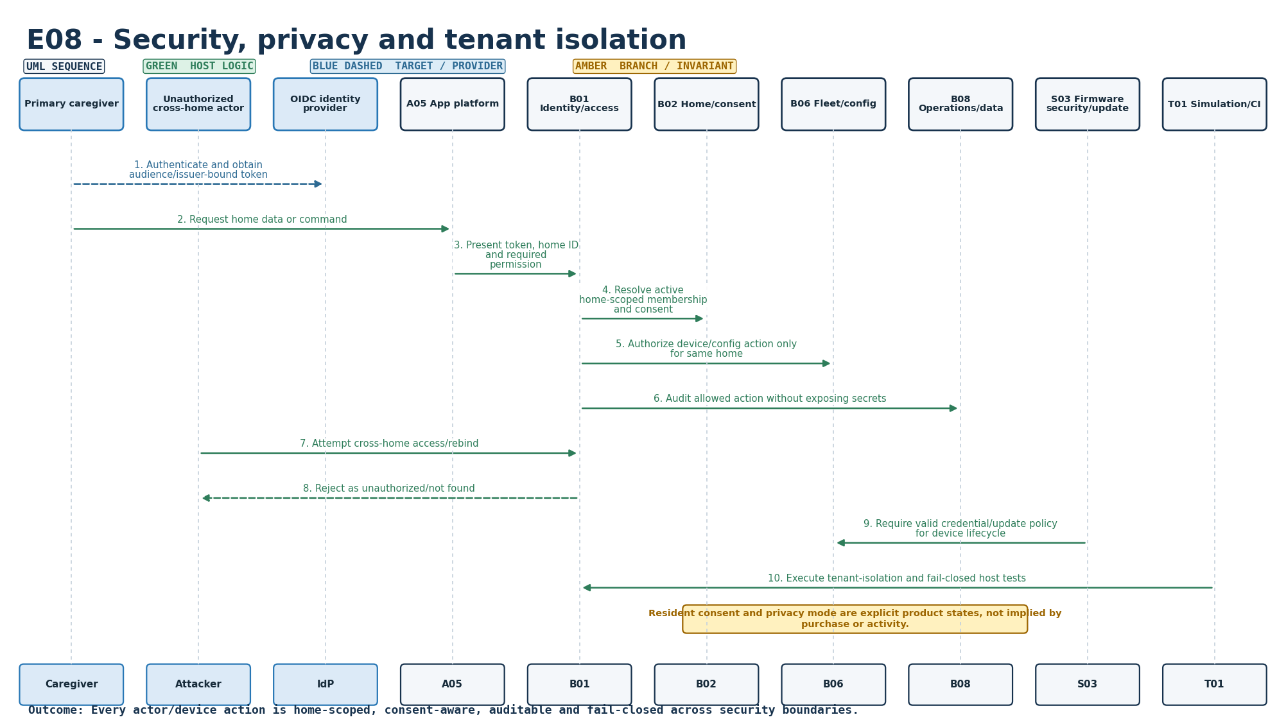
Figure S-22. Requirement-level call flow for E08.
Mapped modules: S03, B01, B02, B06, B08, A05, T01. Participants: Caregiver, Attacker, IdP, A05, B01, B02, B06, B08, S03, T01. Outcome: Every actor/device action is home-scoped, consent-aware, auditable and fail-closed across security boundaries.
Editable source: diagrams/sequences/uml/E08.puml

E09 - Signed firmware update and recovery
Meaning. OTA is a controlled update with authenticity checks and a recoverable boot path. Version comparison alone does not establish that a firmware image is genuine or healthy.
Worked example. An image signed for a different board arrives. Reject it even if its version is newer. If a valid image boots but repeatedly fails health checks, the target boot strategy must restore the prior working image.
Reference implementation boundary. The current code validates manifest metadata through a testable seam. Image download, real hash/signature verification, flash partitions, bootloader rollback, watchdog and signed fleet rollout are pending.
Acceptance experiment. Test wrong board, stale version, bad hash text and rejected signature on host. Later interrupt download/write/first boot on hardware and demonstrate recovery before a field update.
Participants and traceability. S03, H07, N04, B06, B08, T02. Source paths and test references are in the traceability register. See diagrams/sequences/png and diagrams/sequences/uml for the corresponding E09 flow.
SEQUENCE DESIGN COMPLETE | TARGET EXECUTION/INTEGRATION EVIDENCE PENDING
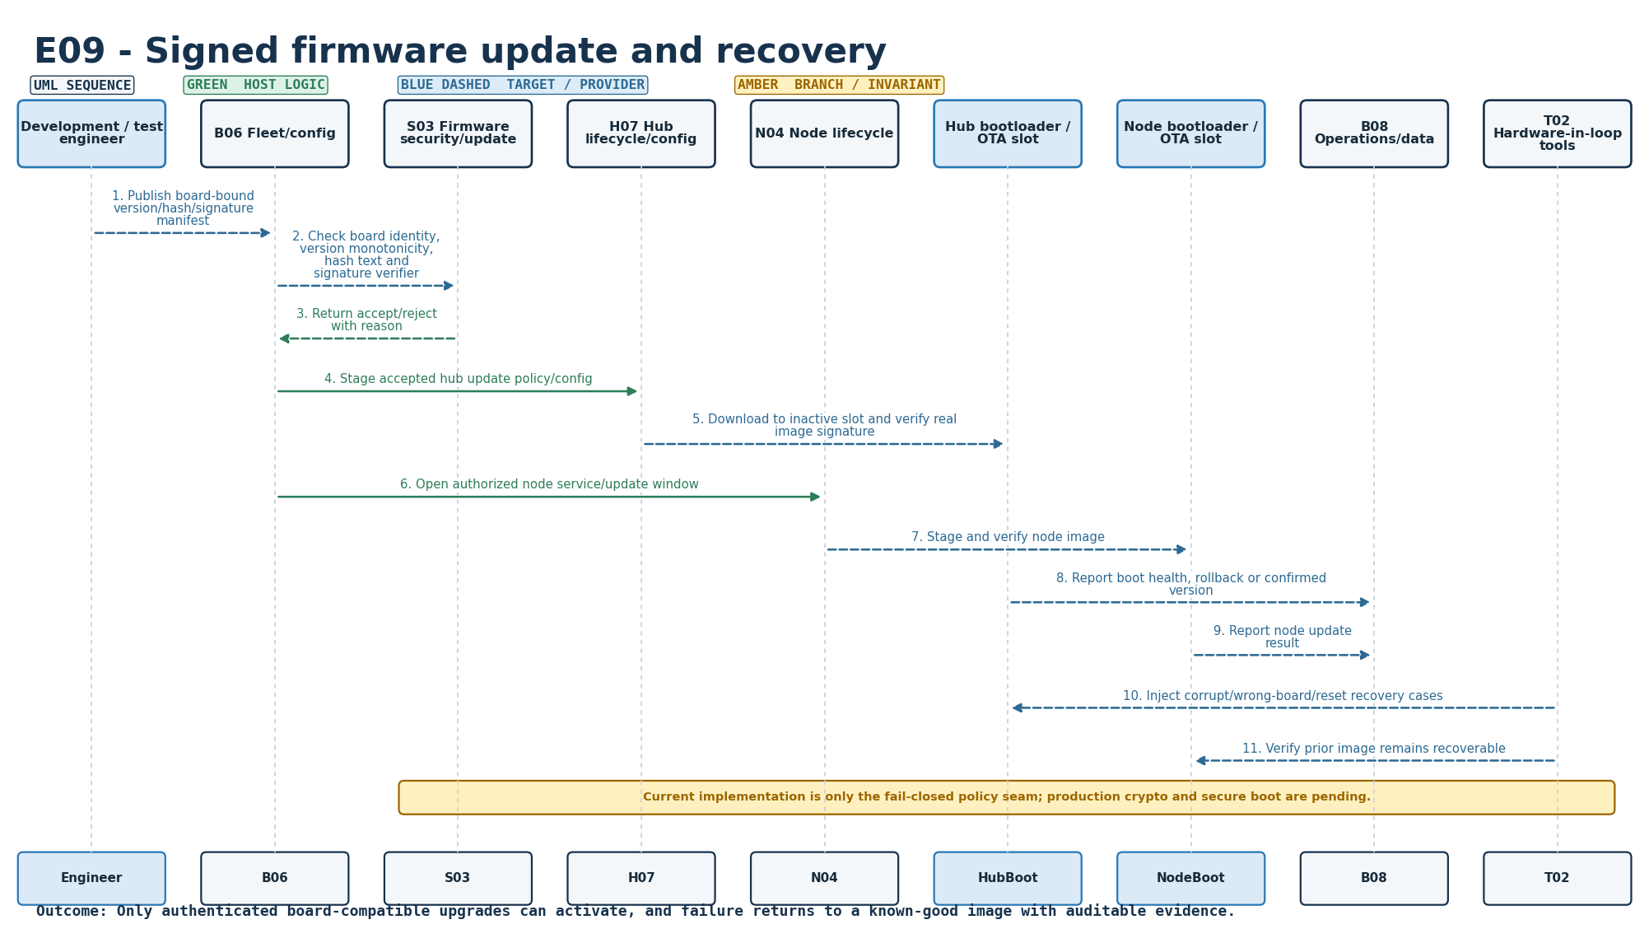
Figure S-23. Requirement-level call flow for E09.
Mapped modules: S03, H07, N04, B06, B08, T02. Participants: Engineer, B06, S03, H07, N04, HubBoot, NodeBoot, B08, T02. Outcome: Only authenticated board-compatible upgrades can activate, and failure returns to a known-good image with auditable evidence.
Editable source: diagrams/sequences/uml/E09.puml

E10 - Verification, observability and release evidence
Meaning. Observability lets an engineer explain where a flow stopped without collecting unnecessary household information. A useful log identifies the module and failure boundary; a green test report identifies exactly what was tested.
Worked example. A Call family request does not appear on the phone. Follow the same event through node retention, hub commit, cloud replay, backend incident, notification job and app freshness. Do not start by assuming a sensor failure.
Reference implementation boundary. The C++ formatter uses a 384-byte stack buffer; it calls the sink synchronously. ERROR is an unconditional hook but may be lost with no sink or failed I/O. Arbitrary null dereference, double free or corruption needs sanitizer/panic tooling, not a log macro.
Acceptance experiment. Inject queue exhaustion, provider failure and missing sink; verify error records without secrets. Run TRACE-on/off profiles and separate sanitizer and target crash-recovery tests. Record toolchain, command, result and remaining limitations.
Participants and traceability. B08, A02, T01, T02, T03, H02, H08. Source paths and test references are in the traceability register. See diagrams/sequences/png and diagrams/sequences/uml for the corresponding E10 flow.
SEQUENCE DESIGN COMPLETE | TARGET EXECUTION/INTEGRATION EVIDENCE PENDING
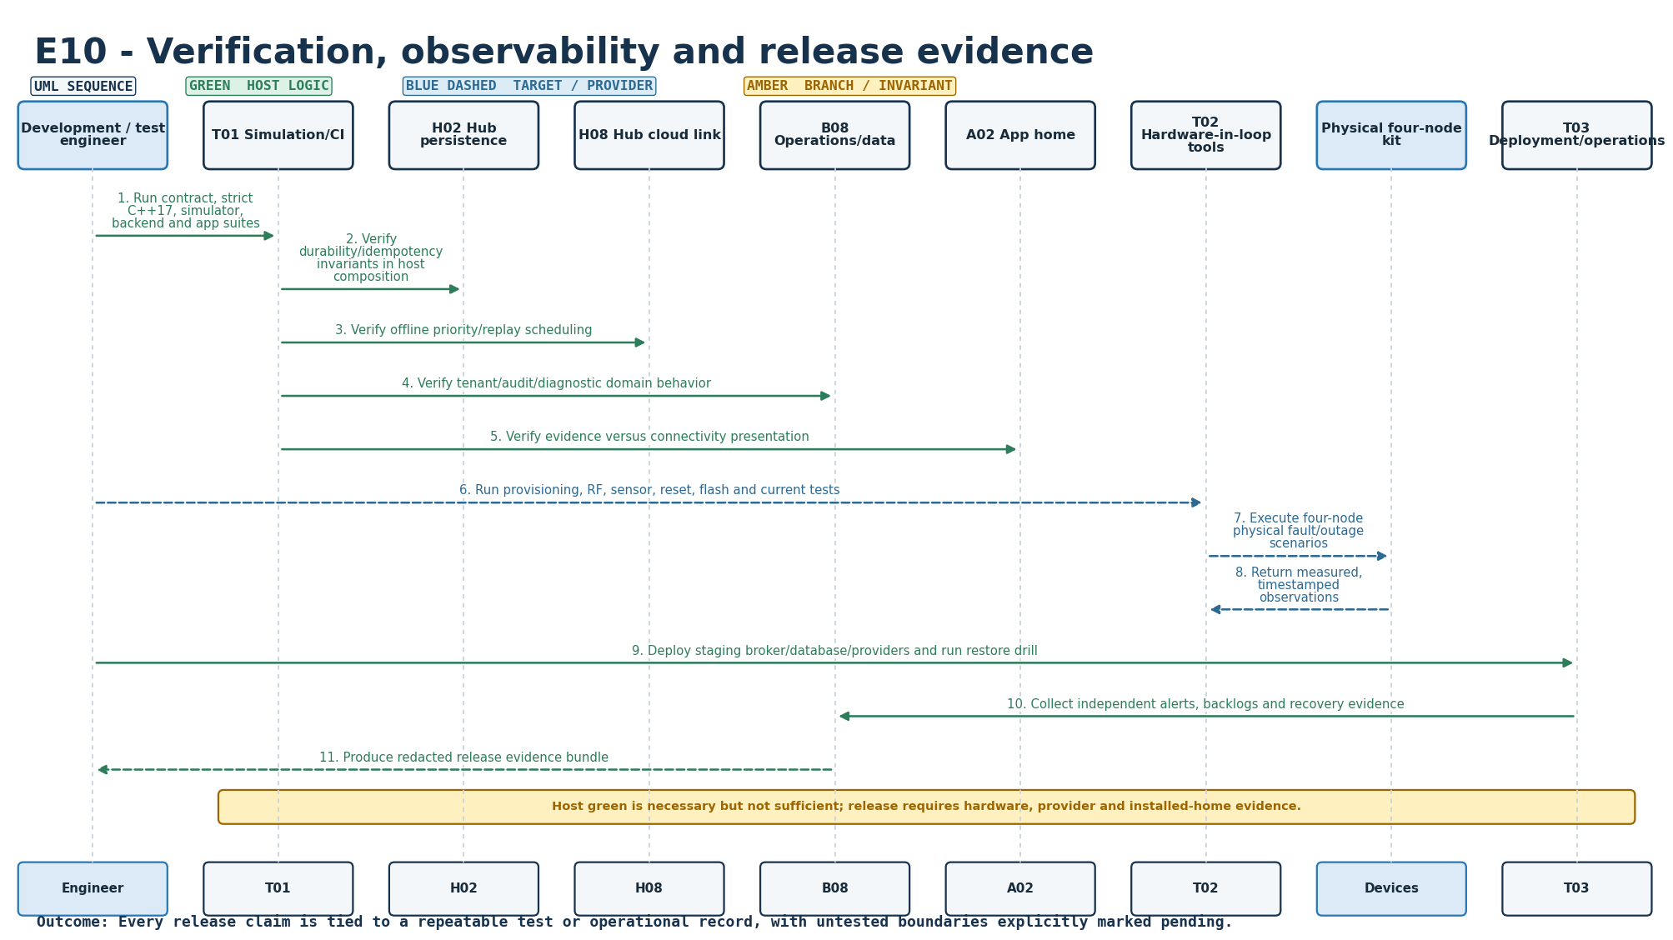
Figure S-24. Requirement-level call flow for E10.
Mapped modules: B08, A02, T01, T02, T03, H02, H08. Participants: Engineer, T01, H02, H08, B08, A02, T02, Devices, T03. Outcome: Every release claim is tied to a repeatable test or operational record, with untested boundaries explicitly marked pending.
Editable source: diagrams/sequences/uml/E10.puml

Requirement-to-participant traceability
ID | Requirement | Mapped modules | All sequence participants | Diagram
F01 | Household profile and caregiver roles | B01, B02, A01, S01 | Owner, A01, S01, B02, B01, B08 | Complete
F02 | Resident consent and privacy controls | B02, H06, H07, A01, B08 | Resident, H06, H07, B02, B08, A01 | Complete
F03 | Kit provisioning and installation verification | N04, H07, B06, A01, S03, T02 | Installer, A01, B06, S03, H07, N04, T02 | Complete
F04 | Configurable morning routine | A03, B06, H07, H03, H05, S02 | Caregiver, A03, B06, H07, H03, H05, S02 | Complete
F05 | Morning activity evidence | N01, H01, H02, H05, S02, B07, A02 | Sensor, N01, N05, N02, H01, H02, H05, S02, H08, B07, A02 | Complete
F06 | Explicit I’m OK check-in | H06, H02, H05, S02, B07, A02 | Resident, H06, H02, H05, S02, H08, B07, A02 | Complete
F07 | Call family request | H06, H02, H05, B04, B05, A04 | Resident, H06, H02, H05, H08, B04, B05, Push, A04, Caregiver | Complete
F08 | Missing morning activity workflow | H03, H04, H05, S02, B04, B05 | HubTimer, H03, H04, H05, S02, H02, H08, B04, B05, Push, A04, Caregiver | Complete
F09 | Main-door history and quiet notice | N01, H05, S02, B07, B05, A02 | Sensor, N01, N05, N02, H05, S02, B07, B05, Push, A02 | Complete
F10 | Away, pause and visitor modes | A03, B02, H07, H06, H05, S02 | Caregiver, A03, B02, H07, H06, H05, S02, A02 | Complete
F11 | Caregiver dashboard and timeline | B07, B08, A02, A05 | Caregiver, A05, B01, B07, B08, A02 | Complete
F12 | Acknowledgement and resolution | B04, B07, B05, A04, H08 | Caregiver, A04, B04, B05, B07, H08 | Complete
F13 | Backup routing and delivery visibility | B05, B04, B08, A04, A05 | HubTimer, B04, B05, Push, Primary, Backup, A04, A05, B08 | Complete
F14 | Opt-in daily morning summary | B05, B07, A03, A02 | Scheduler, A03, B07, B05, Push, A02, Caregiver | Complete
E01 | Node health, battery and coverage | N03, N02, H04, B08, A02 | NodeTimer, N03, N02, H04, B08, A02 | Complete
E02 | Reliable transport and duplicate handling | N02, N05, H01, H02, H08, B03, S01 | N05, N02, S01, H01, H02, H08, B03 | Complete
E03 | Local operation during internet failure | H03, H04, H05, H06, H02, H08 | Resident, N01, H02, H03, H04, H05, H06, H08, WAN | Complete
E04 | Hub/cloud/app connectivity and freshness | H08, B08, B07, A05, A02 | Caregiver, A05, H08, B08, B07, A02 | Complete
E05 | Persistence, recovery and bounded storage | N05, H02, B03, B04, B05, B08 | N05, H02, H08, B03, B04, B05, B08, Ops | Complete
E06 | Trusted time and boundary handling | H03, H07, H05, S01, S02 | Clock, S01, H07, H03, H05, S02, H02 | Complete
E07 | Versioned configuration and atomic application | B06, A03, H07, N04, H08, S01 | Caregiver, A03, S01, B06, H08, H07, N04 | Complete
E08 | Security, privacy and tenant isolation | S03, B01, B02, B06, B08, A05, T01 | Caregiver, Attacker, IdP, A05, B01, B02, B06, B08, S03, T01 | Complete
E09 | Signed firmware update and recovery | S03, H07, N04, B06, B08, T02 | Engineer, B06, S03, H07, N04, HubBoot, NodeBoot, B08, T02 | Complete
E10 | Verification, observability and release evidence | B08, A02, T01, T02, T03, H02, H08 | Engineer, T01, H02, H08, B08, A02, T02, Devices, T03 | Complete

Sequence handoff boundary
The call flows define intended behavior and cross-module responsibility. A sequence becomes P0-complete only after the matching requirement exit criterion has evidence on the selected ESP32 boards, services and phones. In particular, no sequence may turn missing evidence or unknown coverage into a claim that a resident is safe.

AI extension carried forward from version 1 4
The implemented AI-specific addition is an interaction session controller and product build gate. It is testable without microphones, speakers or a real model. The provider interface contains only start and cancel requests; it has no transcript/audio payload contract. A real voice pipeline therefore requires additional adapters and schemas.

Build choice
Current code. PRODUCT=base supplies GS_PRODUCT_AI=0; PRODUCT=ai supplies 1. Unknown product names fail make.
Integration design. Ship and validate Base first. Keep optional interfaces in the repository without enabling recording.
Required evidence. Build both profiles; in Base verify fake provider start count stays zero.

Session admission
Current code. begin rejects Disabled, NoConsent, Offline, Busy and ID Exhausted conditions before starting a new request.
Integration design. Obtain consent and connectivity from authoritative owner state, not arbitrary booleans from a web client.
Required evidence. Exercise every rejection and verify no provider side effect.

Start and completion
Current code. A permitted start advances a uint64 ID and enters Waiting. complete accepts only the active Waiting ID.
Integration design. Route asynchronous results through H10 and give each boot/session a safe correlation epoch in a real adapter.
Required evidence. Test wrong ID, duplicate completion, completion after cancel and callback after reboot.

Timeout
Current code. tick uses elapsed monotonic milliseconds and fails the request at 30000 ms, cancelling the provider.
Integration design. Schedule tick even when no network response arrives; bound the worker queue and provider deadline too.
Required evidence. Test 29999 and 30000 ms and ensure monitoring continues during stalled provider work.

Cancellation
Current code. cancel resets H09 to Idle and invokes Provider.cancel only while Waiting.
Integration design. H10/H11 must separately stop recording and playback, including audio already buffered after Ready.
Required evidence. Revoke consent during capture, network wait and playback; inspect that buffers and workers stop.

Errors
Current code. A false Provider.start puts state in Failed but begin still returns Accepted. Errors and timeout have metadata hooks.
Integration design. Review an explicit start-failed result when the public API evolves; do not equate Accepted with spoken output.
Required evidence. Inject immediate start failure and negative completion; verify state and diagnostics.

Privacy and authority
Current code. H09 carries IDs and lifecycle state, not audio/transcript buffers, and exposes no incident mutation interface.
Integration design. Define retention, provider processing region, redaction and separate AI consent before any real provider activation.
Required evidence. Prove no transcript in logs and no model-generated acknowledgement or resolution.

Cost and hardware
Current code. There is no model, speech pipeline, quota gateway or audio implementation in this release.
Integration design. Select provider/audio hardware later after Base acceptance; measure recurring costs, RAM and cancellation latency.
Required evidence. Use a fake streaming adapter first, then measured provider and hardware trials; do not publish speculative costs.
State or result | Meaning
Idle | No active wait; begin may admit a new request if policy permits.
Waiting | Provider was requested; only matching completion can finish this session.
Ready | Completion succeeded. This does not itself mean that audio has played.
Failed | Start, completion or timeout failed; a new begin can create a new ID.
Accepted | Admission occurred; inspect state because immediate provider start failure also returns Accepted.
Disabled / NoConsent / Offline / Busy / Exhausted | Admission refusal reasons; no new provider start for these cases.

Worked timeout and cancellation example
Assume an AI build, consent true and online true. begin(1000, true, true) creates request 1 and enters Waiting. complete(99, true) returns false because the ID is wrong. tick(30999) leaves Waiting; tick(31000) reaches the 30000 ms timeout, enters Failed and calls provider.cancel(1). A subsequent complete(1, true) returns false. The next begin uses request 2, so a late result from request 1 cannot complete it.
The controller borrows the Provider object, which must outlive it. Provider methods must return promptly and must not call back into Controller synchronously. H10, still planned, will serialize callback messages on one owner. Cancellation after Ready requires separate playback handling because H09 only invokes Provider.cancel while Waiting.

AI requirement register

V01 Build-selected product identity
Scope: Both. Participants: S04, T01.
Acceptance requirement. make verify PRODUCT=base|ai; invalid PRODUCT fails; Product::name/version identify build.
Implementation status. Passed at the stated component boundary. Product enum/profile tests and invalid-build check.

AI01 Base provider exclusion
Scope: Base. Participants: S04, H09, T01.
Acceptance requirement. Base begin returns Disabled and fake provider receives zero starts.
Implementation status. Passed at the stated component boundary. tests/cpp/test_product.cpp: base branch.

AI02 Consented interaction admission
Scope: AI. Participants: H09, B02, H10.
Acceptance requirement. Reject missing consent/offline before start; active session rejects a second start.
Implementation status. Partial at the stated component boundary. Controller tests pass; consent propagation and audio capture gate pending.

AI03 Correlated completion and timeout
Scope: AI. Participants: H09, T01.
Acceptance requirement. Reject wrong, duplicate and late IDs; expire at 30000 monotonic milliseconds.
Implementation status. Passed at the stated component boundary. tests/cpp/test_product.cpp: timeout and completion checks.

AI04 Resident cancellation and privacy revocation
Scope: AI. Participants: H09, H10, H11, B02.
Acceptance requirement. Controller cancels pending provider; physical cancel and consent withdrawal stop recording/playback.
Implementation status. Partial at the stated component boundary. Controller cancellation tested; physical and privacy wiring pending.

AI05 Monitoring priority over conversation
Scope: AI. Participants: H05, H06, H09, H10.
Acceptance requirement. Monitoring never waits for model response; urgent prompt preempts interaction.
Implementation status. Pending at the stated component boundary. Coordinator and load/latency tests not implemented.

AI06 Audio and model-provider integration
Scope: AI. Participants: H11, B09.
Acceptance requirement. Bounded audio buffers; authenticated provider path; explain offline/unavailable state.
Implementation status. Pending at the stated component boundary. No live provider, microphone capture or speech synthesis implemented.

AI07 Capability and cost policy
Scope: AI. Participants: S04, B09, A06, B01.
Acceptance requirement. Server enforces tenant/edition/consent/quota; UI reflects availability, not authorization.
Implementation status. Pending at the stated component boundary. No capability endpoint or spending limiter implemented.

AI08 Diagnostic and monitoring separation
Scope: AI. Participants: S05, H09, S02.
Acceptance requirement. Controller logs no audio/transcript; AI response cannot acknowledge or resolve incidents.
Implementation status. Partial at the stated component boundary. Metadata-only hooks exist; live adapter and incident-isolation integration tests pending.
Base P0 development should continue without implementing H10, H11, B09 or A06. Retain these designs so future work does not introduce an AI dependency into deterministic monitoring. S3/audio selection and live service costs are open decisions, not purchases required for Base.

Standalone sequence image and UML index
Baseline F01–F14 and E01–E10 diagrams are retained as target flows and copied to diagrams/sequences/png and diagrams/sequences/uml. The AI source/PNG pairs are separate files. The catalogue marks target versus implemented-controller scope. Read the feature boundary paragraphs before interpreting a diagram as runtime evidence.

AI admission
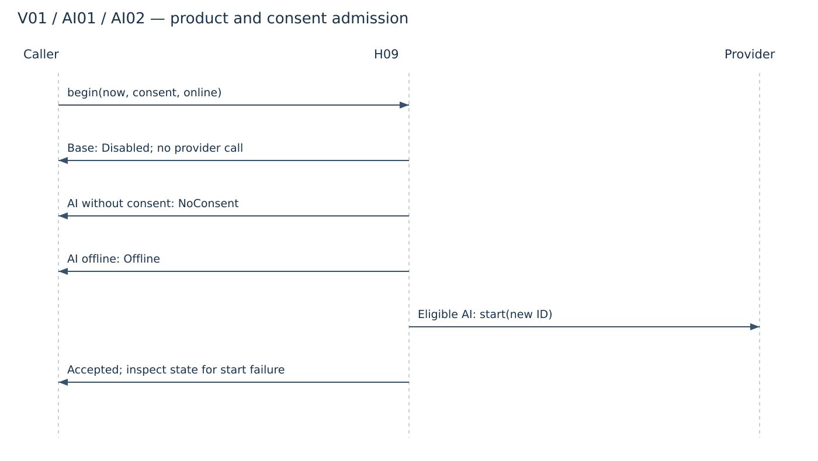
Editable source: diagrams/sequences/uml/AI_admission.puml. Future coordinator/audio/gateway participants are planned.

AI completion
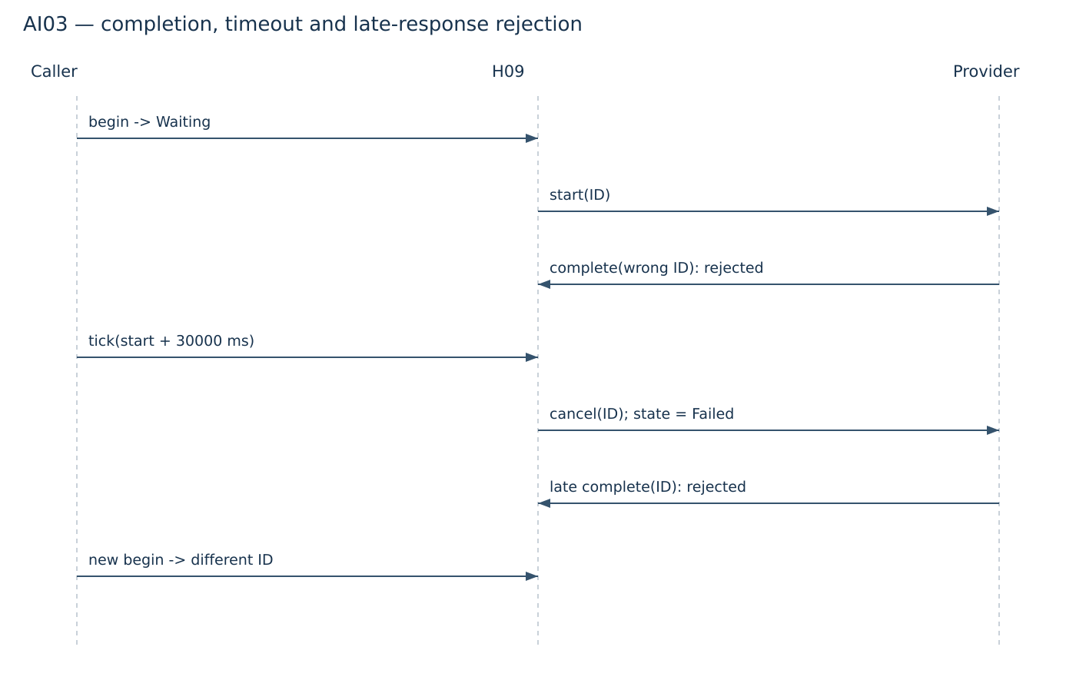
Editable source: diagrams/sequences/uml/AI_completion.puml. Future coordinator/audio/gateway participants are planned.

AI cancel
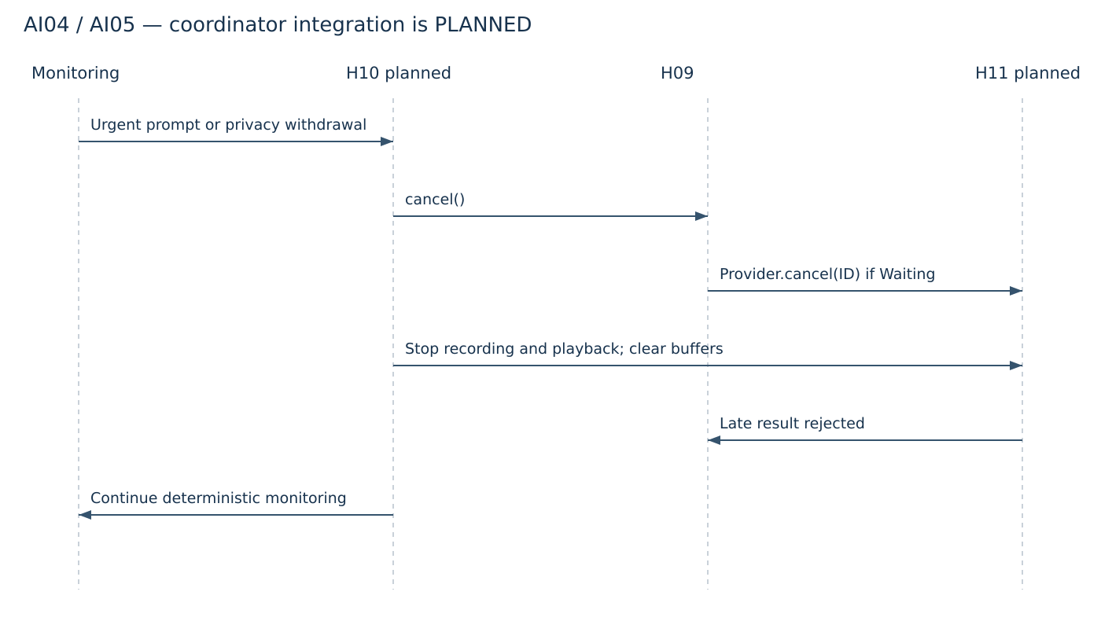
Editable source: diagrams/sequences/uml/AI_cancel.puml. Future coordinator/audio/gateway participants are planned.

AI gateway
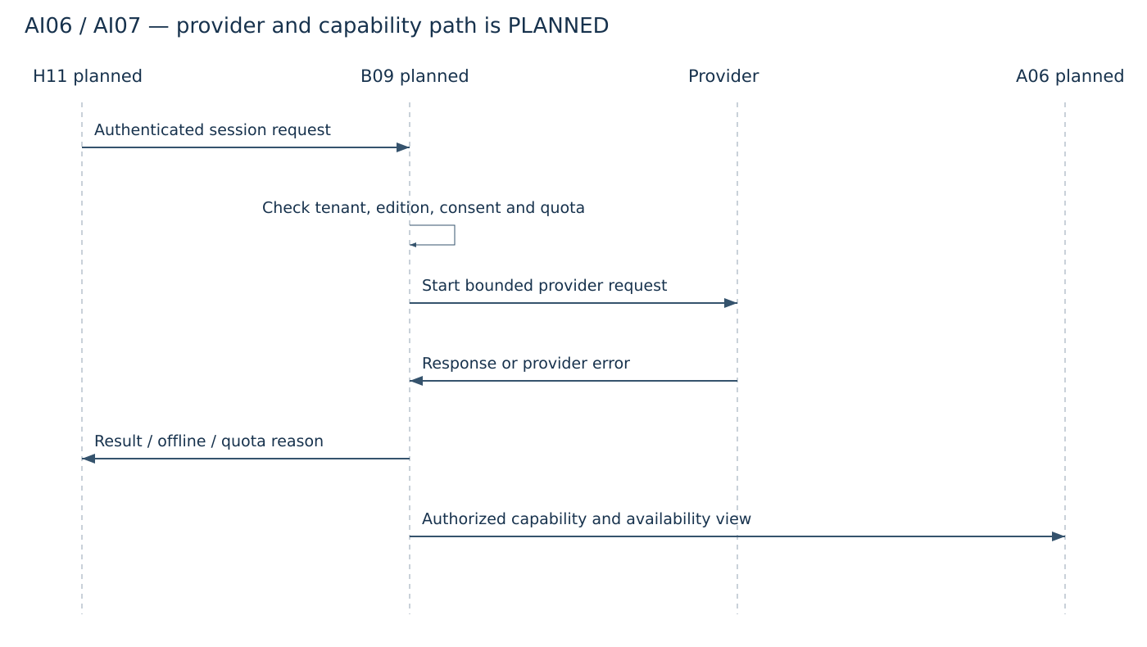
Editable source: diagrams/sequences/uml/AI_gateway.puml. Future coordinator/audio/gateway participants are planned.

AI logs
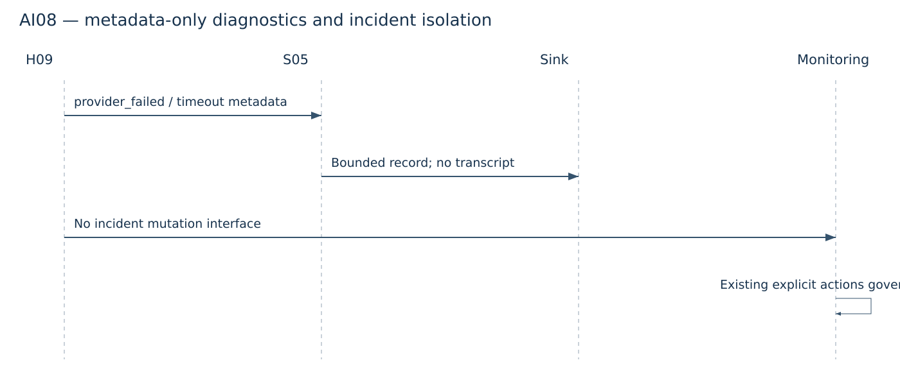
Editable source: diagrams/sequences/uml/AI_logs.puml. Future coordinator/audio/gateway participants are planned.

Revision and implementation status
Edition 2.0 expands the supplied baseline and carries forward the version 1.4 AI session design. Code 1.4.2 changes comments and version metadata only. Base P0 remains the development priority. Existing tests cover components; no complete hardware or unattended field acceptance is claimed. Read progress.txt and the workbook for current gaps.

