ENGINEERING REFERENCE GUIDE
Ghar Sajag System Architecture and Module UML
Interfaces, dependencies, state ownership and functionality diagrams for the 32-module P0 baseline
Design inventory | Coverage
Architecture baseline | Requirements/Software Design v1.2 + Hardware-Independent LLD v1.0
Module coverage | 32 of 32 logical modules
Architecture figures | 1 whole-system component view + 32 module functionality/dependency views
Status convention | Green host behavior; blue pending target/provider binding; amber partial/caution
Boundary: host logic and design are documented; ESP32, RF, flash, cloud-provider and installed-home evidence remain separate P0 gates.

Edition 2 reading guide
This edition is written for an engineer joining the project now or returning after a year. It expands the uploaded baseline with reasons, concrete household examples, execution order, failure cases and implementation boundaries. The original detailed chapters, tables and figures are retained. Their target designs are interpreted using the current status notes in this edition.
The immediate product is Ghar Sajag Parivar Saathi with Base P0. P1 is a future development stage or optional add-on decision, not a promised third product. Sarthi AI is a future interaction offering using the shared monitoring core. Base monitoring does not depend on a model, microphone or cloud inference.
Documentation edition 2.0 accompanies reference source 1.4.2. Source 1.4.2 adds requirement comments and version metadata to the 1.4.1 code; it does not implement new monitoring or AI algorithms. The 1.4 AI session controller is retained and explained in the AI design volume.
Term | How to interpret it
Required | An acceptance obligation from the SRD. It can remain unimplemented.
Implemented reference | A host-language component exists; it may use volatile stores or fake adapters.
Verified host checkpoint | The specific assertion ran on the development host. It is not full requirement coverage.
Target integration pending | GPIO, FreeRTOS, radio, flash, server/provider or full UI work still needs implementation and evidence.
Future AI | An extension excluded from the immediate Base P0 build scope.
Read START_HERE.md for the full document order. Use Requirement_Traceability.csv and Code_Traceability.csv to move from a requirement to module, source file and existing test. A comment such as @requirements F05, E02 is a responsibility link, not a claim that those requirements are fully complete.
Source baseline: Ghar_Sajag_System_Architecture_and_Module_UML_v1.0(1).docx. The original upload is also included under reference_baselines. The preservation report records original and revised word/table/figure counts and heading retention. Market prices and supplier availability are historical inputs unless explicitly dated as rechecked; this edition does not refresh market research.

Current decisions that resolve earlier ambiguity
Routine evidence. The current reducer accepts one qualifying activity event or OK in its window. Two-zone/session-duration examples are retained as future hypotheses. They are not implemented P0 qualification rules.
Coverage. Current lease status exists. Full-window coverage history and local prompt/grace orchestration are pending. Missing activity must not be presented as a wellbeing or medical conclusion.
Timing. The reference NodeConfig uses a 60-second heartbeat and HubRuntime a 190-second lease. Older 15-minute heartbeat and 35-minute timeout examples are trial alternatives and must not be mixed with these defaults.
Persistence. DURABLE is the target application-ACK meaning. In-memory test stores model ordering; they do not survive power loss. Production flash/database adapters and compaction remain open.
Modules. Canonical modules are N01–N05, H01–H08, B01–B08, A01–A05, S01–S03 and T01–T03, with S04 product profile, H09 interaction and S05 diagnostics. H10/H11/B09/A06 are planned. Legacy log aliases are not extra deployed modules.
Logs. ERROR hooks remain available in the commercial build profile, but absent/failed sinks can lose records. Current host logging is synchronous; it does not catch arbitrary memory corruption or guarantee crash persistence.

Architecture explained for implementation

Why there is one shared core
A requirement such as detecting a missing check-in should behave identically whether or not the product has audio. Put event identity, rule decisions, incident workflow and service health in shared modules. Optional interaction is a client of selected state and a separate request lifecycle. It cannot replace the rule engine or create human acknowledgement.

Where state is authoritative
The node owns unsent sensor evidence. The hub owns local routine/configuration/coverage state and its unsent cloud records. The backend owns household access, incidents, notification jobs and caregiver projections. The app owns presentation and pending user commands. Copying a snapshot does not transfer authority; every mutation returns to its owner.

Commit order across the home
Record a business event at the node before transmission. Admit and commit it at the hub before a durable node ACK. Persist it and its required backend effects before the backend application ACK. Retries reuse the same key. Every failure between two commits must have a defined replay action. This gives idempotent effects under at-least-once transport; it does not guarantee exactly-once network delivery.

Task boundary on the hub
The proposed hub_event_task owns routine, coverage and configuration mutations. Radio and timer callbacks enqueue bounded messages. A cloud worker owns blocking network work and exchanges immutable snapshots/commands with the state owner. UI sampling may happen in a separate task but applies semantic actions through the same owner. Queue overflow is a visible service fault, not a reason to invent resident evidence.

Storage concurrency
The earlier FreeRTOS sketch lets the state task write the journal and a cloud task read it. A concrete binding must serialize those accesses or copy a committed outbox snapshot through the owner. A deque reference is not a safe shared cross-task view. ACK commands also return to the journal owner so reclamation cannot race a read.

Scaling beyond a pilot
Start with a backend modular monolith and one database, preserving B01–B08 boundaries in code. Scale stateless API replicas and leased delivery workers when measured load warrants it. Keep household_id in keys, queries and authorisation checks. Use database unique constraints and outbox transactions for concurrent idempotency; in-memory dictionaries are not a multi-replica design.

Backpressure and resource sizing
Capacity limits must include payload lengths, evidence IDs, retry queues, diagnostic records and result batches. A container with a maximum item count can still exceed RAM if each item owns unbounded strings. Measure high-water marks under duplicate storms, long outages and replay. Determine release budgets from the actual C3/DevKit board and firmware build rather than host sizeof alone.

Hardware independent development
Host tests can verify parsing policies, reducers, ownership outcomes, retries and fake provider errors. They cannot measure RF range, deep-sleep current, flash wear, brownout, GPIO polarity or actual notification delivery. Keep each hardware/network port injectable so the same domain behaviour can be exercised with a fake first and a measured adapter later.

Design decision record
Keep a short record whenever a behaviour changes: requirement ID, previous rule, new rule, reason, affected modules, compatibility impact and acceptance evidence. Record decisions on schedule change timing, grace-window OK handling, coverage history and duplicate evidence before implementation. Do not silently resolve these by changing a dashboard label.
Boundary | Participants | Data and completion meaning
I01 | N02/N05 → H01/H02 | Versioned event with source/session/sequence; application ACK after hub commitment. Encrypted ESP-NOW target adapter pending.
I02 | H08 → B03/B06 | Replay, application commit ACK and versioned configuration through authenticated remote transport.
I03 | A05 → B01/B07 | Authenticated query or idempotent command; response includes version/freshness and a reason on rejection.
I04 | GPIO/UI → H06/H05 | Resident semantic actions and fixed feedback; physical debounce and accessibility binding pending.
I05 | H09 → Provider | Nonblocking start(id)/cancel(id); completion returned on controller owner. Fake-provider reference only.
I06 | H05/H06 → H10/H11 | Planned priority cancellation and microphone/playback stop; never wait for a model to finish monitoring.

Proposed FreeRTOS starting configuration
Context | Initial sketch | Ownership and validation
Radio callback | No business task work | Validate/copy a bounded frame; enqueue; return. Callback latency must be measured.
hub_event_task | Priority 8; 8 KiB stack | Own state, commit and decisions. Measure stack and scheduling latency under replay.
cloud_sync_task | Priority 5; 8 KiB stack | Own remote transport; request snapshots and enqueue ACK/config commands to state owner.
ui_task | Priority 6; 5 KiB stack | Sample/debounce controls and render immutable feedback snapshots.
maintenance_task | Priority 3; 8 KiB stack | Controlled maintenance/update work; avoid competing flash writers.
Future AI worker | Not sized | Separate audio/provider I/O, bounded buffers and cancellation. No priority or stack promise before measurement.
These are inherited initial estimates, not verified ESP-IDF settings. ESP-IDF projects and actual task creation are not included in the portable reference release. Define static queue sizes, message ownership and persistence acknowledgements before mapping these responsibilities onto tasks.

Retained detailed baseline with edition 2 explanations
The chapters below retain the uploaded detail. New explanatory paragraphs are placed at the relevant requirement/module headings. Historical implementation counts and future-state diagrams must be read with the current boundaries and open-work register above.

How to read this volume
This volume is the architecture and per-module visual companion to the existing HLD and LLD. Each module sheet shows its public surface, owned state, functional flow, failure guard and direct logical collaborators.
A dependency arrow means that a module exchanges a versioned contract or calls an injected port. It does not automatically mean that both modules execute in one process. The interface catalog below identifies physical, local-runtime and cloud boundaries.
Visual state | Meaning
Green | HLD/LLD and host-executable responsibility exist and pass the included host checks
Amber | A scaffold, policy seam or operational example exists but its target evidence is incomplete
Blue / dashed | ESP32, RF, flash, network, identity, notification, phone or OTA provider binding remains pending
Red | Reserved for a failed/blocked gate; none is claimed by this design pack

Whole-system component architecture
HOST DESIGN BASELINE COMPLETE | TARGET INTEGRATIONS PENDING
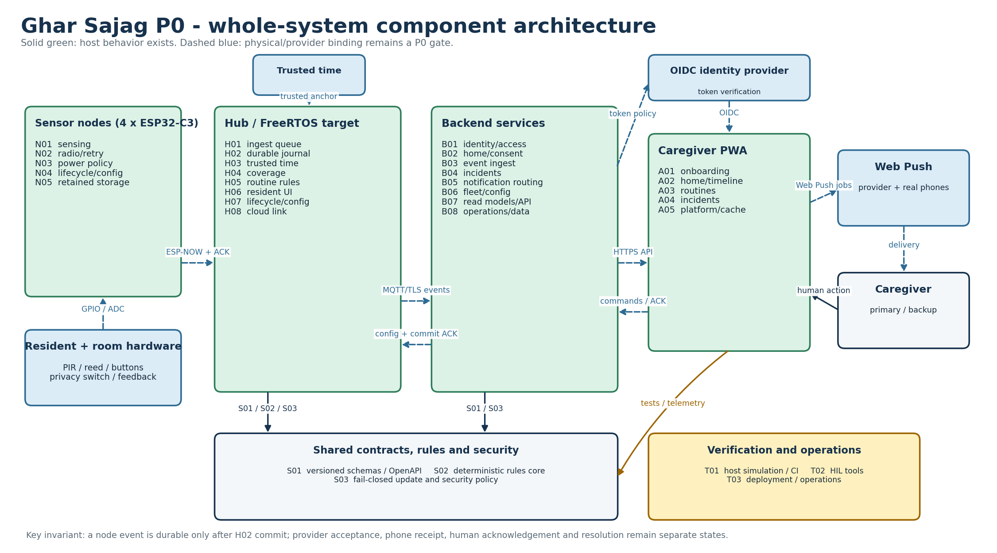
Figure A-1. P0 runtime layers, external actors, principal interfaces and persistence boundaries.
The node-to-hub and hub-to-cloud links preserve stable event identity. H02 durability precedes node retirement; the backend separately tracks provider acceptance, human acknowledgement and incident resolution.
Editable source: plantuml/architecture/whole_system_architecture.puml

Interface catalog
The catalog is normative for dependency direction and acceptance testing. Status describes the current baseline, not commercial readiness.
ID | Source | Target | Mode | Contract | Reliability rule | Current state
I01 | Sensor hardware | N01 / H06 | GPIO / ADC / local debounce | Qualified input transition or explicit resident action | Warm-up, debounce, retrigger and physical-input tests | Target binding pending
I02 | N02 node radio | H01 hub ingest | ESP-NOW; fixed versioned frame | S01 node event v1 + VOLATILE/DURABLE/DISCARDED_POLICY ACK | Persist before send; duplicate-safe; bounded retry | Host semantics complete; RF pending
I03 | H01 / H06 / timers | Hub state-core | Bounded FreeRTOS queues and serialized commands | Fixed-value ingress/UI/deadline/config command | One domain-state owner; callback never blocks or writes flash | Design complete; binding pending
I04 | H02 hub journal | H08 cloud link | Local append-only outbox | Committed event record with original event time | Retire only on backend application-commit ACK | Host complete; flash pending
I05 | H08 hub cloud link | B03 backend ingest | Wi-Fi + MQTT/TLS | S01 CloudEvent v1; home/device topic ACL | Reconnect/backoff, idempotent ingest, application ACK | Adapter seam complete; provider pending
I06 | A01-A05 caregiver PWA | B01-B08 backend | HTTPS/JSON using OpenAPI; optional SSE | OIDC bearer + idempotency key + versioned response | Server authoritative; stale cache shown explicitly | Domain complete; production integration pending
I07 | B05 notification routing | Caregiver phone | Web Push | Notification job and separate delivery/human-ACK states | Primary then bounded backup route; no delivery assumption | Policy complete; provider/phone pending
I08 | B06 fleet/config | H07 / N04 lifecycle | HTTPS then MQTT/TLS; local atomic apply | Versioned HomeConfig / NodeConfig | Reject stale/conflicting version; desired != applied | Version semantics complete; binding pending
I09 | B06 + S03 update policy | Hub/node bootloader | Signed HTTPS OTA with recovery slot | Board-bound version/hash/signature manifest | Fail closed; rollback prevention; recover prior image | Policy seam partial; production crypto pending

Module dependency index
Full exact collaborator lists are retained here even when a dense test/shared module groups dependencies visually on its figure.
Module | Responsibility | Provided API | Direct collaborators / ports | Status
N01 | Node sensing | QualifiedInput::sample(raw_level, now_ms); stable_level() | S01, N05, N02 | HOST COMPLETE; TARGET PENDING
N02 | Node radio | enqueue(); next_due(); record_transport_result(); apply_ack() | S01, N05, H01 | HOST COMPLETE; TARGET PENDING
N03 | Node power | PowerPolicy::classify(); PowerPolicy::plan() | N02, N04 | HOST COMPLETE; TARGET PENDING
N04 | Node lifecycle | LifecycleService::apply(); open_service_window(); service_window_open() | S01, S03, H07, B06 | HOST COMPLETE; TARGET PENDING
N05 | Node storage | NodeStore::append(); acknowledge(); oldest() | S01, N02 | HOST COMPLETE; TARGET PENDING
H01 | Hub ingest | PeerRegistry::authorize/accepts; IngestQueue::callback_copy/pop | S01, H02, H04, N02 | HOST COMPLETE; TARGET PENDING
H02 | Hub persistence | HubJournal::commit(); pending_cloud(); acknowledge_cloud(); contains() | S01, H04, H05, H08 | HOST COMPLETE; TARGET PENDING
H03 | Hub time | TrustedClock::anchor(); estimate(); valid_for_absence() | S01, H05, H07 | HOST COMPLETE; TARGET PENDING
H04 | Hub coverage | require_node(); observe(); set_sensor_fault(); current(); reasons() | H01, H02, H05, B08 | HOST COMPLETE; TARGET PENDING
H05 | Hub rules adapter | start_window(); set_coverage(); apply(); deadline() | S02, H02, H03, H04, H06, B04 | HOST COMPLETE; TARGET PENDING
H06 | Hub resident interface | ResidentUi::make_action(); feedback_for() | S01, H02, H05 | HOST COMPLETE; TARGET PENDING
H07 | Hub lifecycle/config | ConfigService::apply(); active() | S01, S03, H03, H05, N04, B06 | HOST COMPLETE; TARGET PENDING
H08 | Hub cloud link | set_connected(); next_batch(); application_commit_ack(); record_failure() | S01, H02, B03, B08 | HOST COMPLETE; TARGET PENDING
B01 | Identity/access | IdentityService.grant/revoke/require | B02, B06, B07, B08, A01, A05 | HOST COMPLETE; TARGET PENDING
B02 | Home/consent | HomeService.create/set_caregivers/set_mode/withdraw_resident_consent | B01, B06, B08, A01, A03, H07 | HOST COMPLETE; TARGET PENDING
B03 | Event ingestion | IngestService.accept() | S01, B01, B04, B07, B08, H08 | HOST COMPLETE; TARGET PENDING
B04 | Incident workflow | IncidentService.create/claim/acknowledge/resolve | B01, B05, B07, B08, A04, H05 | HOST COMPLETE; TARGET PENDING
B05 | Notification routing | schedule_for_incident(); due(); provider_result(); human_acknowledged(); create_door_notice(); build_daily_summary() | B04, B07, B08, A04, A05 | HOST COMPLETE; TARGET PENDING
B06 | Fleet/config | register_device(); publish_config(); record_applied() | S01, S03, B01, B02, H07, N04, A03 | HOST COMPLETE; TARGET PENDING
B07 | Read models/API | QueryService.snapshot/timeline; JsonApi.dispatch/WSGI | B01, B03, B04, B08, A02, A05 | HOST COMPLETE; TARGET PENDING
B08 | Operations/data | hub_health(); diagnostics(); record_support_action() | B01, B02, B03, B04, B05, B06, B07, A02, T03 | HOST COMPLETE; TARGET PENDING
A01 | App onboarding | validateHouseholdDraft(); buildCreateHomeCommand(); installationGate() | S01, B01, B02, B06 | HOST COMPLETE; TARGET PENDING
A02 | App home | formatFreshness(); buildHomeView(); timelineLabel() | B07, B08, A05 | HOST COMPLETE; TARGET PENDING
A03 | App routines | validateMorningRoutine(); buildDesiredConfig(); configStatus() | S01, B02, B06, H07 | HOST COMPLETE; TARGET PENDING
A04 | App incidents | incidentActions(); actionCommand(); deliveryLabel() | B04, B05, B07, A05 | HOST COMPLETE; TARGET PENDING
A05 | App platform | ApiClient.request(); VersionedCache.put/get(); pushCapability(); classifyFetchFailure() | B01, B07, B08 | HOST COMPLETE; TARGET PENDING
S01 | Shared contracts | Schema v1 fields and OpenAPI operation IDs | N01, N02, N04, N05, H01, H02, H03, H06, H07, H08, B03, B06, A01, A03 | HOST COMPLETE; TARGET PENDING
S02 | Deterministic rules core | RulesCore::event_overlaps_window/apply_event/evaluate_deadline | H05 | HOST COMPLETE; TARGET PENDING
S03 | Firmware security/update | CredentialRegistry::install/revoke/get; UpdatePolicy::validate | N04, H07, B06 | HOST COMPLETE; TARGET PENDING
T01 | Simulation/CI | make verify | N01, N02, N03, N04, N05, H01, H02, H03, H04, H05, H06, H07, H08, B01, B02, B03, B04, B05, B06, B07, B08, A01, A02, A03, A04, A05, S01, S02, S03 | HOST COMPLETE; TARGET PENDING
T02 | Hardware-in-loop tools | build_plan(); InstallationRun.observe/result(); summarize() | T01, N01, N02, N03, N04, N05, H01, H02, H03, H04, H05, H06, H07, H08 | HOST PARTIAL; TARGET PENDING
T03 | Deployment/operations | Container/broker configuration and operator procedures | T01, B03, B05, B08, H08, A05 | HOST PARTIAL; TARGET PENDING

N01 - Node sensing
How this module works. The constructor selects motion or reed semantics. sample is called with a raw level and elapsed milliseconds. Keep GPIO inversion and electrical pull configuration in the adapter. Do not read a PIR high level at boot as a newly observed person. The debounce clock and sensor warm-up are different responsibilities.
Input to output flow. Raw PIR/reed level → optional qualified Motion/DoorOpen/DoorClosed event kind. Initialize without emitting; record raw edge; require stability for debounce interval; enforce retrigger interval; emit only a qualified transition.
State and lifetime. raw/stable level, edge timestamp, debounce and retrigger clocks. Firmware state is owned by one task in the target binding; the host reference must not be assumed thread-safe. Backend reference services share an in-memory store; the production transaction boundary must preserve the same business invariants.
Failure behaviour. Bounce and repeated PIR holds are suppressed. Initial level is state, not an invented event. Queueing and persistence happen outside this module.
Code navigation. Requirements F05, F09. Files: firmware/node/components/sensing/sensing.hpp, sensing.cpp. Public entry points: QualifiedInput::sample(raw_level, now_ms); stable_level().
Verification boundary. tests/cpp/test_main.cpp: initial, bounce and stable-rise checks. Host behavior passes; hardware exit requires voltage, warm-up, hold-time, wake-loop and placement tests. See the current evidence transcript; historical numerical test counts in retained tables belong to their original release.
Enhancement scope. Per-board sensor adapters, supervised wiring and measured false-trigger diagnostics.
HLD COMPLETE | LLD COMPLETE | HOST COMPLETE | TARGET PENDING
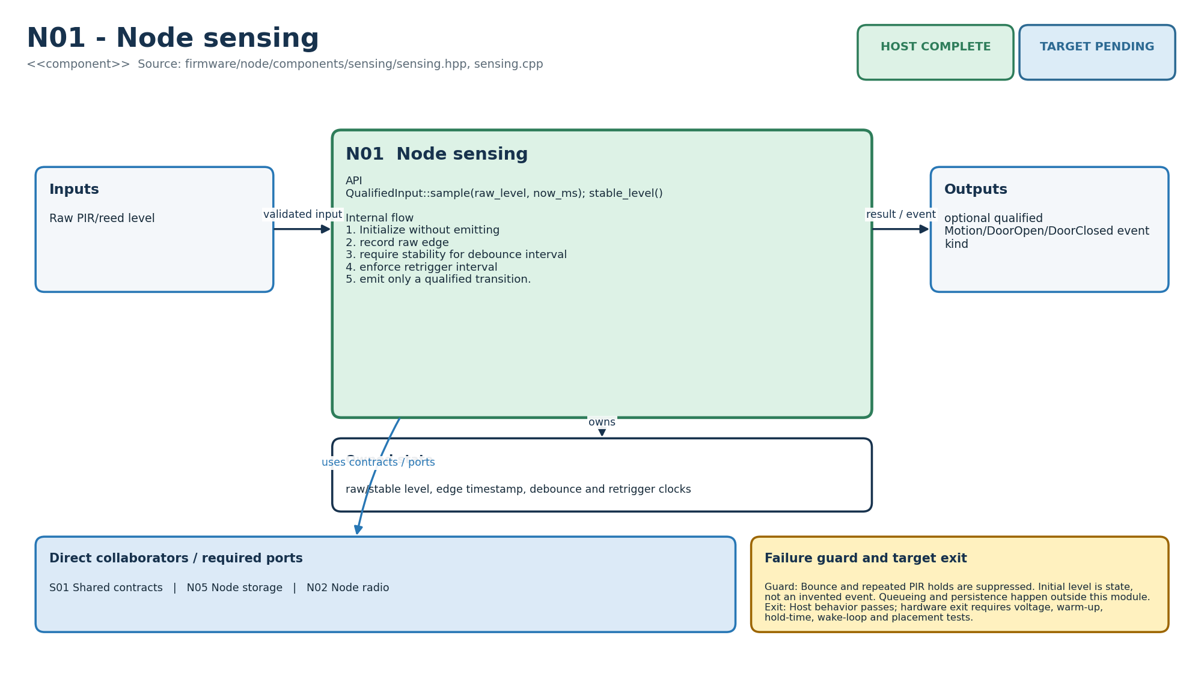
Figure M-01. Functionality, state ownership, I/O boundary and dependencies for N01.
Direct collaborators: S01 Shared contracts, N05 Node storage, N02 Node radio. Target exit: Host behavior passes; hardware exit requires voltage, warm-up, hold-time, wake-loop and placement tests.
Editable source: diagrams/modules/uml/N01.puml

N02 - Node radio
How this module works. The pending transmission queue owns retry timing but does not own physical RF. A caller asks next_due, transmits through an adapter, then reports the transport result. Only an application acknowledgement with the expected event identity may retire retained business data. Call this component from one owner, not directly from concurrent radio callbacks.
Input to output flow. DomainEvent + application ACK → scheduled transmissions / retired entries. Queue once; expose due item; schedule deterministic jittered retry; reject volatile ACK for business events; retire only DURABLE or policy-discard ACK.
State and lifetime. bounded PendingTx deque, attempt count and next-attempt deadline. Firmware state is owned by one task in the target binding; the host reference must not be assumed thread-safe. Backend reference services share an in-memory store; the production transaction boundary must preserve the same business invariants.
Failure behaviour. Full queue returns false. Radio success is not durable success. Backoff is bounded by the scheduled wake policy.
Code navigation. Requirements E01, E02, NFR-04. Files: firmware/node/components/radio/node_radio.hpp, node_radio.cpp. Public entry points: enqueue(); next_due(); record_transport_result(); apply_ack().
Verification boundary. C++ tests cover immediate send, volatile ACK retention and durable retirement. Host retry/ACK semantics pass; ESP-NOW encryption, channel search, callback timing and loss tests remain. See the current evidence transcript; historical numerical test counts in retained tables belong to their original release.
Enhancement scope. ESP-NOW adapter first; BLE/Thread transport may implement the same port later.
HLD COMPLETE | LLD COMPLETE | HOST COMPLETE | TARGET PENDING
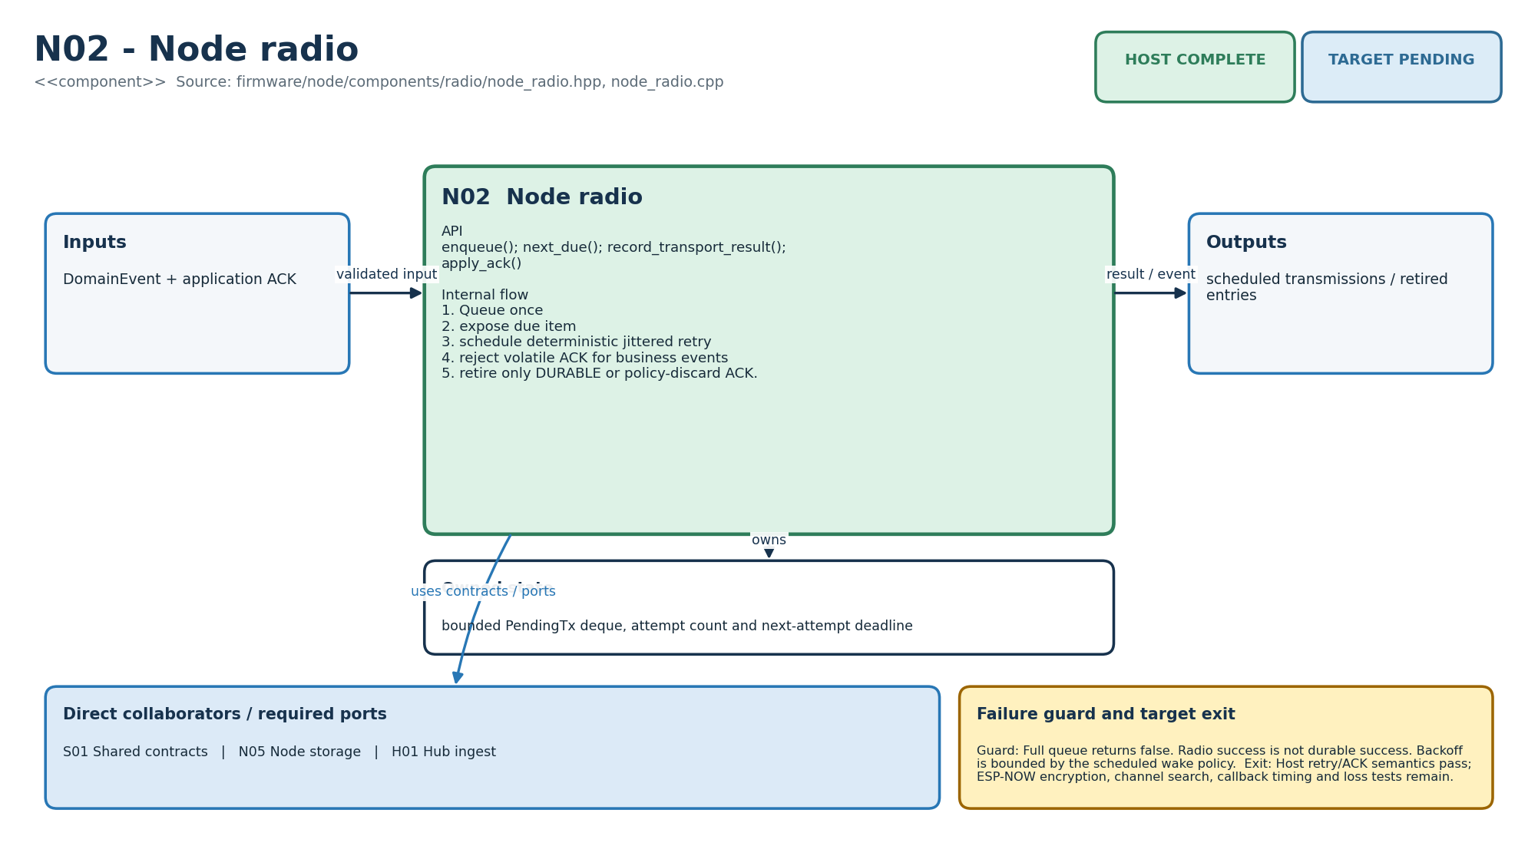
Figure M-02. Functionality, state ownership, I/O boundary and dependencies for N02.
Direct collaborators: S01 Shared contracts, N05 Node storage, H01 Hub ingest. Target exit: Host retry/ACK semantics pass; ESP-NOW encryption, channel search, callback timing and loss tests remain.
Editable source: diagrams/modules/uml/N02.puml

N03 - Node power
How this module works. Battery classification is a policy applied to a calibrated reading, not a fuel gauge. A 3.7 V cell label is nominal voltage, not a regulated MCU supply. Sleep planning must be reconciled with the heartbeat lease and the actual board current; a sleep duration is not a battery-life promise.
Input to output flow. Calibrated millivolts + pending work + NodeConfig → BatteryReading and SleepPlan. Never convert an uncalibrated voltage to percentage; classify voltage band; shorten wake for retry; lengthen it at critical voltage; enable only configured wake sources.
State and lifetime. No mutable ownership; thresholds are explicit policy inputs/constants. Firmware state is owned by one task in the target binding; the host reference must not be assumed thread-safe. Backend reference services share an in-memory store; the production transaction boundary must preserve the same business invariants.
Failure behaviour. Unknown calibration stays UNKNOWN. Software thresholds do not replace cell protection or charger qualification.
Code navigation. Requirements E01, NFR-05. Files: firmware/node/components/power/power.hpp, power.cpp. Public entry points: PowerPolicy::classify(); PowerPolicy::plan().
Verification boundary. C++ tests verify low/unknown bands and retry wake plan. Logic passes; ADC calibration, divider leakage, charge status and full current profile require hardware. See the current evidence transcript; historical numerical test counts in retained tables belong to their original release.
Enhancement scope. Fuel-gauge adapter, ageing model and observed runtime forecast.
HLD COMPLETE | LLD COMPLETE | HOST COMPLETE | TARGET PENDING
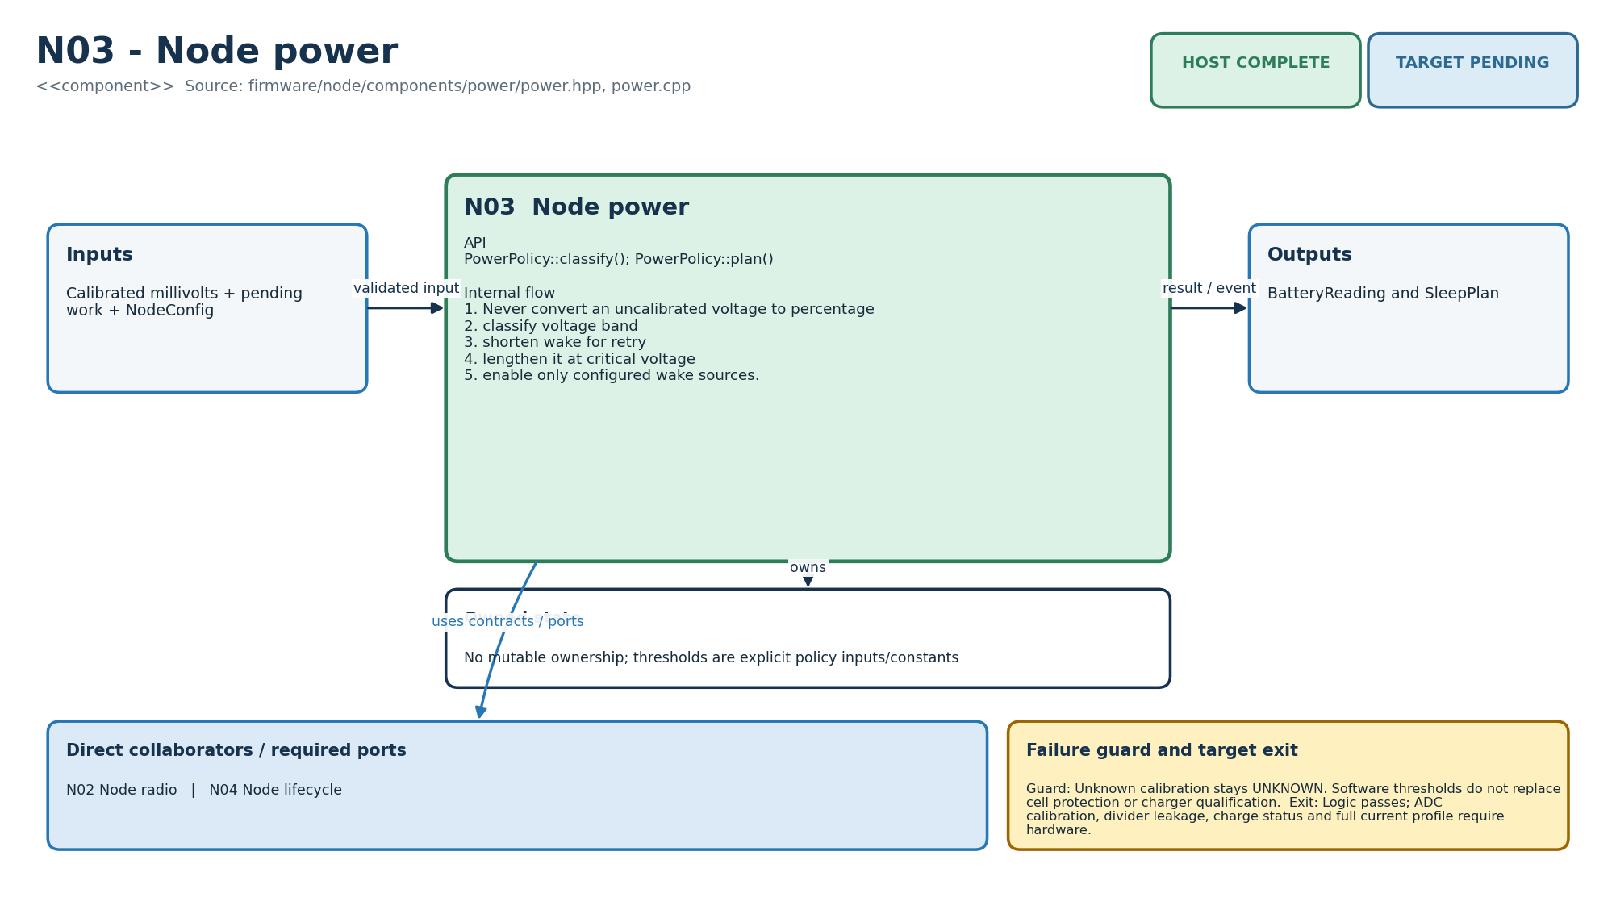
Figure M-03. Functionality, state ownership, I/O boundary and dependencies for N03.
Direct collaborators: N02 Node radio, N04 Node lifecycle. Target exit: Logic passes; ADC calibration, divider leakage, charge status and full current profile require hardware.
Editable source: diagrams/modules/uml/N03.puml

N04 - Node lifecycle
How this module works. Apply receives a complete proposed configuration and returns a reason rather than partially mutating fields. The service-window timer represents a limited maintenance opportunity. Neither a timer nor a node ID authenticates a provisioning party; the transport and credential adapter must supply that trust.
Input to output flow. Versioned NodeConfig / physical action → atomic applied config or reason. Validate identity, location, enabled capability and heartbeat range; reject same/older version; replace active snapshot atomically.
State and lifetime. active NodeConfig and physical-service-window deadline. Firmware state is owned by one task in the target binding; the host reference must not be assumed thread-safe. Backend reference services share an in-memory store; the production transaction boundary must preserve the same business invariants.
Failure behaviour. No open radio enrollment. Invalid config leaves prior version intact. Service access expires by monotonic deadline.
Code navigation. Requirements F03, E07, E09. Files: firmware/node/components/lifecycle/lifecycle.hpp, lifecycle.cpp. Public entry points: LifecycleService::apply(); open_service_window(); service_window_open().
Verification boundary. C++ tests cover invalid capability, valid apply, rollback and 120-second window. Host state transition passes; NVS atomicity, USB jig and authenticated boot registration remain. See the current evidence transcript; historical numerical test counts in retained tables belong to their original release.
Enhancement scope. Signed delta configuration and controlled node firmware orchestration.
HLD COMPLETE | LLD COMPLETE | HOST COMPLETE | TARGET PENDING
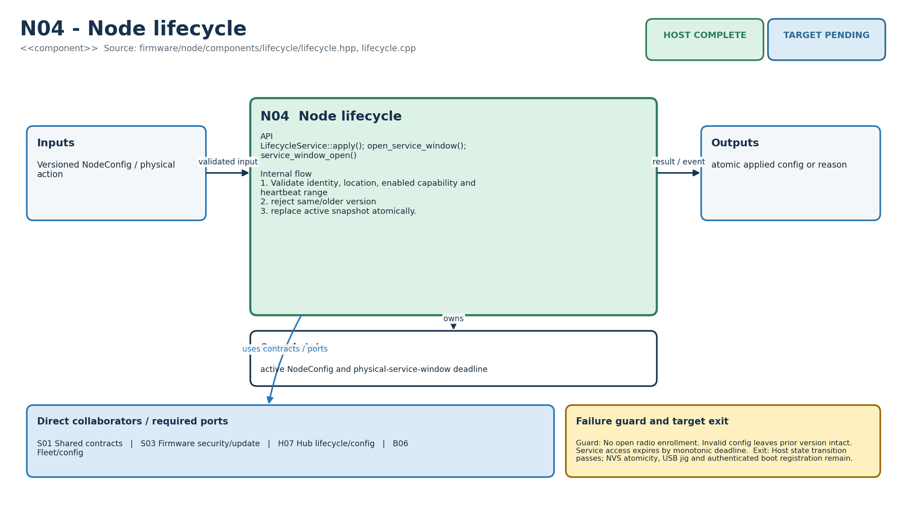
Figure M-04. Functionality, state ownership, I/O boundary and dependencies for N04.
Direct collaborators: S01 Shared contracts, S03 Firmware security/update, H07 Hub lifecycle/config, B06 Fleet/config. Target exit: Host state transition passes; NVS atomicity, USB jig and authenticated boot registration remain.
Editable source: diagrams/modules/uml/N04.puml

N05 - Node storage
How this module works. Business events are retained while ordinary heartbeats need not be journalled in the same way. A full store raises a gap requirement. In the current composition a stored event can remain after transmit enqueue fails; do not retry by recording a fresh event, because that changes identity. Add a replay/refill path.
Input to output flow. Business DomainEvent + ACK → retained/released event or overflow signal. Ignore periodic heartbeat for flash journal; deduplicate; append before transmit; retire on DURABLE or DISCARDED_POLICY; signal capacity loss.
State and lifetime. bounded business-event deque and explicit gap-marker flag. Firmware state is owned by one task in the target binding; the host reference must not be assumed thread-safe. Backend reference services share an in-memory store; the production transaction boundary must preserve the same business invariants.
Failure behaviour. Full store does not silently drop; gap_marker_required becomes true. Volatile ACK cannot delete business evidence.
Code navigation. Requirements E02, E05, NFR-03. Files: firmware/node/components/storage/node_store.hpp, node_store.cpp. Public entry points: NodeStore::append(); acknowledge(); oldest().
Verification boundary. C++ tests cover persist-before-send and ACK class behavior; NodeRuntime composition tested. Host semantics pass; CRC/commit-marker flash ring and interrupted-write recovery require board partitions. See the current evidence transcript; historical numerical test counts in retained tables belong to their original release.
Enhancement scope. Wear-aware compaction and measured retention sizing.
HLD COMPLETE | LLD COMPLETE | HOST COMPLETE | TARGET PENDING
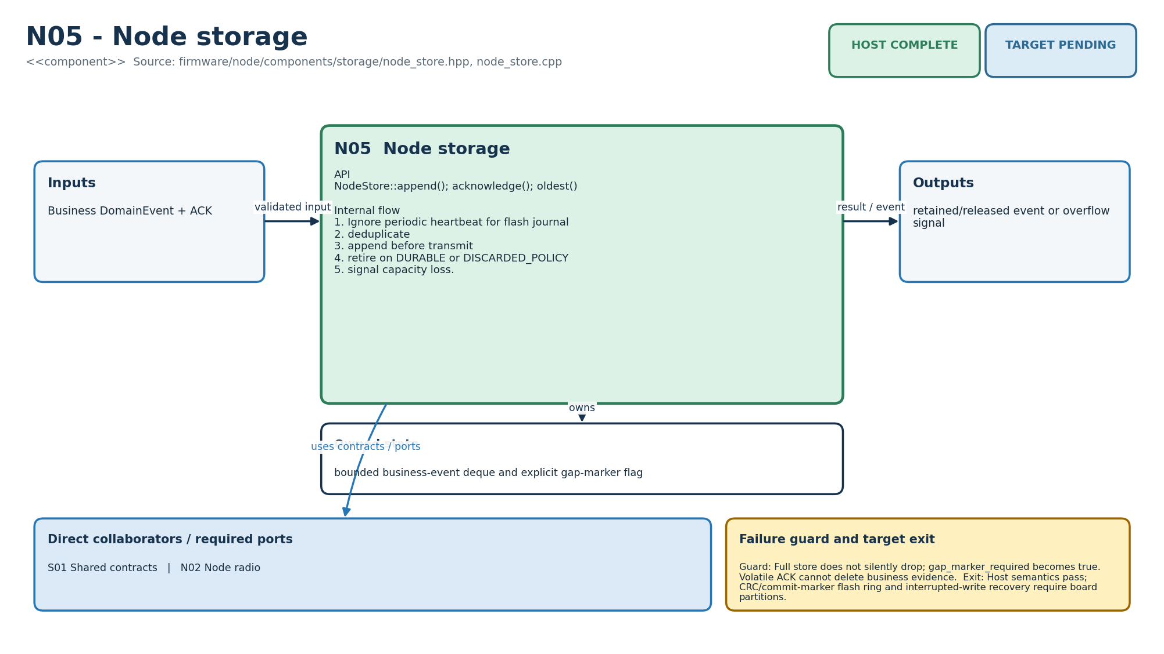
Figure M-05. Functionality, state ownership, I/O boundary and dependencies for N05.
Direct collaborators: S01 Shared contracts, N02 Node radio. Target exit: Host semantics pass; CRC/commit-marker flash ring and interrupted-write recovery require board partitions.
Editable source: diagrams/modules/uml/N05.puml

H01 - Hub ingest
How this module works. The callback boundary should validate and copy bounded values, then return quickly. The reference uses STL values and a deque, so it models the ownership rule rather than proving an allocation-free interrupt path. The physical frame parser must validate length, version, authentication and numeric ranges before constructing a DomainEvent.
Input to output flow. Radio callback DomainEvent → admitted fixed-value mailbox entry. Authenticate source/session and sequence; copy into bounded queue; return immediately; state task later pops and processes.
State and lifetime. authorized source→session map, bounded ingress deque and rejection count. Firmware state is owned by one task in the target binding; the host reference must not be assumed thread-safe. Backend reference services share an in-memory store; the production transaction boundary must preserve the same business invariants.
Failure behaviour. Unknown session or full queue rejects and increments observable count. Callback never writes flash or runs rules.
Code navigation. Requirements F05, E02, NFR-04. Files: firmware/hub/components/ingest/ingest.hpp, ingest.cpp. Public entry points: PeerRegistry::authorize/accepts; IngestQueue::callback_copy/pop.
Verification boundary. C++ tests cover known/unknown peer and callback-to-worker copy. Host admission passes; frame authentication, payload bounds and ISR/callback latency remain on ESP-IDF. See the current evidence transcript; historical numerical test counts in retained tables belong to their original release.
Enhancement scope. Per-peer rate caps and captured RF diagnostics.
HLD COMPLETE | LLD COMPLETE | HOST COMPLETE | TARGET PENDING
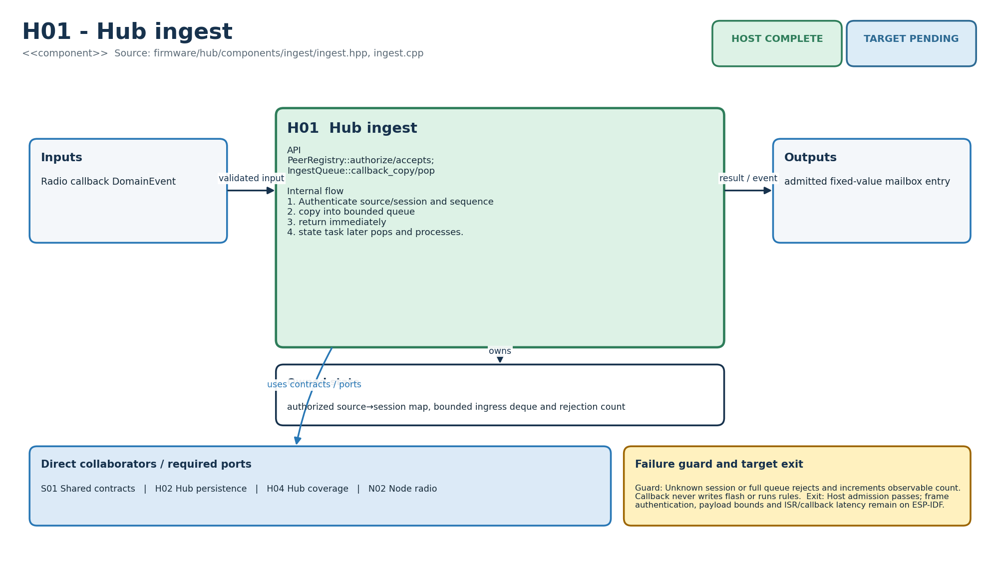
Figure M-06. Functionality, state ownership, I/O boundary and dependencies for H01.
Direct collaborators: S01 Shared contracts, H02 Hub persistence, H04 Hub coverage, N02 Node radio. Target exit: Host admission passes; frame authentication, payload bounds and ISR/callback latency remain on ESP-IDF.
Editable source: diagrams/modules/uml/H01.puml

H02 - Hub persistence
How this module works. A commit result has three meanings: Stored adds a new record, Duplicate refers to an already known key, and Full refuses new evidence. The name journal describes intended semantics; the current deque is volatile. Cloud acknowledgements mark records but do not currently free capacity.
Input to output flow. DomainEvent → Stored/Duplicate/Full; committed records → cloud outbox batch. Check event key; commit once; expose unacknowledged records; retain until backend application-commit ACK.
State and lifetime. bounded ordered records, event-ID set and application-ACK set. Firmware state is owned by one task in the target binding; the host reference must not be assumed thread-safe. Backend reference services share an in-memory store; the production transaction boundary must preserve the same business invariants.
Failure behaviour. Full returns Full and therefore no DURABLE node ACK. Duplicate returns committed equivalence. MQTT PUBACK is intentionally absent from retirement API.
Code navigation. Requirements F05, F06, F07, E02, E03, E05, E10, NFR-03, NFR-05. Files: firmware/hub/components/storage/journal.hpp, journal.cpp. Public entry points: HubJournal::commit(); pending_cloud(); acknowledge_cloud(); contains().
Verification boundary. C++ tests cover store, duplicate, pending outbox and application ACK. Host invariants pass; append-only flash record, CRC, checkpoint, wear and 100-cycle crash test remain. See the current evidence transcript; historical numerical test counts in retained tables belong to their original release.
Enhancement scope. Priority partitions and compaction tuned to measured event volume.
HLD COMPLETE | LLD COMPLETE | HOST COMPLETE | TARGET PENDING
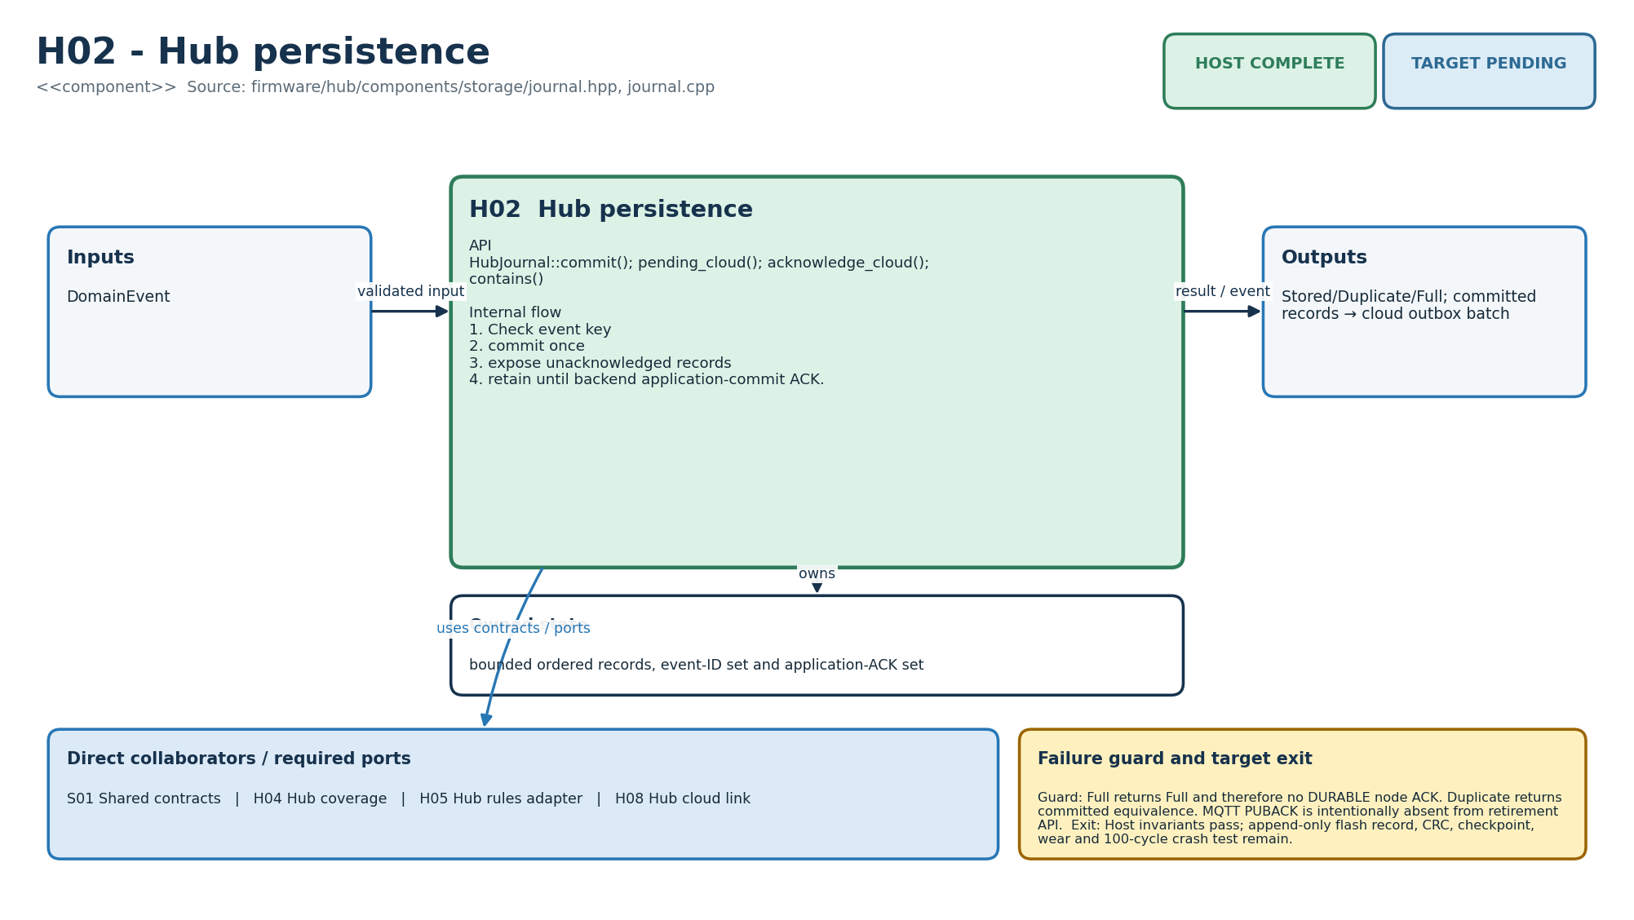
Figure M-07. Functionality, state ownership, I/O boundary and dependencies for H02.
Direct collaborators: S01 Shared contracts, H04 Hub coverage, H05 Hub rules adapter, H08 Hub cloud link. Target exit: Host invariants pass; append-only flash record, CRC, checkpoint, wear and 100-cycle crash test remain.
Editable source: diagrams/modules/uml/H02.puml

H03 - Hub time
How this module works. Use estimate only with a monotonic value from the same continuity epoch as the anchor. A wall-time correction is not a reason to jump a monotonic timeout. An expired or missing anchor prevents absence inference until trusted time is restored; the reference is not itself a network time client.
Input to output flow. Authenticated time anchor + monotonic now → earliest/latest wall-time estimate and trust. Advance from monotonic elapsed time; expand uncertainty by conservative drift; expire anchor after 72 hours; gate absence evaluation by trust and uncertainty.
State and lifetime. trusted server anchor, monotonic anchor and uncertainty. Firmware state is owned by one task in the target binding; the host reference must not be assumed thread-safe. Backend reference services share an in-memory store; the production transaction boundary must preserve the same business invariants.
Failure behaviour. No anchor, monotonic rollback or expired anchor produces untrusted/expired state. Manual buttons remain valid elsewhere.
Code navigation. Requirements F04, F08, E03, E06. Files: firmware/hub/components/time/clock.hpp, clock.cpp. Public entry points: TrustedClock::anchor(); estimate(); valid_for_absence().
Verification boundary. C++ tests verify unanchored suppression and trusted bounded estimate. Host math passes; authenticated exchange, reboot lower-bound and optional RTC behavior remain. See the current evidence transcript; historical numerical test counts in retained tables belong to their original release.
Enhancement scope. Board-measured oscillator drift and generated DST boundary fixtures.
HLD COMPLETE | LLD COMPLETE | HOST COMPLETE | TARGET PENDING
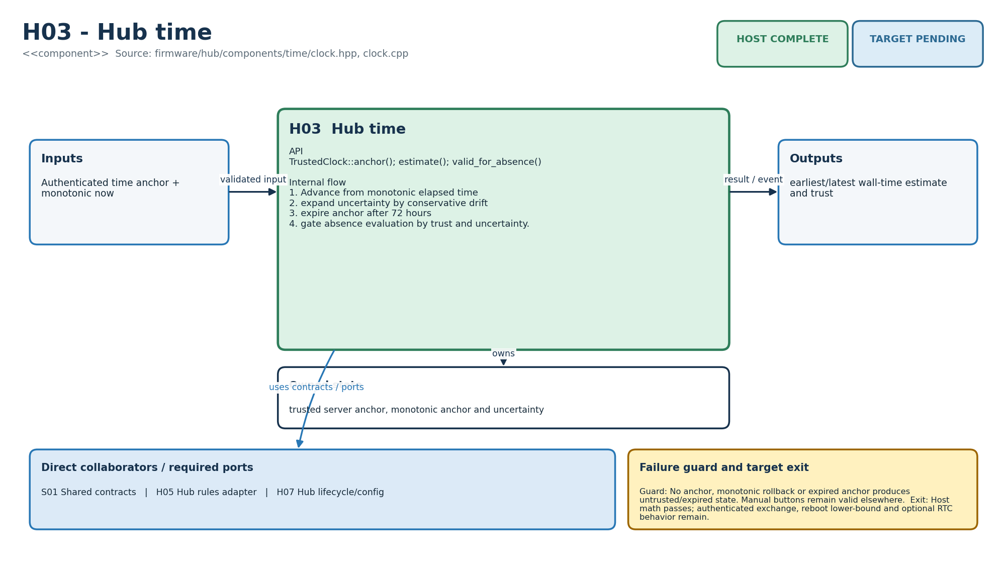
Figure M-08. Functionality, state ownership, I/O boundary and dependencies for H03.
Direct collaborators: S01 Shared contracts, H05 Hub rules adapter, H07 Hub lifecycle/config. Target exit: Host math passes; authenticated exchange, reboot lower-bound and optional RTC behavior remain.
Editable source: diagrams/modules/uml/H03.puml

H04 - Hub coverage
How this module works. CoverageTracker owns contact and fault state for required nodes. Optional nodes should not invalidate unrelated routines. Its current/reasons methods describe the present moment; they do not reconstruct whether the entire morning was observable. Store interval history before making that stronger claim.
Input to output flow. Heartbeat/business contact + lease clock → Covered/Unknown/Fault and reason list. Require only configured routine sources; refresh contact; report unknown for unseen/expired source; report fault separately from activity.
State and lifetime. required-node set and per-node last contact, battery and fault. Firmware state is owned by one task in the target binding; the host reference must not be assumed thread-safe. Backend reference services share an in-memory store; the production transaction boundary must preserve the same business invariants.
Failure behaviour. Current recovery never erases the historical gap. A heartbeat cannot clear an explicit sensor fault.
Code navigation. Requirements F08, E01, E03. Files: firmware/hub/components/coverage/coverage.hpp, coverage.cpp. Public entry points: require_node(); observe(); set_sensor_fault(); current(); reasons().
Verification boundary. C++ tests cover never-seen, fresh and 190-second expired lease. Current-state host logic passes; interval reconstruction and physical sensor-path drills remain. See the current evidence transcript; historical numerical test counts in retained tables belong to their original release.
Enhancement scope. Coverage intervals, mounting-drift checks and source-specific eligibility.
HLD COMPLETE | LLD COMPLETE | HOST COMPLETE | TARGET PENDING
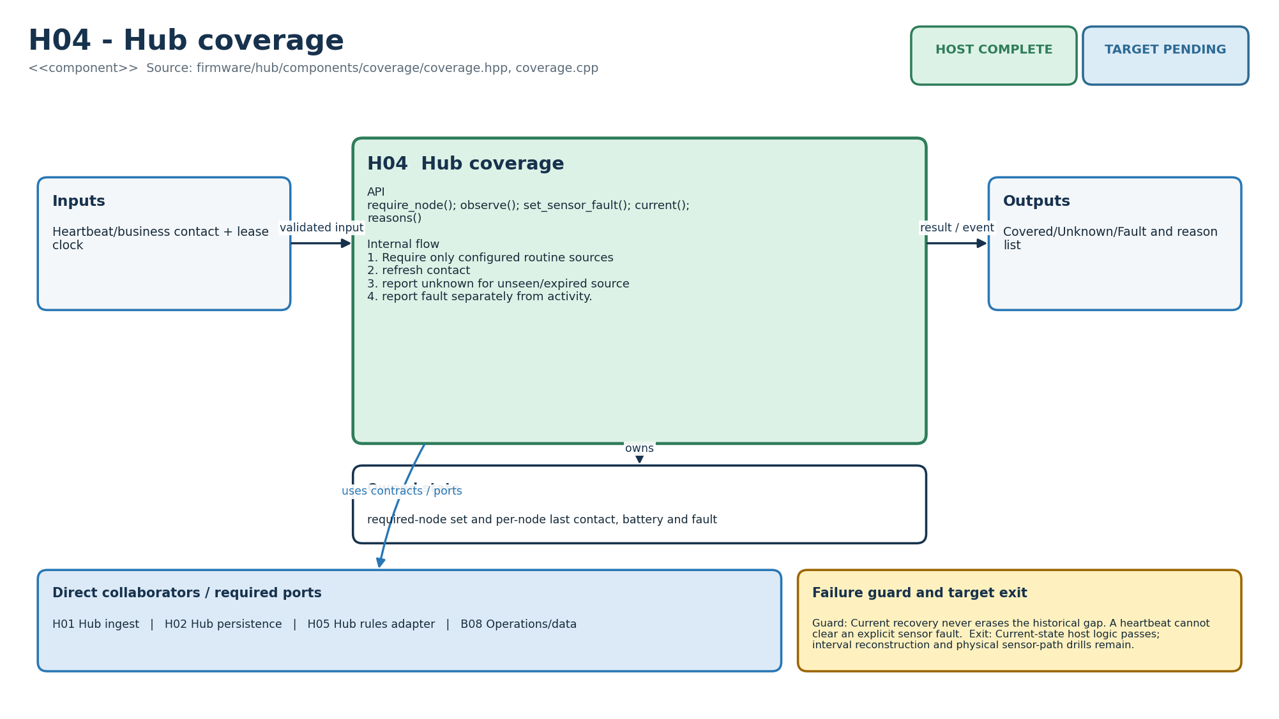
Figure M-09. Functionality, state ownership, I/O boundary and dependencies for H04.
Direct collaborators: H01 Hub ingest, H02 Hub persistence, H05 Hub rules adapter, B08 Operations/data. Target exit: Current-state host logic passes; interval reconstruction and physical sensor-path drills remain.
Editable source: diagrams/modules/uml/H04.puml

H05 - Hub rules adapter
How this module works. RoutineService is the stateful shell around the pure RulesCore. start_window replaces configuration and resets the caller-owned routine state. It is the natural owner for future persisted window checkpoints, but the current code has no autonomous timer, calendar scheduler or prompt/grace coordinator.
Input to output flow. Committed event / deadline / coverage → evidence state or stable incident decision. Reset on stable window ID; apply pure S02 reducer; at grace deadline require trusted time, HOME mode and Covered state; create once if no evidence.
State and lifetime. one RoutineConfig and RoutineState owned by the hub state task. Firmware state is owned by one task in the target binding; the host reference must not be assumed thread-safe. Backend reference services share an in-memory store; the production transaction boundary must preserve the same business invariants.
Failure behaviour. Unknown coverage, privacy/away/pause, test data or untrusted time suppresses missing-activity creation with a reason.
Code navigation. Requirements F04, F05, F06, F07, F08, F09, F10, E03, E06, AI05, NFR-01. Files: firmware/hub/components/rules/routine_service.hpp, routine_service.cpp. Public entry points: start_window(); set_coverage(); apply(); deadline().
Verification boundary. C++ tests cover evidence, missing, duplicate deadline, coverage unknown and privacy. Rule paths pass; full scenario replay and long-running device timer/reboot tests remain. See the current evidence transcript; historical numerical test counts in retained tables belong to their original release.
Enhancement scope. Additional deterministic routines without opaque risk scores.
HLD COMPLETE | LLD COMPLETE | HOST COMPLETE | TARGET PENDING
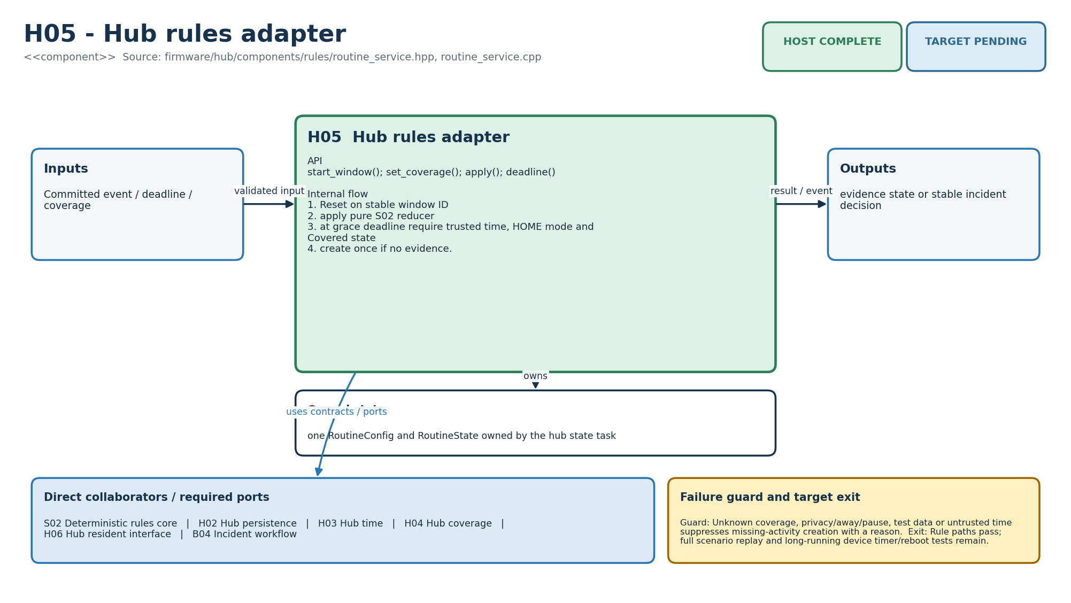
Figure M-10. Functionality, state ownership, I/O boundary and dependencies for H05.
Direct collaborators: S02 Deterministic rules core, H02 Hub persistence, H03 Hub time, H04 Hub coverage, H06 Hub resident interface, B04 Incident workflow. Target exit: Rule paths pass; full scenario replay and long-running device timer/reboot tests remain.
Editable source: diagrams/modules/uml/H05.puml

H06 - Hub resident interface
How this module works. ResidentUi creates semantic events and feedback values. The physical input adapter must separately debounce, distinguish buttons and enforce accessibility. feedback_for receives remote availability from the caller; that boolean is not proof that a notification was delivered to a person.
Input to output flow. OK/Call/Privacy action → durable DomainEvent and local feedback code/text. Map physically distinct controls to explicit event kinds; state whether action was saved locally or accepted remotely; use fixed prompt flag only.
State and lifetime. Stateless command builder; physical debounce belongs to GPIO adapter. Firmware state is owned by one task in the target binding; the host reference must not be assumed thread-safe. Backend reference services share an in-memory store; the production transaction boundary must preserve the same business invariants.
Failure behaviour. No microphone or generated speech. Offline Call family remains stored and explicitly says internet unavailable.
Code navigation. Requirements F02, F06, F07, F10, E03, AI05, NFR-02, NFR-10. Files: firmware/hub/components/ui/resident_ui.hpp, resident_ui.cpp. Public entry points: ResidentUi::make_action(); feedback_for().
Verification boundary. C++ tests verify Call family event and offline wording. Host event/feedback contract passes; buttons, latching switch, OLED/LED, audio load and resident usability remain. See the current evidence transcript; historical numerical test counts in retained tables belong to their original release.
Enhancement scope. Localized fixed prompts and accessibility options after testing.
HLD COMPLETE | LLD COMPLETE | HOST COMPLETE | TARGET PENDING
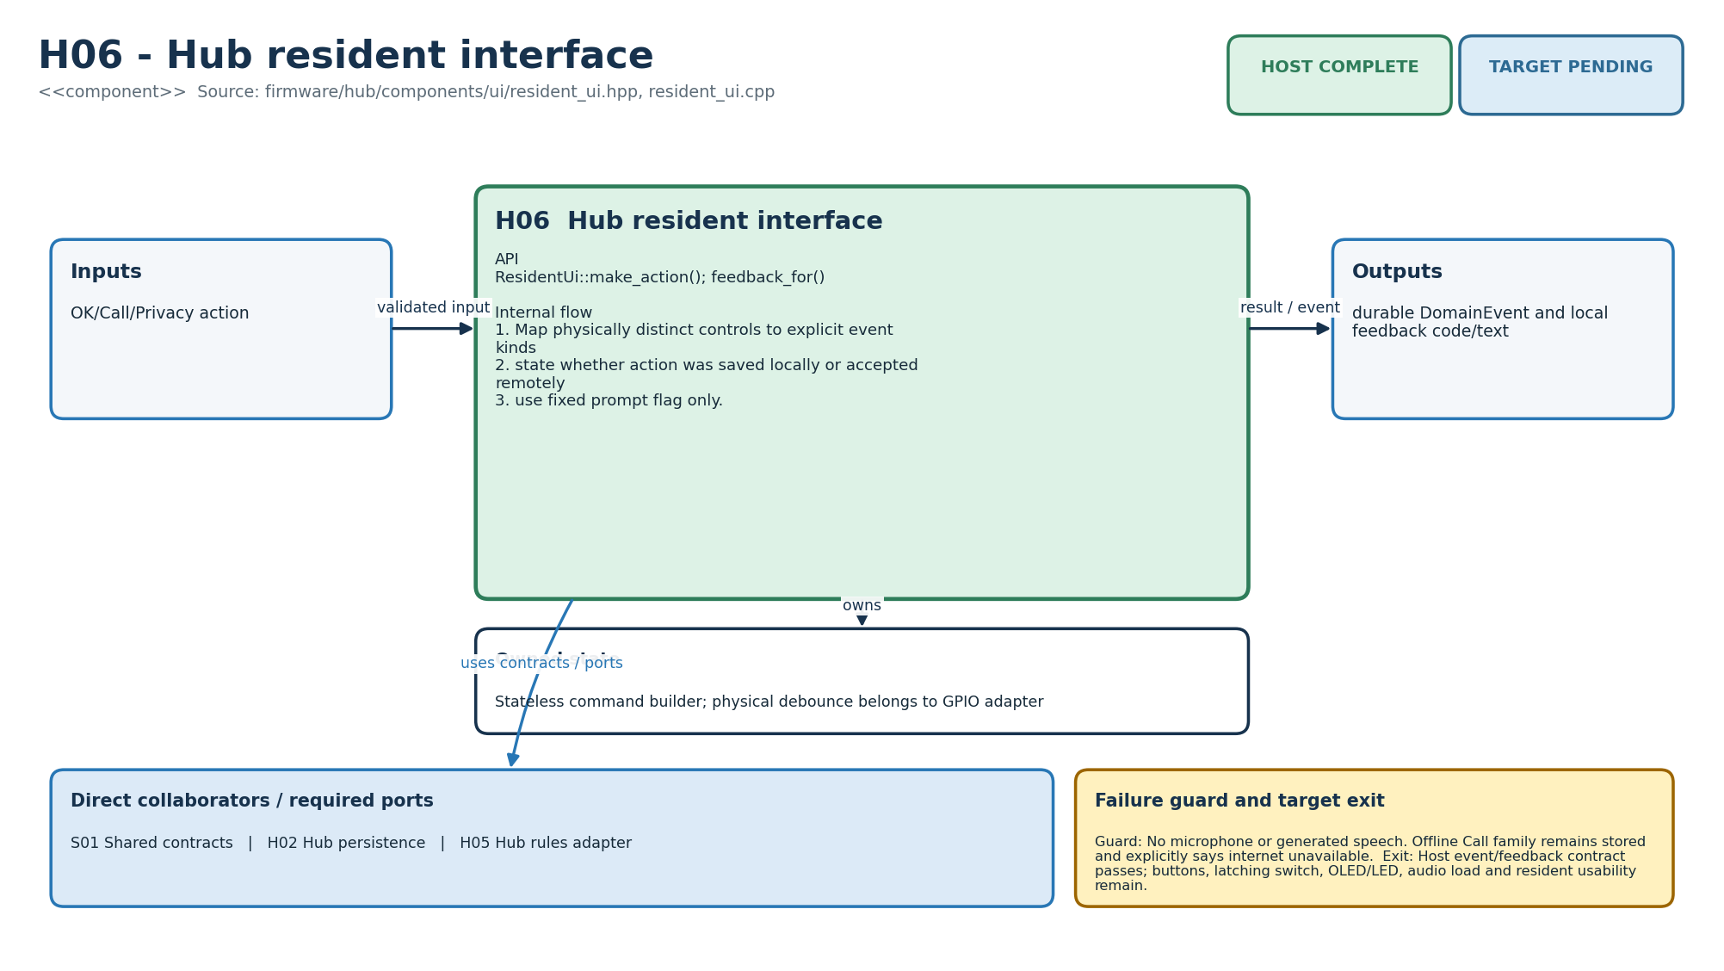
Figure M-11. Functionality, state ownership, I/O boundary and dependencies for H06.
Direct collaborators: S01 Shared contracts, H02 Hub persistence, H05 Hub rules adapter. Target exit: Host event/feedback contract passes; buttons, latching switch, OLED/LED, audio load and resident usability remain.
Editable source: diagrams/modules/uml/H06.puml

H07 - Hub lifecycle/config
How this module works. ConfigService maintains the active hub snapshot and rejects stale versions and invalid ordering. Production persistence must replace the whole snapshot atomically and retain the prior valid one after interruption. Report both desired and applied versions to avoid hiding an offline hub.
Input to output flow. Desired HomeConfig → applied version or rejection reason. Validate home/timezone and ordered window boundaries; reject same/older version; replace atomically; expose applied version.
State and lifetime. active immutable HomeConfig snapshot and applied version. Firmware state is owned by one task in the target binding; the host reference must not be assumed thread-safe. Backend reference services share an in-memory store; the production transaction boundary must preserve the same business invariants.
Failure behaviour. Invalid version never partially mutates active rules. Device update orchestration is separated by S03 policy.
Code navigation. Requirements F02, F03, F04, F10, E06, E07, E09, NFR-07. Files: firmware/hub/components/lifecycle/config_service.hpp, config_service.cpp. Public entry points: ConfigService::apply(); active().
Verification boundary. C++ tests cover valid apply and stale-version rejection. Host atomic snapshot passes; NVS transaction, reboot restore, provisioning and OTA binding remain. See the current evidence transcript; historical numerical test counts in retained tables belong to their original release.
Enhancement scope. Staged rollout, rollback health window and fleet cohort controls.
HLD COMPLETE | LLD COMPLETE | HOST COMPLETE | TARGET PENDING
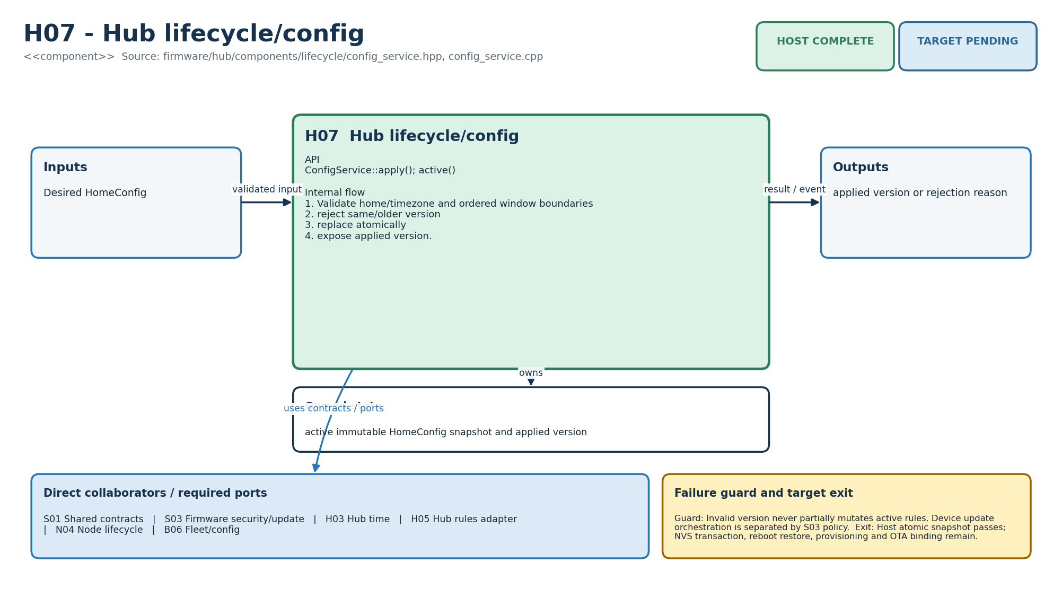
Figure M-12. Functionality, state ownership, I/O boundary and dependencies for H07.
Direct collaborators: S01 Shared contracts, S03 Firmware security/update, H03 Hub time, H05 Hub rules adapter, N04 Node lifecycle, B06 Fleet/config. Target exit: Host atomic snapshot passes; NVS transaction, reboot restore, provisioning and OTA binding remain.
Editable source: diagrams/modules/uml/H07.puml

H08 - Hub cloud link
How this module works. CloudSync asks the journal for outstanding events, orders important events and applies backoff. Transport-level PUBACK does not call application_commit_ack. The backend acknowledgement must mean its transaction has committed the event and its required effects.
Input to output flow. Committed outbox + connection/ACK → prioritized batch and retirement. Send only when connected/due; prioritize Call family over history; use bounded reconnect schedule; retire on backend commit ACK.
State and lifetime. connection flag, failure count and retry-after deadline; journal owns payload. Firmware state is owned by one task in the target binding; the host reference must not be assumed thread-safe. Backend reference services share an in-memory store; the production transaction boundary must preserve the same business invariants.
Failure behaviour. Disconnect/backoff preserves outbox. Transport ACK cannot call application_commit_ack. Original event time is unchanged.
Code navigation. Requirements F12, E02, E03, E04, E07, E10, NFR-03. Files: firmware/hub/components/cloud/cloud_sync.hpp, cloud_sync.cpp. Public entry points: set_connected(); next_batch(); application_commit_ack(); record_failure().
Verification boundary. C++ tests cover urgent ordering and application-level retirement; simulator replays one offline record. Host scheduling passes; Wi-Fi/TLS/MQTT, ACL, broker failure and 72-hour field replay remain. See the current evidence transcript; historical numerical test counts in retained tables belong to their original release.
Enhancement scope. Cellular adapter only after cost and operational design.
HLD COMPLETE | LLD COMPLETE | HOST COMPLETE | TARGET PENDING
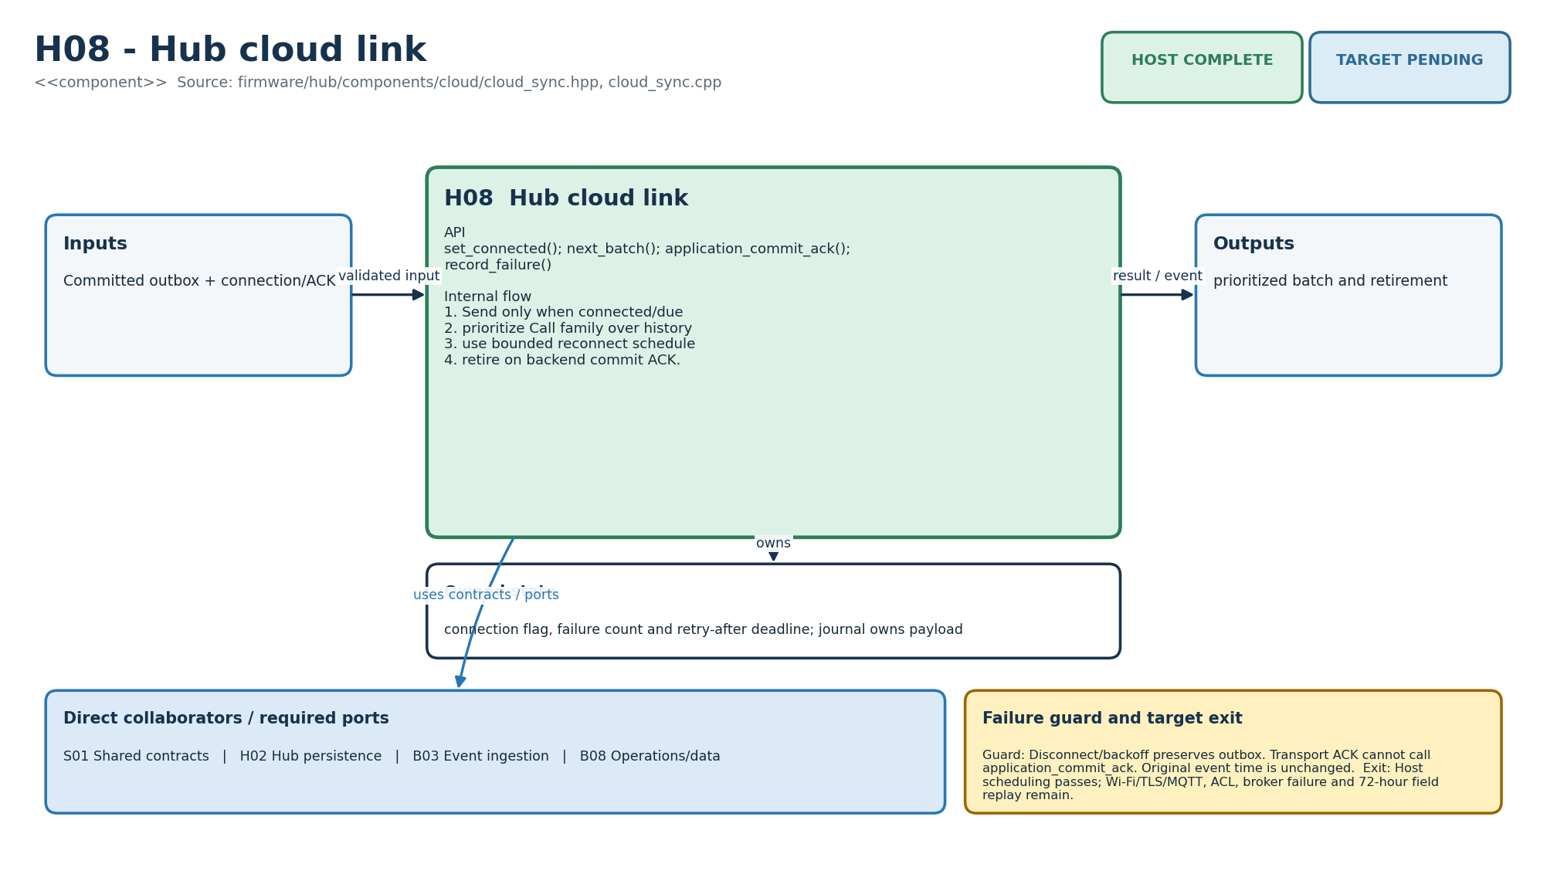
Figure M-13. Functionality, state ownership, I/O boundary and dependencies for H08.
Direct collaborators: S01 Shared contracts, H02 Hub persistence, B03 Event ingestion, B08 Operations/data. Target exit: Host scheduling passes; Wi-Fi/TLS/MQTT, ACL, broker failure and 72-hour field replay remain.
Editable source: diagrams/modules/uml/H08.puml

B01 - Identity/access
How this module works. IdentityService checks a household membership and its permission/expiry rules. It does not perform OIDC token validation. The API adapter must turn an authenticated principal into actor_id, and mutating methods need stricter permissions than an unrestricted read role.
Input to output flow. Verified actor claim + home + permission → membership or AuthorizationError. Resolve exact home-scoped membership; distinguish manage/read role sets; enforce expiry; audit grant/revoke.
State and lifetime. Membership rows keyed by (home_id, actor_id), active flag and expiry. Firmware state is owned by one task in the target binding; the host reference must not be assumed thread-safe. Backend reference services share an in-memory store; the production transaction boundary must preserve the same business invariants.
Failure behaviour. No global caregiver access and no serial-number authorization. Cross-home lookup fails closed.
Code navigation. Requirements F01, E08, AI07, NFR-06. Files: backend/ghar_sajag/identity.py. Public entry points: IdentityService.grant/revoke/require.
Verification boundary. test_B01_F01_membership_is_tenant_scoped. Domain policy passes; production OIDC verification, token audience/issuer and database row-level controls remain. See the current evidence transcript; historical numerical test counts in retained tables belong to their original release.
Enhancement scope. Delegated care teams and support impersonation with explicit approval/audit.
HLD COMPLETE | LLD COMPLETE | HOST COMPLETE | TARGET PENDING
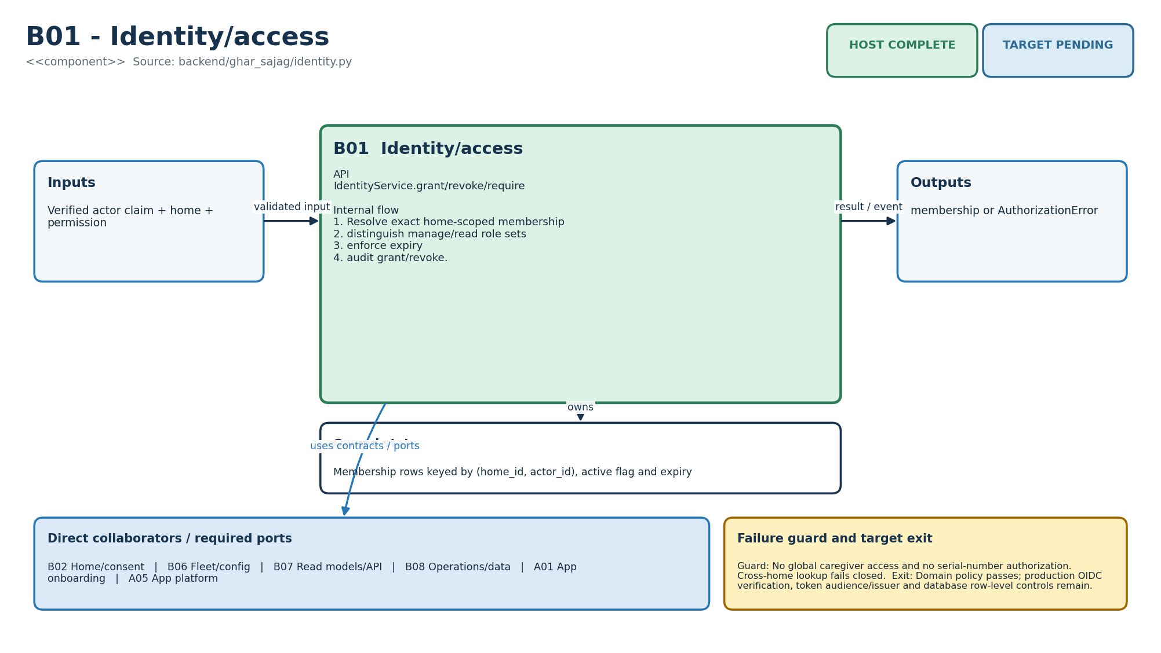
Figure M-14. Functionality, state ownership, I/O boundary and dependencies for B01.
Direct collaborators: B02 Home/consent, B06 Fleet/config, B07 Read models/API, B08 Operations/data, A01 App onboarding, A05 App platform. Target exit: Domain policy passes; production OIDC verification, token audience/issuer and database row-level controls remain.
Editable source: diagrams/modules/uml/B01.puml

B02 - Home/consent
How this module works. HomeService creates household state and records consent/mode changes in an in-memory store. A production transaction must make household, memberships and audit records consistent. Consent withdrawal must also reach devices and retention workers; changing one dictionary is not the full privacy flow.
Input to output flow. Owner commands → validated home/configuration changes and audit. Require valid timezone/name and active resident consent; create owner membership; require distinct primary/backup; privacy on withdrawal.
State and lifetime. Home, resident consents, caregiver route, mode and version. Firmware state is owned by one task in the target binding; the host reference must not be assumed thread-safe. Backend reference services share an in-memory store; the production transaction boundary must preserve the same business invariants.
Failure behaviour. Duplicate home, missing consent or same backup fails. Purchase does not imply consent and PIR never identifies a resident.
Code navigation. Requirements F01, F02, F10, E08, AI02, AI04, NFR-07. Files: backend/ghar_sajag/homes.py. Public entry points: HomeService.create/set_caregivers/set_mode/withdraw_resident_consent.
Verification boundary. F01 role test and test_B02_consent_withdrawal_enters_privacy. Domain state passes; invitation tokens, durable repository and deletion workflow remain. See the current evidence transcript; historical numerical test counts in retained tables belong to their original release.
Enhancement scope. Multiple residents without passive identity inference.
HLD COMPLETE | LLD COMPLETE | HOST COMPLETE | TARGET PENDING
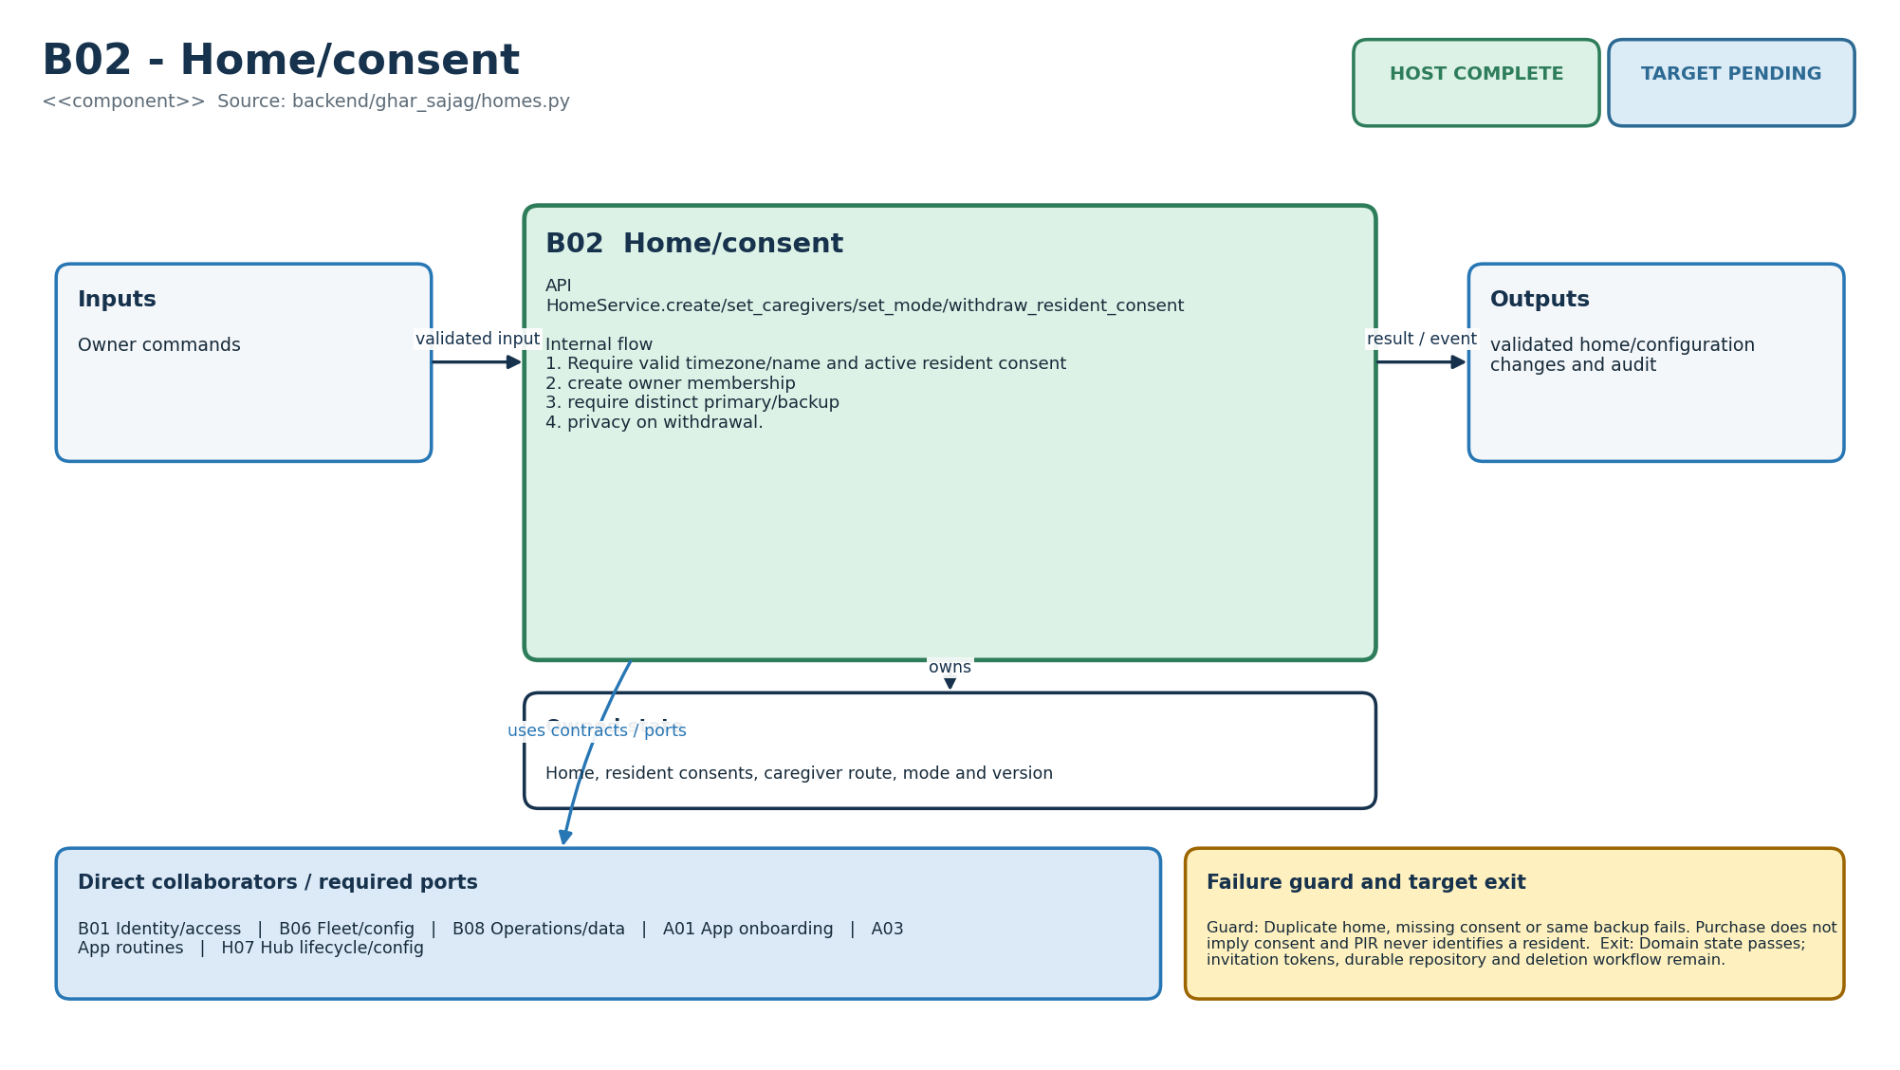
Figure M-15. Functionality, state ownership, I/O boundary and dependencies for B02.
Direct collaborators: B01 Identity/access, B06 Fleet/config, B08 Operations/data, A01 App onboarding, A03 App routines, H07 Hub lifecycle/config. Target exit: Domain state passes; invitation tokens, durable repository and deletion workflow remain.
Editable source: diagrams/modules/uml/B02.puml

B03 - Event ingestion
How this module works. IngestService accepts a cloud event once per home/event key and updates receipt state. A production unique constraint must reproduce this behaviour under concurrent workers. Domain event acceptance must not be acknowledged until required incident/outbox effects are safely committed.
Input to output flow. Validated CloudEvent → (stored event, duplicate flag). Verify known home, event kind and timing fields; use unique event key; append audit in the same host operation.
State and lifetime. CloudEvent dictionary keyed by (home_id, event_id). Firmware state is owned by one task in the target binding; the host reference must not be assumed thread-safe. Backend reference services share an in-memory store; the production transaction boundary must preserve the same business invariants.
Failure behaviour. Unknown home/kind and invalid timing fail. Duplicate returns prior commit without another domain effect.
Code navigation. Requirements E02, E05, NFR-03. Files: backend/ghar_sajag/ingest.py. Public entry points: IngestService.accept().
Verification boundary. test_B03_ingest_is_idempotent. Domain idempotency passes; PostgreSQL transaction/outbox, MQTT consumer and commit ACK adapter remain. See the current evidence transcript; historical numerical test counts in retained tables belong to their original release.
Enhancement scope. Partitioning and batch replay after measured load.
HLD COMPLETE | LLD COMPLETE | HOST COMPLETE | TARGET PENDING
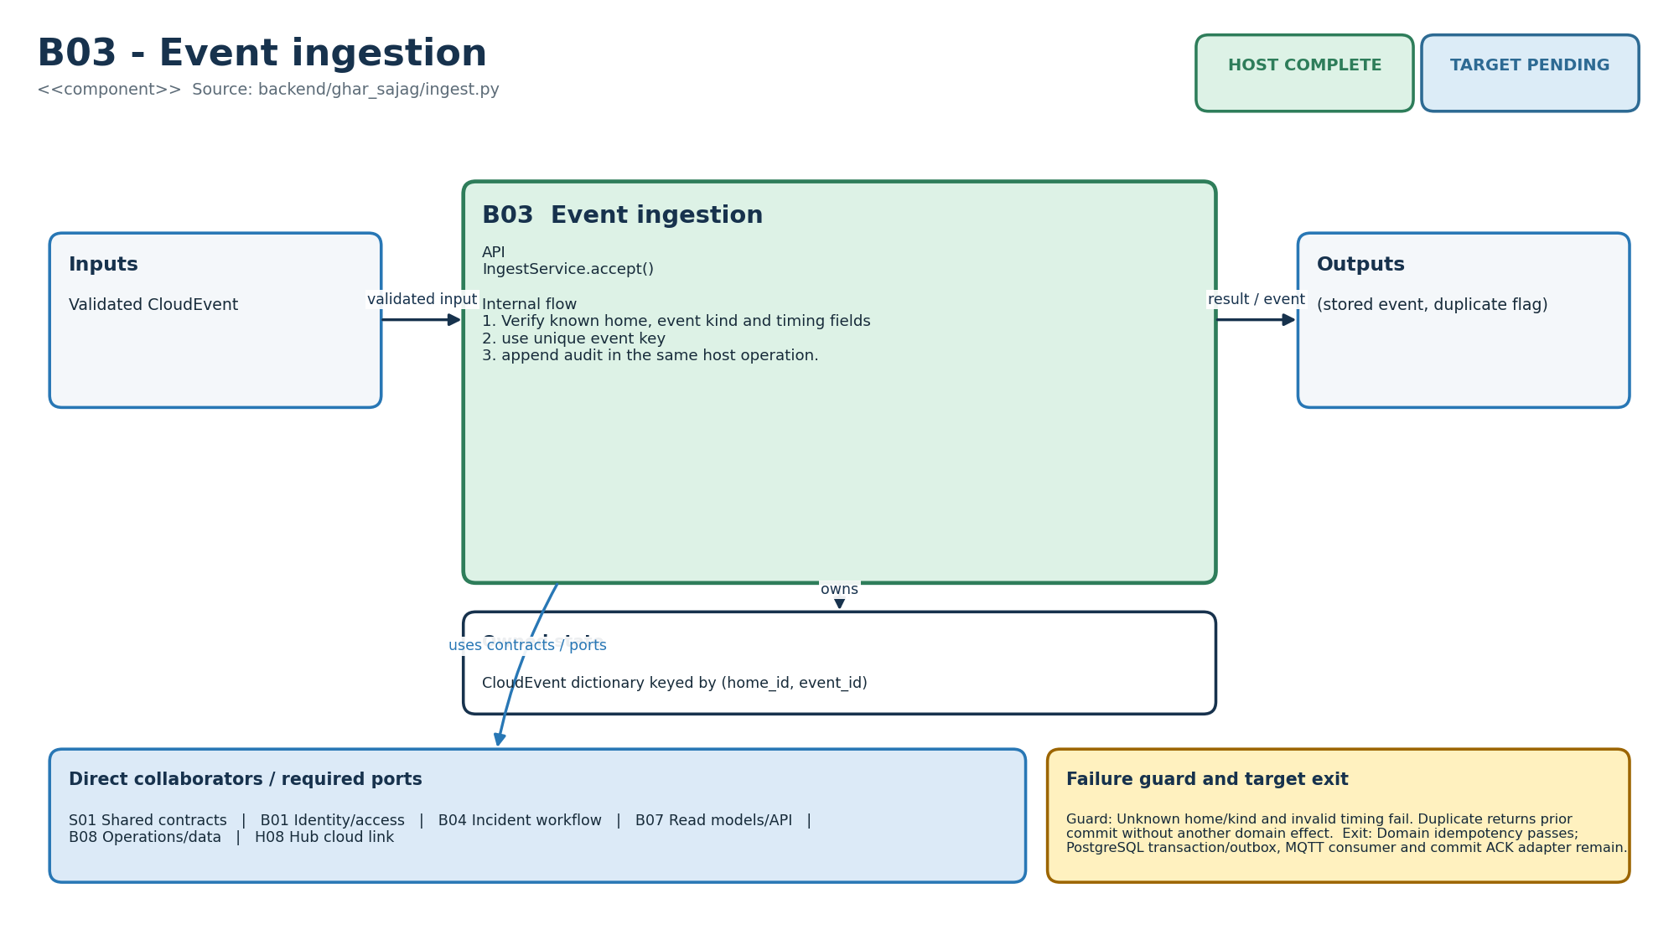
Figure M-16. Functionality, state ownership, I/O boundary and dependencies for B03.
Direct collaborators: S01 Shared contracts, B01 Identity/access, B04 Incident workflow, B07 Read models/API, B08 Operations/data, H08 Hub cloud link. Target exit: Domain idempotency passes; PostgreSQL transaction/outbox, MQTT consumer and commit ACK adapter remain.
Editable source: diagrams/modules/uml/B03.puml

B04 - Incident workflow
How this module works. IncidentService uses a stable business key to avoid duplicate incidents and a lease to coordinate caregivers. A lease expiry allows a deliberate new owner; it does not prove an earlier caregiver stopped acting. Resolve currently calls acknowledge first. Database compare-and-set and explicit mutation roles remain necessary.
Input to output flow. Hub incident intent / caregiver command → idempotent incident transition. Create once by stable key; claim with bounded lease; prevent live dual ownership; acknowledge then explicitly resolve; audit human action.
State and lifetime. Incident plus stable-key index, owner and lease. Firmware state is owned by one task in the target binding; the host reference must not be assumed thread-safe. Backend reference services share an in-memory store; the production transaction boundary must preserve the same business invariants.
Failure behaviour. Closed incidents reject claim; another live owner causes conflict; home mismatch behaves as not found.
Code navigation. Requirements F07, F08, F12, F13, E05. Files: backend/ghar_sajag/incidents.py. Public entry points: IncidentService.create/claim/acknowledge/resolve.
Verification boundary. call idempotency and test_B04_claim_lease_prevents_double_ownership. State machine passes; database compare-and-set, HANDOFF_TO_BACKUP and concurrency load tests remain. See the current evidence transcript; historical numerical test counts in retained tables belong to their original release.
Enhancement scope. Structured Contacted/Unable-to-reach outcome and professional adapter only under contract.
HLD COMPLETE | LLD COMPLETE | HOST COMPLETE | TARGET PENDING
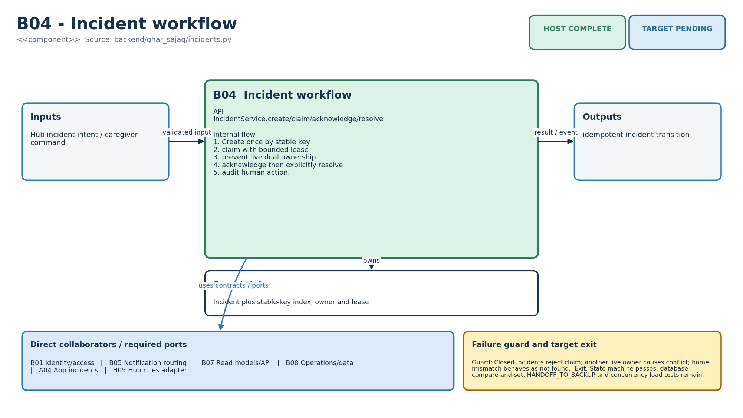
Figure M-17. Functionality, state ownership, I/O boundary and dependencies for B04.
Direct collaborators: B01 Identity/access, B05 Notification routing, B07 Read models/API, B08 Operations/data, A04 App incidents, H05 Hub rules adapter. Target exit: State machine passes; database compare-and-set, HANDOFF_TO_BACKUP and concurrency load tests remain.
Editable source: diagrams/modules/uml/B04.puml

B05 - Notification routing
How this module works. NotificationService is a scheduler/state model, not an SMS or push sender. due returns created jobs whose deadline arrived. provider_result records acceptance/failure; it does not implement a retry worker. Daily summaries need date filtering and consent enforcement before use outside fixtures.
Input to output flow. Incident/event/window projection → primary/backup jobs, opt-in advisory or summary. Schedule primary now and backup at +300 s; select due open jobs; keep provider acceptance separate from human ACK; cancel pending jobs after ACK; summarize coverage honestly.
State and lifetime. unique stage jobs, provider state, advisory notices and one-per-day summary keys. Firmware state is owned by one task in the target binding; the host reference must not be assumed thread-safe. Backend reference services share an in-memory store; the production transaction boundary must preserve the same business invariants.
Failure behaviour. No recipient means no invented route; tests never create production notice; a summary cannot resolve an incident; duplicate keys reuse prior intent.
Code navigation. Requirements F07, F08, F09, F12, F13, F14, E05. Files: backend/ghar_sajag/notifications.py. Public entry points: schedule_for_incident(); due(); provider_result(); human_acknowledged(); create_door_notice(); build_daily_summary().
Verification boundary. B04/B05 route tests, F09 notice test, F14 summary test and TEST exclusion. Domain routing passes; real Web Push, worker lease, retry/jitter and phone delivery tests remain. See the current evidence transcript; historical numerical test counts in retained tables belong to their original release.
Enhancement scope. Funded SMS/voice and emergency-response service only with explicit provider contract.
HLD COMPLETE | LLD COMPLETE | HOST COMPLETE | TARGET PENDING
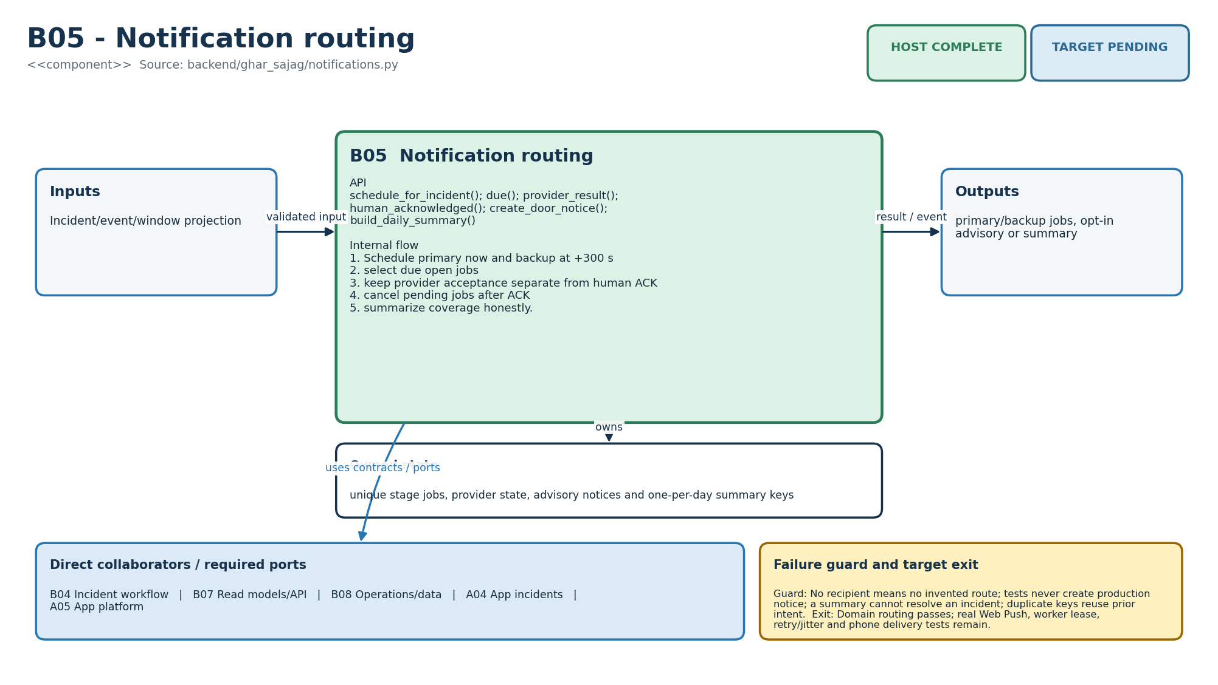
Figure M-18. Functionality, state ownership, I/O boundary and dependencies for B05.
Direct collaborators: B04 Incident workflow, B07 Read models/API, B08 Operations/data, A04 App incidents, A05 App platform. Target exit: Domain routing passes; real Web Push, worker lease, retry/jitter and phone delivery tests remain.
Editable source: diagrams/modules/uml/B05.puml

B06 - Fleet/config
How this module works. FleetService handles device records and desired/applied configuration. A desired configuration cannot be called active until the target confirms it. The service needs manufacturing claim trust, protected device credentials and persisted version concurrency before field rollout.
Input to output flow. Owner/install command or hub ACK → device/config version state. Authorize owner; prevent cross-home device rebind; increment desired version; record only known applied versions; audit.
State and lifetime. device registry and latest desired/applied configuration. Firmware state is owned by one task in the target binding; the host reference must not be assumed thread-safe. Backend reference services share an in-memory store; the production transaction boundary must preserve the same business invariants.
Failure behaviour. Unknown future apply and device conflict reject. Desired does not equal applied until hub reports it.
Code navigation. Requirements F03, F04, E07, E08, E09, NFR-06. Files: backend/ghar_sajag/fleet.py. Public entry points: register_device(); publish_config(); record_applied().
Verification boundary. test_B06_config_version_and_device_binding. Version semantics pass; PostgreSQL, one-use claim, signed manifest publication and cohort rollout remain. See the current evidence transcript; historical numerical test counts in retained tables belong to their original release.
Enhancement scope. Fleet cohorts, staged update and field diagnostics.
HLD COMPLETE | LLD COMPLETE | HOST COMPLETE | TARGET PENDING
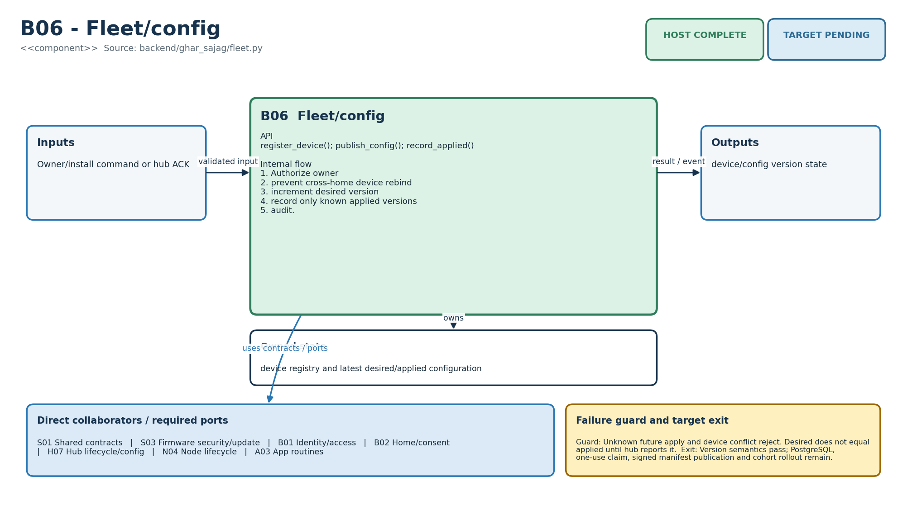
Figure M-19. Functionality, state ownership, I/O boundary and dependencies for B06.
Direct collaborators: S01 Shared contracts, S03 Firmware security/update, B01 Identity/access, B02 Home/consent, H07 Hub lifecycle/config, N04 Node lifecycle, A03 App routines. Target exit: Version semantics pass; PostgreSQL, one-use claim, signed manifest publication and cohort rollout remain.
Editable source: diagrams/modules/uml/B06.puml

B07 - Read models/API
How this module works. QueryService builds a caregiver projection from authoritative backend records and checks household access. The projection may be stale even when the backend is healthy; include source ages. The demo HTTP adapter is a local development adapter and is not equivalent to the planned authenticated production API.
Input to output flow. Authorized read + events/incidents → dashboard snapshot/timeline JSON. Sort by original occurrence; compute hub lease from server receipts; choose latest activity independently; expose incidents and fetched time.
State and lifetime. Derived view only; source facts remain in store. Firmware state is owned by one task in the target binding; the host reference must not be assumed thread-safe. Backend reference services share an in-memory store; the production transaction boundary must preserve the same business invariants.
Failure behaviour. Fresh phone fetch cannot make stale hub data current. Test events are excluded from production timeline.
Code navigation. Requirements F05, F06, F09, F11, F12, F14, E04. Files: backend/ghar_sajag/queries.py, http_api.py. Public entry points: QueryService.snapshot/timeline; JsonApi.dispatch/WSGI.
Verification boundary. test_B07_B08_snapshot_separates_activity_from_reachability. Projection logic passes; pagination, SSE, OpenAPI conformance and React integration remain. See the current evidence transcript; historical numerical test counts in retained tables belong to their original release.
Enhancement scope. Materialized PostgreSQL projections and regional read replicas only when needed.
HLD COMPLETE | LLD COMPLETE | HOST COMPLETE | TARGET PENDING
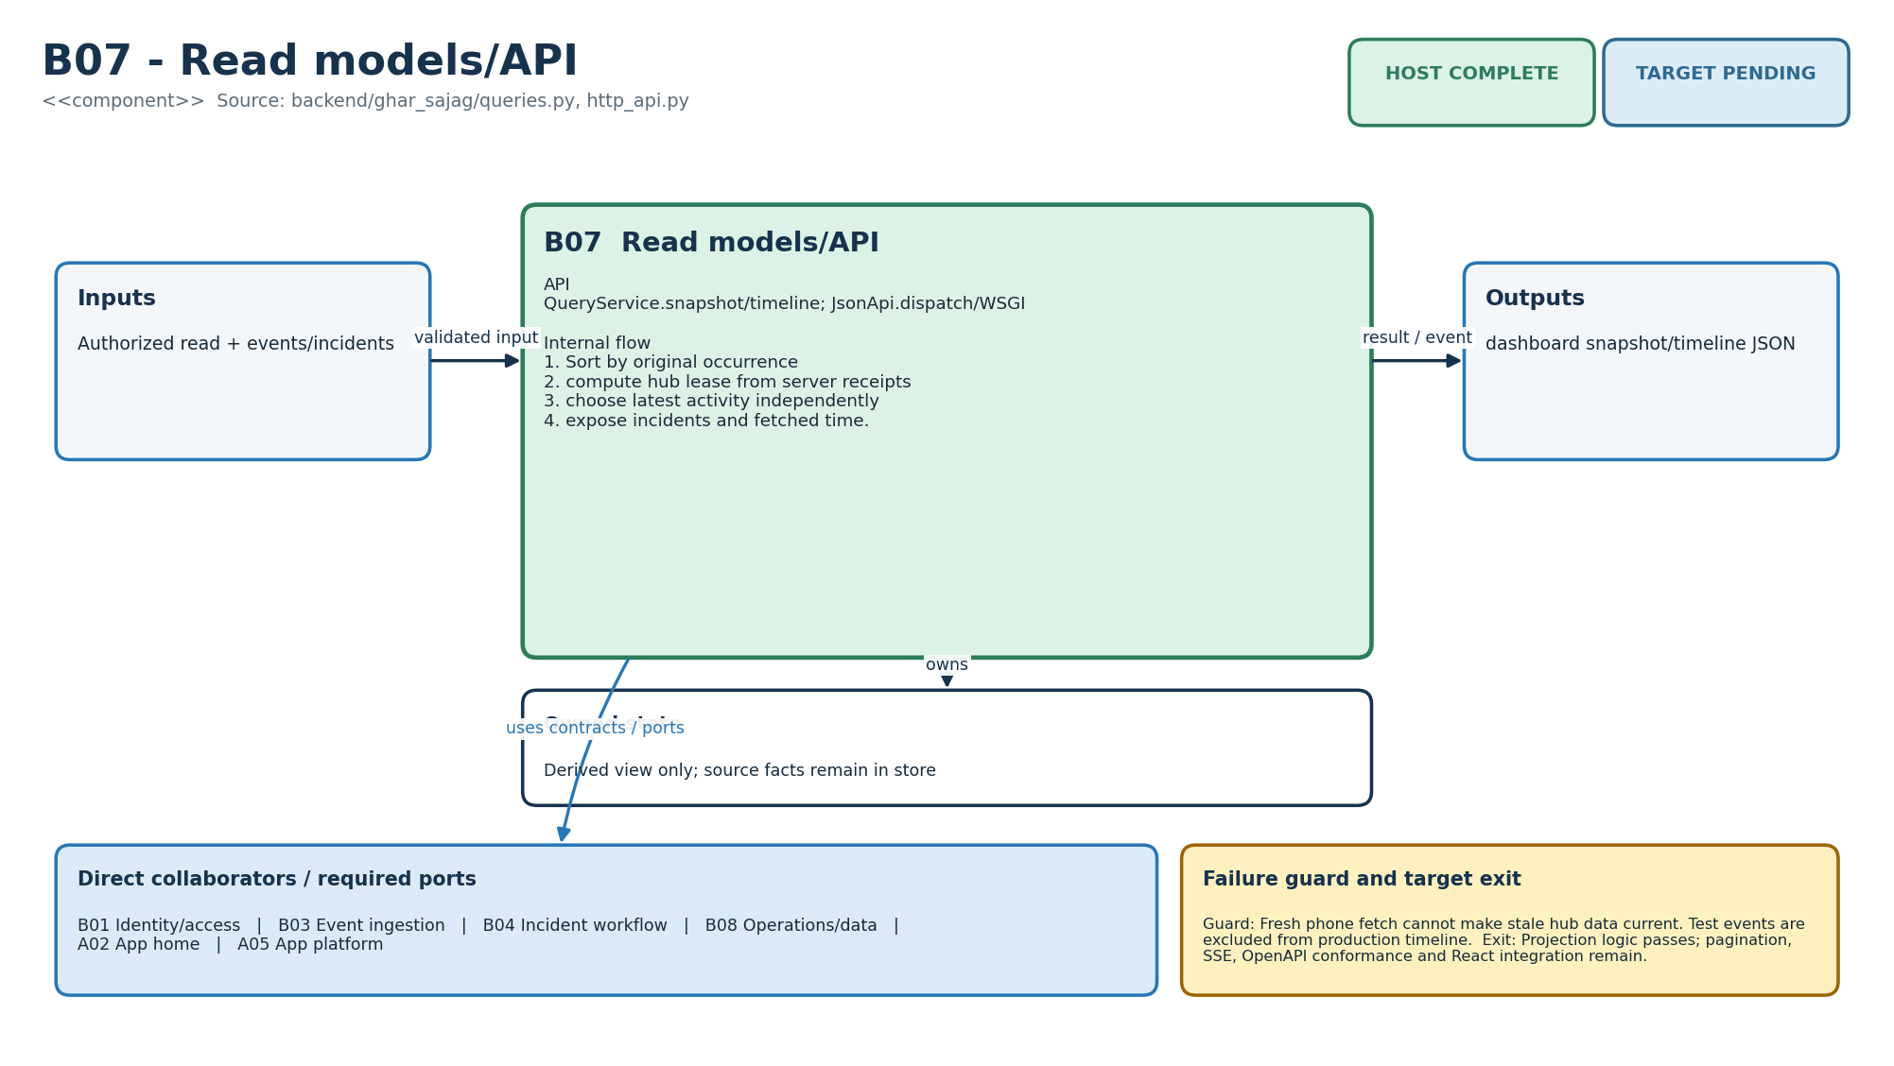
Figure M-20. Functionality, state ownership, I/O boundary and dependencies for B07.
Direct collaborators: B01 Identity/access, B03 Event ingestion, B04 Incident workflow, B08 Operations/data, A02 App home, A05 App platform. Target exit: Projection logic passes; pagination, SSE, OpenAPI conformance and React integration remain.
Editable source: diagrams/modules/uml/B07.puml

B08 - Operations/data
How this module works. OperationsService separates fleet freshness and support auditing from routine evidence. Operational counters can identify missing links without recording resident names or raw payloads. Backups, export/deletion, retention and independent service monitoring need a real storage/deployment adapter.
Input to output flow. Events/actions/current time → health, diagnostics and auditable support record. Evaluate hub server-receipt lease; count each domain independently; record support actions without editing historical events.
State and lifetime. audit trail plus counts and independent hub lease. Firmware state is owned by one task in the target binding; the host reference must not be assumed thread-safe. Backend reference services share an in-memory store; the production transaction boundary must preserve the same business invariants.
Failure behaviour. Broker retained online state is not authoritative. In-memory store is a host adapter, not a durable production claim.
Code navigation. Requirements F02, F11, F13, E01, E04, E05, E08, E09, E10, NFR-09. Files: backend/ghar_sajag/operations.py, store.py. Public entry points: hub_health(); diagnostics(); record_support_action().
Verification boundary. B07/B08 snapshot test and diagnostics assertions. Host observability passes; PostgreSQL retention/export, independent uptime and restore drill remain. See the current evidence transcript; historical numerical test counts in retained tables belong to their original release.
Enhancement scope. Privacy-preserving fleet metrics and support bundle redaction.
HLD COMPLETE | LLD COMPLETE | HOST COMPLETE | TARGET PENDING
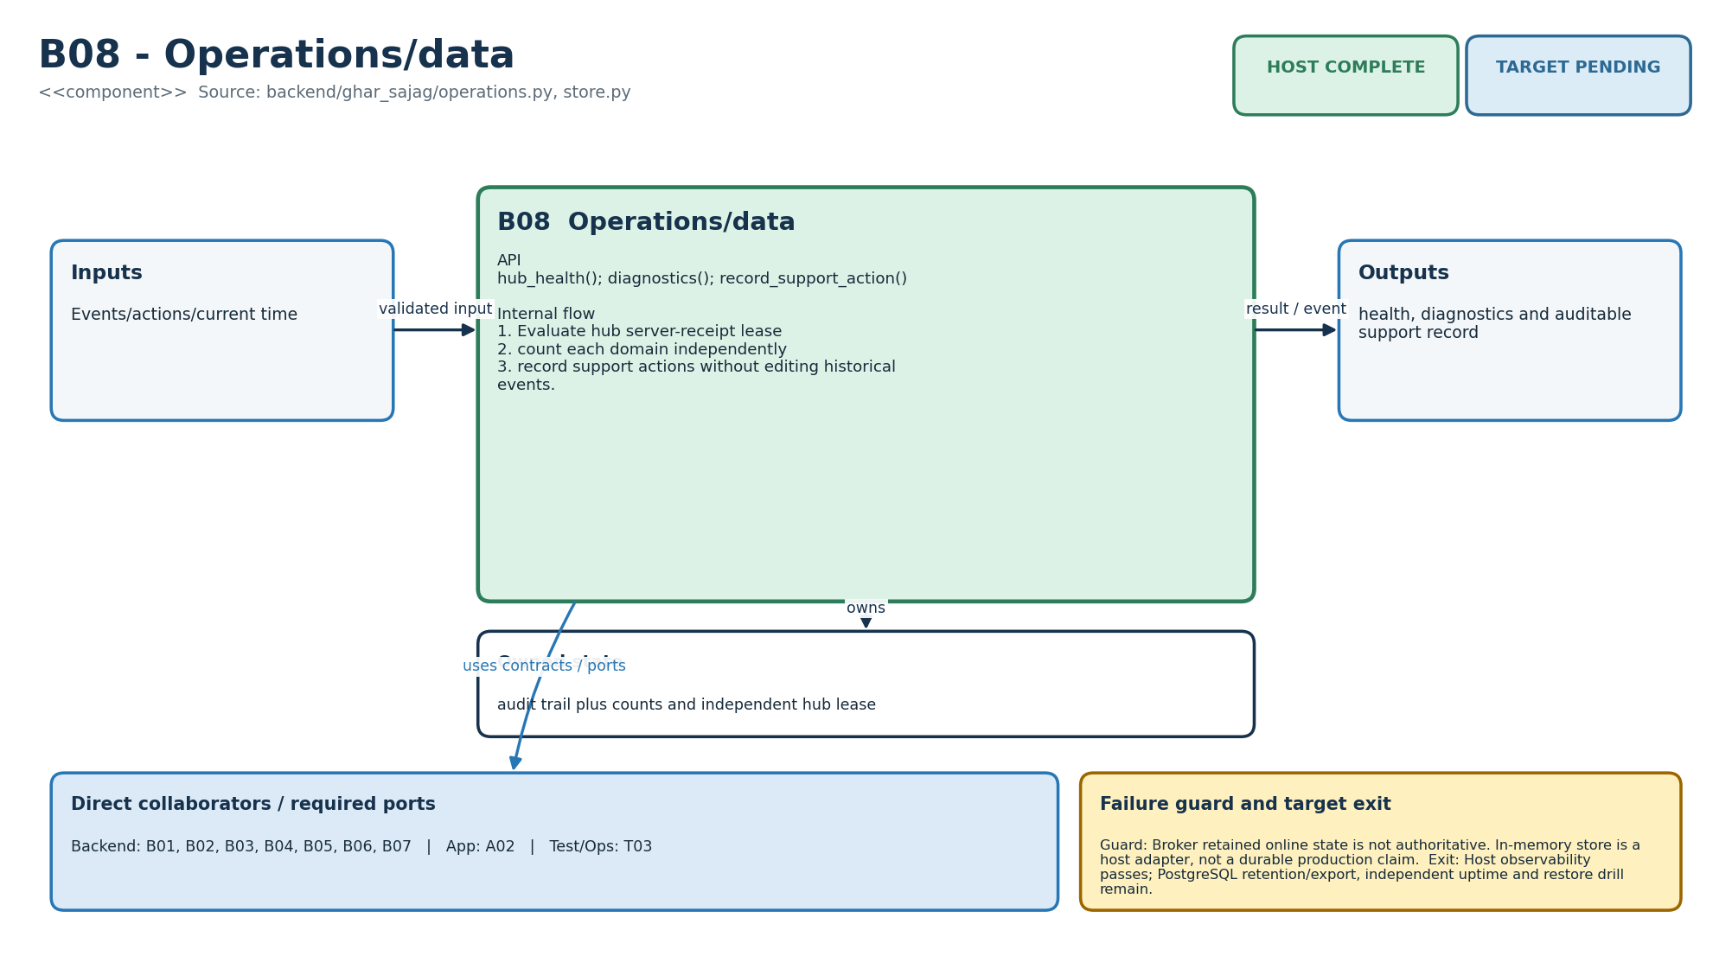
Figure M-21. Functionality, state ownership, I/O boundary and dependencies for B08.
Direct collaborators: B01 Identity/access, B02 Home/consent, B03 Event ingestion, B04 Incident workflow, B05 Notification routing, B06 Fleet/config, B07 Read models/API, A02 App home, T03 Deployment/operations. Target exit: Host observability passes; PostgreSQL retention/export, independent uptime and restore drill remain.
Editable source: diagrams/modules/uml/B08.puml

A01 - App onboarding
How this module works. Onboarding functions validate a draft and produce a command; they do not persist it. installationGate consumes evidence flags, so the caller must distinguish a genuine completed drill from a manually checked box. The UI should explain every missing prerequisite.
Input to output flow. Household draft and install evidence → validation errors, API command, pilot eligibility. Require home/timezone/resident consent/distinct caregiver pair; construct idempotent home command; require every enabled input plus hub controls and real delivery drill.
State and lifetime. Pure draft/result values; no hidden authoritative state. Firmware state is owned by one task in the target binding; the host reference must not be assumed thread-safe. Backend reference services share an in-memory store; the production transaction boundary must preserve the same business invariants.
Failure behaviour. Missing check remains visible and blocks unattended eligibility. No default consent or inferred backup.
Code navigation. Requirements F01, F02, F03, NFR-10. Files: app/src/features/onboarding/index.mjs. Public entry points: validateHouseholdDraft(); buildCreateHomeCommand(); installationGate().
Verification boundary. Node tests: onboarding validation and installation gate. Domain/UI model passes; React form, QR claim, accessibility and real phone workflow remain. See the current evidence transcript; historical numerical test counts in retained tables belong to their original release.
Enhancement scope. Installer role UX and multilingual consent evidence.
HLD COMPLETE | LLD COMPLETE | HOST COMPLETE | TARGET PENDING
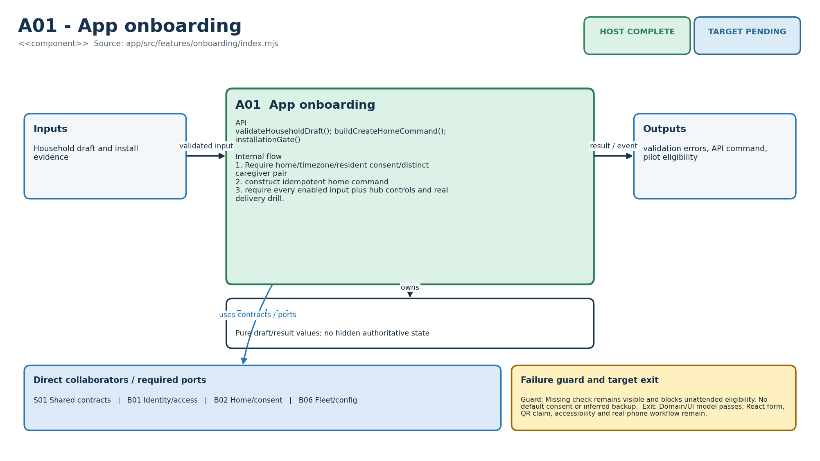
Figure M-22. Functionality, state ownership, I/O boundary and dependencies for A01.
Direct collaborators: S01 Shared contracts, B01 Identity/access, B02 Home/consent, B06 Fleet/config. Target exit: Domain/UI model passes; React form, QR claim, accessibility and real phone workflow remain.
Editable source: diagrams/modules/uml/A01.puml

A02 - App home
How this module works. Home view functions convert a server snapshot to readable labels. Do not move eligibility or incident creation into this layer. A stale value can remain visible if labelled with age; it must not acquire a new timestamp because the page rerendered.
Input to output flow. Backend snapshot/timeline + phone now → evidence/connectivity cards. Format separate freshness; show household activity only; render hub availability independently; explicitly state no activity evidence is not presence proof.
State and lifetime. Rendered projection only; optional A05 cache. Firmware state is owned by one task in the target binding; the host reference must not be assumed thread-safe. Backend reference services share an in-memory store; the production transaction boundary must preserve the same business invariants.
Failure behaviour. Stale/never-seen is visible. No safe/fine/wellbeing label and no resident identity inference.
Code navigation. Requirements F05, F06, F09, F11, F14, E01, E04, E10, NFR-01, NFR-02, NFR-10. Files: app/src/features/home/index.mjs, app/public/*. Public entry points: formatFreshness(); buildHomeView(); timelineLabel().
Verification boundary. Home-view separation test; static responsive prototype included. View-model tests pass; React/PWA accessibility, localization and supported-phone tests remain. See the current evidence transcript; historical numerical test counts in retained tables belong to their original release.
Enhancement scope. Weekly digest and richer source explanations.
HLD COMPLETE | LLD COMPLETE | HOST COMPLETE | TARGET PENDING
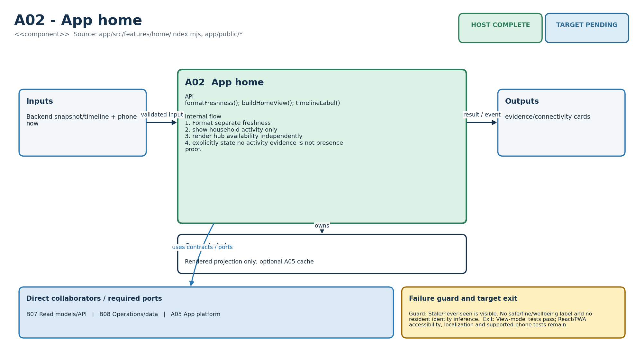
Figure M-23. Functionality, state ownership, I/O boundary and dependencies for A02.
Direct collaborators: B07 Read models/API, B08 Operations/data, A05 App platform. Target exit: View-model tests pass; React/PWA accessibility, localization and supported-phone tests remain.
Editable source: diagrams/modules/uml/A02.puml

A03 - App routines
How this module works. Routine functions validate local form values and build a desired-version request. The hub remains authoritative for what it has applied. A newer applied version than the screen knows about is a conflict requiring refresh, not permission to overwrite it.
Input to output flow. Schedule/mode form → schema-aligned desired configuration and status. Validate minute ranges/grace; deduplicate locations; build versioned config; compare desired against applied without pretending pending succeeded.
State and lifetime. Desired draft and server/applied versions. Firmware state is owned by one task in the target binding; the host reference must not be assumed thread-safe. Backend reference services share an in-memory store; the production transaction boundary must preserve the same business invariants.
Failure behaviour. Invalid mode/routine throws explicit client error. Newer hub version becomes conflict, not silent overwrite.
Code navigation. Requirements F04, F10, F14, E07. Files: app/src/features/routines/index.mjs. Public entry points: validateMorningRoutine(); buildDesiredConfig(); configStatus().
Verification boundary. Routine command and desired/applied status test. Pure UI logic passes; screen, timezone boundary preview and backend persistence remain. See the current evidence transcript; historical numerical test counts in retained tables belong to their original release.
Enhancement scope. Multiple deterministic routine templates.
HLD COMPLETE | LLD COMPLETE | HOST COMPLETE | TARGET PENDING
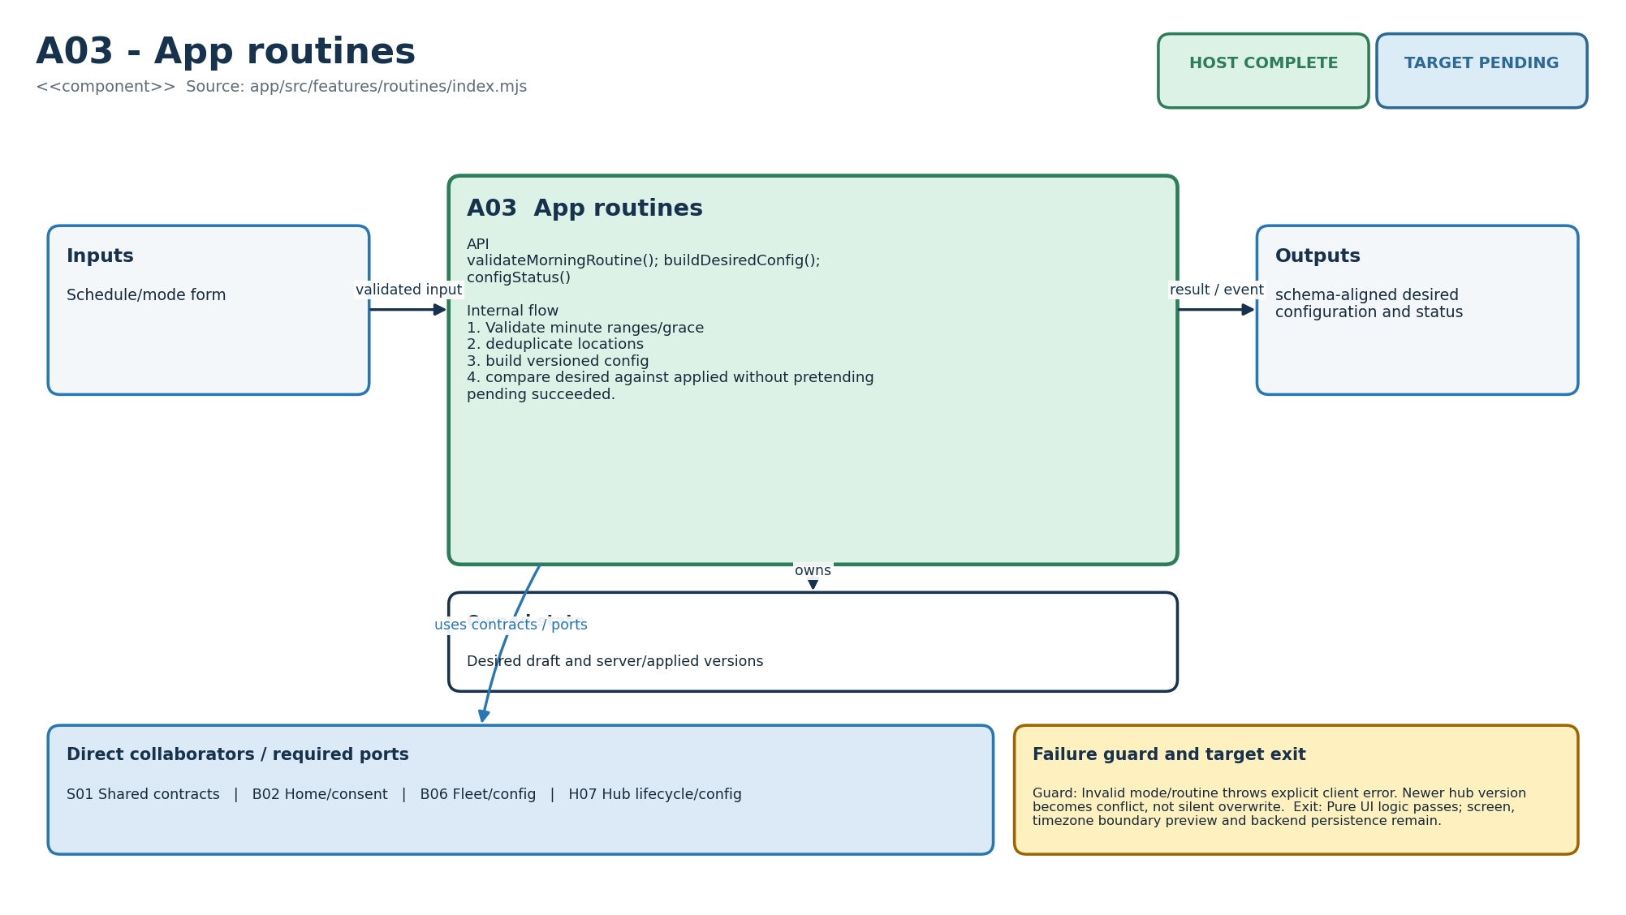
Figure M-24. Functionality, state ownership, I/O boundary and dependencies for A03.
Direct collaborators: S01 Shared contracts, B02 Home/consent, B06 Fleet/config, H07 Hub lifecycle/config. Target exit: Pure UI logic passes; screen, timezone boundary preview and backend persistence remain.
Editable source: diagrams/modules/uml/A03.puml

A04 - App incidents
How this module works. Incident UI helpers expose actions consistent with a snapshot and build commands with idempotency keys. The server repeats authorisation and lease checks because the view can be stale. A pending click must not be shown as completed human acknowledgement before a confirmed result.
Input to output flow. Incident/actor/time → permitted actions and idempotent REST command. Hide mutation actions when another live owner holds lease; distinguish claim, acknowledge and resolve; label provider acceptance separately.
State and lifetime. Server incident snapshot and pending client command only. Firmware state is owned by one task in the target binding; the host reference must not be assumed thread-safe. Backend reference services share an in-memory store; the production transaction boundary must preserve the same business invariants.
Failure behaviour. Offline action cannot become authoritative. Unsupported action is rejected before request.
Code navigation. Requirements F07, F12, F13, NFR-10. Files: app/src/features/incidents/index.mjs. Public entry points: incidentActions(); actionCommand(); deliveryLabel().
Verification boundary. Incident ownership/action and command-path test. View/action rules pass; optimistic-pending UI, SSE reconciliation and caregiver comprehension remain. See the current evidence transcript; historical numerical test counts in retained tables belong to their original release.
Enhancement scope. Contact outcome and deliberate handoff UI.
HLD COMPLETE | LLD COMPLETE | HOST COMPLETE | TARGET PENDING
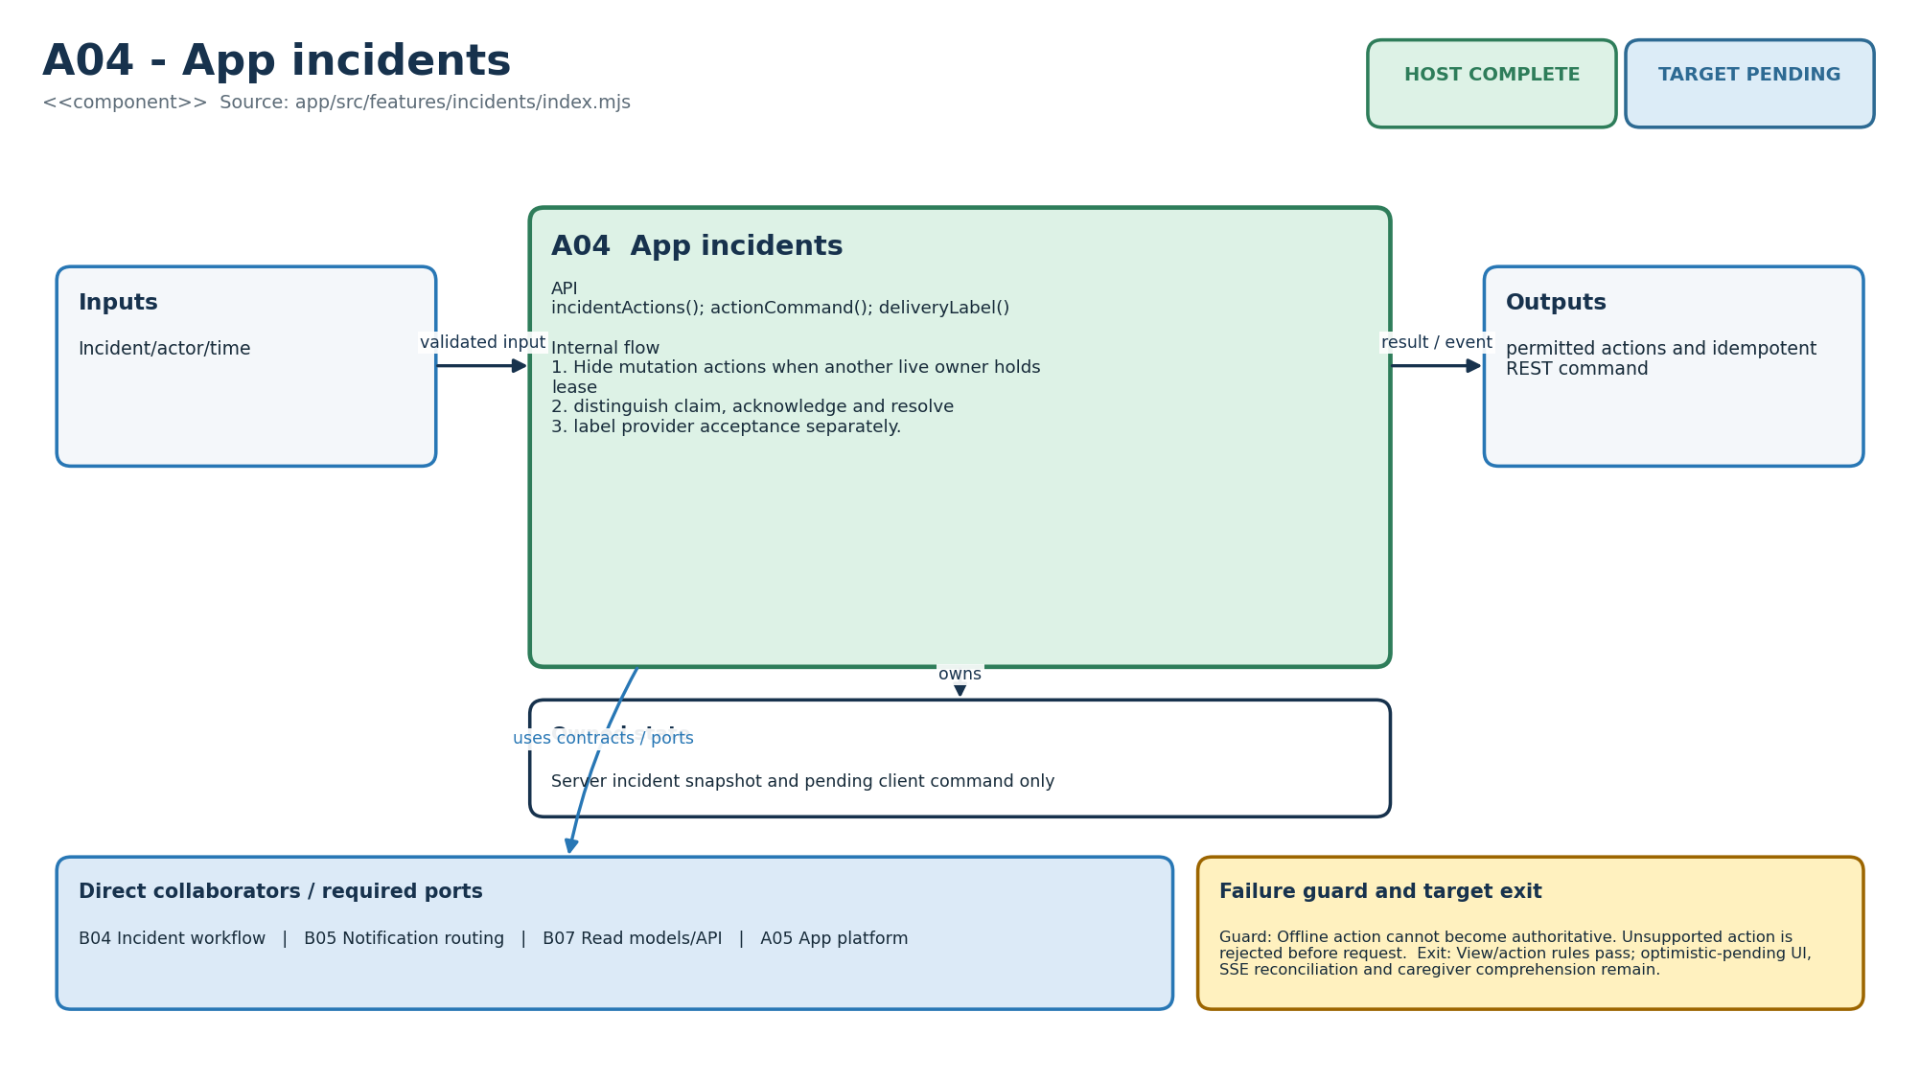
Figure M-25. Functionality, state ownership, I/O boundary and dependencies for A04.
Direct collaborators: B04 Incident workflow, B05 Notification routing, B07 Read models/API, A05 App platform. Target exit: View/action rules pass; optimistic-pending UI, SSE reconciliation and caregiver comprehension remain.
Editable source: diagrams/modules/uml/A04.puml

A05 - App platform
How this module works. ApiClient uses injected fetch and token providers so tests can simulate failures. VersionedCache refuses older snapshots and labels age. Browser cache and service-worker assets are not durable server state, and a push subscription is not notification delivery evidence.
Input to output flow. Injected fetch/token + command → JSON result/error; cached snapshot → explicit stale flag. Attach bearer/idempotency headers; classify auth/service/network failures; retain only newer cache versions; expose exact push capability reason.
State and lifetime. Versioned local cache; browser subscription state. Firmware state is owned by one task in the target binding; the host reference must not be assumed thread-safe. Backend reference services share an in-memory store; the production transaction boundary must preserve the same business invariants.
Failure behaviour. Cache never claims server commit. Push permission/subscription is not human acknowledgement.
Code navigation. Requirements F11, F13, E04, E08. Files: app/src/platform/index.mjs, app/public/service-worker.mjs. Public entry points: ApiClient.request(); VersionedCache.put/get(); pushCapability(); classifyFetchFailure().
Verification boundary. Cache and push capability test. Framework-neutral adapter passes; OIDC SDK, service worker push handler, IndexedDB and real browser tests remain. See the current evidence transcript; historical numerical test counts in retained tables belong to their original release.
Enhancement scope. Native wrapper only if PWA constraints justify it.
HLD COMPLETE | LLD COMPLETE | HOST COMPLETE | TARGET PENDING
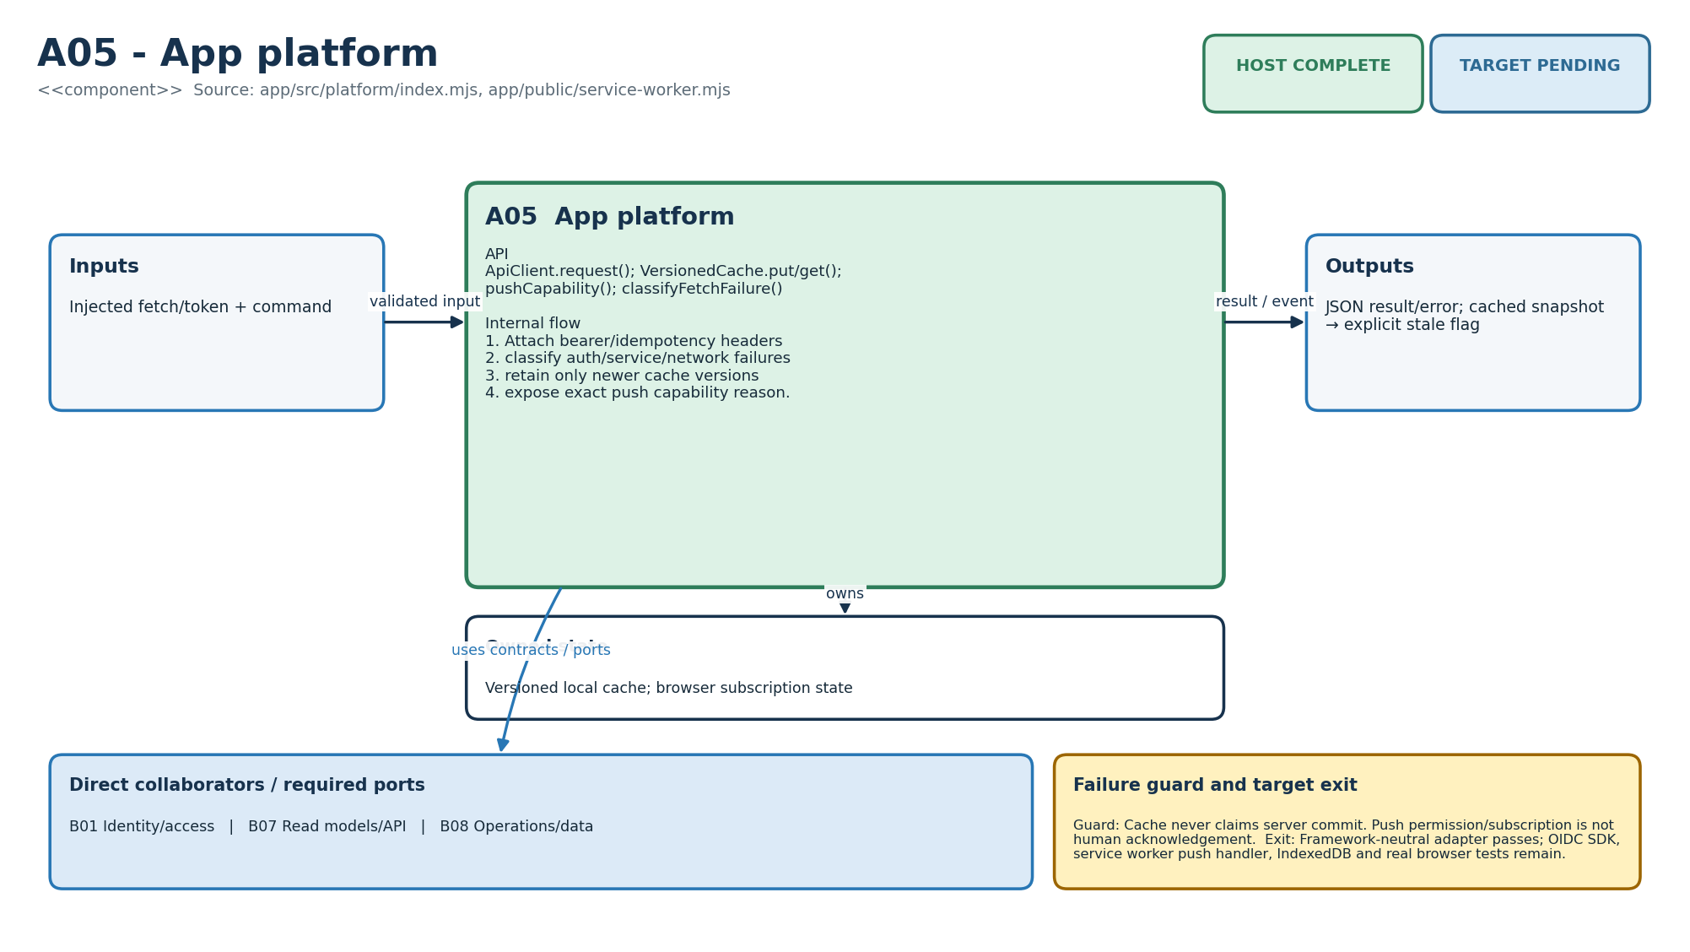
Figure M-26. Functionality, state ownership, I/O boundary and dependencies for A05.
Direct collaborators: B01 Identity/access, B07 Read models/API, B08 Operations/data. Target exit: Framework-neutral adapter passes; OIDC SDK, service worker push handler, IndexedDB and real browser tests remain.
Editable source: diagrams/modules/uml/A05.puml

S01 - Shared contracts
How this module works. Contracts are the shared vocabulary across languages. Field names and event identity require explicit adapters; the C++ enum spelling is not the JSON wire spelling. The current contracts check validates source structure, so add producer/consumer golden payload tests before relying on schema compatibility.
Input to output flow. Producer payload → structural acceptance or explicit schema/version rejection. Keep node event identity, cloud timestamps/test flag and desired configuration version canonical; validate source structure in CI.
State and lifetime. Versioned source files only. Firmware state is owned by one task in the target binding; the host reference must not be assumed thread-safe. Backend reference services share an in-memory store; the production transaction boundary must preserve the same business invariants.
Failure behaviour. Unknown additional fields fail in JSON schemas; schema change requires a new version and compatibility tests.
Code navigation. Requirements F01, E02, E06, E07, NFR-08. Files: contracts/node.schema.json, cloud.schema.json, config.schema.json, openapi.yaml; scripts/verify_contracts.py. Public entry points: Schema v1 fields and OpenAPI operation IDs.
Verification boundary. make contracts verifies three required-field sets and API surface. Source contracts pass; CBOR CDDL/generated C++/Python/TypeScript bindings and golden vectors remain. See the current evidence transcript; historical numerical test counts in retained tables belong to their original release.
Enhancement scope. Generated clients and formal compatibility matrix.
HLD COMPLETE | LLD COMPLETE | HOST COMPLETE | TARGET PENDING
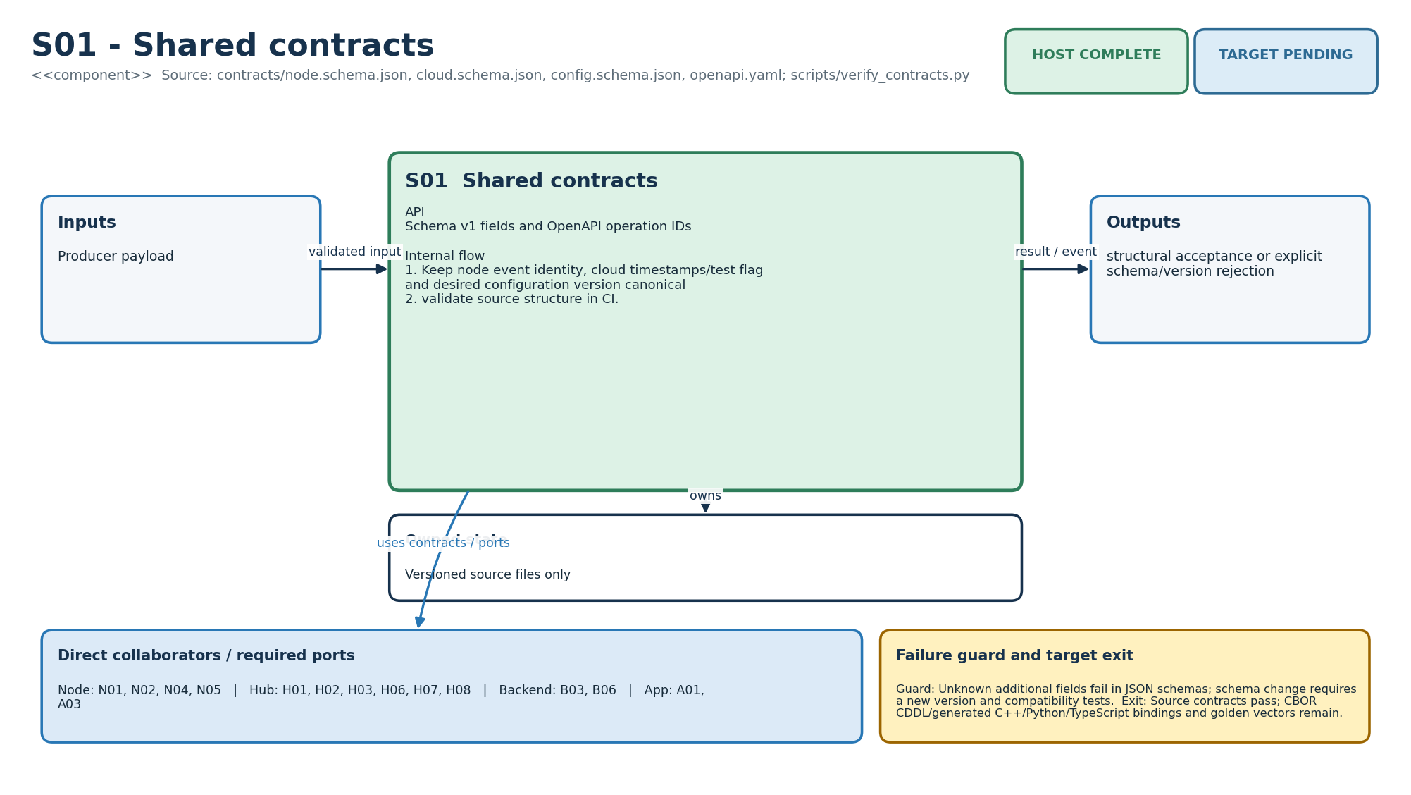
Figure M-27. Functionality, state ownership, I/O boundary and dependencies for S01.
Direct collaborators: N01 Node sensing, N02 Node radio, N04 Node lifecycle, N05 Node storage, H01 Hub ingest, H02 Hub persistence, H03 Hub time, H06 Hub resident interface, H07 Hub lifecycle/config, H08 Hub cloud link, B03 Event ingestion, B06 Fleet/config, A01 App onboarding, A03 App routines. Target exit: Source contracts pass; CBOR CDDL/generated C++/Python/TypeScript bindings and golden vectors remain.
Editable source: diagrams/modules/uml/S01.puml

S02 - Deterministic rules core
How this module works. The reducer has no network or storage I/O and mutates only the supplied RoutineState. apply_event uses window overlap including timestamp uncertainty. evaluate_deadline returns a stable incident key after ordered gates. Evidence IDs are not deduplicated or bounded here; callers must not assume pure means resource-safe.
Input to output flow. RoutineConfig + ordered DomainEvent/deadline → deterministic state and IncidentDecision. Use uncertainty interval overlap; ignore tests; gate modes; record evidence IDs; produce stable incident key only after all eligibility gates.
State and lifetime. Caller-owned RoutineState; no global state or I/O. Firmware state is owned by one task in the target binding; the host reference must not be assumed thread-safe. Backend reference services share an in-memory store; the production transaction boundary must preserve the same business invariants.
Failure behaviour. Time, coverage and mode uncertainty return a reason instead of a false incident. Same state/input is replayable.
Code navigation. Requirements F04, F05, F06, F08, F09, F10, E06, AI08, NFR-01. Files: shared/include/gs/rules.hpp, shared/src/rules.cpp, domain.hpp. Public entry points: RulesCore::event_overlaps_window/apply_event/evaluate_deadline.
Verification boundary. C++ rule tests and HubRuntime composition. Host reducer passes; scenario-property, reorder and reboot checkpoint tests remain. See the current evidence transcript; historical numerical test counts in retained tables belong to their original release.
Enhancement scope. Additional transparent rules compiled into the same host/firmware core.
HLD COMPLETE | LLD COMPLETE | HOST COMPLETE | TARGET PENDING
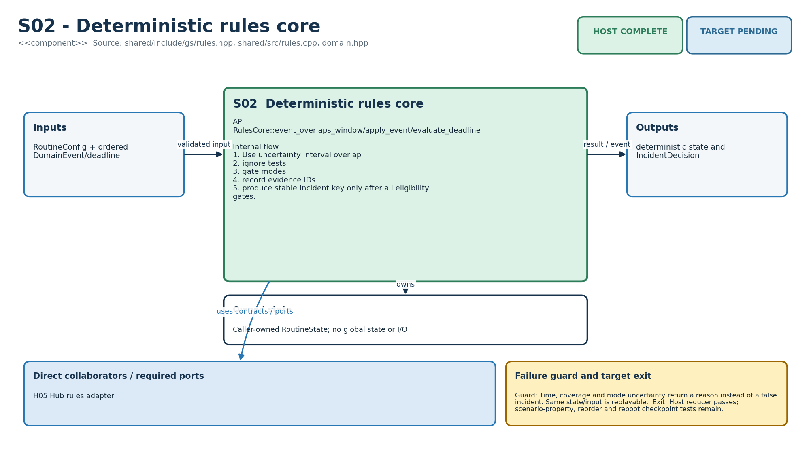
Figure M-28. Functionality, state ownership, I/O boundary and dependencies for S02.
Direct collaborators: H05 Hub rules adapter. Target exit: Host reducer passes; scenario-property, reorder and reboot checkpoint tests remain.
Editable source: diagrams/modules/uml/S02.puml

S03 - Firmware security/update
How this module works. CredentialRegistry keeps credential references and UpdatePolicy delegates authenticity to a verifier. The reference tests can replace that verifier. Production cryptographic verification, secret protection, revocation transport and bootloader enforcement must be proved separately.
Input to output flow. Credential/update manifest + verifier → install/reject decision with reason. Reject missing/stale credential; match board; prevent rollback; validate hash text; delegate signature verification to injected production crypto.
State and lifetime. versioned credential references; no raw secret bytes; running version supplied. Firmware state is owned by one task in the target binding; the host reference must not be assumed thread-safe. Backend reference services share an in-memory store; the production transaction boundary must preserve the same business invariants.
Failure behaviour. Host verifier is a seam, not cryptographic proof. Wrong board/version/hash/signature fails closed.
Code navigation. Requirements F03, E08, E09, NFR-06. Files: firmware/common/security/security.hpp, security.cpp. Public entry points: CredentialRegistry::install/revoke/get; UpdatePolicy::validate.
Verification boundary. C++ tests cover install, rollback, revoke and manifest policy. Policy passes; protected NVS/secure element, real SHA-256/ECDSA, secure boot and rollback recovery remain. See the current evidence transcript; historical numerical test counts in retained tables belong to their original release.
Enhancement scope. Key rotation and manufacturing HSM workflow.
HLD COMPLETE | LLD COMPLETE | HOST COMPLETE | TARGET PENDING
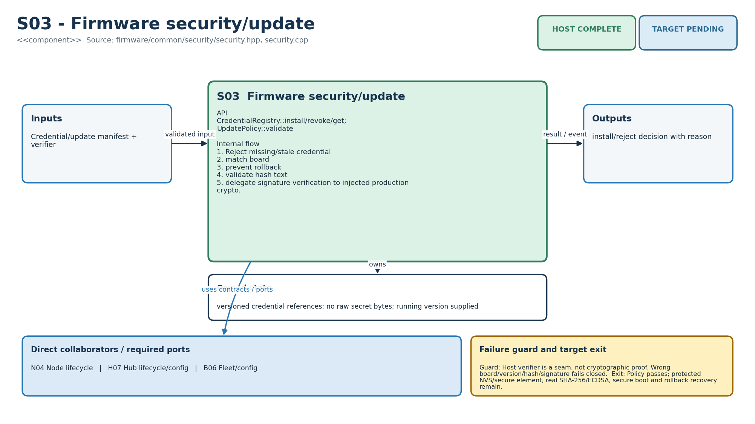
Figure M-29. Functionality, state ownership, I/O boundary and dependencies for S03.
Direct collaborators: N04 Node lifecycle, H07 Hub lifecycle/config, B06 Fleet/config. Target exit: Policy passes; protected NVS/secure element, real SHA-256/ECDSA, secure boot and rollback recovery remain.
Editable source: diagrams/modules/uml/S03.puml

T01 - Simulation/CI
How this module works. The Makefile builds host C++17 and runs Python/JavaScript tests plus simulator fixtures. Tests prove their asserted paths, not every SRD criterion. Keep a clean command transcript and attach additional scenario tests as requirements are integrated.
Input to output flow. Source tree → contract/build/test/simulator result. Validate contracts; compile strict C++17; execute 52 checks; run simulator; run 10 Python and 6 Node tests.
State and lifetime. Deterministic fixtures and executable assertions. Firmware state is owned by one task in the target binding; the host reference must not be assumed thread-safe. Backend reference services share an in-memory store; the production transaction boundary must preserve the same business invariants.
Failure behaviour. Any command returns non-zero. Report never claims RF/power/provider coverage.
Code navigation. Requirements E08, E10, V01, AI01, AI03, NFR-08. Files: Makefile, tests/cpp/test_main.cpp, tests/python/test_backend.py, tests/js/app.test.mjs, tests/scenarios.json, host/simulator/main.cpp. Public entry points: make verify.
Verification boundary. VERIFICATION_REPORT.md records the successful 7 September 2026 run. Current host suite green; add CI runner, fuzz/property tests and coverage thresholds. See the current evidence transcript; historical numerical test counts in retained tables belong to their original release.
Enhancement scope. Nightly long replay and hardware-in-loop lane.
HLD COMPLETE | LLD COMPLETE | HOST COMPLETE | TARGET PENDING
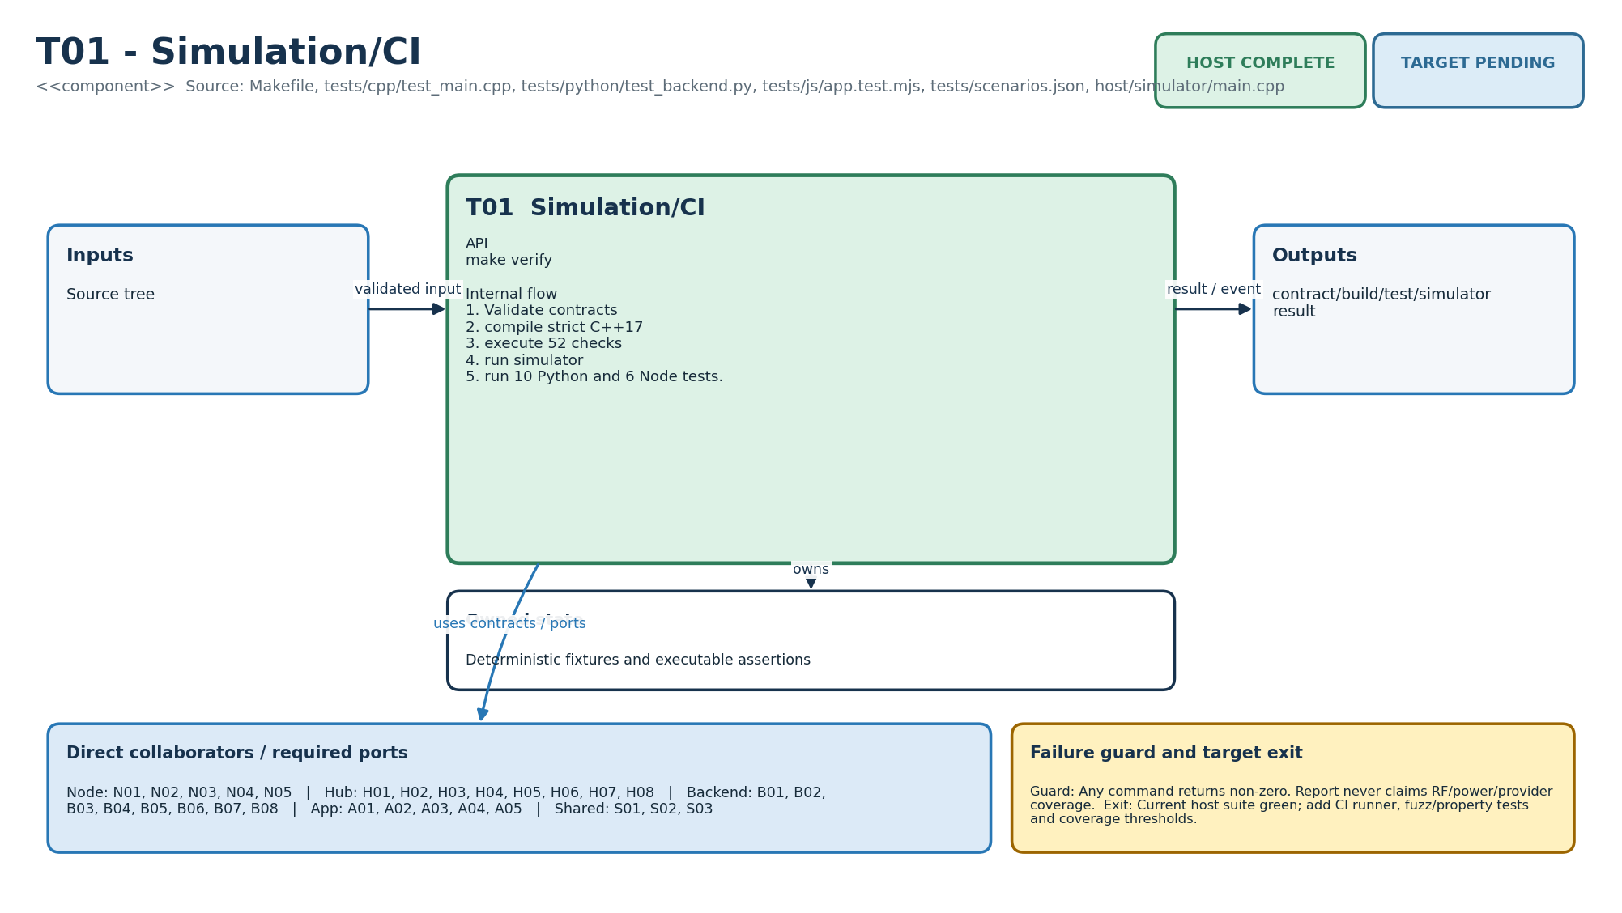
Figure M-30. Functionality, state ownership, I/O boundary and dependencies for T01.
Direct collaborators: N01 Node sensing, N02 Node radio, N03 Node power, N04 Node lifecycle, N05 Node storage, H01 Hub ingest, H02 Hub persistence, H03 Hub time, H04 Hub coverage, H05 Hub rules adapter, H06 Hub resident interface, H07 Hub lifecycle/config, H08 Hub cloud link, B01 Identity/access, B02 Home/consent, B03 Event ingestion, B04 Incident workflow, B05 Notification routing, B06 Fleet/config, B07 Read models/API, B08 Operations/data, A01 App onboarding, A02 App home, A03 App routines, A04 App incidents, A05 App platform, S01 Shared contracts, S02 Deterministic rules core, S03 Firmware security/update. Target exit: Current host suite green; add CI runner, fuzz/property tests and coverage thresholds.
Editable source: diagrams/modules/uml/T01.puml

T02 - Hardware-in-loop tools
How this module works. The HIL scripts model provisioning plans, installation checks and current summaries. They do not operate a board without serial, power and instrument adapters. Record measured evidence and instrument settings rather than marking a design target green.
Input to output flow. Kit IDs / physical observations / current CSV → redacted plan, eligibility, power summary. Require four unique nodes; never print claim token; fail unknown checks; gate eligibility on every required check; summarize measured current.
State and lifetime. Provisioning plan, required/pass/fail check set and current capture statistics. Firmware state is owned by one task in the target binding; the host reference must not be assumed thread-safe. Backend reference services share an in-memory store; the production transaction boundary must preserve the same business invariants.
Failure behaviour. Scripts cannot prove a board action without an adapter/evidence. Sensitive plan is explicitly separated from console output.
Code navigation. Requirements F03, E09, E10, NFR-05. Files: tools/hil/provision.py, runner.py, power_profile.py, installation_checklist.md. Public entry points: build_plan(); InstallationRun.observe/result(); summarize().
Verification boundary. Syntax/import covered by backend run context; physical execution deliberately pending. Host tooling exists; serial adapter, fault injector, power instrument and installed-home run are required. See the current evidence transcript; historical numerical test counts in retained tables belong to their original release.
Enhancement scope. Automated relay/power-cycle jig and signed evidence bundle.
HLD COMPLETE | LLD COMPLETE | HOST PARTIAL | TARGET PENDING
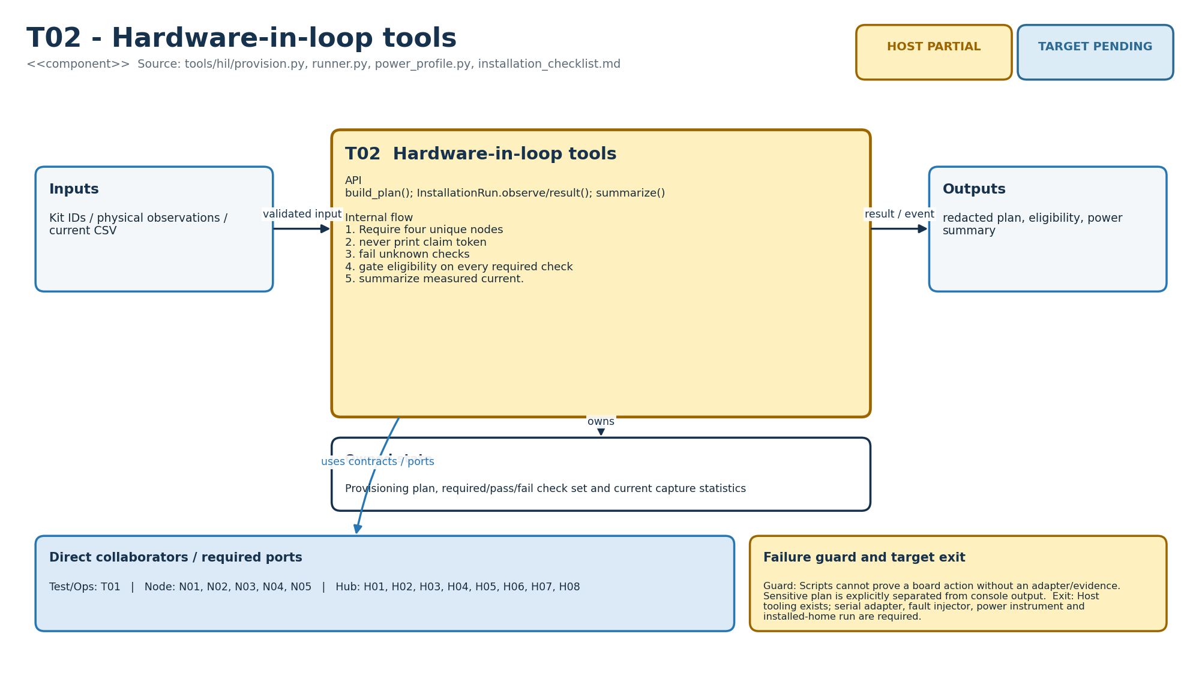
Figure M-31. Functionality, state ownership, I/O boundary and dependencies for T02.
Direct collaborators: T01 Simulation/CI, N01 Node sensing, N02 Node radio, N03 Node power, N04 Node lifecycle, N05 Node storage, H01 Hub ingest, H02 Hub persistence, H03 Hub time, H04 Hub coverage, H05 Hub rules adapter, H06 Hub resident interface, H07 Hub lifecycle/config, H08 Hub cloud link. Target exit: Host tooling exists; serial adapter, fault injector, power instrument and installed-home run are required.
Editable source: diagrams/modules/uml/T02.puml

T03 - Deployment/operations
How this module works. The compose, broker and runbook files are deployment examples. A configured container is not evidence of production authentication, backups or a successful restore. Keep secrets outside version control and record a staging rollout/rollback drill.
Input to output flow. Deployment secrets/certs/images → regional pilot services and independent alerts. Use TLS client identity and topic ACL; durable broker/database; alert ingest/backlog/fleet/backup; follow idempotent recovery runbook.
State and lifetime. PostgreSQL volume, broker persistence, alert/routing state outside application domain. Firmware state is owned by one task in the target binding; the host reference must not be assumed thread-safe. Backend reference services share an in-memory store; the production transaction boundary must preserve the same business invariants.
Failure behaviour. Example files omit secrets by design and are not a production deployment certificate. Restore and provider failures remain explicit.
Code navigation. Requirements E10. Files: ops/compose.yaml, mosquitto.conf, broker_acl.conf, alerts.yaml, runbook.md. Public entry points: Container/broker configuration and operator procedures.
Verification boundary. Configuration reviewed structurally; live broker/database/backup drill pending. Examples complete; staging deployment, secret store, migrations, external monitoring and restore evidence remain. See the current evidence transcript; historical numerical test counts in retained tables belong to their original release.
Enhancement scope. Horizontal process replicas before service decomposition.
HLD COMPLETE | LLD COMPLETE | HOST PARTIAL | TARGET PENDING
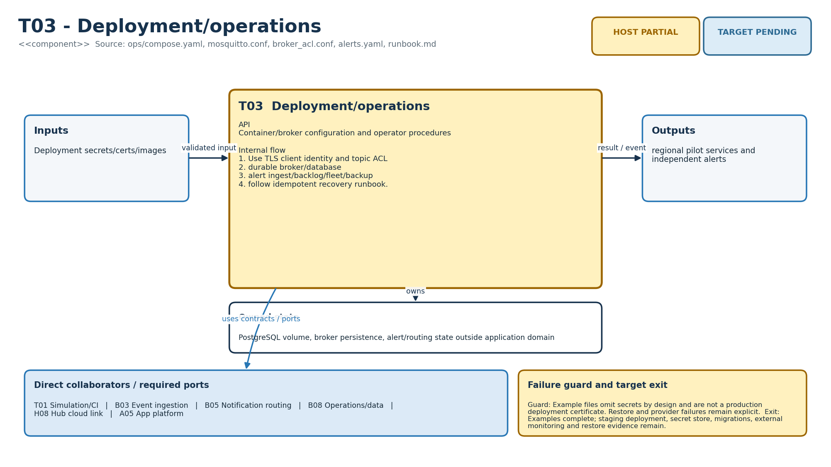
Figure M-32. Functionality, state ownership, I/O boundary and dependencies for T03.
Direct collaborators: T01 Simulation/CI, B03 Event ingestion, B05 Notification routing, B08 Operations/data, H08 Hub cloud link, A05 App platform. Target exit: Examples complete; staging deployment, secret store, migrations, external monitoring and restore evidence remain.
Editable source: diagrams/modules/uml/T03.puml

Architecture handoff boundary
These figures complete visual HLD/LLD traceability for all 32 modules. They do not replace the remaining target gates: ESP-IDF board profiles, one real PIR-to-dashboard vertical slice, flash/RF/power qualification, production PostgreSQL/OIDC/MQTT/Web Push integration, signed OTA recovery and the four-node installed-home validation.

Additional product and interaction responsibilities

S04 Product profile
How this module works. Product::ai is decided by GS_PRODUCT_AI and exposed through PRODUCT=base or ai in the Makefile. Invalid values fail the build. The runtime returns Disabled before calling a provider in the Base profile; the shared core remains identical. The older per-feature flags need separate enforcement review.
Input to output flow. Build selection -> edition identity and AI admission gate. Validate PRODUCT; define GS_PRODUCT_AI; reject illegal values; expose identity.
State and lifetime. Compile-time constants. Firmware state is owned by one task in the target binding; the host reference must not be assumed thread-safe. Backend reference services share an in-memory store; the production transaction boundary must preserve the same business invariants.
Failure behaviour. Unknown product is a build error; Base cannot start provider through H09.
Code navigation. Requirements V01, AI01, AI07, E07, E10, NFR-08. Files: shared/include/gs/product.hpp; Makefile. Public entry points: Product::ai/name/version; PRODUCT=base|ai.
Verification boundary. tests/cpp/test_product.cpp; invalid PRODUCT check. Profile host test passed; capability API remains pending. See the current evidence transcript; historical numerical test counts in retained tables belong to their original release.
Enhancement scope. Signed capability manifest and server-side entitlement policy.

H09 Interaction controller
How this module works. Controller owns state, current ID and start timestamp and borrows Provider by reference. Provider must outlive Controller, return promptly and never reenter it from start/cancel. A single owner serializes begin, complete, tick and cancel. start failure leaves Failed although begin returns Accepted; callers must inspect state.
Input to output flow. Consent/connectivity/time -> lifecycle result; provider completion -> Ready/Failed. Admit at most one request; correlate completion; expire at 30 seconds; cancel without accepting late results.
State and lifetime. State + request ID + monotonic start time + borrowed Provider reference. Firmware state is owned by one task in the target binding; the host reference must not be assumed thread-safe. Backend reference services share an in-memory store; the production transaction boundary must preserve the same business invariants.
Failure behaviour. Disabled, NoConsent, Offline, Busy, Exhausted; failed start returns Accepted with state Failed.
Code navigation. Requirements AI01, AI02, AI03, AI04, AI05, AI08, NFR-04, NFR-07. Files: shared/include/gs/interaction.hpp. Public entry points: begin; complete; tick; cancel; state; id.
Verification boundary. tests/cpp/test_product.cpp. Lifecycle tested with fake provider; hub coordinator/audio/provider integration pending. See the current evidence transcript; historical numerical test counts in retained tables belong to their original release.
Enhancement scope. Explicit start-failure Result and injected configurable deadline after API review.

S05 Diagnostics facade and sinks
How this module works. The atomic sink pointer only makes pointer publication atomic; it does not make sink lifetime or writes thread-safe. The host file sink performs synchronous I/O and rotation. Production should enqueue fixed records to one writer, reserve error capacity and expose drops; this future writer is not in the current source.
Input to output flow. Metadata-only event -> bounded diagnostic record. ERROR hook unconditional; TRACE compiled out by default; downstream sinks export text.
State and lifetime. Borrowed sink; bounded formatting/file rotation; browser ring. Firmware state is owned by one task in the target binding; the host reference must not be assumed thread-safe. Backend reference services share an in-memory store; the production transaction boundary must preserve the same business invariants.
Failure behaviour. Logger cannot detect arbitrary memory corruption; host sink is synchronous and not thread-safe.
Code navigation. Requirements AI08, E10, NFR-05, NFR-09. Files: shared/include/gs/logging.hpp; shared/src/logging.cpp; host/logging/file_log_sink.cpp; backend/ghar_sajag/logging_config.py; app/src/platform/logging.mjs. Public entry points: GS_ERROR; GS_TRACE; set_sink; host file sink; backend logger; app bounded export.
Verification boundary. Inherited logging tests and historical sanitizer evidence; no new board evidence. Reference exists; async firmware writer, panic/coredump and flash wear pending. See the current evidence transcript; historical numerical test counts in retained tables belong to their original release.
Enhancement scope. Single-owner diagnostic queue, drop counters, crash breadcrumb persistence.

H10 Interaction coordinator (planned)
How this module works. This planned coordinator will own H09 and serialize resident commands, consent changes, model completions and monitoring priority. It must explicitly stop playback even if H09 is already Ready. Calling Controller.cancel alone only calls Provider.cancel while Waiting.
Input to output flow. Resident/monitoring events -> H09 methods and H11 stop. Single task serializes lifecycle; monitoring/consent cancels model and playback.
State and lifetime. Owns H09 and consent/capability snapshot. Firmware state is owned by one task in the target binding; the host reference must not be assumed thread-safe. Backend reference services share an in-memory store; the production transaction boundary must preserve the same business invariants.
Failure behaviour. Queue saturation must preserve monitoring; stale callbacks dropped at lifecycle boundary.
Code navigation. Requirements AI02, AI04, AI05. Files: PLANNED: firmware/hub/interaction/coordinator. Public entry points: Proposed resident_start; consent_changed; monitoring_prompt; provider_completion.
Verification boundary. Pending coordinator integration tests. Physical cancel, privacy revocation and monitoring preemption demonstrated. See the current evidence transcript; historical numerical test counts in retained tables belong to their original release.
Enhancement scope. Localized accessibility flows.

H11 Audio/provider adapter (planned)
How this module works. This planned adapter will implement Provider with an asynchronous worker and bounded audio chunks. Start should only accept work; completion returns to the controller owner. Cancellation must stop microphone capture, model stream and playback and discard stale chunks without blocking the monitoring task.
Input to output flow. Consented microphone capture -> provider stream -> audio playback. Nonblocking adapter dispatches work; queues completion to H10.
State and lifetime. Bounded chunk buffers and worker handles. Firmware state is owned by one task in the target binding; the host reference must not be assumed thread-safe. Backend reference services share an in-memory store; the production transaction boundary must preserve the same business invariants.
Failure behaviour. Reboot invalidates callbacks; failure stops capture and releases resources.
Code navigation. Requirements AI04, AI06. Files: PLANNED: firmware/hub/interaction/audio_adapter. Public entry points: Proposed Provider::start/cancel; audio capture/playback ports.
Verification boundary. Pending hardware and fake streaming adapter tests. Bounded RAM, cancellation, acoustic and outage tests pass. See the current evidence transcript; historical numerical test counts in retained tables belong to their original release.
Enhancement scope. Qualified local commands where useful.

B09 AI gateway (planned)
How this module works. This planned gateway will keep provider credentials on the server, authenticate the home and enforce edition, consent and usage quotas. No provider can directly create, acknowledge or resolve an incident. A response is interaction content only; monitored safety decisions remain deterministic.
Input to output flow. Authorized request -> restricted model/speech provider. Authorize home; enforce edition/consent/budget; limit concurrency; deadline requests.
State and lifetime. Tenant quota, provider credentials, session lease. Firmware state is owned by one task in the target binding; the host reference must not be assumed thread-safe. Backend reference services share an in-memory store; the production transaction boundary must preserve the same business invariants.
Failure behaviour. No credentials on node; quota/provider failure explicit; no automated incident mutation.
Code navigation. Requirements AI06, AI07. Files: PLANNED: backend/ghar_sajag/interaction_gateway.py. Public entry points: Proposed authenticated session creation/cancel and quota checks.
Verification boundary. Pending tenant, quota, provider and retention tests. Provider integration and measured cost/quality pass. See the current evidence transcript; historical numerical test counts in retained tables belong to their original release.
Enhancement scope. Provider portability and regional hosting.

A06 Interaction availability UI (planned)
How this module works. This planned UI will explain why interaction is unavailable: Base edition, absent consent, offline link, exhausted quota or unsupported audio hardware. Hiding a control is only presentation; the server and hub enforce the policy again. AI preference changes cannot silently change Base monitoring settings.
Input to output flow. Server capability/consent -> visible availability and settings. Distinguish edition, consent, online and quota state; never authorize through UI flag.
State and lifetime. Read-only availability projection and pending commands. Firmware state is owned by one task in the target binding; the host reference must not be assumed thread-safe. Backend reference services share an in-memory store; the production transaction boundary must preserve the same business invariants.
Failure behaviour. Stale view cannot authorize capture; server rejects forbidden requests.
Code navigation. Requirements AI07. Files: PLANNED: app/src/features/interaction. Public entry points: Proposed capability view and interaction preferences.
Verification boundary. Pending UI and server contract tests. Consent/availability comprehension and accessibility pass. See the current evidence transcript; historical numerical test counts in retained tables belong to their original release.
Enhancement scope. Localized prompts and caregiver explanations.

Canonical IDs and older diagnostic aliases
Some retained log strings predate the module catalogue: S00 in rules identifies canonical S02; the security log S01 identifies S03; H00 and N00 identify runtime composition rather than new module responsibilities; B10 in service.py identifies backend composition. Use the source path and event name together when analysing logs. The new @module comments and traceability register provide canonical ownership without silently changing runtime log formats.

Shared architecture with the optional interaction boundary
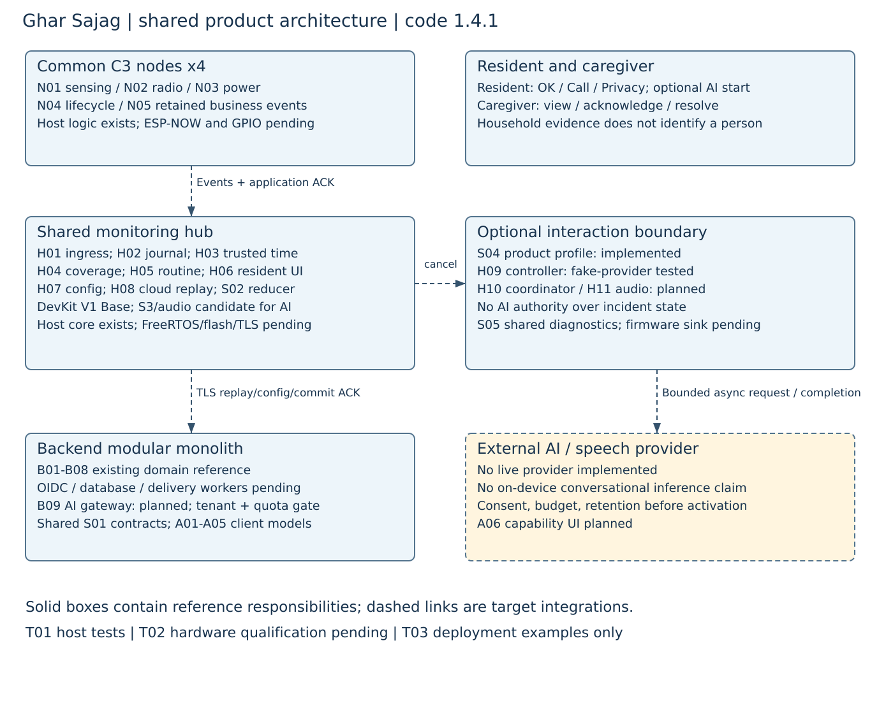
Editable sources: diagrams/architecture. The diagram carries the inherited 1.4.1 topology because no runtime architecture was changed by the 1.4.2 comment patch. All physical/provider links remain target integration boundaries.

AI extension carried forward from version 1 4
The implemented AI-specific addition is an interaction session controller and product build gate. It is testable without microphones, speakers or a real model. The provider interface contains only start and cancel requests; it has no transcript/audio payload contract. A real voice pipeline therefore requires additional adapters and schemas.

Build choice
Current code. PRODUCT=base supplies GS_PRODUCT_AI=0; PRODUCT=ai supplies 1. Unknown product names fail make.
Integration design. Ship and validate Base first. Keep optional interfaces in the repository without enabling recording.
Required evidence. Build both profiles; in Base verify fake provider start count stays zero.

Session admission
Current code. begin rejects Disabled, NoConsent, Offline, Busy and ID Exhausted conditions before starting a new request.
Integration design. Obtain consent and connectivity from authoritative owner state, not arbitrary booleans from a web client.
Required evidence. Exercise every rejection and verify no provider side effect.

Start and completion
Current code. A permitted start advances a uint64 ID and enters Waiting. complete accepts only the active Waiting ID.
Integration design. Route asynchronous results through H10 and give each boot/session a safe correlation epoch in a real adapter.
Required evidence. Test wrong ID, duplicate completion, completion after cancel and callback after reboot.

Timeout
Current code. tick uses elapsed monotonic milliseconds and fails the request at 30000 ms, cancelling the provider.
Integration design. Schedule tick even when no network response arrives; bound the worker queue and provider deadline too.
Required evidence. Test 29999 and 30000 ms and ensure monitoring continues during stalled provider work.

Cancellation
Current code. cancel resets H09 to Idle and invokes Provider.cancel only while Waiting.
Integration design. H10/H11 must separately stop recording and playback, including audio already buffered after Ready.
Required evidence. Revoke consent during capture, network wait and playback; inspect that buffers and workers stop.

Errors
Current code. A false Provider.start puts state in Failed but begin still returns Accepted. Errors and timeout have metadata hooks.
Integration design. Review an explicit start-failed result when the public API evolves; do not equate Accepted with spoken output.
Required evidence. Inject immediate start failure and negative completion; verify state and diagnostics.

Privacy and authority
Current code. H09 carries IDs and lifecycle state, not audio/transcript buffers, and exposes no incident mutation interface.
Integration design. Define retention, provider processing region, redaction and separate AI consent before any real provider activation.
Required evidence. Prove no transcript in logs and no model-generated acknowledgement or resolution.

Cost and hardware
Current code. There is no model, speech pipeline, quota gateway or audio implementation in this release.
Integration design. Select provider/audio hardware later after Base acceptance; measure recurring costs, RAM and cancellation latency.
Required evidence. Use a fake streaming adapter first, then measured provider and hardware trials; do not publish speculative costs.
State or result | Meaning
Idle | No active wait; begin may admit a new request if policy permits.
Waiting | Provider was requested; only matching completion can finish this session.
Ready | Completion succeeded. This does not itself mean that audio has played.
Failed | Start, completion or timeout failed; a new begin can create a new ID.
Accepted | Admission occurred; inspect state because immediate provider start failure also returns Accepted.
Disabled / NoConsent / Offline / Busy / Exhausted | Admission refusal reasons; no new provider start for these cases.

Worked timeout and cancellation example
Assume an AI build, consent true and online true. begin(1000, true, true) creates request 1 and enters Waiting. complete(99, true) returns false because the ID is wrong. tick(30999) leaves Waiting; tick(31000) reaches the 30000 ms timeout, enters Failed and calls provider.cancel(1). A subsequent complete(1, true) returns false. The next begin uses request 2, so a late result from request 1 cannot complete it.
The controller borrows the Provider object, which must outlive it. Provider methods must return promptly and must not call back into Controller synchronously. H10, still planned, will serialize callback messages on one owner. Cancellation after Ready requires separate playback handling because H09 only invokes Provider.cancel while Waiting.

AI requirement register

V01 Build-selected product identity
Scope: Both. Participants: S04, T01.
Acceptance requirement. make verify PRODUCT=base|ai; invalid PRODUCT fails; Product::name/version identify build.
Implementation status. Passed at the stated component boundary. Product enum/profile tests and invalid-build check.

AI01 Base provider exclusion
Scope: Base. Participants: S04, H09, T01.
Acceptance requirement. Base begin returns Disabled and fake provider receives zero starts.
Implementation status. Passed at the stated component boundary. tests/cpp/test_product.cpp: base branch.

AI02 Consented interaction admission
Scope: AI. Participants: H09, B02, H10.
Acceptance requirement. Reject missing consent/offline before start; active session rejects a second start.
Implementation status. Partial at the stated component boundary. Controller tests pass; consent propagation and audio capture gate pending.

AI03 Correlated completion and timeout
Scope: AI. Participants: H09, T01.
Acceptance requirement. Reject wrong, duplicate and late IDs; expire at 30000 monotonic milliseconds.
Implementation status. Passed at the stated component boundary. tests/cpp/test_product.cpp: timeout and completion checks.

AI04 Resident cancellation and privacy revocation
Scope: AI. Participants: H09, H10, H11, B02.
Acceptance requirement. Controller cancels pending provider; physical cancel and consent withdrawal stop recording/playback.
Implementation status. Partial at the stated component boundary. Controller cancellation tested; physical and privacy wiring pending.

AI05 Monitoring priority over conversation
Scope: AI. Participants: H05, H06, H09, H10.
Acceptance requirement. Monitoring never waits for model response; urgent prompt preempts interaction.
Implementation status. Pending at the stated component boundary. Coordinator and load/latency tests not implemented.

AI06 Audio and model-provider integration
Scope: AI. Participants: H11, B09.
Acceptance requirement. Bounded audio buffers; authenticated provider path; explain offline/unavailable state.
Implementation status. Pending at the stated component boundary. No live provider, microphone capture or speech synthesis implemented.

AI07 Capability and cost policy
Scope: AI. Participants: S04, B09, A06, B01.
Acceptance requirement. Server enforces tenant/edition/consent/quota; UI reflects availability, not authorization.
Implementation status. Pending at the stated component boundary. No capability endpoint or spending limiter implemented.

AI08 Diagnostic and monitoring separation
Scope: AI. Participants: S05, H09, S02.
Acceptance requirement. Controller logs no audio/transcript; AI response cannot acknowledge or resolve incidents.
Implementation status. Partial at the stated component boundary. Metadata-only hooks exist; live adapter and incident-isolation integration tests pending.
Base P0 development should continue without implementing H10, H11, B09 or A06. Retain these designs so future work does not introduce an AI dependency into deterministic monitoring. S3/audio selection and live service costs are open decisions, not purchases required for Base.

Revision and implementation status
Edition 2.0 expands the supplied baseline and carries forward the version 1.4 AI session design. Code 1.4.2 changes comments and version metadata only. Base P0 remains the development priority. Existing tests cover components; no complete hardware or unattended field acceptance is claimed. Read progress.txt and the workbook for current gaps.

