PROTOTYPE DEPLOYMENT GUIDE
Family Check-In
House placement, morning-routine logic and communication behaviour
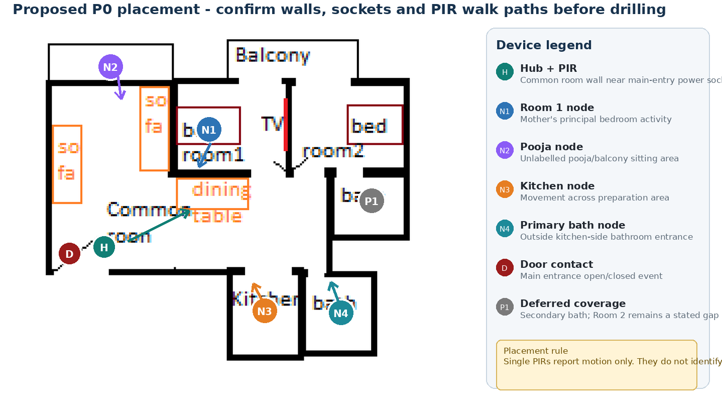
Conceptual placement based on the supplied sketch; validate exact walls, sockets and movement paths on site.
Version | Status | Base configuration | Date
2.0 | Expanded engineering handover | 1 hub + 4 nodes | 9 September 2026

Edition 2 reading guide
This edition is written for an engineer joining the project now or returning after a year. It expands the uploaded baseline with reasons, concrete household examples, execution order, failure cases and implementation boundaries. The original detailed chapters, tables and figures are retained. Their target designs are interpreted using the current status notes in this edition.
The immediate product is Ghar Sajag Parivar Saathi with Base P0. P1 is a future development stage or optional add-on decision, not a promised third product. Sarthi AI is a future interaction offering using the shared monitoring core. Base monitoring does not depend on a model, microphone or cloud inference.
Documentation edition 2.0 accompanies reference source 1.4.2. Source 1.4.2 adds requirement comments and version metadata to the 1.4.1 code; it does not implement new monitoring or AI algorithms. The 1.4 AI session controller is retained and explained in the AI design volume.
Term | How to interpret it
Required | An acceptance obligation from the SRD. It can remain unimplemented.
Implemented reference | A host-language component exists; it may use volatile stores or fake adapters.
Verified host checkpoint | The specific assertion ran on the development host. It is not full requirement coverage.
Target integration pending | GPIO, FreeRTOS, radio, flash, server/provider or full UI work still needs implementation and evidence.
Future AI | An extension excluded from the immediate Base P0 build scope.
Read START_HERE.md for the full document order. Use Requirement_Traceability.csv and Code_Traceability.csv to move from a requirement to module, source file and existing test. A comment such as @requirements F05, E02 is a responsibility link, not a claim that those requirements are fully complete.
Source baseline: Family_CheckIn_Deployment_and_Routine_Logic_Guide(2).docx. The original upload is also included under reference_baselines. The preservation report records original and revised word/table/figure counts and heading retention. Market prices and supplier availability are historical inputs unless explicitly dated as rechecked; this edition does not refresh market research.

Current decisions that resolve earlier ambiguity
Routine evidence. The current reducer accepts one qualifying activity event or OK in its window. Two-zone/session-duration examples are retained as future hypotheses. They are not implemented P0 qualification rules.
Coverage. Current lease status exists. Full-window coverage history and local prompt/grace orchestration are pending. Missing activity must not be presented as a wellbeing or medical conclusion.
Timing. The reference NodeConfig uses a 60-second heartbeat and HubRuntime a 190-second lease. Older 15-minute heartbeat and 35-minute timeout examples are trial alternatives and must not be mixed with these defaults.
Persistence. DURABLE is the target application-ACK meaning. In-memory test stores model ordering; they do not survive power loss. Production flash/database adapters and compaction remain open.
Modules. Canonical modules are N01–N05, H01–H08, B01–B08, A01–A05, S01–S03 and T01–T03, with S04 product profile, H09 interaction and S05 diagnostics. H10/H11/B09/A06 are planned. Legacy log aliases are not extra deployed modules.
Logs. ERROR hooks remain available in the commercial build profile, but absent/failed sinks can lose records. Current host logging is synchronous; it does not catch arbitrary memory corruption or guarantee crash persistence.

Installation reasoning for this home
Mother mainly uses Room 1 and sits in the pooja area daily; father also uses Room 2 and the common/dining area. Both use the kitchen and mainly the kitchen-side bathroom. These facts explain placement, but they do not make a PIR identify a person. The system remains household-level.
Point | Base placement | Reason and limitation
Hub | Common room near usable mains/socket and radio coverage | Can host common-room PIR and door input if the cable route is practical. Keep buttons reachable; a high PIR mounting position must not force buttons out of reach.
Node R1 | Room 1 crossing path | Covers a frequently used room; avoid treating a stationary person on the bed as absent.
Node PJ | Pooja entry/crossing path | Captures entry or movement. Fifteen minutes of still sitting is not measurable occupancy.
Node KT | Kitchen crossing/preparation path | Activity only; cannot prove cooking, tea preparation or stove safety.
Node B1 | Dry approach outside primary bathroom | Approach evidence only. Avoid collecting unnecessary detailed bathroom behaviour.
Known gaps | Room 2 and secondary bathroom | Record gaps visibly and review shadow observations before buying another node.
The drawing is conceptual. Measure the actual door-to-hub cable route and radio reception before fixing placement. Power availability near the CP Plus camera socket is useful, but do not assume the camera adapter output is electrically suitable for the hub. Use the selected regulated supply and qualified wiring.

Assembly and software readiness are separate
Use the uploaded BOM as the purchasing/assembly record. Commercial alternative in a spreadsheet means a candidate for qualification, not a certified part or an approved complete power subsystem. Battery shielding, protection, charging under load, switch-over, low-load shutoff and enclosure access must be checked for the exact purchased module.
Before field placement, run one node and one hub on a supervised bench. Validate the input polarity, warm-up and debounce; record a single event through both journals; unplug the link and recover it. Only then clone the node identity/configuration to four locations. Keep a printed label matching node ID, zone and firmware version.

Shadow trial record
For each day record configured window/version, known modes, first observed activity, explicit OK, required-node coverage gaps, clock state, hub reboot, predicted incident and caregiver interpretation. Include unusual but normal days such as a late start, visitors and an away day. This labelled record explains false alerts better than an opaque score.
Start with alerts disabled and manually review the predicted outcome. Enable local prompts only after physical usability works; enable remote routing only after primary and backup caregivers can explain the difference between missing activity and lost coverage. A seven-day trial is a proposed minimum observation period, not statistical proof of reliability.

Retained detailed baseline with edition 2 explanations
The chapters below retain the uploaded detail. New explanatory paragraphs are placed at the relevant requirement/module headings. Historical implementation counts and future-state diagrams must be read with the current boundaries and open-work register above.

1. Purpose and frozen decisions
This guide converts the current product requirements into an installable first prototype. It fixes the P0 device placement, defines how raw sensor events become a morning check-in decision, and states the communication and testing behaviour needed before enabling caregiver alerts.
P0 product claim: Camera-free household routine-deviation and family check-in support. It is not a fall detector, medical monitor, smoke detector, cooking detector or emergency-response service.

1.1 Decisions fixed for this prototype
- One ESP32 DevKit V1 hub remains continuously powered where practical and contains the common-room PIR, buzzer, OLED and OK button.
- Four ESP32-C3 SuperMini nodes cover Room 1, the pooja/balcony sitting area, the kitchen and the kitchen-side primary bathroom entrance.
- The main-door magnetic contact connects to the hub because the hub is placed inside the common room near the existing camera power socket. This avoids a fifth node in the base build.
- Nodes communicate to the hub using ESP-NOW. The hub uses home Wi-Fi for the dashboard and outbound caregiver notifications.
- P0 decisions are rule-based and configurable. Historical learning is deferred until the system has collected reliable labelled data.
- Room 2 and the secondary bathroom are documented coverage gaps, not silently treated as monitored areas.

1.2 Non-negotiable interpretations
Observed signal | What P0 may say | What P0 must not claim
PIR event | Movement detected in a named zone | Which person moved, travel direction, a fall, sleep or wellbeing
Kitchen event cluster | Kitchen activity occurred | Food was cooked, milk boiled or a stove was used
Bathroom-entrance motion | Movement occurred near the bathroom entrance | Bathroom occupancy, duration or an emergency
No expected event | Expected household activity was not observed | A person is inactive or in danger
Missing heartbeat | Coverage is unknown because a node is offline | No resident activity

2. House layout and placement
Figure 1. Proposed P0 placement and indicative PIR look directions.

2.1 Device placement register
ID | Location | Hardware | Mounting intent | Routine value
HUB-01 | Common room wall near main entrance and camera-power socket | ESP32 DevKit V1, PIR, buzzer, OLED, OK button; door contact input | PIR about 1.8-2.2m high, facing across common/dining movement; hub accessible for USB service | Common/dining activity, local prompts, door event and central communications
NODE-R1 | Room 1 | ESP32-C3 + AM312 PIR | High corner or wall facing the room crossing path, not directly at the bed | Mother's main-room activity and first-morning movement evidence
NODE-PJ | Unlabelled pooja/balcony sitting area | ESP32-C3 + AM312 PIR | Face across the sitting/entry path; verify the exact pooja boundary before mounting | Repeated motion over a time span may support a pooja-session proxy
NODE-KT | Kitchen | ESP32-C3 + AM312 PIR | Face across the preparation path; keep away from stove heat, direct sunlight and exhaust airflow | Kitchen activity proxy; never treated as proof that food was cooked
NODE-B1 | Outside kitchen-side primary bathroom | ESP32-C3 + AM312 PIR | Install outside the wet area and face across the approach | Bathroom-approach evidence without sensing inside the bathroom
DOOR-01 | Main entrance | MC-38 magnetic contact | Fixed and moving halves aligned; short cable to HUB-01 with strain relief | Door-open/closed event; not direction or identity

2.2 Placement rules
- Aim each PIR so people cross its field of view. Direct approach or departure along the sensor centre line is less reliable, and one PIR cannot determine direction.
- Start with removable tape or a temporary bracket. Drill only after the walk test and seven-day shadow trial.
- Keep the PIR away from direct sun, hot appliances, strong drafts and rapidly changing heat sources that can cause false events.
- Keep ESP32 antennas clear of batteries, large wires, metal enclosures and the CP Plus camera power adapter where possible.
- The base system is household-level. It cannot independently confirm the mother in Room 1 and the father in Room 2.
Room 2 decision: Do not move a P0 node there initially. During the shadow trial, record how often meaningful activity begins or remains in Room 2. Add a fifth node only if the gap causes missed or misleading routine decisions.

3. P0 morning-routine algorithm
The algorithm evaluates household evidence, not individual identity. It must first prove that monitoring coverage is healthy, then evaluate whether sufficient expected morning activity occurred. Only after both conditions hold may it ask the resident to check in or notify a caregiver.
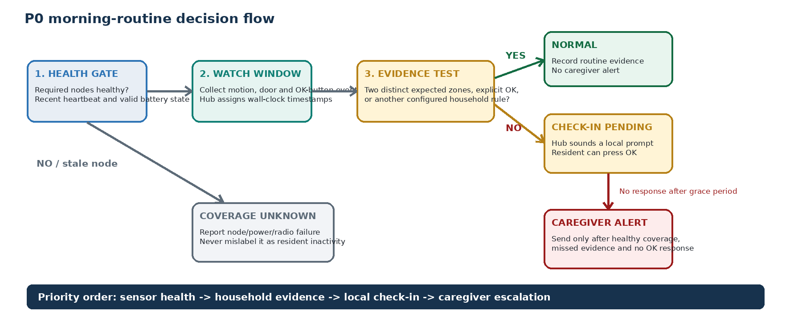
Figure 2. Sensor health always precedes inactivity interpretation.

3.1 Configurable starting parameters
Edition 2 status. The following retained baseline describes a target or trial hypothesis. Current reference code uses single-event evidence and present-state coverage; session thresholds, full prompt/grace orchestration and a local hub dashboard are not implemented. Use Edition 2 current decisions and the gap register before implementation.
These are safe starting values for a shadow trial, not assumptions about the parents' actual schedule. Update them after observing normal routines.
Parameter | Initial value | Meaning and tuning rule
Morning watch start | 05:30 | Begin evaluating morning evidence; events remain logged outside this window
Routine deadline | 10:00 | If evidence remains insufficient at this time, enter CHECK_IN_PENDING only when coverage is healthy
Distinct-zone threshold | 2 zones / 120 min | Two different expected zones are a strong household-activity signal; tune from shadow data
Pooja-session proxy | 3 events spanning >=10 min | Indicates repeated movement in the pooja zone; does not prove continuous presence
Kitchen-session proxy | 2 events within 20 min | Indicates kitchen activity; does not infer cooking
Heartbeat interval | 15 min | Node health report while idle; measure battery impact before reducing
Offline threshold | 35 min | Two missed heartbeats plus margin; affected coverage becomes UNKNOWN
Local check-in grace | 10 min | Time for the resident to press OK after the hub prompt
Caregiver acknowledgement | 10 min reminder | Repeat notification if not acknowledged; do not auto-call emergency services in P0

3.2 Evidence evaluation
Edition 2 status. The following retained baseline describes a target or trial hypothesis. Current reference code uses single-event evidence and present-state coverage; session thresholds, full prompt/grace orchestration and a local hub dashboard are not implemented. Use Edition 2 current decisions and the gap register before implementation.
- At the watch start, create a new daily routine record and set the state to WATCHING.
- Run the health gate. A required node is healthy only if its heartbeat is recent and its battery status is valid.
- Convert raw PIR edges into de-duplicated motion events. The hub assigns the household wall-clock timestamp.
- Build short zone sessions by grouping events separated by less than the configured session-gap threshold.
- Mark routine evidence sufficient after an explicit OK, two distinct expected zones within the evidence window, or another deliberately configured rule.
- At the routine deadline, enter CHECK_IN_PENDING only if evidence is insufficient and all required coverage is healthy.
- If the resident presses OK, record the outcome and return to NORMAL. If there is no response after the grace period, issue a caregiver alert.
- If any required node becomes stale, enter COVERAGE_UNKNOWN and issue a technical coverage alert instead of an inactivity alert.

3.3 Daily state machine
Edition 2 status. The following retained baseline describes a target or trial hypothesis. Current reference code uses single-event evidence and present-state coverage; session thresholds, full prompt/grace orchestration and a local hub dashboard are not implemented. Use Edition 2 current decisions and the gap register before implementation.
State | Entry condition | Hub behaviour | Exit condition
SUSPENDED | Away mode, maintenance or disabled schedule | Log health only; suppress routine alerts | Schedule resumes or caregiver enables monitoring
WATCHING | Morning window begins with healthy minimum coverage | Collect and evaluate household evidence | Evidence sufficient, deadline reached or coverage lost
NORMAL | Evidence sufficient or resident presses OK | Show last activity and routine completion | Next watch window or new fault
CHECK_IN_PENDING | Deadline reached with insufficient evidence and healthy coverage | Sound local prompt; display Press OK | OK pressed, grace expires or coverage lost
CAREGIVER_ALERTED | No OK response after grace period | Send notification and await acknowledgement | Caregiver acknowledges, resident responds or alert is resolved
ACKNOWLEDGED | Caregiver accepts the alert | Stop repeated notifications; retain audit trail | Manually resolved or new independent alert
COVERAGE_UNKNOWN | Required node, hub power or radio status is stale | Send technical alert; never claim resident inactivity | Health recovers and a fresh evaluation begins

4. Communication and failure scenarios

4.1 Node-to-hub protocol
Message | Trigger | Minimum fields | Reliability behaviour
BOOT | Node starts or resets | protocol_version, node_id, boot_id, firmware, battery_mV | Hub records restart and replies with ACK/config version
EVENT | PIR, button or door transition | node_id, boot_id, sequence, event_type, local_uptime, battery_mV | Hub de-duplicates by node_id + boot_id + sequence; node retries up to three times
HEARTBEAT | Periodic idle timer | node_id, sequence, battery_mV, uptime, fault flags | Every 15 minutes initially; hub declares stale after 35 minutes
ACK | Valid packet received | node_id, boot_id, acknowledged_sequence, hub_status | Stops retry and confirms delivery
CONFIG | Hub changes allowed node parameters | config_version, heartbeat interval, sensor mode | Apply only after validation; acknowledge active version

ESP-NOW is used only inside the home between paired nodes and the hub. The hub maintains an allow-list of node identities. For a commercial pilot, add authenticated/encrypted messages and a secure re-pairing process; MAC-address filtering alone is not sufficient security.

4.2 Hub-to-dashboard behaviour
Edition 2 status. The following retained baseline describes a target or trial hypothesis. Current reference code uses single-event evidence and present-state coverage; session thresholds, full prompt/grace orchestration and a local hub dashboard are not implemented. Use Edition 2 current decisions and the gap register before implementation.
- The local web dashboard displays last activity by zone, routine state, node heartbeat age, battery status, internet status and alert acknowledgement.
- The hub sends caregiver notifications through an outbound HTTPS adapter. Do not expose the hub directly to the internet or require router port forwarding.
- When Wi-Fi is unavailable, the hub continues local routine evaluation, local prompting and event logging. Remote alerts are marked queued and transmitted after connectivity returns.
- OTA may update the hub over Wi-Fi after rollback testing. P0 nodes retain physical USB recovery; node OTA is a later controlled enhancement, not the only recovery path.

4.3 Scenario matrix
Scenario | What must happen | User-facing status
Normal motion | Node sends EVENT, hub ACKs, de-duplicates and updates zone timestamp | Activity detected in [zone]
Duplicate/retried packet | Hub keeps one logical event and ACKs the repeated sequence | No duplicate dashboard count
One node offline | Hub stops using that zone as negative evidence and raises a coverage fault | [Zone] sensor offline - coverage unknown
All nodes quiet but healthy | At deadline, hub prompts locally; escalates only after grace period | Expected activity missing - check-in requested
Resident presses OK | Hub records source/time, cancels pending escalation and reports completion | Resident checked in
Caregiver acknowledges | Hub records actor/time and stops reminder notifications | Family acknowledged
Home Wi-Fi fails | ESP-NOW and local logic continue; alerts queue for outbound delivery | Internet unavailable - local monitoring active
Hub loses power | Nodes cannot guarantee delivery; on reboot hub declares recovery and re-establishes health | Hub was offline - coverage gap recorded
Low node battery | Warn before expected shutdown and keep health distinct from activity | Low battery: [zone]

5. Software behaviour and stored data

5.1 Logical modules
Module | Runs on | Responsibility
Sensor input | Node | Debounce PIR/button/reed input and create logical events
Power and health | Node | Measure battery through the approved divider, generate heartbeat and flag faults
ESP-NOW transport | Node + hub | Pairing, packet validation, ACK/retry, versioning and sequence de-duplication
Event store | Hub | Assign wall-clock time; retain event, node health and alert outcome records
Routine engine | Hub | Sessionise events, run health gate, evaluate rules and transition state
Prompt and acknowledgement | Hub | Drive buzzer/OLED/button and record resident response
Notification adapter | Hub | Send queued caregiver alerts and receive acknowledgement through the application service
Local dashboard | Hub | Present zone activity, coverage, batteries, configuration and audit history
Configuration | Hub | Store household schedule, thresholds, zone roles and versioned node parameters
OTA and recovery | Hub; nodes later | Signed/staged update, rollback and physical recovery path

5.2 Minimum event record
Each logical event should retain: event_id, household_id, node_id, zone_id, boot_id, sequence number, event type, hub timestamp, node uptime, battery millivolts, transport result, routine state before/after and any alert or acknowledgement correlation ID. Raw continuous sensor streams are unnecessary for P0.

5.3 Privacy and retention
- Store motion events rather than images, audio or inferred personal identity.
- Give residents a visible pause/away control and show when coverage is suspended.
- Use a configurable retention period; start with 30 days of detailed events and longer-lived daily summaries only after consent.
- Do not expose precise bathroom timing in caregiver views; use only coarse activity evidence and device health.
- Separate resident OK, caregiver acknowledgement and automatic routine evidence in the audit trail.

5.4 Learning roadmap
Historical learning is P1. First collect at least two to four weeks of reliable, labelled events in shadow mode. Labels must include normal day, late start, away day, guest activity, sensor moved, power failure and false trigger. Begin with per-household statistical baselines before considering a trained model.
Do not train yet: Temperature, humidity and PIR changes can later become contextual features, but correlation is not proof of cooking or risk. Add sensors only after the P0 event quality and caregiver workflow are validated.

6. Installation, calibration and acceptance

6.1 Installation sequence
- Bench-test each ESP32, PIR, button, reed input, buzzer and battery reading before soldering.
- Assign permanent node IDs and labels that match the dashboard and this document.
- Assemble on perfboard using the final BOM wiring guide: 22AWG red/black for power and multistrand ribbon for signals.
- Place devices temporarily with removable tape; keep enclosures open only while supervised and batteries inaccessible to residents.
- Perform crossing-path and direct-approach walk tests for every PIR and adjust angle before drilling.
- Run a 24-hour connectivity test, then a seven-day silent shadow trial with alerts disabled.
- Tune the routine window and evidence thresholds from labelled shadow data.
- Enable local prompts first. Enable caregiver notifications only after the family understands every status message.

6.2 Room-by-room checks
Zone | Required test | Pass criterion
Common/dining | Twenty normal crossing walks plus seated dining activity | At least 18 walks detected; no repeated false triggering from TV, fan or sunlight during an empty two-hour period
Room 1 | Bed-to-door and door-to-bed paths | Movement consistently detected without aiming directly at the bed
Pooja | Enter, sit for 15 minutes with normal small movement, then leave | Activity cluster is recorded; system does not claim continuous occupancy
Kitchen | Normal preparation paths with stove off, then during typical cooking | Human movement is detected; no cooking conclusion is produced
Primary bath approach | Approach and leave by typical route | Entrance-area movement detected without sensing inside the wet area
Main door | Twenty open/close cycles and slight misalignment test | Correct state in all cycles; hub reports cable/sensor fault separately when feasible

6.3 P0 exit criteria
- All nodes run for seven consecutive days without unexplained resets or duplicate logical events.
- Every zone reports a heartbeat within the configured interval and changes to COVERAGE_UNKNOWN after the offline threshold.
- Loss of one node never generates a false resident-inactivity alert.
- Wi-Fi loss does not stop ESP-NOW reception, local logging, local prompts or the OK button.
- The hub recovers after power cycling and clearly records the monitoring gap.
- The resident can complete an OK check-in without using a phone.
- The caregiver can distinguish activity missing, sensor offline, resident OK and family acknowledged in a comprehension test.
- At least seven shadow mornings are labelled and reviewed before live escalation is enabled.
- No enclosure exposes loose cells, bare conductors or unsupported wiring to residents.

6.4 Trial log template
Date | Normal routine? | System result | False/missed event | Cause/action

7. Known gaps and controlled enhancements
Gap or enhancement | P0 treatment | Trigger for P1
Room 2 coverage | Explicitly unmonitored | Shadow data shows repeated missed activity or individual monitoring becomes a requirement
Secondary bathroom | Explicitly unmonitored | Meaningful use frequency justifies an additional node
Main-door dedicated node | Reed connects to nearby hub | Cable run proves impractical or hub placement weakens common-room coverage
Temperature/humidity | Excluded from decisions | P0 events are reliable and a labelled kitchen-context experiment is defined
Smoke/fire detection | Use a certified standalone alarm; do not add hobby gas sensors | Only through certified-device integration and regulatory review
mmWave/fall detection | Excluded | Separate accuracy, privacy and liability programme is funded
Person identification | Not possible with PIR | Resident consent and a suitable privacy-preserving technology are established
Node OTA | Physical USB recovery retained | Signed update, rollback and recovery have passed repeated failure tests
Commercial power | Prototype battery shields only | Qualified load-sharing, protection, thermal and supplier controls are ready

7.1 Immediate next action
Build order: Assemble and program HUB-01 plus one Room 1 node first. Prove ESP-NOW event delivery, heartbeat/offline logic, local dashboard and OK-button flow before duplicating the remaining three nodes.

After the first pair operates reliably for 48 hours on the bench, clone the node firmware with a different node ID, then add pooja, kitchen and primary-bathroom nodes one at a time. This keeps hardware faults, radio faults and algorithm faults separable.

Appendix A. Related project artifacts
This document should be used with Family_CheckIn_P0_Requirements_and_Software_Design.docx for detailed module requirements and Family_CheckIn_Hardware_BOM.xlsx for component purchasing, wiring products and perfboard assembly guidance.

Revision and implementation status
Edition 2.0 expands the supplied baseline and carries forward the version 1.4 AI session design. Code 1.4.2 changes comments and version metadata only. Base P0 remains the development priority. Existing tests cover components; no complete hardware or unattended field acceptance is claimed. Read progress.txt and the workbook for current gaps.

