ENGINEERING CALL-FLOW SPECIFICATION
Ghar Sajag P0 Requirement Sequence Diagrams
End-to-end participants, messages, durability points, branches and outcomes for F01-F14 and E01-E10
Design inventory | Coverage
Requirement coverage | 24 of 24 P0 requirements
Functional flows | F01-F14 (14 diagrams)
Engineering flows | E01-E10 (10 diagrams)
Participant rule | Every module mapped in Requirements v1.2 appears in its requirement sequence
Boundary: host logic and design are documented; ESP32, RF, flash, cloud-provider and installed-home evidence remain separate P0 gates.

Sequence notation and interpretation
Each diagram is a normative logical call flow. Participant order is chosen for readability; deployment/process boundaries are identified by the architecture volume and interface catalog.
Green arrows represent host behavior already expressed by the reference implementation. Dashed blue arrows identify target hardware, network, identity, push, phone or OTA interactions that remain integration gates. Amber notes encode suppression rules, privacy boundaries or non-negotiable invariants.
Notation | Meaning
Call arrow | Request/event/command crossing a module or actor boundary
Dashed return | Explicit response, acknowledgement or applied-state report
Self call | Atomic validation/state transition owned by that participant
Amber note | Alternate/suppressed path or invariant that prevents false reassurance
Outcome | Required postcondition; not a claim that target testing has passed

F01 - Household profile and caregiver roles
SEQUENCE DESIGN COMPLETE | TARGET EXECUTION/INTEGRATION EVIDENCE PENDING
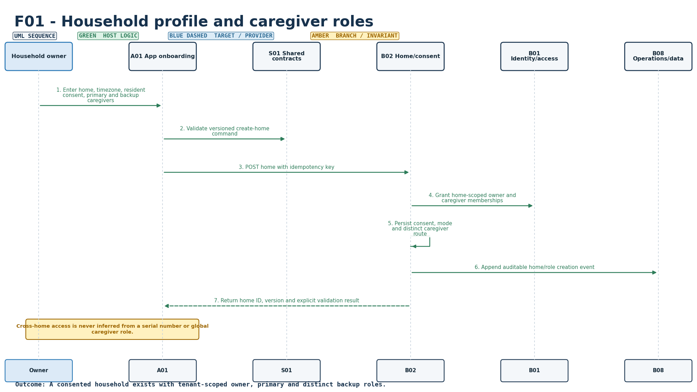
Figure S-01. Requirement-level call flow for F01.
Mapped modules: B01, B02, A01, S01. Participants: Owner, A01, S01, B02, B01, B08. Outcome: A consented household exists with tenant-scoped owner, primary and distinct backup roles.
Editable source: plantuml/sequences/F01.puml

F02 - Resident consent and privacy controls
SEQUENCE DESIGN COMPLETE | TARGET EXECUTION/INTEGRATION EVIDENCE PENDING
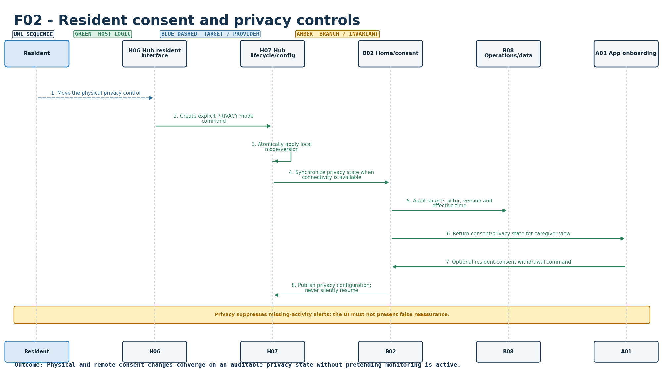
Figure S-02. Requirement-level call flow for F02.
Mapped modules: B02, H06, H07, A01, B08. Participants: Resident, H06, H07, B02, B08, A01. Outcome: Physical and remote consent changes converge on an auditable privacy state without pretending monitoring is active.
Editable source: plantuml/sequences/F02.puml

F03 - Kit provisioning and installation verification
SEQUENCE DESIGN COMPLETE | TARGET EXECUTION/INTEGRATION EVIDENCE PENDING
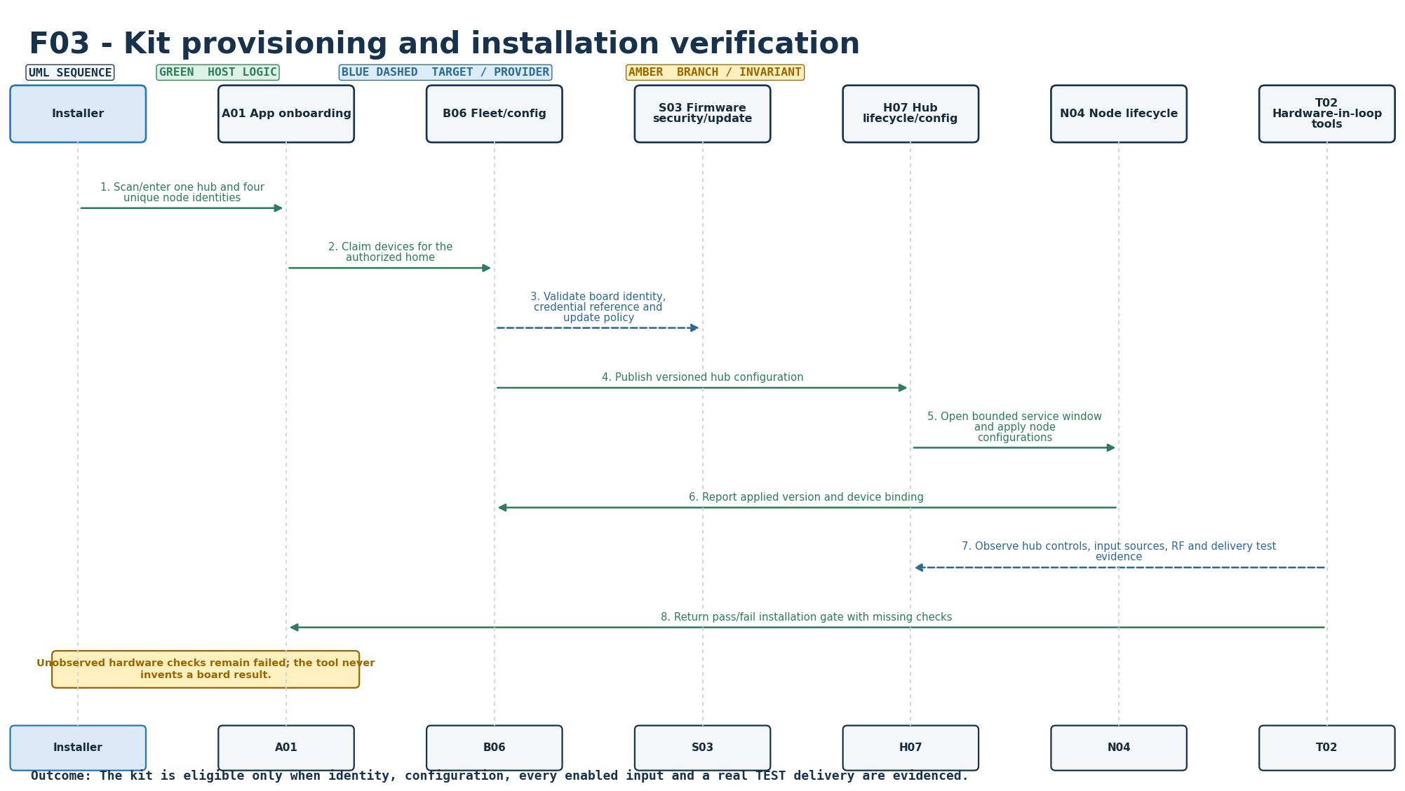
Figure S-03. Requirement-level call flow for F03.
Mapped modules: N04, H07, B06, A01, S03, T02. Participants: Installer, A01, B06, S03, H07, N04, T02. Outcome: The kit is eligible only when identity, configuration, every enabled input and a real TEST delivery are evidenced.
Editable source: plantuml/sequences/F03.puml

F04 - Configurable morning routine
SEQUENCE DESIGN COMPLETE | TARGET EXECUTION/INTEGRATION EVIDENCE PENDING
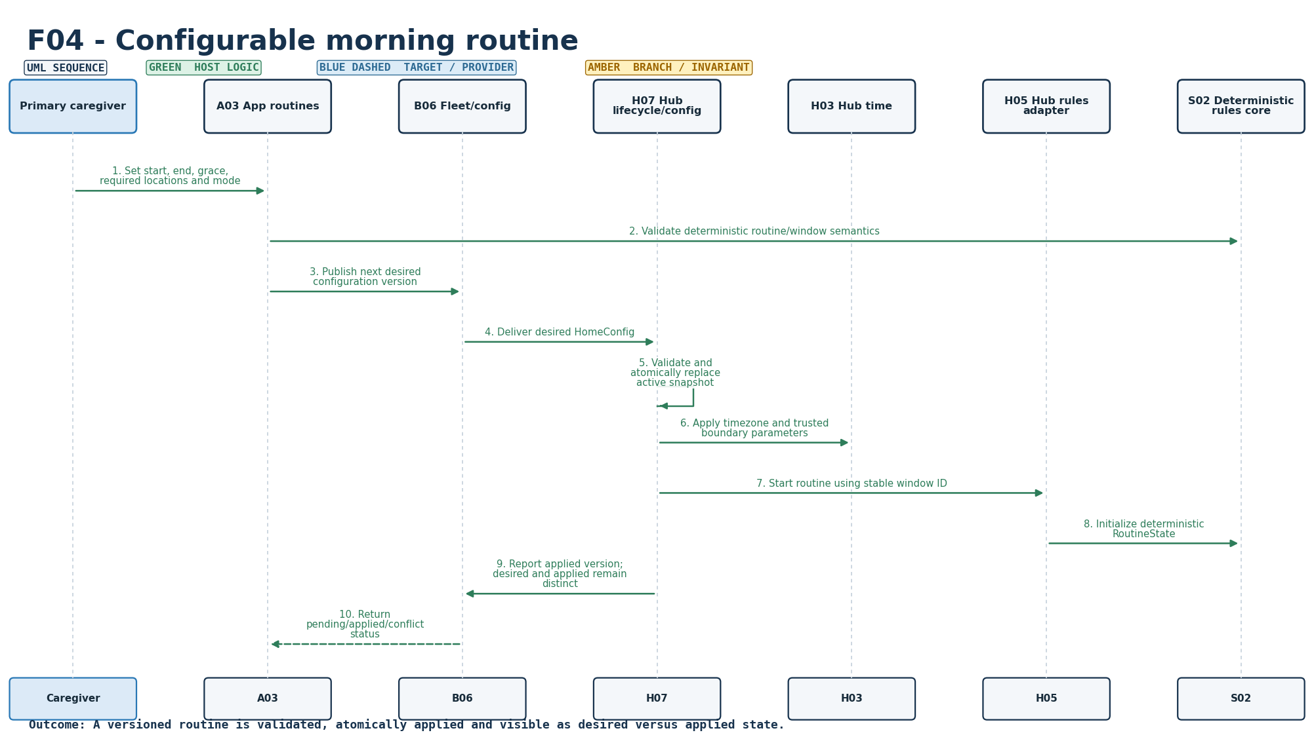
Figure S-04. Requirement-level call flow for F04.
Mapped modules: A03, B06, H07, H03, H05, S02. Participants: Caregiver, A03, B06, H07, H03, H05, S02. Outcome: A versioned routine is validated, atomically applied and visible as desired versus applied state.
Editable source: plantuml/sequences/F04.puml

F05 - Morning activity evidence
SEQUENCE DESIGN COMPLETE | TARGET EXECUTION/INTEGRATION EVIDENCE PENDING
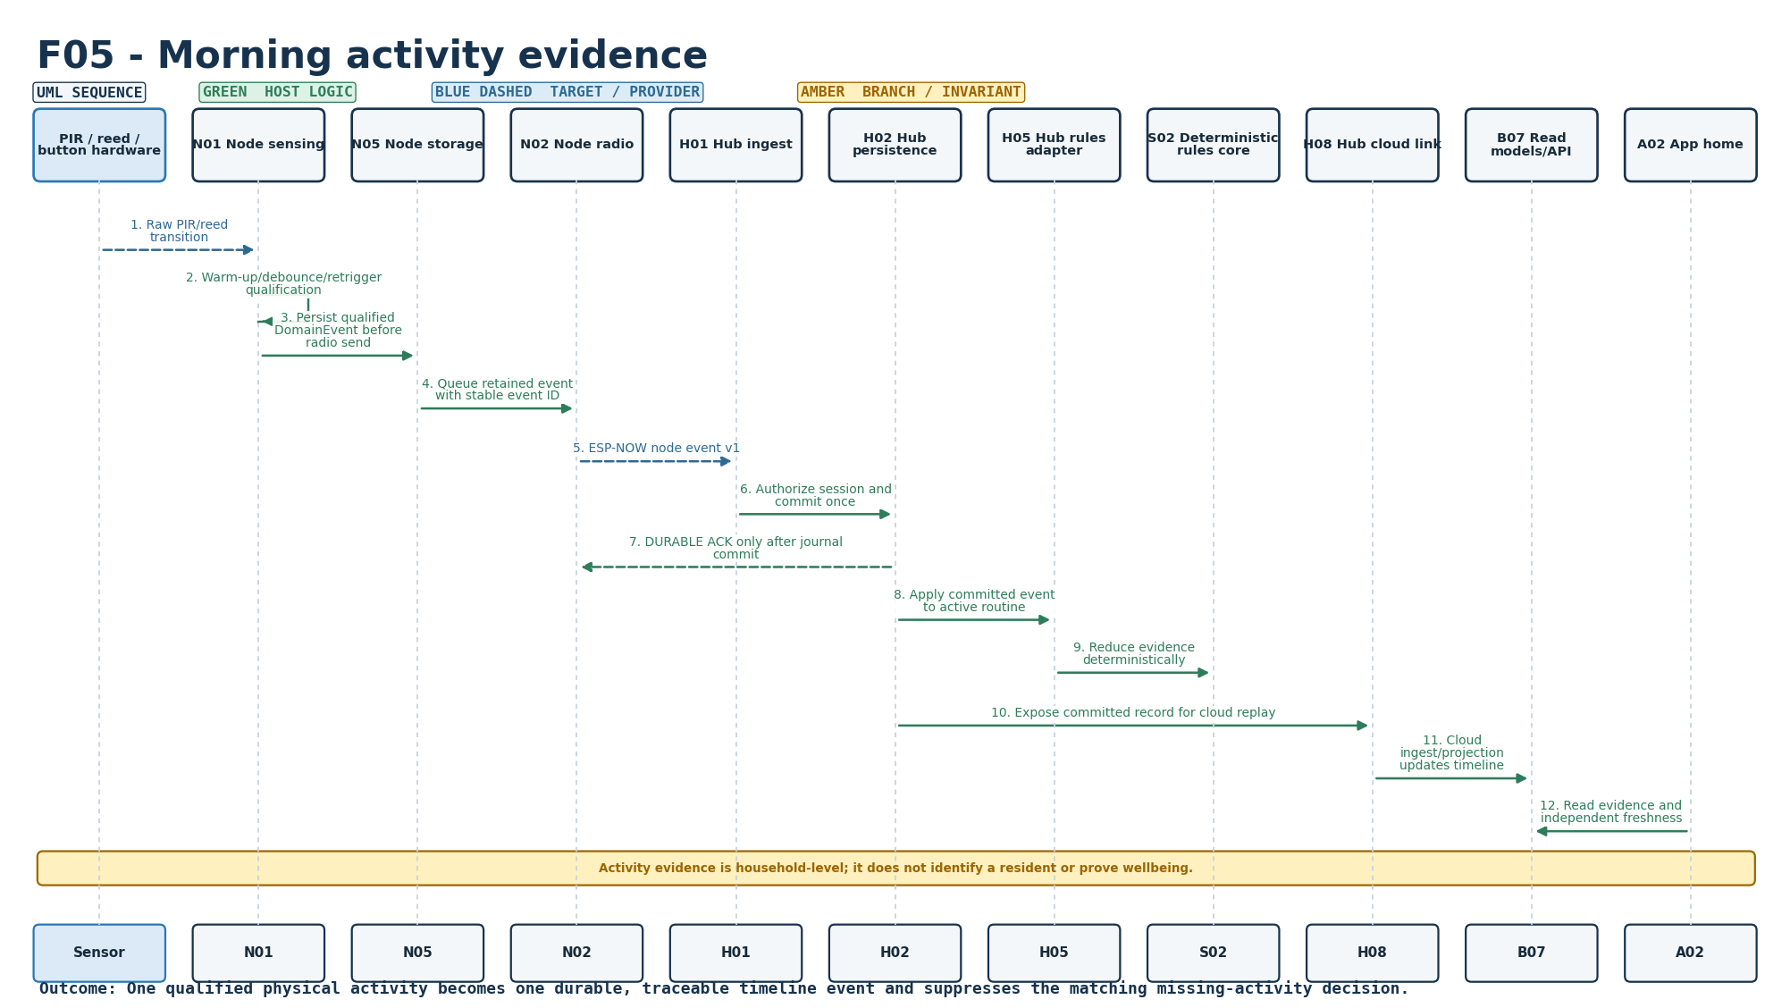
Figure S-05. Requirement-level call flow for F05.
Mapped modules: N01, H01, H02, H05, S02, B07, A02. Participants: Sensor, N01, N05, N02, H01, H02, H05, S02, H08, B07, A02. Outcome: One qualified physical activity becomes one durable, traceable timeline event and suppresses the matching missing-activity decision.
Editable source: plantuml/sequences/F05.puml

F06 - Explicit I'm OK check-in
SEQUENCE DESIGN COMPLETE | TARGET EXECUTION/INTEGRATION EVIDENCE PENDING
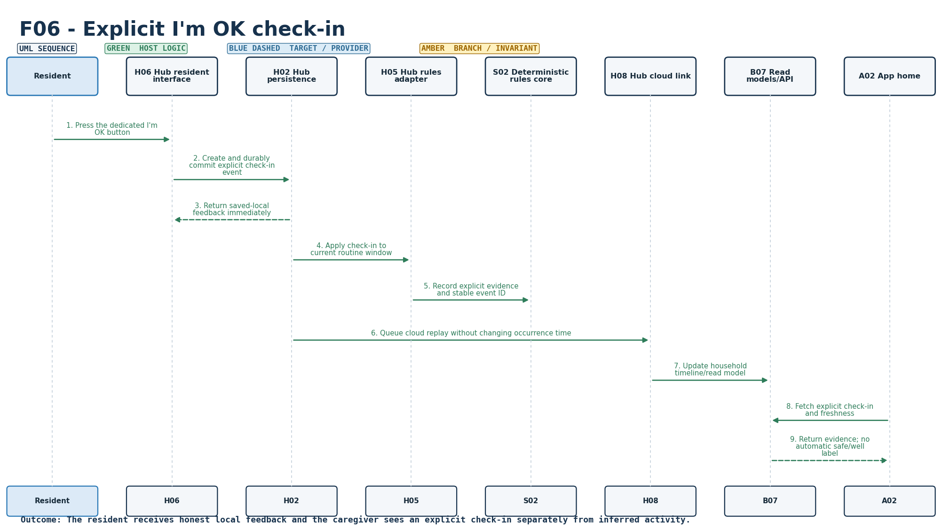
Figure S-06. Requirement-level call flow for F06.
Mapped modules: H06, H02, H05, S02, B07, A02. Participants: Resident, H06, H02, H05, S02, H08, B07, A02. Outcome: The resident receives honest local feedback and the caregiver sees an explicit check-in separately from inferred activity.
Editable source: plantuml/sequences/F06.puml

F07 - Call family request
SEQUENCE DESIGN COMPLETE | TARGET EXECUTION/INTEGRATION EVIDENCE PENDING
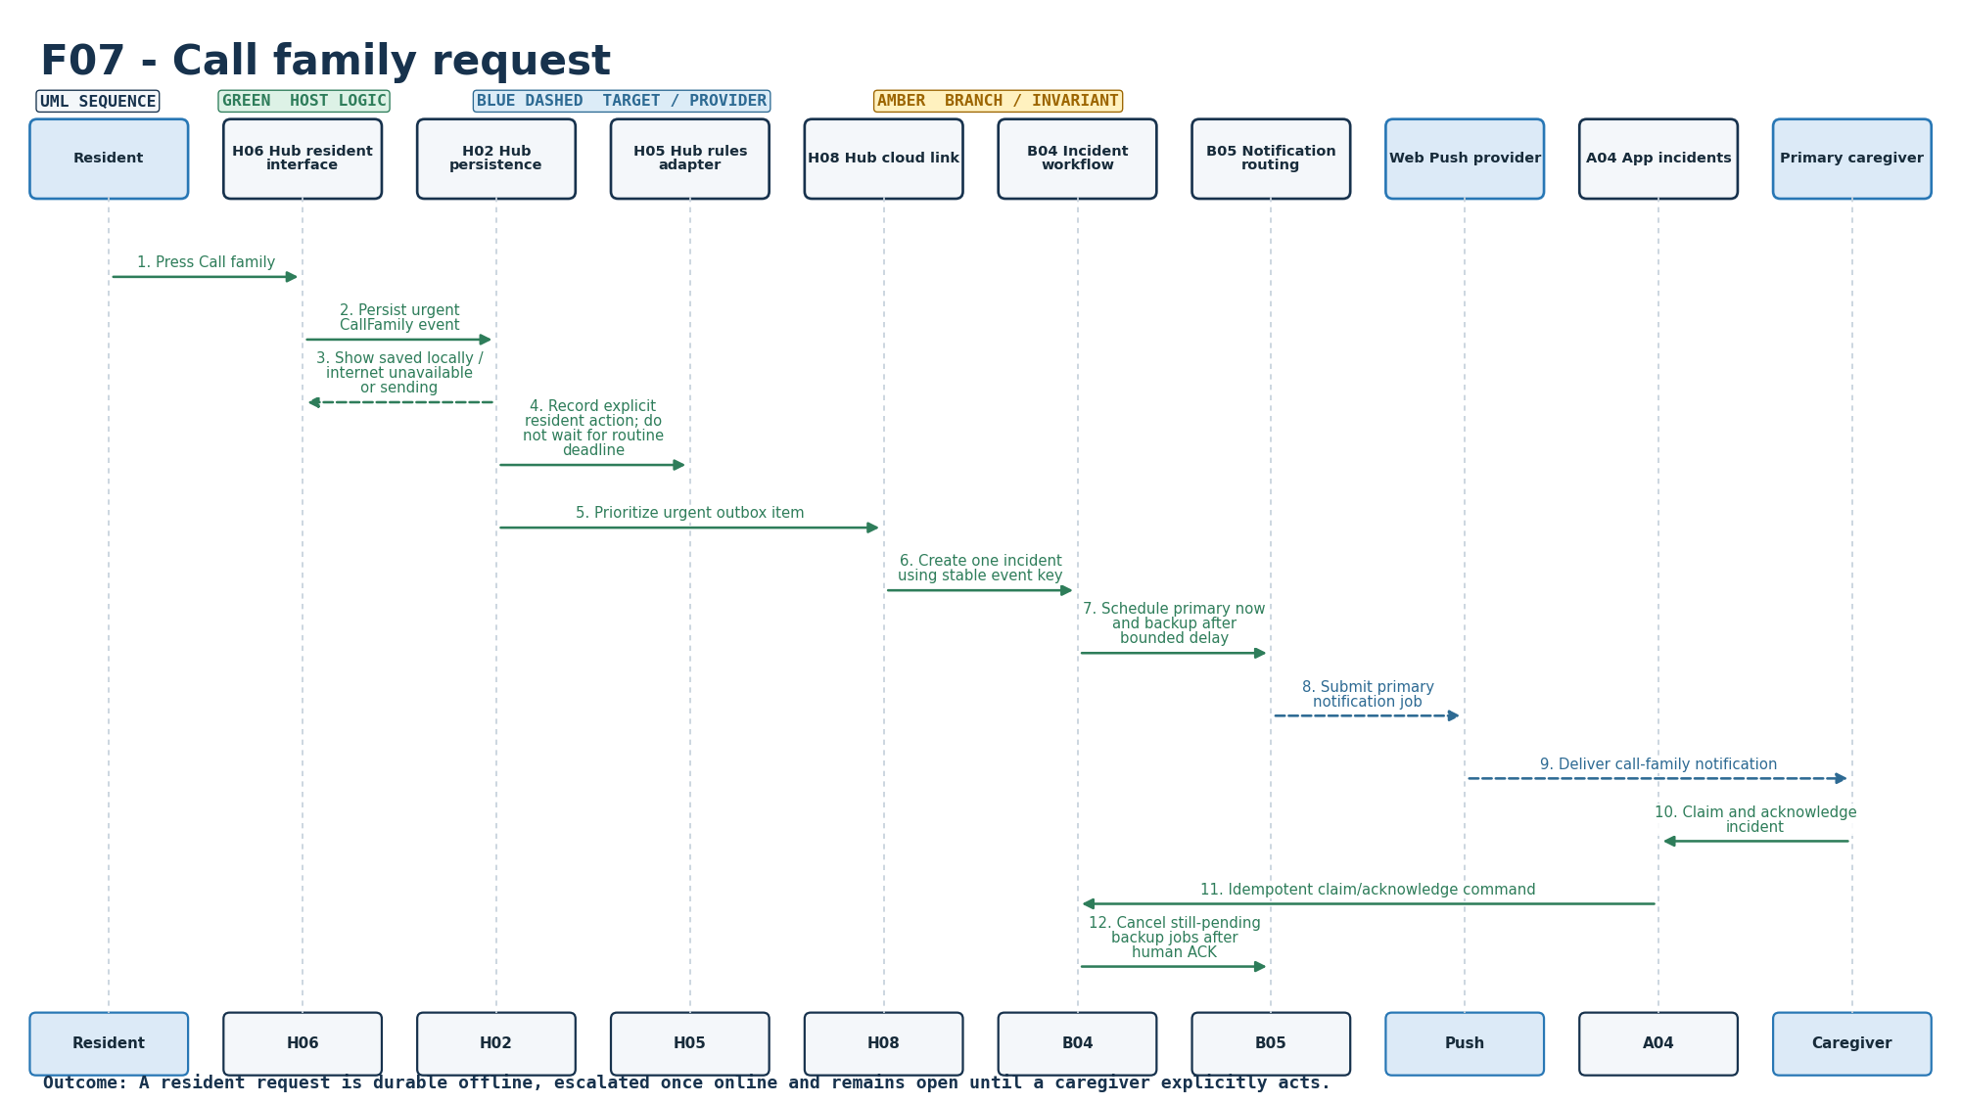
Figure S-07. Requirement-level call flow for F07.
Mapped modules: H06, H02, H05, B04, B05, A04. Participants: Resident, H06, H02, H05, H08, B04, B05, Push, A04, Caregiver. Outcome: A resident request is durable offline, escalated once online and remains open until a caregiver explicitly acts.
Editable source: plantuml/sequences/F07.puml

F08 - Missing morning activity workflow
SEQUENCE DESIGN COMPLETE | TARGET EXECUTION/INTEGRATION EVIDENCE PENDING
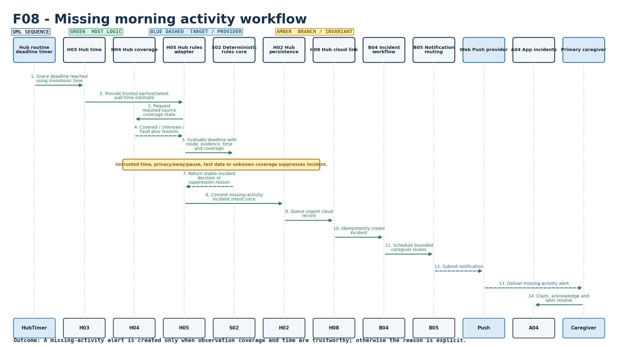
Figure S-08. Requirement-level call flow for F08.
Mapped modules: H03, H04, H05, S02, B04, B05. Participants: HubTimer, H03, H04, H05, S02, H02, H08, B04, B05, Push, A04, Caregiver. Outcome: A missing-activity alert is created only when observation coverage and time are trustworthy; otherwise the reason is explicit.
Editable source: plantuml/sequences/F08.puml

F09 - Main-door history and quiet notice
SEQUENCE DESIGN COMPLETE | TARGET EXECUTION/INTEGRATION EVIDENCE PENDING
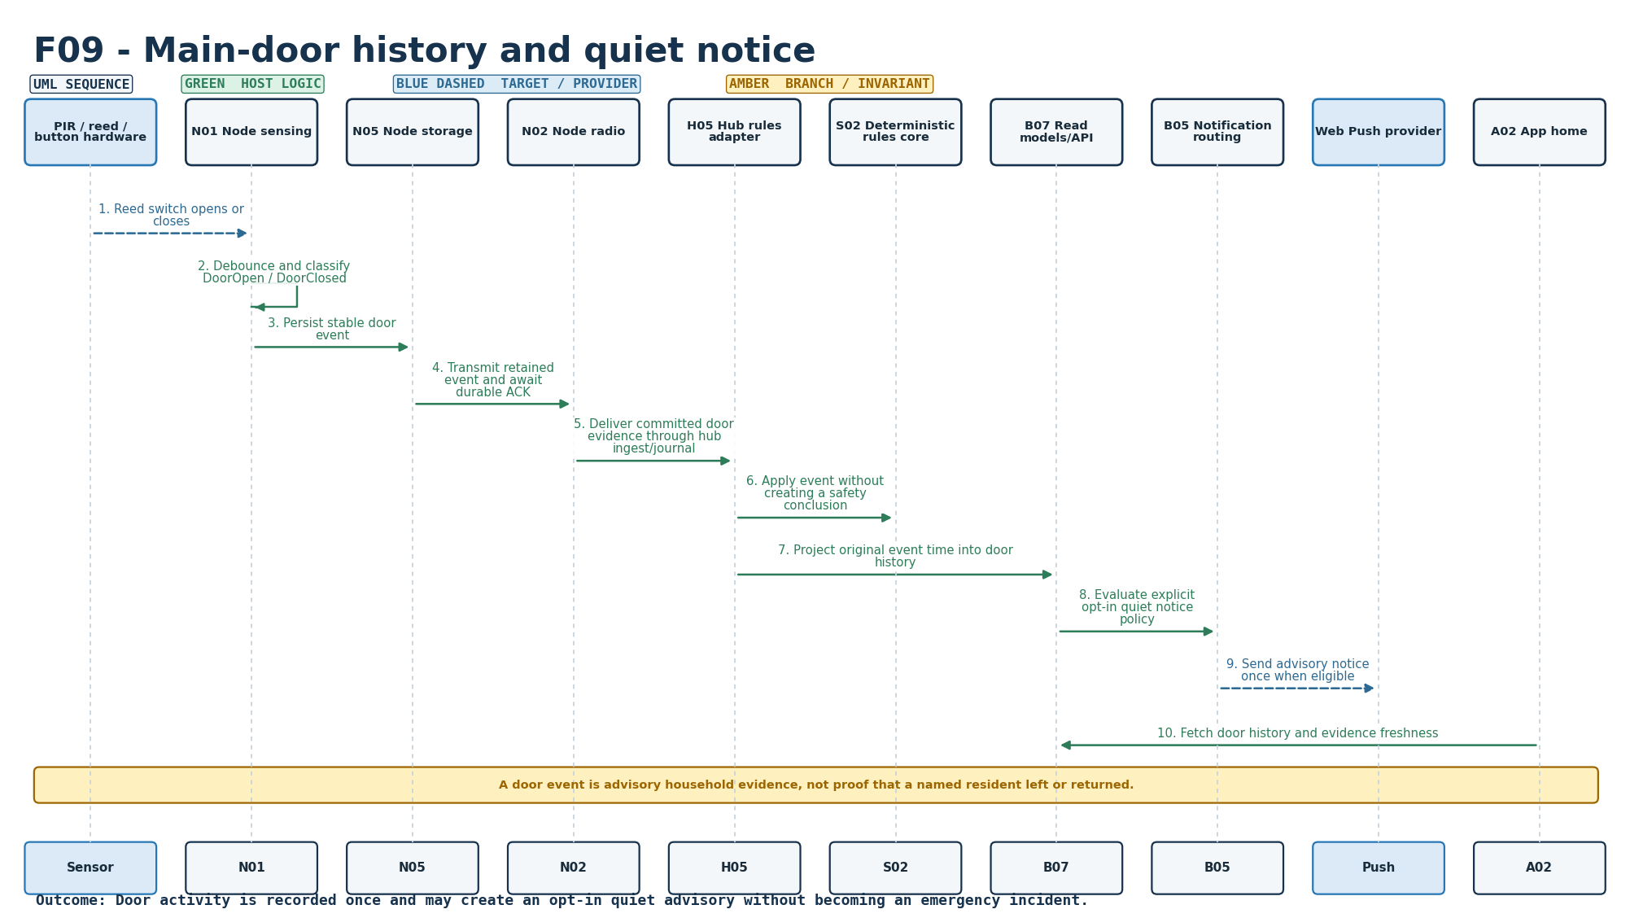
Figure S-09. Requirement-level call flow for F09.
Mapped modules: N01, H05, S02, B07, B05, A02. Participants: Sensor, N01, N05, N02, H05, S02, B07, B05, Push, A02. Outcome: Door activity is recorded once and may create an opt-in quiet advisory without becoming an emergency incident.
Editable source: plantuml/sequences/F09.puml

F10 - Away, pause and visitor modes
SEQUENCE DESIGN COMPLETE | TARGET EXECUTION/INTEGRATION EVIDENCE PENDING
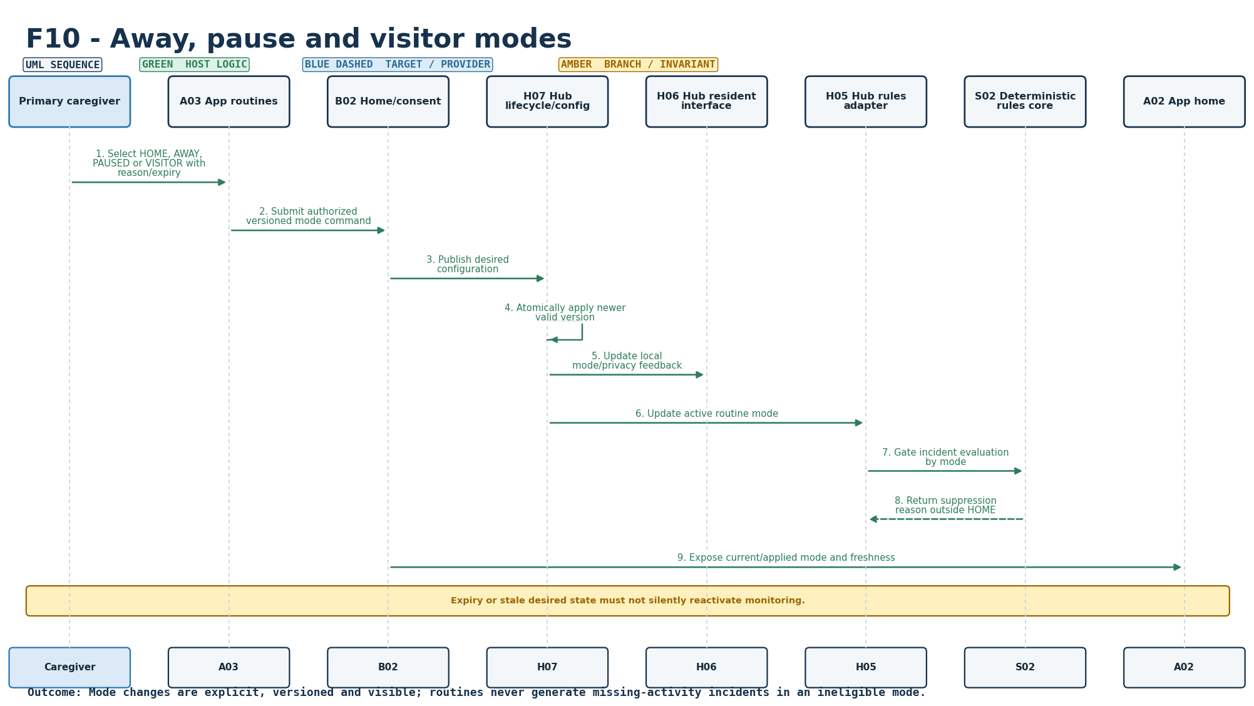
Figure S-10. Requirement-level call flow for F10.
Mapped modules: A03, B02, H07, H06, H05, S02. Participants: Caregiver, A03, B02, H07, H06, H05, S02, A02. Outcome: Mode changes are explicit, versioned and visible; routines never generate missing-activity incidents in an ineligible mode.
Editable source: plantuml/sequences/F10.puml

F11 - Caregiver dashboard and timeline
SEQUENCE DESIGN COMPLETE | TARGET EXECUTION/INTEGRATION EVIDENCE PENDING
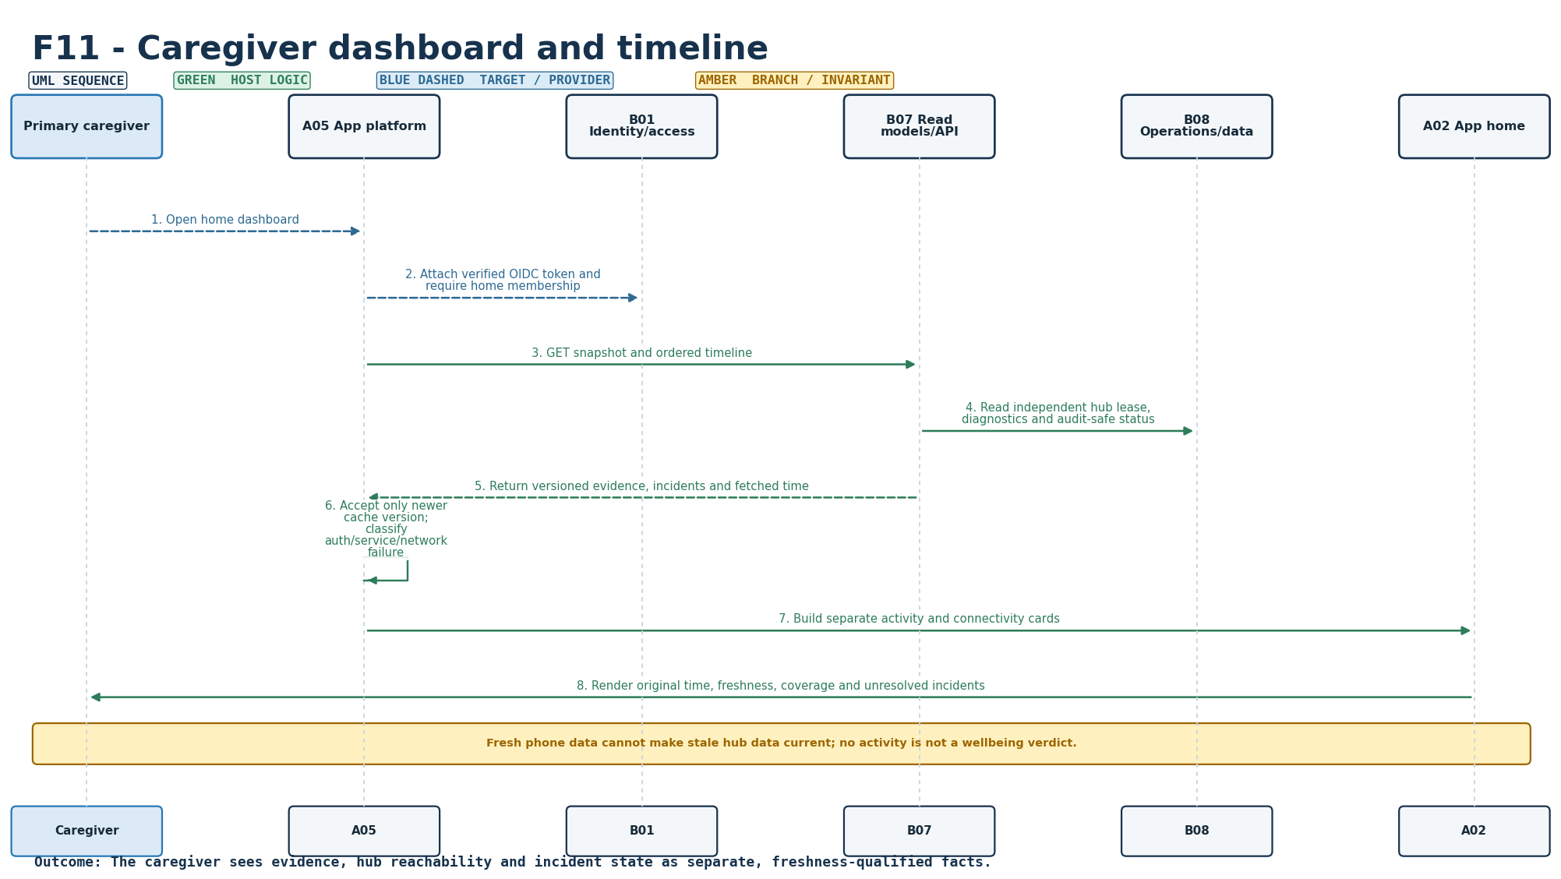
Figure S-11. Requirement-level call flow for F11.
Mapped modules: B07, B08, A02, A05. Participants: Caregiver, A05, B01, B07, B08, A02. Outcome: The caregiver sees evidence, hub reachability and incident state as separate, freshness-qualified facts.
Editable source: plantuml/sequences/F11.puml

F12 - Acknowledgement and resolution
SEQUENCE DESIGN COMPLETE | TARGET EXECUTION/INTEGRATION EVIDENCE PENDING
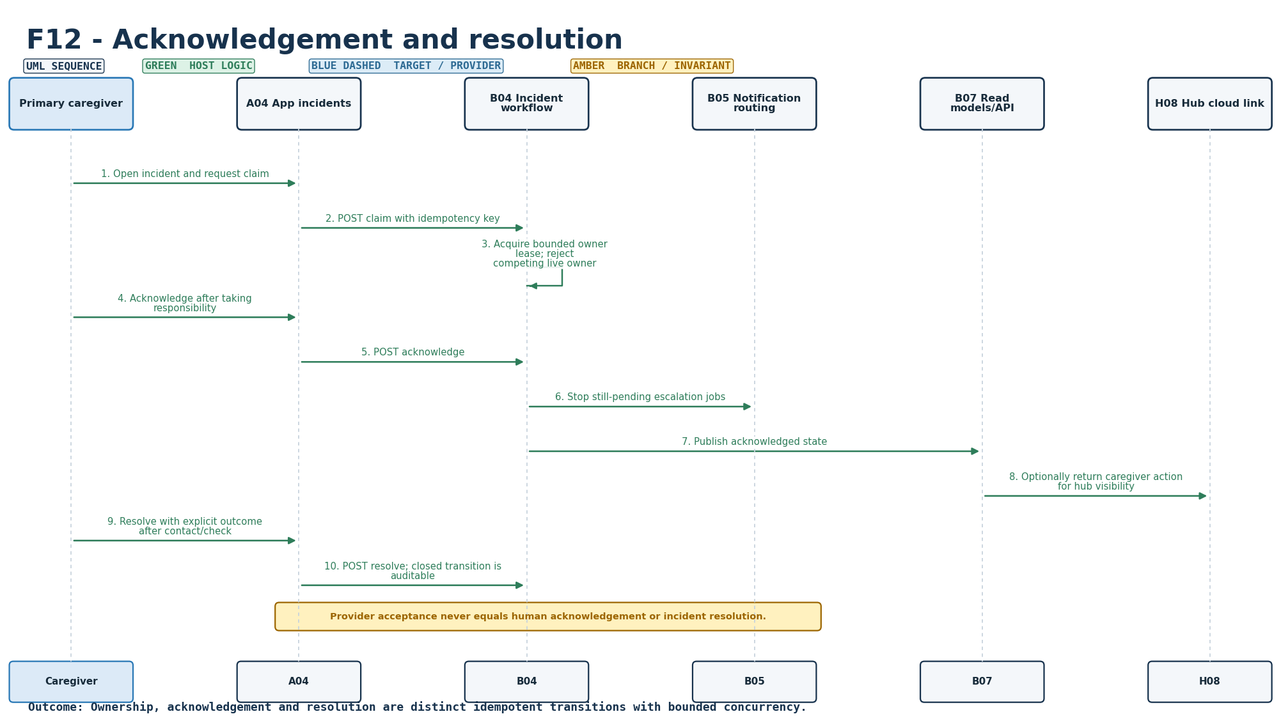
Figure S-12. Requirement-level call flow for F12.
Mapped modules: B04, B07, B05, A04, H08. Participants: Caregiver, A04, B04, B05, B07, H08. Outcome: Ownership, acknowledgement and resolution are distinct idempotent transitions with bounded concurrency.
Editable source: plantuml/sequences/F12.puml

F13 - Backup routing and delivery visibility
SEQUENCE DESIGN COMPLETE | TARGET EXECUTION/INTEGRATION EVIDENCE PENDING
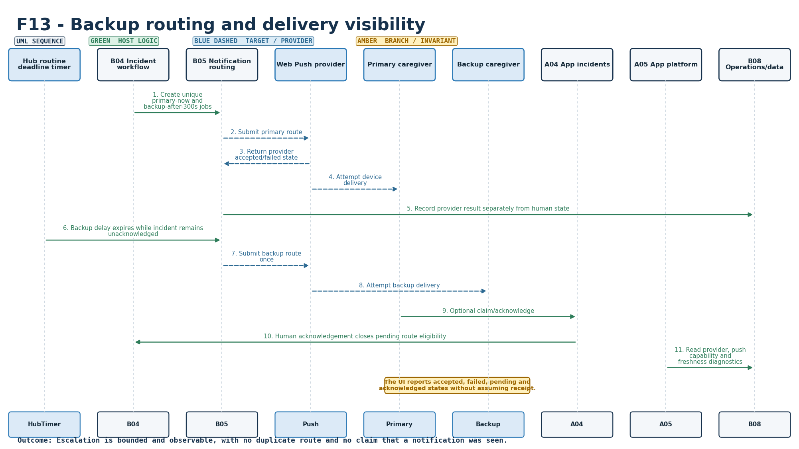
Figure S-13. Requirement-level call flow for F13.
Mapped modules: B05, B04, B08, A04, A05. Participants: HubTimer, B04, B05, Push, Primary, Backup, A04, A05, B08. Outcome: Escalation is bounded and observable, with no duplicate route and no claim that a notification was seen.
Editable source: plantuml/sequences/F13.puml

F14 - Opt-in daily morning summary
SEQUENCE DESIGN COMPLETE | TARGET EXECUTION/INTEGRATION EVIDENCE PENDING
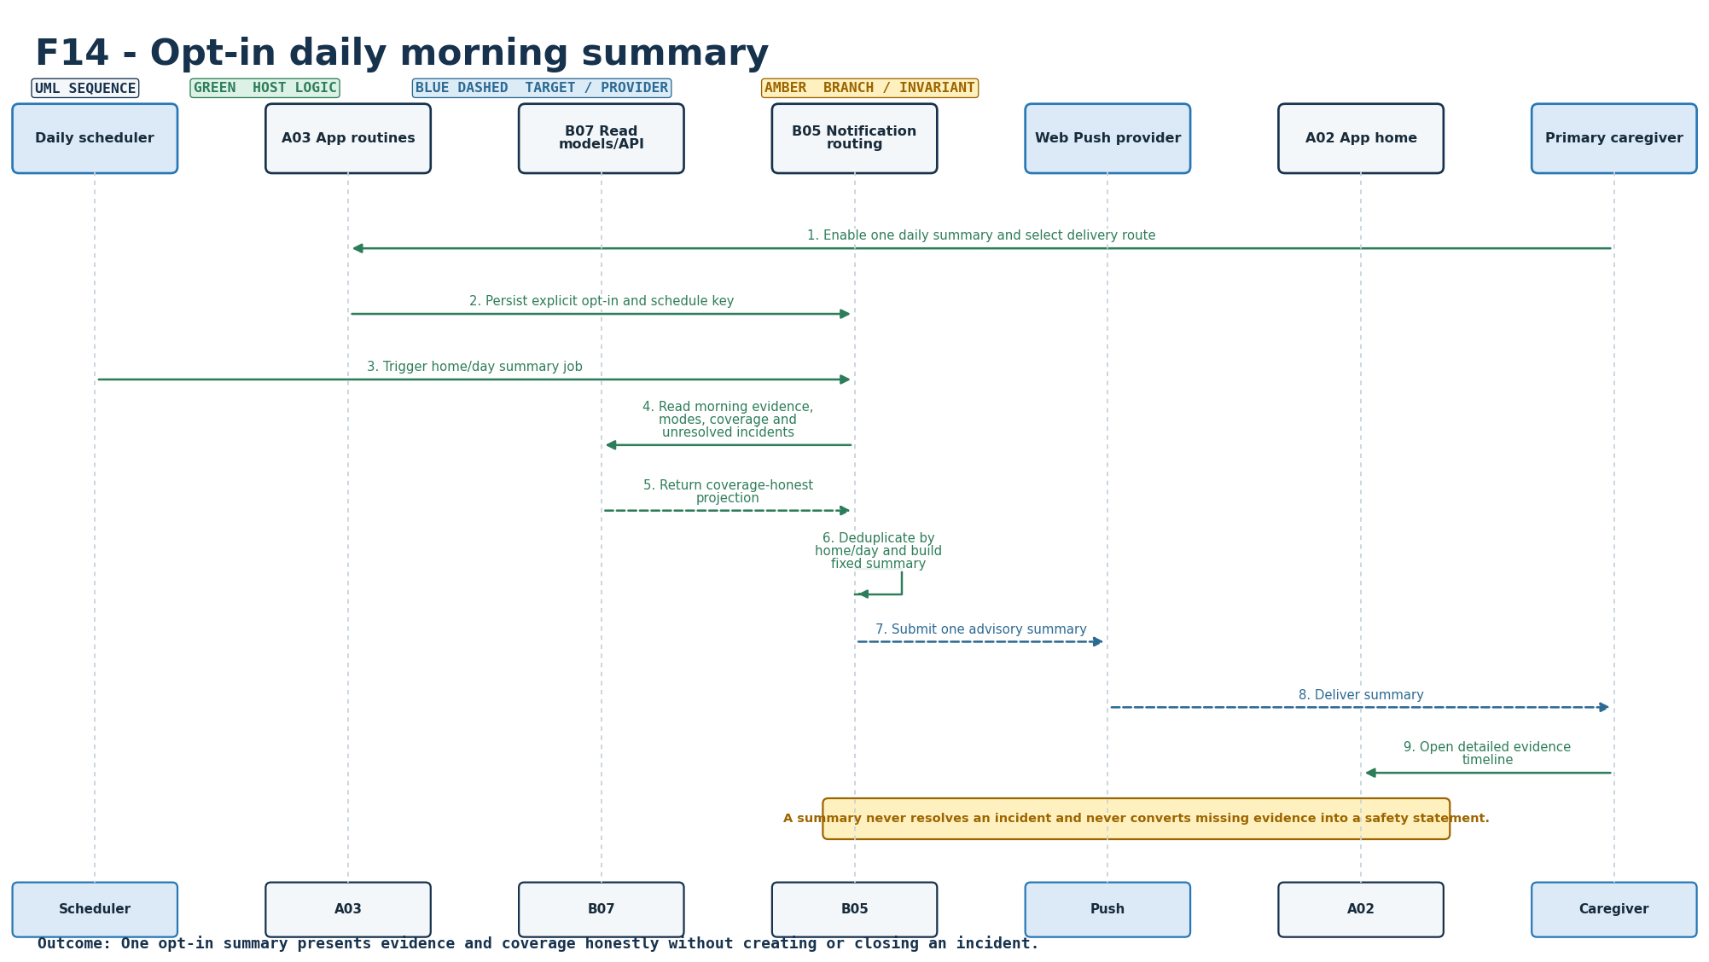
Figure S-14. Requirement-level call flow for F14.
Mapped modules: B05, B07, A03, A02. Participants: Scheduler, A03, B07, B05, Push, A02, Caregiver. Outcome: One opt-in summary presents evidence and coverage honestly without creating or closing an incident.
Editable source: plantuml/sequences/F14.puml

E01 - Node health, battery and coverage
SEQUENCE DESIGN COMPLETE | TARGET EXECUTION/INTEGRATION EVIDENCE PENDING
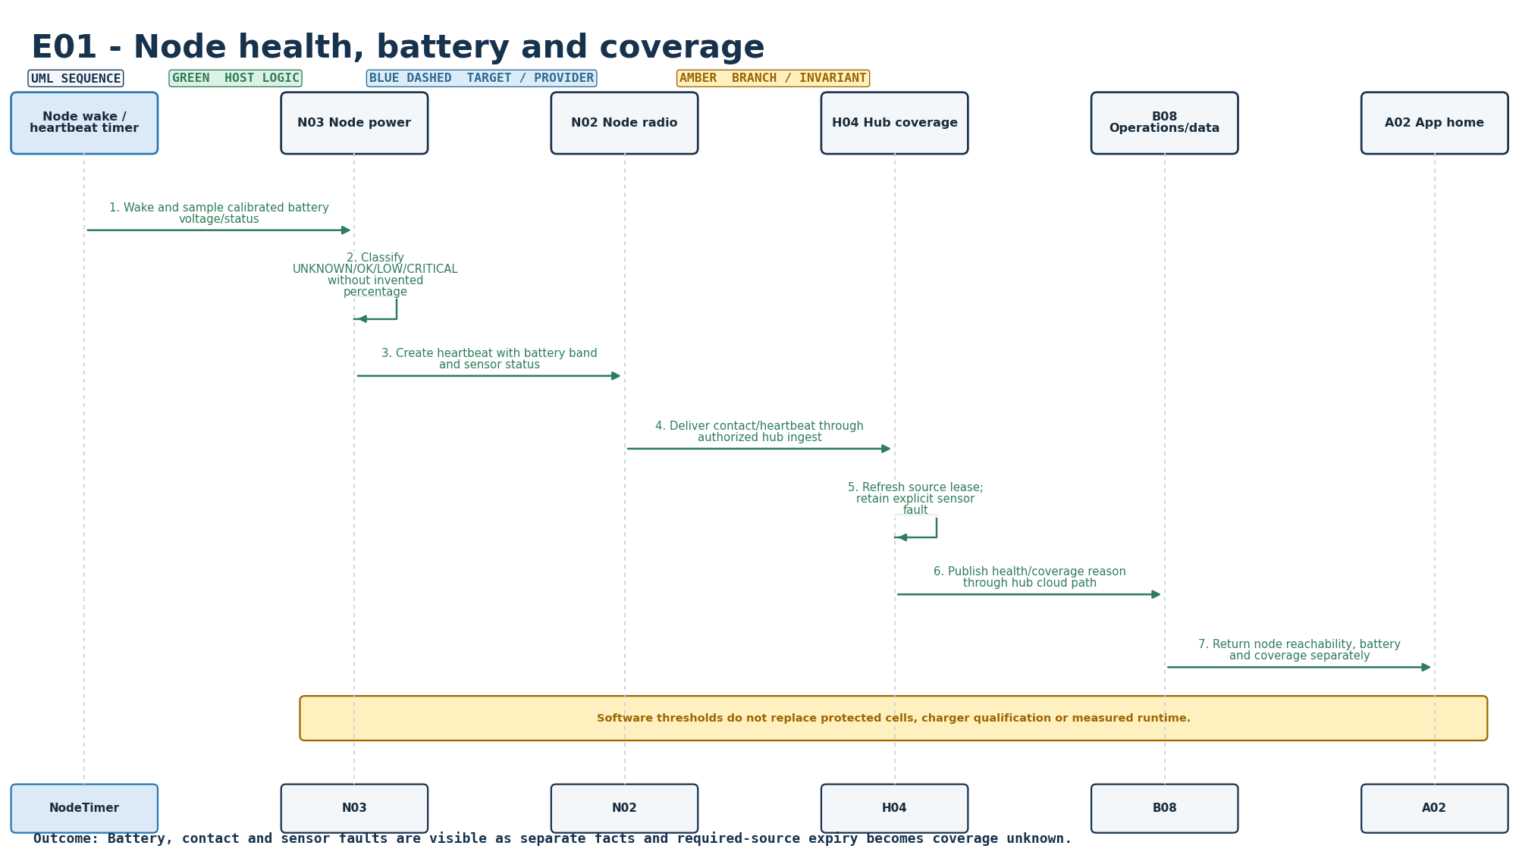
Figure S-15. Requirement-level call flow for E01.
Mapped modules: N03, N02, H04, B08, A02. Participants: NodeTimer, N03, N02, H04, B08, A02. Outcome: Battery, contact and sensor faults are visible as separate facts and required-source expiry becomes coverage unknown.
Editable source: plantuml/sequences/E01.puml

E02 - Reliable transport and duplicate handling
SEQUENCE DESIGN COMPLETE | TARGET EXECUTION/INTEGRATION EVIDENCE PENDING
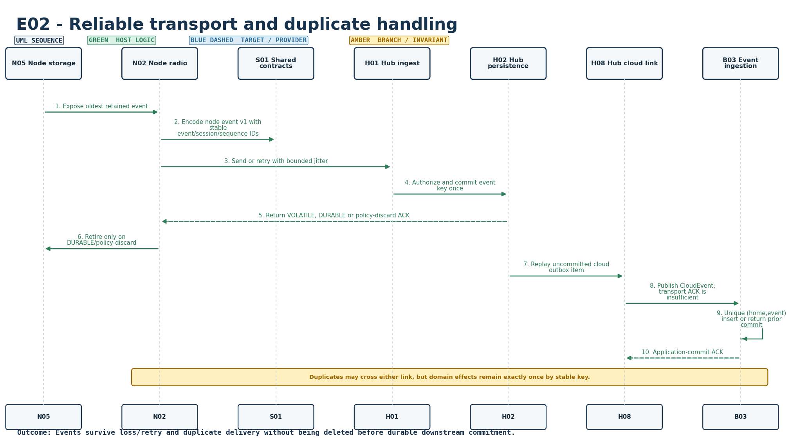
Figure S-16. Requirement-level call flow for E02.
Mapped modules: N02, N05, H01, H02, H08, B03, S01. Participants: N05, N02, S01, H01, H02, H08, B03. Outcome: Events survive loss/retry and duplicate delivery without being deleted before durable downstream commitment.
Editable source: plantuml/sequences/E02.puml

E03 - Local operation during internet failure
SEQUENCE DESIGN COMPLETE | TARGET EXECUTION/INTEGRATION EVIDENCE PENDING
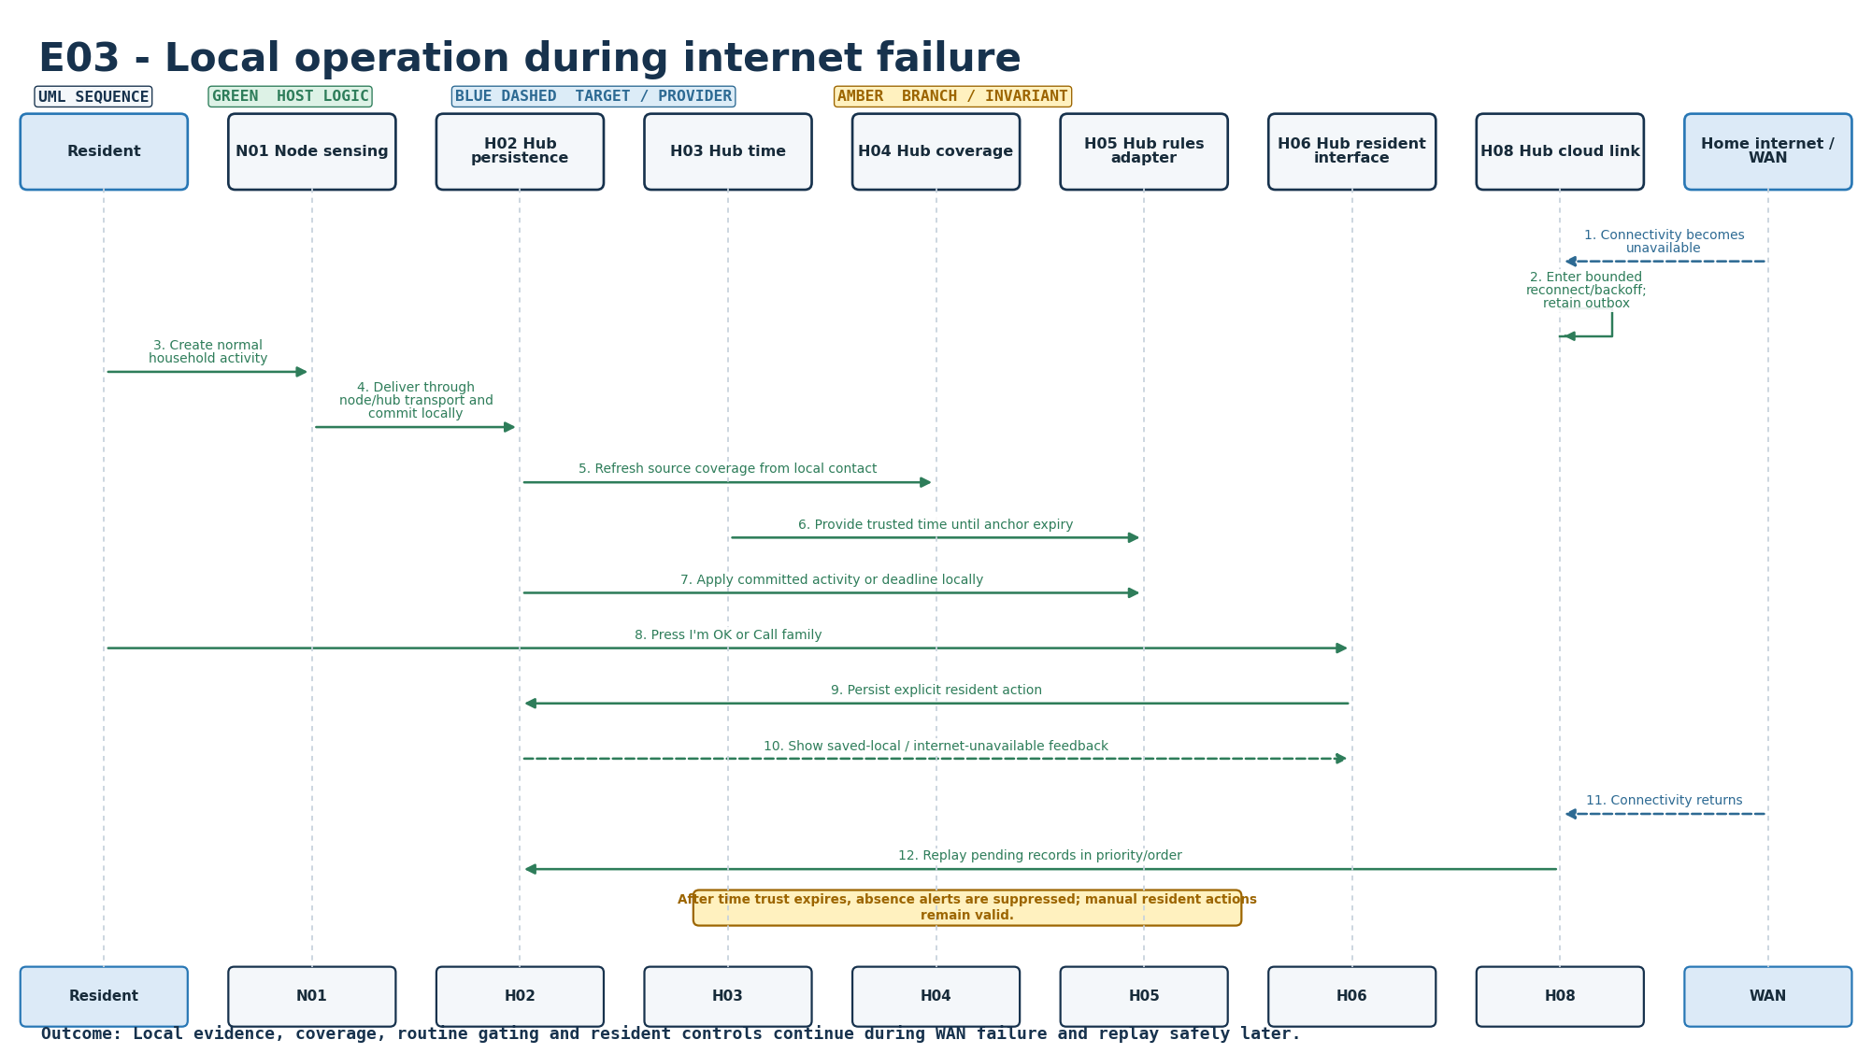
Figure S-17. Requirement-level call flow for E03.
Mapped modules: H03, H04, H05, H06, H02, H08. Participants: Resident, N01, H02, H03, H04, H05, H06, H08, WAN. Outcome: Local evidence, coverage, routine gating and resident controls continue during WAN failure and replay safely later.
Editable source: plantuml/sequences/E03.puml

E04 - Hub/cloud/app connectivity and freshness
SEQUENCE DESIGN COMPLETE | TARGET EXECUTION/INTEGRATION EVIDENCE PENDING
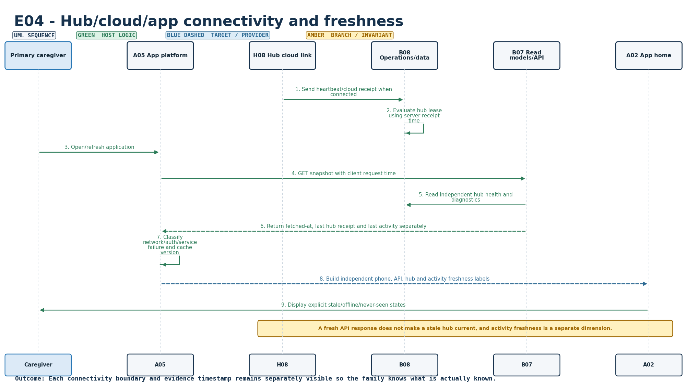
Figure S-18. Requirement-level call flow for E04.
Mapped modules: H08, B08, B07, A05, A02. Participants: Caregiver, A05, H08, B08, B07, A02. Outcome: Each connectivity boundary and evidence timestamp remains separately visible so the family knows what is actually known.
Editable source: plantuml/sequences/E04.puml

E05 - Persistence, recovery and bounded storage
SEQUENCE DESIGN COMPLETE | TARGET EXECUTION/INTEGRATION EVIDENCE PENDING
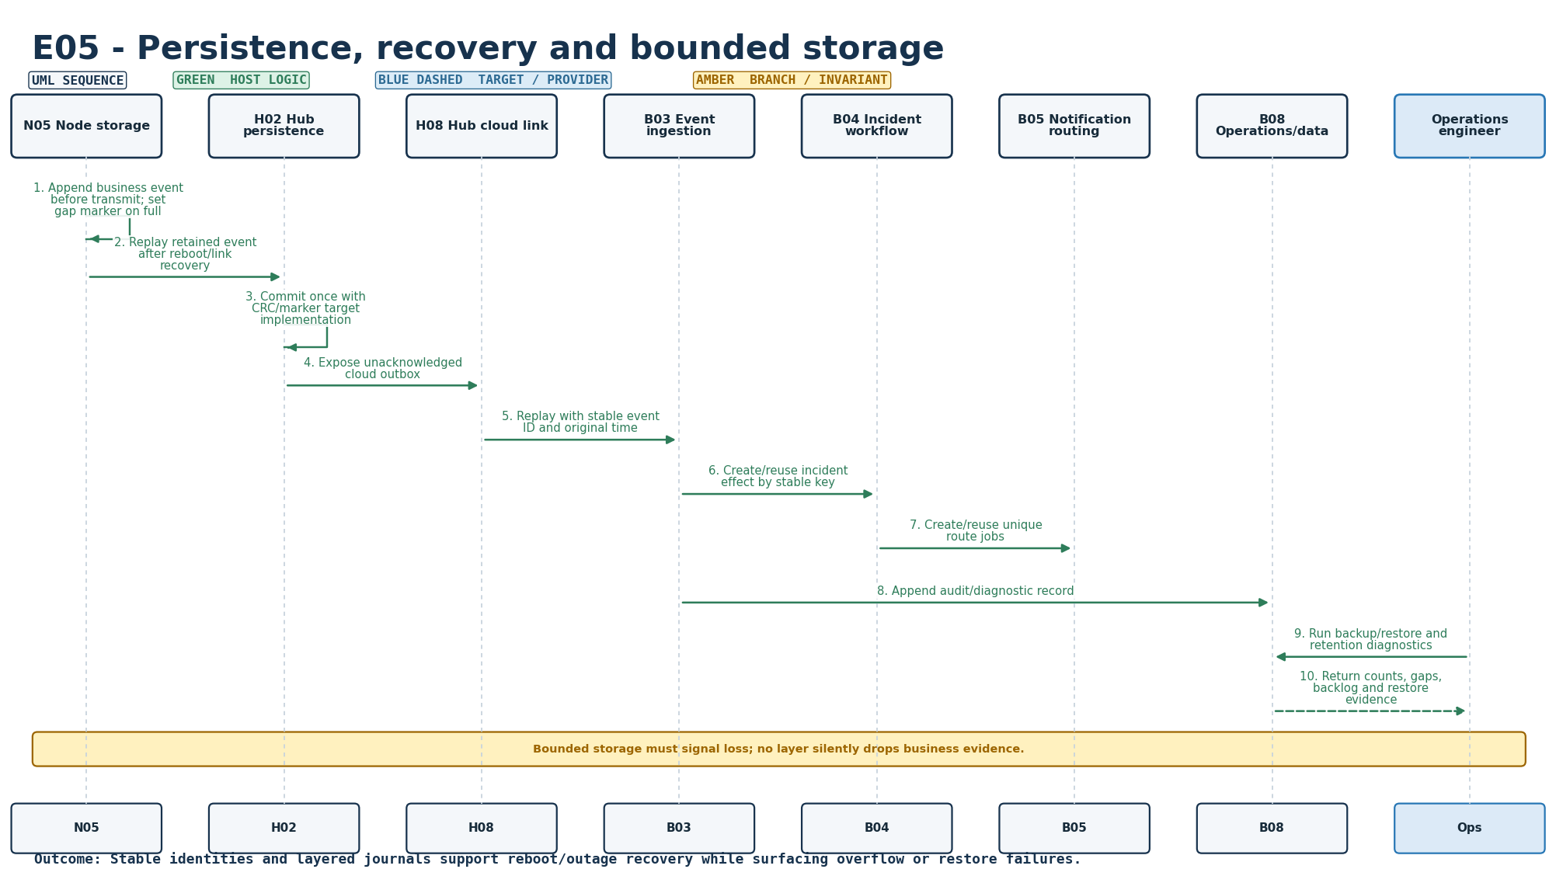
Figure S-19. Requirement-level call flow for E05.
Mapped modules: N05, H02, B03, B04, B05, B08. Participants: N05, H02, H08, B03, B04, B05, B08, Ops. Outcome: Stable identities and layered journals support reboot/outage recovery while surfacing overflow or restore failures.
Editable source: plantuml/sequences/E05.puml

E06 - Trusted time and boundary handling
SEQUENCE DESIGN COMPLETE | TARGET EXECUTION/INTEGRATION EVIDENCE PENDING
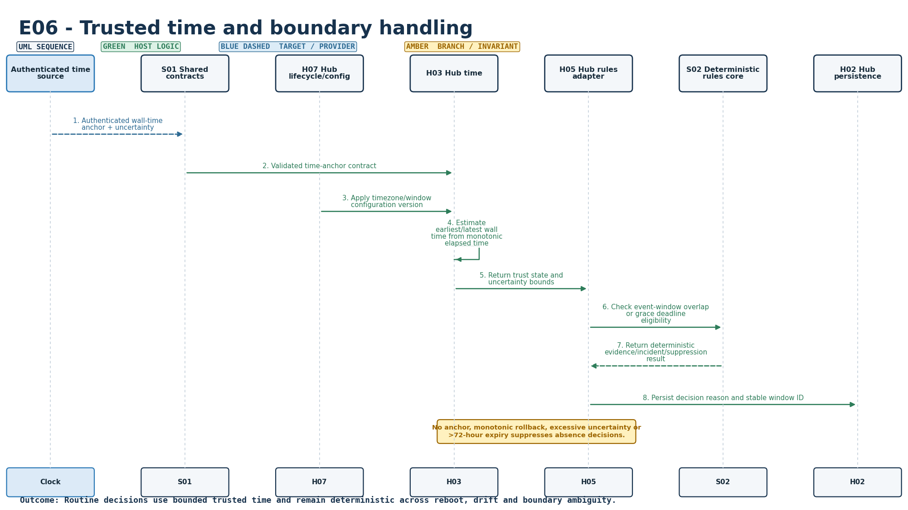
Figure S-20. Requirement-level call flow for E06.
Mapped modules: H03, H07, H05, S01, S02. Participants: Clock, S01, H07, H03, H05, S02, H02. Outcome: Routine decisions use bounded trusted time and remain deterministic across reboot, drift and boundary ambiguity.
Editable source: plantuml/sequences/E06.puml

E07 - Versioned configuration and atomic application
SEQUENCE DESIGN COMPLETE | TARGET EXECUTION/INTEGRATION EVIDENCE PENDING
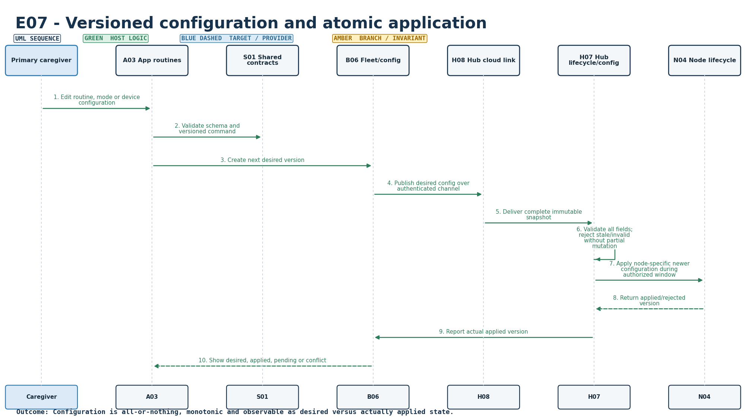
Figure S-21. Requirement-level call flow for E07.
Mapped modules: B06, A03, H07, N04, H08, S01. Participants: Caregiver, A03, S01, B06, H08, H07, N04. Outcome: Configuration is all-or-nothing, monotonic and observable as desired versus actually applied state.
Editable source: plantuml/sequences/E07.puml

E08 - Security, privacy and tenant isolation
SEQUENCE DESIGN COMPLETE | TARGET EXECUTION/INTEGRATION EVIDENCE PENDING
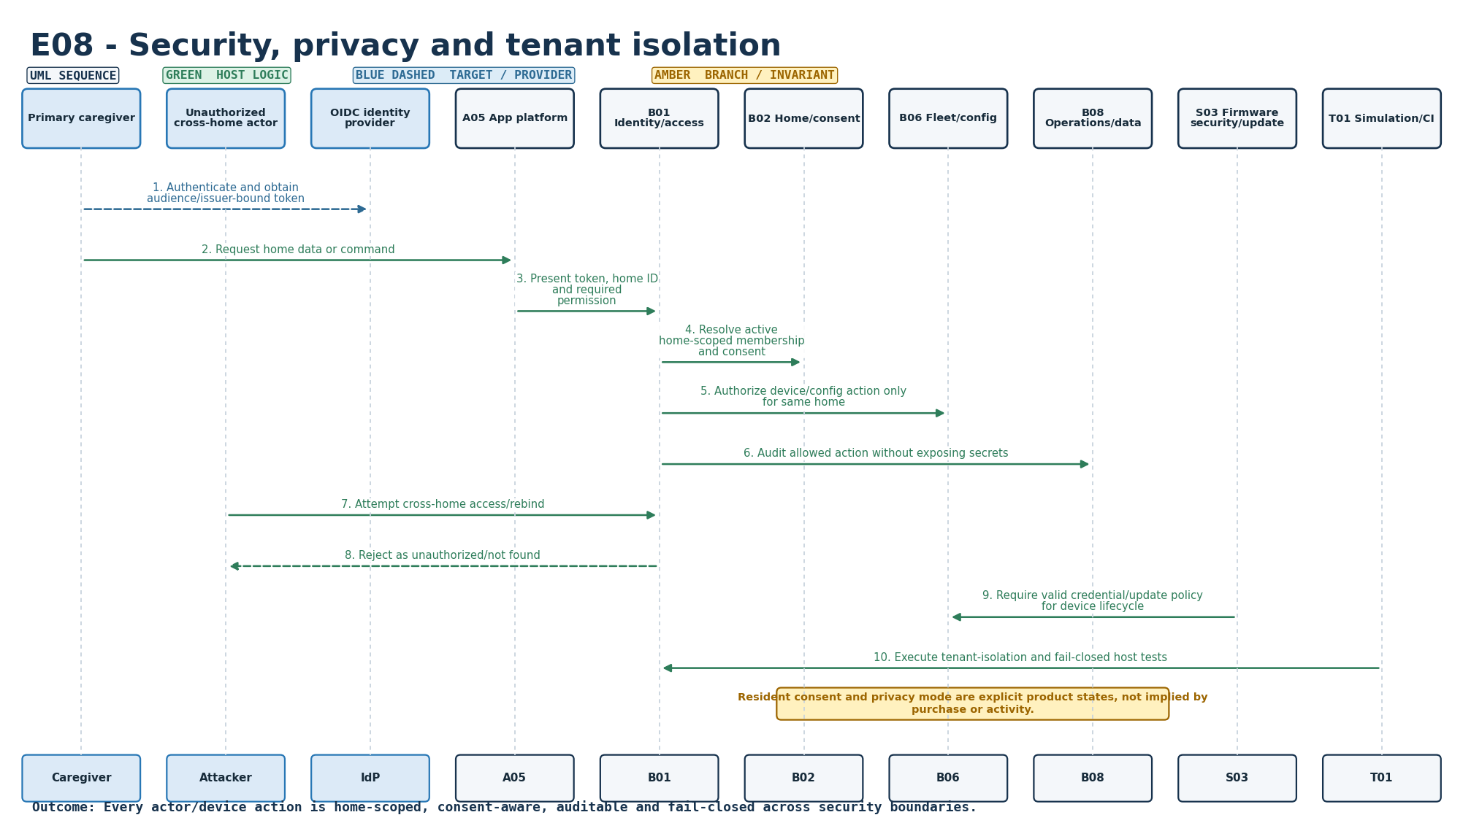
Figure S-22. Requirement-level call flow for E08.
Mapped modules: S03, B01, B02, B06, B08, A05, T01. Participants: Caregiver, Attacker, IdP, A05, B01, B02, B06, B08, S03, T01. Outcome: Every actor/device action is home-scoped, consent-aware, auditable and fail-closed across security boundaries.
Editable source: plantuml/sequences/E08.puml

E09 - Signed firmware update and recovery
SEQUENCE DESIGN COMPLETE | TARGET EXECUTION/INTEGRATION EVIDENCE PENDING
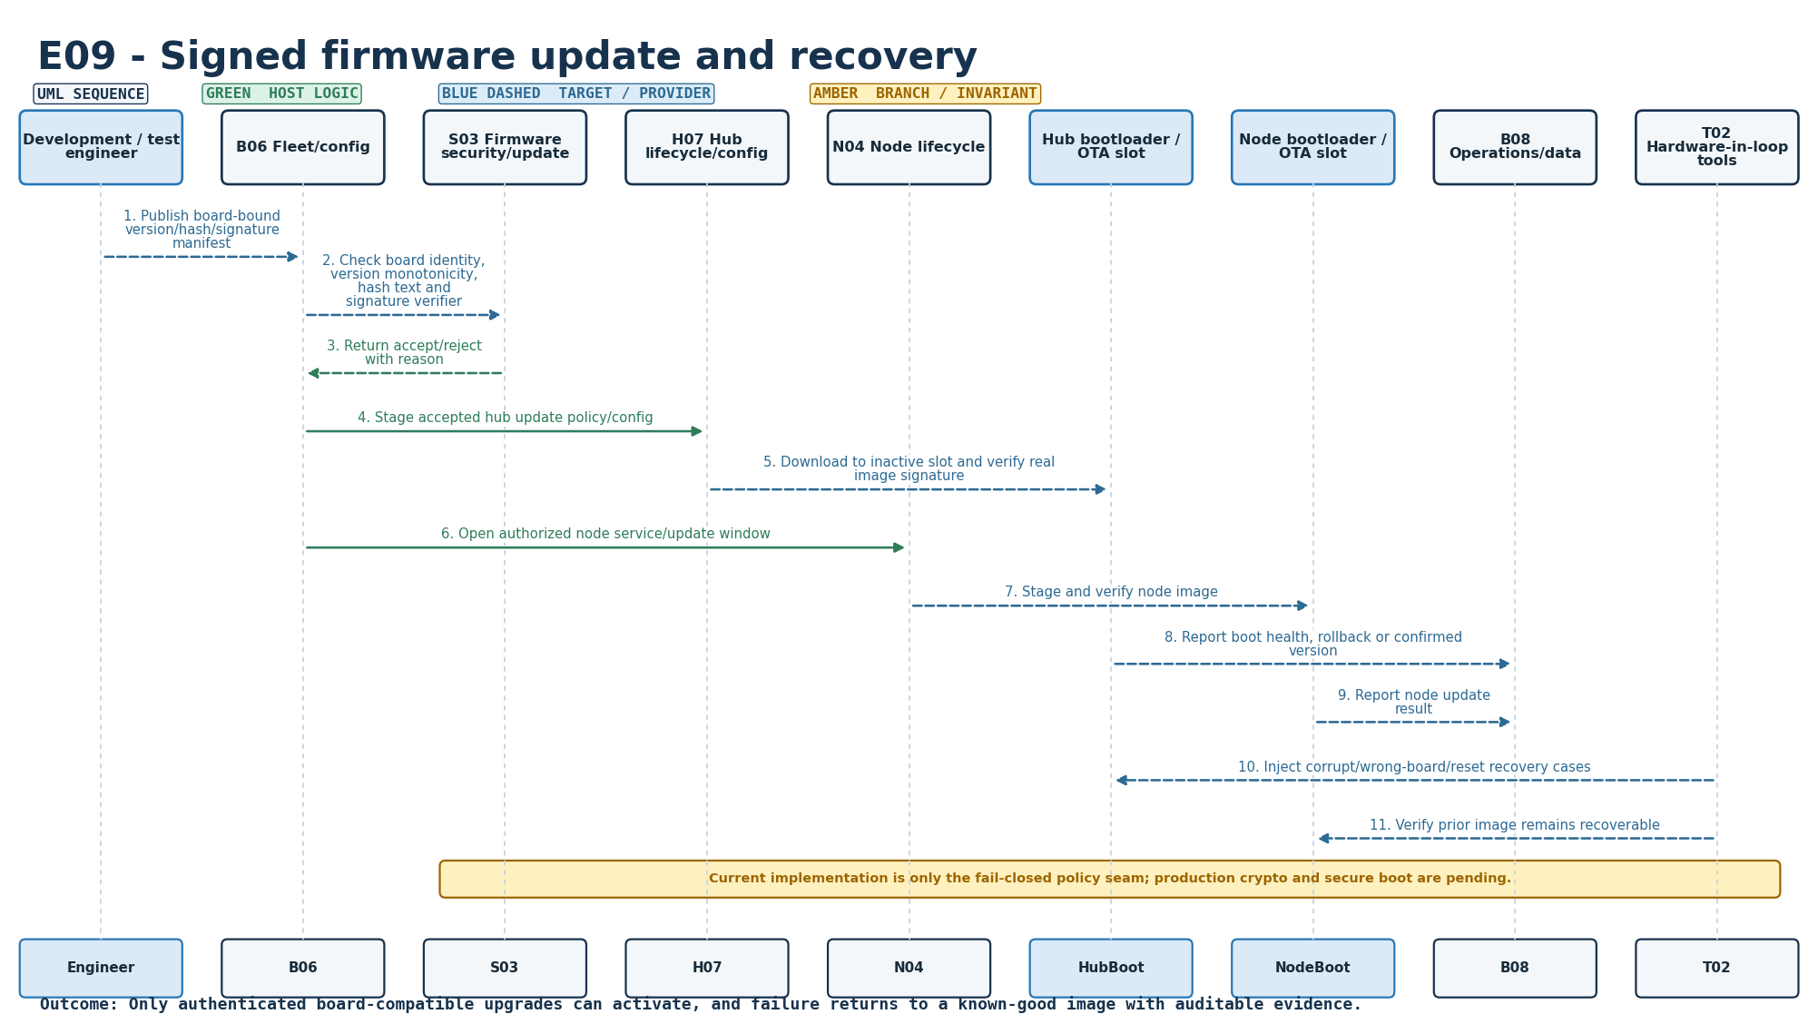
Figure S-23. Requirement-level call flow for E09.
Mapped modules: S03, H07, N04, B06, B08, T02. Participants: Engineer, B06, S03, H07, N04, HubBoot, NodeBoot, B08, T02. Outcome: Only authenticated board-compatible upgrades can activate, and failure returns to a known-good image with auditable evidence.
Editable source: plantuml/sequences/E09.puml

E10 - Verification, observability and release evidence
SEQUENCE DESIGN COMPLETE | TARGET EXECUTION/INTEGRATION EVIDENCE PENDING
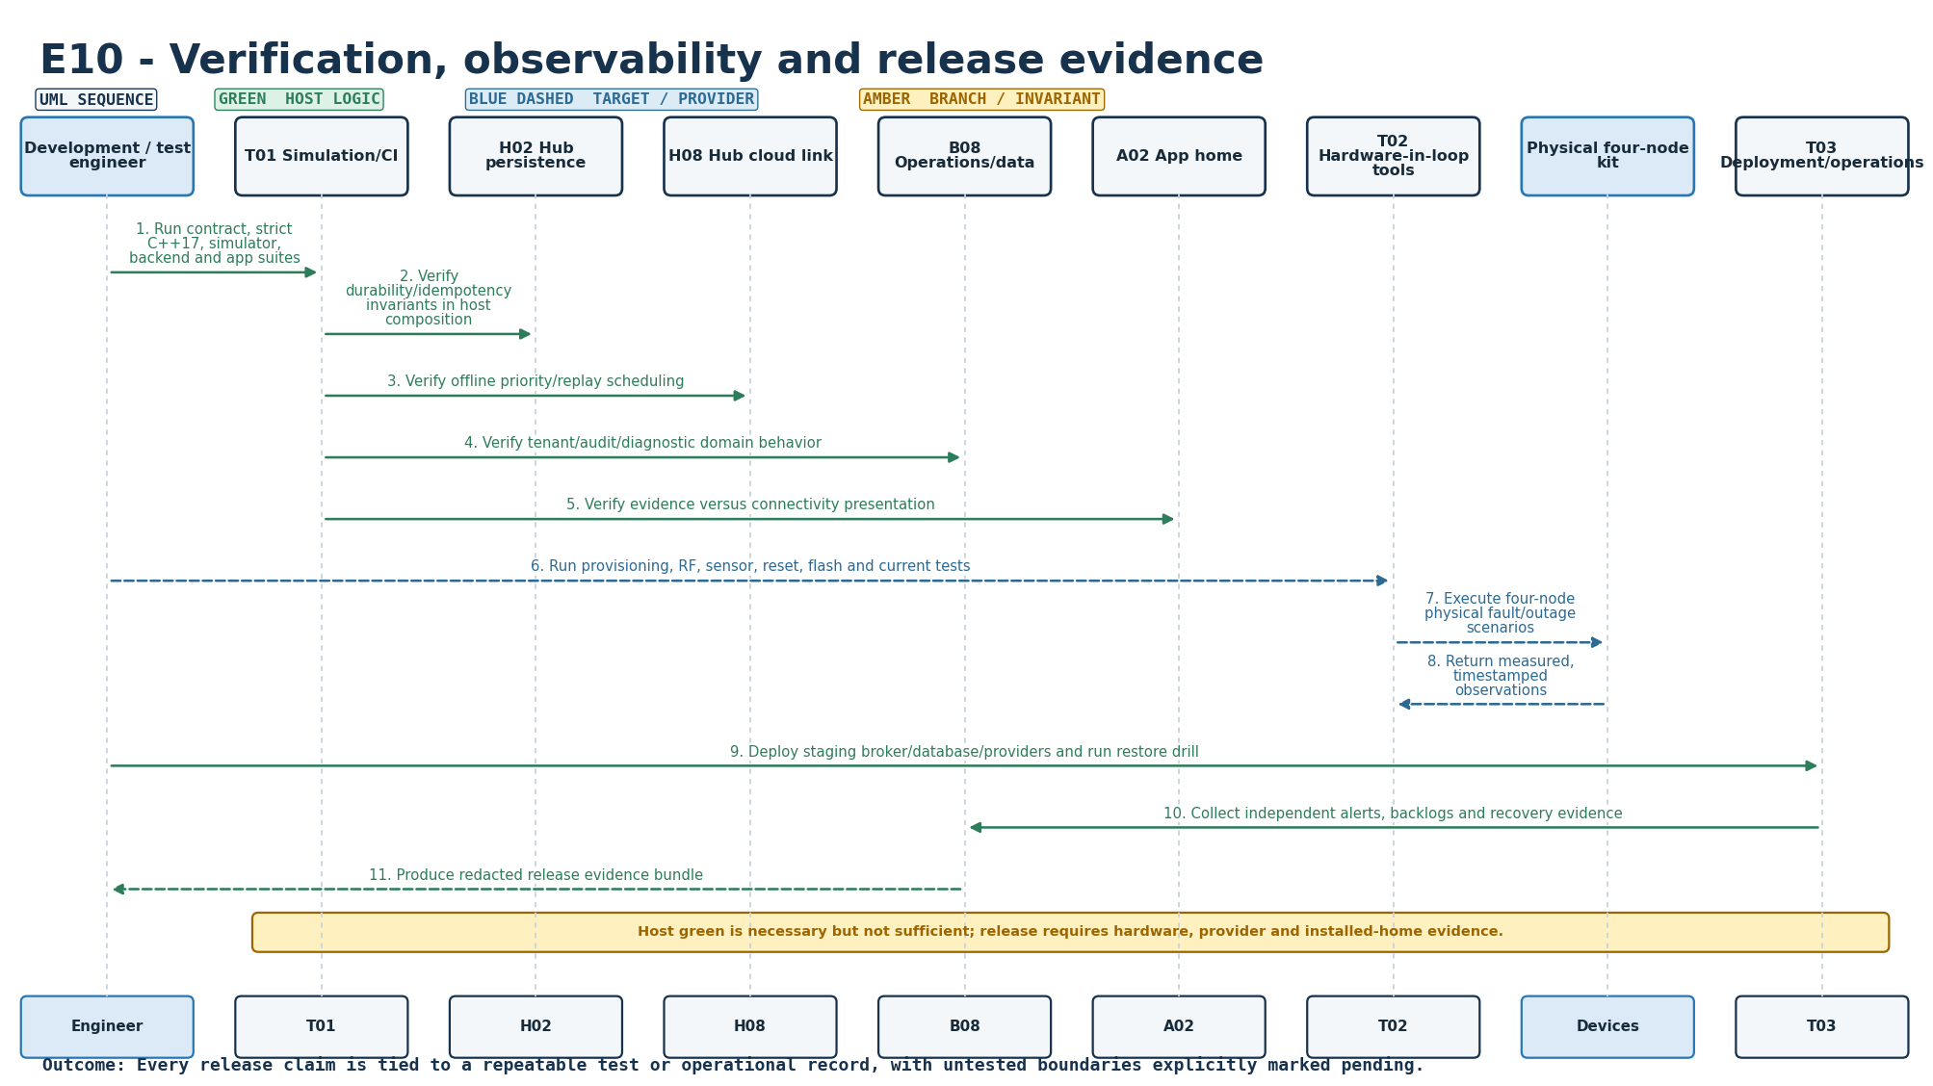
Figure S-24. Requirement-level call flow for E10.
Mapped modules: B08, A02, T01, T02, T03, H02, H08. Participants: Engineer, T01, H02, H08, B08, A02, T02, Devices, T03. Outcome: Every release claim is tied to a repeatable test or operational record, with untested boundaries explicitly marked pending.
Editable source: plantuml/sequences/E10.puml

Requirement-to-participant traceability
ID | Requirement | Mapped modules | All sequence participants | Diagram
F01 | Household profile and caregiver roles | B01, B02, A01, S01 | Owner, A01, S01, B02, B01, B08 | Complete
F02 | Resident consent and privacy controls | B02, H06, H07, A01, B08 | Resident, H06, H07, B02, B08, A01 | Complete
F03 | Kit provisioning and installation verification | N04, H07, B06, A01, S03, T02 | Installer, A01, B06, S03, H07, N04, T02 | Complete
F04 | Configurable morning routine | A03, B06, H07, H03, H05, S02 | Caregiver, A03, B06, H07, H03, H05, S02 | Complete
F05 | Morning activity evidence | N01, H01, H02, H05, S02, B07, A02 | Sensor, N01, N05, N02, H01, H02, H05, S02, H08, B07, A02 | Complete
F06 | Explicit I’m OK check-in | H06, H02, H05, S02, B07, A02 | Resident, H06, H02, H05, S02, H08, B07, A02 | Complete
F07 | Call family request | H06, H02, H05, B04, B05, A04 | Resident, H06, H02, H05, H08, B04, B05, Push, A04, Caregiver | Complete
F08 | Missing morning activity workflow | H03, H04, H05, S02, B04, B05 | HubTimer, H03, H04, H05, S02, H02, H08, B04, B05, Push, A04, Caregiver | Complete
F09 | Main-door history and quiet notice | N01, H05, S02, B07, B05, A02 | Sensor, N01, N05, N02, H05, S02, B07, B05, Push, A02 | Complete
F10 | Away, pause and visitor modes | A03, B02, H07, H06, H05, S02 | Caregiver, A03, B02, H07, H06, H05, S02, A02 | Complete
F11 | Caregiver dashboard and timeline | B07, B08, A02, A05 | Caregiver, A05, B01, B07, B08, A02 | Complete
F12 | Acknowledgement and resolution | B04, B07, B05, A04, H08 | Caregiver, A04, B04, B05, B07, H08 | Complete
F13 | Backup routing and delivery visibility | B05, B04, B08, A04, A05 | HubTimer, B04, B05, Push, Primary, Backup, A04, A05, B08 | Complete
F14 | Opt-in daily morning summary | B05, B07, A03, A02 | Scheduler, A03, B07, B05, Push, A02, Caregiver | Complete
E01 | Node health, battery and coverage | N03, N02, H04, B08, A02 | NodeTimer, N03, N02, H04, B08, A02 | Complete
E02 | Reliable transport and duplicate handling | N02, N05, H01, H02, H08, B03, S01 | N05, N02, S01, H01, H02, H08, B03 | Complete
E03 | Local operation during internet failure | H03, H04, H05, H06, H02, H08 | Resident, N01, H02, H03, H04, H05, H06, H08, WAN | Complete
E04 | Hub/cloud/app connectivity and freshness | H08, B08, B07, A05, A02 | Caregiver, A05, H08, B08, B07, A02 | Complete
E05 | Persistence, recovery and bounded storage | N05, H02, B03, B04, B05, B08 | N05, H02, H08, B03, B04, B05, B08, Ops | Complete
E06 | Trusted time and boundary handling | H03, H07, H05, S01, S02 | Clock, S01, H07, H03, H05, S02, H02 | Complete
E07 | Versioned configuration and atomic application | B06, A03, H07, N04, H08, S01 | Caregiver, A03, S01, B06, H08, H07, N04 | Complete
E08 | Security, privacy and tenant isolation | S03, B01, B02, B06, B08, A05, T01 | Caregiver, Attacker, IdP, A05, B01, B02, B06, B08, S03, T01 | Complete
E09 | Signed firmware update and recovery | S03, H07, N04, B06, B08, T02 | Engineer, B06, S03, H07, N04, HubBoot, NodeBoot, B08, T02 | Complete
E10 | Verification, observability and release evidence | B08, A02, T01, T02, T03, H02, H08 | Engineer, T01, H02, H08, B08, A02, T02, Devices, T03 | Complete

Sequence handoff boundary
The call flows define intended behavior and cross-module responsibility. A sequence becomes P0-complete only after the matching requirement exit criterion has evidence on the selected ESP32 boards, services and phones. In particular, no sequence may turn missing evidence or unknown coverage into a claim that a resident is safe.

