ENGINEERING REFERENCE GUIDE
Ghar Sajag System Architecture and Module UML
Interfaces, dependencies, state ownership and functionality diagrams for the 32-module P0 baseline
Design inventory | Coverage
Architecture baseline | Requirements/Software Design v1.2 + Hardware-Independent LLD v1.0
Module coverage | 32 of 32 logical modules
Architecture figures | 1 whole-system component view + 32 module functionality/dependency views
Status convention | Green host behavior; blue pending target/provider binding; amber partial/caution
Boundary: host logic and design are documented; ESP32, RF, flash, cloud-provider and installed-home evidence remain separate P0 gates.

How to read this volume
This volume is the architecture and per-module visual companion to the existing HLD and LLD. Each module sheet shows its public surface, owned state, functional flow, failure guard and direct logical collaborators.
A dependency arrow means that a module exchanges a versioned contract or calls an injected port. It does not automatically mean that both modules execute in one process. The interface catalog below identifies physical, local-runtime and cloud boundaries.
Visual state | Meaning
Green | HLD/LLD and host-executable responsibility exist and pass the included host checks
Amber | A scaffold, policy seam or operational example exists but its target evidence is incomplete
Blue / dashed | ESP32, RF, flash, network, identity, notification, phone or OTA provider binding remains pending
Red | Reserved for a failed/blocked gate; none is claimed by this design pack

Whole-system component architecture
HOST DESIGN BASELINE COMPLETE | TARGET INTEGRATIONS PENDING
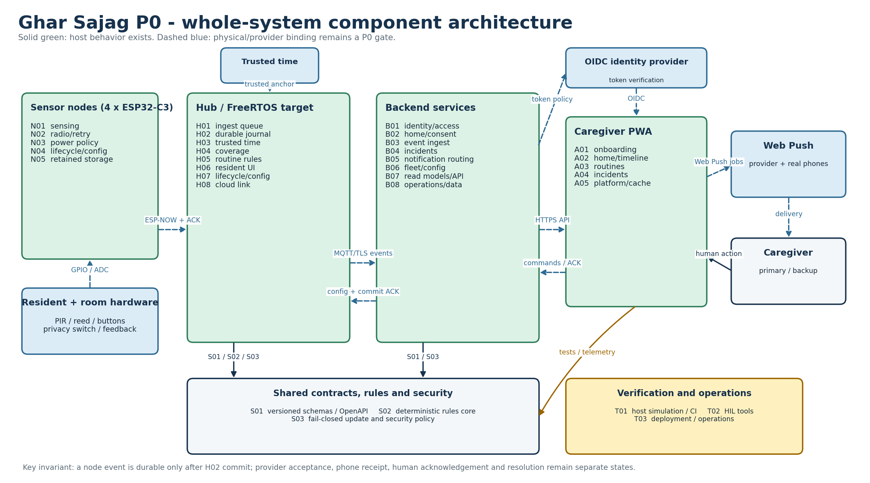
Figure A-1. P0 runtime layers, external actors, principal interfaces and persistence boundaries.
The node-to-hub and hub-to-cloud links preserve stable event identity. H02 durability precedes node retirement; the backend separately tracks provider acceptance, human acknowledgement and incident resolution.
Editable source: plantuml/architecture/whole_system_architecture.puml

Interface catalog
The catalog is normative for dependency direction and acceptance testing. Status describes the current baseline, not commercial readiness.
ID | Source | Target | Mode | Contract | Reliability rule | Current state
I01 | Sensor hardware | N01 / H06 | GPIO / ADC / local debounce | Qualified input transition or explicit resident action | Warm-up, debounce, retrigger and physical-input tests | Target binding pending
I02 | N02 node radio | H01 hub ingest | ESP-NOW; fixed versioned frame | S01 node event v1 + VOLATILE/DURABLE/DISCARDED_POLICY ACK | Persist before send; duplicate-safe; bounded retry | Host semantics complete; RF pending
I03 | H01 / H06 / timers | Hub state-core | Bounded FreeRTOS queues and serialized commands | Fixed-value ingress/UI/deadline/config command | One domain-state owner; callback never blocks or writes flash | Design complete; binding pending
I04 | H02 hub journal | H08 cloud link | Local append-only outbox | Committed event record with original event time | Retire only on backend application-commit ACK | Host complete; flash pending
I05 | H08 hub cloud link | B03 backend ingest | Wi-Fi + MQTT/TLS | S01 CloudEvent v1; home/device topic ACL | Reconnect/backoff, idempotent ingest, application ACK | Adapter seam complete; provider pending
I06 | A01-A05 caregiver PWA | B01-B08 backend | HTTPS/JSON using OpenAPI; optional SSE | OIDC bearer + idempotency key + versioned response | Server authoritative; stale cache shown explicitly | Domain complete; production integration pending
I07 | B05 notification routing | Caregiver phone | Web Push | Notification job and separate delivery/human-ACK states | Primary then bounded backup route; no delivery assumption | Policy complete; provider/phone pending
I08 | B06 fleet/config | H07 / N04 lifecycle | HTTPS then MQTT/TLS; local atomic apply | Versioned HomeConfig / NodeConfig | Reject stale/conflicting version; desired != applied | Version semantics complete; binding pending
I09 | B06 + S03 update policy | Hub/node bootloader | Signed HTTPS OTA with recovery slot | Board-bound version/hash/signature manifest | Fail closed; rollback prevention; recover prior image | Policy seam partial; production crypto pending

Module dependency index
Full exact collaborator lists are retained here even when a dense test/shared module groups dependencies visually on its figure.
Module | Responsibility | Provided API | Direct collaborators / ports | Status
N01 | Node sensing | QualifiedInput::sample(raw_level, now_ms); stable_level() | S01, N05, N02 | HOST COMPLETE; TARGET PENDING
N02 | Node radio | enqueue(); next_due(); record_transport_result(); apply_ack() | S01, N05, H01 | HOST COMPLETE; TARGET PENDING
N03 | Node power | PowerPolicy::classify(); PowerPolicy::plan() | N02, N04 | HOST COMPLETE; TARGET PENDING
N04 | Node lifecycle | LifecycleService::apply(); open_service_window(); service_window_open() | S01, S03, H07, B06 | HOST COMPLETE; TARGET PENDING
N05 | Node storage | NodeStore::append(); acknowledge(); oldest() | S01, N02 | HOST COMPLETE; TARGET PENDING
H01 | Hub ingest | PeerRegistry::authorize/accepts; IngestQueue::callback_copy/pop | S01, H02, H04, N02 | HOST COMPLETE; TARGET PENDING
H02 | Hub persistence | HubJournal::commit(); pending_cloud(); acknowledge_cloud(); contains() | S01, H04, H05, H08 | HOST COMPLETE; TARGET PENDING
H03 | Hub time | TrustedClock::anchor(); estimate(); valid_for_absence() | S01, H05, H07 | HOST COMPLETE; TARGET PENDING
H04 | Hub coverage | require_node(); observe(); set_sensor_fault(); current(); reasons() | H01, H02, H05, B08 | HOST COMPLETE; TARGET PENDING
H05 | Hub rules adapter | start_window(); set_coverage(); apply(); deadline() | S02, H02, H03, H04, H06, B04 | HOST COMPLETE; TARGET PENDING
H06 | Hub resident interface | ResidentUi::make_action(); feedback_for() | S01, H02, H05 | HOST COMPLETE; TARGET PENDING
H07 | Hub lifecycle/config | ConfigService::apply(); active() | S01, S03, H03, H05, N04, B06 | HOST COMPLETE; TARGET PENDING
H08 | Hub cloud link | set_connected(); next_batch(); application_commit_ack(); record_failure() | S01, H02, B03, B08 | HOST COMPLETE; TARGET PENDING
B01 | Identity/access | IdentityService.grant/revoke/require | B02, B06, B07, B08, A01, A05 | HOST COMPLETE; TARGET PENDING
B02 | Home/consent | HomeService.create/set_caregivers/set_mode/withdraw_resident_consent | B01, B06, B08, A01, A03, H07 | HOST COMPLETE; TARGET PENDING
B03 | Event ingestion | IngestService.accept() | S01, B01, B04, B07, B08, H08 | HOST COMPLETE; TARGET PENDING
B04 | Incident workflow | IncidentService.create/claim/acknowledge/resolve | B01, B05, B07, B08, A04, H05 | HOST COMPLETE; TARGET PENDING
B05 | Notification routing | schedule_for_incident(); due(); provider_result(); human_acknowledged(); create_door_notice(); build_daily_summary() | B04, B07, B08, A04, A05 | HOST COMPLETE; TARGET PENDING
B06 | Fleet/config | register_device(); publish_config(); record_applied() | S01, S03, B01, B02, H07, N04, A03 | HOST COMPLETE; TARGET PENDING
B07 | Read models/API | QueryService.snapshot/timeline; JsonApi.dispatch/WSGI | B01, B03, B04, B08, A02, A05 | HOST COMPLETE; TARGET PENDING
B08 | Operations/data | hub_health(); diagnostics(); record_support_action() | B01, B02, B03, B04, B05, B06, B07, A02, T03 | HOST COMPLETE; TARGET PENDING
A01 | App onboarding | validateHouseholdDraft(); buildCreateHomeCommand(); installationGate() | S01, B01, B02, B06 | HOST COMPLETE; TARGET PENDING
A02 | App home | formatFreshness(); buildHomeView(); timelineLabel() | B07, B08, A05 | HOST COMPLETE; TARGET PENDING
A03 | App routines | validateMorningRoutine(); buildDesiredConfig(); configStatus() | S01, B02, B06, H07 | HOST COMPLETE; TARGET PENDING
A04 | App incidents | incidentActions(); actionCommand(); deliveryLabel() | B04, B05, B07, A05 | HOST COMPLETE; TARGET PENDING
A05 | App platform | ApiClient.request(); VersionedCache.put/get(); pushCapability(); classifyFetchFailure() | B01, B07, B08 | HOST COMPLETE; TARGET PENDING
S01 | Shared contracts | Schema v1 fields and OpenAPI operation IDs | N01, N02, N04, N05, H01, H02, H03, H06, H07, H08, B03, B06, A01, A03 | HOST COMPLETE; TARGET PENDING
S02 | Deterministic rules core | RulesCore::event_overlaps_window/apply_event/evaluate_deadline | H05 | HOST COMPLETE; TARGET PENDING
S03 | Firmware security/update | CredentialRegistry::install/revoke/get; UpdatePolicy::validate | N04, H07, B06 | HOST COMPLETE; TARGET PENDING
T01 | Simulation/CI | make verify | N01, N02, N03, N04, N05, H01, H02, H03, H04, H05, H06, H07, H08, B01, B02, B03, B04, B05, B06, B07, B08, A01, A02, A03, A04, A05, S01, S02, S03 | HOST COMPLETE; TARGET PENDING
T02 | Hardware-in-loop tools | build_plan(); InstallationRun.observe/result(); summarize() | T01, N01, N02, N03, N04, N05, H01, H02, H03, H04, H05, H06, H07, H08 | HOST PARTIAL; TARGET PENDING
T03 | Deployment/operations | Container/broker configuration and operator procedures | T01, B03, B05, B08, H08, A05 | HOST PARTIAL; TARGET PENDING

N01 - Node sensing
HLD COMPLETE | LLD COMPLETE | HOST COMPLETE | TARGET PENDING
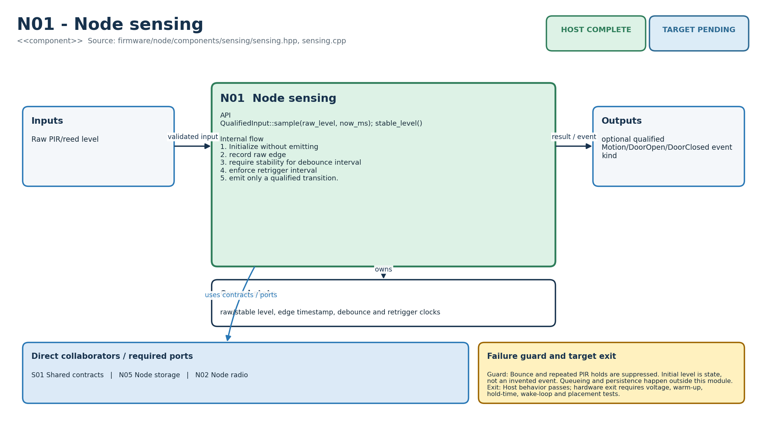
Figure M-01. Functionality, state ownership, I/O boundary and dependencies for N01.
Direct collaborators: S01 Shared contracts, N05 Node storage, N02 Node radio. Target exit: Host behavior passes; hardware exit requires voltage, warm-up, hold-time, wake-loop and placement tests.
Editable source: plantuml/modules/N01.puml

N02 - Node radio
HLD COMPLETE | LLD COMPLETE | HOST COMPLETE | TARGET PENDING
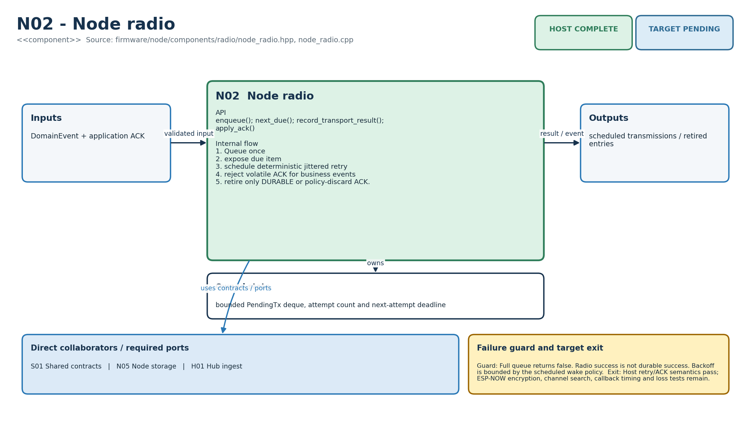
Figure M-02. Functionality, state ownership, I/O boundary and dependencies for N02.
Direct collaborators: S01 Shared contracts, N05 Node storage, H01 Hub ingest. Target exit: Host retry/ACK semantics pass; ESP-NOW encryption, channel search, callback timing and loss tests remain.
Editable source: plantuml/modules/N02.puml

N03 - Node power
HLD COMPLETE | LLD COMPLETE | HOST COMPLETE | TARGET PENDING
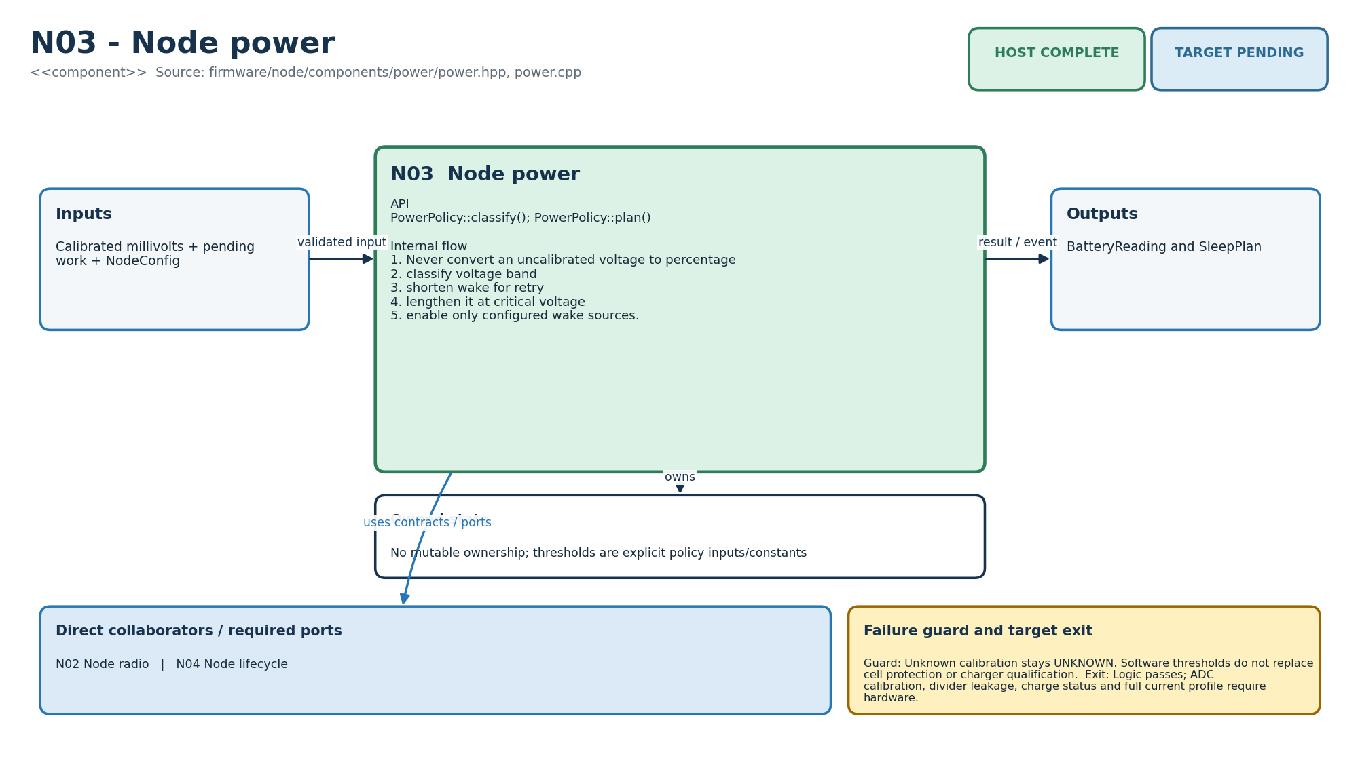
Figure M-03. Functionality, state ownership, I/O boundary and dependencies for N03.
Direct collaborators: N02 Node radio, N04 Node lifecycle. Target exit: Logic passes; ADC calibration, divider leakage, charge status and full current profile require hardware.
Editable source: plantuml/modules/N03.puml

N04 - Node lifecycle
HLD COMPLETE | LLD COMPLETE | HOST COMPLETE | TARGET PENDING
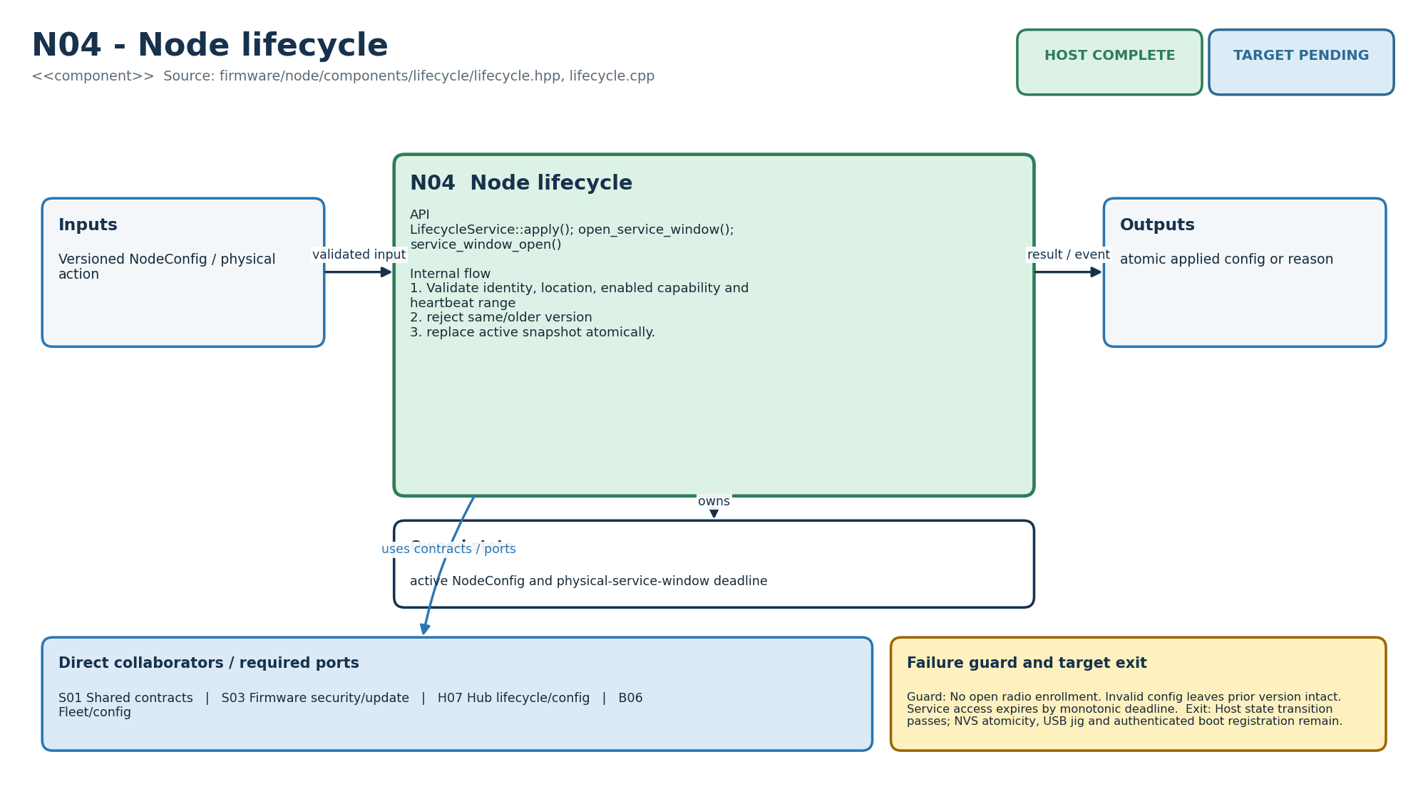
Figure M-04. Functionality, state ownership, I/O boundary and dependencies for N04.
Direct collaborators: S01 Shared contracts, S03 Firmware security/update, H07 Hub lifecycle/config, B06 Fleet/config. Target exit: Host state transition passes; NVS atomicity, USB jig and authenticated boot registration remain.
Editable source: plantuml/modules/N04.puml

N05 - Node storage
HLD COMPLETE | LLD COMPLETE | HOST COMPLETE | TARGET PENDING
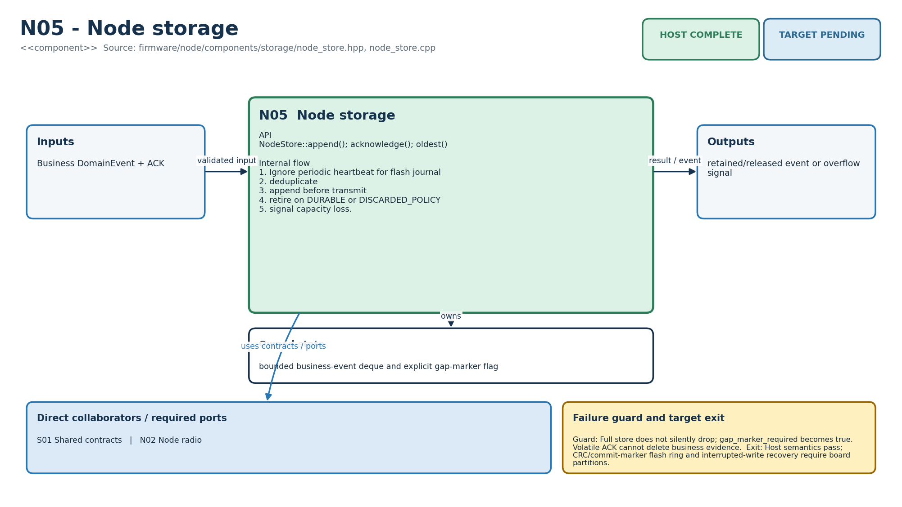
Figure M-05. Functionality, state ownership, I/O boundary and dependencies for N05.
Direct collaborators: S01 Shared contracts, N02 Node radio. Target exit: Host semantics pass; CRC/commit-marker flash ring and interrupted-write recovery require board partitions.
Editable source: plantuml/modules/N05.puml

H01 - Hub ingest
HLD COMPLETE | LLD COMPLETE | HOST COMPLETE | TARGET PENDING
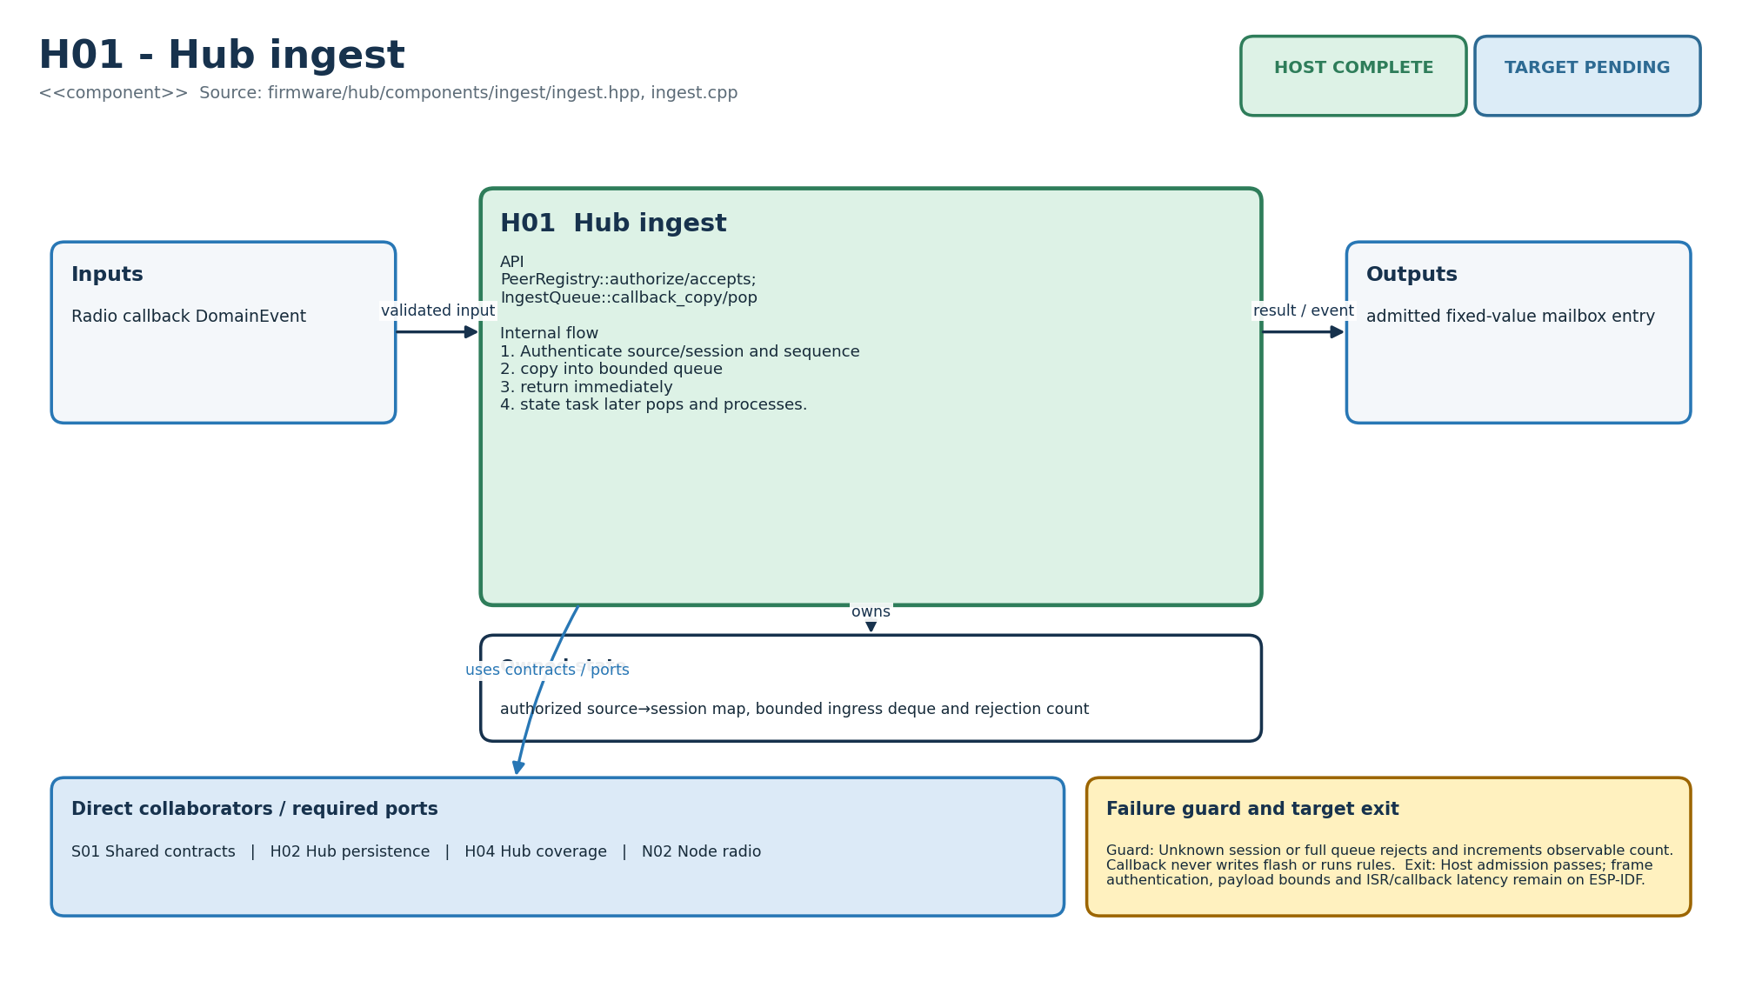
Figure M-06. Functionality, state ownership, I/O boundary and dependencies for H01.
Direct collaborators: S01 Shared contracts, H02 Hub persistence, H04 Hub coverage, N02 Node radio. Target exit: Host admission passes; frame authentication, payload bounds and ISR/callback latency remain on ESP-IDF.
Editable source: plantuml/modules/H01.puml

H02 - Hub persistence
HLD COMPLETE | LLD COMPLETE | HOST COMPLETE | TARGET PENDING
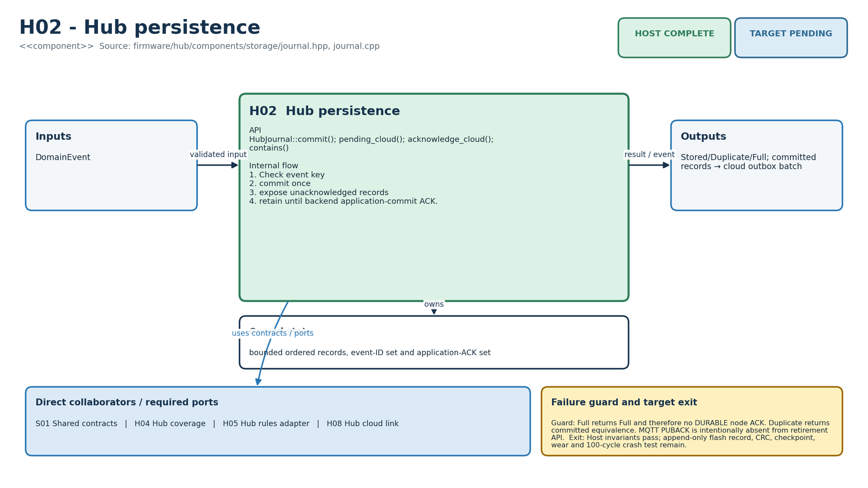
Figure M-07. Functionality, state ownership, I/O boundary and dependencies for H02.
Direct collaborators: S01 Shared contracts, H04 Hub coverage, H05 Hub rules adapter, H08 Hub cloud link. Target exit: Host invariants pass; append-only flash record, CRC, checkpoint, wear and 100-cycle crash test remain.
Editable source: plantuml/modules/H02.puml

H03 - Hub time
HLD COMPLETE | LLD COMPLETE | HOST COMPLETE | TARGET PENDING
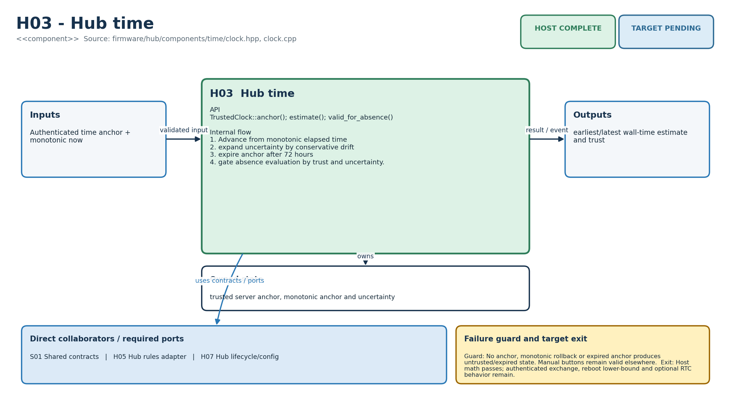
Figure M-08. Functionality, state ownership, I/O boundary and dependencies for H03.
Direct collaborators: S01 Shared contracts, H05 Hub rules adapter, H07 Hub lifecycle/config. Target exit: Host math passes; authenticated exchange, reboot lower-bound and optional RTC behavior remain.
Editable source: plantuml/modules/H03.puml

H04 - Hub coverage
HLD COMPLETE | LLD COMPLETE | HOST COMPLETE | TARGET PENDING
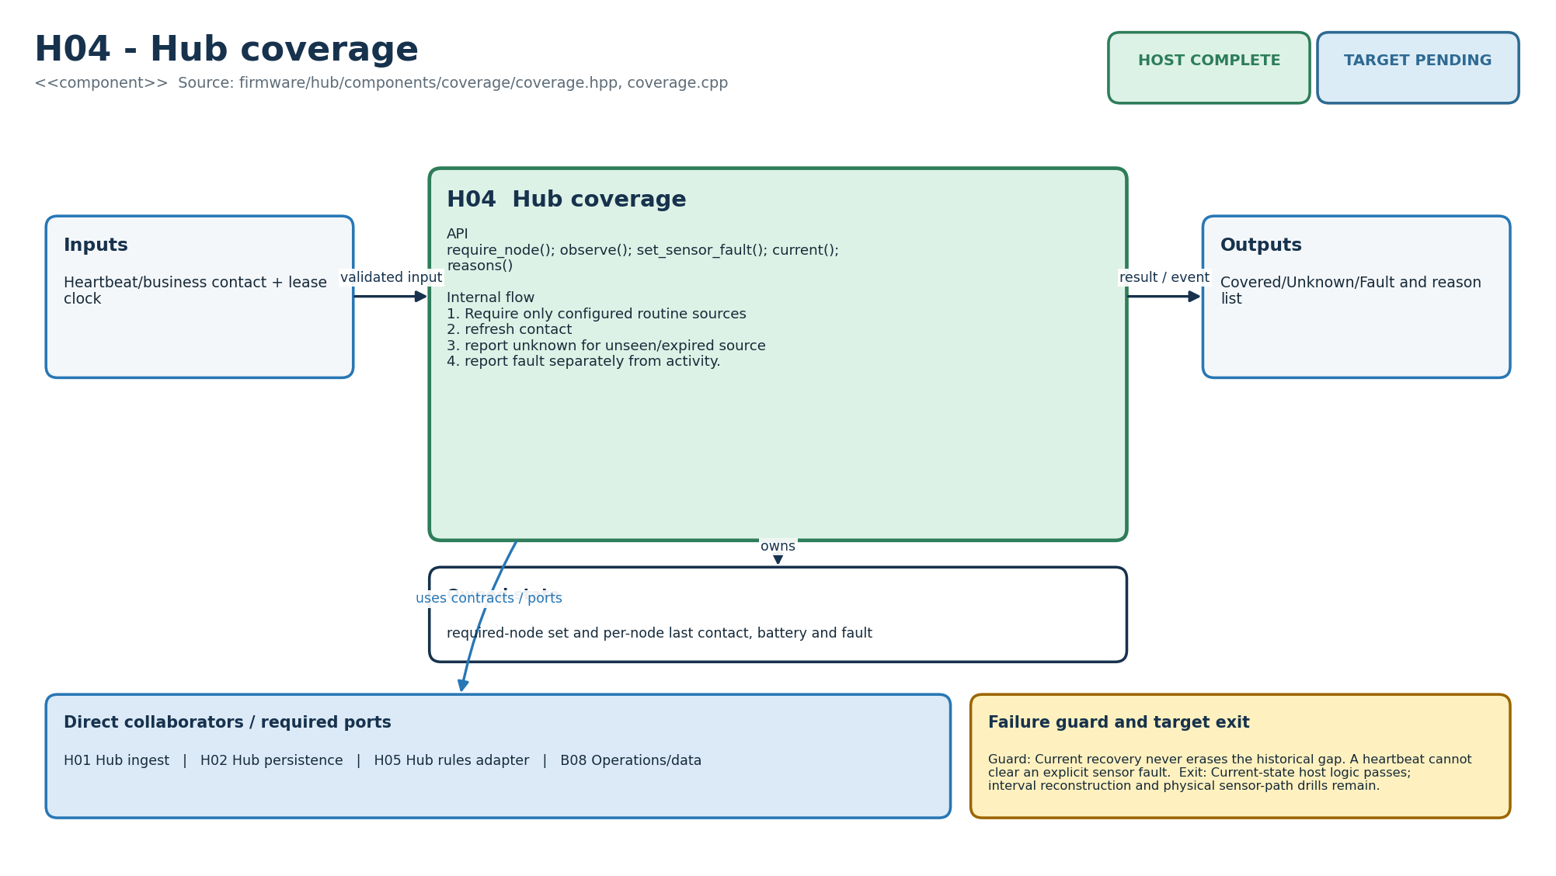
Figure M-09. Functionality, state ownership, I/O boundary and dependencies for H04.
Direct collaborators: H01 Hub ingest, H02 Hub persistence, H05 Hub rules adapter, B08 Operations/data. Target exit: Current-state host logic passes; interval reconstruction and physical sensor-path drills remain.
Editable source: plantuml/modules/H04.puml

H05 - Hub rules adapter
HLD COMPLETE | LLD COMPLETE | HOST COMPLETE | TARGET PENDING
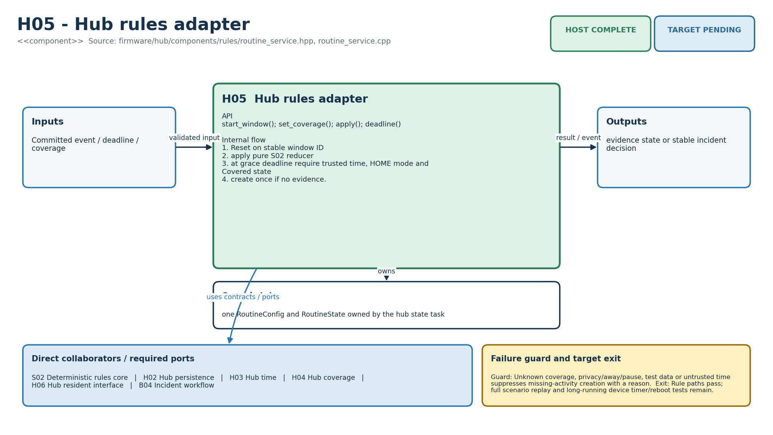
Figure M-10. Functionality, state ownership, I/O boundary and dependencies for H05.
Direct collaborators: S02 Deterministic rules core, H02 Hub persistence, H03 Hub time, H04 Hub coverage, H06 Hub resident interface, B04 Incident workflow. Target exit: Rule paths pass; full scenario replay and long-running device timer/reboot tests remain.
Editable source: plantuml/modules/H05.puml

H06 - Hub resident interface
HLD COMPLETE | LLD COMPLETE | HOST COMPLETE | TARGET PENDING
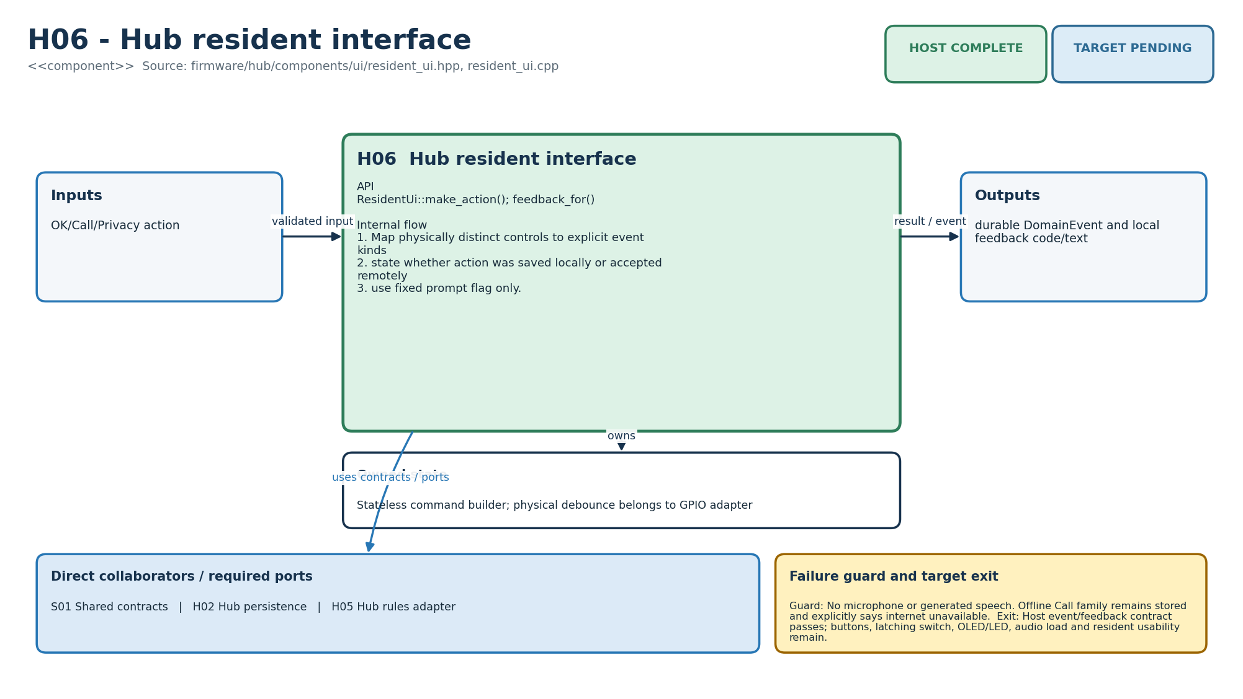
Figure M-11. Functionality, state ownership, I/O boundary and dependencies for H06.
Direct collaborators: S01 Shared contracts, H02 Hub persistence, H05 Hub rules adapter. Target exit: Host event/feedback contract passes; buttons, latching switch, OLED/LED, audio load and resident usability remain.
Editable source: plantuml/modules/H06.puml

H07 - Hub lifecycle/config
HLD COMPLETE | LLD COMPLETE | HOST COMPLETE | TARGET PENDING
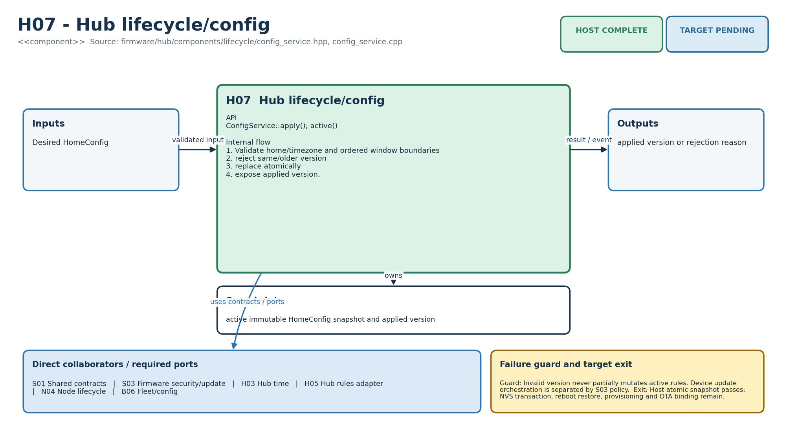
Figure M-12. Functionality, state ownership, I/O boundary and dependencies for H07.
Direct collaborators: S01 Shared contracts, S03 Firmware security/update, H03 Hub time, H05 Hub rules adapter, N04 Node lifecycle, B06 Fleet/config. Target exit: Host atomic snapshot passes; NVS transaction, reboot restore, provisioning and OTA binding remain.
Editable source: plantuml/modules/H07.puml

H08 - Hub cloud link
HLD COMPLETE | LLD COMPLETE | HOST COMPLETE | TARGET PENDING
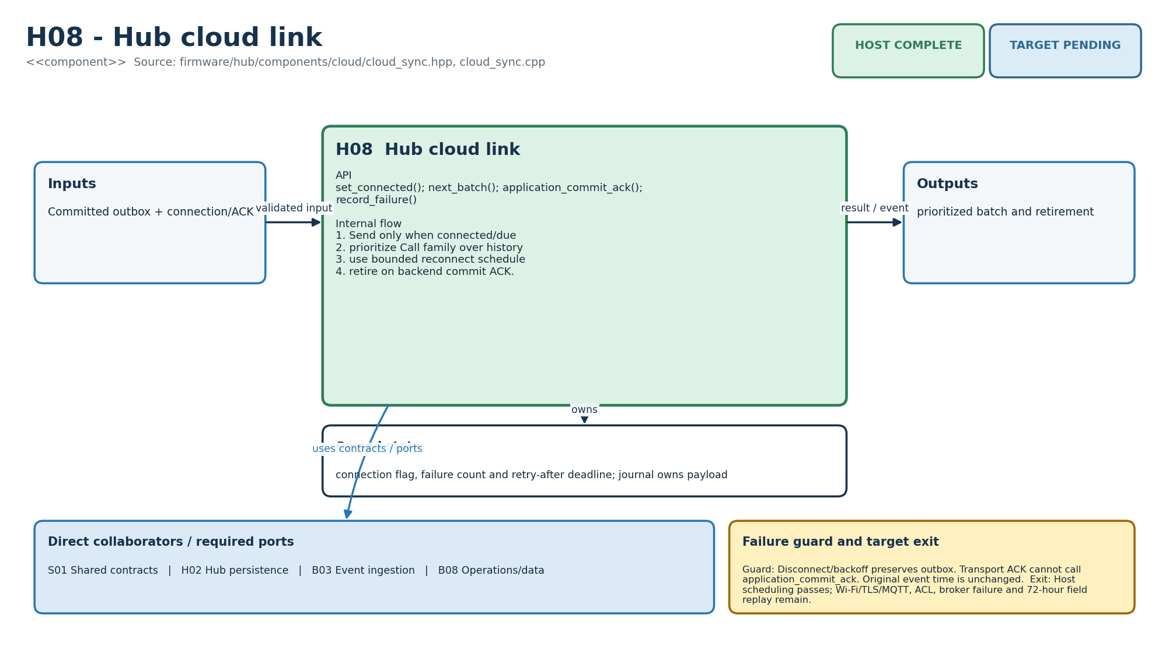
Figure M-13. Functionality, state ownership, I/O boundary and dependencies for H08.
Direct collaborators: S01 Shared contracts, H02 Hub persistence, B03 Event ingestion, B08 Operations/data. Target exit: Host scheduling passes; Wi-Fi/TLS/MQTT, ACL, broker failure and 72-hour field replay remain.
Editable source: plantuml/modules/H08.puml

B01 - Identity/access
HLD COMPLETE | LLD COMPLETE | HOST COMPLETE | TARGET PENDING
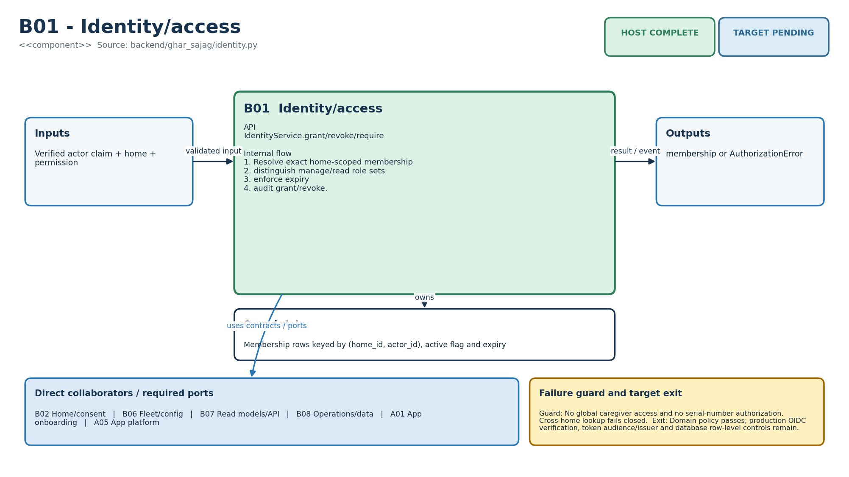
Figure M-14. Functionality, state ownership, I/O boundary and dependencies for B01.
Direct collaborators: B02 Home/consent, B06 Fleet/config, B07 Read models/API, B08 Operations/data, A01 App onboarding, A05 App platform. Target exit: Domain policy passes; production OIDC verification, token audience/issuer and database row-level controls remain.
Editable source: plantuml/modules/B01.puml

B02 - Home/consent
HLD COMPLETE | LLD COMPLETE | HOST COMPLETE | TARGET PENDING
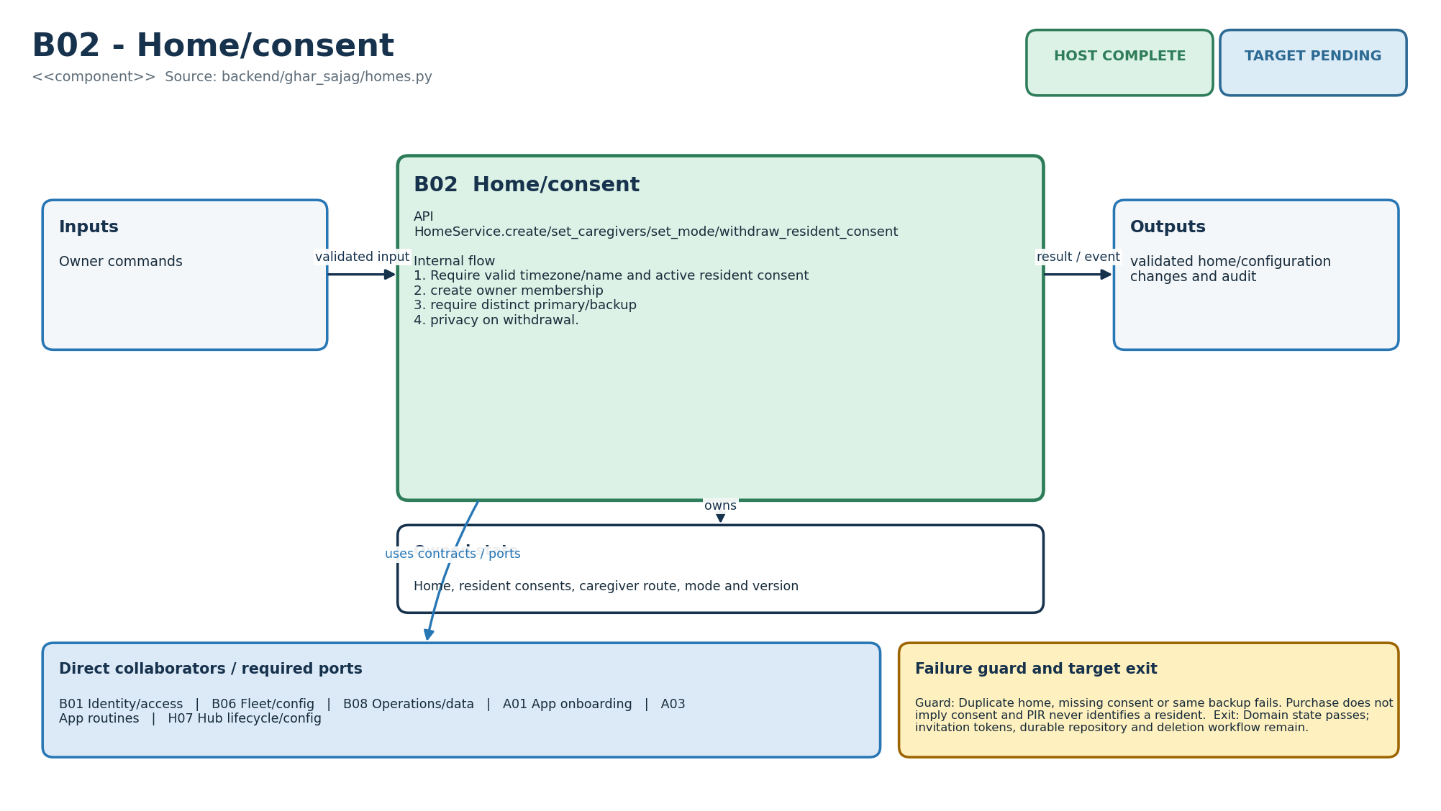
Figure M-15. Functionality, state ownership, I/O boundary and dependencies for B02.
Direct collaborators: B01 Identity/access, B06 Fleet/config, B08 Operations/data, A01 App onboarding, A03 App routines, H07 Hub lifecycle/config. Target exit: Domain state passes; invitation tokens, durable repository and deletion workflow remain.
Editable source: plantuml/modules/B02.puml

B03 - Event ingestion
HLD COMPLETE | LLD COMPLETE | HOST COMPLETE | TARGET PENDING
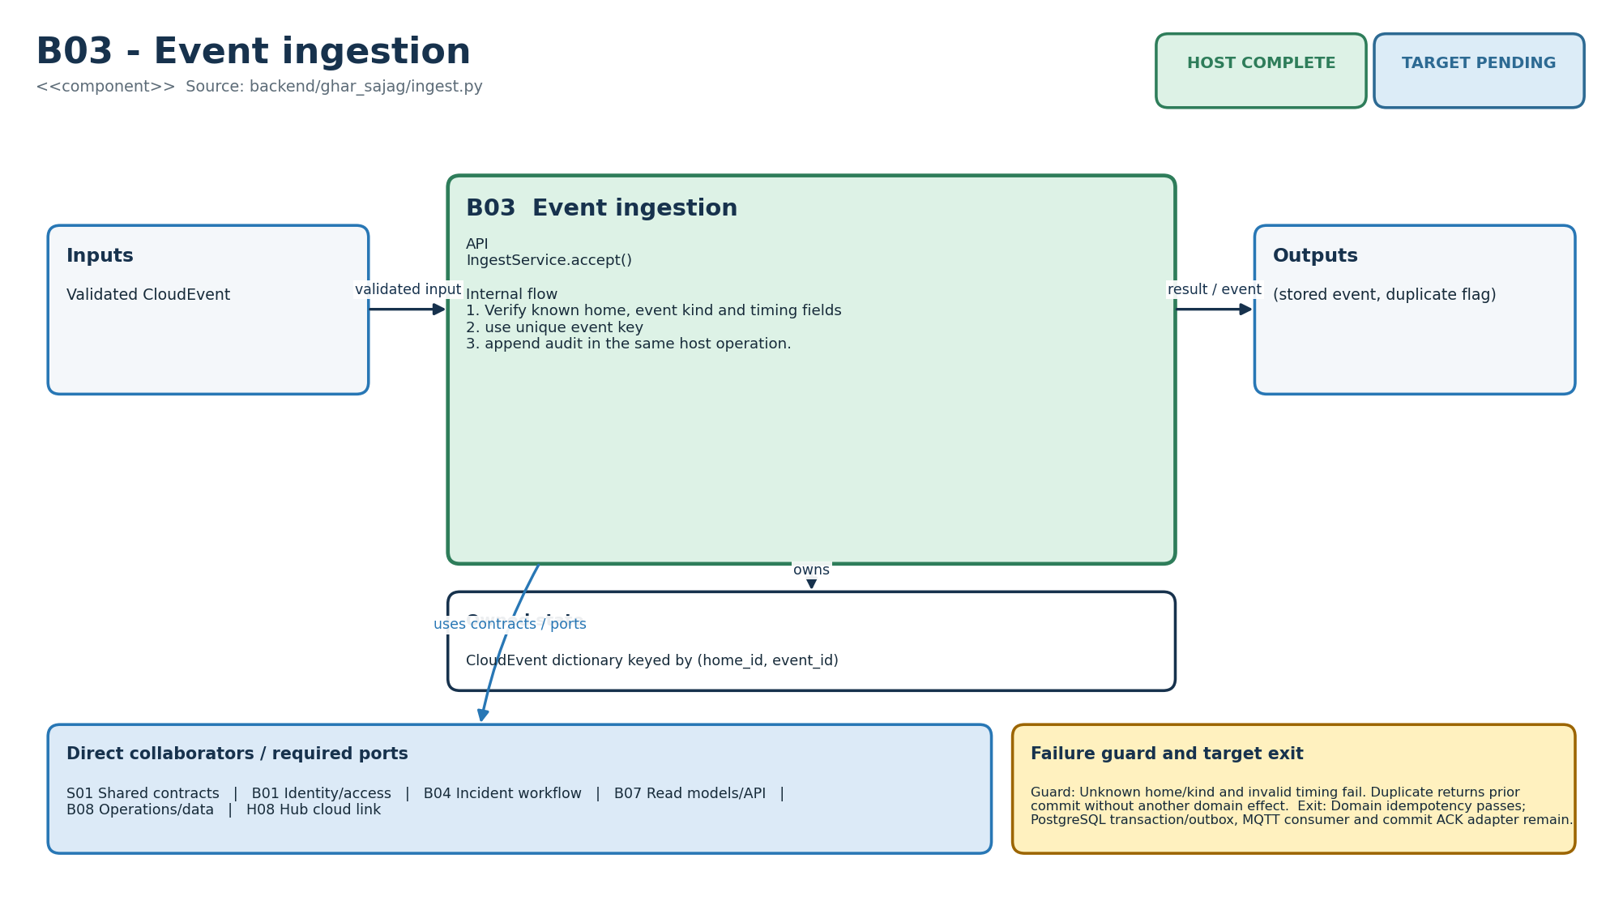
Figure M-16. Functionality, state ownership, I/O boundary and dependencies for B03.
Direct collaborators: S01 Shared contracts, B01 Identity/access, B04 Incident workflow, B07 Read models/API, B08 Operations/data, H08 Hub cloud link. Target exit: Domain idempotency passes; PostgreSQL transaction/outbox, MQTT consumer and commit ACK adapter remain.
Editable source: plantuml/modules/B03.puml

B04 - Incident workflow
HLD COMPLETE | LLD COMPLETE | HOST COMPLETE | TARGET PENDING
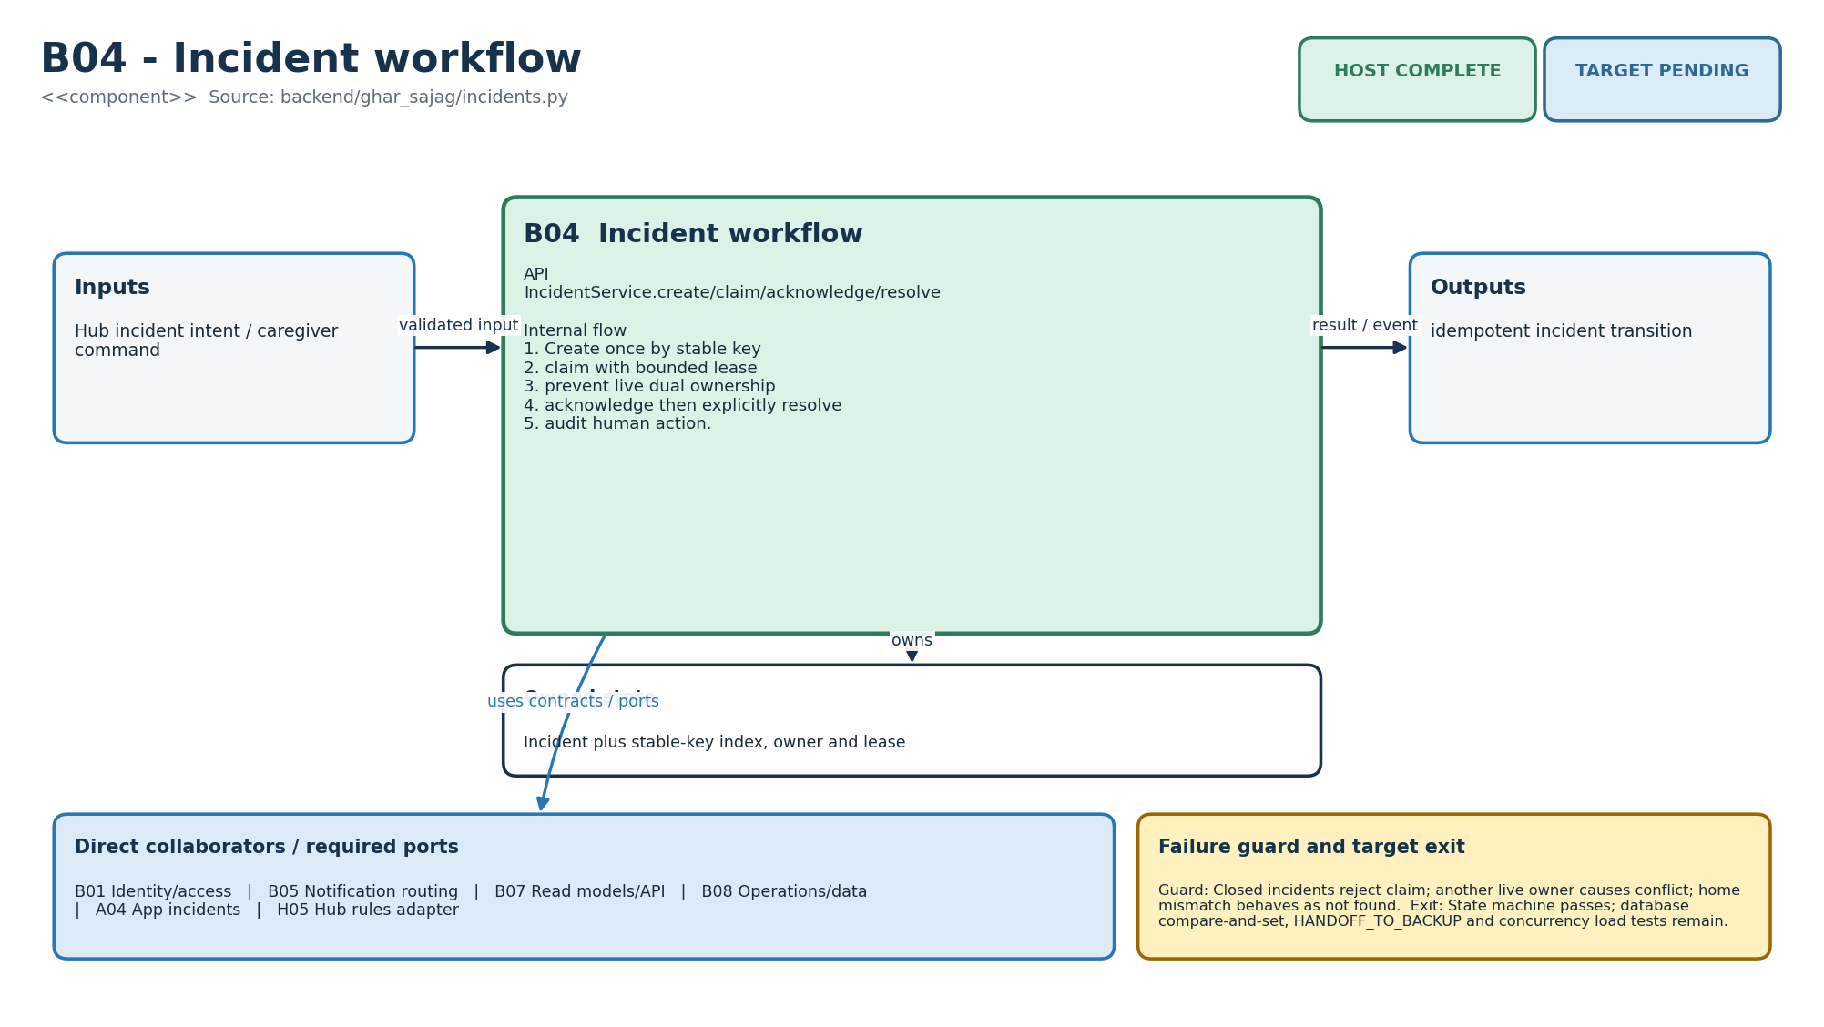
Figure M-17. Functionality, state ownership, I/O boundary and dependencies for B04.
Direct collaborators: B01 Identity/access, B05 Notification routing, B07 Read models/API, B08 Operations/data, A04 App incidents, H05 Hub rules adapter. Target exit: State machine passes; database compare-and-set, HANDOFF_TO_BACKUP and concurrency load tests remain.
Editable source: plantuml/modules/B04.puml

B05 - Notification routing
HLD COMPLETE | LLD COMPLETE | HOST COMPLETE | TARGET PENDING
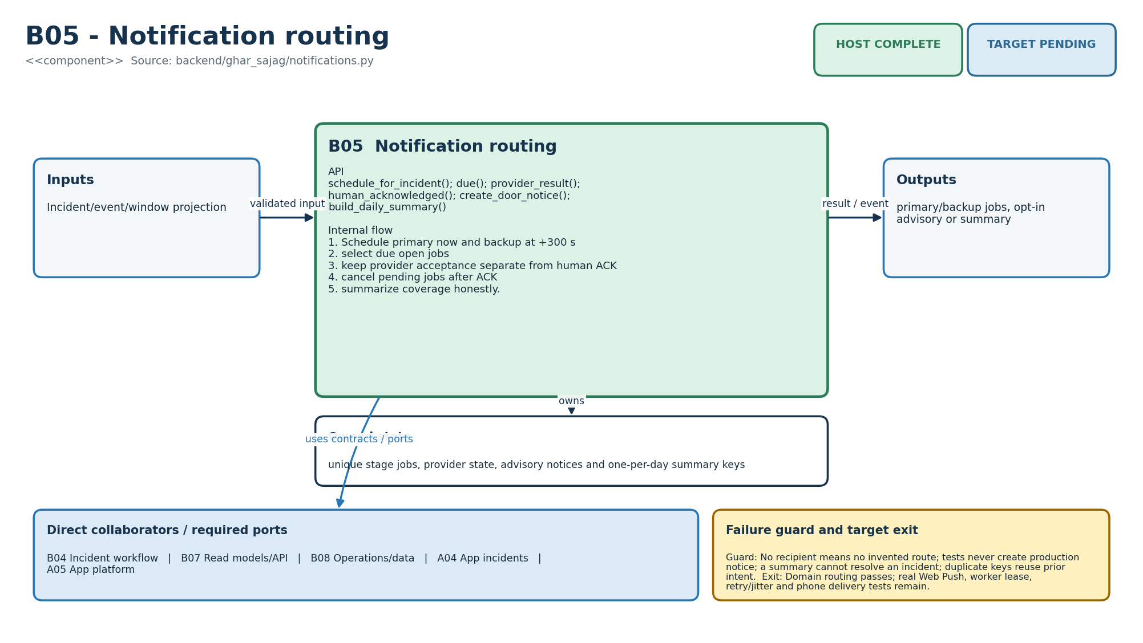
Figure M-18. Functionality, state ownership, I/O boundary and dependencies for B05.
Direct collaborators: B04 Incident workflow, B07 Read models/API, B08 Operations/data, A04 App incidents, A05 App platform. Target exit: Domain routing passes; real Web Push, worker lease, retry/jitter and phone delivery tests remain.
Editable source: plantuml/modules/B05.puml

B06 - Fleet/config
HLD COMPLETE | LLD COMPLETE | HOST COMPLETE | TARGET PENDING
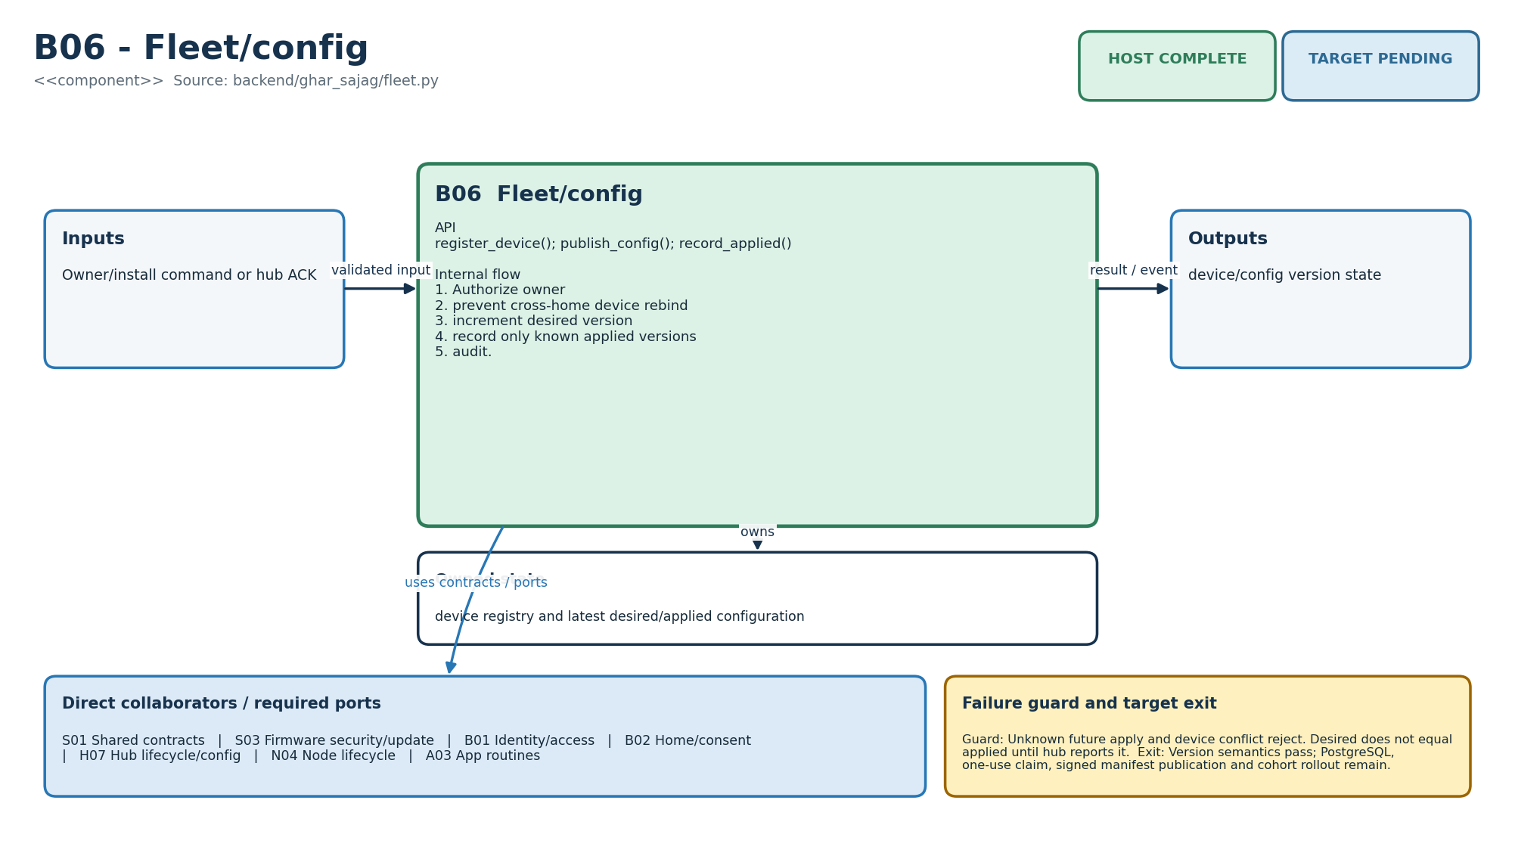
Figure M-19. Functionality, state ownership, I/O boundary and dependencies for B06.
Direct collaborators: S01 Shared contracts, S03 Firmware security/update, B01 Identity/access, B02 Home/consent, H07 Hub lifecycle/config, N04 Node lifecycle, A03 App routines. Target exit: Version semantics pass; PostgreSQL, one-use claim, signed manifest publication and cohort rollout remain.
Editable source: plantuml/modules/B06.puml

B07 - Read models/API
HLD COMPLETE | LLD COMPLETE | HOST COMPLETE | TARGET PENDING
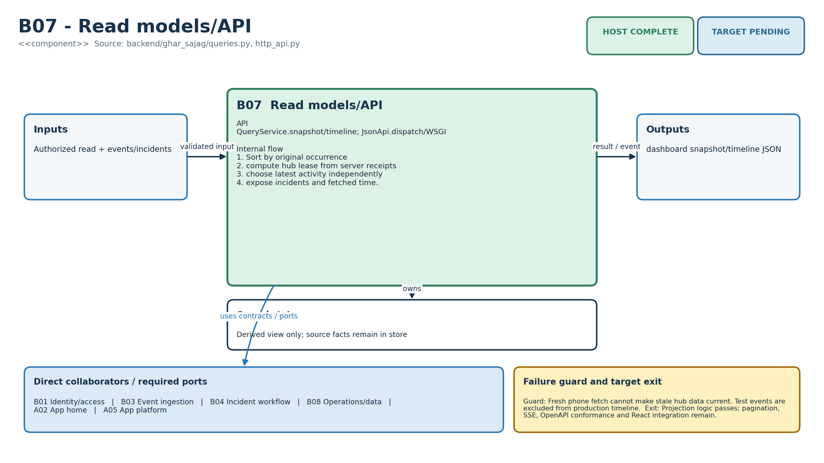
Figure M-20. Functionality, state ownership, I/O boundary and dependencies for B07.
Direct collaborators: B01 Identity/access, B03 Event ingestion, B04 Incident workflow, B08 Operations/data, A02 App home, A05 App platform. Target exit: Projection logic passes; pagination, SSE, OpenAPI conformance and React integration remain.
Editable source: plantuml/modules/B07.puml

B08 - Operations/data
HLD COMPLETE | LLD COMPLETE | HOST COMPLETE | TARGET PENDING
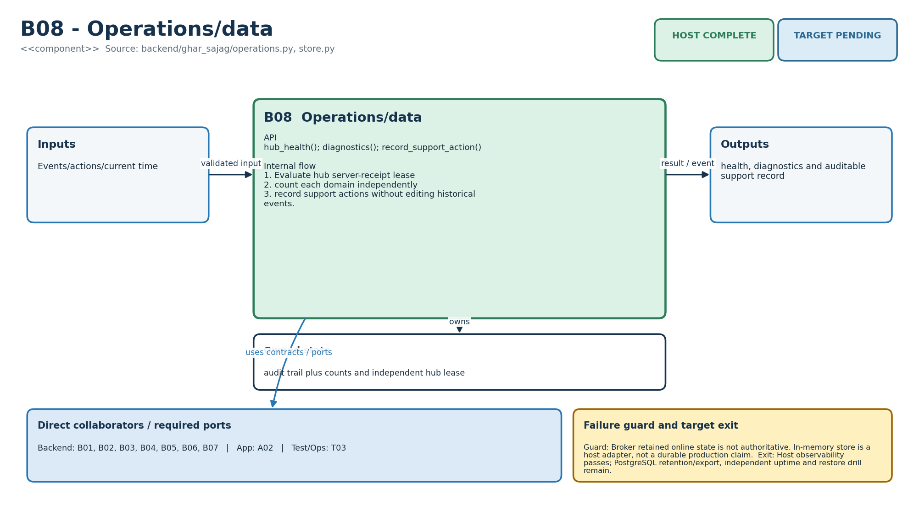
Figure M-21. Functionality, state ownership, I/O boundary and dependencies for B08.
Direct collaborators: B01 Identity/access, B02 Home/consent, B03 Event ingestion, B04 Incident workflow, B05 Notification routing, B06 Fleet/config, B07 Read models/API, A02 App home, T03 Deployment/operations. Target exit: Host observability passes; PostgreSQL retention/export, independent uptime and restore drill remain.
Editable source: plantuml/modules/B08.puml

A01 - App onboarding
HLD COMPLETE | LLD COMPLETE | HOST COMPLETE | TARGET PENDING
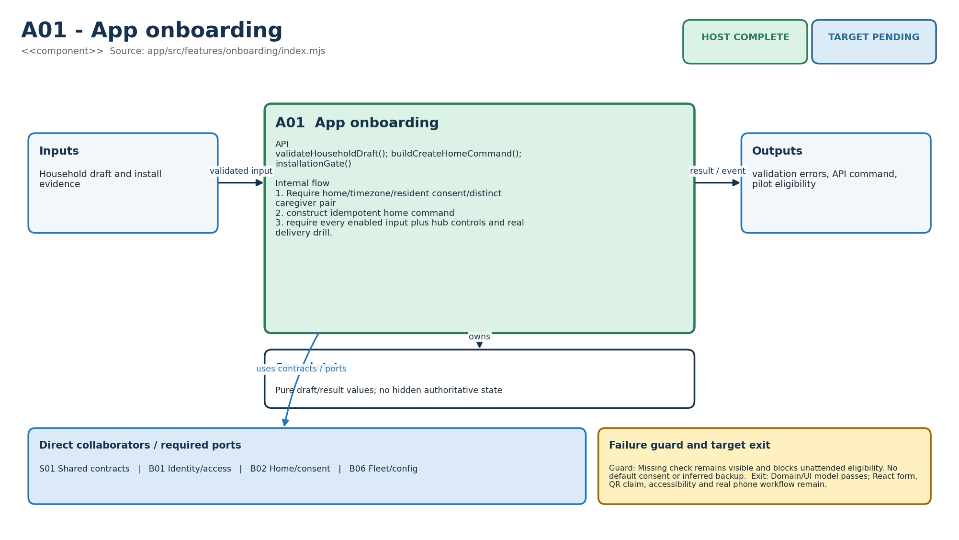
Figure M-22. Functionality, state ownership, I/O boundary and dependencies for A01.
Direct collaborators: S01 Shared contracts, B01 Identity/access, B02 Home/consent, B06 Fleet/config. Target exit: Domain/UI model passes; React form, QR claim, accessibility and real phone workflow remain.
Editable source: plantuml/modules/A01.puml

A02 - App home
HLD COMPLETE | LLD COMPLETE | HOST COMPLETE | TARGET PENDING
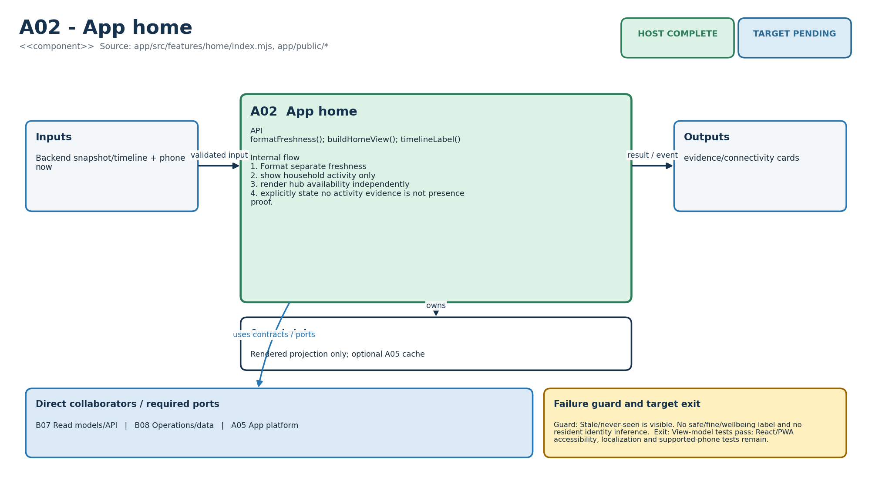
Figure M-23. Functionality, state ownership, I/O boundary and dependencies for A02.
Direct collaborators: B07 Read models/API, B08 Operations/data, A05 App platform. Target exit: View-model tests pass; React/PWA accessibility, localization and supported-phone tests remain.
Editable source: plantuml/modules/A02.puml

A03 - App routines
HLD COMPLETE | LLD COMPLETE | HOST COMPLETE | TARGET PENDING
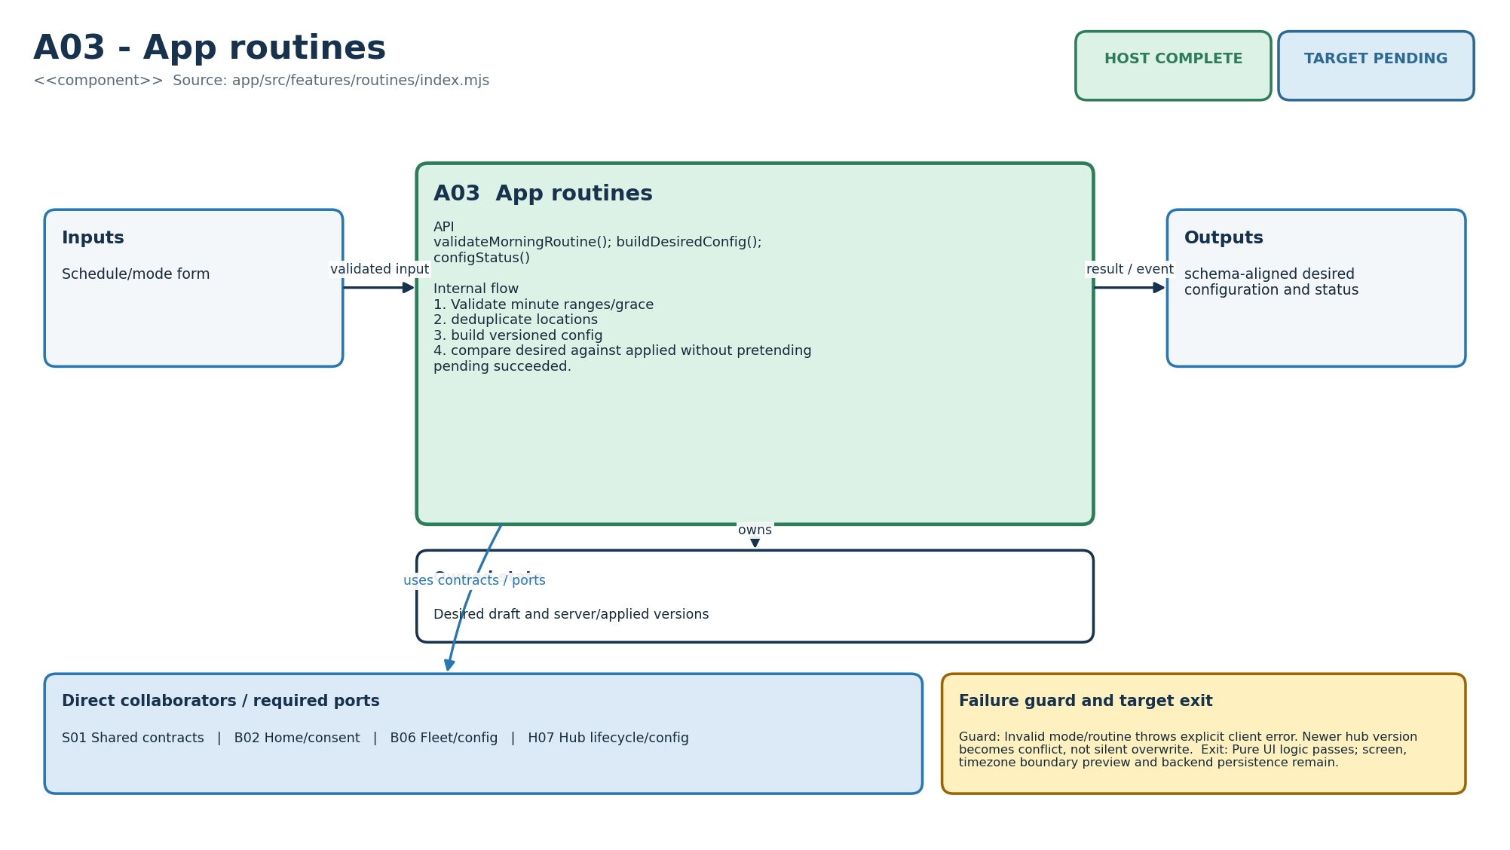
Figure M-24. Functionality, state ownership, I/O boundary and dependencies for A03.
Direct collaborators: S01 Shared contracts, B02 Home/consent, B06 Fleet/config, H07 Hub lifecycle/config. Target exit: Pure UI logic passes; screen, timezone boundary preview and backend persistence remain.
Editable source: plantuml/modules/A03.puml

A04 - App incidents
HLD COMPLETE | LLD COMPLETE | HOST COMPLETE | TARGET PENDING
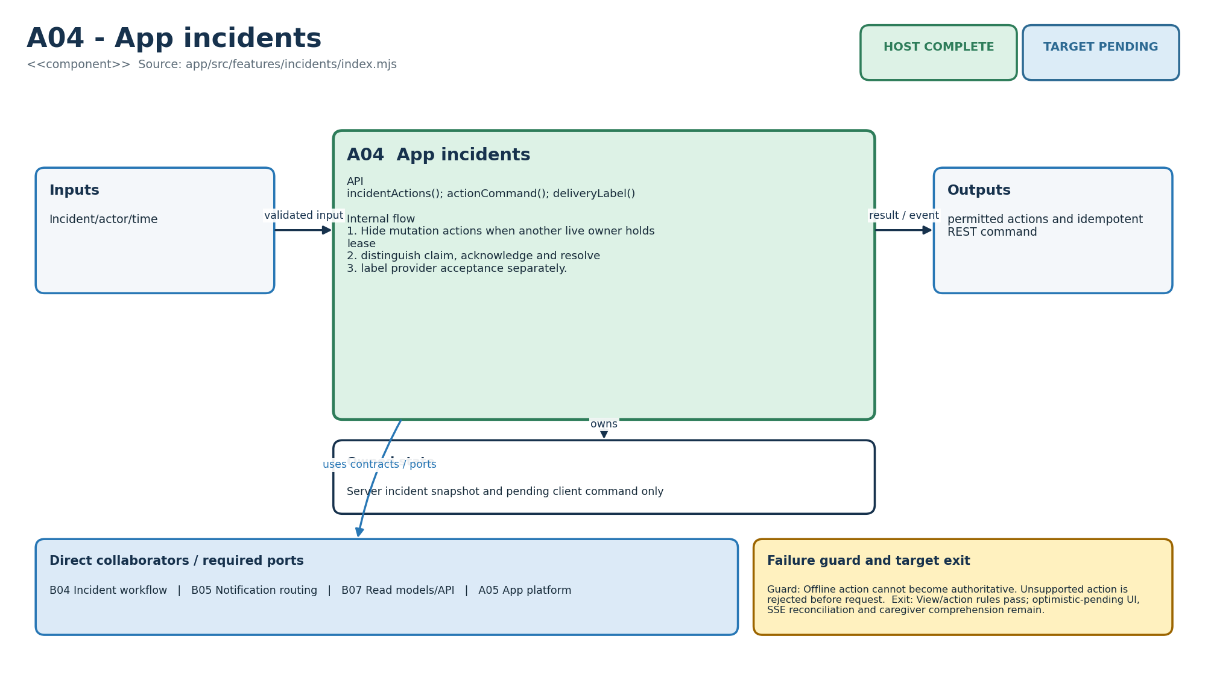
Figure M-25. Functionality, state ownership, I/O boundary and dependencies for A04.
Direct collaborators: B04 Incident workflow, B05 Notification routing, B07 Read models/API, A05 App platform. Target exit: View/action rules pass; optimistic-pending UI, SSE reconciliation and caregiver comprehension remain.
Editable source: plantuml/modules/A04.puml

A05 - App platform
HLD COMPLETE | LLD COMPLETE | HOST COMPLETE | TARGET PENDING
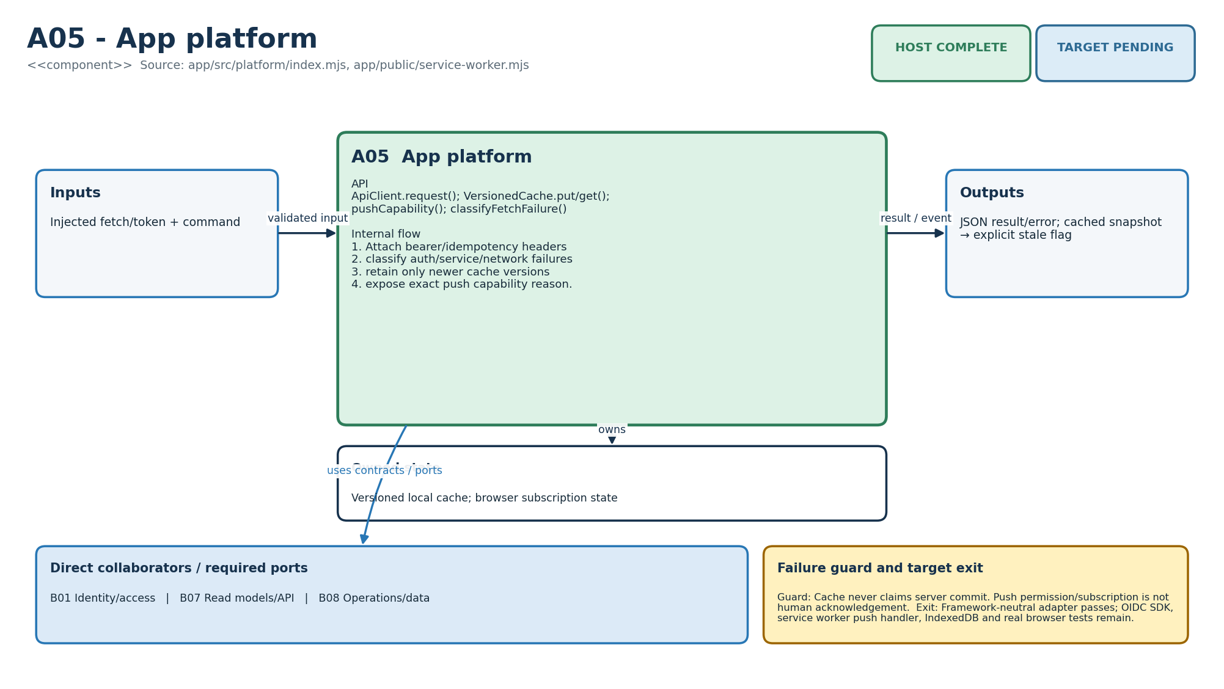
Figure M-26. Functionality, state ownership, I/O boundary and dependencies for A05.
Direct collaborators: B01 Identity/access, B07 Read models/API, B08 Operations/data. Target exit: Framework-neutral adapter passes; OIDC SDK, service worker push handler, IndexedDB and real browser tests remain.
Editable source: plantuml/modules/A05.puml

S01 - Shared contracts
HLD COMPLETE | LLD COMPLETE | HOST COMPLETE | TARGET PENDING
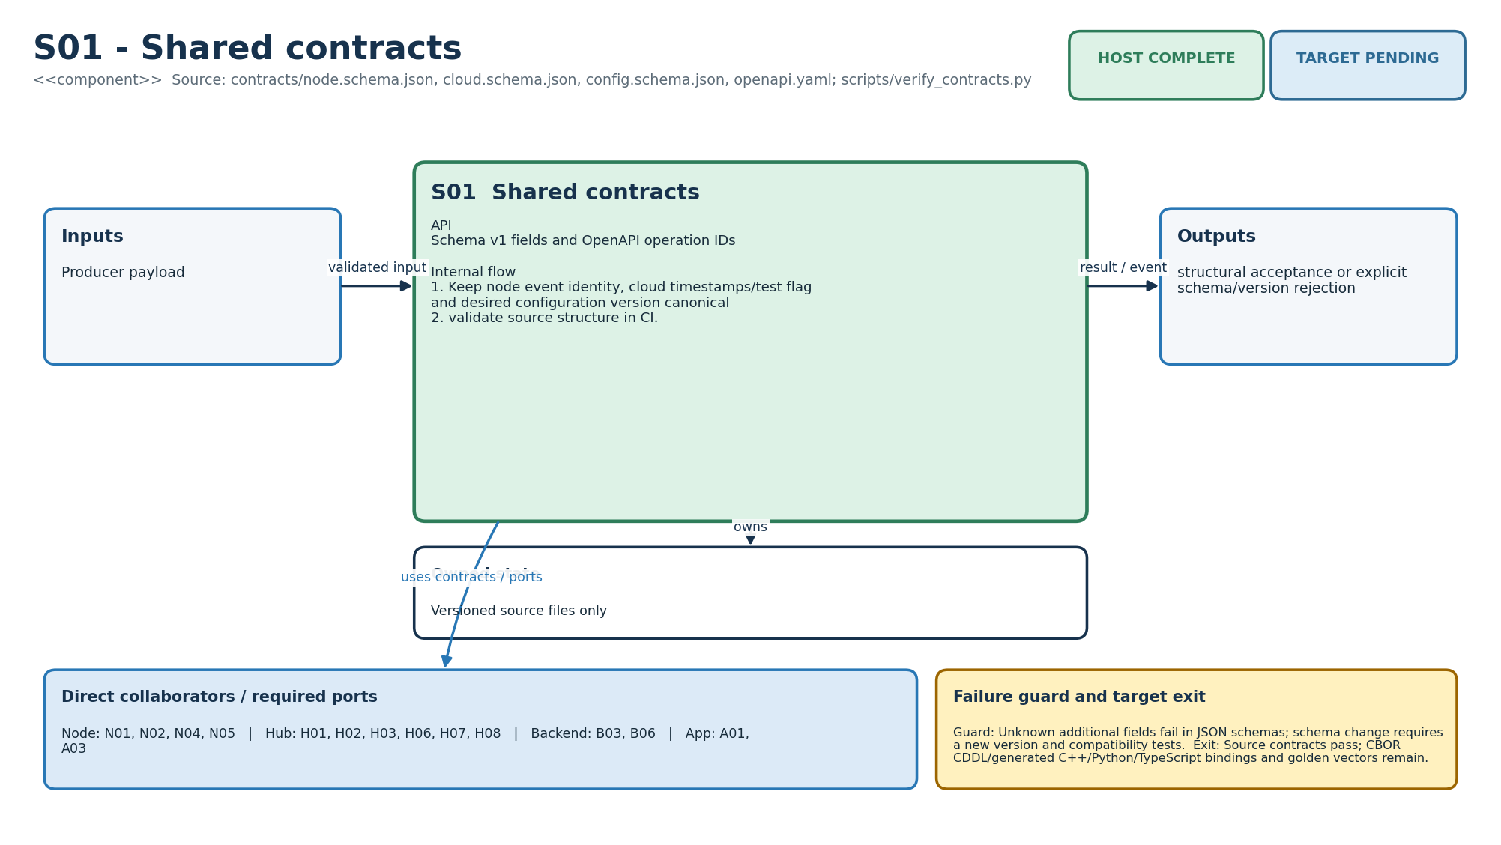
Figure M-27. Functionality, state ownership, I/O boundary and dependencies for S01.
Direct collaborators: N01 Node sensing, N02 Node radio, N04 Node lifecycle, N05 Node storage, H01 Hub ingest, H02 Hub persistence, H03 Hub time, H06 Hub resident interface, H07 Hub lifecycle/config, H08 Hub cloud link, B03 Event ingestion, B06 Fleet/config, A01 App onboarding, A03 App routines. Target exit: Source contracts pass; CBOR CDDL/generated C++/Python/TypeScript bindings and golden vectors remain.
Editable source: plantuml/modules/S01.puml

S02 - Deterministic rules core
HLD COMPLETE | LLD COMPLETE | HOST COMPLETE | TARGET PENDING
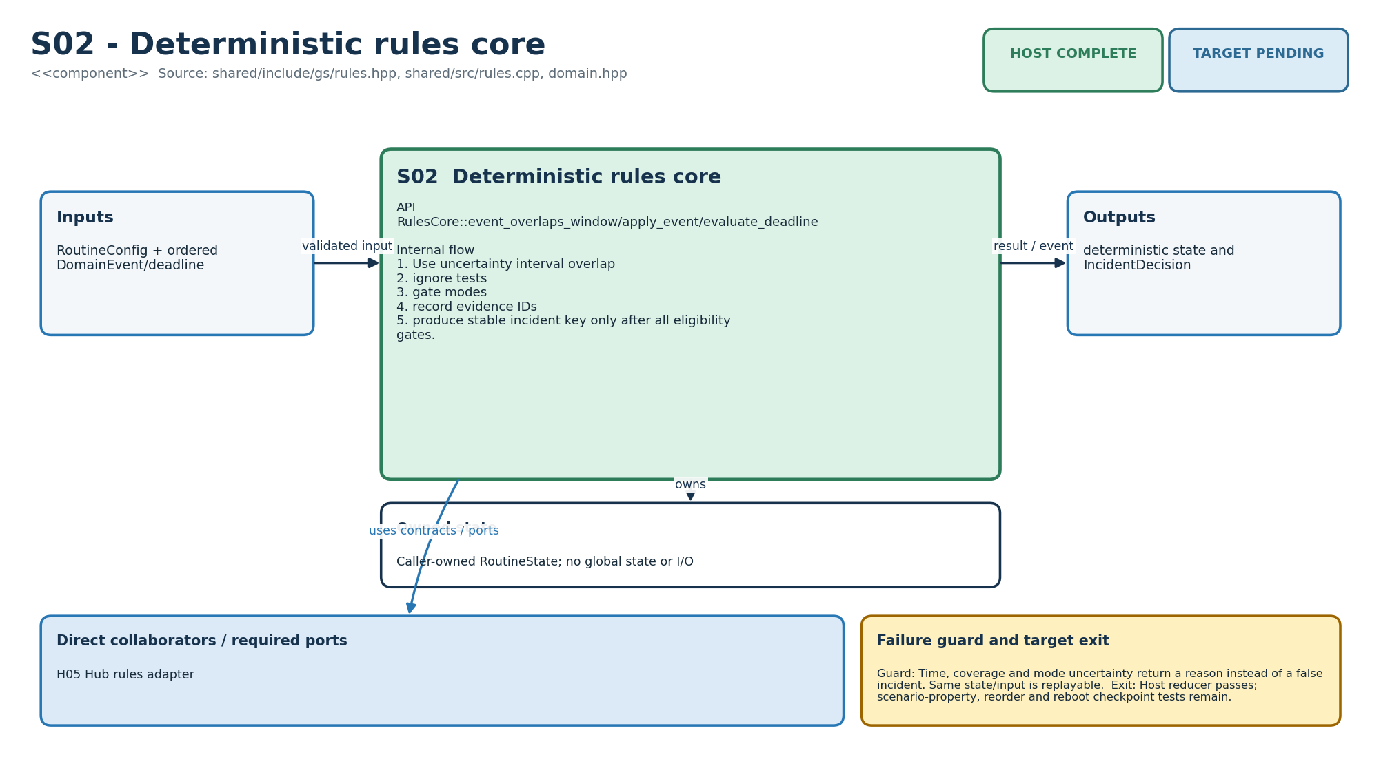
Figure M-28. Functionality, state ownership, I/O boundary and dependencies for S02.
Direct collaborators: H05 Hub rules adapter. Target exit: Host reducer passes; scenario-property, reorder and reboot checkpoint tests remain.
Editable source: plantuml/modules/S02.puml

S03 - Firmware security/update
HLD COMPLETE | LLD COMPLETE | HOST COMPLETE | TARGET PENDING
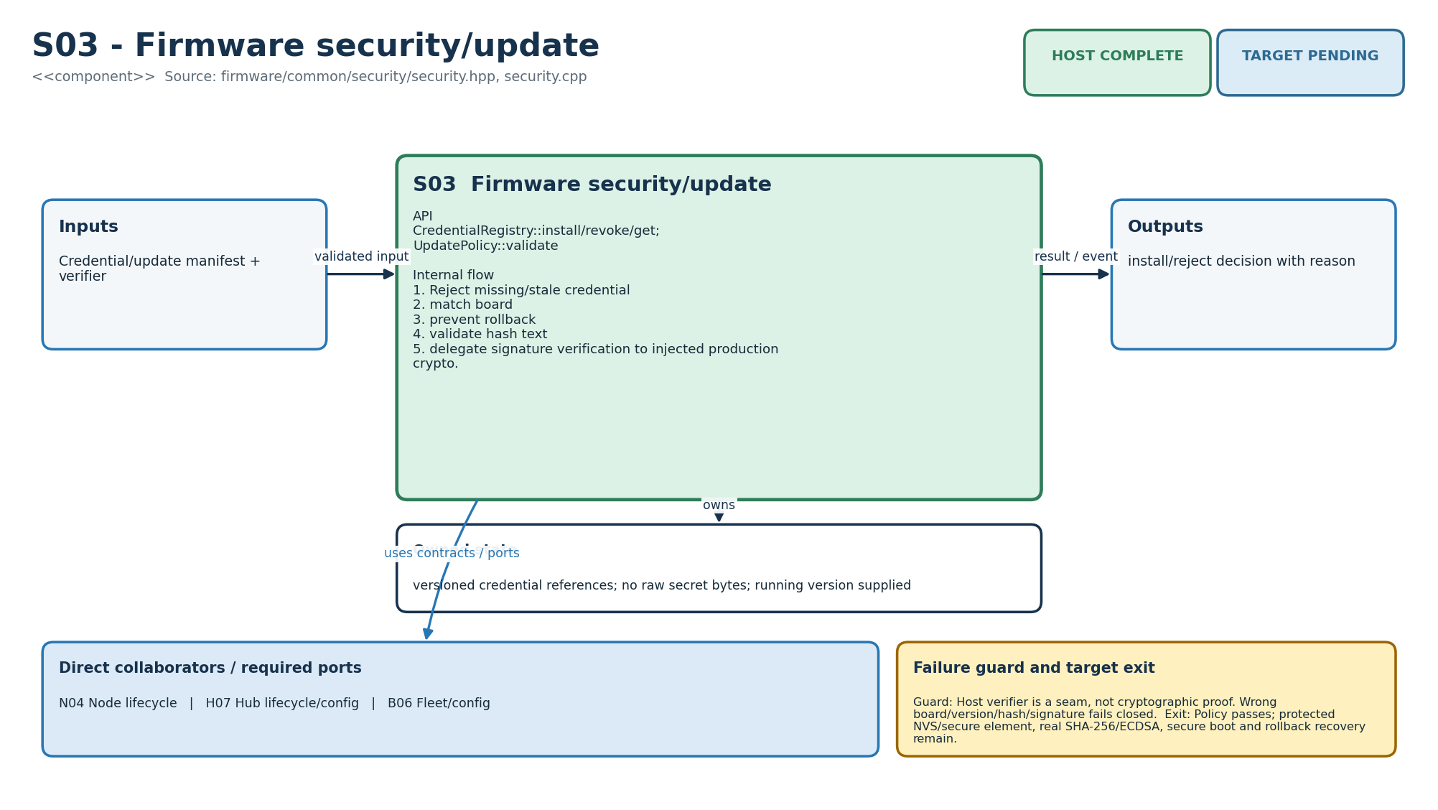
Figure M-29. Functionality, state ownership, I/O boundary and dependencies for S03.
Direct collaborators: N04 Node lifecycle, H07 Hub lifecycle/config, B06 Fleet/config. Target exit: Policy passes; protected NVS/secure element, real SHA-256/ECDSA, secure boot and rollback recovery remain.
Editable source: plantuml/modules/S03.puml

T01 - Simulation/CI
HLD COMPLETE | LLD COMPLETE | HOST COMPLETE | TARGET PENDING
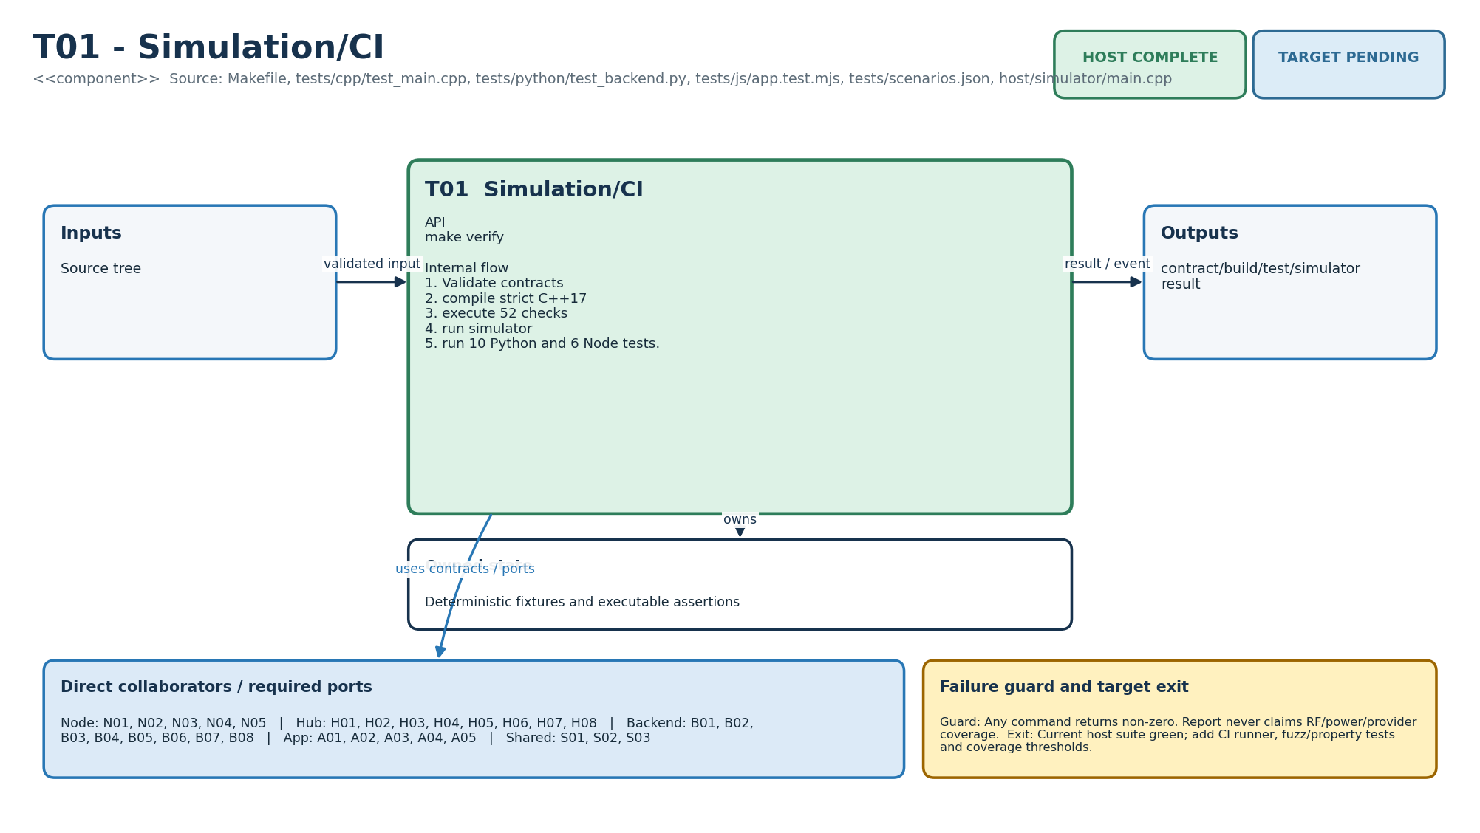
Figure M-30. Functionality, state ownership, I/O boundary and dependencies for T01.
Direct collaborators: N01 Node sensing, N02 Node radio, N03 Node power, N04 Node lifecycle, N05 Node storage, H01 Hub ingest, H02 Hub persistence, H03 Hub time, H04 Hub coverage, H05 Hub rules adapter, H06 Hub resident interface, H07 Hub lifecycle/config, H08 Hub cloud link, B01 Identity/access, B02 Home/consent, B03 Event ingestion, B04 Incident workflow, B05 Notification routing, B06 Fleet/config, B07 Read models/API, B08 Operations/data, A01 App onboarding, A02 App home, A03 App routines, A04 App incidents, A05 App platform, S01 Shared contracts, S02 Deterministic rules core, S03 Firmware security/update. Target exit: Current host suite green; add CI runner, fuzz/property tests and coverage thresholds.
Editable source: plantuml/modules/T01.puml

T02 - Hardware-in-loop tools
HLD COMPLETE | LLD COMPLETE | HOST PARTIAL | TARGET PENDING
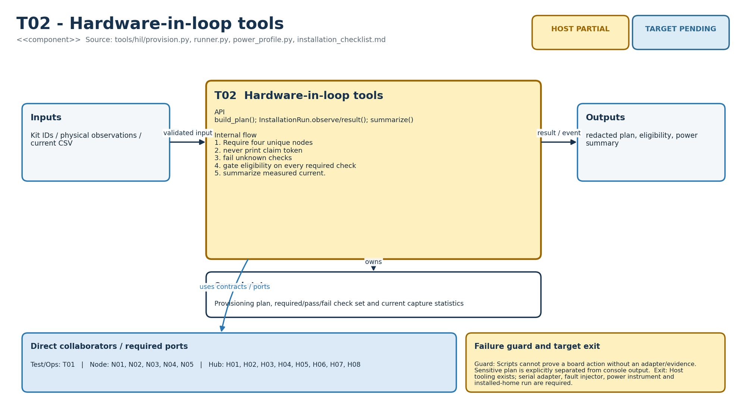
Figure M-31. Functionality, state ownership, I/O boundary and dependencies for T02.
Direct collaborators: T01 Simulation/CI, N01 Node sensing, N02 Node radio, N03 Node power, N04 Node lifecycle, N05 Node storage, H01 Hub ingest, H02 Hub persistence, H03 Hub time, H04 Hub coverage, H05 Hub rules adapter, H06 Hub resident interface, H07 Hub lifecycle/config, H08 Hub cloud link. Target exit: Host tooling exists; serial adapter, fault injector, power instrument and installed-home run are required.
Editable source: plantuml/modules/T02.puml

T03 - Deployment/operations
HLD COMPLETE | LLD COMPLETE | HOST PARTIAL | TARGET PENDING
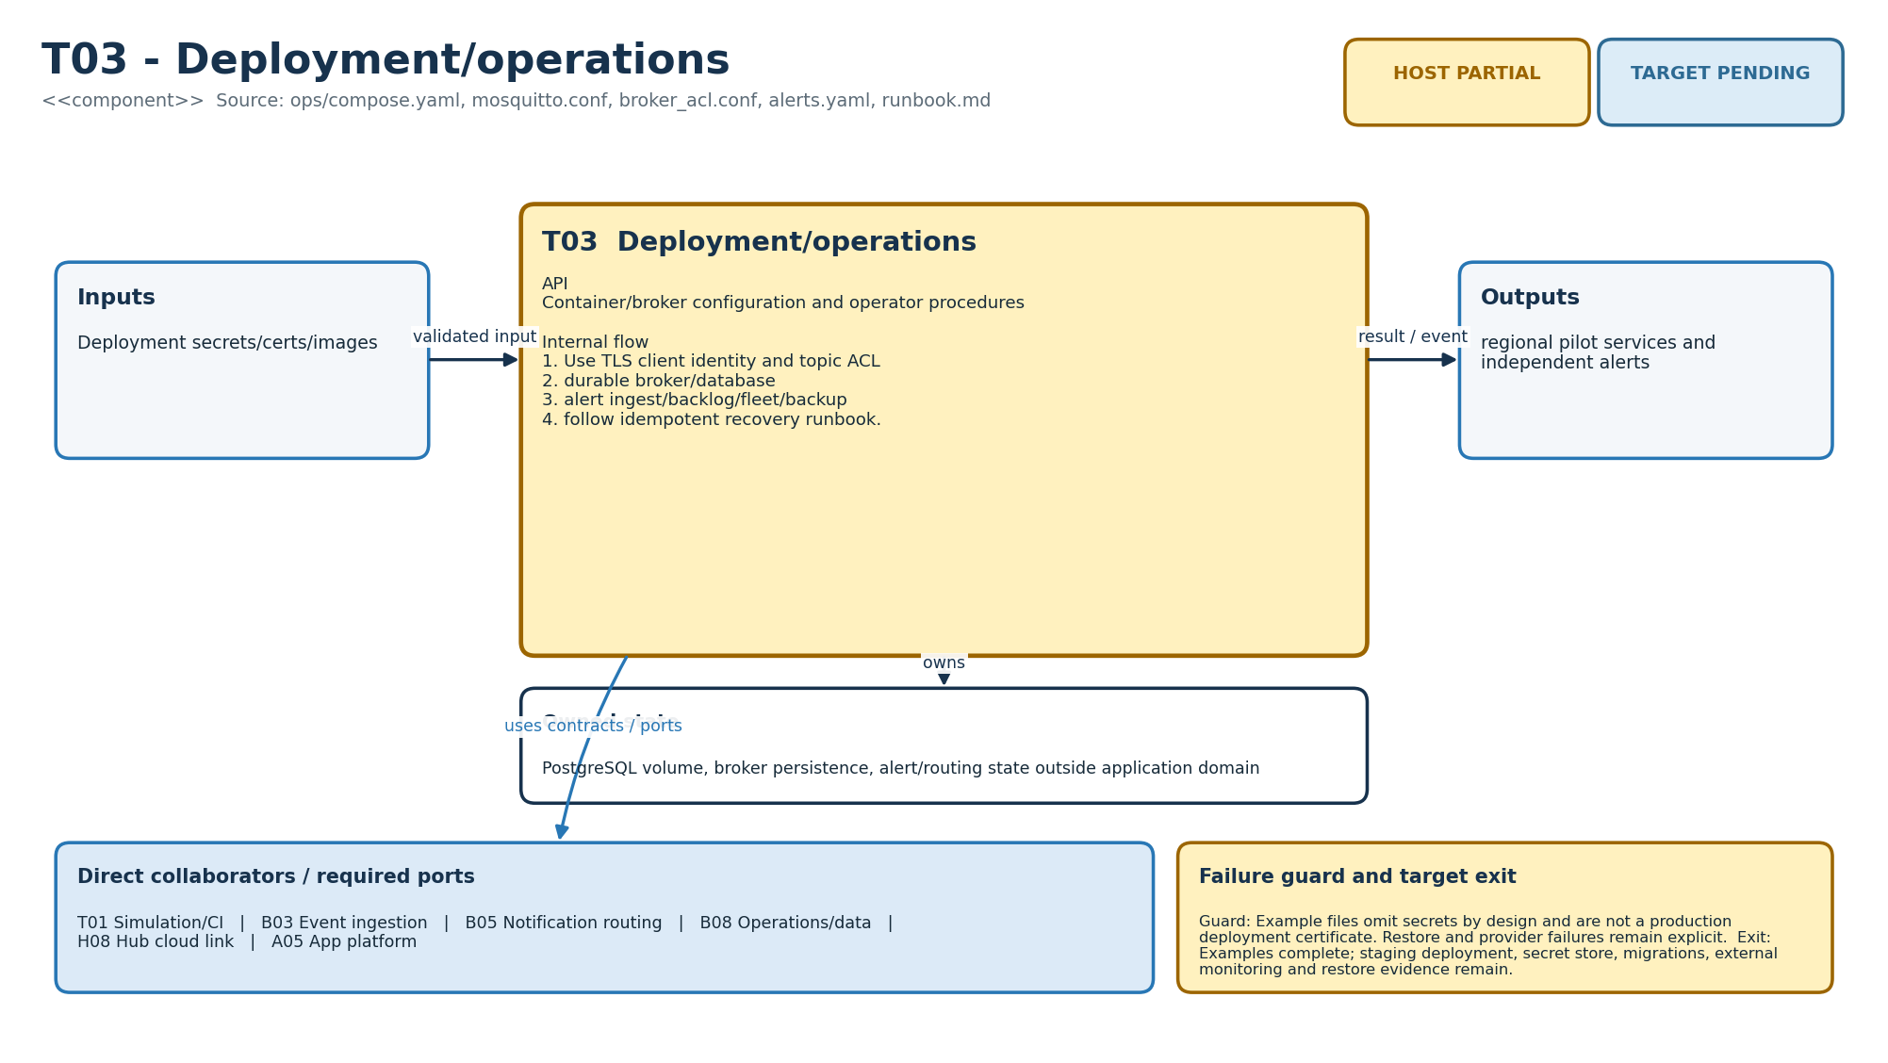
Figure M-32. Functionality, state ownership, I/O boundary and dependencies for T03.
Direct collaborators: T01 Simulation/CI, B03 Event ingestion, B05 Notification routing, B08 Operations/data, H08 Hub cloud link, A05 App platform. Target exit: Examples complete; staging deployment, secret store, migrations, external monitoring and restore evidence remain.
Editable source: plantuml/modules/T03.puml

Architecture handoff boundary
These figures complete visual HLD/LLD traceability for all 32 modules. They do not replace the remaining target gates: ESP-IDF board profiles, one real PIR-to-dashboard vertical slice, flash/RF/power qualification, production PostgreSQL/OIDC/MQTT/Web Push integration, signed OTA recovery and the four-node installed-home validation.

