PARIVAR SATHI / GHAR SAJAG

Ghar Sajag Engineer Handover Guide
  - How to understand, build, validate and safely extend the current Parivar Sathi software baseline

Document version | 2.1
Reference source | ParivarSathi_v1.5.4_PWA_BatteryAnalytics_v3_4_2
Reference Git state | main / commit 0cc5ca6 (reported after push)
Date | 12 September 2026
Status | v2.1 handover guide for validated v3.4.2 host/reference baseline
Audience | Firmware, backend, PWA, verification and integration engineers

Boundary: this document describes the currently validated hardware-independent software. Real ESP32 GPIO/RF, power/charging, flash durability, signed OTA, provider delivery and installed-home acceptance remain separate physical/HIL gates.

1. Start here
The current official software baseline is the native-WSL source tree for ParivarSathi_v1.5.4_PWA_BatteryAnalytics_v3_4_2. It is a hardware-independent reference and connected simulator/PWA, not yet flashable commercial ESP-IDF firmware. The most important engineering rule is to preserve deterministic monitoring semantics while replacing host adapters with real hardware/provider adapters.
Question | Answer
Where is authoritative source? | Git repository main branch; validated code folder ParivarSathi_v1.5.4_PWA_BatteryAnalytics_v3_4_2.
What is the release command? | make release-gate-final
What must pass? | Host release gate + mandatory real Chromium PWA gate. Current baseline: PASS + 22/22 Playwright.
What is not certified? | Physical ESP32 GPIO/RF/power/flash/OTA/provider and installed-home operation.
What is the canonical scenario source? | tests/functional/scenario_catalog.json (92 cases).
What should not be committed? | build/, logs/, evidence/, node_modules/, test-results/, playwright-report/, __pycache__, *.pyc.

2. Repository reading order
1. README.md — current product/release overview and main commands.
2. IMPLEMENTATION_STATUS.md — current host/software vs physical acceptance boundary.
3. docs/PRODUCT_ARCHITECTURE_v1.4.md and this architecture/LLD set — module/dependency design.
4. shared/include/gs/domain.hpp, protocol.hpp, rules.hpp + shared/src/rules.cpp — canonical domain and deterministic rule semantics.
5. firmware/node and firmware/hub components — hardware-independent node/hub composition.
6. backend/ghar_sajag — service boundaries, read models, config and battery analytics.
7. tools/sim/local_lab.py + tools/sim/pwa — connected host lab and product PWA.
8. tests/functional/scenario_catalog.json + tests/playwright/pwa_release_gate.spec.ts — canonical regression and mandatory browser acceptance.
9. docs/BATTERY_ANALYTICS_DESIGN.md + tests/python/test_battery_analytics.py — battery model and limits.
10. tools/hil — future physical provisioning/power/installation harness.
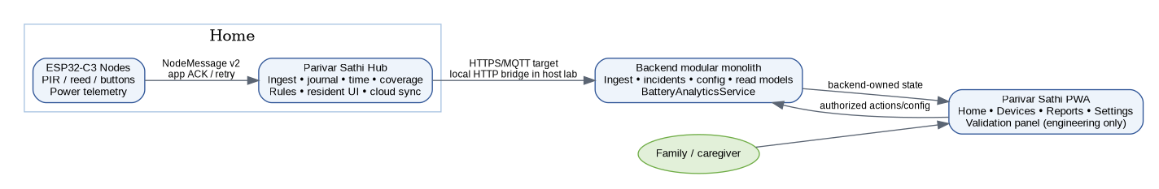
Figure H-1. Mental model for source ownership.

3. Build and environment
Official local qualification path — Use ~/projects/Ghar_sajag/... in native WSL. On the current low-memory laptop, /mnt/f is materially slower and showed browser timing flakiness; keep F: for backups/docs/releases, not qualification.

cd ~/projects/Ghar_sajag/code/ParivarSathi_v1.5.4_PWA_BatteryAnalytics_v3_4_2
# first clone / after deleting node_modules
npm install
# complete release qualification
make release-gate-final
If this is a completely new machine, use make playwright-install once to install the project dependency and Chromium/system prerequisites. node_modules is generated local state and remains ignored by Git.

4. Current release evidence
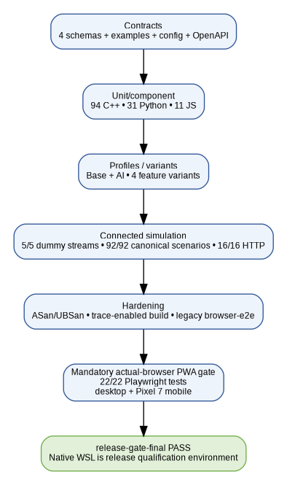
Figure H-2. Release evidence stack.
Layer | Current baseline
Validation coverage | PASS
Contracts | PASS
C++ | 94 checks PASS
Python | 31 PASS
JavaScript | 11 PASS
Feature variants | 4 variants PASS
Product profiles | Base + AI PASS
Dummy streams | 5/5 PASS
Functional catalog | 92/92 PASS
HTTP | 16/16 PASS
Sanitizers/trace | PASS
Legacy browser-e2e | PASS in latest full run
Mandatory PWA Playwright | 22/22 PASS, desktop + mobile
Final release target | PASS

5. Current product behavior a new engineer must understand

5.1 Care vs device health
- The top banner represents household-care state only.
- Specific concerns belong in routine cards; banner wording remains generic.
- Low battery, high drain or device operational health never independently turns the care banner red.
- The same authorized dashboard can be used by family/caregiver roles; authorization controls actions, not a separate P0 page.

5.2 Morning routine
- Bedroom starts sequence; bathroom + kitchen after it complete in either order within configured window.
- Before-deadline incomplete state is “pending,” not “missing.”
- Missing-morning concern requires eligibility (HOME/coverage/trusted time) and turns the generic banner red.
- Current v3.4.2 code restarts sequence on another bedroom motion. Do not change this silently; first define desired behavior + add a regression case.

5.3 Night, door and inactivity
- Night bathroom/common visits use configurable thresholds and a configurable PIR merge interval.
- Count equal to threshold is normal; count greater than threshold raises concern.
- Door-left-open and post-door inactivity are configurable and shown in Main Door card.
- Expected vs unexpected event colors/labels are part of browser regression.

5.4 Device Schedules
- Family-specific values must be configurable; defaults only seed new homes.
- The editor is backend-versioned and must remain open despite periodic polling.
- Transport reliability parameters remain engineering-controlled.

5.5 Battery analytics
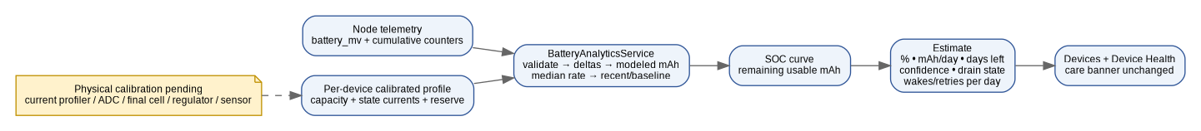
Figure H-3. Battery analytics mental model.
- Voltage + cumulative usage counters feed the estimator; current values come from a per-device calibration profile.
- The algorithm outputs percent, mAh/day, remaining days, confidence, drain state, wakes/day and RF retries/day.
- Current host profile values are synthetic. Hardware calibration is required before trusting field lifetime numbers.

6. Change workflow
1. Define the observable product behavior and the owner of truth (node/hub/backend/PWA).
2. Change deterministic rules/contracts before UI duplication; keep hardware/provider specifics behind adapters.
3. Add positive + negative + boundary/recovery coverage in the canonical catalog or lower-level suite.
4. Run focused tests during development, then make release-gate-final before release candidate.
5. Inspect Git diff and stage only intended source/docs. Generated evidence and dependency folders stay ignored.
6. Commit/push only after the tested tree is cleanly understood. If a physical claim is not tested on hardware, keep it marked pending in docs.

7. Debugging map
Symptom | Start here
Wrong care banner | backend read model care.alert → tools/sim/pwa/app.js banner selector → rule/incident event that set care state.
Routine card wrong | RulesCore state + scenario snapshot → backend queries/read model → PWA card presenter.
Settings not saved | PWA form serialization → /pwa/action/config path → B06 desired config → state refresh/config_version.
Settings editor closes | Check scheduleEditorOpen and render polling path; regression test waits >3.5 s.
Battery estimate odd | Check telemetry validity, profile, sample history, counter reset, observation confidence and recent/baseline rates.
Care banner turns red on battery | Bug: device-health isolation invariant violated; see Playwright low-battery/high-drain tests.
Event ordering confusing | Check actual detection timestamp and newest-first sort in read model/PWA.
Playwright module missing | npm install (or make playwright-install on a new machine); node_modules is intentionally not committed.
Browser gate flaky on /mnt/f | Move qualification run to native WSL path; do not weaken useful assertions to compensate for filesystem slowness.

8. Physical integration plan
Gate | Required evidence before pilot
GPIO/sensors | PIR/reed/button debounce, edge behavior, false triggers, mounting and capability mapping on exact boards.
RF | ESP-NOW/BLE/Wi-Fi security, RSSI/range, loss/retry, coexistence, channel/router changes and queue occupancy.
Power | Measured deep-sleep/awake/sensor/TX/RX currents, ADC/fuel-gauge, usable cell capacity, charger/UPS transition, brownout.
Storage/recovery | Flash commit markers/CRC, wear/full-store behavior, repeated power cuts, reboot/watchdog/coredump.
OTA/security | Signed compatible images, secure boot, credential lifecycle, revocation and rollback/interruption.
Cloud/provider | TLS/broker ACL/OIDC, notification provider acceptance, app receipt and backup-caregiver drill.
Installed home | Four-node + hub placement, coverage, multi-day WAN/router outage, usability and false-positive/false-negative review.

9. Git hygiene and release packaging
# from repository root
git status --short
git diff --cached --stat
# generated directories must remain untracked
build/
logs/
evidence/
node_modules/
test-results/
playwright-report/
__pycache__/
*.pyc
Keep code changes and documentation/progress changes separate when practical. The tested v3.4.2 source baseline was already pushed successfully to origin/main; later design-document updates can be committed as a dedicated documentation commit.

10. Handover checklist
- Can explain node → hub → backend → PWA flow and identify each state owner.
- Can explain why missing evidence is not a wellbeing conclusion and why battery cannot drive the care banner.
- Can trace morning completion, missing morning, door-left-open, post-door inactivity, night-activity and battery high-drain from event to PWA.
- Can edit a Device Schedule, identify config_version change and explain desired/applied semantics.
- Can run make release-gate-final and interpret host vs physical acceptance.
- Knows the current morning-bedroom restart behavior and does not alter it without explicit product/test update.
- Knows which folders are generated and should not be committed.
- Knows the remaining physical/HIL gates before any unattended pilot claim.

