PARIVAR SATHI / GHAR SAJAG

Ghar Sajag Hardware-Independent Low-Level Design
  - Current code flow, interfaces, state ownership, battery analytics and handoff gates

Document version | 2.1
Reference source | ParivarSathi_v1.5.4_PWA_BatteryAnalytics_v3_4_2
Reference Git state | main / commit 0cc5ca6 (reported after push)
Date | 12 September 2026
Status | v2.1 current implementation design; host release qualified, hardware/HIL pending
Audience | Firmware, backend, PWA, verification and integration engineers

Boundary: this document describes the currently validated hardware-independent software. Real ESP32 GPIO/RF, power/charging, flash durability, signed OTA, provider delivery and installed-home acceptance remain separate physical/HIL gates.

1. Purpose, authority and delta from v2.0
This edition reconciles the design line with the implementation that was actually validated in ParivarSathi_v1.5.4_PWA_BatteryAnalytics_v3_4_2. It is the engineering handoff reference for the current host software. Where an older v2.0 description conflicts with this edition, this v2.1 implementation-status interpretation is authoritative.
Area | Current v2.1 design status
Deterministic monitoring | Generic DomainEvent + RulesCore path retained; routine and activity rules consume versioned household configuration.
PWA | Backend-driven Parivar Sathi PWA at /; engineering lab at /lab. Browser-local state is presentation only.
Routine expansion | Configurable morning sequence, night bathroom/common-room counts, PIR visit merge, door-left-open threshold and post-door inactivity are implemented.
Battery analytics | NodeMessage v2 optional cumulative power telemetry + backend BatteryAnalyticsService + Device Health/Devices read model implemented.
Validation | 92 canonical connected scenarios and mandatory 22-test desktop/mobile Playwright release gate are current.
Physical product | Real GPIO/RF/power/flash/OTA/provider/installed-home acceptance remains pending.

Key safety invariant — The software reports observed evidence, coverage and configured-rule outcomes. It does not infer that a resident is medically safe. Device/battery faults are operational health concerns and never independently turn the household-care banner red.

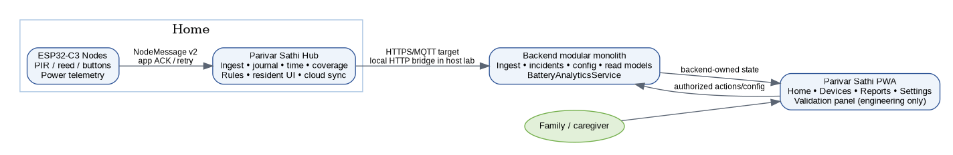
Figure 1. Current logical runtime architecture and dependency direction.

2. State ownership and dependency direction
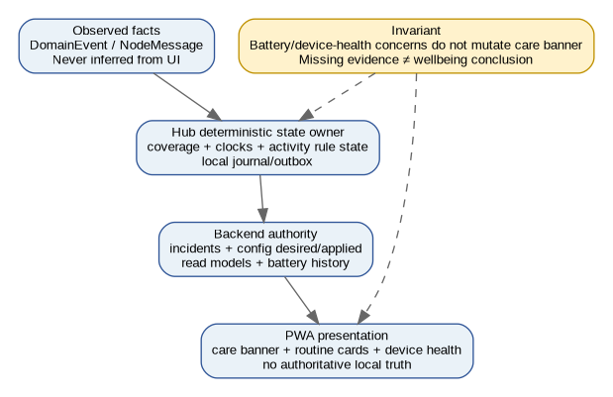
Figure 2. Authoritative state boundaries.
Owner | Owns | Must not own / infer
Node | Sensor qualification, event identity, cumulative power counters, local retry/persist boundary | Care incidents, household UI state, family policy.
Hub | Authenticated ingest, local journal/outbox, trusted time/coverage, deterministic routine/activity state, applied config | Caregiver workflow ownership or battery calibration guesswork.
Backend | Tenant access, desired config, incident workflow, notification state, read models, battery history/analytics | Raw GPIO logic or UI-only truth.
PWA | Presentation and authorized commands; editor state only | Canonical event truth, missing-routine inference independent of backend, care alerts from battery-only state.

- Hub event/rule state changes remain deterministic and testable without GPIO/RF dependencies.
- The backend read model is the source for care.alert, card details, device state and versioned settings presented by the PWA.
- The Settings editor uses an explicit open-state guard so 2-second polling does not rebuild/close the editor while a user is editing.
- Recent Important Events are ordered newest-first from backend chronology; rule-generated events retain their detection timestamp.

3. Canonical contracts and data structures

3.1 DomainEvent and NodeMessage v2
Contract | Important fields / semantics
DomainEvent | EventKey(source_id, session_id, sequence), kind, location, monotonic_ms, occurred_at/received_at, uncertainty_s, battery_mv, sensor_type, RSSI, test flag.
NodeMessage v2 | Typed node identity + sequence, sensor/event/location, monotonic and optional wall-clock time, battery mV, RSSI, optional NodePowerTelemetry.
NodeAckMessage | Application acknowledgement class + exact event identity. Physical transport adapter may vary; identity/ACK semantics shall not.
NodePowerTelemetry | Cumulative deep_sleep, awake, sensor-active, radio TX/RX time; packet/retry, wake/heartbeat, boot/brownout counters.

Node protocol policy
wire schema = 2
heartbeat = 60 s
offline threshold = 3 missed heartbeats + 10 s grace
retry delays = 200 / 600 / 1800 / 10000 ms (+ bounded jitter)
Validation rule — Power telemetry is rejected when sensor/radio active time exceeds total awake time. Battery voltage is bounded by the transport validator. Counter decreases are treated as reboot/reset boundaries by battery analytics.

3.2 Household ActivityRuleConfig
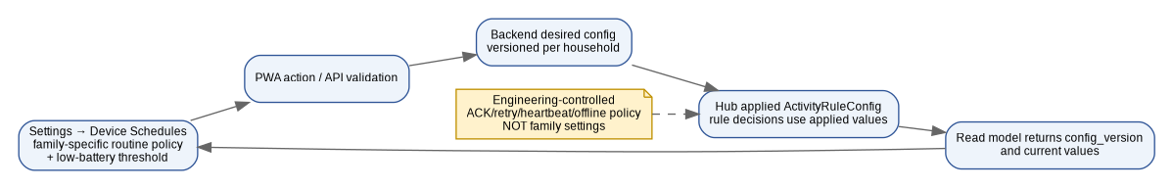
Figure 3. Household policy configuration path.
Policy | Implemented configuration
Morning | enabled; start/end minute; completion window; bedroom/bathroom/kitchen locations.
Night | enabled; night window; bathroom/common locations; independent visit thresholds; visit merge interval.
Door | quiet-hours window; door-left-open timeout; post-door inactivity enable + timeout.
Daytime inactivity | enabled; active window; inactivity threshold.
Battery warning | battery_alert_percent is household configuration exposed under Device Schedules.

Transport reliability constants (ACK/retry/heartbeat/offline timing) remain engineering-controlled and are intentionally not exposed as family-person settings.

4. Node runtime LLD
Module | Current responsibility | Important current boundary
N01 Node sensing | Qualifies PIR/reed/button input into typed DomainEvent values. Capability checks reject impossible event/sensor combinations in simulation. | Real GPIO levels, debounce, pull configuration and exact sensor electrical behavior pending.
N02 Node radio | Builds NodeMessage, preserves event key, retries according to bounded policy until application acknowledgement. | Actual ESP-NOW/BLE/Wi-Fi security/range/coexistence/RSSI behavior pending.
N03 Node power | Tracks battery mV and cumulative power-state counters needed by analytics. | Current-to-mAh coefficients are not measured by firmware; physical calibration is external.
N04 Node lifecycle | Versioned config/lifecycle seam and future OTA binding. | Secure boot, signed image verification, rollback and interrupted OTA pending.
N05 Node storage | Persist-before-retire model for queued events. | Flash partition, wear, CRC/commit marker and power-cut durability pending on target.

5. Hub runtime LLD
Module | Current responsibility | Key invariant / extension
H01 Ingest | Validate/authenticate node messages, deduplicate identity, translate to DomainEvent. | Bad schema/capability is rejected before rules.
H02 Journal | Commit accepted events and maintain outbox semantics before durable acknowledgement. | Production flash adapter still required.
H03 Time | Supply trusted clock/local minute to pure rules. | Untrusted time suppresses time-bound absence/door decisions.
H04 Coverage | Track node/hub lease and observation eligibility independently from activity. | Unknown/fault coverage suppresses absence claims.
H05 Rules adapter | Own RoutineState/ActivityRuleState shell around S02 RulesCore. | Pure core remains hardware/network independent.
H06 Resident UI | Handle physical OK / Call Family / local resident interactions. | No user-facing arbitrary Privacy ON/OFF control.
H07 Lifecycle/config | Apply desired versioned household/node configuration. | Desired != applied until target confirmation in production.
H08 Cloud link | Publish committed outbox; maintain cloud freshness/ACK seam. | Host uses local bridge; MQTT/TLS provider integration pending.
H09 Interaction controller | Optional AI interaction lifecycle retained behind product profile. | Base P0 monitoring does not depend on AI/audio/provider.

FreeRTOS target composition remains: radio_callback copies/authenticates into a bounded queue; one hub_event_task owns routine/coverage/applied-state mutation; cloud_sync_task drains committed outbox. Host execution calls the same logical components synchronously.

6. Deterministic routine/activity rule LLD
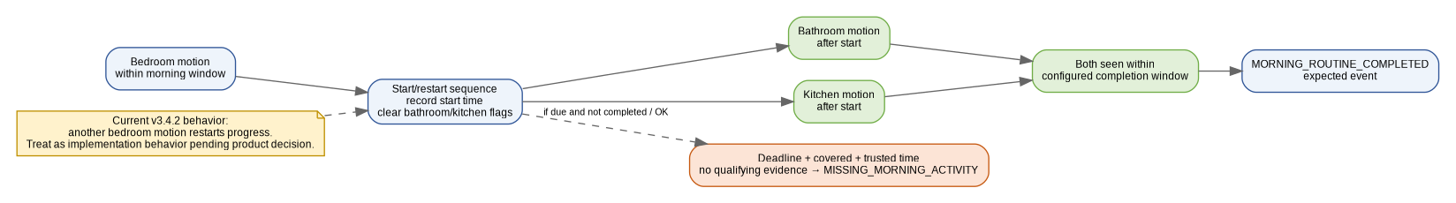
Figure 4. Morning sequence state machine as implemented in v3.4.2.

6.1 Morning sequence
- A qualifying bedroom motion inside the configured morning window starts the sequence and records the start timestamp.
- Bathroom and kitchen may occur in either order, but both must occur after the start and within morning_sequence_window_seconds.
- Activity in bathroom/kitchen before bedroom does not satisfy the current sequence.
- Completion creates MORNING_ROUTINE_COMPLETED as an expected event.
- Pending completion is not the same as MISSING_MORNING_ACTIVITY; the top banner remains positive until a real concern is created.
- Current implementation behavior: another bedroom motion while the sequence is active restarts the sequence and clears bathroom/kitchen flags. This is documented as a design-review item rather than silently treated as intended product behavior.

6.2 Night activity
- Distinct visits are merged when repeated PIR events occur inside night_visit_merge_seconds.
- A concern fires only when the count is greater than the configured threshold, not equal to it.
- Bathroom and common-room counters are independent and reset when a daytime event proves the night window has ended.
- Night activity concerns are care concerns: they highlight Night Activity and set the generic household banner to attention.

6.3 Door and inactivity
- Door open during configured quiet hours can produce UnexpectedDoorOpen when mode/time are eligible.
- DoorLeftOpen fires at the configured timeout only when HOME + covered + trusted time.
- Door close after a long-open condition emits a resolving expected event with measured duration.
- PostDoorInactivity starts from a door-close anchor and is cancelled by qualifying indoor motion before threshold.
- Daytime inactivity uses last activity or the explicit monitoring-start anchor and is suppressed by Away/Paused/Visitor eligibility policy, unavailable coverage or untrusted time as defined by the connected simulator.

7. Backend LLD
Module/service | Current implementation
B01 Identity/access | Membership/permission/expiry checks. Real OIDC token validation remains an adapter concern.
B02 Home/consent | Household, resident, mode/consent state and audit semantics.
B03 Ingest | Idempotent cloud event acceptance and backend receipt state.
B04 Incidents | Stable business keys; claim/acknowledge/resolve workflow.
B05 Notifications | Routing/scheduling/provider-result state; not a real push/SMS sender yet.
B06 Fleet/config | Versioned desired household configuration and device records.
B07 Read models/API | Caregiver/family projection, exact event labels, chronology, PWA HTTP bridge.
B08 Operations/data | Freshness, diagnostics, audit, persistence contract and operational history.
BatteryAnalyticsService / B12 trace code | SOC, energy rate, remaining runtime, confidence, high-drain and usage-pattern metrics from validated telemetry + calibration.

The relational contract includes battery_history, battery_power_profiles and battery_usage_history in addition to core household/event/incident/configuration tables. The deterministic host still uses an in-memory runtime store; SQLite validates the schema contract and production PostgreSQL wiring remains pending.

8. Battery analytics LLD
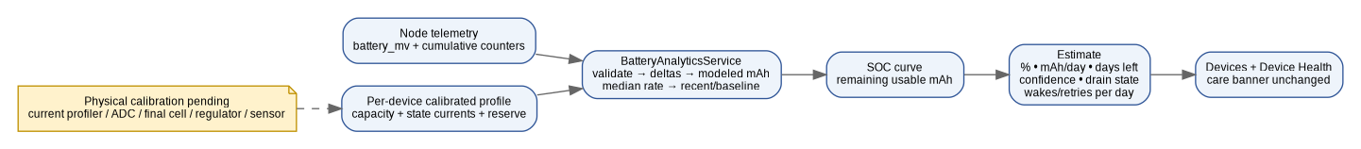
Figure 5. Battery estimation path and calibration boundary.
Stage | Algorithm / rule
Input validation | Reject invalid profile values; reject negative counters or sensor/radio time greater than awake time.
SOC | Piecewise non-linear 1S Li-ion curve from 3300 mV=0% through 4200 mV=100%; production curve/fuel-gauge can replace it.
Energy model | Base deep-sleep and awake states partition elapsed time; sensor/radio currents are incremental above awake base to avoid double counting.
Rate | Interval mAh converted to mAh/day. Median of recent valid rates reduces noise.
High drain | Recent-vs-baseline rate above calibrated high_drain_ratio marks HIGH and remaining-life prediction intentionally uses the higher recent rate.
Reboot/counter reset | Any cumulative counter decrease invalidates that delta interval; new boot segment may still yield LOW-confidence estimate.
Confidence | LOW until enough history; MEDIUM >=24h and >=3 samples; HIGH >=72h and >=8 samples.
Reserve | Usable remaining mAh protects configured reserve; low voltage does not over-promise remaining days.

Physical acceptance dependency — Field prediction accuracy is not certified until deep-sleep, awake, sensor, TX/RX current, ADC/fuel-gauge accuracy, usable cell capacity, temperature/aging and UPS behavior are measured on the exact commercial hardware.

9. PWA and presentation LLD
UI element | Authoritative behavior
Overall care banner | Generic only. Red: “Attention needed at home / Please check the highlighted routine below.” Positive: “Home looks normal / All is well at home.” Driven by backend care alert, not browser inference.
Morning Routine card | Completed / pending / missing are distinct. Missing highlights the card and care banner; pending does not.
I am OK card | Positive explicit check-in shown in green with relative age. Chronology remains visible alongside other events.
Main Door card | Shows open/closed, quiet-hours concern, long-open concern or post-door inactivity reason.
Night Activity card | Shows bathroom/common counts and configured-routine concern.
Device Health card | Battery/offline/high-drain operational concerns. Never changes household care banner by itself.
Settings → Device Schedules | Editable household-specific rule thresholds/locations and battery alert threshold; versioned backend state.
Validation panel | Engineering-only manual/run-all bridge for canonical scenarios; must be removed/hidden in production deployment.

Dashboard card order in the validated PWA: Morning Routine → I am OK → Main Door → Night Activity → Device Health. Desktop and Android-sized mobile rendering are both release-gated.

10. End-to-end flows

10.1 Configurable morning completion
PIR motion → Node DomainEvent/NodeMessage
→ Hub authenticated ingest + journal
→ RulesCore.apply_activity_event
→ morning state update
→ when bathroom_seen && kitchen_seen: MORNING_ROUTINE_COMPLETED
→ backend timeline/read model
→ PWA Morning Routine = Completed; care banner remains positive

10.2 Missing morning concern
routine deadline/grace due + HOME + covered + trusted time
→ RulesCore/RoutineService absence decision
→ MISSING_MORNING_ACTIVITY incident
→ backend care.alert = true
→ PWA generic red banner + Morning Routine card holds specific reason

10.3 Battery high-drain concern
node cumulative power telemetry + battery mV
→ backend history + BatteryAnalyticsService
→ recent rate >> baseline
→ drain_status = HIGH + shorter estimated_days
→ Device Health / Devices highlighted
→ care.alert remains unchanged

10.4 Device schedule edit
Settings editor open
→ validated field values
→ backend versioned config patch
→ desired/applied simulation path
→ state refresh returns incremented config_version
→ editor remains stable during polling due scheduleEditorOpen guard

11. Validation and release design
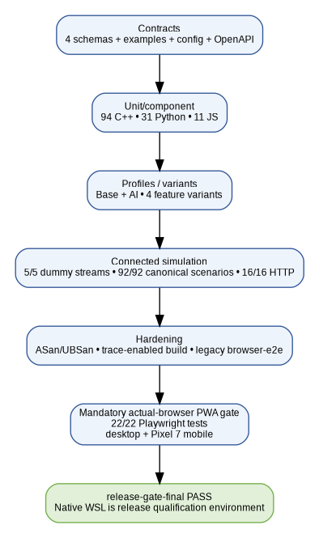
Figure 6. Current release qualification stack.
Layer | Current validated result
Requirement coverage | PASS; F01–F14 + E01–E10 mapped (24/24).
Contracts | PASS; 4 JSON schemas + examples/config/OpenAPI verification.
C++ | 94 checks PASS.
Python | 31 tests PASS.
JavaScript | 11 tests PASS.
Profiles/variants | Base + AI profiles PASS; four feature variants PASS.
Dummy streams | 5/5 PASS.
Canonical connected catalog | 92/92 PASS.
HTTP integration | 16/16 PASS.
Sanitizers / trace | AddressSanitizer/UBSan PASS; trace-enabled build/test PASS.
Legacy browser-e2e | PASS in latest native-WSL release-gate run.
Mandatory Playwright PWA | 22/22 PASS using one worker: 11 logical tests × desktop/mobile.
Final command | make release-gate-final → PASS on native WSL baseline.

The canonical catalog is tests/functional/scenario_catalog.json and the generated manual plan is tests/MANUAL_FUNCTIONAL_VALIDATION.md. The PWA run-all path consumes the live HTTP results and the same assertion specification; Playwright verifies visible N/N PASS in a real Chromium DOM.

12. Known limitations and design-review items
Item | Current status / required action
Morning bedroom restart | Implemented v3.4.2 behavior resets progress when another bedroom motion occurs. Product decision and dedicated regression case are recommended before hardware pilot.
Power accuracy | Algorithm exists; calibration is synthetic until measured on final board/sensor/regulator/cell.
Persistence | In-memory runtime + validated SQL schema; production flash/PostgreSQL adapters and power-cut evidence pending.
RF | Semantic transport tested; real ESP-NOW/BLE/Wi-Fi security/range/loss/coexistence pending.
OTA | Policy seams exist; signed firmware/secure boot/rollback interrupted-update evidence pending.
Notification delivery | Scheduler/state modeled; real push/SMS/provider acceptance and caregiver receipt drills pending.
Installed-home coverage | Sensor placement, dead zones, multi-resident interpretation and long-duration household pilot pending.
Performance/resource | Real ESP32 RAM/flash/CPU/current/thermal measurements pending.

13. Engineering handoff gates
1. Use the native WSL working tree as the official build/test/release environment on this laptop; /mnt/f is a backup/document/release-artifact location, not the qualification path.
2. Before any code release candidate, run make release-gate-final and retain evidence only as generated artifacts, not as source-controlled build output.
3. For a new behavior, update the canonical functional catalog or the relevant unit/integration suite before calling the feature release-complete.
4. When real ESP32 hardware arrives, replace synthetic adapters incrementally without changing domain contracts/rules unless a measured constraint requires a reviewed design change.
5. Do not claim unattended/pilot readiness until physical GPIO/RF/power/flash/OTA/provider/installed-home gates have recorded evidence.

