ENGINEERING CALL-FLOW SPECIFICATION

Ghar Sajag P0 Requirement
Sequence Diagrams
  - Preservation-first v2.1 update for F01-F14 and E01-E10
Document item | Value
Document version | 2.1
Reference implementation | ParivarSathi_v1.5.4_PWA_BatteryAnalytics_v3_4_2
Git baseline | main / commit 0cc5ca6
Date | 12 September 2026
Current software qualification | release-gate-final PASS in native WSL; mandatory Playwright 22/22 PASS
Physical/HIL qualification | PENDING - exact ESP32/RF/power/flash/OTA/provider/installed-home evidence still required

Preservation rule: the complete 24-requirement sequence baseline is retained in Appendix A. Current v2.1 overlays are additive and take precedence only where they explicitly update an older flow. No historical sequence is silently deleted.

1. Reading model and preservation policy
This edition preserves the existing end-to-end sequence set and layers the current v3.4.2 implementation and validation behavior on top. The retained sequence pages remain useful for actors, durability boundaries, target-provider seams and failure paths that did not change.
Where implementation changed after the preserved baseline, the v2.1 overlay states the new behavior explicitly. Current code/test behavior governs over an older diagram when the two differ. Hardware/provider completion is never inferred from host PASS.
Observed facts, care decisions, device health and human workflow remain separate. A battery/device-health problem must not become a resident-care concern; missing evidence must not become a wellbeing conclusion.
Status term | Meaning
Implemented + release-gated | Executable host/PWA behavior covered by current release evidence.
Retained | Existing sequence still represents current behavior; only maturity/evidence status changed.
Updated | Current implementation adds or changes a step/guard/read-model effect; v2.1 overlay governs.
Physical/HIL pending | Exact boards, sensors, RF, power, flash, OTA, provider or installed-home evidence is still required.

2. Current validation baseline
Validation layer | Current evidence
Requirement coverage | 24/24 P0 IDs mapped
Canonical connected functional catalog | 92/92 PASS
Dummy sensor streams | 5/5 PASS
HTTP integration | 16/16 PASS
C++ unit/component | 94 checks PASS
Python backend/database/logging/framework | 31 PASS
JavaScript app/domain | 11 PASS
Hardening | ASan/UBSan PASS; trace-enabled build PASS; legacy browser-e2e PASS
Mandatory actual-browser PWA | 22/22 PASS: 11 logical checks x desktop/mobile
Qualification environment | Native WSL path is the release qualification environment on the current machine
Physical/HIL | Still PENDING; host/browser success does not certify installed hardware or provider delivery

3. Requirement change-impact matrix
ID | Requirement | v2.1 disposition | Current implementation / validation delta
F01 | Household profile and caregiver roles | Retained | Household/access boundary remains valid. Current host validation does not change the target production OIDC/database boundary.
F02 | Resident consent and privacy controls | Retained / clarified | Consent withdrawal remains authoritative internal privacy enforcement. There is no ordinary caregiver/resident Privacy ON/OFF toggle in the current PWA.
F03 | Kit provisioning and installation verification | Retained | Provisioning/installation sequence remains a target integration flow; exact board, RF, placement and installation evidence remain HIL pending.
F04 | Configurable morning routine | Updated | Device Schedules now carries versioned household activity policy: morning sequence, night bathroom/common-room thresholds, visit merge interval, door-open timeout and post-door inactivity. Family-specific values are configuration, not hardcoded behavior.
F05 | Morning activity evidence | Updated | Current morning sequence starts on configured bedroom activity, then requires configured bathroom and kitchen in either order within the sequence window. Pre-bedroom bathroom/kitchen does not count. Current v3.4.2 restarts progress on another bedroom event; this is explicitly documented as a design-review item.
F06 | Explicit I'm OK check-in | Updated | I am OK is a distinct positive self-check-in, presented in green with elapsed age. It is chronological evidence and does not automatically close an unrelated Call Family incident.
F07 | Call family request | Updated | Call Family remains a durable unresolved human-contact request. Later I am OK/activity is appended chronologically; it does not silently resolve the request.
F08 | Missing morning activity workflow | Updated | Morning sequence pending is not a missing-morning care alert. Only a true MISSING_MORNING_ACTIVITY decision sets care.alert and drives the generic red household banner plus the Morning Routine card.
F09 | Main-door history and quiet notice | Updated | Door history now includes exact open/closed events, configurable door-left-open concern and post-door-close inactivity. Door close arms post-door monitoring; qualifying indoor motion cancels it.
F10 | Away, pause and visitor modes | Retained / product UI constrained | HOME/AWAY/PAUSED/VISITOR rule semantics remain in the host design. The current product PWA keeps Away disabled/hidden; internal privacy enforcement remains separate from modes.
F11 | Caregiver dashboard and timeline | Updated | PWA is backend-driven. Generic household banner is separate from routine cards. Card order: Morning Routine, I am OK, Main Door, Night Activity, Device Health. Device Health/battery cannot turn the care banner red. Recent Important Events are newest-first.
F12 | Acknowledgement and resolution | Retained | Acknowledgement/resolution lifecycle remains distinct from observation and resident self-check-in. Production database concurrency remains a target integration concern.

3. Requirement change-impact matrix (continued)
ID | Requirement | v2.1 disposition | Current implementation / validation delta
F13 | Backup routing and delivery visibility | Retained | Primary/backup routing and delivery visibility semantics remain; real provider/phone acceptance remains pending.
F14 | Opt-in daily morning summary | Retained | Opt-in summary semantics remain; provider/date/consent hardening remains target work.
E01 | Node health, battery and coverage | Updated | Node health now includes optional cumulative power telemetry. Backend BatteryAnalyticsService estimates non-linear voltage-to-SOC, mAh/day, remaining life, confidence and high-drain state from telemetry plus calibrated power profile/history. Low battery/high drain are Device Health only. Field accuracy requires real-board current/ADC/capacity calibration.
E02 | Reliable transport and duplicate handling | Retained | Persist/retry/deduplicate/application-ACK semantics remain unchanged; physical RF security/range/loss testing remains pending.
E03 | Local operation during internet failure | Retained | Hub local rules/journal/resident UI continue during WAN loss and replay after restore; real router/WAN outage drills remain pending.
E04 | Hub/cloud/app connectivity and freshness | Retained / strengthened UI evidence | Freshness and connectivity remain separate facts. Current PWA/browser gate validates backend-driven state presentation; deployed service/broker monitoring remains pending.
E05 | Persistence, recovery and bounded storage | Retained | Layered persistence/idempotency remains the intended ordering. Production flash/PostgreSQL/power-cut/wear evidence remains pending.
E06 | Trusted time and boundary handling | Retained | Trusted time/window suppression semantics remain. Current routine/night/post-door policies use configured local-minute windows and suppress absence when time is untrusted.
E07 | Versioned configuration and atomic application | Updated | Device Schedules save -> backend validate/version -> applied household ActivityRuleConfig -> RulesCore. scheduleEditorOpen prevents polling from destroying an open editor. Transport heartbeat/retry constants remain engineering-owned, not household preferences.
E08 | Security, privacy and tenant isolation | Retained | Tenant/access/security/privacy design remains; production OIDC/TLS/device credential lifecycle remains pending.
E09 | Signed firmware update and recovery | Retained | Signed OTA/update policy remains a target design; real signature, secure boot, rollback and interrupted-update evidence remain pending.
E10 | Verification, observability and release evidence | Updated | Final native-WSL release qualification passes: host release gate PASS, 92/92 canonical scenarios, 5/5 dummy streams, 16/16 HTTP integration, 94 C++ checks, 31 Python tests, 11 JavaScript tests, sanitizers/trace build PASS, legacy browser-e2e PASS and mandatory Playwright 22/22 desktop/mobile PASS. Physical/HIL/provider gates remain separate.

4. v2.1 current implementation sequence overlays
The following flows changed materially after the retained sequence baseline. These diagrams and notes are normative for the current v3.4.2 host/PWA implementation. Requirements not shown here keep their preserved sequence, subject to the evidence-status updates in Section 3.

F04 - Configurable morning routine
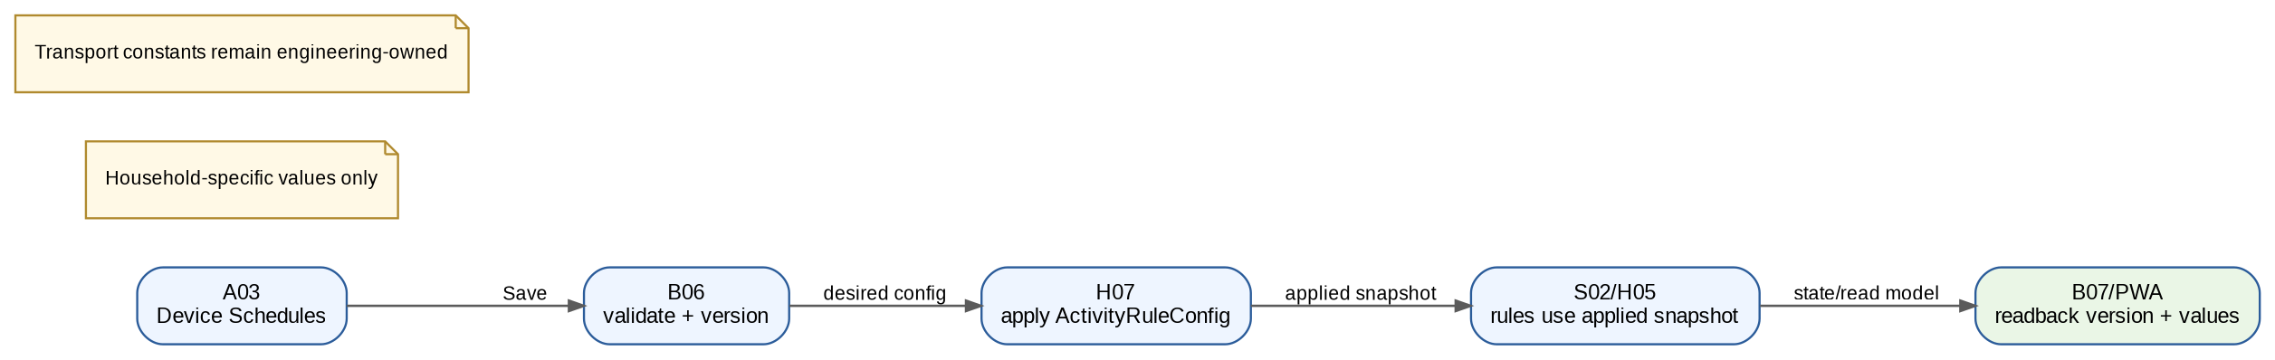
Figure F04-v2.1. Current implementation overlay.
Field | v2.1 interpretation
Current behavior | Device Schedules now carries versioned household activity policy: morning sequence, night bathroom/common-room thresholds, visit merge interval, door-open timeout and post-door inactivity. Family-specific values are configuration, not hardcoded behavior.
Preserved baseline relation | All earlier actors/durability/provider boundaries remain valid except where this overlay explicitly changes rule or presentation semantics.
- Validation covers configurable morning locations/window, night bathroom/common-room thresholds, visit merge interval, door-open timeout and post-door inactivity; changed values alter behavior.
- Settings editor remains stable across >3.5 s polling and save through the mandatory browser gate.

F05 - Morning activity evidence
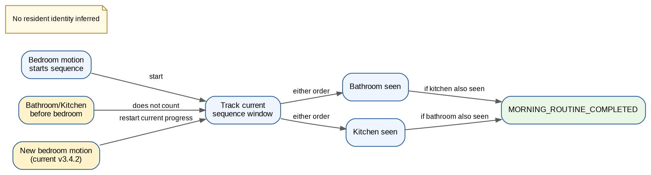
Figure F05-v2.1. Current implementation overlay.
Field | v2.1 interpretation
Current behavior | Current morning sequence starts on configured bedroom activity, then requires configured bathroom and kitchen in either order within the sequence window. Pre-bedroom bathroom/kitchen does not count. Current v3.4.2 restarts progress on another bedroom event; this is explicitly documented as a design-review item.
Preserved baseline relation | All earlier actors/durability/provider boundaries remain valid except where this overlay explicitly changes rule or presentation semantics.
- Bathroom and kitchen may occur in either order after bedroom; pre-bedroom bathroom/kitchen does not count.
- Known current behavior: a later bedroom event restarts sequence progress. Do not silently change without code + TC update.

F06 - Explicit I'm OK check-in
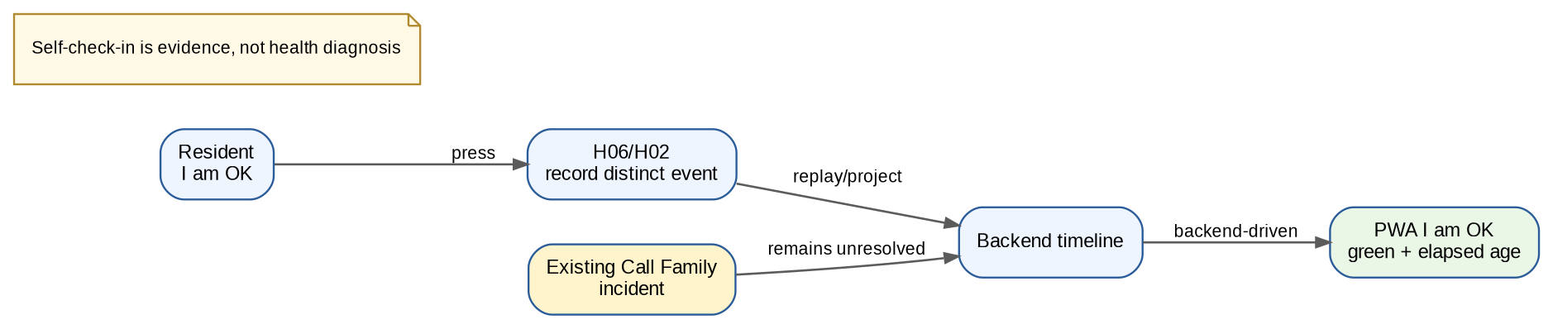
Figure F06-v2.1. Current implementation overlay.
Field | v2.1 interpretation
Current behavior | I am OK is a distinct positive self-check-in, presented in green with elapsed age. It is chronological evidence and does not automatically close an unrelated Call Family incident.
Preserved baseline relation | All earlier actors/durability/provider boundaries remain valid except where this overlay explicitly changes rule or presentation semantics.
- PWA shows I am OK in green and displays elapsed age; chronology is retained.

F07 - Call family request
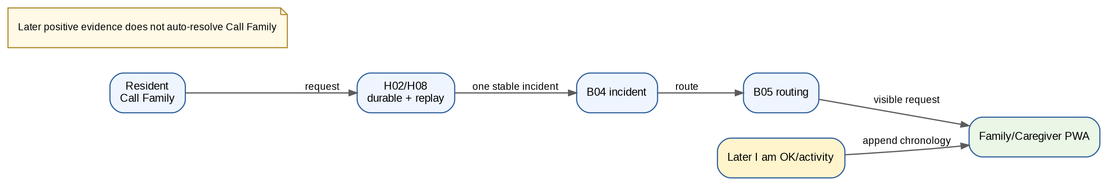
Figure F07-v2.1. Current implementation overlay.
Field | v2.1 interpretation
Current behavior | Call Family remains a durable unresolved human-contact request. Later I am OK/activity is appended chronologically; it does not silently resolve the request.
Preserved baseline relation | All earlier actors/durability/provider boundaries remain valid except where this overlay explicitly changes rule or presentation semantics.
- Call Family remains open until explicit caregiver workflow resolves it; later I am OK/activity is not an implicit resolution.

F08 - Missing morning activity workflow
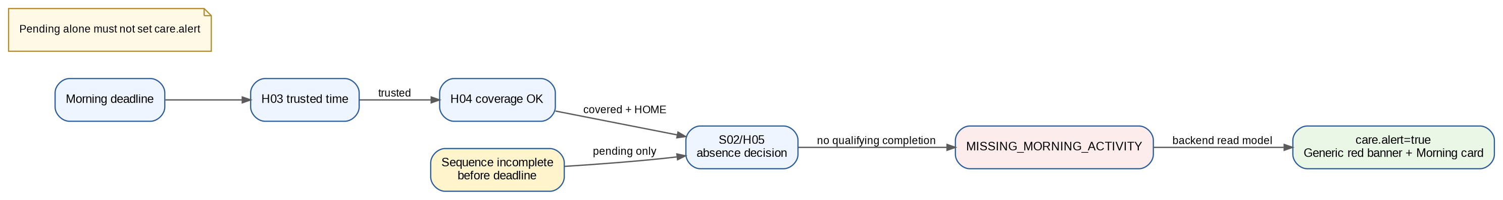
Figure F08-v2.1. Current implementation overlay.
Field | v2.1 interpretation
Current behavior | Morning sequence pending is not a missing-morning care alert. Only a true MISSING_MORNING_ACTIVITY decision sets care.alert and drives the generic red household banner plus the Morning Routine card.
Preserved baseline relation | All earlier actors/durability/provider boundaries remain valid except where this overlay explicitly changes rule or presentation semantics.
- Regression gate separates pending/not-yet-complete from actual missing-morning concern and resets validation state after run-all.

F09 - Main-door history and quiet notice
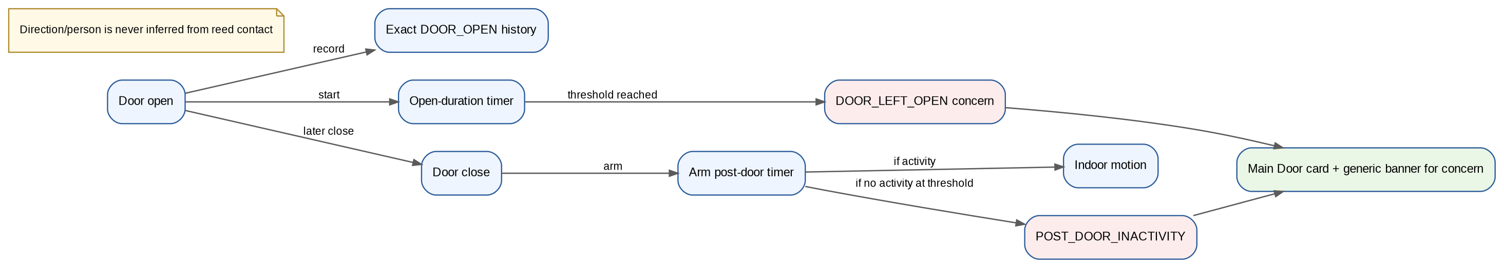
Figure F09-v2.1. Current implementation overlay.
Field | v2.1 interpretation
Current behavior | Door history now includes exact open/closed events, configurable door-left-open concern and post-door-close inactivity. Door close arms post-door monitoring; qualifying indoor motion cancels it.
Preserved baseline relation | All earlier actors/durability/provider boundaries remain valid except where this overlay explicitly changes rule or presentation semantics.
- Expected events are exact Door Open/Closed history; concerns are rule-specific and attach to Main Door card.

F11 - Caregiver dashboard and timeline
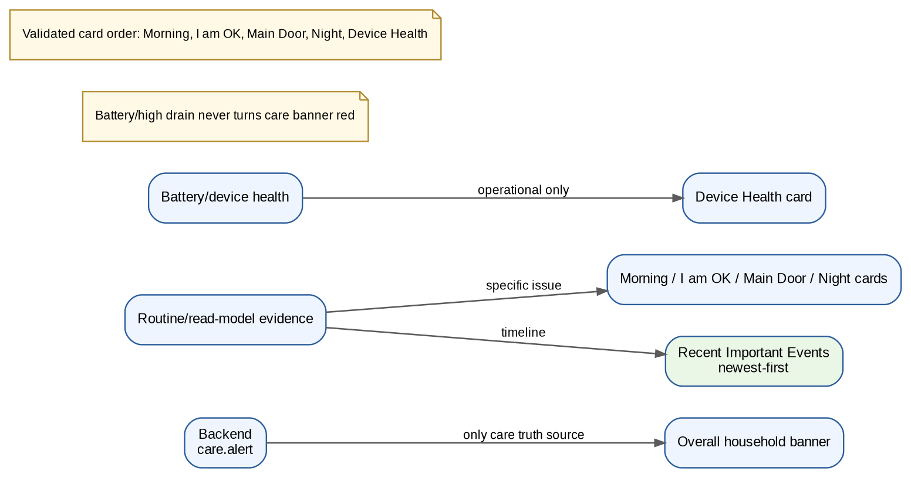
Figure F11-v2.1. Current implementation overlay.
Field | v2.1 interpretation
Current behavior | PWA is backend-driven. Generic household banner is separate from routine cards. Card order: Morning Routine, I am OK, Main Door, Night Activity, Device Health. Device Health/battery cannot turn the care banner red. Recent Important Events are newest-first.
Preserved baseline relation | All earlier actors/durability/provider boundaries remain valid except where this overlay explicitly changes rule or presentation semantics.
- Validated card order: Morning Routine -> I am OK -> Main Door -> Night Activity -> Device Health.
- Recent Important Events are newest-first; battery-only warnings never mutate care.alert.

E01 - Node health, battery and coverage
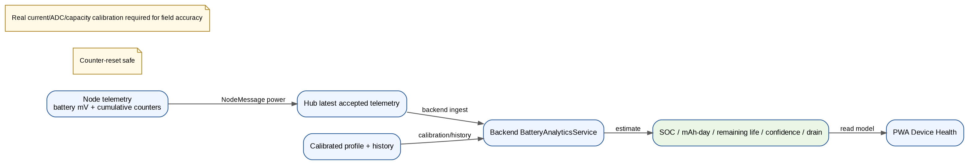
Figure E01-v2.1. Current implementation overlay.
Field | v2.1 interpretation
Current behavior | Node health now includes optional cumulative power telemetry. Backend BatteryAnalyticsService estimates non-linear voltage-to-SOC, mAh/day, remaining life, confidence and high-drain state from telemetry plus calibrated power profile/history. Low battery/high drain are Device Health only. Field accuracy requires real-board current/ADC/capacity calibration.
Preserved baseline relation | All earlier actors/durability/provider boundaries remain valid except where this overlay explicitly changes rule or presentation semantics.
- Battery estimator supports SOC, historical mAh/day, remaining-life prediction, LOW/MEDIUM/HIGH confidence, high-drain detection and counter-reset safety.
- Canonical battery cases extend the catalog to 92. Real-board calibration remains required before field-accurate runtime claims.

E07 - Versioned configuration and atomic application
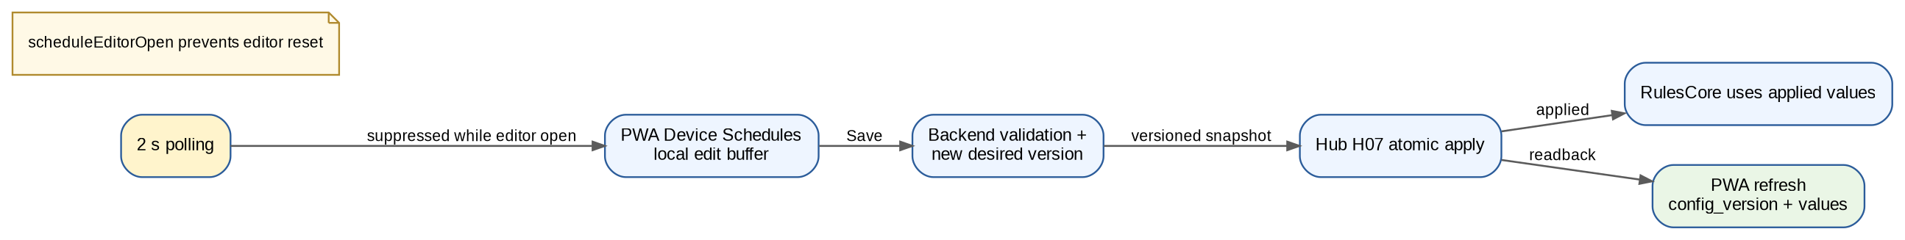
Figure E07-v2.1. Current implementation overlay.
Field | v2.1 interpretation
Current behavior | Device Schedules save -> backend validate/version -> applied household ActivityRuleConfig -> RulesCore. scheduleEditorOpen prevents polling from destroying an open editor. Transport heartbeat/retry constants remain engineering-owned, not household preferences.
Preserved baseline relation | All earlier actors/durability/provider boundaries remain valid except where this overlay explicitly changes rule or presentation semantics.
- Household policies are versioned end-to-end; engineering transport constants are intentionally excluded from ordinary family settings.

E10 - Verification, observability and release evidence
Figure E10-v2.1. Current implementation overlay.
Field | v2.1 interpretation
Current behavior | Final native-WSL release qualification passes: host release gate PASS, 92/92 canonical scenarios, 5/5 dummy streams, 16/16 HTTP integration, 94 C++ checks, 31 Python tests, 11 JavaScript tests, sanitizers/trace build PASS, legacy browser-e2e PASS and mandatory Playwright 22/22 desktop/mobile PASS. Physical/HIL/provider gates remain separate.
Preserved baseline relation | All earlier actors/durability/provider boundaries remain valid except where this overlay explicitly changes rule or presentation semantics.
- Final run: host release gate PASS and mandatory Playwright/Chromium PWA gate 22/22 PASS in native WSL.
- Release-gate stability changes in v3.4.2 are infrastructure-only and do not change product logic or the 92-case catalog.

5. Mandatory PWA browser validation - current 22-test gate
Each logical case below runs once in chromium-desktop and once in chromium-mobile (Pixel 7 profile), producing 22 actual-browser tests. The most recent native-WSL release run passed all 22.
# | Logical browser case | Current result
1 | PWA loads and primary tabs are visible | PASS desktop + mobile
2 | Routine cards below banner; Morning before I am OK | PASS desktop + mobile
3 | Low battery affects Device Health only | PASS desktop + mobile
4 | High drain shortens prediction and affects Device Health only | PASS desktop + mobile
5 | Recent Important Events newest-first | PASS desktop + mobile
6 | Device Schedules remains open during polling and saves | PASS desktop + mobile
7 | Missing morning -> generic red banner + Morning Routine card | PASS desktop + mobile
8 | Post-door inactivity -> generic red banner + Main Door card | PASS desktop + mobile
9 | Night bathroom concern -> generic red banner + Night Activity card | PASS desktop + mobile
10 | Door-left-open/common-room concerns -> generic banner + affected card | PASS desktop + mobile
11 | Run all canonical scenarios through PWA -> visible PASS summary | PASS desktop + mobile

Appendix A. Retained requirement sequence baseline
All 24 baseline requirement diagrams are retained below. They preserve the original actors, module boundaries, durability points and target-integration seams. When a v2.1 overlay exists in Section 4, that overlay supersedes only the changed behavior; the rest of the baseline sequence remains applicable.
Notation retained from the prior sequence volume: request/event/command arrows cross actor/module boundaries; self transitions represent atomic validation/state changes; suppression guards prevent false concerns/reassurance; target hardware/network/provider interactions remain separate integration gates.

F01 - Household profile and caregiver roles
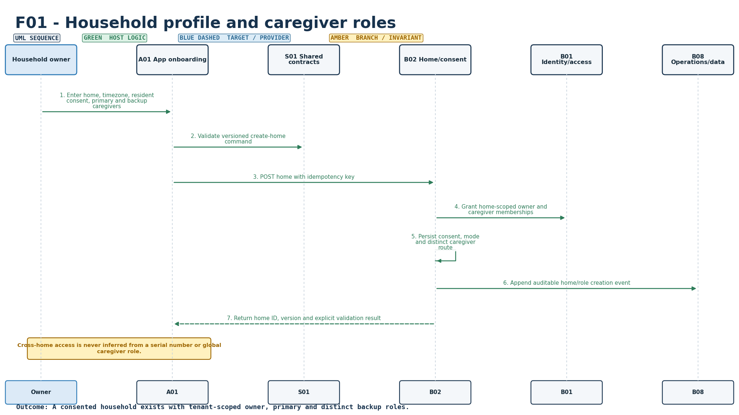
Figure S-01. Requirement-level call flow for F01. Retained baseline diagram.
Mapped modules: B01, B02, A01, S01. Participants: Owner, A01, S01, B02, B01, B08. Outcome: A consented household exists with tenant-scoped owner, primary and distinct backup roles.
Editable source: plantuml/sequences/F01.puml
v2.1 disposition: Retained. Household/access boundary remains valid. Current host validation does not change the target production OIDC/database boundary.

F02 - Resident consent and privacy controls
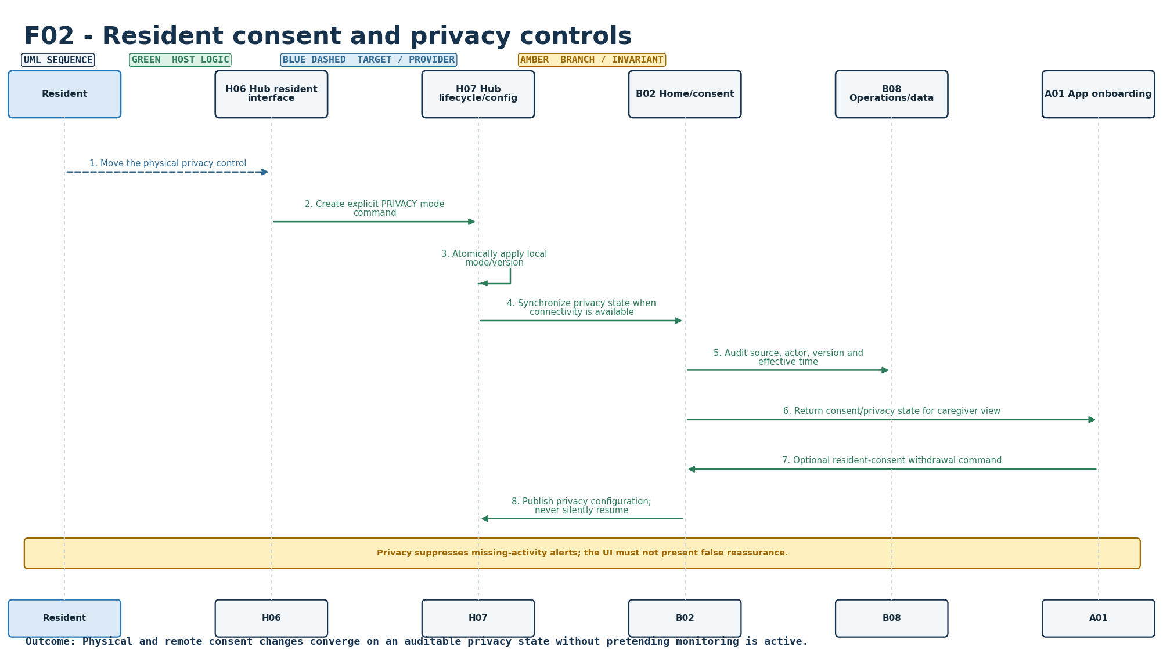
Figure S-02. Requirement-level call flow for F02. Retained baseline diagram.
Mapped modules: B02, H06, H07, A01, B08. Participants: Resident, H06, H07, B02, B08, A01. Outcome: Physical and remote consent changes converge on an auditable privacy state without pretending monitoring is active.
Editable source: plantuml/sequences/F02.puml
v2.1 disposition: Retained / clarified. Consent withdrawal remains authoritative internal privacy enforcement. There is no ordinary caregiver/resident Privacy ON/OFF toggle in the current PWA.

F03 - Kit provisioning and installation verification
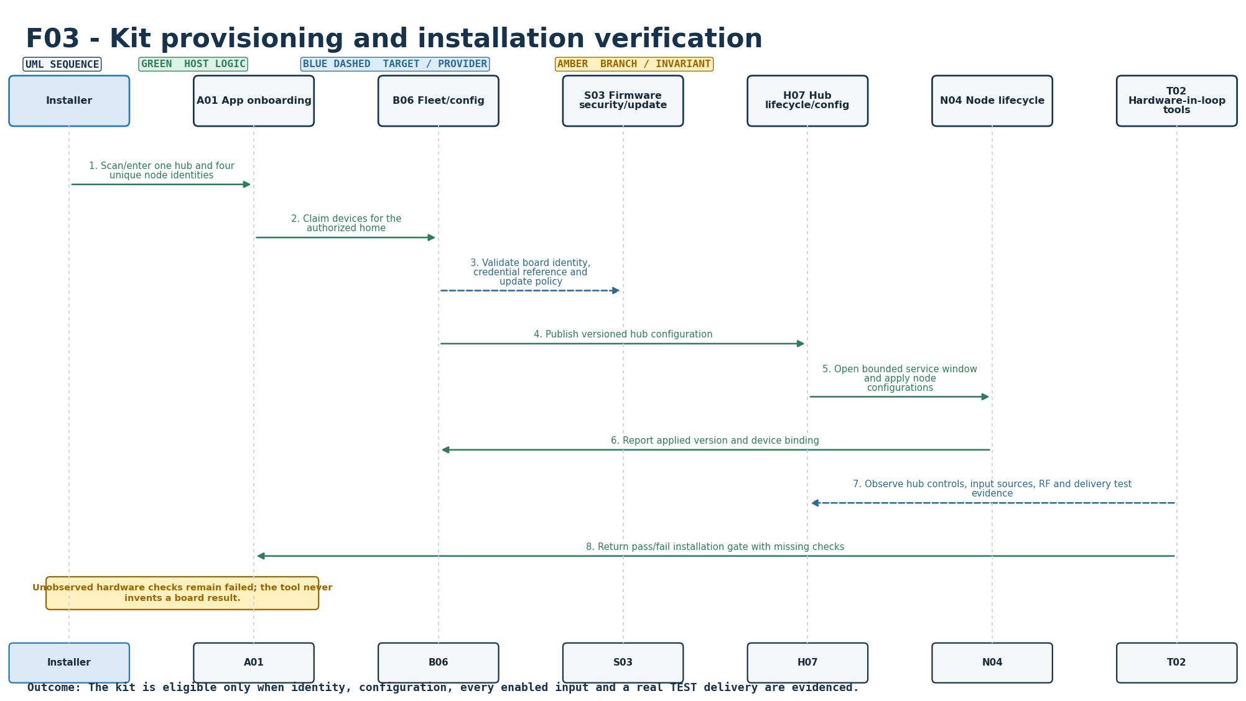
Figure S-03. Requirement-level call flow for F03. Retained baseline diagram.
Mapped modules: N04, H07, B06, A01, S03, T02. Participants: Installer, A01, B06, S03, H07, N04, T02. Outcome: The kit is eligible only when identity, configuration, every enabled input and a real TEST delivery are evidenced.
Editable source: plantuml/sequences/F03.puml
v2.1 disposition: Retained. Provisioning/installation sequence remains a target integration flow; exact board, RF, placement and installation evidence remain HIL pending.

F04 - Configurable morning routine
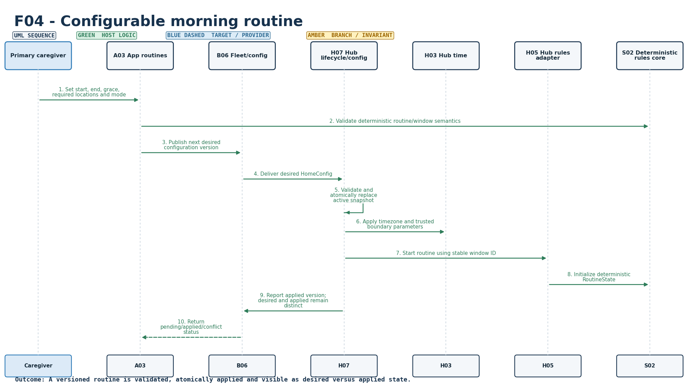
Figure S-04. Requirement-level call flow for F04. Retained baseline diagram.
Mapped modules: A03, B06, H07, H03, H05, S02. Participants: Caregiver, A03, B06, H07, H03, H05, S02. Outcome: A versioned routine is validated, atomically applied and visible as desired versus applied state.
Editable source: plantuml/sequences/F04.puml
v2.1 disposition: Updated. Device Schedules now carries versioned household activity policy: morning sequence, night bathroom/common-room thresholds, visit merge interval, door-open timeout and post-door inactivity. Family-specific values are configuration, not hardcoded behavior.

F05 - Morning activity evidence
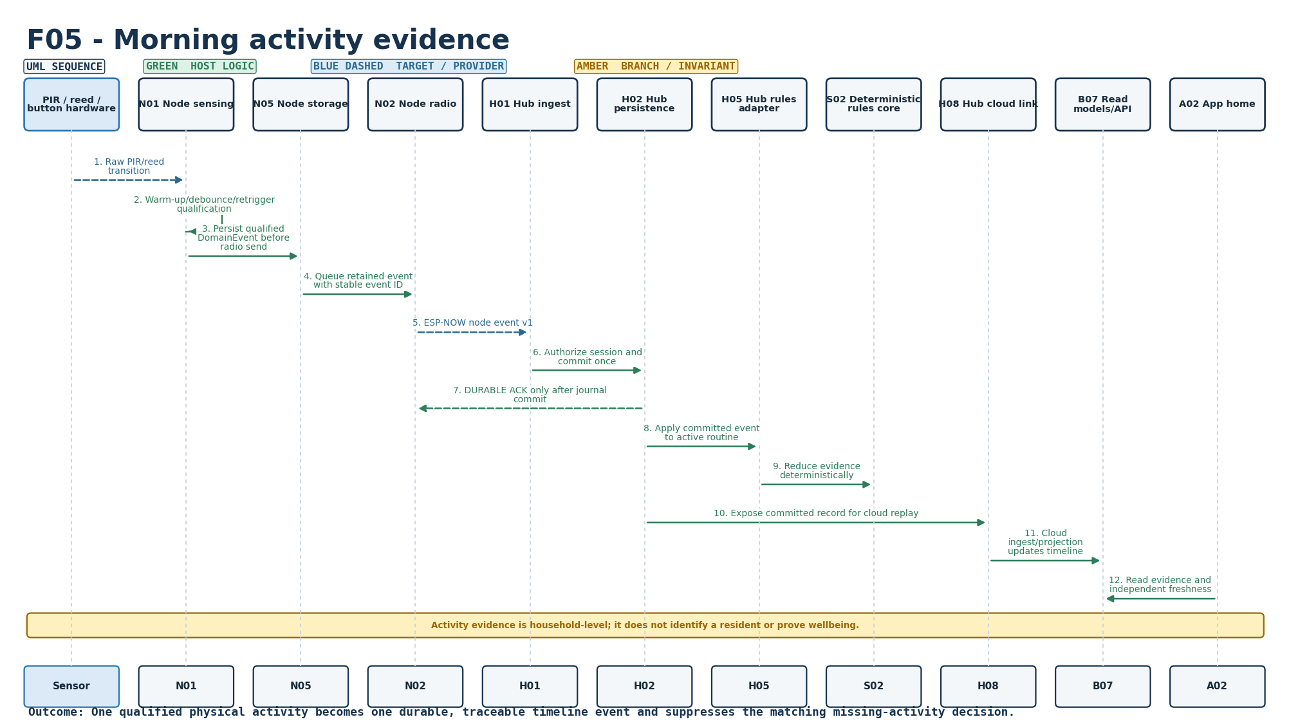
Figure S-05. Requirement-level call flow for F05. Retained baseline diagram.
Mapped modules: N01, H01, H02, H05, S02, B07, A02. Participants: Sensor, N01, N05, N02, H01, H02, H05, S02, H08, B07, A02. Outcome: One qualified physical activity becomes one durable, traceable timeline event and suppresses the matching missing-activity decision.
Editable source: plantuml/sequences/F05.puml
v2.1 disposition: Updated. Current morning sequence starts on configured bedroom activity, then requires configured bathroom and kitchen in either order within the sequence window. Pre-bedroom bathroom/kitchen does not count. Current v3.4.2 restarts progress on another bedroom event; this is explicitly documented as a design-review item.

F06 - Explicit I'm OK check-in
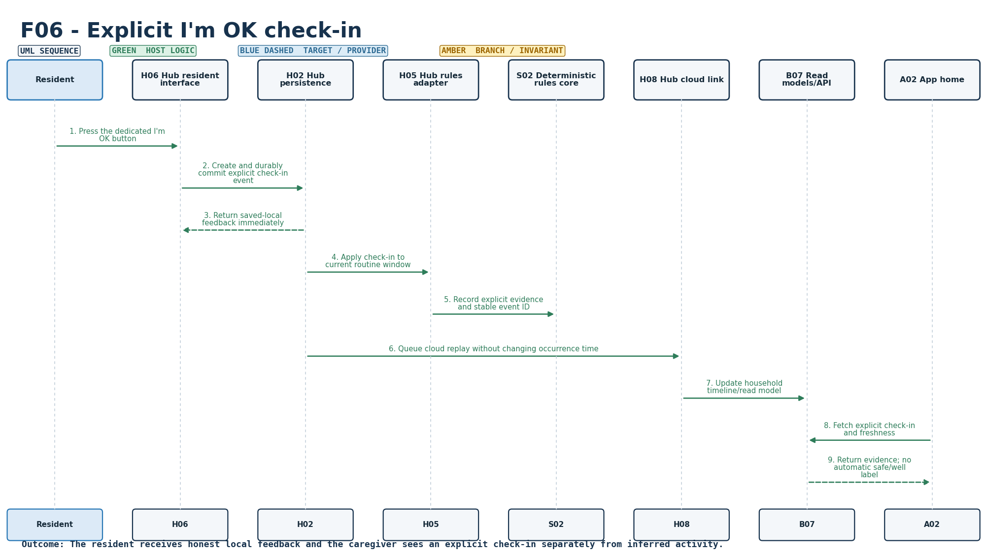
Figure S-06. Requirement-level call flow for F06. Retained baseline diagram.
Mapped modules: H06, H02, H05, S02, B07, A02. Participants: Resident, H06, H02, H05, S02, H08, B07, A02. Outcome: The resident receives honest local feedback and the caregiver sees an explicit check-in separately from inferred activity.
Editable source: plantuml/sequences/F06.puml
v2.1 disposition: Updated. I am OK is a distinct positive self-check-in, presented in green with elapsed age. It is chronological evidence and does not automatically close an unrelated Call Family incident.

F07 - Call family request
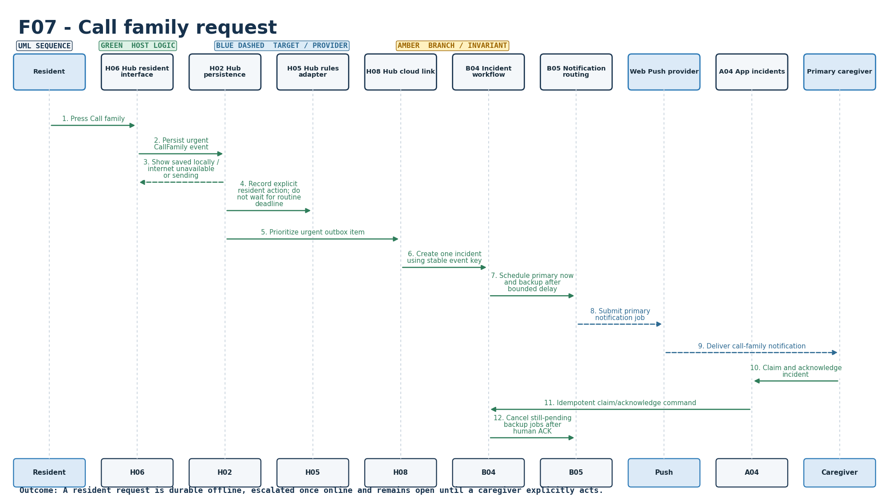
Figure S-07. Requirement-level call flow for F07. Retained baseline diagram.
Mapped modules: H06, H02, H05, B04, B05, A04. Participants: Resident, H06, H02, H05, H08, B04, B05, Push, A04, Caregiver. Outcome: A resident request is durable offline, escalated once online and remains open until a caregiver explicitly acts.
Editable source: plantuml/sequences/F07.puml
v2.1 disposition: Updated. Call Family remains a durable unresolved human-contact request. Later I am OK/activity is appended chronologically; it does not silently resolve the request.

F08 - Missing morning activity workflow
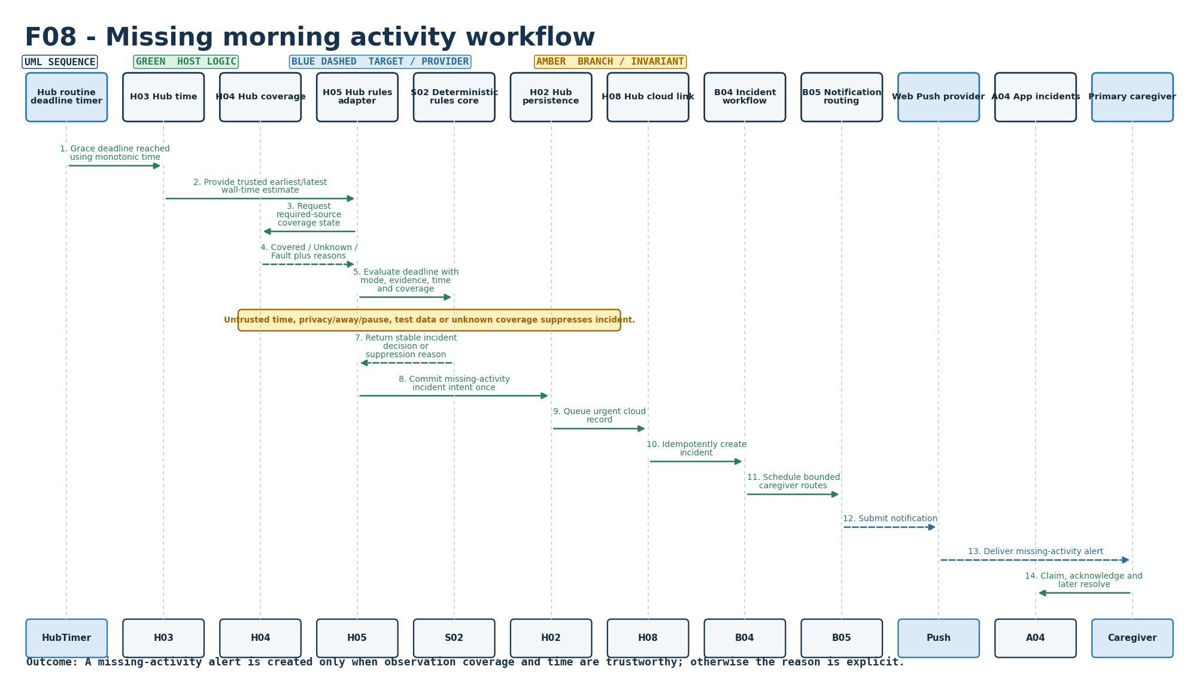
Figure S-08. Requirement-level call flow for F08. Retained baseline diagram.
Mapped modules: H03, H04, H05, S02, B04, B05. Participants: HubTimer, H03, H04, H05, S02, H02, H08, B04, B05, Push, A04, Caregiver. Outcome: A missing-activity alert is created only when observation coverage and time are trustworthy; otherwise the reason is explicit.
Editable source: plantuml/sequences/F08.puml
v2.1 disposition: Updated. Morning sequence pending is not a missing-morning care alert. Only a true MISSING_MORNING_ACTIVITY decision sets care.alert and drives the generic red household banner plus the Morning Routine card.

F09 - Main-door history and quiet notice
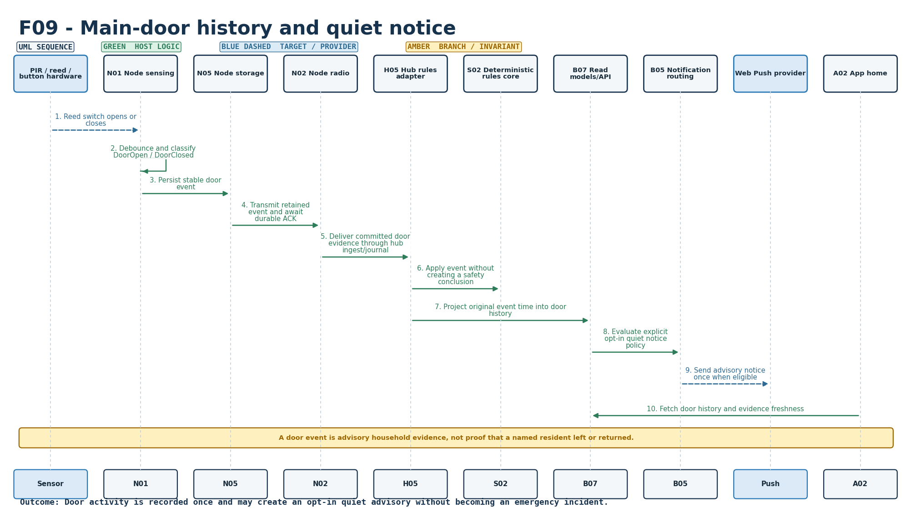
Figure S-09. Requirement-level call flow for F09. Retained baseline diagram.
Mapped modules: N01, H05, S02, B07, B05, A02. Participants: Sensor, N01, N05, N02, H05, S02, B07, B05, Push, A02. Outcome: Door activity is recorded once and may create an opt-in quiet advisory without becoming an emergency incident.
Editable source: plantuml/sequences/F09.puml
v2.1 disposition: Updated. Door history now includes exact open/closed events, configurable door-left-open concern and post-door-close inactivity. Door close arms post-door monitoring; qualifying indoor motion cancels it.

F10 - Away, pause and visitor modes
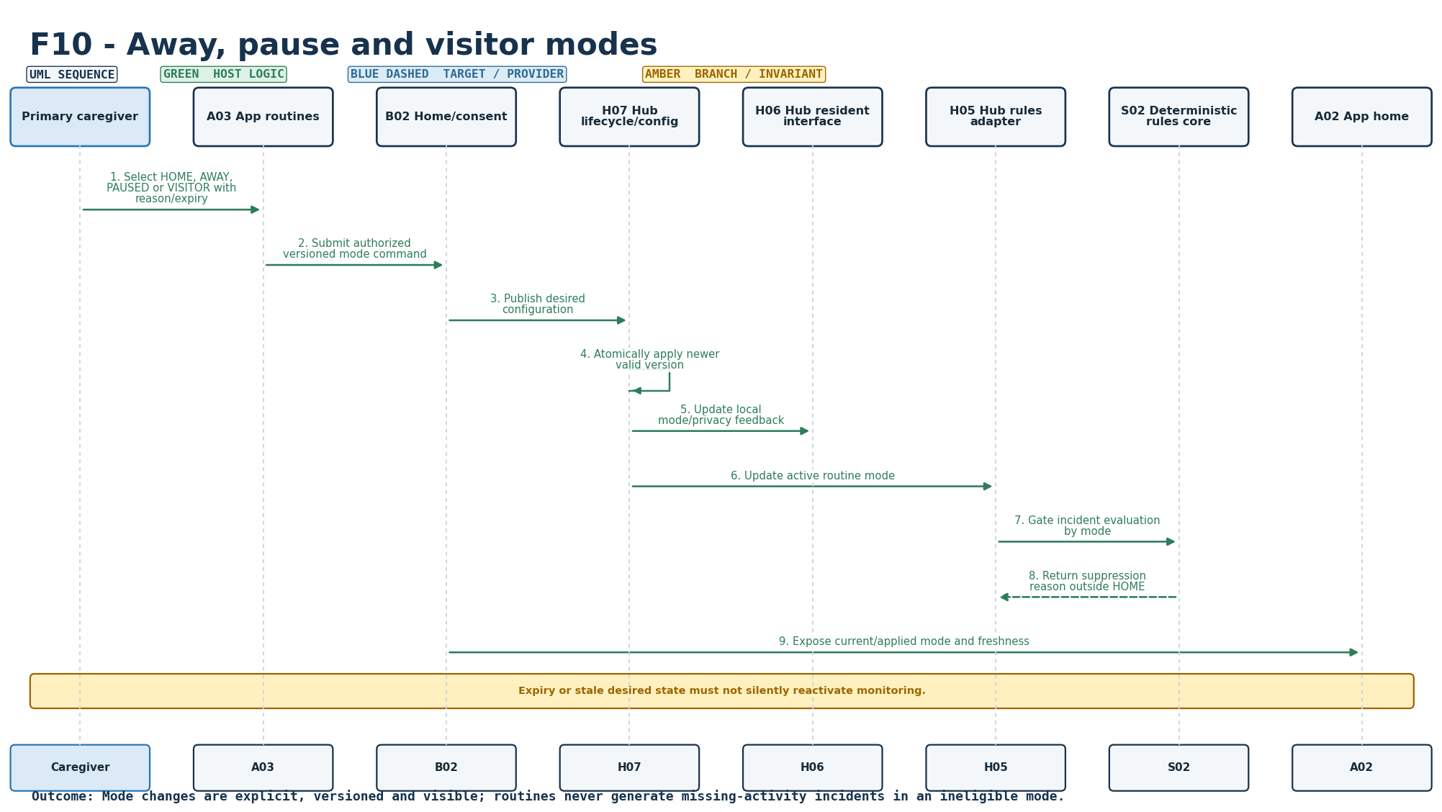
Figure S-10. Requirement-level call flow for F10. Retained baseline diagram.
Mapped modules: A03, B02, H07, H06, H05, S02. Participants: Caregiver, A03, B02, H07, H06, H05, S02, A02. Outcome: Mode changes are explicit, versioned and visible; routines never generate missing-activity incidents in an ineligible mode.
Editable source: plantuml/sequences/F10.puml
v2.1 disposition: Retained / product UI constrained. HOME/AWAY/PAUSED/VISITOR rule semantics remain in the host design. The current product PWA keeps Away disabled/hidden; internal privacy enforcement remains separate from modes.

F11 - Caregiver dashboard and timeline
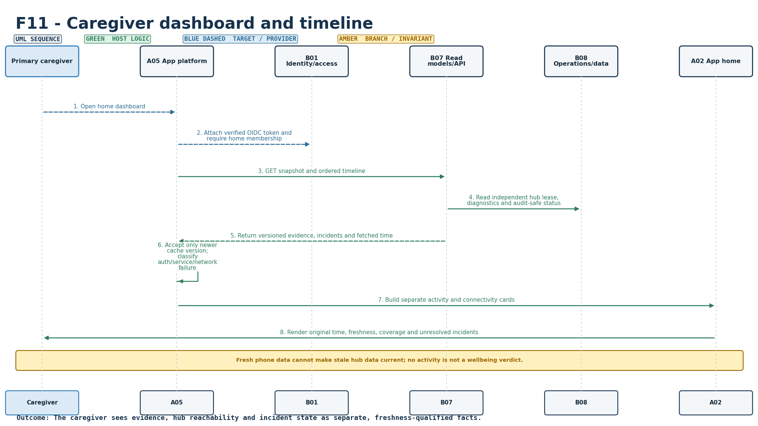
Figure S-11. Requirement-level call flow for F11. Retained baseline diagram.
Mapped modules: B07, B08, A02, A05. Participants: Caregiver, A05, B01, B07, B08, A02. Outcome: The caregiver sees evidence, hub reachability and incident state as separate, freshness-qualified facts.
Editable source: plantuml/sequences/F11.puml
v2.1 disposition: Updated. PWA is backend-driven. Generic household banner is separate from routine cards. Card order: Morning Routine, I am OK, Main Door, Night Activity, Device Health. Device Health/battery cannot turn the care banner red. Recent Important Events are newest-first.

F12 - Acknowledgement and resolution
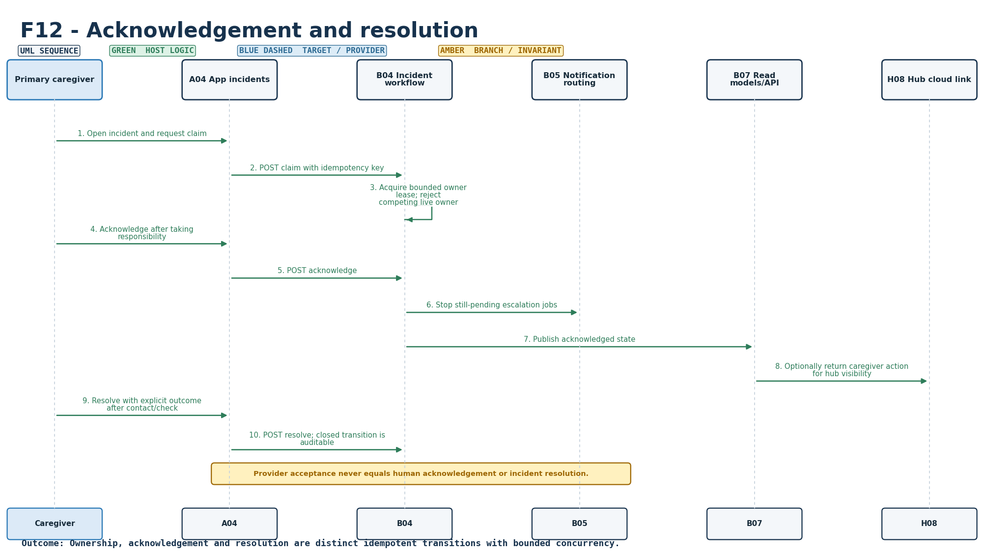
Figure S-12. Requirement-level call flow for F12. Retained baseline diagram.
Mapped modules: B04, B07, B05, A04, H08. Participants: Caregiver, A04, B04, B05, B07, H08. Outcome: Ownership, acknowledgement and resolution are distinct idempotent transitions with bounded concurrency.
Editable source: plantuml/sequences/F12.puml
v2.1 disposition: Retained. Acknowledgement/resolution lifecycle remains distinct from observation and resident self-check-in. Production database concurrency remains a target integration concern.

F13 - Backup routing and delivery visibility
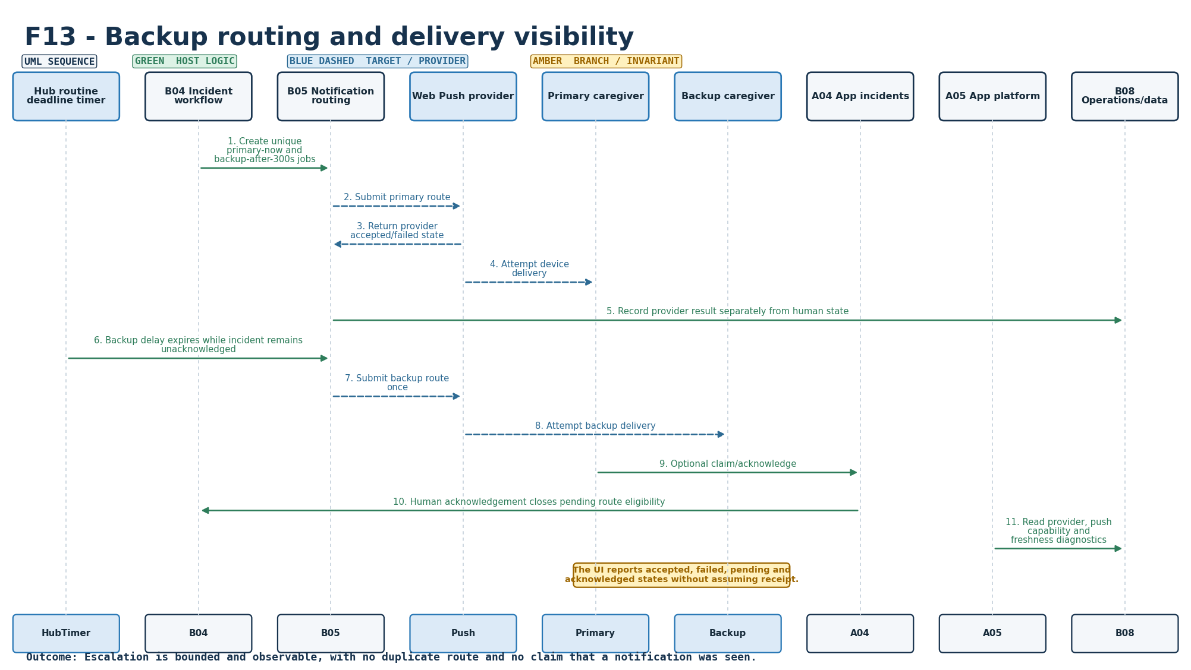
Figure S-13. Requirement-level call flow for F13. Retained baseline diagram.
Mapped modules: B05, B04, B08, A04, A05. Participants: HubTimer, B04, B05, Push, Primary, Backup, A04, A05, B08. Outcome: Escalation is bounded and observable, with no duplicate route and no claim that a notification was seen.
Editable source: plantuml/sequences/F13.puml
v2.1 disposition: Retained. Primary/backup routing and delivery visibility semantics remain; real provider/phone acceptance remains pending.

F14 - Opt-in daily morning summary
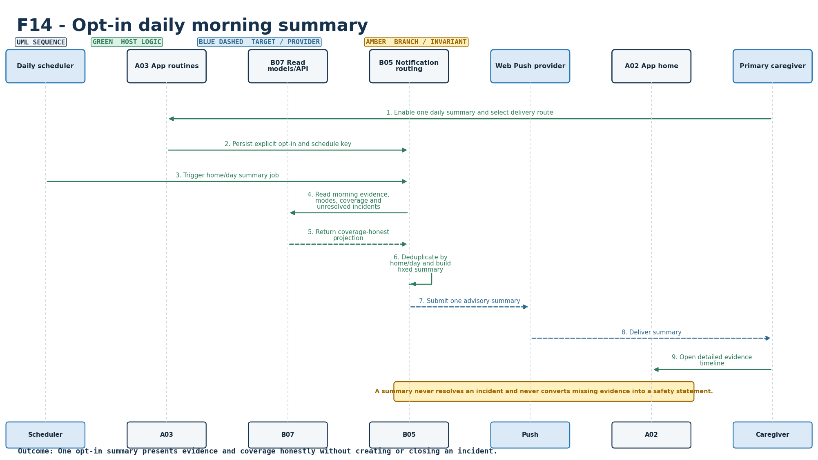
Figure S-14. Requirement-level call flow for F14. Retained baseline diagram.
Mapped modules: B05, B07, A03, A02. Participants: Scheduler, A03, B07, B05, Push, A02, Caregiver. Outcome: One opt-in summary presents evidence and coverage honestly without creating or closing an incident.
Editable source: plantuml/sequences/F14.puml
v2.1 disposition: Retained. Opt-in summary semantics remain; provider/date/consent hardening remains target work.

E01 - Node health, battery and coverage
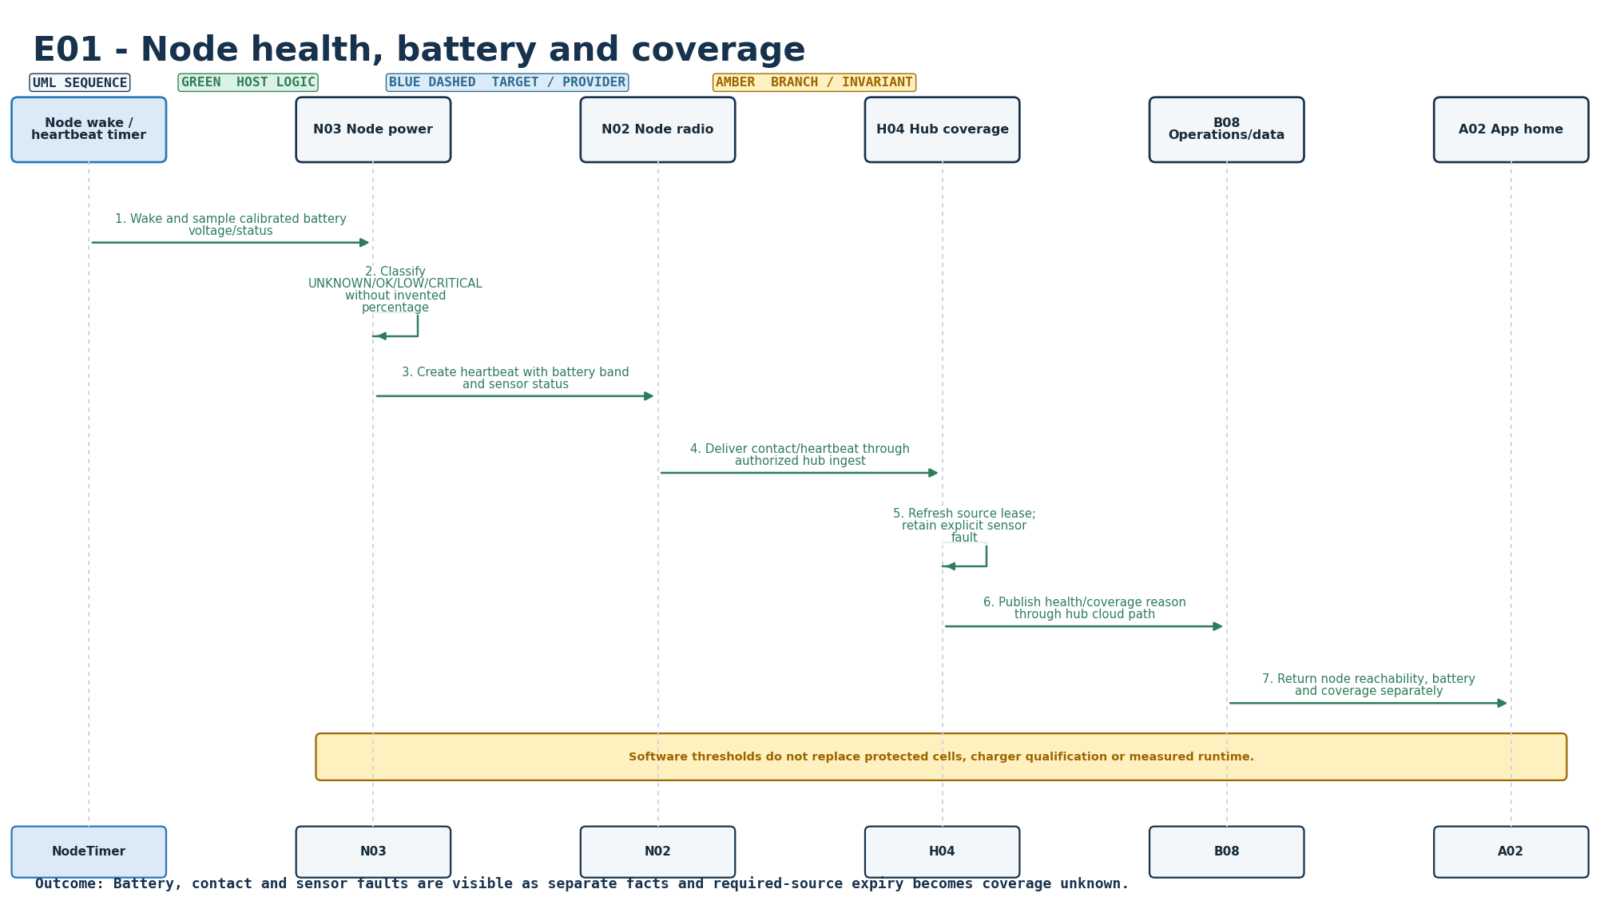
Figure S-15. Requirement-level call flow for E01. Retained baseline diagram.
Mapped modules: N03, N02, H04, B08, A02. Participants: NodeTimer, N03, N02, H04, B08, A02. Outcome: Battery, contact and sensor faults are visible as separate facts and required-source expiry becomes coverage unknown.
Editable source: plantuml/sequences/E01.puml
v2.1 disposition: Updated. Node health now includes optional cumulative power telemetry. Backend BatteryAnalyticsService estimates non-linear voltage-to-SOC, mAh/day, remaining life, confidence and high-drain state from telemetry plus calibrated power profile/history. Low battery/high drain are Device Health only. Field accuracy requires real-board current/ADC/capacity calibration.

E02 - Reliable transport and duplicate handling
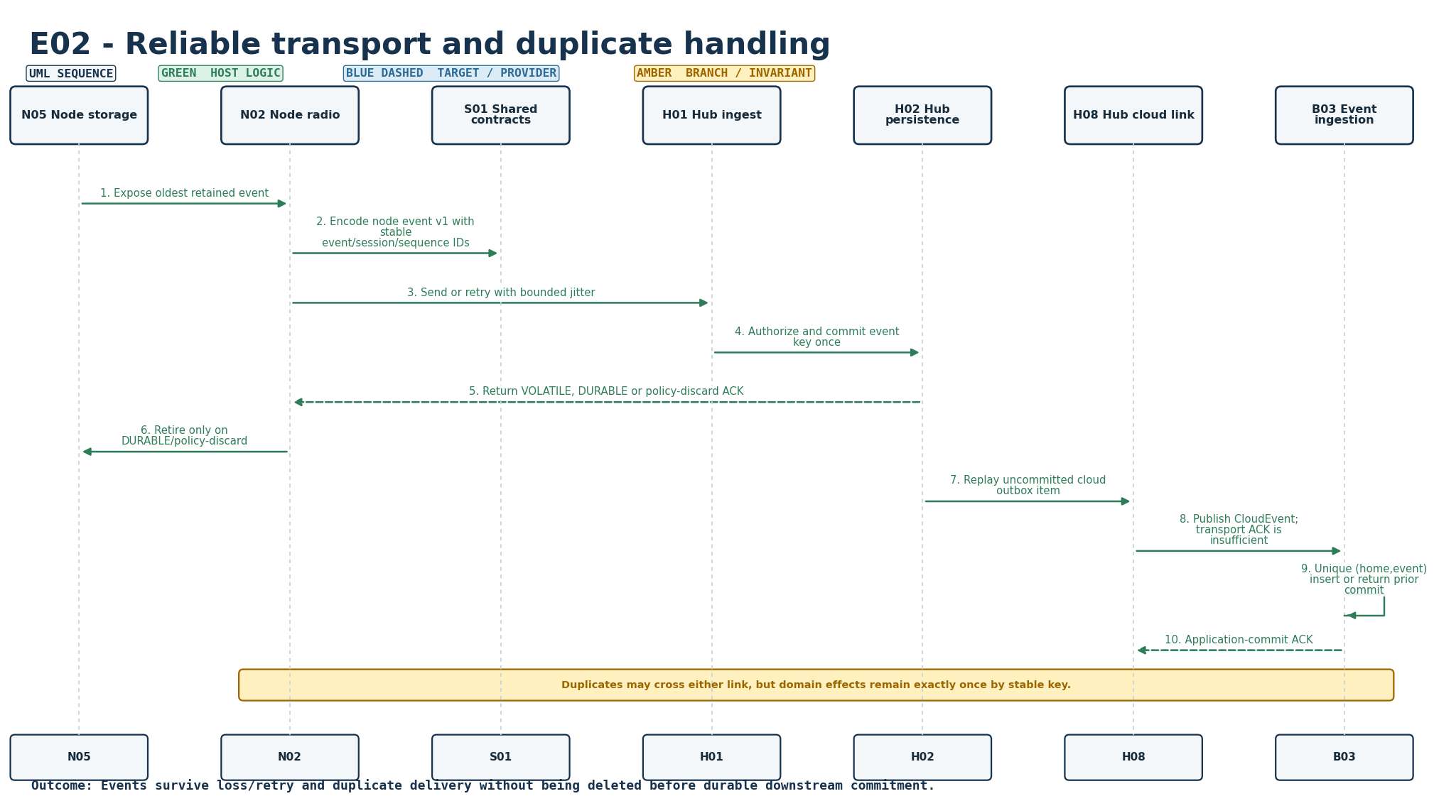
Figure S-16. Requirement-level call flow for E02. Retained baseline diagram.
Mapped modules: N02, N05, H01, H02, H08, B03, S01. Participants: N05, N02, S01, H01, H02, H08, B03. Outcome: Events survive loss/retry and duplicate delivery without being deleted before durable downstream commitment.
Editable source: plantuml/sequences/E02.puml
v2.1 disposition: Retained. Persist/retry/deduplicate/application-ACK semantics remain unchanged; physical RF security/range/loss testing remains pending.

E03 - Local operation during internet failure
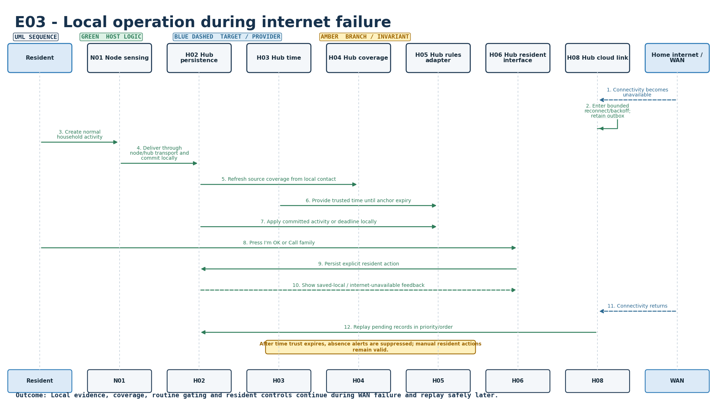
Figure S-17. Requirement-level call flow for E03. Retained baseline diagram.
Mapped modules: H03, H04, H05, H06, H02, H08. Participants: Resident, N01, H02, H03, H04, H05, H06, H08, WAN. Outcome: Local evidence, coverage, routine gating and resident controls continue during WAN failure and replay safely later.
Editable source: plantuml/sequences/E03.puml
v2.1 disposition: Retained. Hub local rules/journal/resident UI continue during WAN loss and replay after restore; real router/WAN outage drills remain pending.

E04 - Hub/cloud/app connectivity and freshness
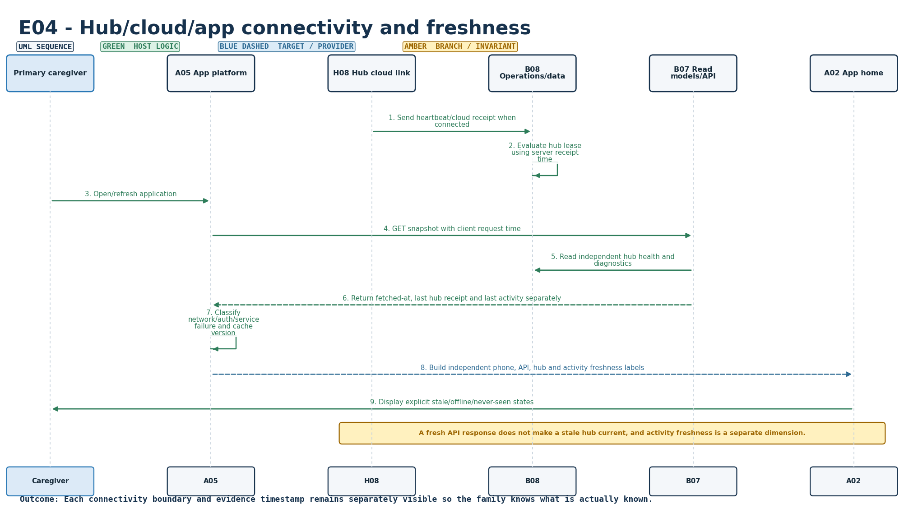
Figure S-18. Requirement-level call flow for E04. Retained baseline diagram.
Mapped modules: H08, B08, B07, A05, A02. Participants: Caregiver, A05, H08, B08, B07, A02. Outcome: Each connectivity boundary and evidence timestamp remains separately visible so the family knows what is actually known.
Editable source: plantuml/sequences/E04.puml
v2.1 disposition: Retained / strengthened UI evidence. Freshness and connectivity remain separate facts. Current PWA/browser gate validates backend-driven state presentation; deployed service/broker monitoring remains pending.

E05 - Persistence, recovery and bounded storage
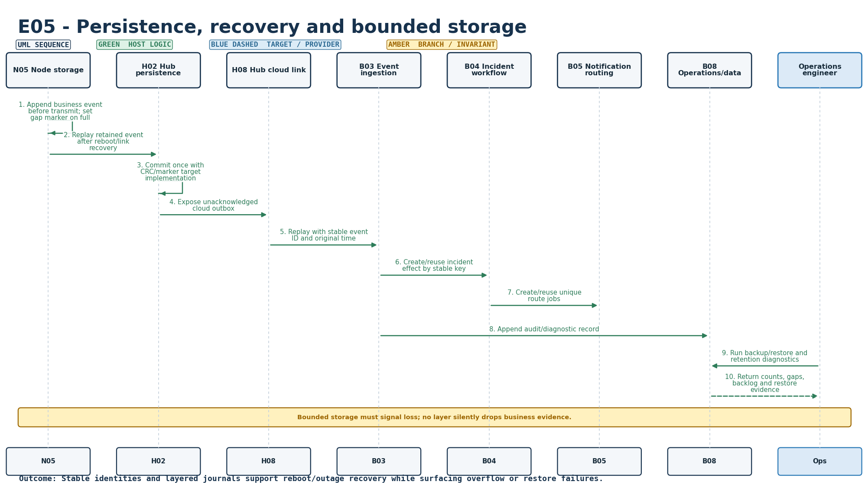
Figure S-19. Requirement-level call flow for E05. Retained baseline diagram.
Mapped modules: N05, H02, B03, B04, B05, B08. Participants: N05, H02, H08, B03, B04, B05, B08, Ops. Outcome: Stable identities and layered journals support reboot/outage recovery while surfacing overflow or restore failures.
Editable source: plantuml/sequences/E05.puml
v2.1 disposition: Retained. Layered persistence/idempotency remains the intended ordering. Production flash/PostgreSQL/power-cut/wear evidence remains pending.

E06 - Trusted time and boundary handling
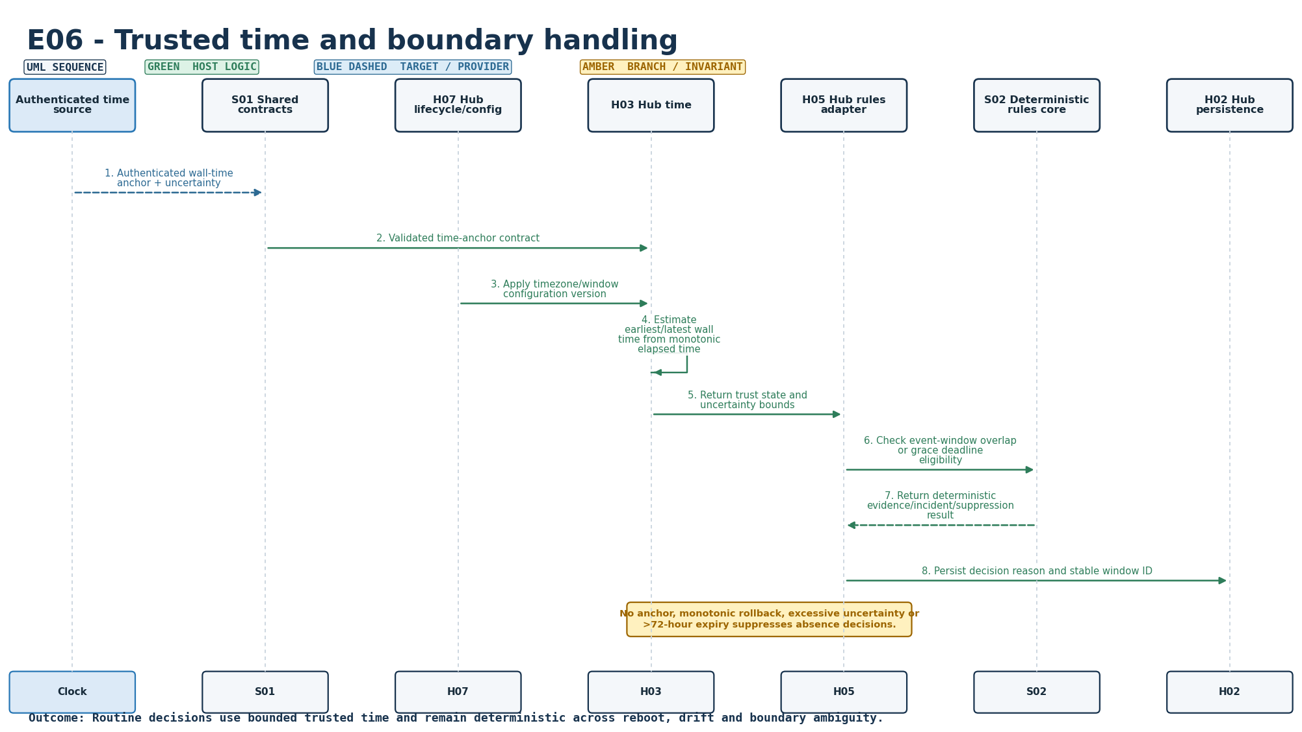
Figure S-20. Requirement-level call flow for E06. Retained baseline diagram.
Mapped modules: H03, H07, H05, S01, S02. Participants: Clock, S01, H07, H03, H05, S02, H02. Outcome: Routine decisions use bounded trusted time and remain deterministic across reboot, drift and boundary ambiguity.
Editable source: plantuml/sequences/E06.puml
v2.1 disposition: Retained. Trusted time/window suppression semantics remain. Current routine/night/post-door policies use configured local-minute windows and suppress absence when time is untrusted.

E07 - Versioned configuration and atomic application
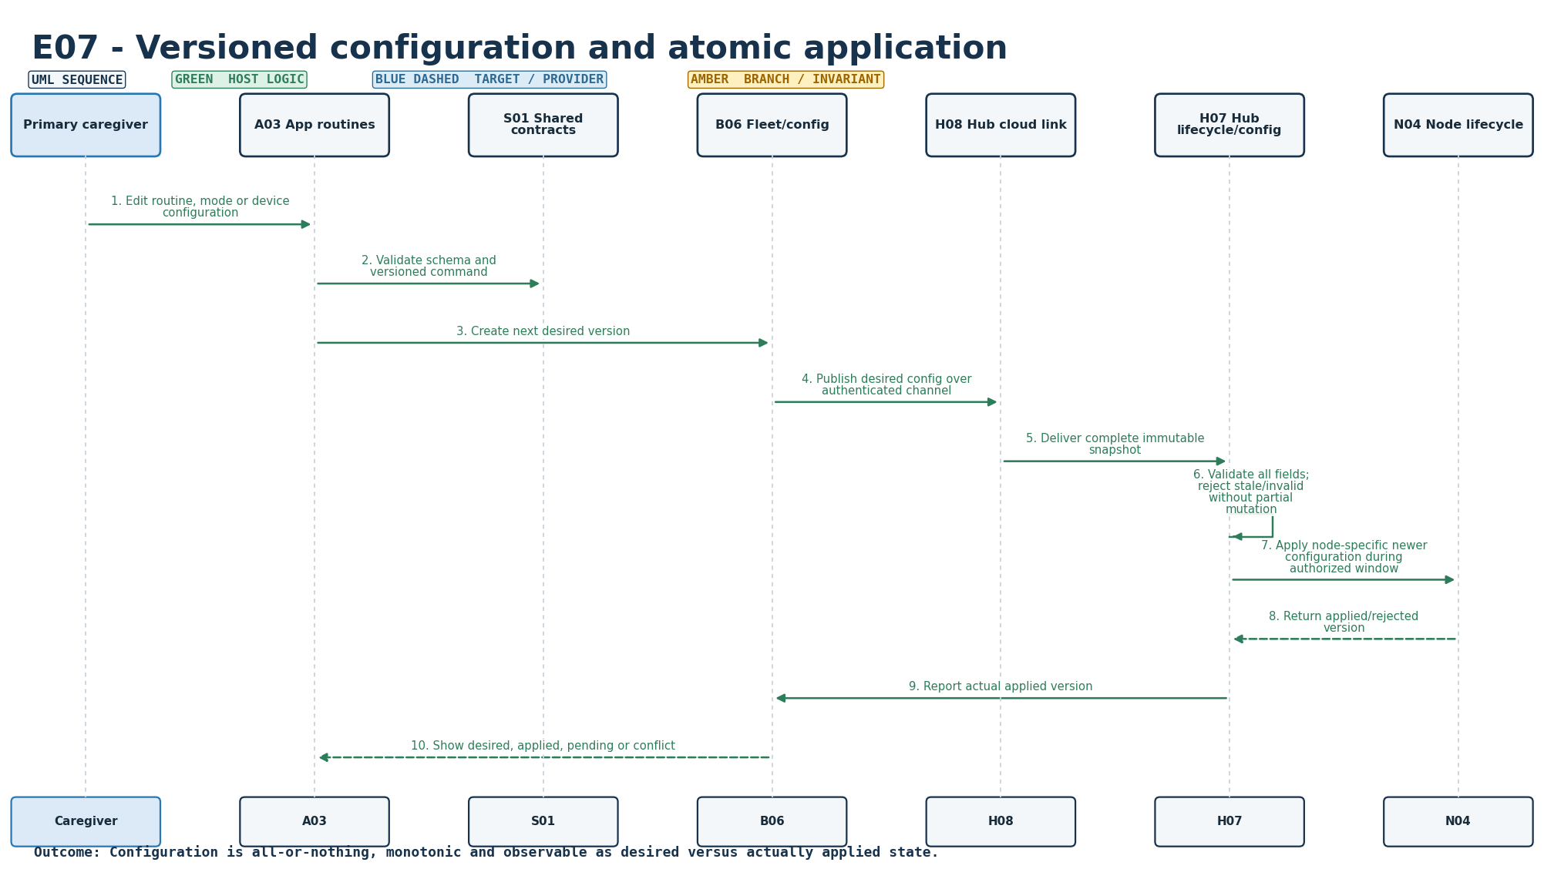
Figure S-21. Requirement-level call flow for E07. Retained baseline diagram.
Mapped modules: B06, A03, H07, N04, H08, S01. Participants: Caregiver, A03, S01, B06, H08, H07, N04. Outcome: Configuration is all-or-nothing, monotonic and observable as desired versus actually applied state.
Editable source: plantuml/sequences/E07.puml
v2.1 disposition: Updated. Device Schedules save -> backend validate/version -> applied household ActivityRuleConfig -> RulesCore. scheduleEditorOpen prevents polling from destroying an open editor. Transport heartbeat/retry constants remain engineering-owned, not household preferences.

E08 - Security, privacy and tenant isolation
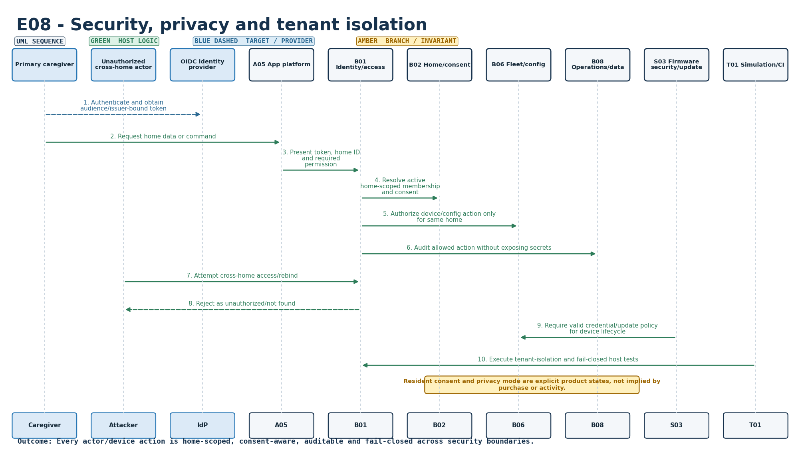
Figure S-22. Requirement-level call flow for E08. Retained baseline diagram.
Mapped modules: S03, B01, B02, B06, B08, A05, T01. Participants: Caregiver, Attacker, IdP, A05, B01, B02, B06, B08, S03, T01. Outcome: Every actor/device action is home-scoped, consent-aware, auditable and fail-closed across security boundaries.
Editable source: plantuml/sequences/E08.puml
v2.1 disposition: Retained. Tenant/access/security/privacy design remains; production OIDC/TLS/device credential lifecycle remains pending.

E09 - Signed firmware update and recovery
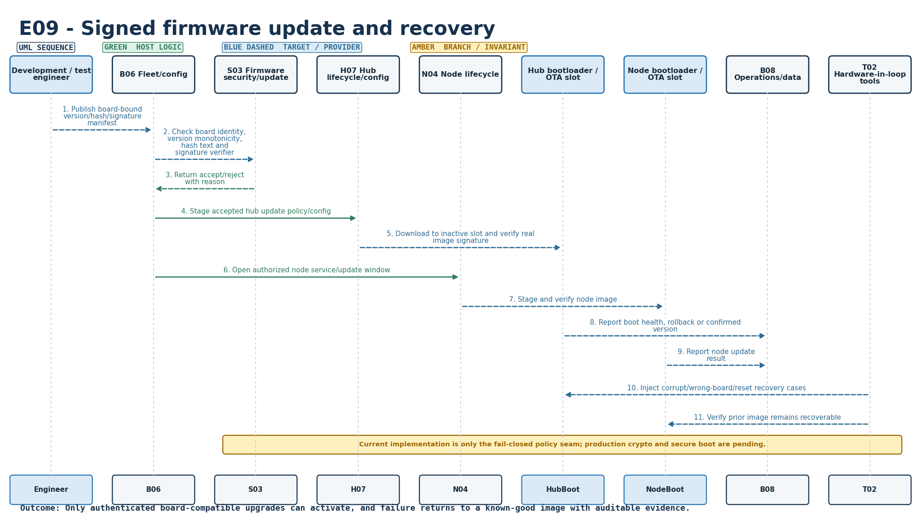
Figure S-23. Requirement-level call flow for E09. Retained baseline diagram.
Mapped modules: S03, H07, N04, B06, B08, T02. Participants: Engineer, B06, S03, H07, N04, HubBoot, NodeBoot, B08, T02. Outcome: Only authenticated board-compatible upgrades can activate, and failure returns to a known-good image with auditable evidence.
Editable source: plantuml/sequences/E09.puml
v2.1 disposition: Retained. Signed OTA/update policy remains a target design; real signature, secure boot, rollback and interrupted-update evidence remain pending.

E10 - Verification, observability and release evidence
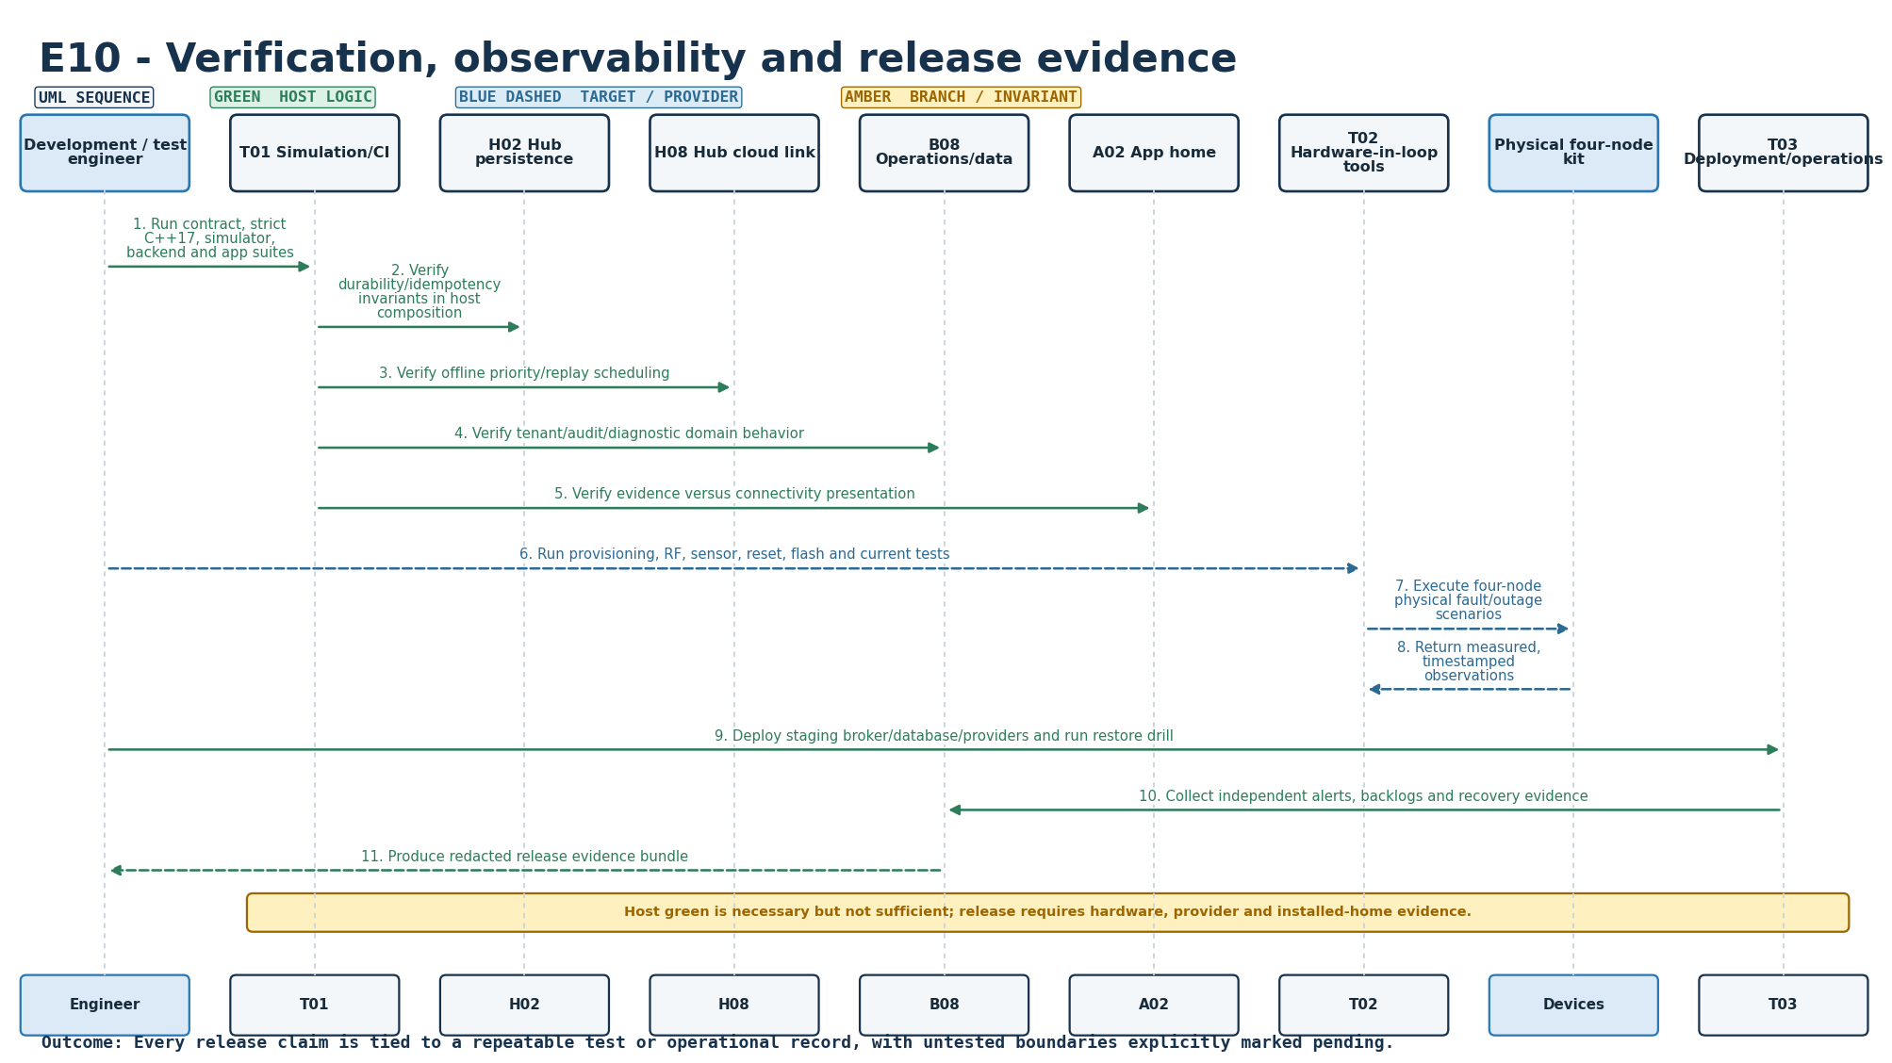
Figure S-24. Requirement-level call flow for E10. Retained baseline diagram.
Mapped modules: B08, A02, T01, T02, T03, H02, H08. Participants: Engineer, T01, H02, H08, B08, A02, T02, Devices, T03. Outcome: Every release claim is tied to a repeatable test or operational record, with untested boundaries explicitly marked pending.
Editable source: plantuml/sequences/E10.puml
v2.1 disposition: Updated. Final native-WSL release qualification passes: host release gate PASS, 92/92 canonical scenarios, 5/5 dummy streams, 16/16 HTTP integration, 94 C++ checks, 31 Python tests, 11 JavaScript tests, sanitizers/trace build PASS, legacy browser-e2e PASS and mandatory Playwright 22/22 desktop/mobile PASS. Physical/HIL/provider gates remain separate.

Appendix B. Requirement-to-sequence traceability and handoff boundary
ID | Requirement | Baseline sequence retained | v2.1 status
F01 | Household profile and caregiver roles | YES | Retained
F02 | Resident consent and privacy controls | YES | Retained / clarified
F03 | Kit provisioning and installation verification | YES | Retained
F04 | Configurable morning routine | YES | Updated
F05 | Morning activity evidence | YES | Updated
F06 | Explicit I'm OK check-in | YES | Updated
F07 | Call family request | YES | Updated
F08 | Missing morning activity workflow | YES | Updated
F09 | Main-door history and quiet notice | YES | Updated
F10 | Away, pause and visitor modes | YES | Retained / product UI constrained
F11 | Caregiver dashboard and timeline | YES | Updated
F12 | Acknowledgement and resolution | YES | Retained
F13 | Backup routing and delivery visibility | YES | Retained
F14 | Opt-in daily morning summary | YES | Retained
E01 | Node health, battery and coverage | YES | Updated
E02 | Reliable transport and duplicate handling | YES | Retained
E03 | Local operation during internet failure | YES | Retained
E04 | Hub/cloud/app connectivity and freshness | YES | Retained / strengthened UI evidence
E05 | Persistence, recovery and bounded storage | YES | Retained
E06 | Trusted time and boundary handling | YES | Retained
E07 | Versioned configuration and atomic application | YES | Updated
E08 | Security, privacy and tenant isolation | YES | Retained
E09 | Signed firmware update and recovery | YES | Retained
E10 | Verification, observability and release evidence | YES | Updated

Handoff boundary
The software/reference sequence set is release-qualified on the host and actual Chromium browser for the stated v3.4.2 baseline. That evidence does not certify real ESP32 GPIO/RF timing, physical sensor placement, flash power-cut durability, battery-current calibration, charger/UPS behavior, signed OTA, provider delivery or installed-home usability.
Any future change to a rule, sequence, banner/card ownership, configuration semantics or battery-health isolation must update the implementation, canonical scenario catalog, browser regression where visible, and this sequence volume together. Historical diagrams should be marked superseded in part rather than silently removed.

