**Code Challenge API Documataion**

**1) Technology used**

1) PHP version : 7.4.3

2) composer

3) core php with oops

4) Postman

5) Data save in session

6) unit test install using below command

- composer global require phpunit/phpunit

7) Unit test run using below command

- php ./vendor/bin/phpunit

**2) End points:**

**API Request and Response**

**1) Create New account**

**Url**  : http://localhost/bank-app-core/account.php

**Input Data**

{

"api_type":"createaccount",

"accountType":"Checking",

"accountSubType":"individual",

"ownerName":"uday",

"mobile":"9000749143",

"address":"chepur near busstop 508256"

}

**Output Data:**

{

"status": "success",

"data": {

"id": 3,

"bank_name": "HDFC",

"accountType": "Checking",

"account_sub_type": "individual",

"account_number": "5010041337",

"account_owner_name": "udaykiran",

"account_balance": "0.00",

"mobile": "9000749142",

"address": "chepur near busstop 508256",

"account_status": "Active"

},

"message": "Account created successfully"

}

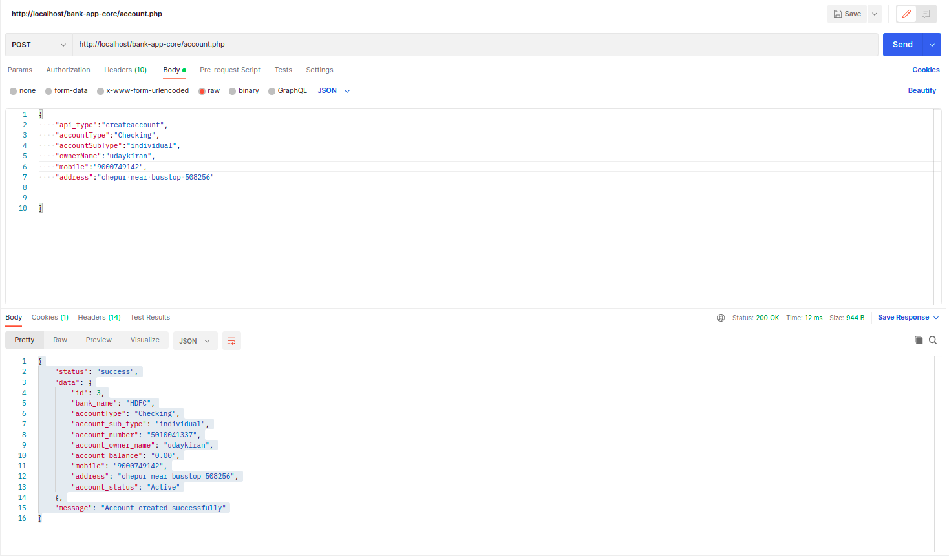

**2 ) A bank also has several accounts.**

**Url**  : http://localhost/bank-app-core/account.php

**Input Data:**

{

"api_type":"accountowner",

}

**Output Data**

{

"status": "success",

"data": [

{

"bank_name": "HDFC",

"account_Type": "Checking",

"account_sub_type": "individual",

"accountOwnerId": "1",

"account_no": "5010099556",

"account_name": "Nikitha",

"available balance": "0.00",

"mobile": "9000749144",

"address": "chepur near busstop 508256",

"account_status": "Active"

},

{

"bank_name": "HDFC",

"account_Type": "Checking",

"account_sub_type": "individual",

"accountOwnerId": 2,

"account_no": "5010041787",

"account_name": "uday",

"available balance": "0.00",

"mobile": "9000749143",

"address": "chepur near busstop 508256",

"account_status": "Active"

}

],

"message": "Bank Account Owner List."

}

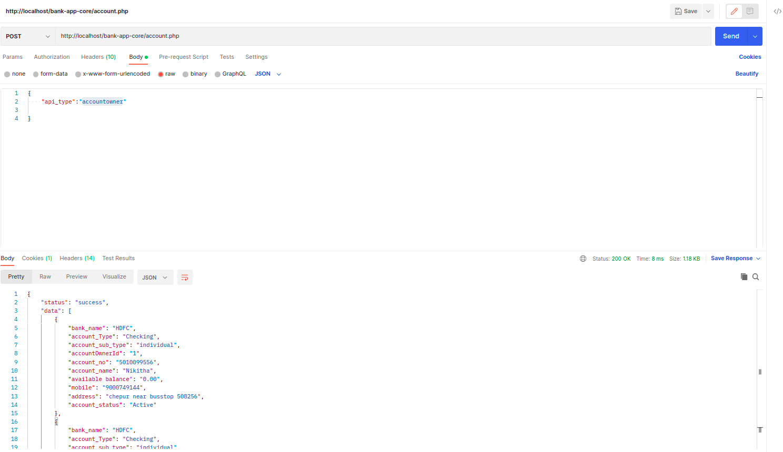

**3) Show single account details bases on passed account number and owner id**

**Url** : http://localhost/bank-app-core/account.php

**Input Data:**

{

"api_type":"accountdetails",

"ownerId":"3",

"accountNumber": "5010041337"

}

**Output Data**

{

"status": "success",

"data": {

"bank_name": "HDFC",

"accountType": "Checking",

"subAccountType": "individual",

"accountOwnerID": 3,

"account_no": "5010041337",

"ownerName": "udaykiran",

"accountBalance": "0.00",

"mobile": "9000749142",

"address": "chepur near busstop 508256",

"account_status": "Active"

},

"message": "Bank account owner details."

}

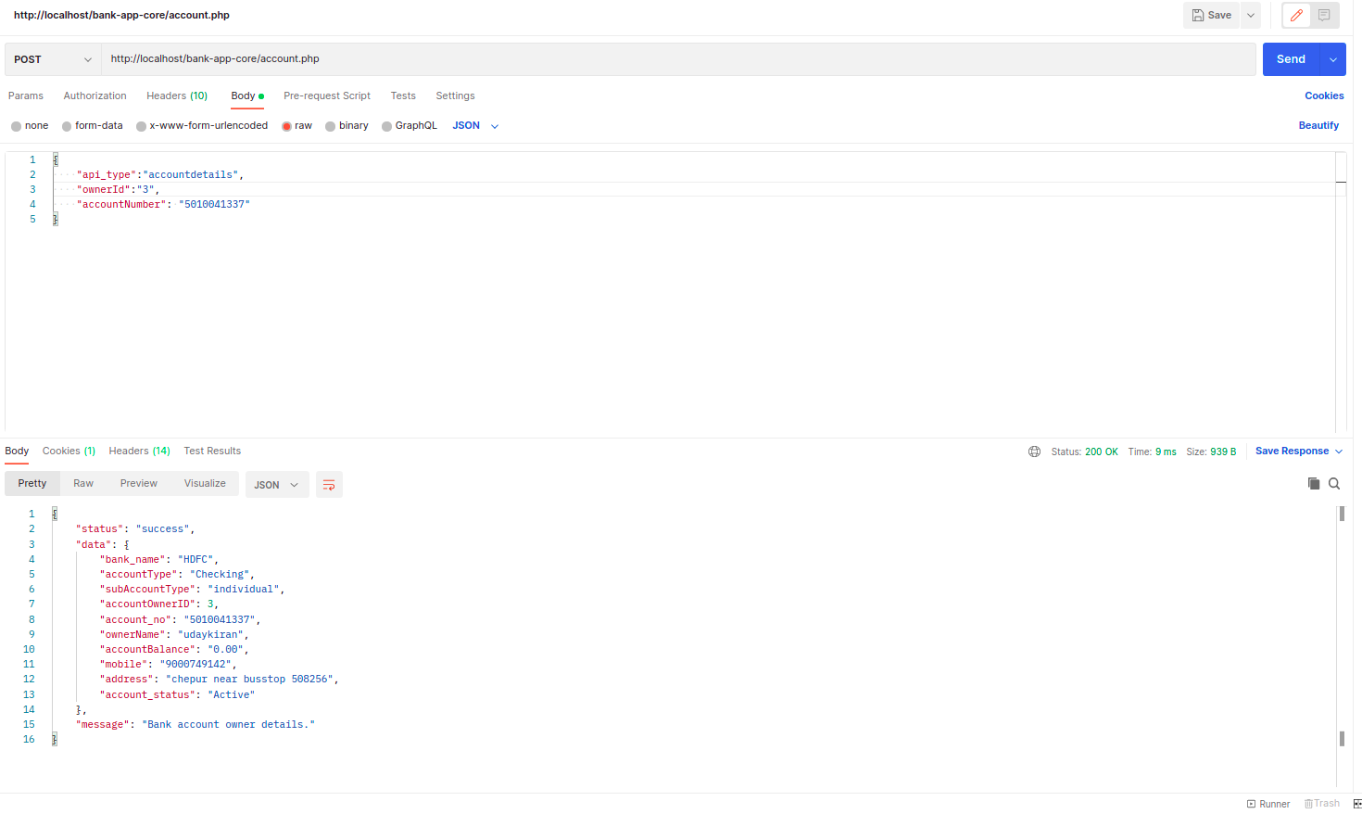

**4) Remove an account with soft delete**

**Url** :: http://localhost/bank-app-core/account.php

**Input Data :**

{

"api_type":"removeAccount",

"owner_id":"2"

}

**Output Data :**

{

"status": "success",

"data": [],

"message": "Owner account has been removed"

}

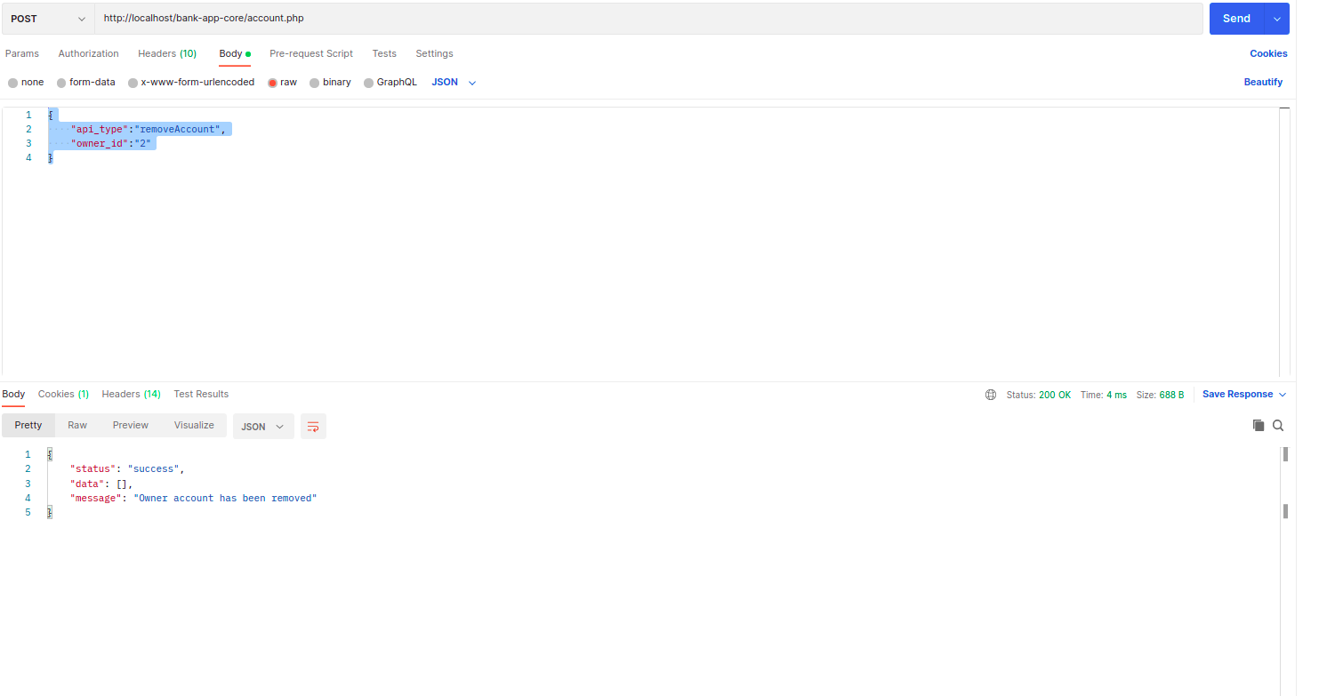

**5) Deposite the account**

**Url :** http://localhost/bank-app-core/account.php

**Input Data :**

{

"api_type":"banktransaction",

"ownerId" :"1",

"transactionType":"Deposit",

"amount":"500.50",

"tarnsactionMode":"CASH"

}

**Output Data:**

{

"status": "success",

"data": [],

"message": "Amount Deposited successfully."

}

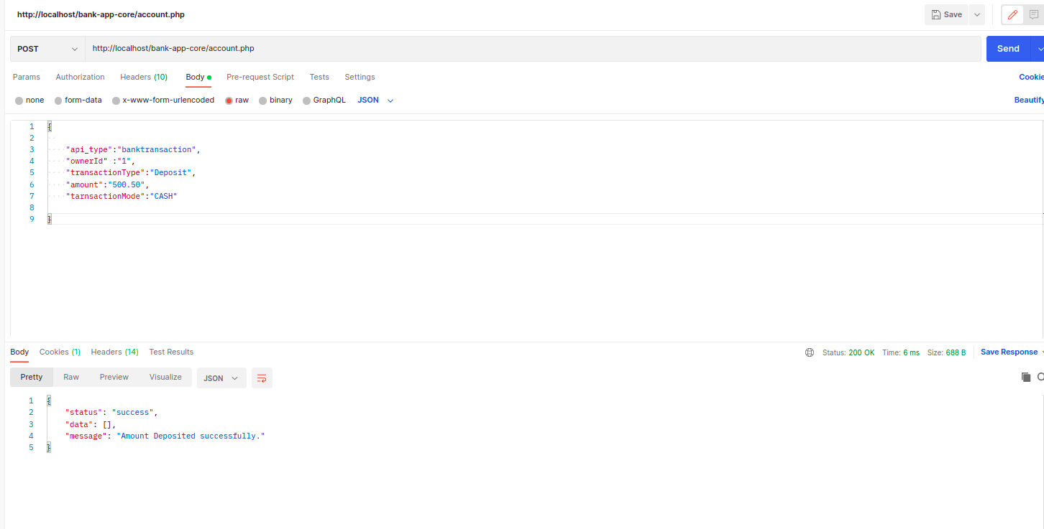

**6 ) Update an existing account details**

**Url :** http://localhost/bank-app-core/account.php

**Input Data :**

{

"api_type":"updateaccount",

"accountType":"investment",

"accountSubType":"individual",

"ownerId":"1",

"ownerName":"Nikitha",

"mobile":"9000749143",

"address":"Hyd near bus stop"

}

**Output Data:**

{

"status": "success",

"data": {

"bank_name": "HDFC",

"accountType": "Checking",

"subAccountType": "individual",

"accountOwenrId": "1",

"accountOwenName": "Nikitha",

"account_no": "5010099556",

"availableBalance": "500.50",

"mobile": "9000749143",

"address": "Hyd near bus stop",

"accountStatus": "Active"

},

"message": "Account Updated Successfully."

}

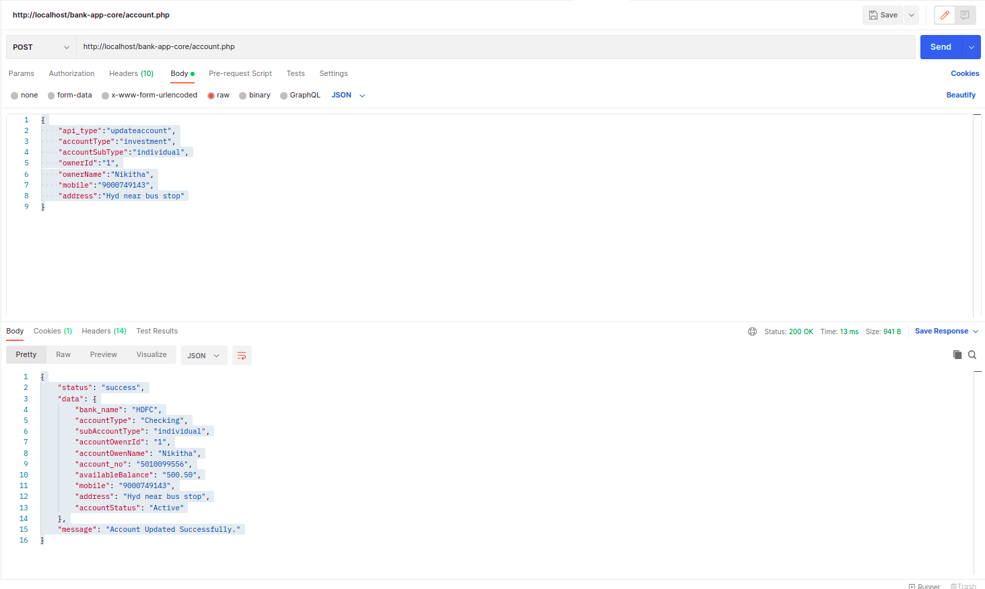

**7) Money withdraw from acocunt**

**Url** : http://localhost/bank-app-core/account.php

**Input Data :**

{

"api_type":"withdrawaltransaction",

"ownerId":"1",

"account_no":"5010027851",

"transactionType":"withdrawal",

"tarnsactionMode":"CASH",

"amount":"500"

}

**Output Data :**

{

"status": "success",

"data": [],

"message": "Amount withdrawal successfully."

}

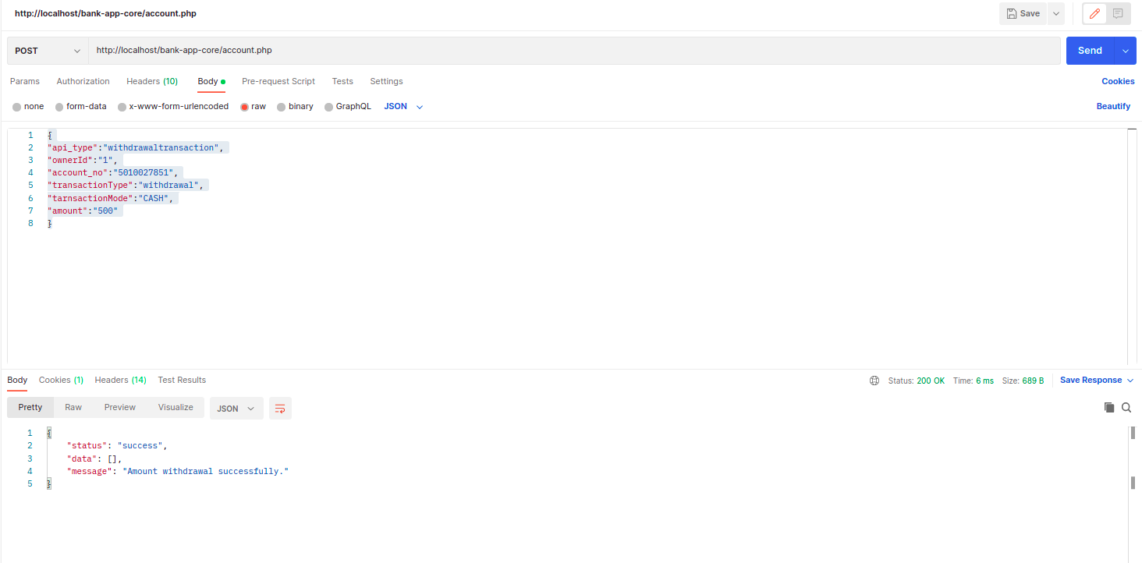

**8) Individual accounts have a withdrawal limit of 500 dollars.**

**Url :** http://localhost/bank-app-core/account.php

**InputData:**

{

"api_type":"withdrawaltransaction",

"ownerId":"1",

"account_no":"5010099556",

"transactionType":"withdrawal",

"tarnsactionMode":"CASH",

"amount":"502"

}

**Output Data:**

{

"status": "failed",

"message": "Individual accounts have a withdrawal limits of 500 dollers"

}

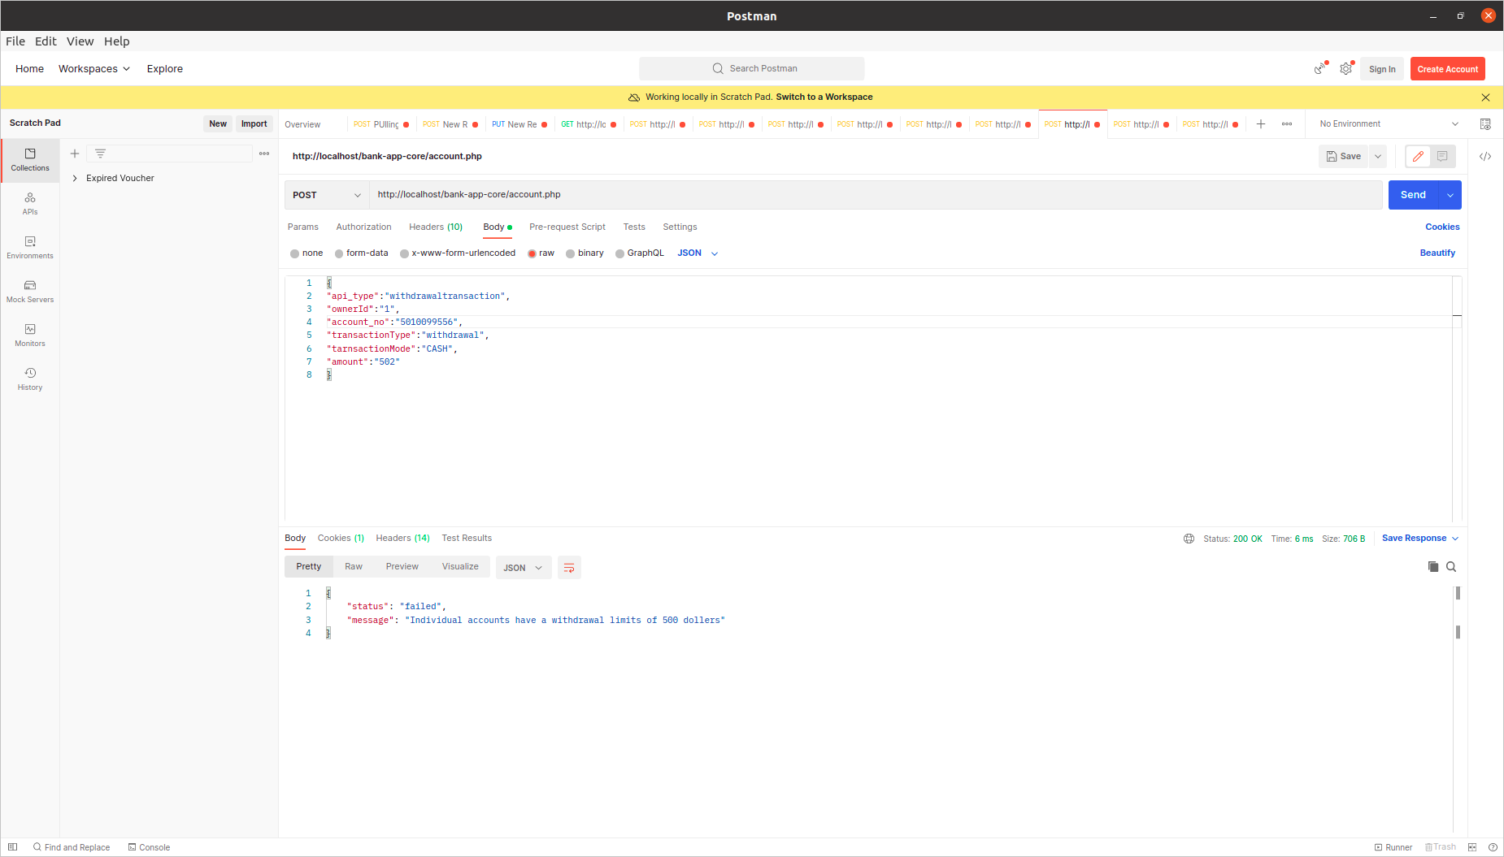

**9 ) Transfer amount one user to other user**

**Url** : http://localhost/bank-app-core/account.php

**InputData :**

{

"api_type":"balancetransfer",

"ownerId":"1",

"account_no":"5010065181",

"transactionType":"Transfer",

"tarnsactionMode":"NEFT",

"amount":"50",

"toOwnerid":"3",

"toaccountno":"5010041337"

}

**Output Data :**

{

"status": "success",

"data": [],

"message": "Amount transferred successfully"

}

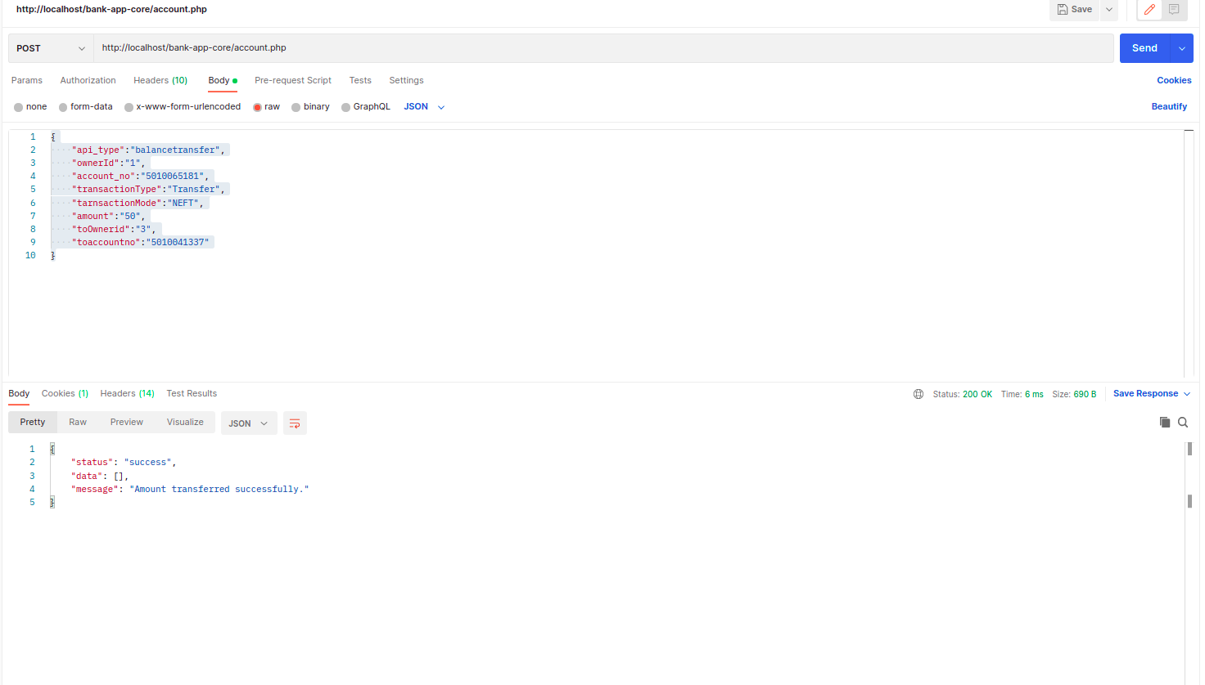

**10 ) Show account Type with name of account owner name.**

**Url :** http://localhost/bank-app-core/account.php

**Input data :**

{

"api_type":"accountdetailschekcing",

"ownerId":"1"

}

**OutPut Data :**

{

"status": "success",

"data": {

"accountType": "investment",

"subAccountType": "individual",

"ownerName": "Uday mahi",

"accountStatus": "Active"

},

"message": "Bank account owner name with account types."

}

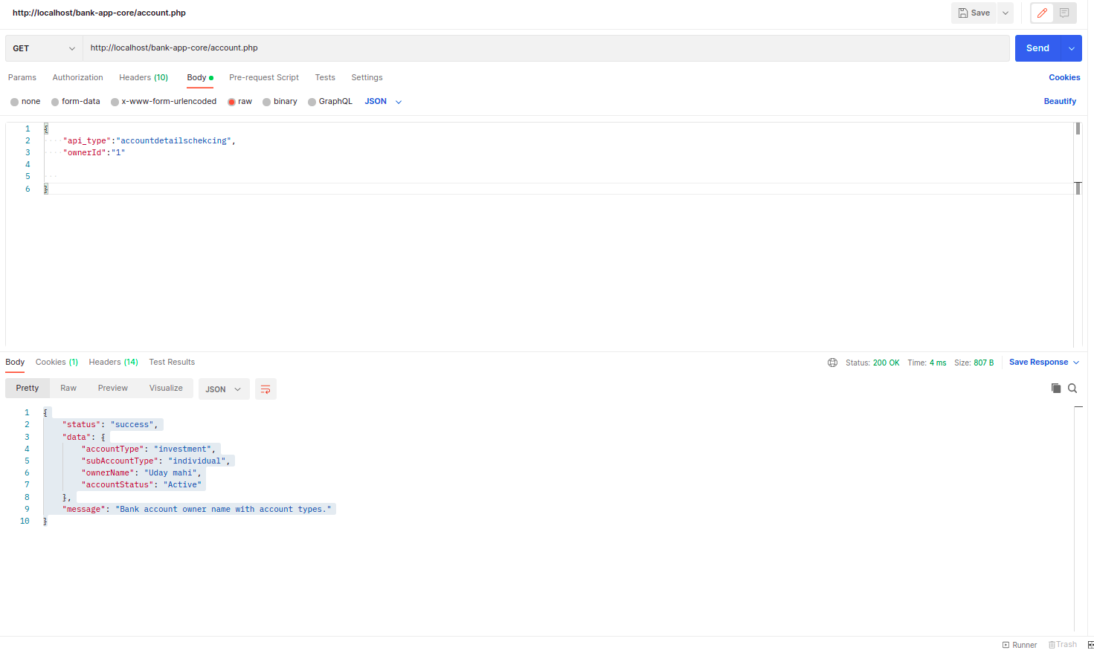

**3) Unit Testing**

Using below command i have test unit test.

- php artisan test --filter BankApiTest

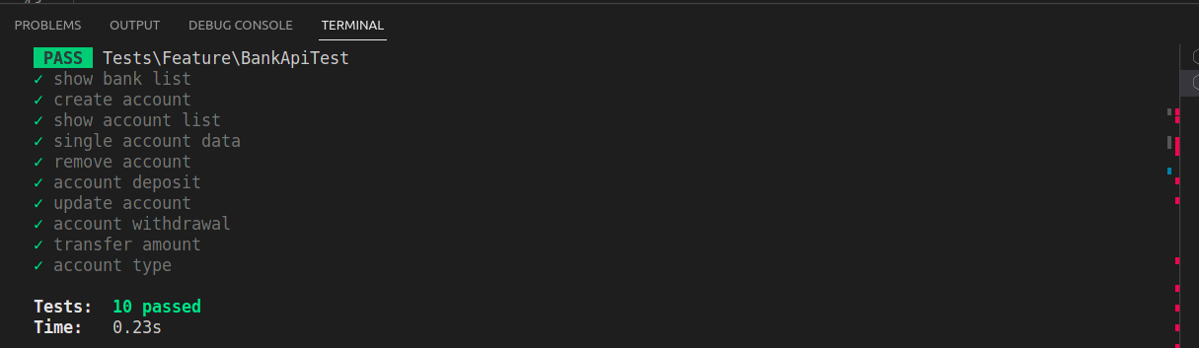

**4) Folder Structure**

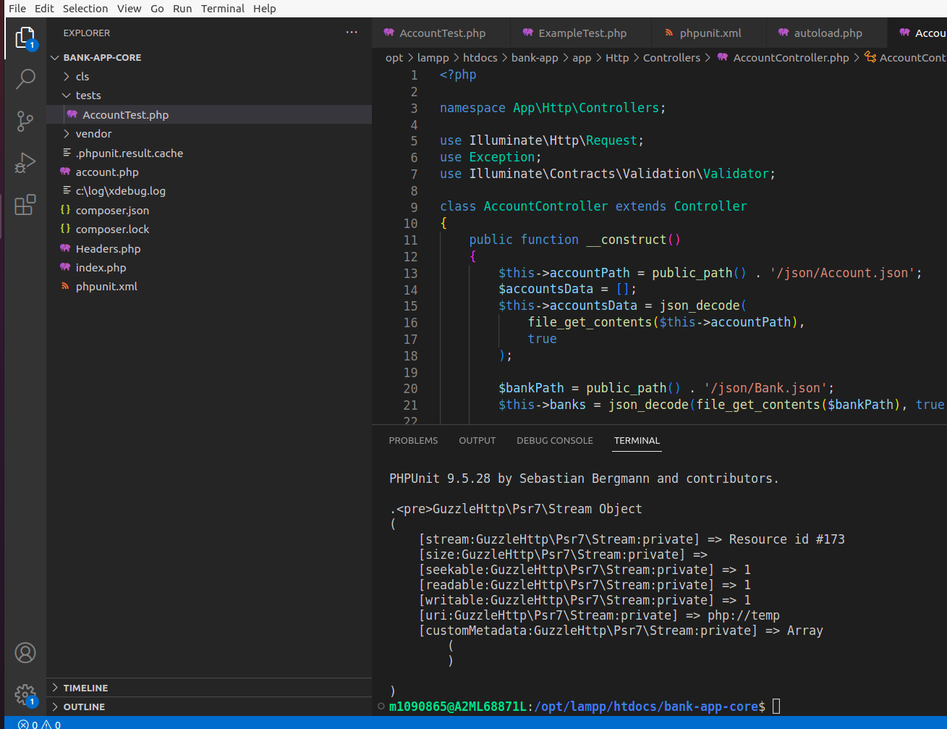

**4) Sample Code.**

