**\*DOOR SECURITY SYSTEM USING ARDUINO\***

**ABSTRACT:**

The Door Security System is a sophisticated yet accessible solution designed to enhance security measures for residential and commercial premises. Utilizing Arduino microcontroller technology, this system integrates various components to control and monitor access to doors effectively. The system employs authentication mechanisms such as keypads, RFID readers, or biometric scanners to verify the identity of users seeking entry. Upon successful authentication, a servo motor or electromagnetic lock mechanism unlocks the door, allowing authorized access. The system provides real-time feedback to users through LEDs, LCD displays, or audible alerts, indicating the status of access attempts. Moreover, optional connectivity features enable remote monitoring and control, enhancing flexibility and convenience. With its customizable nature and cost-effective implementation, the Door Security System offers a reliable solution to safeguard valuable assets and ensure peace of mind for property owners.

**COMPONENTS USED:**

1.Arduino UNO

2.IR sensor module with LED

3.Buzzer

4.9v Battery

5.Jumper wires

**CODE:**

byte ir_sensor=2;

byte buzzer=11;

void setup()

{

PinMode(ir_sensor,INPUT);

pinMode(buzzer,OUTPUT);

}

Void loop()

{

Int sensor_state=digitalRead(ir_sensor);

If(sensor_state==HIGH)

{

analogwrite(buzzer,200);

delay(110);

analogwrite(buzzer,100);

delay(110);

}

Else

{

Digitalwrite(buzzer,LOW);

}

}

**CIRCUIT DIAGRAM:**

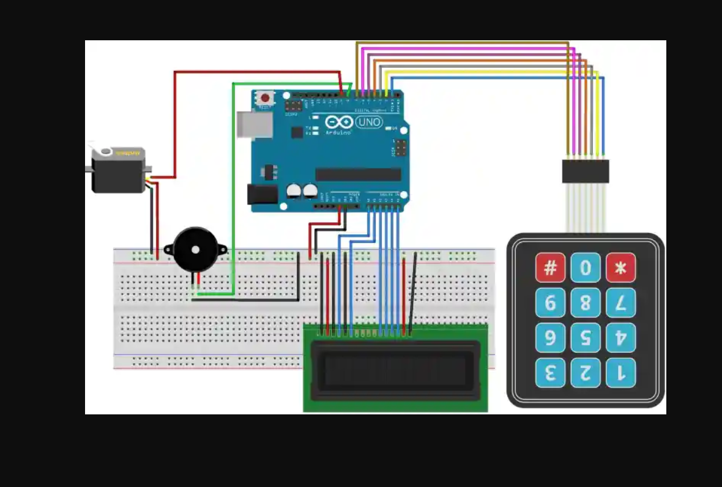

**PROCEDURE:**

To set up a door security alarm, you'll need a few components and follow these general steps:

1. *Choose Your Alarm System*: Select a door alarm system that suits your needs. This could be a standalone door alarm or part of a larger security system.

2. *Placement*: Install the alarm sensor on the door frame and the magnet on the door itself, ensuring they are aligned properly when the door is closed.

3. *Power*: Depending on the type of alarm, you may need batteries or a power source. Ensure the alarm has sufficient power to operate effectively.

4. *Testing*: Test the alarm to make sure it triggers properly when the door is opened.

5. *Settings*: Adjust any settings on the alarm system, such as volume or sensitivity, to meet your preferences.

6. *Notification*: If your alarm system is connected to a monitoring service or app, set up notifications for when the alarm is triggered.

7. *Regular Maintenance*: Check the alarm system periodically to ensure it's functioning correctly, and replace batteries as needed.

8. *Additional Security Measures*: Consider additional security measures such as security cameras or motion sensors to enhance your overall security setup.

Remember to follow the specific instructions provided with your door alarm system for the best results.

**RESULT:**

The result of a door security alarm is to alert you when the door is opened unauthorizedly, deterring intruders and providing you with a sense of security and peace of mind. It serves as a deterrent to potential burglars and can also notify you or authorities in case of a breach, allowing for prompt action to be taken.

**OUTPUT:**

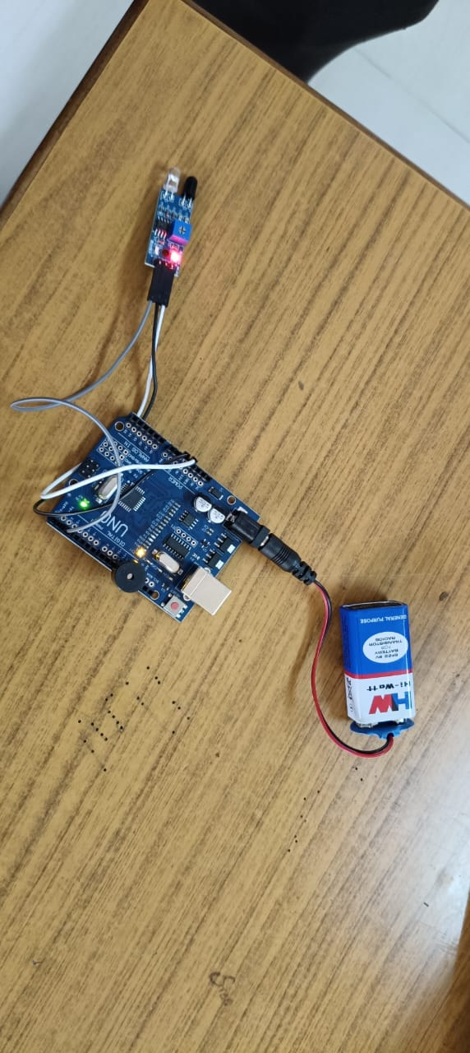

SIGNATURE OF GUIDE