-Open VS code
-Update Node, NPM and ng CLI
Download Node from 'https://nodejs.org/en/download/current/ '
>> npm install -g npm
>> npm install @angular/cli
>> npm cache verify
-Create new project using ng CLI
>> ng new cms
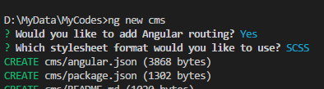
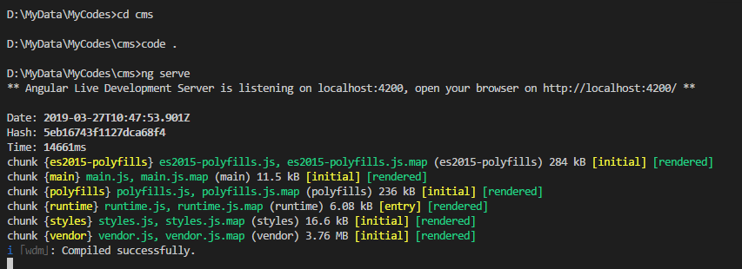
-Run the app

- Install packages for Angular material and others
>> npm install --save @angular/material @angular/cdk
>> npm install --save @angular/animations
>> npm install --save @angular/flex-layout
>> npm i --save-dev @types/angular

-Add a module file to import all the material modules and use this file wherever needed
>> ng g m shared/material --flat

