Nagios-monitoring-project/

On Nagios machine
- sudo yum update -y
- sudo yum install -y httpd php gcc glibc glibc-common wget unzip make net-snmp openssl-devel
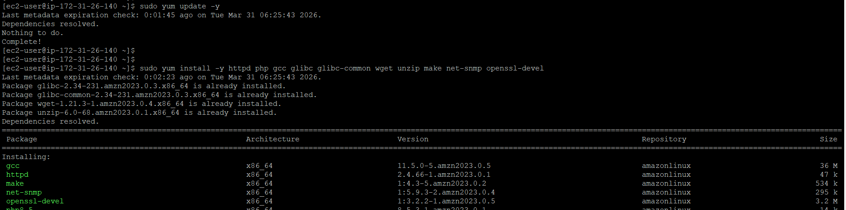

- sudo systemctl enable httpd
- sudo systemctl enable httpd
- cd /tmp
- wget https://assets.nagios.com/downloads/nagioscore/releases/nagios-4.4.6.tar.gz
- tar -xvf nagios-4.4.6.tar.gz

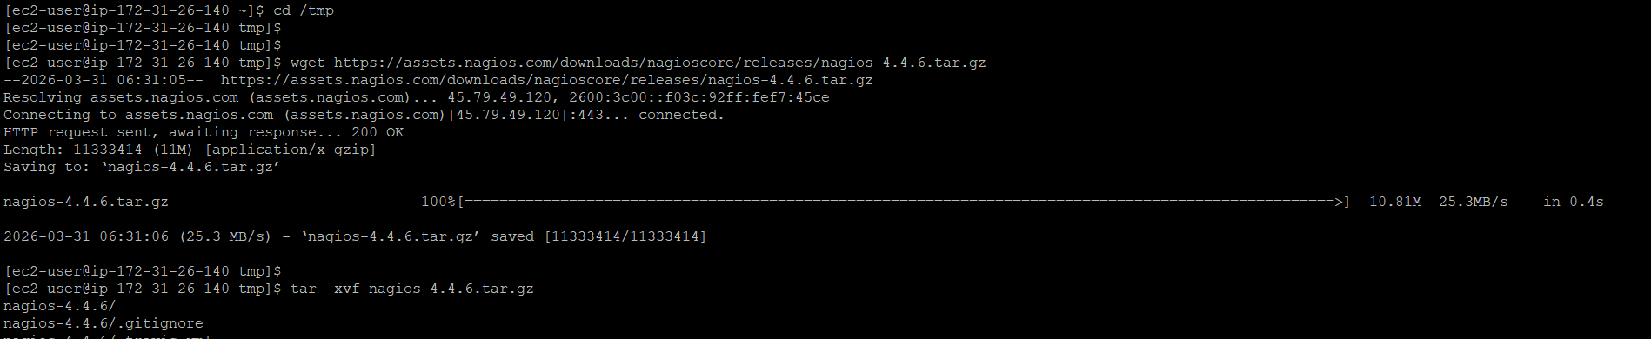

- sudo useradd Nagios
- sudo groupadd Nagios
- sudo usermod -a -G nagios Nagios
- sudo groupadd nagcmd
- sudo usermod -a -G nagcmd Nagios
- sudo usermod -a -G nagcmd apache



- cd nagios-4.4.6
- ./configure
- make all

- sudo make install
- sudo make install-init
- sudo make install-commandmode
- sudo make install-config

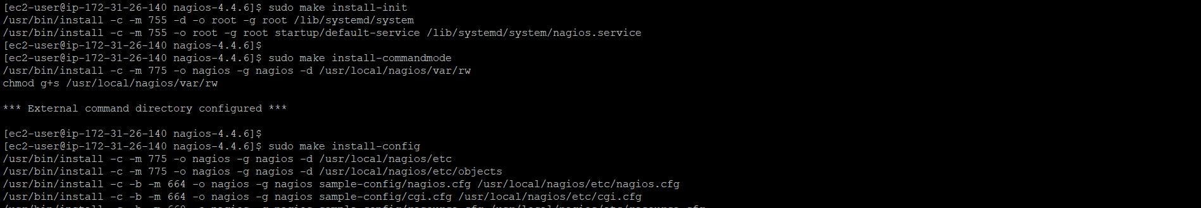

- sudo make install-webconf

- sudo htpasswd -c /usr/local/nagios/etc/htpasswd.users nagiosadmin

- Access URL

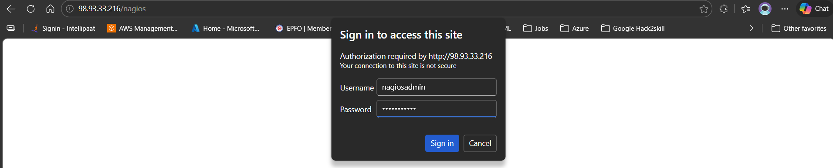
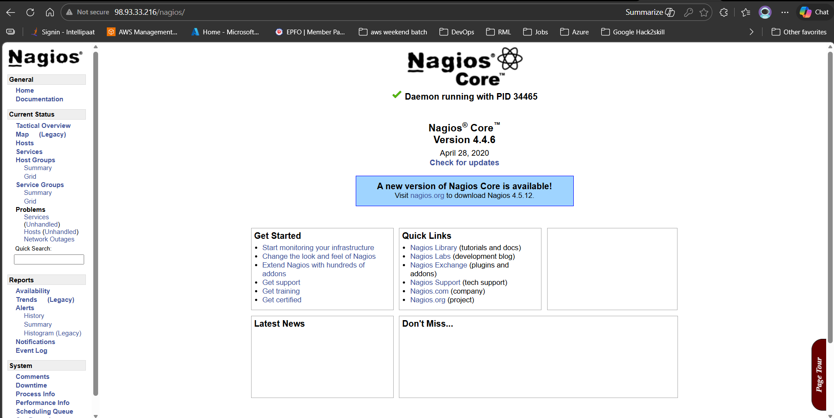

Install nagios plugins

cd /tmp
wget https://nagios-plugins.org/download/nagios-plugins-2.3.3.tar.gz
tar -xvf nagios-plugins-*.tar.gz
cd nagios-plugins-*

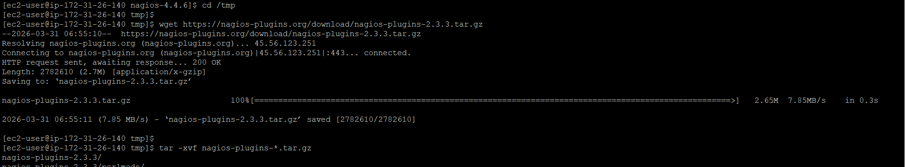

- ./configure
- Make
- sudo make install
- sudo make install
- sudo make install-config
- sudo make install-init
- sudo systemctl enable nrpe
- sudo systemctl start nrpe

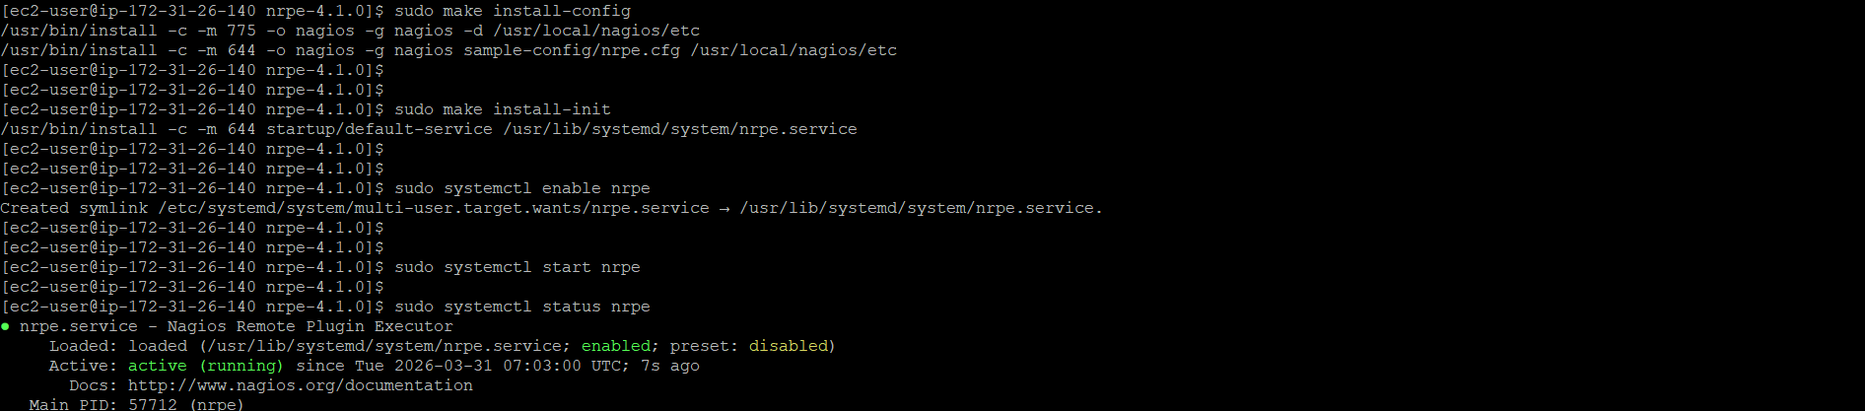

Client (remote) machine

- sudo yum install -y gcc glibc glibc-common make wget openssl openssl-devel

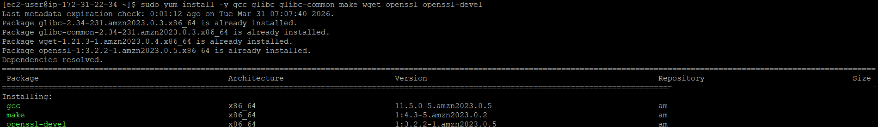

- sudo useradd nagios
- sudo passwd Nagios

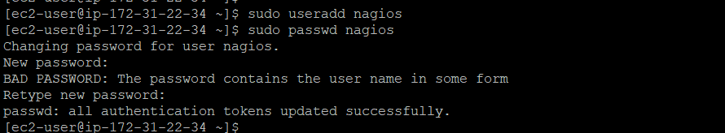

- cd /tmp
- wget https://nagios-plugins.org/download/nagios-plugins-2.3.3.tar.gz
- tar -xvf nagios-plugins-2.3.3.tar.gz
- cd nagios-plugins-2.3.3

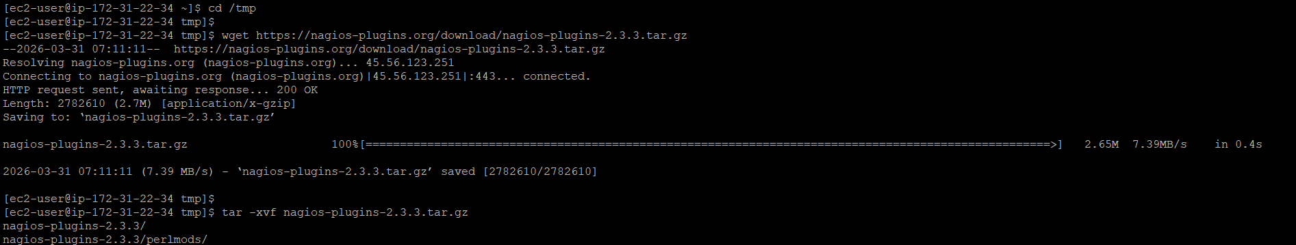

- cd /tmp
- wget https://github.com/NagiosEnterprises/nrpe/releases/download/nrpe-4.1.0/nrpe-4.1.0.tar.gz
- tar -xvf nrpe-4.1.0.tar.gz
- cd nrpe-4.1.0
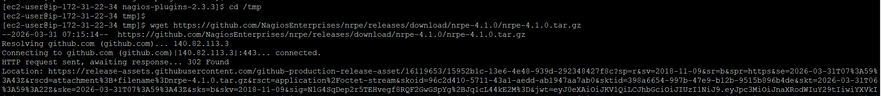

- ./configure
- make all
- sudo make install
- sudo make install-config
- sudo make install-init

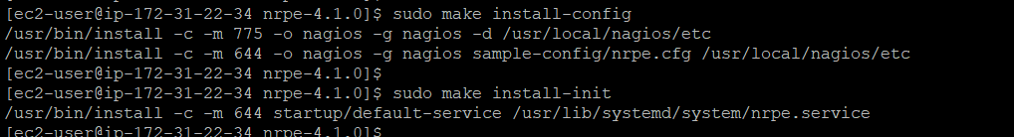

make changes in config(remote)

- sudo vi /usr/local/nagios/etc/nrpe.cfg
- allowed_hosts=127.0.0.1,<NAGIOS_SERVER_PRIVATE_IP>
- sudo systemctl enable nrpe
- sudo systemctl start nrpe

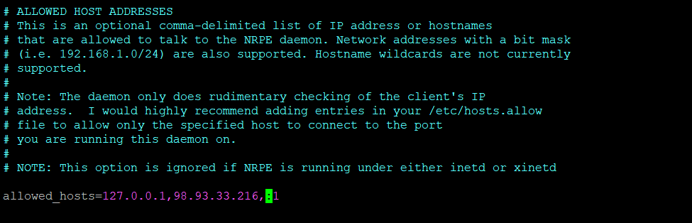

Add client to Nagios server(Server)

- sudo nano /usr/local/nagios/etc/objects/hosts.cfg
- define host {
- use linux-server
- host_name client1
- address <CLIENT_PRIVATE_IP>
- }

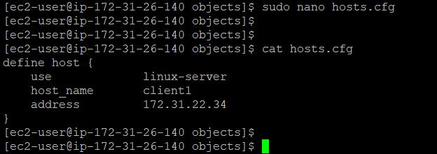

- Add Service Check

- sudo nano /usr/local/nagios/etc/objects/services.cfg

- define service {
- use generic-service
- host_name client1
- service_description CPU Load
- check_command check_nrpe!check_load
- }

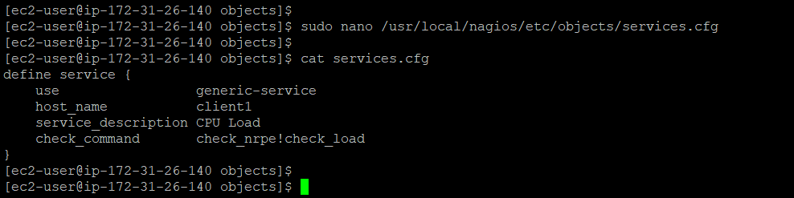

- Checking NRPE connection between server and client

On server machine
- sudo vi /usr/local/nagios/etc/nagios.cfg

- make sure
- cfg_file=/usr/local/nagios/etc/objects/hosts.cfg
- cfg_file=/usr/local/nagios/etc/objects/services.cfg

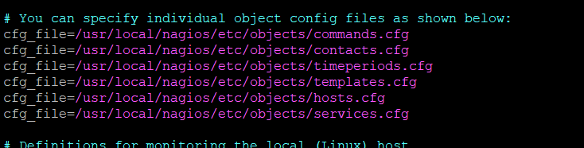

- host_name = same as in hosts.cfg
- check_command = must exist

Nagios panel – check remote machine
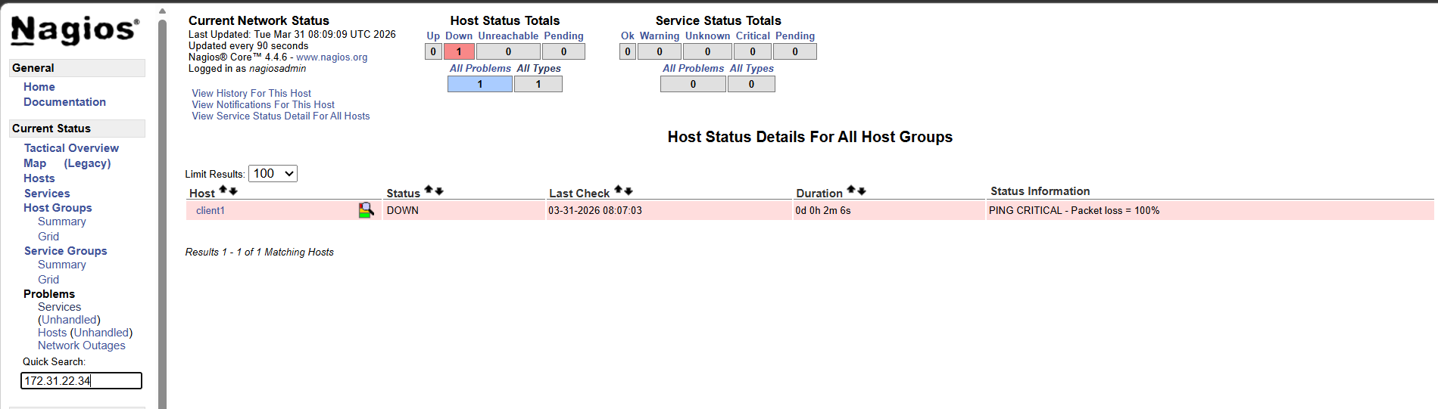

Configure email notification(on server)
- sudo yum install -y mailx
- sudo vi /etc/mail.rc


set smtp=smtp://smtp.gmail.com:587
set smtp-auth=login
set smtp-auth-user=your-email@gmail.com
set smtp-auth-password=your-app-password
set smtp-use-starttls
set ssl-verify=ignore
- verify


configure contacts
- sudo vi /usr/local/nagios/etc/objects/contacts.cfg
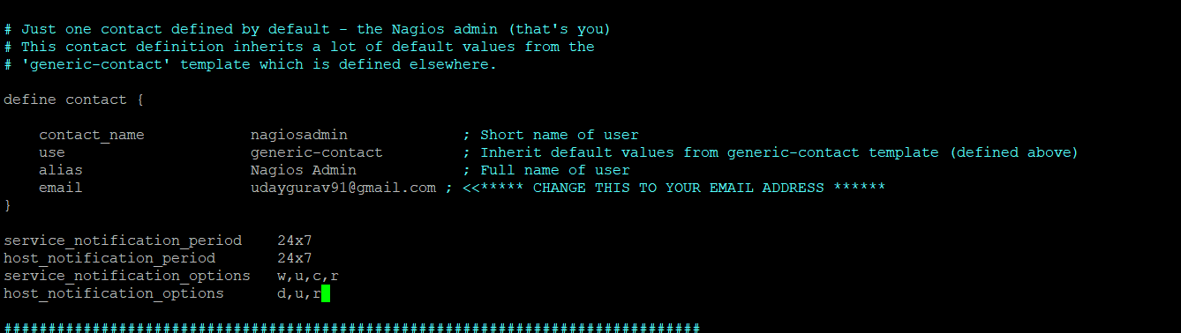

- make changes in hosts.cfg and service.cfg
add this - contact_groups admins


- edit contact.cfg
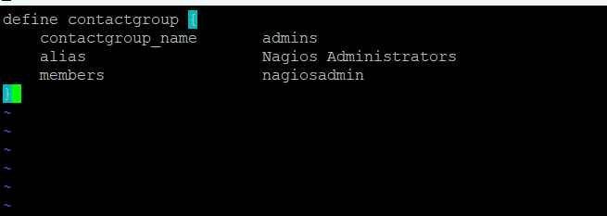

- Enable Notifications in Nagios config
sudo vi /usr/local/nagios/etc/nagios.cfg
enable_notifications=1
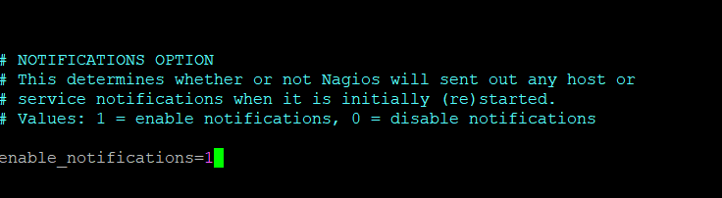

Email alert received
