INTERNAL ASSESSMENT – MACHINE LEARNING
Dataset Training Assignment
Name: B A UdayKiran
USN: 1AM23CI020
Department: CSE-AIML
Semester: VII

1. Objective
To train the datasets supplied for the internal assessment using corresponding machine-learning techniques for classification, boosting and clustering, evaluate the results, and organize the implementation for GitHub submission.

2. Dataset Mapping
Task | Dataset | Algorithm
Classification | Social_Network_Ads.csv | Random Forest Classifier
Boosting | insurance_pre.csv | AdaBoost Regressor
Clustering | Mall_Customers.csv | K-Means

3. Classification – Social Network Ads
The dataset contains 400 records. Gender was one-hot encoded, while Age and EstimatedSalary were used as numerical features. A Random Forest classifier with 100 trees was trained with a 75:25 train-test split. The test accuracy was 90.00%.
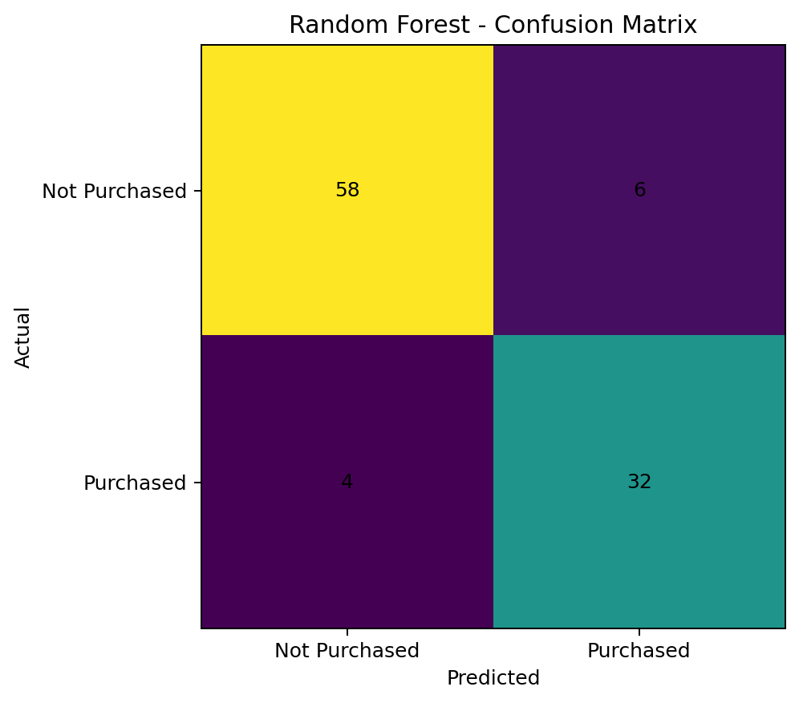

4. Boosting – Insurance
The dataset contains 1338 records. The target `charges` is continuous, so AdaBoost was applied as a regression algorithm using a decision-tree regressor as the base estimator.
- MAE: 3899.35
- RMSE: 4925.61
- R² Score: 0.8437
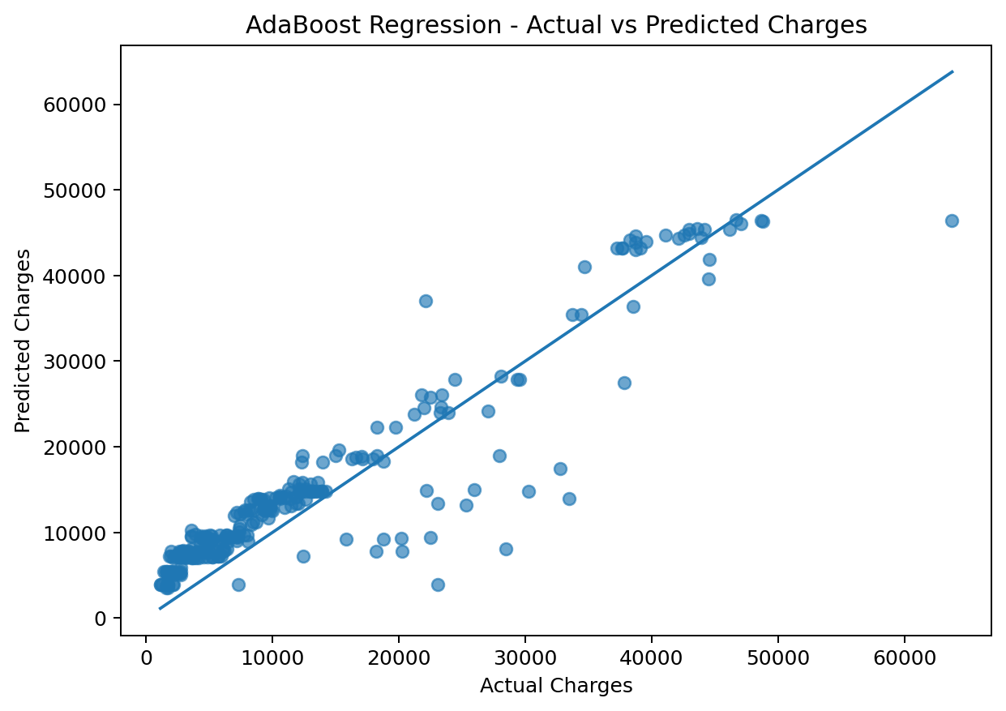

5. Clustering – Mall Customers
The dataset contains 200 customers. Annual Income and Spending Score were standardized before K-Means. Silhouette scores were evaluated for k=2 to 10. The best value was k=5, with a silhouette score of 0.5547.
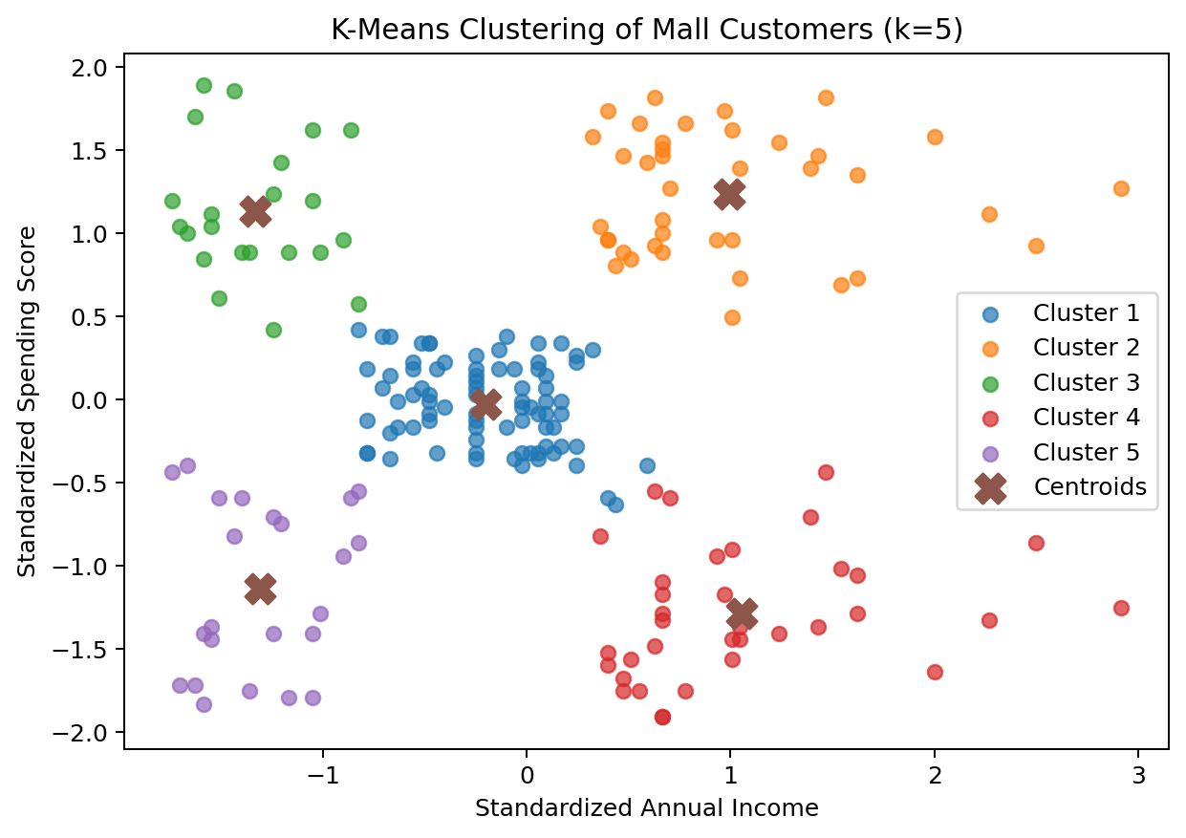
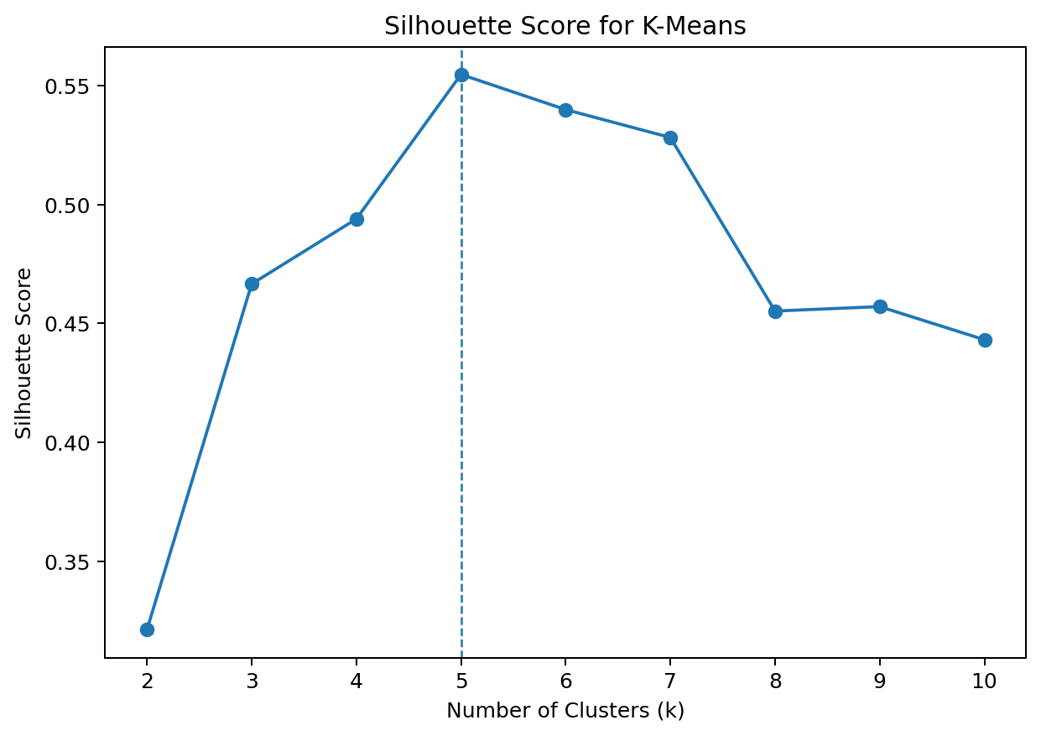

6. Conclusion
The three supplied datasets were successfully processed using appropriate machine-learning techniques. The classification model predicts purchase decisions, the boosting model estimates insurance charges, and K-Means identifies customer groups. The code, datasets, graphs and results are organized in a GitHub-ready project structure.

