# WIRELESS NETWORKS

# PA1 Report

**GROUP 1**

**Team Members**:

UDAY KIRAN RAVURI

MRUNMAYI SHARAD PARANJAPE

PRAPURNA JAYAKRISHNA DUVVURI

RAKTIM PAL

**(a)**. Total throughput achieved with four MAC protocols (CSMA/CA, CSMA+RTS/CTS, CSMA+ACK, and CSMA) under zero packet loss in both topologies is as shown below:

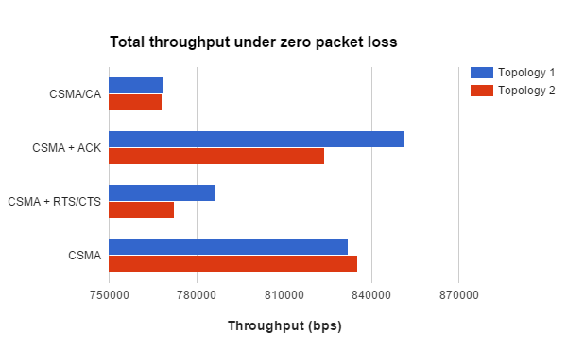

**(b)** In both topologies, positions of nodes N1 and N2 are fixed but position of node N3 is different.

In Topology 1, we have a Hidden Terminal Problem. This is because we have set the carrier sense range to be 300 m for each node whereas nodes N1 and N3 are 400 m apart. Hence, nodes N1 and N3 cannot hear one another in the wireless medium.

In contrast, Topology 2 does not have a hidden terminal problem as all nodes are within range of carrier sensing.

With zero packet loss, Topology 1 shows higher throughput than Topology 2 on an average. In general, when the nodes are closely located, each of the nodes can sense if the channel is busy and if any other node is transmitting. If the channel is found to be busy, a node will back off and contend later. Due to this, the overall throughput in Topology 2 is decreased as the channel remains idle for more time than in Topology 1.

In Topology 1, as nodes N1 and N3 cannot hear each other, N1 may transmit even though N3 is currently transmitting (in case of CSMA). Though the RTS/CTS and ACK packets are employed to reduce collisions in CSMA/CA, the throughput will still increase (though not much) because these control packets also have finite length and also contribute to the throughput at node N2.

Shown below are the values obtained after running 20 simulations (each for 100 seconds) for zero packet loss for all MAC protocols in both topologies:

|  |  |  |
| --- | --- | --- |
| Protocol | Topology 1 | Topology 2 |
| CSMA/CA | 768908 | 768044 |
| CSMA + ACK | 851480 | 824000 |
| CSMA+RTS/CTS | 786760 | 772262 |
| CSMA | 831910 | 835356 |

**(c)** For Topology 1,

CSMA + ACK (without RTS/CTS) has highest Throughput.

Using CSMA/CA, we get lowest throughput.

In CSMA, each node senses channel and if it is busy, nodes refrain from sending information. This topology has a hidden terminal problem. But in CSMA, there is a possibility that nodes N1 and N3 transmit simultaneously thus leading to collisions. CSMA/CA is introduced to avoid such collisions hence increasing the throughput. On the contrary, we have observed that the throughput is higher in case of CSMA than in CSMA/CA, even in the presence of hidden terminals. This is because there are not many collisions occurring in the channel and the channel is less contentious. This might be due to the fact that the CBR traffic being sent is random. Hence, as the number of collisions are low, using RTS/CTS and ACK would simply be an overhead and the actual data received is lesser than expected. Hence, the lesser throughput in CSMA/CA is justified.

In CSMA + RTS/CTS, we are disabling the ACK from being sent by the receiver. Hence, the sender will wait for the ACK (which it won’t receive) until the ACK timeout. Then it will try to retransmit the lost packet. But we have disabled the retransmit mechanism as well so the transmitter will now send a new packet (RTS). As the channel is idle until the ACK timeout period, the throughput decreases eventually when compared to the CSMA + ACK mode.

In CSMA + ACK mode, the RTS/CTS is not sent. Whenever the transmitter finds the channel to be idle, it starts transmitting after a random back-off timer. In this case, the transmitter does not transmit RTS or wait for CTS. So, a larger amount of data can be transmitted to node N2 within a given time. Hence, this leads to increased throughput. Added to this, it also seems that the number of collisions are less in this configuration so the throughput increases further.

**(d)** For Topology 2,

CSMA has highest throughput.

CSMA/CA gives lowest throughput.

In topology 2, the placement of nodes is in such a way that each node can hear the other nodes and the problem of hidden terminal does not surface in this topology. Here based on the simulated data we found that CSMA (without RTS/CTS and ACK) gives highest throughput whereas the CSMA/CA gives the lowest throughput. CSMA+ACK gives the second best throughput after CSMA followed by CSMA+RTS/CTS which gives the third best output.

It is quite evident that as there is no hidden terminal problem in this topology, enabling RTS/CTS for either of the CSMA (ACK disabled) or CSMA (ACK enabled) protocols will not help in increasing the throughput. For this reason the throughput values for protocols with RTS/CTS enabled are lesser than the throughput values for protocols without RTS/CTS enabled.

When we enable acknowledgments (ACK) in a protocol we observed that our throughput values were lesser than what they were in protocols without acknowledgements enabled. Although it is true that acknowledgements were introduced to reduce packet losses and improve throughput, in our experiment the channel is not very contentious and there are not many collisions as the CBR data we are sending is random. The ACK packets would also act as an extra overhead and the actual amount of data that is received would be less.

When we compare the effects of adding acknowledgements and RTS/CTS to a protocol we find that here in topology 2, adding RTS/CTS will have bigger impact than adding acknowledgements. For this reason the throughput values of CSMA/CA and CSMA+RTS/CTS are lower than CSMA+ACK and CSMA.

On the other hand when we enable ACKs for CSMA and CSMA+RTS/CTS ie. in protocols CSMA+ACK and CSMA/respectively, the throughput values are not as badly affected as they are when we enable RTS/CTS for a protocol as enabling RTS/CTS in this topology where hidden terminal problem does not exist and where the channel is not very contentious would reduce the throughput considerably.

**(e)** In both the topologies and in all 4 medium access strategies,

As loss rate increases, overall throughput keeps decreasing. We have introduced packet loss rates at each incoming node using “-IncomingErrProc” functionality of the node-configuration. We have varied the loss rates from 0% to 10% and ran the simulations for each loss rate in all four MAC protocols. The results are summarised in the bar charts below.

For higher losses, both topologies have similar throughput, but for low losses, specifically, 1-4% we find lot of variations in both the topologies.

In most of the loss models, CSMA and CSMA + ACK (without RTS/CTS) give highest Throughput.

When all loss models (varying loss rates) are simulated, we find that CSMA + ACK in Topology 1 has higher throughput than in Topology 2, which is consistent with zero loss model.

